**Project Report**

on

Guti-Baj game.

Course name: C-Project with lab

Course code: SWE 231

Submitted by :

***Mahadi Hasaan joy***

***Mostasim Billah***

***Md. Aawlad Hossain***

Submission Date: 10-04-1216

Course Teacher :

***Rayhan Hossain Mukul.***

**Lecturer**

**Department of Software Engineering**



**Department of Software Engineering**

**Document Approval**

The following Software Project Report on Guti_Baj game has been accepted and approved by the following:

|  |  |  |  |
| --- | --- | --- | --- |
| **Course teacher name:** | **Project name:** | **Signature** | **Date** |
| Rayhan Hossain Mukul | Guti-Baj  Game |  |  |

**Letter of Transmittal**

10th April

Course Teacher

Department of Software Engineering

Daffodil International University

Main campus

Subject: Submission of Project Report on Guti-Baj game.

Dear Sir,

Here we are submitting you our project report on Guti-Baj game for the c-project with lab course code is SWE-231 of 3rd semester. The project has been prepared based on c programming language.

The object of the course for the project was to follow and practice about c language and also use ability of the programming language.By this project we apprise with us with new experience and we learnt a lot of new things in this language.

Always we have tried to give best from our level to implement this project.We hope that user will enjoy this game. we have some plan around this game so that user can play this game by using app.

Sincerely Yours

Mahadi Hasan Joy

Mostasim Billah

Md. Aawlad Hossain

Department of Software Engineering

**Acknowledgement**

First of all we would like to thank almighty Allah for giving me the patience and proper time to complete the project successfully. We want to thank our course teacher Raihan Hossain Mukul for help us about made this game.

we start from zero and now after finished this project we realized that we gain many knowledge and we know that how a software project start and end. By this project our target was not only for complete this course but also we tried to learn new things and also new experience. From the beginning of the program we have learned the software development life cycle and have a chance toutilized on made this project.

At last we want to thank our friend for support and give us instruction and also gives us their opinion about our game.

**Preface**

This present world we are depend on software . Today we can see that everywhere we have used software for your easier lifestyle. The world of Software Engineering, practicing software development life cycle is mandatory. Software engineering course under of daffodil international university.This course makes a student practical in using the software development life cycle in software development.

1st semester we had a course that is introduction to software engineering.By this course we know that about software development life cycle. We made this project based on c programming language and software development lifecycle.2nd semester we have learnt about c language. Our basis knowledge in c language is good for that reason we able to made this game .we thankful to our teacher Raihan Hossain Mukul because he made our basic strong in c.

**Executive Summary**

This present world we are depend on software . Today we can see that everywhere we have used software for your easier lifestyle. We are students of software engineering (swe) program. We want to thanked Daffodil International university for given its students offering a wonderful program .

In this project document, the processes of software development life cycle have been followed as much as possible to develop the software. The first part has an introduction of this project document with an overall description in the second part. Software requirement specification (SRS) is the most important part of this documentation and we have introduced about (SRS) in 2ndsemester.We use here use-case diagram requirement and stakeholder test plan of our project. In the last there is a conclusion on this project document based on the experience we got during the long duration of project development.

**Table of Contents**

Document Approval ................................................................................................................................ II Letter of Transmittal............................................................................................................................... III Acknowledgement..................................................................................................................................IV Preface ....................................................................................................................................................V Executive Summary ...............................................................................................................................VI Revision History....................................................................................................................................VII Part 1……............................................................................................................................................8 Introduction ..........................................................................................................................................

Part 2

Part 3

Part 4

Part 5

Part 6

**Part 1:**

**Introduction:**

This section gives an overview of everything included in this project report document as well as purpose for this document is described. There is also a list of abbreviations and definitions are provided.

**Purpose of The Project**

Teen Guti game is the rural game of our country. Today this game almost lost from us. So, we have decided to bring the game in mobile or pc platform. From this people will still enjoy this game as like they enjoy earlier.

**Short description of project**

This is a console base game project. Two players can play this game at a time. It's basically a strategy type game. There are nine point on the game. Each player have particular one side. Each player have 3 pawn on their base position. The game begin when a player move his first pawn. If a player can match his three pawn in middle position on the board or diagonally match teen pawn or opposite side of the board if he can match three pawn then the player is win and the game is over. There is no limit of movement until the game is over.

**Feature of the project**

1. Multiplayer game

2.Smooth Movement

3.Nice console base graphic.

4.Time and date save.

5.Movement Counter.

6.Score count.

7.Save your game details.

**Evaluation of this document:**

The final goal of this document is to represent the total project report of the system for the clients, developers and persons related to this project which include SRS, design, implementation as well as testing

**Product Scope:**

The proposed of this project titledGuti-Baj.This is a traditional game of our country. In this game each player have 3 pawn on their base position. The game begin when a player move his first pawn. If a player can match his three pawn in middle position on the board or diagonally match teen pawn or opposite side of the board if he can match three pawn then which player can match his 3 pawn in 1st he or she will be win and he or she got 1 point.When a player got 3 point the he or she win and game is over.If player want to save his/her score he can save to the file with date and time.

**Tools and Technology**

1.Codeblocks

2.windows platform

3.C- language

**Timeline**

About two month to complete this project.

**Future plan**

Our future plan is to make the game available in different platform such as windows, android , IOS and web based.

**Part 2:**

**Overall Description**

This section has been designed to describe the overall characteristics of the proposed system. Why the system is going to be implemented and in which constraints the system will be implemented. The implementation criteria, product viewpoint, development environment will be included here.

**Requirements of the game**

**Functional Requirements**

* Six pawns of two different types.
* Matches one type of three pawns at particular side, except players own side.
* Move pawn.
* Win or lose.

**Non-functional Requirements**

* Score board.
* Move count.
* Time.
* Log in.
* Save detail.
* Sound/beep.
* Multiplayer system

**Stakeholder of this game**

* Internal stakeholder
* Developer
* External stakeholder
* Gamer

**Raw requirement of this game**

* This is a console base game project.
* Two players can play this game at a time.
* There are nine point on the game.
* This is c-language based game.
* Each player have particular one side.
* Each player have 3 pawn on their base position.
* There is no limit of movement until the game is over.
* If a player can match his pawn without his side then he will be win.

**Part 3:**

**Software Requirements Specification**

|  |  |  |  |  |
| --- | --- | --- | --- | --- |
| **No.** | **SRS Name** | **SRS description** | **SRS Type** | **Priority** |
| 1 | Move | Player 1 and 2 can move pawn | Functional | High |
| 2 | Check | System can check player pawns for valid position | Functional | High |
| 3 | Win or, lose | System decide that which player win or, lose | Functional | High |
| 4 | Score | Score count by the system | Non-functional | Low |
| 5 | Log in | Player can logged in this system | Non-functional | Medium |

**Requirements analysis diagram:**

**1.use case diagram of this game**

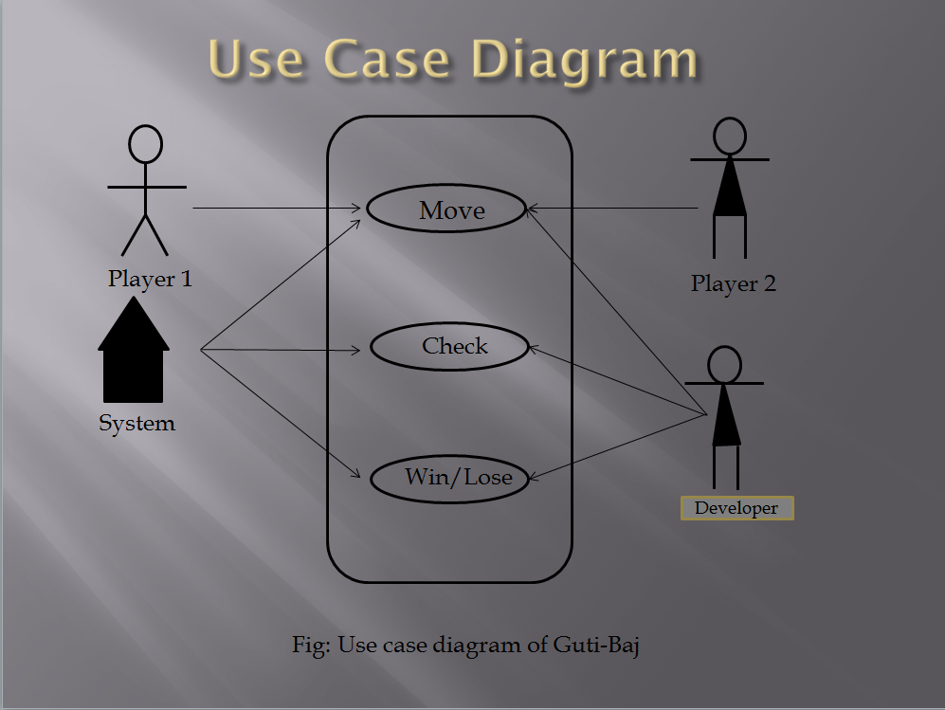Fig 1-system environment use-case

**2.Player use-case diagram**

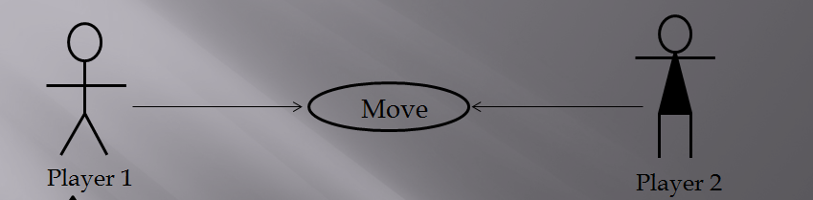

Fig-2.Player use-case diagram

**3.System use-case diagram**

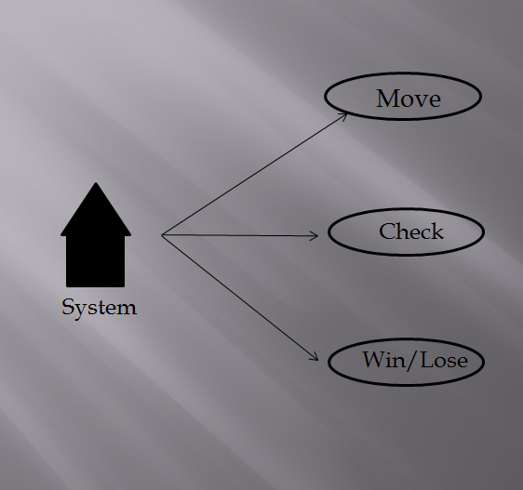Fig3-system use-case diagram

**4.Developer use-case diagram**

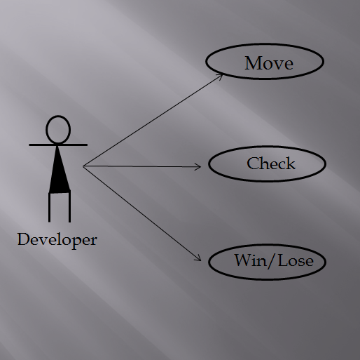 Fig4-Developer use-case diagram

**Part-4**

**Test plan of this game**

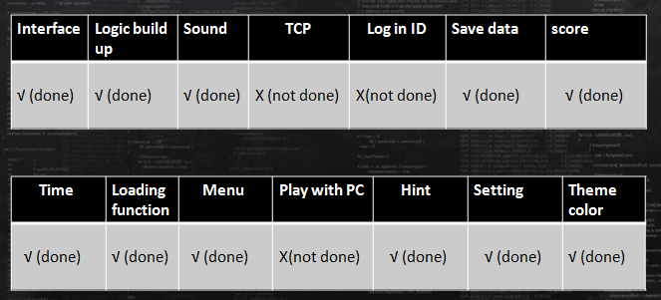

**Project Timeline:**

|  |  |  |  |  |  |  |  |
| --- | --- | --- | --- | --- | --- | --- | --- |
| Inception | 14feb2016 |  |  |  |  |  |  |
| Elicitation |  | 28feb2016 |  |  |  |  |  |
| Requirements analysis |  |  | 10march2016 |  |  |  |  |
| Design |  |  |  | 20march2016 |  |  |  |
| Implementation |  |  |  |  | 1april2016 |  |  |
| Testing & Improvement |  |  |  |  |  | 5april2016 |  |
| Release |  |  |  |  |  |  | 8april2016 |

**Project Ending dateline:10-04-2016**

**Activity diagram**

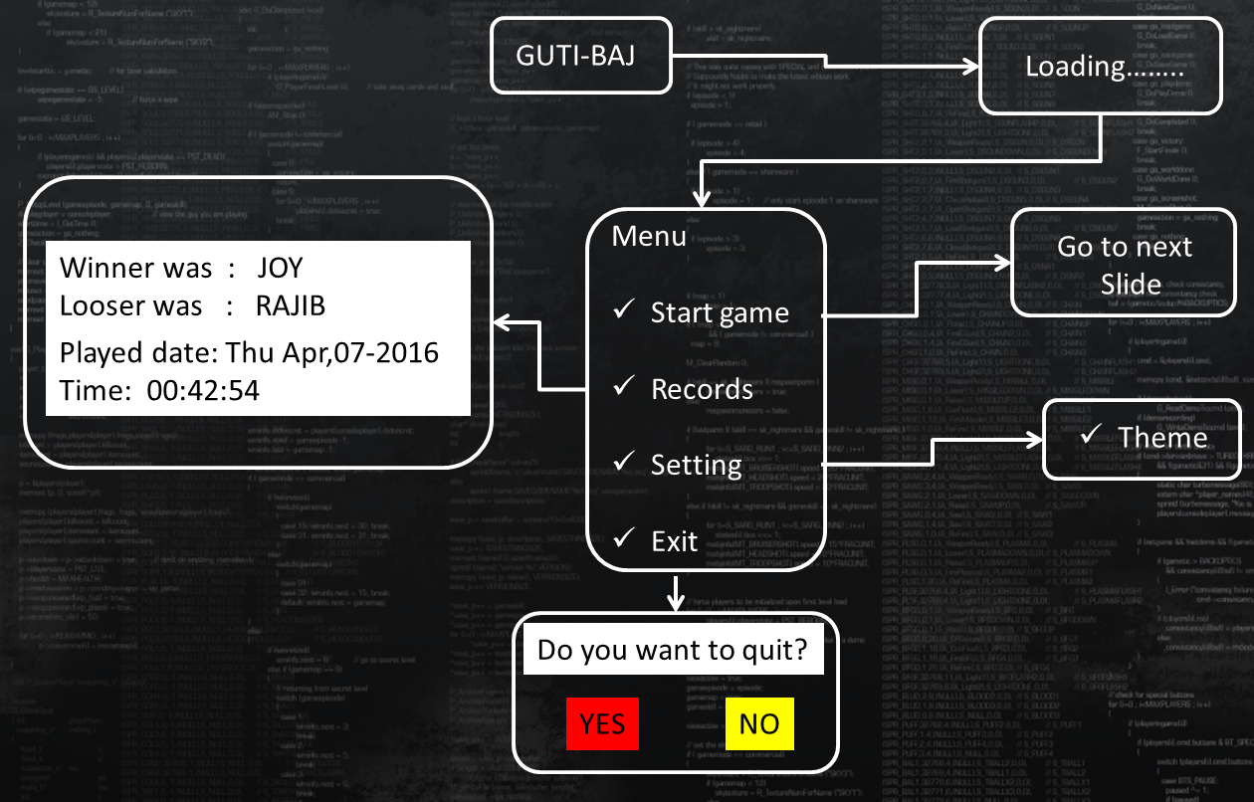

**Part 5**

**Interface of the game:**

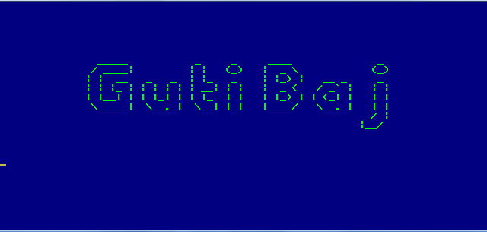

Fig4-Interface of the game

**Main menu:**

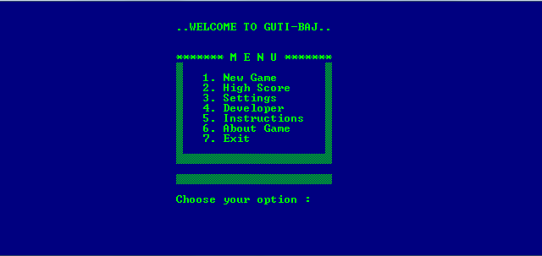

Fig5-Main menu of the game

**Main interface of the game**

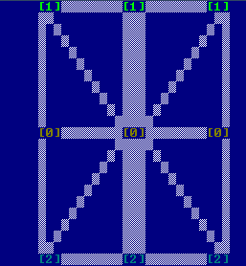

Fig6-Main interface of the game

**Conclusion**

This semester we have tried to give best from our level to make this project success.The project document is an evidence of what has been done in the undertaken project from the software requirement specification to Software testing. By made this c-project game we have learnt many things in c-language. we think that it will help us for our future project. We really happy to made this game with success.