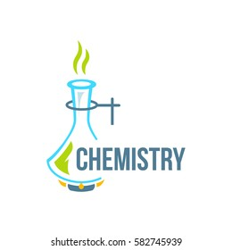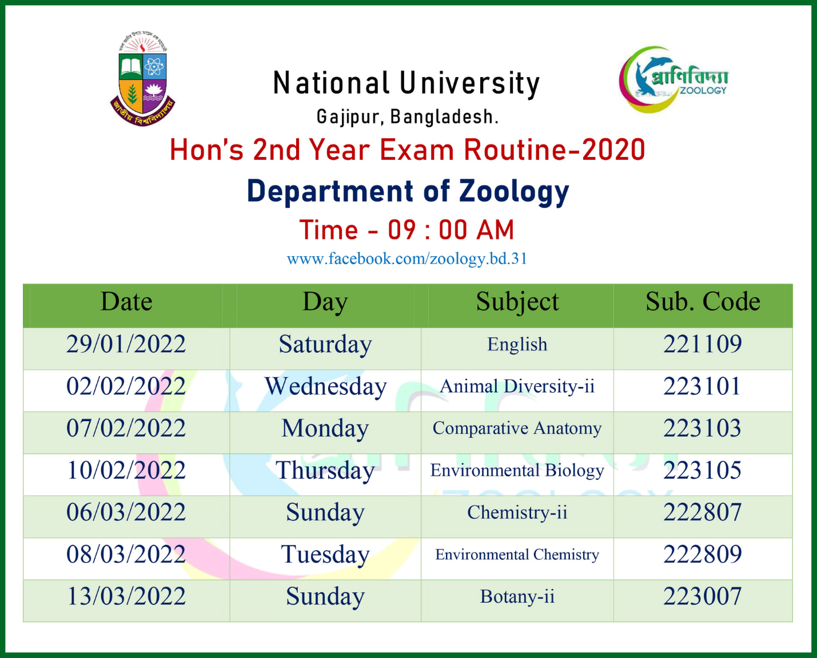

|  |  |  |  |
| --- | --- | --- | --- |
| Date | Day | Subject | Sub. Code |
| 14/02/2022 | **Saturday** | English | **221109** |
| 17/02/2022 | **Wednesday** | Physical Chemistry-II | **222801** |
| 20/02/2022 | **Monday** | Organic Chemistry | **222803** |
| 23/02/2022 | **Thursday** | Chemistry of the Representative Elements | **222805** |
| 09/03/2022 | **Tuesday** | Physics-III | **222707** |
| 16/03/2022 | **Thursday** | Calculus-II | **223707** |

Department of Chemistry

Time – 09 : 00 AM

A Prominent Software Farm in Bangladesh - Wake up ICT