HeartCop

For

Cardiology Department

Of

Bangabandhu Sheikh Mujib Medical University Hospital

*Prepared By:*

**WAKEUPICT**

The Nation’s Leading Software Company

**Introduction**

Thank you for your interest in **WAKEUPICT**. It is a great privilege to provide **HeartCop - Cardiology department patient data store and analysis System** for The Cardiology department of Bangabandhu Sheikh Mujib Medical University Hospital. A comprehensive price quote is provided for your kind perusal.

To give a brief about ourselves, WAKUPICT is the Nation’s Leading Software Company in Rajbari. It is located in Panna Chottor commercial area, Rajbari at its OWN and permanent premise in Nannu Tower. Our in-house team of UX designers, graphic designers, web designers, and developers uphold the highest standards for project planning and execution, and we’re dedicated to building the perfect software for your company on time and on budget.

We’ve built websites and apps for several brands around the local and global market with great success, and are quite excited to get to work on yours.

In this proposal, you’ll find examples of our past work along with what we feel is the optimal solution for the Cardiology Consultant’s needs, along with the associated delivery timeline, costs, and project terms. Once you’ve reviewed this proposal thoroughly, simply electronically sign it at the bottom to indicate your approval.

Thank you again for the opportunity to earn your business!

Mahmuduz Zaman

Managing Director & CEO

Wake Up ICT

Cell: +14168770890

Email: mahmuduz@wakeupict.com

.

**Overview**

**HeartCop - Cardiology department patient data store and analysis System** was introduced to resolve the complications coming from managing all the paper works of every patient associated with the various departments of hospitalization with confidentiality. **HeartCop** provides the ability to manage all the paperwork’s in one place, reducing the work of staff in arranging and analyzing the paperwork of the patients.

**HeartCop** **does many works like:**

* Maintain the medical records of the patient
* Maintain the contact details of the patient
* Keep track of the reports
* Save the time
* Give facilities of different types of enquiry
* Establish your clinic as technically advanced

**features**

**Digital Medical Records:**

* No risk to lose any patient information
* Basic Information
* Lab Test Report
* Prescription
* Save time
* Find patient information
* No need to search on paper
* Access anytime, anywhere.

**Digital Call Management System**

* Managing Schedule Call
* Storing Data and Analysis
* Making Reports
* Easy To Track

**Digital Prescription Analysis**

* Current Prescription
* Previous Prescription
* Compare between current and previous prescriptions side by side.

**Digital Reports**

* Clinical Report
* Patient Registration Report
* Patients Prescription Report
* Visiting Type Report
* NYHA Trend Report
* Age Distribution of Patient Report
* Reasons of Mortality Report (Total)
* Death Report (Month Wise)
* Medicine Report
  + Beta Blocker Report
    - Total Prescription Done
    - Number of BB Prescribed
    - BB Prescription Compliance age
    - BB Target
  + ACEI Report
  + ARNI Report
  + AA Report
* Device Profile (implanted) Report
* Device Eligibility Report (Month wise)
* Device Eligibility Report (Total)
* Patients Enrolled Report
* Patient Age Range (months wise)
* Gender Ratio Report
* Common Comorbidities Report
* Coronary Risk Factors Report
  + Entry Part Report
  + Improvement Part Report
* Echo Ejection Report
  + Lvdd Report
  + Lvids Report
  + Ef% Report
* ECG QRS Duration Report
  + Sinus Report
  + (RBBB/LBBB) Report
  + Heart Block Report
  + Extra Beats Report
  + Qrs Report
* Potassium Value Report
* Hemoglobin Value Report
* Creatinine Value Report
* Reason of hospital Admissions
* Vitamin D3 Report
* Uri Acid Report
* TSH Value Report
* TSH Value Report
* T3 Value Report
* T4 Value Report
* Angiogram Report
* Monthly Income Report
* Nt-Pro Report
* Major Adverse Cardiac Events Report
* Six Minutes’ Walk Test Report
* HF Medication Report
* On Track Program Report
* On Track Program Outcomes Report
  + Understanding of Fluid Restrictions
  + Understanding of Deit Restrictions
  + Understanding of Medications
  + Understanding of Exercise and Activity
* Frist Diet and Lifestyles Counselling Report
* Optimum Medication Therapy Report
* LV Function Evaluated Report
* Anticoagulants in AF Report
* HF Medication
  + Yes
  + No
  + Contraindication

**Best Part Of Our Application**

* Smart in-house solutions and adopting innovative technology.
* Highly Secured and Reliable.
* Hassle-Free Server Management.
* Our Software is verified by two international Vendor (AWS for Server and Kaspersky for Security).
* Easy to Use, Manage, Migrate and Customize.

**architecture**

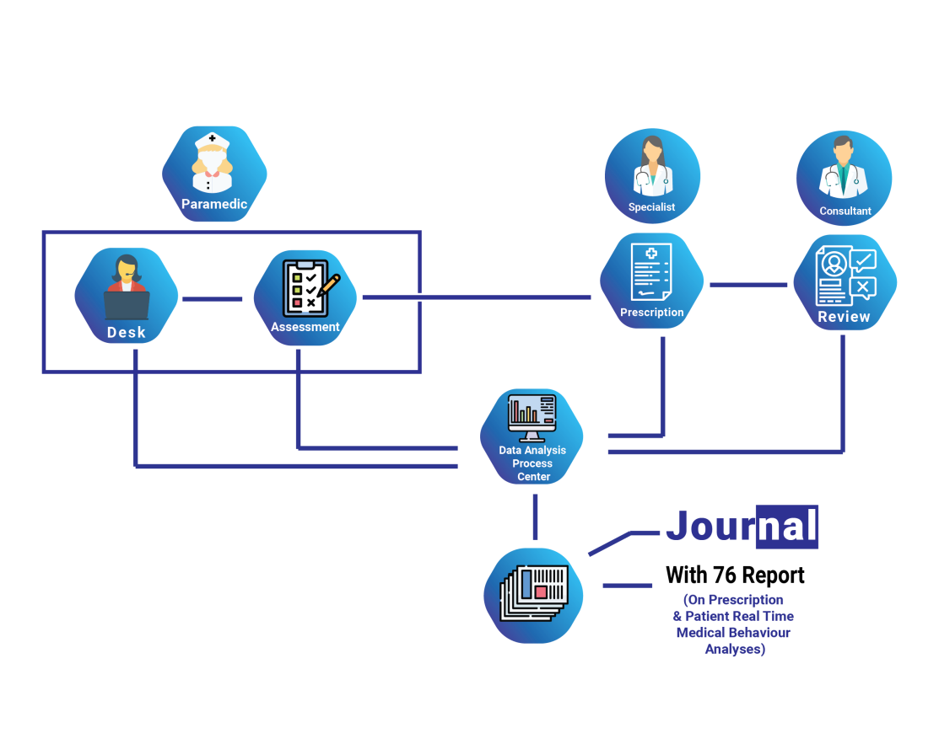

**Paramedic**

* Patient receive
* Basic information entry
* Follow up
* Physical examinations
* Lab test data entry
* Call management

**Specialist**

* Manage patient
* Compare patient’s previous and present prescription
* Identify and highlights problem areas

**Consultant**

* Manage patient
* Compare patient’s previous and present prescription
* Highlights problem areas
* Analysis data
* Analysis report

**New Custom Requirements**

**Patient Entry Process Modification:**

Patient entry process consists of 4 Sub modules. Authority can have the access control to all those sub modules.

*(First Sub Module) Patient Basic/Demographic Information:*

* Patient Registration Date
* HF ID
* Hospital ID
* Patient Name
* Gender
  + Male
  + Female
  + others
* Age
* Phone Number(multiple)
* Address
* Education Level(dropdown)
* Occupation
* Monthly Income
* Marital Status
* No. of Children
* Blood Group
* Menstrual History
* Caregiver Name
* Caregiver Relation
* Caregiver Phone No
* Treating Cardiologist
* Height (in cm)
* Vaccination
* Image

*(Second Sub Module) Initial Clinical Assessment:*

* Past Medical History
* Diagnosis
* Risk Factor
* Hypertension
* DM Type
  + 1
  + 2
* DL
* Positive FH
* Smoking History
  + Ex Smoker
  + Non -Smoker
  + Smoker
* Alcohol
* Comorbidities
* Asthma
* COPD
* Associated CAD
* Thyroid Dysfunction
* Obstructive Sleep Apnoea
* Severe musculoskeletal disease
* Bleeding diathesis
* Renal Failure (CKD)
* Valvular Disease
* Anaemia
* Cerebrovascular Accident
* Cancer
* Peripheral Vascular Disease

*(Third Sub Module) Investigations:*

* Ecg
  + Date
  + Findings
  + Rhythm
  + Qrs
  + Rbbb/lbbb
  + Heart block
  + Qt/qtc
  + Extra beats
* Echo
  + Date
  + LVIDd
  + LVIDs
  + EF%
  + RVSP/PASP
  + RWMA
  + D/D   
    I/II/III/IV
  + MR None  
    /1+/2+/3+/4+
  + LA
  + FS
  + EF   
    (by Teichholz)
  + EF   
    (by Simpsons Method)
  + Mitral Annulus S1
  + VTI
  + Stroke Volume
  + GLS
  + Comment
* Stress Echo
  + Date
  + Involved Regions
  + Involved Coronary
  + Viable
  + Non-viable
  + Ischemia
  + Arrhythmias
  + THR Achieved
  + At Rest
    - RWMA+
    - E'
    - E/E'
    - LVOT
    - MR
    - Stroke Volume
    - SPAP
  + After Stress
    - RWMA+
    - E'
    - E/E'
    - LVOT
    - MR
    - Stroke Volume
    - SPAP
* Lung Ultrasound
  + Date
  + AT Rest Blinx
  + After Exercise Blinx
* Chest X-ray
  + Date
  + Findings
  + Pulmonary edema
  + PVH
  + Pleural effusion
  + CT ratio
* 6 minute walk test
  + Date
  + VPC
  + Atrial Arrhythmia
  + Minimum HR
  + Maximum HR
  + Average HR
  + Pause 2.5s
  + Others
* MPI
  + Date
  + LVEF
  + Territory
  + %
  + Scar
* Angiogram
  + Date
  + Value
    - Normal
    - Non-critical
    - CAD
    - SVD
    - DVD
    - TVD
    - LMCA
    - Anomalous origin
    - Ectatic vessels

*(Fourth Sub Module) Laboratory test:*

* S.Creatinine
  + Date
  + Value
* S. Electrolytes
  + Date
  + Sodium
  + Potassium
* Lipid Profile
  + TC
  + LDL
  + HDL
  + TG
* CBC
  + HB
  + Platelet
  + TC
  + Dc
    - Neutrophils
    - Lymphocytes
    - Monocytes
    - Eosinophils
    - Basophils
* Glucose
  + Date
  + FBS
  + RBS
  + 2HAB
  + HBA1c

(Fifth sub module) Other

* Vitamin D3
  + Date
  + Value
* Uric acid
  + Date
  + Value
* INR
  + Date
  + Value
* TSH
  + Date
  + Value
* T3
  + Date
  + Value
* T4
  + Date
  + Value
* Calcium
  + Date
  + Value
* Magnesium
  + Date
  + Value
* Nt-pro BNP
  + Date
  + Value
* Others
  + Date
  + Test name
  + Value

**Follow up**

* Visit type
* Assessment date
* Visit no
* Type of
  + HFr EF (HF with reduced EF)
  + HFmrEF (HF with mid range EF)
  + HFpEF (HF with preserved EF)
* HF Aetiology
  + Cardiovascular
    - Ischemic
    - Toxic(Alcohol, Cocaine, Chemotherapeutic)
    - Idiopathic(Dilated)
    - Hypertrophic
    - Restrictive (Amyloid, Sarcoid)
    - Valvular/Rheumatic Heart Disease
    - Hypertensive
    - Tachycardia induced
    - Metabolic Diseases/Hemochromatosis
    - HIV and Viral Cardiomyopathy
    - Inflammatory Cardiomyopathy
    - Arrhythmia
  + Non-Cardiac
    - Pregnancy
    - Thyroid Disease
    - Pheochromocytoma
    - Chronic Renal Disease
  + Pulmonary
    - CorPulmonale Secondary to COPD
    - Pulmonary Hypertension
* VT/VF Risk Assessment
  + Documented Episode of VT/VF
  + History of Syncope / Pre-syncope
  + Frequency of episodes
  + Documented Number of PVCS
  + Documented NSVT
* AF STATUS
  + Permanent
  + Paroxysmal
  + Persistent
  + NSR
* Major Adverse Cardiac Events
  + Hospitalization
  + Stroke
  + Major Bleeding
  + Severe Arrhythmia
  + Major Procedures
  + Other
* Recent Hospitalization
  + Yes
    - Date
    - Reason
  + No
* Device
  + Choose Device
    - AICD
    - CRTD
    - PPM
      * PPM SINGLE
      * PPM DUAL
    - TPM
  + DATE
* Sign and symptoms
  + Exertional SOB
    - Present
    - Absent
  + NYHA Classification
    - I
    - II
    - III
    - IV
  + Orthopnoea
    - Yes
    - No
  + PND
    - Yes
    - No
  + Exertional Chest Pain
    - Present
    - Absent
  + Palpitation
    - Present
    - Absent
  + Fatigue
    - Present
    - Absent
  + Dizziness
    - Present
    - Absent
  + Syncope/Presyncope
    - Yes
    - No
  + Overall QOL
    - Poor
    - Medium
    - Fair
    - Good
  + Leg Swelling
    - Present
    - Absent
  + Sleep Disturbance
    - Present
    - Absent
  + Appetite
    - Poor
    - Fair
    - Good
  + Bowel habit
    - Normal
    - Diarrhea
    - Constipation
  + Sexual Activities
    - Normal
    - Hampered
  + Mental status
    - Alert
    - Confused
    - Drowsy
  + Psychological Status
    - Depression
    - Anxiety
    - Loss of memory
    - Anger
    - Normal
* Physical Examination
  + Weight
  + Anaemia
    - Present
    - Absent
  + Jaundice
    - Present
    - Absent
  + Cyanosis
    - Yes
    - No
  + Oedema
    - G-0
    - G-1
    - G-2
    - G-3
    - G-4
  + JVP
    - G-0
    - G-1
    - G-2
    - G-3
    - G-4
  + Pulse
  + BP
  + Heart
  + Lungs

**Smart Users Management System:**

*Section Module:*

Authority can be able to create Departments and Users. To create a user, first authority have to assign his/her department and type. A user can only process his/her sections data. He / She cannot see other department’s data.

*User Type Module:*

In the default system, we create 4 static users (Administrator, Paramedics, Specialist, and Consultant). After developing this module, Authority can create a different types of users as required. such as Sister, Nurse, etc.

*User Access Module:*

In this module, the authority can be able to control the access of any user type. First, they have to create user type in ‘**User Type Module’** then they can setup that user type access in the built in modules and sub-modules. The Built in modules are

* Patient Entry
  + Patient Basic/Demographic Information
  + Initial Clinical Assessment
  + Clinical Findings
  + Laboratory test
* Prescription
* Prescription Review
* Reports

**Excution timeline**

After confirming the order, it takes **90 working days** to develop the system to the client.

**cost**

1. **One Time Fee**

The costs associated with this project are shown below along with the payment plan.

|  |  |  |  |
| --- | --- | --- | --- |
| Name | Price | QTY | Subtotal |
| Software onetime cost | 3,00,000 | 1 | 5,00,000 |
| **Total One Time Fee (A)** | | | **5,00,000** |

1. **Ongoing fees (Yearly)**

The table below details monthly fees which will begin once the software is successfully launched.

|  |  |  |  |
| --- | --- | --- | --- |
| Name | Price | QTY | Subtotal |
| Monthly subscription Fee  (include server, server maintenance, data security) | 24,000 | 12 | 3,88,000 |
| Standard Customer Support ( in person ) | 2500 | Per day | On demand |
| Standard Customer Support ( online/phone call ) | 500 | 1 hour | On demand |
| **Total Yearly Subscription Fee excluding support services (B)** | | | **3,88,000** |

|  |  |
| --- | --- |
| **Total Cost (A + B)** | **8,88,000** |

* 50% of the onetime cost need to be paid in advance with the work order. (2, 50,000/-)

** Rest 50% will be paid after delivering the project. (2, 50,000/-)

*** Monthly subscription fee can be paid monthly/yearly in advance after delivering the software.

(32,334/Month)/ (3, 88,000/Year)  
**** Next year’s yearly/Monthly subscription fee will be changed on the basis of previous year’s data usage.

**terms and conditions**

**Authorization**

Client is engaging WAKEUPICT as an independent contractor for this specific project.

**Completion**

WAKEUPICT and Client must work together to complete the project in a timely manner. WAKEUPICT Agrees to work expeditiously to complete the project no later than project deadline (depending on date of acceptance of agreement)

**Payment**

Fees to WAKEUPICT are due in accordance with the above notes (*) under the pricing table. Subscription fees can be paid monthly or yearly in advance. Payment has to be made by 30th of the month for the following month’s subscription if the client chose the monthly option. For yearly subscription option, the full yearly amount has to be paid in advance. All payments will be made in BDT.

**Assignment of project**

WAKEUPICT reserves the right to assign subcontractors to this project to ensure the right fit for the job as well as on-time completion. Revision during execution, client may be charged additional fees if it decides to make changes to the agreed upon project scope and objectives.

**Copyrights & Trademarks**

All copyrights and trademarks of this software are reserved by WAKEUPICT, Client has no right to resale it.

**Acceptance**

|  |  |
| --- | --- |
| Clients Acceptance:  SIGNATURE  Date | WAKEUPICT Acceptance:  SIGNATURE  Date |

**contact us**

WAKEUPICT

3rd Floor, Nannu Tower.

Panna Chottor, Rajbari.

Contact Numbers

+88 01791612121

+88 01710016092

Email: [info@wakeupict.com](mailto:info@wakeupict.com)

Web: https://www.wakeupict.com

**conclusion**

WAKEUPICT is an efficient and dedicated software development firm with the correct solution-based approach in meeting and exceeding our Client’s expectations.

Our experienced and focused team members are well placed and equipped and contain the correct experience and qualifications to carry out their functions with diligence and skills. It is our vision that WAKEUPICT May be of service to all prospective Clients in the Private, Professionals and Public sectors.

Please direct all enquiries and/or requests for additional information to WAKEUPICT on the details provided above and let us provide you with excellent service, proving our motto of “Development that you can trust. . . “