Assignment submitted by: Pankaj Mahadik

This document explains the steps to import and deploy the KYC contract to remex IDE.

Notes:
- Overall flow of contract is:
First deploy the contract. The account (first from the account field) which deploys the contract will be registered as admin.
- Next, call addBank function using admin account as invoker, and use next 6 addresses for 6 banks to add.
- Select either of bank account in account field, and call addCustomer function to simulate that new customer is added.
- Once customer is added, call the function addRequest to create a KYCRequest for this newly added customer.
- The banks can now vote (upVote or downVote) for this customer.
- During every upVote or downVote operation, it performs the logic to decide whether customer KYC is successful or not, and also the complaint count of the bank that has initiated the KYC process for a customer gets increased by one if the downVote is reported by any other bank.
- Various events are defined and will get emitted depending on the business flow that’s getting executed.
- If customer submits new documents then modifyCustomer function will be get called which will reset the upVote and downVote counts and all banks are again made eligible to vote for the customer once the addRequest for the customer is added.
- Each bank is allowed to vote only once per customer (either upVote or downVote, not both).

The steps for solution:

- Open the remex IDE: https://remix.ethereum.org/
- Open the ‘Solidity Compiler’ menu and tick the checkbox in front of ‘Auto compile’.

- On the left pane, click on the ‘contracts’ folder
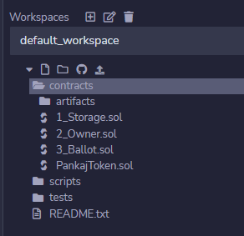
- Click on the first icon besides the drop down or right click on the contracts and select ‘New File’ option. Name this new file as KYC.sol
- Copy the entire code from the KYC.sol from the submission and paste in the KYC.sol in remix IDE.
- Make sure the compile options shows green tick mark, that is indication of successful compilation of KYC.sol

- Click on ‘Deploy and run transactions’ option on left pane.
- Confirm ENVIRONMENT shows ‘JavaScript VM (London)’
- Click on ACCOUNT field, and copy first 7 addresses one by one and paste in other notepad or text editor. Will refer them as account-1, account-2, …, account-7 in later steps.
- Select account-1 in ACCOUNT field, confirm CONTRACT field shows KYC - contracts/KYC.sol and then deploy the contract.
- The Deployed Contracts section will show 1 contract listed.
- Click on small arrow > in front of the contract to expand. It will show similar to below:
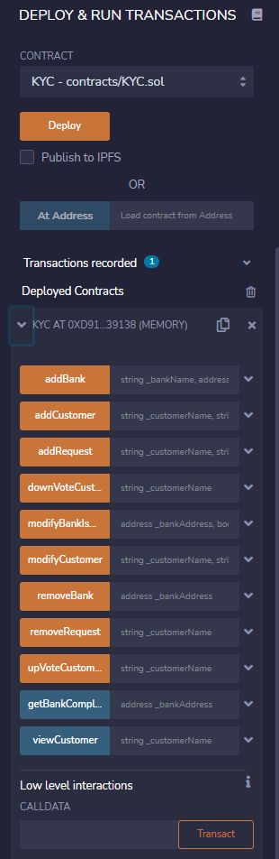
- Keep account-1 selected in ACCOUNTS field and invoke addBank function. Select account-2 and give appropriate name for the bank and registration number while invoking. When you call transact button, the transaction gets initiated and should get completed successfully.
- Repeat the same process in step-13 with account-3 till account-7.
- Thus so far, we have one admin account (account-1) and 6 Banks (account-2 through account-7).
- Negative case: Select any account other than account-1, and try to invoke addBank functionality. It will get errored out saying only admin user can perform this operation. Same behavior will be observed for modifyBank and removeBank functions.
- Negative case: select account-1 and invoke addCustomer function. This will error out as account-1 is admin account, and not a bank address. The addCustomer needs to be invoked by a bank, hence the error.
- Select any account other than account-1 in ACCOUNTS field (account-2 to account-7), and invoke addCustomer function. This should be successful.
- Invoke addCustomer with some other account (account-2 to account-7) and new customers should get added to the bank.
- Negative case: Try to add a customer with customer name that is already added, and it should get errored out as the customer name is treated as unique in the implementation.
- Negative case: For already added customer, try to invoke upVoteCustomer or downVoteCustomer, and both will get error out saying the KYCRequest is not yet available.
- Invoke addRequest for the customers that added above.
- Now, invoke the upVoteCustomer (and downVoteCustomer) with different banks for a customer.
- Negative case: Try to invoke upVoteCustomer or downVoteCustomer again for which it was already performed. It should restrict you from doing so with error indicating that the bank has already voted for this customer.
- Invoke modifyCustomer, and then all banks should be able to vote (invoke upVoteCustomer or downVoteCustomer) for this customer.
- Invoke getBankComplaintsCount for any bank (account-2 to account-7) with account-1 selected in ACCOUNT field and it should return the number of complaint. If KYC request initiated by a bank get downVoted by other bank, then it is counted as complaint and count increased by one for this bank that has initiated KYC request.
- It also has logic to count number of KYC requests initiated by all banks.
- Function viewCustomer will show the current state of the customer such as: all the attributes like upvotes, downVotes and KYC status of the customer.
- Function removeBank can be called by admin (account-1) to remove a bank from KYC.
- Function removeRequest can be called by a bank to remove any KYC request that is submitted for a customer earlier.

