NOTES ## English Discussion on Noun Exercise & Pronoun -1 (Live-7)

Section 1: Lecture Flow Outline
- Subject Nouns SVA, Uncountable Advice, & Primary Omissions
- Pronoun Subjective Case, Indefinite Consistency, & Emphatic It
- Uncountable Classifiers, Mountain range the-prefix, & Negative Quantifiers
- Body organs Article the-prefix, Plural Police SVA, & Closest Subject Agreement
- Proper Noun quality Comparisons, divided collective Plurals, & 2-3-1 pronoun order
- Indefinite Articles A vs An Sound Rules

Section 2: Detailed Concept Blocks

CB1: Subject Nouns SVA, Uncountable Advice, & Primary Omissions
Introduces Subject-Verb Agreement and uncountable nouns. Covers subject nouns ending in 's', one of constructions, distance/temperature quantifiers, uncountable advice, with joiners, and primary purpose article omissions and their exam-relevant rules.

Worked Examples:
Q: Measles is one of those diseases that weakens a person's immunity.
Rule: Disease names are singular; 'one of' takes a plural noun; the relative clause verb agrees with singular 'one'.
Working:
Measles -> is (singular disease) | one of those disease -> incorrect -> change to 'one of those diseases' | that weaken -> teacher-specified relative agreement -> change to 'that weakens'.
Answer: change to 'that weakens'.
Q: Twenty million degrees at the core of the sun is enough to melt anything and everything.
Rule: Expressions of temperature, distance, or sums are treated as a singular unified quantity.
Working:
twenty million degrees... are enough -> represents a single temperature -> change 'are' to 'is'.
Answer: change 'are' to 'is'.
Q: When Katie decided to adopt a child, her mother gave her a piece of advice.
Rule: 'Advice' is an uncountable noun (noun case); do not write 'an advice' or 'advices'. 'Advise' is the verb form.
Working:
gave her an advice -> uncountable -> change to 'gave her a piece of advice' or 'gave her advice'.
Answer: change to 'gave her a piece of advice' or 'gave her advice'.
Q: During elections his star with thousands of his fans campaigns for the ruling party.
Rule: Subjects joined by 'with', 'together with', 'along with', 'as well as', 'besides' agree with the first subject.
Working:
star (singular) with fans (plural) -> campaign -> first subject is singular -> change to 'campaigns' or 'campaigned'.
Answer: change to 'campaigns' or 'campaigned'.
Q: Jimmy goes to church every Sunday and the church he goes to is located near the library.
Rule: Omit articles for routine visits to places for their primary purpose; use 'the' for specific building references.
Working:
goes to the church -> primary purpose (worship) -> omit 'the' -> 'goes to church' | the church he goes to -> specific building -> correct.
Answer: correct.
Exercise Questions:
- Q1: Measles is one of those diseases that weaken a person's immunity.
- Q2: Twenty million degrees at the core of the sun are enough to melt anything and everything.
- Q3: When Katie decided to adopt a child, her mother gave her an advice.
- Q4: During elections his star with thousands of his fans campaigned for the ruling party.
- Q5: Jimmy goes to the church every Sunday and the church he goes to is located near the library.
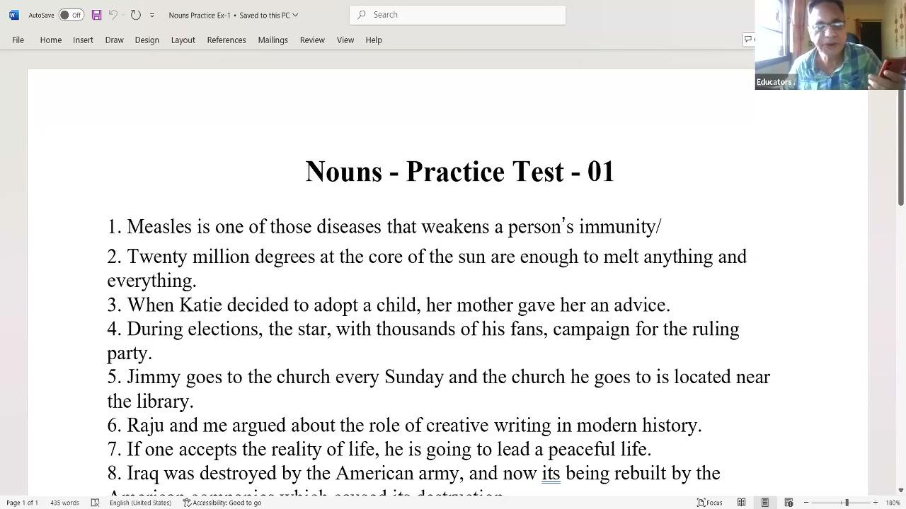
📝 QUOTE: "Measles is... Disease name is always a singular. One of के पीछे हर हालत में plural noun आएगा... One out of many ही हो सकता है."
📝 QUOTE: "Preposition जो पहली है वो of है तो of के पहले one है, one singular है, one के साथ weakens आएगा, weaken नहीं आएगा."
📝 QUOTE: "Five hundred rupees is a big sum... the subject is a temperature of twenty million degrees, which is singular."
📝 QUOTE: "Goes to church means routine activity, no article needed. But the church he goes to represents a specific building, so the is required."
🚨 TRAP: Never use 'an advice' or 'advices' for general recommendations; do not pluralize primary purpose institutions in routine actions.
💡 TRICK: Preposition rule: Look at the noun *before* the first preposition to find the true subject (e.g., 'one' in 'one of those...').
[⚡ Quick Rev]
• Transcript range: 0% – 24%
• Key trap: Never use 'an advice' or 'advices' for general recommendations; do not pluralize primary purpose institutions in routine actions.
Rule: Subject Nouns SVA, Uncountable Advice, & Primary Omissions

CB2: Pronoun Subjective Case, Indefinite Consistency, & Emphatic It
Introduces active pronoun usage and consistency of indefinite pronouns. Covers active subjective case, indefinite 'one', its vs it's, SVA with each, emphatic subjective cases, and emphatic 'it' structures and their exam-relevant rules.

Worked Examples:
Q: Raju and I argued about the role of creative writing in modern history.
Rule: Active voice subjects must use the subjective pronoun case (I, we, he, she), not objective (me, us) or reflexive.
Working:
Raju and me argued -> 'me' is objective -> change to subjective -> 'Raju and I argued'.
Answer: 'Raju and I argued'.
Q: If one accepts the reality of life, one is going to lead a peaceful life.
Rule: Subsequent pronoun references to the indefinite subject 'one' must remain 'one' or 'one's' for consistency.
Working:
If one accepts... he is going -> change 'he' to 'one' to maintain subject agreement.
Answer: change 'he' to 'one' to maintain subject agreement.
Q: Iraq was destroyed by the American army and now it is being rebuilt by the American companies which caused its destruction.
Rule: Do not omit the subject pronoun/verb ('it is' / 'it's') before passive verbs; distinguish between 'it's' (it is) and 'its' (possessive).
Working:
and now is being rebuilt -> add subject and auxiliary -> change to 'now it is being rebuilt' or 'now it's being rebuilt'.
Answer: change to 'now it is being rebuilt' or 'now it's being rebuilt'.
Q: Every part of Mongolian life is infused with music and each of their songs reminds them of their ancient hymns.
Rule: 'Each' is singular and requires a singular verb ('reminds') in present tense third person; 'hymn' means chant/shlok.
Working:
each of their songs remind -> 'each' is singular -> change 'remind' to 'reminds'.
Answer: change 'remind' to 'reminds'.
Q: It was we who had documented the Naxalite movement among the tribals.
Rule: Emphatic 'It was/is' frames must be followed by subjective pronouns (we, I, he, she), not objective ones (us, me, him, her).
Working:
It was us who -> incorrect -> change 'us' to 'we' | test: 'We had documented the movement' is correct.
Answer: change 'us' to 'we' | test: 'We had documented the movement' is correct.
Q: It is humility which sets apart the truly great men from others.
Rule: Emphatic introductory constructions utilize the pronoun 'It' rather than 'That'.
Working:
That is humility which sets -> change 'That' to 'It'.
Answer: change 'That' to 'It'.
Exercise Questions:
- Q6: Raju and me argued about the role of creative writing in modern history.
- Q7: If one accepts the reality of life, he is going to lead a peaceful life.
- Q8: Iraq was destroyed by the American army and now is being rebuilt by the American companies which caused its destruction.
- Q9: Every part of Mongolian life is infused with music and each of their songs remind them of their ancient hymns.
- Q10: It was we who had documented the Naxalite movement among the tribals.
- Q11: That is humility which sets apart the truly great men from others.
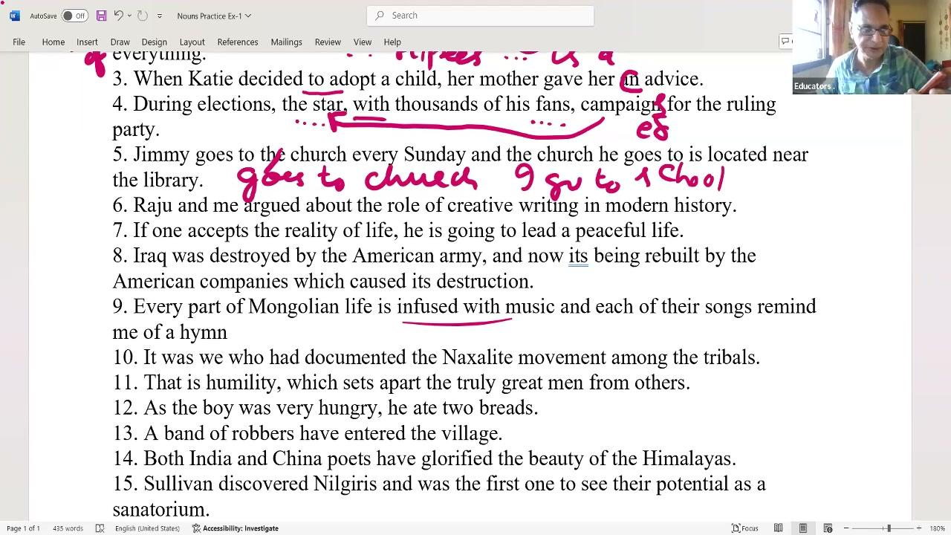
📝 QUOTE: "Never start a sentence with me, him, her, us. When you do the action, it must be active voice: Raju and I argued."
📝 QUOTE: "Calling yourself 'myself Devajit' is the worst kind of introduction. Please say 'I am Devajit Chaudhary'."
📝 QUOTE: "If one accepts... behind one, only one should come, not he or she."
📝 QUOTE: "Its without apostrophe is possessive. It's with apostrophe is it is. Here it must be 'now it is being rebuilt'."
📝 QUOTE: "Each is singular, so it must be reminds, not remind."
📝 QUOTE: "It was we who... Check it by removing 'It was/who': We had documented... So we is subjective and correct."
🚨 TRAP: Avoid introducing yourself with 'Myself' or starting active subject roles with 'me'. Do not confuse the contraction 'it's' with possessive 'its'.
💡 TRICK: Emphatic Check: Drop the 'It was [pronoun] who' frame from the sentence; the correct pronoun will naturally align with the remaining verb (e.g., 'We had documented' -> 'It was we who had documented').
[⚡ Quick Rev]
• Transcript range: 24% – 46%
• Key trap: Avoid introducing yourself with 'Myself' or starting active subject roles with 'me'. Do not confuse the contraction 'it's' with possessive 'its'.
Rule: Pronoun Subjective Case, Indefinite Consistency, & Emphatic It

CB3: Uncountable Classifiers, Mountain range the-prefix, & Negative Quantifiers
Introduces uncountable noun quantifiers and negative comparisons. Covers countable classifiers (slices/loaves of bread), collective noun SVA, separate possessives, mountain range articles, and none/neither negation preferences and their exam-relevant rules.

Worked Examples:
Q: As the boy was very hungry, he ate two slices of bread.
Rule: 'Bread' is uncountable; use classifiers like 'slices', 'pieces', or 'loaves' instead of plural 'breads'.
Working:
he ate two breads -> uncountable -> change to 'two slices of bread' or 'two loaves of bread'.
Answer: change to 'two slices of bread' or 'two loaves of bread'.
Q: A band of robbers has entered the village.
Rule: Collective group subjects ('a band') are singular; 'robbers' must remain plural as a group requires multiple members.
Working:
A band of robbers have entered -> the subject is singular 'band' -> change 'have' to 'has'.
Answer: change 'have' to 'has'.
Q: Both Indian and Chinese poets have glorified the beauty of the Himalayas.
Rule: Separate actions or separate entities require separate possessives ('both India's and China's') or adjectives ('both Indian and Chinese').
Working:
Both India and China poets -> separate entities -> change to 'both Indian and Chinese' or 'both India's and China's'.
Answer: change to 'both Indian and Chinese' or 'both India's and China's'.
Q: Sullivan discovered the Nilgiris and was the first one to see their potential as a sanatorium.
Rule: Mountain ranges require the definite article 'the'; 'sanatorium' is a recovery place for recuperating TB patients.
Working:
discovered Nilgiris -> mountain range -> change to 'discovered the Nilgiris'.
Answer: change to 'discovered the Nilgiris'.
Q: None of us likes the movie.
Rule: Prefer negative quantifiers ('none of us') over 'each of us do not'; 'none' takes a singular verb ('likes') in standard usage.
Working:
Each of us do not like the movie -> negative sense -> change to 'None of us likes the movie'.
Answer: change to 'None of us likes the movie'.
Q: Neither of them is intelligent.
Rule: Prefer 'neither of them' (which is singular and takes a singular verb 'is') over negative both constructions ('both of them are not').
Working:
Both of them are not intelligent -> negative comparison -> change to 'Neither of them is intelligent'.
Answer: change to 'Neither of them is intelligent'.
Exercise Questions:
- Q12: As the boy was very hungry, he ate two breads.
- Q13: A band of robbers have entered the village.
- Q14: Both India and China poets have glorified the beauty of the Himalaya.
- Q15: Sullivan discovered Nilgiris and was the first one to see their potential as a sanatorium.
- Q16: Each of us do not like the movie.
- Q17: Both of them are not intelligent.
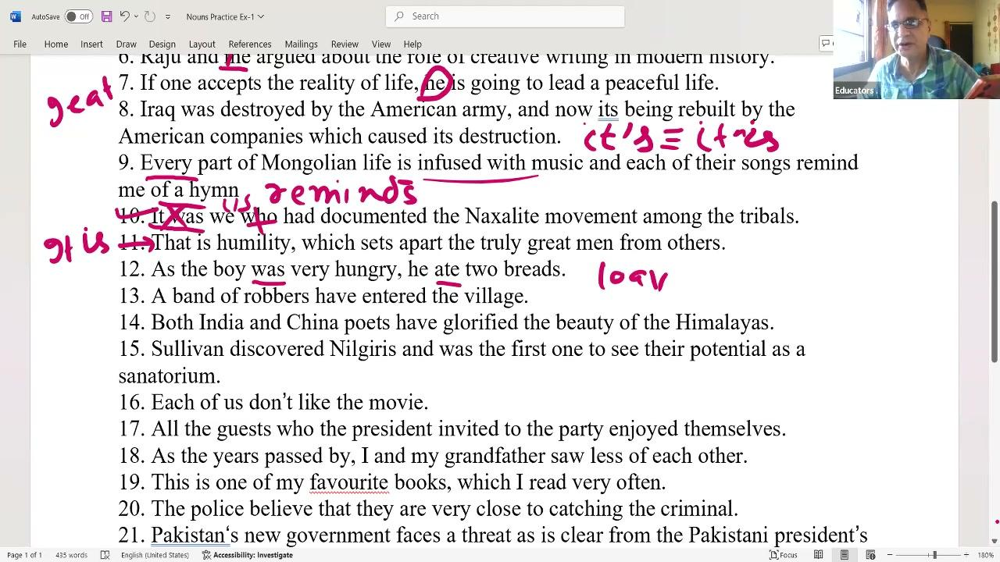
📝 QUOTE: "Breads name ka noun hota hi nahi hai. Pieces of bread, slices of bread, or loaves of bread. Mischiefs nahi hota, acts of mischief hota hai."
📝 QUOTE: "A band of robbers has entered. Robbers is correct, but the verb agrees with singular band."
📝 QUOTE: "Separate possessives: Indias and Chinas, because they wrote separate poems. If joint, we put apostrophe S only on the last name."
📝 QUOTE: "Mountains, rivers name always take the: The Nilgiris, The Satpuras, The Alps. Sanatorium is midway recovery home for TB patients."
📝 QUOTE: "Both of them are not intelligent is bad style. Negative comparison use neither: Neither of them is intelligent. Cut the 'not'."
🚨 TRAP: Never use 'breads' or 'mischiefs'; do not use plural verbs for collective group subjects like 'band' or negative subjects like 'neither'.
💡 TRICK: Negative Formulation Trick: When correcting a sentence containing a negative 'each... not' or 'both... not', substitute 'none' or 'neither' respectively, and convert the verb to singular while removing 'not'.
[⚡ Quick Rev]
• Transcript range: 46% – 68%
• Key trap: Never use 'breads' or 'mischiefs'; do not use plural verbs for collective group subjects like 'band' or negative subjects like 'neither'.
Rule: Uncountable Classifiers, Mountain range the-prefix, & Negative Quantifiers

CB4: Body organs Article the-prefix, Plural Police SVA, & Closest Subject Agreement
Introduces body organs articles, plural collective nouns, and nearest subject agreement. Covers definite articles for anatomical organs, police plural agreement, gerund structures, nearest subject SVA, and logical comparative pronouns and their exam-relevant rules.

Worked Examples:
Q: This is one of my favorite books which I read very often.
Rule: 'One of' takes plural nouns; 'I' takes standard plural verb form; the sentence is correct.
Working:
favorite book -> incorrect -> must be 'favorite books' | which I read -> correct.
Answer: correct.
Q: Pakistan's new government faces a threat as is clear from the Pakistani President's statement.
Rule: A singular country possessive represents a singular entity and agrees with a singular verb.
Working:
government faces -> singular subject -> correct.
Answer: correct.
Q: Dizziness occurs when there is a mismatch in the information sent to the brain.
Rule: Define specific anatomical organs with the definite article 'the'; ensure indefinite modifiers for mismatch.
Working:
information sent to brain -> specific organ -> change to 'sent to the brain'.
Answer: change to 'sent to the brain'.
Q: The police believe they are very close to catching the criminal.
Rule: 'Police' is strictly plural in Indian/British English; follow 'close to' with a gerund (ing form), not an infinitive.
Working:
The police believes -> incorrect -> change to 'believe' | close to catch -> infinitive incorrect -> change to 'close to catching' (gerund like 'addicted to gambling').
Answer: change to 'close to catching' (gerund like 'addicted to gambling').
Q: Neither the leader nor the members have been told about the decision.
Rule: In 'neither... nor' SVA, the verb agrees with the nearest subject ('members' -> plural -> 'have').
Working:
members has been -> nearest subject is plural -> change 'has' to 'have'.
Answer: change 'has' to 'have'.
Q: His car is bigger than mine and I know it quite well.
Rule: Ensure logical comparisons between equivalent items; use possessive pronouns ('mine' -> my car) to avoid repetition.
Working:
bigger than me -> comparing car to a person -> change to 'bigger than mine' or 'bigger than my car'.
Answer: change to 'bigger than mine' or 'bigger than my car'.
Exercise Questions:
- Q18: This is one of my favorite books which I read very often.
- Q19: Pakistan's new government faces a threat as is clear from the Pakistani President's statement.
- Q20: Dizziness occurs when there is a mismatch in the information sent to brain.
- Q21: The police believe they are very close to catching the criminal.
- Q22: Neither the leader nor the members has been told about the decision.
- Q23: His car is bigger than me and I know it quite well.
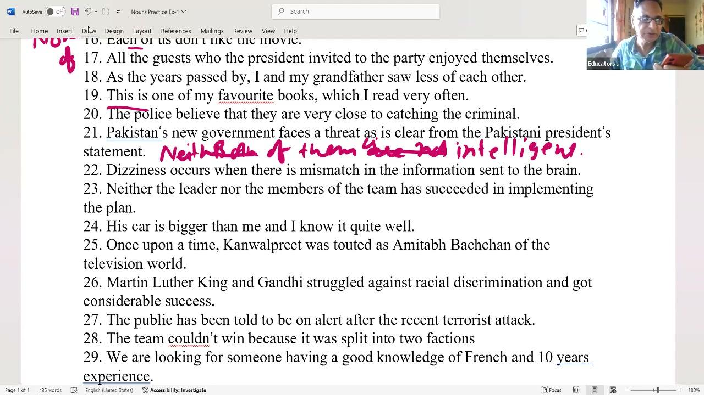
📝 QUOTE: "One of my favorite books... plural noun is mandatory. I read is correct because I takes plural verb form."
📝 QUOTE: "Pakistan's new government faces... government is singular, faces is singular. Correct."
📝 QUOTE: "Mismatch in the information sent to the brain. Brain is organ, the is required."
📝 QUOTE: "Police in Indian and British English is always plural. Believes is wrong, it must be believe. They are close to catching. Gerund will come."
📝 QUOTE: "Close to catching... addicted to gambling, close to reaching. Remember the ing form."
📝 QUOTE: "Neither nor nearest subject agrees. Leader is singular, members is plural. Has closest to members is wrong, it must be have."
📝 QUOTE: "His car is bigger than me is illogical. Comparison must be between car and car. Change me to mine."
🚨 TRAP: Do not treat 'police' as singular; do not use infinitive 'to catch' after 'close to'; avoid illogical comparisons comparing objects to people.
💡 TRICK: Nearest Subject Trick: In 'neither/nor' sentences, physically cover everything before 'nor' and read the remaining subject with the verb to check agreement (e.g., 'the members [have] been told').
[⚡ Quick Rev]
• Transcript range: 68% – 83%
• Key trap: Do not treat 'police' as singular; do not use infinitive 'to catch' after 'close to'; avoid illogical comparisons comparing objects to people.
Rule: Body organs Article the-prefix, Plural Police SVA, & Closest Subject Agreement

CB5: Proper Noun quality Comparisons, divided collective Plurals, & 2-3-1 pronoun order
Introduces proper noun comparisons, divided collective nouns, and pronoun ordering. Covers definite article prefix for famous figures, uncountable success, alert idioms, divided team agreement, time quantifiers, and 2-3-1 pronoun sequence and their exam-relevant rules.

Worked Examples:
Q: Once upon a time Kamal Preet was touted as the Amitabh Bachchan of the television world.
Rule: Use 'the' before a proper noun when comparing a person's qualities to a famous figure.
Working:
touted as Amitabh Bachchan -> quality comparison -> change to 'touted as the Amitabh Bachchan'.
Answer: change to 'touted as the Amitabh Bachchan'.
Q: Martin Luther King and Gandhi struggled against racial discrimination and got success.
Rule: 'Success' is uncountable; do not use 'a lot of' with 'a' article or 'a success' (use 'success' or 'much success').
Working:
got a lot of success -> uncountable -> change to 'got success' or 'got much success' or 'achieved success'.
Answer: change to 'got success' or 'got much success' or 'achieved success'.
Q: The public has been told to be on the alert after the recent terrorist attack.
Rule: 'Public' acts as a singular collective; the fixed prepositional idiom is 'on the alert' or 'on a high alert'.
Working:
to be on alert -> fixed idiom -> change to 'to be on the alert' or 'to be on a high alert'.
Answer: change to 'to be on the alert' or 'to be on a high alert'.
Q: The team couldn't win because they were split into two factions.
Rule: A collective noun is treated as plural when its members are divided in opinion or split; use 'factions' for division.
Working:
because it was split into two halves -> team members divided -> change 'it was' to 'they were' | 'two halves' -> 'two factions'.
Answer: 'two factions'.
Q: We are looking for someone having a good knowledge of French and ten years of experience.
Rule: Do not insert an apostrophe in plural time units preceding 'of' constructions; spell y-e-a-r-s.
Working:
ten years of experience -> spelling y-e-a-r-s -> correct.
Answer: correct.
Q: You, Ravi and I will represent our college in the contest.
Rule: Arrange multiple pronouns in positive/neutral contexts in the 2-3-1 order (Second, Third, First person).
Working:
I, you and Ravi -> incorrect ordering -> change to 'You, Ravi and I'.
Answer: change to 'You, Ravi and I'.
Exercise Questions:
- Q24: Once upon a time Kamal Preet was touted as Amitabh Bachchan of the television world.
- Q25: Martin Luther King and Gandhi struggled against racial discrimination and got a lot of success.
- Q26: The public has been told to be on alert after the recent terrorist attack.
- Q27: The team couldn't win because it was split into two halves.
- Q28: We are looking for someone having a good knowledge of French and ten years of experience.
- Q29: I, you and Ravi will represent our college in the contest.
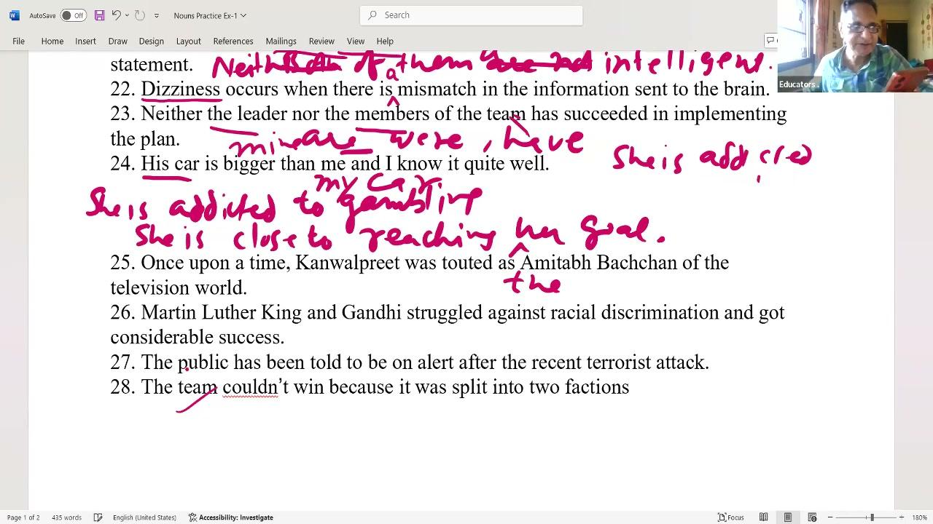
📝 QUOTE: "Comparison with famous figure takes the: The Amitabh Bachchan, The Shakespeare. Touted means promote/publicity."
📝 QUOTE: "Racial discrimination is Apartheid. South Africa policy ended in 1993, Nelson Mandela jail for 27 years."
📝 QUOTE: "Public has been told is singular, but idiom is on the alert or on a high alert. Add the."
📝 QUOTE: "Team couldn't win because they were split. Division makes collective noun plural. Split into two factions."
📝 QUOTE: "Ten years of experience. y-e-a-r-s, no apostrophe, no tricks."
📝 QUOTE: "Pronoun order is 2-3-1: Second person (You), Third person (Ravi/names), First person (I). You, Ravi and I is correct."
🚨 TRAP: Do not use apostrophes in time quantifiers like 'ten years of experience'; do not use singular pronouns for divided collective nouns.
💡 TRICK: Pronoun Ordering Code: Remember '2-3-1' (You, He/Name, I) for standard/polite sentences, putting yourself last.
[⚡ Quick Rev]
• Transcript range: 83% – 100%
• Key trap: Do not use apostrophes in time quantifiers like 'ten years of experience'; do not use singular pronouns for divided collective nouns.
Rule: Proper Noun quality Comparisons, divided collective Plurals, & 2-3-1 pronoun order

CB6: Indefinite Articles A vs An Sound Rules
Introduces indefinite article rules based on phonetic vowel sounds. Covers vowel sound lists, silent 'H' instances, vowel-sound abbreviations (M.A./M.Phil.), consonant-sound vowel letters (university/European/one-eyed), and the three semantic senses of 'A' and their exam-relevant rules.

Worked Examples:
Q: She has an elephantine memory and bought an ink pot.
Rule: Words beginning with vowel letters producing vowel sounds take 'An'.
Working:
elephantine (E sound) -> an elephantine | ink pot (I sound) -> an ink pot.
Answer: an ink pot.
Q: An hour passed before we could find an honest historic hotel.
Rule: Words starting with a silent 'H' where the sound begins with a vowel require 'An'.
Working:
hour (O sound) -> an hour | honest (O sound) -> an honest | hotel (O sound) -> an hotel | historic (I sound) -> an historic.
Answer: an historic.
Q: She holds an M.A. and an M.Phil., whereas he holds a PhD.
Rule: Abbreviations starting with vowel-sound letters (M pronounced as 'em') take 'An'; consonant sounds take 'A'.
Working:
M.A. (em sound) -> an M.A. | M.Phil. (em sound) -> an M.Phil. | PhD (P sound) -> a PhD.
Answer: a PhD.
Q: I met a European university professor who was a one-eyed man.
Rule: Words starting with vowel letters that produce consonant sounds (university/European -> 'Y' sound, one -> 'V' sound) take 'A'.
Working:
European ('yoo' sound) -> a European | university ('yoo' sound) -> a university | one-eyed ('wan' sound) -> a one-eyed.
Answer: a one-eyed.
Q: A surgeon needs to be careful, just as a dog is a faithful animal.
Rule: Use 'A' for group representation to convey a generic quality applicable to all members.
Working:
surgeon (all surgeons) -> a surgeon | dog (all dogs) -> a dog.
Answer: a dog.
Exercise Questions:
- Q30: Indefinite article rules: a university vs an hour, a European vs an honest historic hotel, an M.A. vs a PhD.
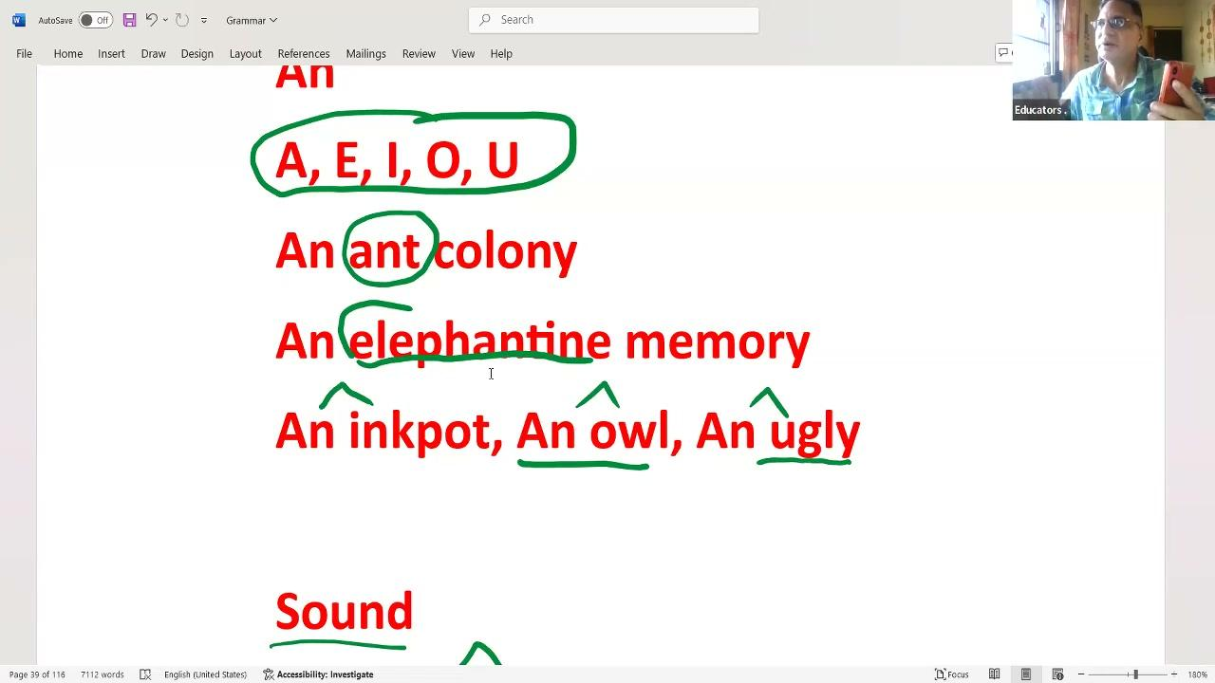
📝 QUOTE: "Indefinite article is entirely sound based, not letter based. Elephantine memory, owl, ugly fight take an."
📝 QUOTE: "Silent H: An honest girl, an hotel, an hour, an historical building, an historic occasion. H is silent."
📝 QUOTE: "An M.Phil., an M.A., an MSc, an M.Com., an MD. M is pronounced as 'em', sound starts with E. But a B.A., a PhD because B and P are consonant sounds."
📝 QUOTE: "A university, a European take a because they start with 'yoo' Y sound. A one-eyed man, a one-rupee note take a because they start with 'wan' V sound."
📝 QUOTE: "A has three senses: One (wait a minute), Uncertainty (a thief came, some unknown thief), and Group Quality (a surgeon needs to be careful, meaning all surgeons)."
🚨 TRAP: Do not write 'an university', 'an European', or 'an one-eyed man'; do not use 'a' for abbreviations starting with vowel sounds like M.A.
💡 TRICK: Phonetic sound test: Pronounce the word aloud. If the first sound is a vowel (e.g. 'em' for M, 'our' for hour), use 'An'. If it is a consonant (e.g. 'yoo' for university, 'wan' for one), use 'A'.
[⚡ Quick Rev]
• Transcript range: 55% – 100%
• Key trap: Do not write 'an university', 'an European', or 'an one-eyed man'; do not use 'a' for abbreviations starting with vowel sounds like M.A.
Rule: Indefinite Articles A vs An Sound Rules

Section 3: Rules, Formulas & Exam Traps
- 🚨 From Subject Nouns SVA, Uncountable Advice, & Primary Omissions: Never use 'an advice' or 'advices' for general recommendations; do not pluralize primary purpose institutions in routine actions.
- 🚨 From Pronoun Subjective Case, Indefinite Consistency, & Emphatic It: Avoid introducing yourself with 'Myself' or starting active subject roles with 'me'. Do not confuse the contraction 'it's' with possessive 'its'.
- 🚨 From Uncountable Classifiers, Mountain range the-prefix, & Negative Quantifiers: Never use 'breads' or 'mischiefs'; do not use plural verbs for collective group subjects like 'band' or negative subjects like 'neither'.
- 🚨 From Body organs Article the-prefix, Plural Police SVA, & Closest Subject Agreement: Do not treat 'police' as singular; do not use infinitive 'to catch' after 'close to'; avoid illogical comparisons comparing objects to people.
- 🚨 From Proper Noun quality Comparisons, divided collective Plurals, & 2-3-1 pronoun order: Do not use apostrophes in time quantifiers like 'ten years of experience'; do not use singular pronouns for divided collective nouns.
- 🚨 From Indefinite Articles A vs An Sound Rules: Do not write 'an university', 'an European', or 'an one-eyed man'; do not use 'a' for abbreviations starting with vowel sounds like M.A.

Section 4: Final Revision Points
- • Subject Nouns SVA, Uncountable Advice, & Primary Omissions: Disease names are singular; 'one of' takes a plural noun; the relative clause verb agrees with singular 'one'.
- • Pronoun Subjective Case, Indefinite Consistency, & Emphatic It: Active voice subjects must use the subjective pronoun case (I, we, he, she), not objective (me, us) or reflexive.
- • Uncountable Classifiers, Mountain range the-prefix, & Negative Quantifiers: 'Bread' is uncountable; use classifiers like 'slices', 'pieces', or 'loaves' instead of plural 'breads'.
- • Body organs Article the-prefix, Plural Police SVA, & Closest Subject Agreement: 'One of' takes plural nouns; 'I' takes standard plural verb form; the sentence is correct.

