Lec-37 Correlated nested query

Correlated Nested Queries

Key Concepts & Definitions:
- Correlated Nested Query: A nested subquery that depends on the outer query's table or attributes and cannot be executed standalone.
- Top-to-Down Execution Flow: The execution model where for each row of the outer table, the inner query is executed once.

Examples & Illustrations:
Example: SELECT A FROM R WHERE EXISTS (SELECT * FROM S WHERE R.A > S.B)
For each row in outer table R, evaluate if there exists at least one row in table S where R.A is strictly greater than S.B.
1. Initialize Table R and S.
2. Evaluate R.A = 10: inner query yields empty. EXISTS returns FALSE. Exclude 10.
3. Evaluate R.A = 20: inner query yields non-empty. EXISTS returns TRUE. Include 20.
4. Final output: {20}.
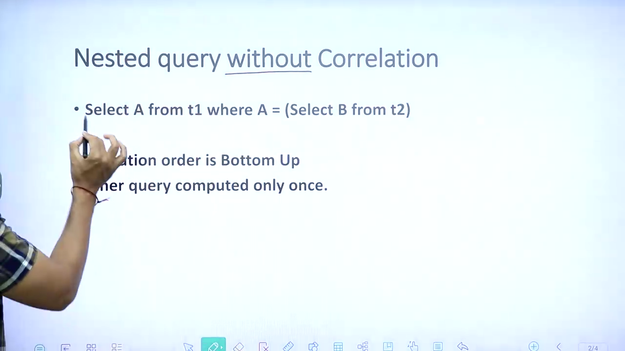
Example: SELECT A FROM R WHERE EXISTS (SELECT * FROM S WHERE R.A > S.B)
1. Initialize Table R and S.
2. Evaluate R.A = 10: inner query yields empty. EXISTS returns FALSE. Exclude 10.
3. Evaluate R.A = 20: inner query yields non-empty. EXISTS returns TRUE. Include 20.
4. Final output: {20}.
🚨 TRAP: Always remember the working of correlated nested queries: it evaluates top-to-down, running the inner query for each row of the outer query, which is different from the bottom-up evaluation of non-correlated queries.

