**Question:**

Implement the Error Check List?

1. ALL Variables declared?

2. Default attributes understood?

3.Arrays and strings initialized properly?

4.Correct lengths, types nd storage classes assigned?

5. Initialization consistent with storage class?

6. Any variables with simialr names?

implement a scenerio for this list …….

**Answer:**

**Scenario:** Simple Bank Account Example:

**Incorrect Code:**

**Correct Code:**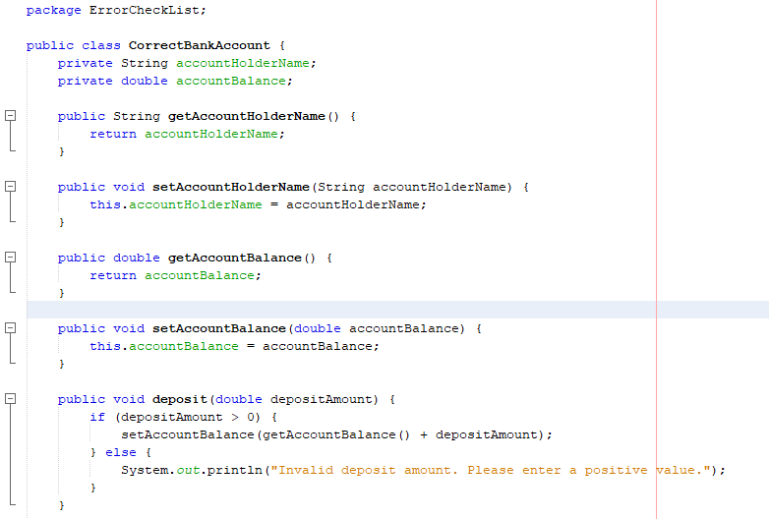

|  |  |
| --- | --- |
| All Variables Declared | |
| Incorrect Version | **Correct Version** |
|  |  |
| The variable “amount” that is being used in the constructor is not declared. | In this version of code all the variables are declared. |

|  |  |
| --- | --- |
| Default attributes are understood | |
| Incorrect Version | **Correct Version** |
|  |  |
| The variable “balance” is declared with public int and its default value is zero (0) which might not be intended. | The variable “accountBalance” is declared in this version of code whose initial value is initialized when its object Is created. |

|  |  |
| --- | --- |
| Incorrect Type/Length Assignment | |
| Incorrect Version | **Correct Version** |
|  |  |
| The deposit Amount is of the type int while the balance is of the double type. This may lead to data loss. | In this version of code the deposit Amount is of correct type (i.e double) |

|  |  |
| --- | --- |
| Inconsistent initialization | |
| Incorrect Version | **Correct Version** |
|  |  |
| The “balance” is not being initialized in the constructor, relying on default value. | In this version of code the “accountBalance” is being initialized in the constructor. |

|  |  |
| --- | --- |
| Similar names of variables | |
| Incorrect Version | **Correct Version** |
|  |  |
| The “balance” & “amount” can be confused. | In this version of code the “accountBalance” is being used and amount is removed. |