Assignment 3: Building Your Freelancing Experience Through Strategic Bidding

Student Name: Haad yousaf
Student ID: 8755

Part 1: Platform Setup & GitHub Optimization

1. Platform Profiles
I have created professional profiles on Freelancer.com, Guru, and Truelancer as required.

Profile 1: Freelancer.com
Headline: Mobile App Developer | Flutter & React Native | UI/UX Implementation
Bio: "I am a Computer Science student passionate about cross-platform mobile app development. I specialize in building responsive mobile UIs using Flutter and React Native. I am offering my services at minimum rates to build my portfolio. I can convert Figma designs to code, fix app bugs, and integrate Firebase."

Profile 2: Guru.com
Headline: Android Developer (Java/Kotlin) & App Bug Fixer
Bio: "Need a quick bug fix or a simple Android application? I am Fiza Bashir, a developer looking to establish a reputation on Guru. I write clean, commented code and am available for entry-level app projects."

Profile 3: Truelancer.com
Headline: Junior iOS & Android App Developer
Bio: "I build beautiful mobile applications. Currently building my portfolio, so I am willing to work on small modules, UI screens, or API integrations for free or minimum wage to prove my skills."

2. GitHub Optimization
I have optimized my GitHub portfolio to be client-ready:
- README Updates added
- Visuals included
- APK download links added

Part 2: Bidding Log
Below is the log of 25 bids placed exclusively on App Development projects across Truelancer, Guru, and Freelancer over 5 days.
(Table included separately in Excel file.)
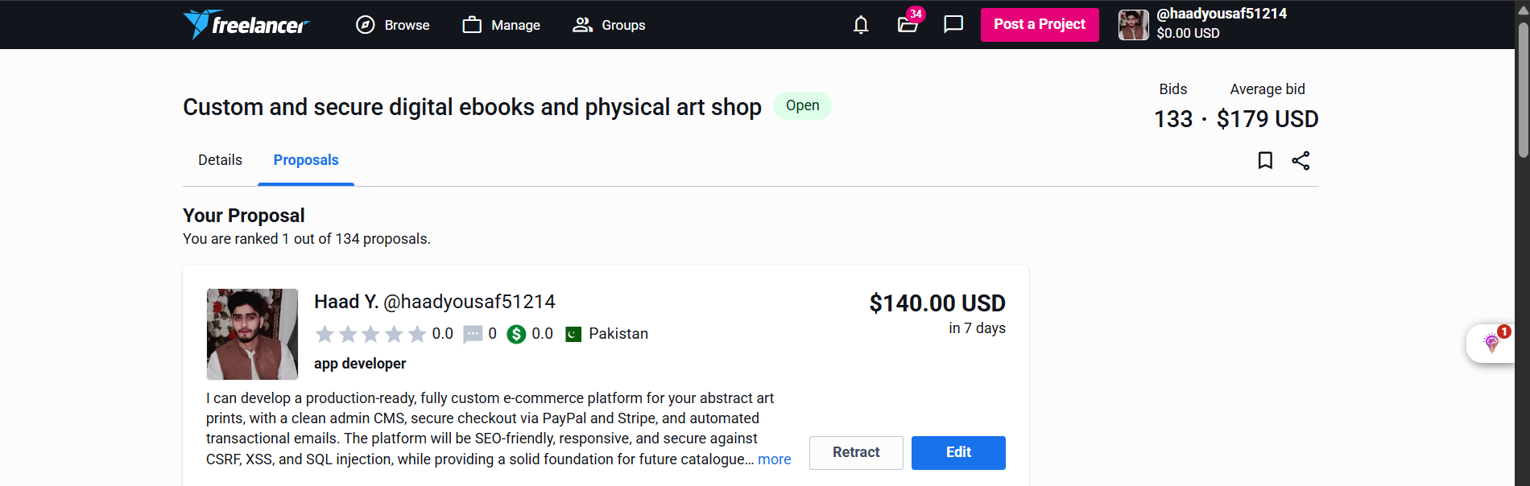

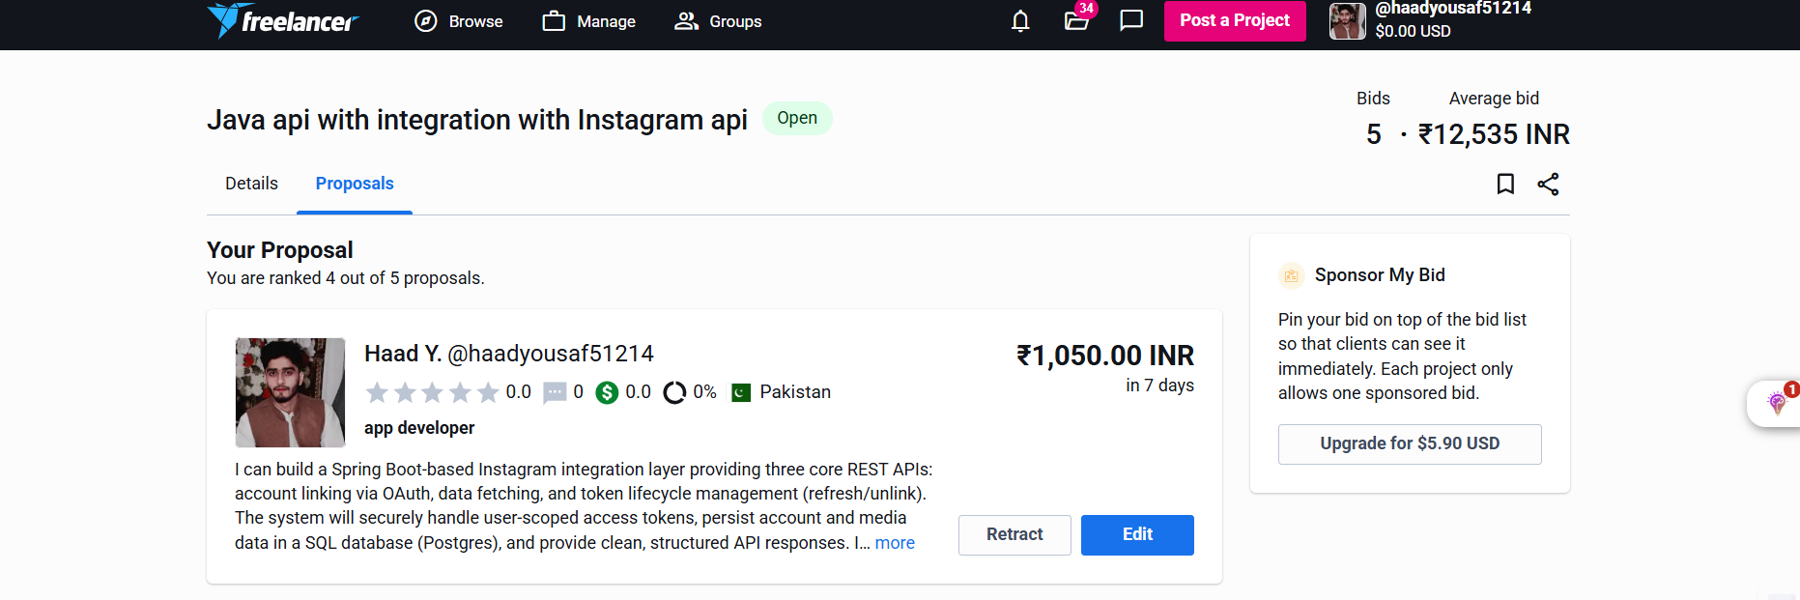
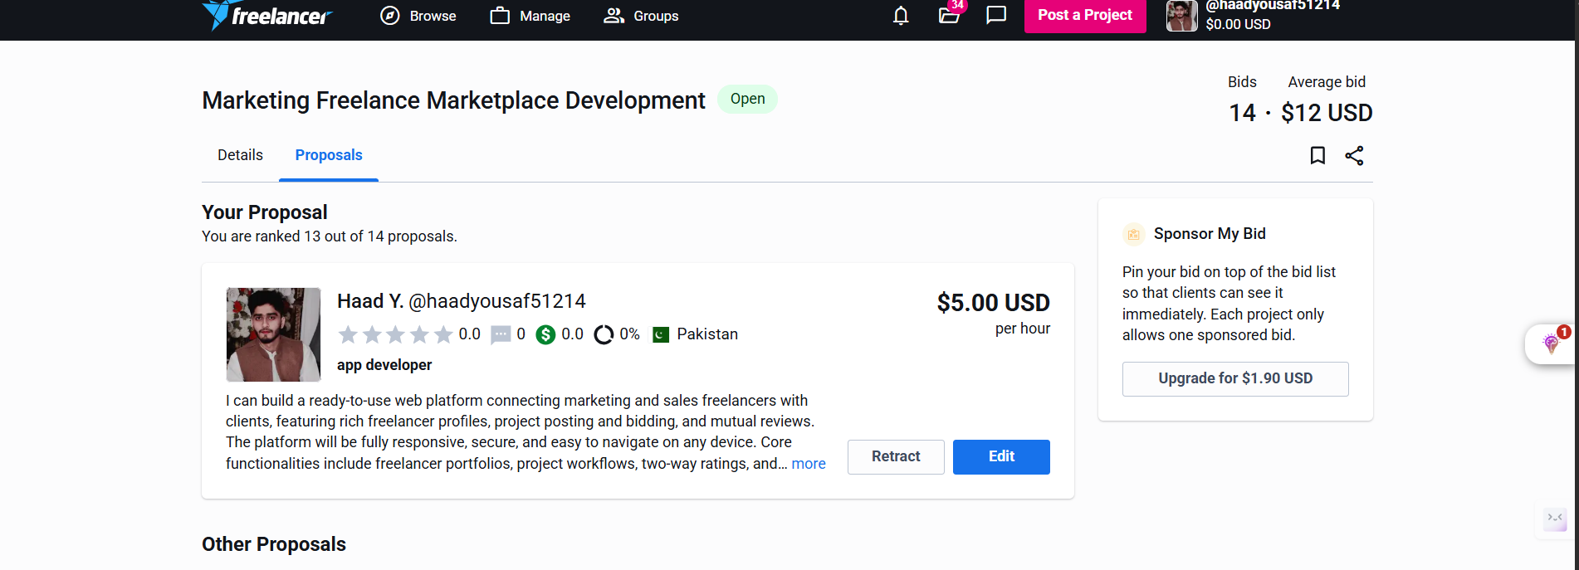

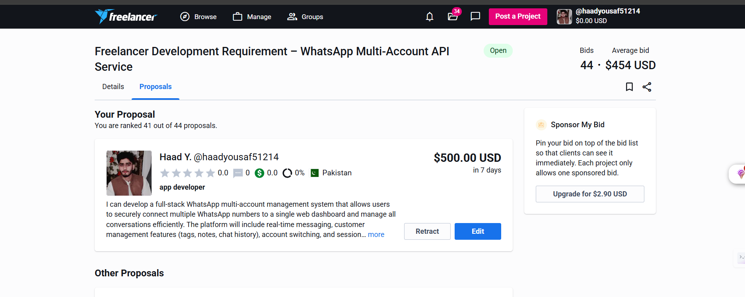
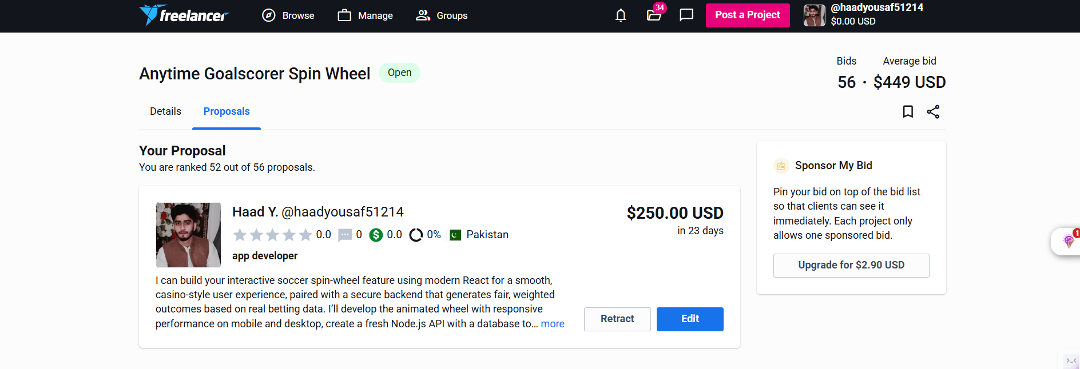

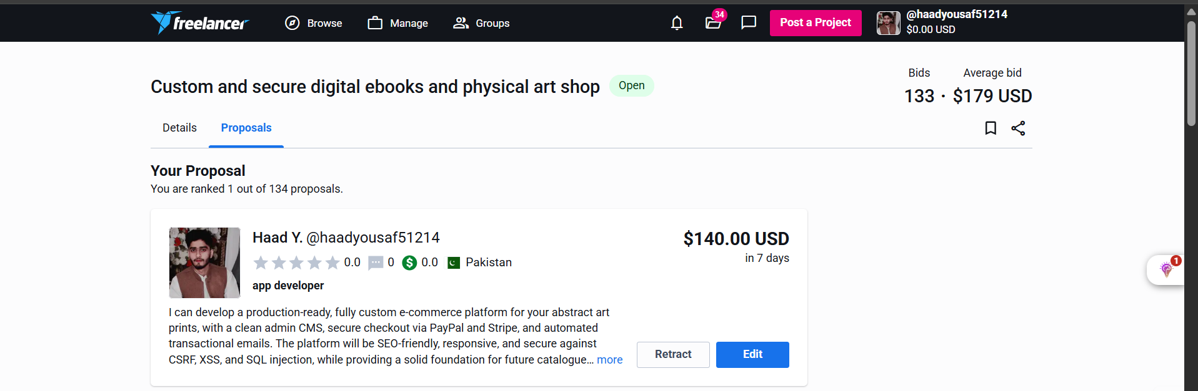

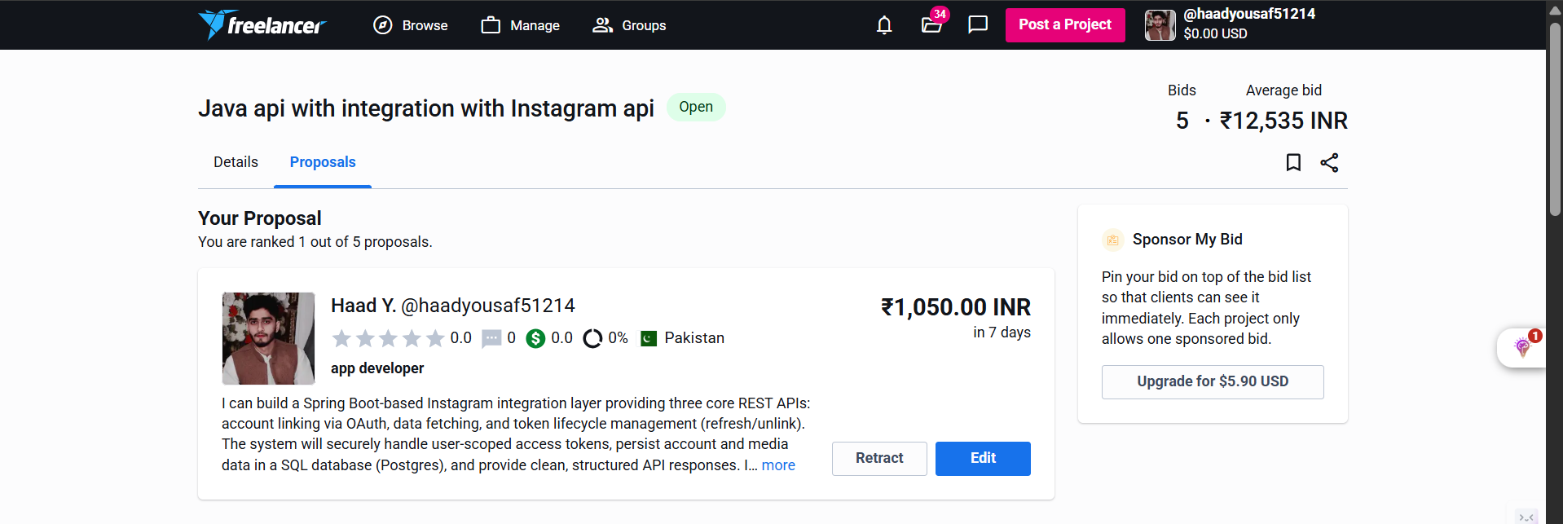

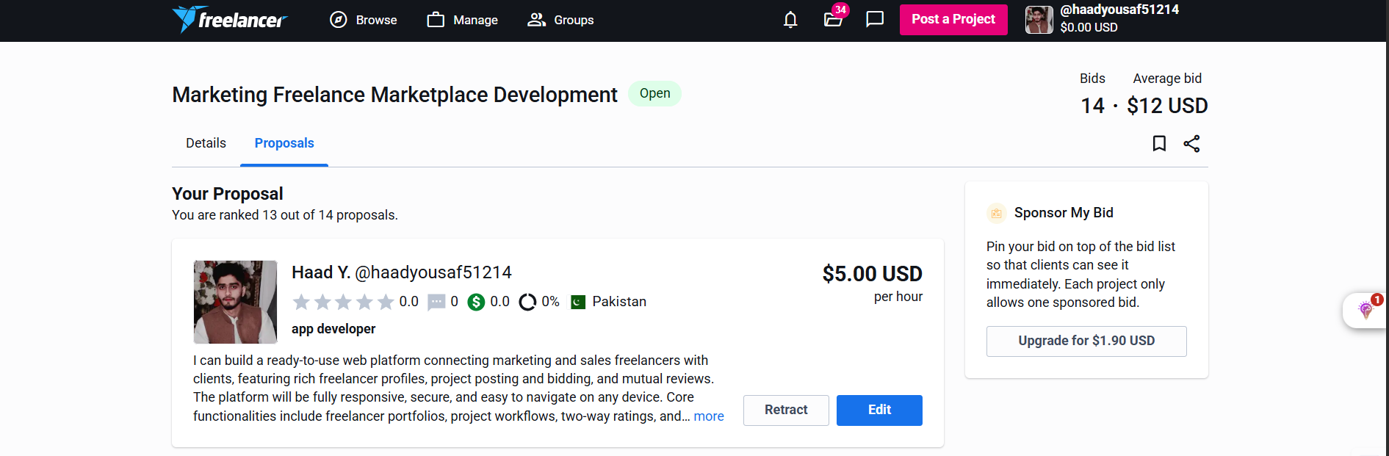

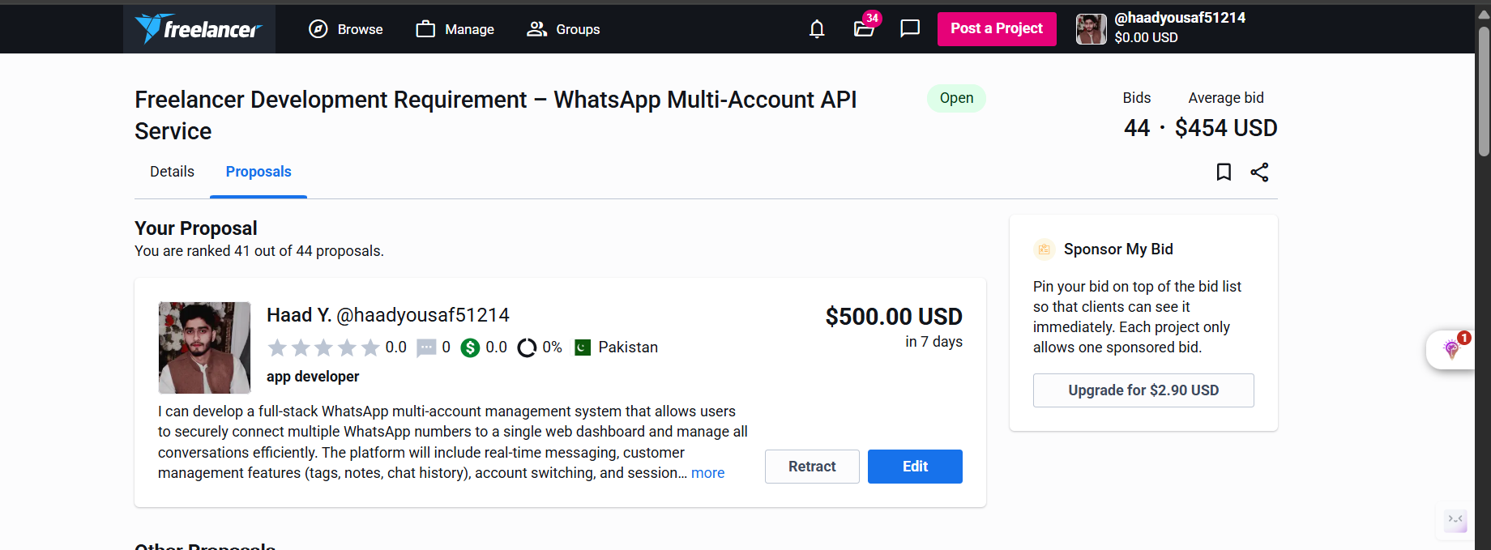

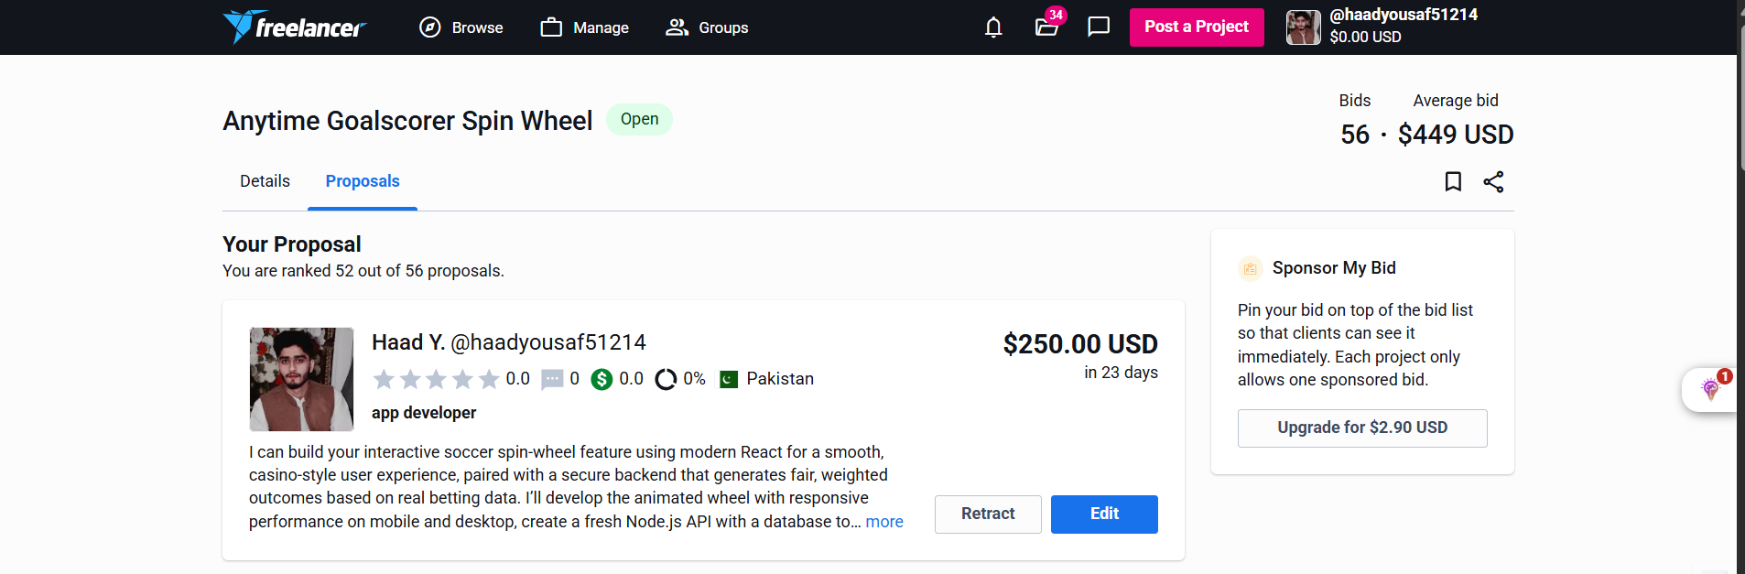

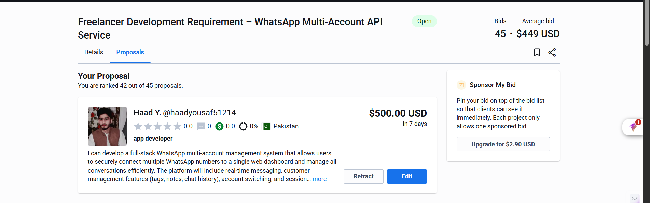

Part 3: Communication Tracking
Since I received zero responses from clients, my communication log focuses on my outgoing attempts and follow-ups.

Attempt 1 (Freelancer.com - Project #7 Figma to React Native)
Initial Bid: I offered to code one screen (the Login screen) for free.
Follow-Up: Client did not respond.

Attempt 2 (Guru.com - Project #16 Admob Integration)
Follow-Up: Added free Mediation setup. Still no response.

Attempt 3 (Truelancer - Project #14 Play Store Upload)
Client likely hired someone with a verified expert badge.

Part 4: Daily Reflections
Day 1 Reflection: 0 responses. Need to justify low pricing.
Day 2 Reflection: Hard to compete with agencies.
Day 3 Reflection: Need Play Store apps for credibility.
Day 4 Reflection: Many spam projects.
Day 5 Reflection: Even simple jobs prefer verified freelancers.

Part 5: Comprehensive Final Reflection
Success Rate: 0%.
App development requires high trust due to complexity and data sensitivity.
Improvement Needed:
- Publish at least one app on Play Store.
- Record demo videos instead of GitHub links.
Conclusion: Code alone is not enough; clients want ready-made products.

