Report – Project 01: Implementing a Python-like List in C++
Name: Maha Faisal

1. Introduction
The objective of this project was to design and implement a PyList class in C++ that mimics the behavior of Python’s built-in list. Python lists are dynamic, heterogeneous containers capable of storing elements of different data types while offering a wide range of operations such as appending, inserting, slicing, sorting, and more.
In contrast, C++ is a statically typed language, and creating such a flexible container requires careful use of object-oriented programming (OOP), polymorphism, templates, operator overloading, and smart pointers.
This project provided valuable experience in building a reusable container that can handle heterogeneous data while preserving type safety, exception safety, and memory management guarantees. This report discusses the design decisions, challenges faced during implementation, testing outcomes, and overall learning experience.

2. Design Choices

2.1 Box System for Type Erasure
To support heterogeneous data types in a single list, a Box System was implemented.
- Box (Abstract Base Class):
  - Defines a common interface with virtual functions:
    - print() for displaying values.
    - type() for retrieving runtime type information.
    - less() for comparing elements.
  - Provides a foundation for polymorphic behavior.
- Boxed<T> (Template Derived Class):
  - Stores actual values of type T.
  - Implements print, type, and less based on the stored type.
  - Provides getVal() for safe retrieval of values.
Key Design Decisions:
- Polymorphism: The Box interface allows all elements to be stored uniformly as std::shared_ptr<Box>.
- Smart Pointers: Using std::shared_ptr automates memory management and eliminates manual delete calls.
- Runtime Type Checking: The type() function ensures elements are compared and cast safely.
This design replicates Python’s dynamic typing within C++ by separating the storage (Boxed<T>) from the interface (Box).

2.2 PyList Class Structure
The PyList class encapsulates a std::vector<std::shared_ptr<Box>> and implements 20+ operations similar to Python’s list.
Key Features:
- Dynamic Resizing: Uses std::vector to grow automatically.
- Operator Overloading: Implements operator+, operator==, operator<, operator[], and operator<< to give the container a Pythonic feel.
- Negative Indexing: Supported in methods like operator[], setitem, and slice, just like Python.
- Extended Functionality: Includes stack methods (push, pop_stack) and queue methods (enqueue, dequeue) for versatility.
- Exception Handling: Throws meaningful errors (std::out_of_range, std::runtime_error) for invalid operations.
- Shallow Copy Behavior: Methods like extend and operator+ share element ownership via smart pointers, reflecting Python’s shallow copy semantics.
This design ensures flexibility, type safety, and user-friendly syntax.

3. Implementation Challenges

3.1 Heterogeneous Storage
- Challenge: C++ containers like std::vector typically store elements of a single type.
- Solution: Type erasure through the Box system allowed different types (int, string, float, Person, even another PyList) to coexist in the same list.

3.2 Type-Safe Operations
- Challenge: Functions like count, index, and remove required type-specific comparisons.
- Solution: Used static_cast to safely retrieve Boxed<T> from Box. Runtime type checking ensured invalid casts were avoided.

3.3 Sorting Mixed Types
- Challenge: Python allows sorting lists of the same type but not across incompatible types.
- Solution: The less() method compares values of the same type, but when types differ, type().before() provides a consistent ordering based on type information.

3.4 Negative Indexing and Slicing
- Challenge: Supporting negative indices and complex slicing ranges (e.g., slice(-3, -1)).
- Solution: Converted negative indices into positive equivalents (len() + index). Multiple cases were handled separately for (positive, negative) start and end values.

3.5 Exception Safety
- Challenge: Preventing crashes during invalid operations (popping from an empty list, accessing out-of-bounds indices).
- Solution: All critical functions throw appropriate exceptions, maintaining safety.

3.6 Memory Management
- Challenge: Avoiding leaks when dynamically allocating heterogeneous objects.
- Solution: Reliance on std::shared_ptr ensures elements are automatically destroyed once no longer referenced. This keeps memory usage safe and predictable.

4. Testing
A menu-driven tester was implemented to validate functionality. It allowed interactive testing of all PyList methods with multiple data types.

4.1 Test Coverage
- Data Types: Integers, floats, strings, characters, doubles, custom Person objects, vectors, and nested PyList instances.
- Edge Cases: Empty lists, invalid indices, duplicate removals, large insertions.
- Custom Types: A Person struct (with comparison and printing) demonstrated support for user-defined types.

4.2 Sample Test Scenarios
- Appending:
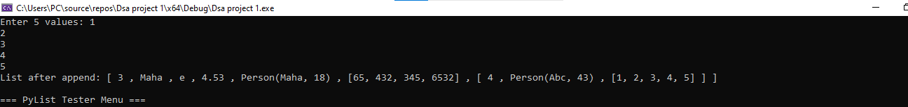
- Count:
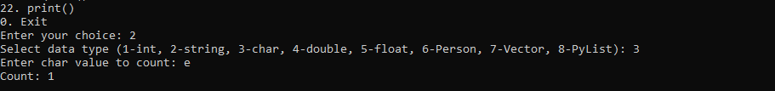

- Extend:
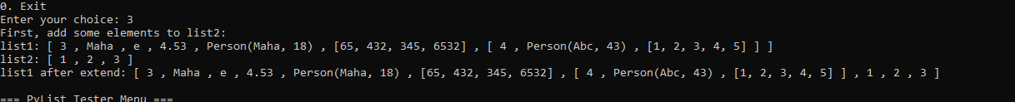

- Index:

- Insert:

- Pop:

- Remove:
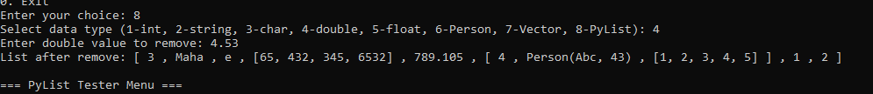

- Reverse:

- Sort:
- Descending:

- Ascending:

- Operator +:

- Contains:

- Operator []:
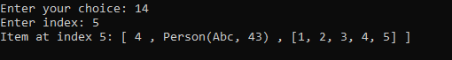

- Len:
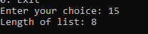

- Set Item:
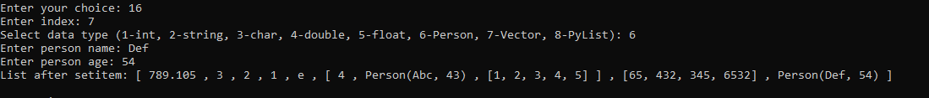

- Slice:
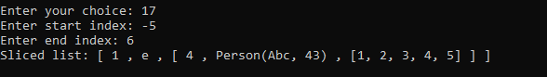

- Push:

- Enqueue:

- Dequeue:

- Print:

5. Conclusion
The PyList project successfully demonstrates that Python-like behavior can be replicated in C++ using OOP, polymorphism, templates, and smart pointers. The implementation supports heterogeneous data storage, negative indexing, slicing, sorting, stack/queue operations, and operator overloading, making it highly versatile.
This project strengthened my understanding of:
- Type erasure and polymorphism for heterogeneous containers.
- Smart pointers for memory safety.
- Templates and operator overloading for generality and intuitive syntax.
- Exception handling for robust and safe operations.
Overall, the PyList implementation achieves its goal of functioning as a flexible, reusable, and Python-like container in C++, highlighting both the power and challenges of C++ in high-level abstractions.

