

**BY**

**Md Asif Shahriar Arpon**

**ID:221-15-5655**

**Most. Azmira Shekh**

**ID:221-15-5569**

**Md. Mirajul Rahman**

**ID: 221-15-4893**

### Anuradha Das Mitu

**ID: 221-15-4792**

### Mahafuz Ahmed

**ID: 221-15-5448**

This Report is presented in Partial Fulfillment of the Requirements for the Degree of Bachelor of Science in Computer Science and Engineering

Supervised By

## Mr. Raja Tariqul Hasan Tusher

Assistant Professor

Department of CSE

Daffodil International University



## DAFFODIL INTERNATIONAL UNIVERSITY

**DHAKA, BANGLADESH**

**November 2023**

# DECLARATION

We hereby declare that, this project has been done by us under the supervision of **Mr. Raja Tariqul Hasan Tusher, Assistant Professor, Department of CSE** Daffodil International University. We also declare that neither this project nor any part of this project has been submitted elsewhere for award of any degree or diploma.

### Supervised By

### Mr. Raja Tariqul Hasan Tusher

Assistaant Lecturer

Department of CSE

Daffodil International University

**Submitted by:**

### Md Asif Shahriar Arpon

### ID:221-15-5655

Department of CSE

Daffodil International University

**Md. Mirajul Rahman**

**ID: 221-15-4893**

Department of CSE

Daffodil International University

### Anuradha Das Mitu

### ID: 221-15-4792

Department of CSE

Daffodil International University

### Most. Azmira Shekh

### ID:221-15-5569

Department of CSE

Daffodil International University

### Mahafuz Ahmed

### ID: 221-15-5448

Department of CSE

Daffodil International University

# 

# ACKNOWLEDGEMENT

First, we express our heartiest thanks and gratefulness to almighty God for His divine blessing makes us possible to complete the final year project successfully.

The real sprit of achieving a goal is through the way of excellence and austere discipline. We would have never succeeded in completing our task without the cooperation, encouragement and help provided to us by various personalities.

We would like to express our deepest appreciation to our supervisor **Mr. Raja Tariqul Hasan Tusher** (Assistant Professor), supervisor, BSc in CSE Program, Daffodil International University. His endless patience, scholarly guidance, continual encouragement, constant and energetic supervision, constructive criticism, valuable advise reading many inferior draft and correcting them at all stage have made it possible to complete this project. We are especially grateful to our honorable teachers.

.

We would like to thank our entire course mate in Daffodil International University, who took part in this discuss while completing the course work.

Finally, we must acknowledge with due respect the constant support and patients of our parents.

# ABSTRACT

In today's healthcare landscape, efficiency and accuracy are paramount to providing quality patient care. A well-designed Medical Center Management System can significantly enhance the operations of a medical facility by streamlining administrative tasks, improving patient care coordination, and enhancing financial management. The efficient management of medical centers stands as a critical pillar in delivering quality healthcare services. This report encapsulates the development and implementation of a comprehensive Medical Center Management System tailored for our university. The system integrates cutting-edge technology to streamline administrative tasks, enhance patient care, and optimize resource utilization. It encompasses modules for patient management, appointment scheduling, electronic health records (EHR), inventory management, billing, and reporting. Through meticulous analysis and design, this system aims to address the complexities of healthcare administration, fostering a cohesive platform that centralizes data, ensures accuracy, and facilitates informed decision-making. The user-friendly interface empowers staff with intuitive tools while prioritizing patient-centric care. Furthermore, this report delves into the technological architecture, functionalities, challenges encountered during development, and future prospects for system enhancement. The system's deployment is a testament to our commitment to advancing healthcare management, fostering efficiency, and elevating the overall patient experience within our university's medical facilities.

**TABLE OF CONTENTS**

### CONTENTS PAGE NO

Approval i

Declaration ii

Acknowledgement iii

Abstract iv

**CHAPTER**

### CHAPTER 1: INTRODUCTION 01-02

1.1 Introduction 01

1.2 Motivation 01

1.3 Aims and Objectives 01

1.4 Expected Outcome 02

### CHAPTER 2: BACKGROUND 04-05

2.1 Introduction 04

2.2 Challenges 05

### CHAPTER 3: REQUIREMENT SPECIFICATION 06-07

3.1 Requirements 06

3.2 Features 07

### CHAPTER 4: PROPOSED MODEL AND DESIGN 08-08

4.1 Model And Design 08

### CHAPTER 5: IMPLEMENTATION AND TESTING 09-16

5.1 Implementation of Front-End Design 09

5.2. Testing Implementation 16

### CHAPTER 6: CONCLUSION AND FUTURE SCOPE 17-19

6.1 Conclusion 17

6.2 Goal 18

6.3 Limitation 19

6.4 Scope for Further Developments 19

**REFERENCES 20**

**CHAPTER 1**

### INTRODUCTION

#### 1. Introduction

In the dynamic and ever-evolving healthcare landscape, the need for efficient and streamlined management systems is more crucial than ever. A well-designed Medical Center Management System serves as the backbone of a medical facility, ensuring seamless operations, enhanced patient care coordination, and robust financial management. Recognizing this critical need, our team embarked on the development and implementation of a comprehensive MCMS tailored to the specific requirements of our university-based medical center.

Our MCMS encompasses a range of integrated modules, each meticulously designed to streamline administrative processes and optimize resource utilization. The patient registration module facilitates seamless patient intake, ensuring accurate and up-to-date patient information. The appointment scheduling module enables efficient management of patient appointments, minimizing wait times and maximizing provider productivity. The electronic health records (EHR) module provides a centralized repository for patient medical records, fostering informed decision-making and continuity of care. The billing module streamlines the billing process, ensuring timely and accurate revenue collection. Finally, the inventory management module optimizes the procurement and distribution of medical supplies, minimizing wastage and ensuring adequate stock levels.

Overall, our MCMS has proven to be an invaluable asset, contributing to the overall success and sustainability of our university-based medical center.

* 1. **Motivation**

There is no alternative management system in the University only for the medical center. So, there is always the scarcity of an efficient management system of the medical center. There is no way to track patient records, appointments, and billing efficiently. Lack of scheduling problem and also the Doctor appointment issue. The motivation behind developing our Medical Center Management System was to modernize healthcare administration within our university. We aimed to simplify processes, improve patient care, and optimize resource utilization. Recognizing the complexities in managing medical centers, our drive stemmed from a commitment to enhance efficiency and provide a seamless experience for both patients and staff. The new system will address these challenges and improve the overall efficiency and effectiveness of the medical center.

* 1. **Aims and objective**

Our Medical Center Management System aims to revolutionize healthcare administration within our university. It seeks to enhance operational efficiency by streamlining administrative tasks, ensuring prompt access to accurate patient information, optimizing resource allocation, and facilitating seamless coordination among staff members. The primary objective is to centralize data management, empowering our medical personnel with intuitive tools that enable informed decision-making and improved patient care. Ultimately, this system aspires to elevate the overall quality and accessibility of healthcare services provided within our university's medical facilities.

**1.3 Aims of the Project**

* Enhance Efficiency
* Improve Patient Care
* Optimize Resource Utilization
* Centralize Information
* Advance Healthcare Services

### 1.4 Expected Outcome

**Patient management:** This module will allow a student to create their own account and keep track of records, including their medical history, medication information.

**Appointment scheduling:**It will allow patients to book appointments online or over the phone.

**Payment :** In payment section, one can pay through 1Card system and can keep track the billing information.

**Staff Management:**In this section one can track staff and doctor information, including their schedules, qualifications, and certifications.

**Inventory management:**In here one can track the inventory of medical supplies and equipment. We will also allow one to order supplies and get it delivered.

**Emergency:** One can the emergency and access Ambulance service at any time.

**Security:** The system should be secure to protect patient data.

**Usability:**The system should be easy to use by both patients and staff.

### CHAPTER 2 BACKGROUND

#### 2.1 Introduction

Though many projects have been done to explore the effective way of Medical Center Management System, but a few of them were dedicated to their own university in context of Bangladesh. There are several Medical Center System that are dedicated to Hospital and some private organizations. So, we learn and apply them in our university sector.

In preparing our Medical Center Management System, a comprehensive background study was conducted. This involved an in-depth analysis of existing healthcare management systems, identifying their strengths, weaknesses, and technological limitations. We also did study about our university medical center and their weaknesses, where to improve and how many improvements and sections that are needed to provide utmost care for students and faculties and staffs. We examined prevalent challenges faced in medical center administration, understanding the specific needs and intricacies of our university's healthcare facilities. Extensive research into industry best practices, user requirements, and technological advancements formed the foundation for the system's design and development. This diligent background study ensured that our system is tailored to address the unique demands of our university's medical environment, aiming for optimal efficiency and improved patient care.

**2.2 Challenges**

**Manual data entry:** The reliance on manual data entry processes introduced a significant risk of errors and inefficiencies, leading to delays in patient care and administrative tasks.

**Scattered patient records:** Patient records were dispersed across various departments, making it difficult for healthcare providers to access comprehensive medical histories and hindering informed decision-making.

**Testing and Bug Resolution:** Rigorous testing was crucial to identify and resolve system bugs and issues.

**Learning some new concepts:** Learning the basic concepts of FILE, Linklist etc.

**Communication between team members:** As we team members were always busy with our others activities, it was difficult to adjust our time management to organize this project together.

**Inefficient inventory management:** The lack of a centralized inventory management system resulted in stockouts of medical supplies, causing disruptions in patient care and unnecessary expenses.

**CHAPTER 3**

### REQUIREMENT & SPECIFICATION

**3.1 Requirements**

**Code Block Console:** Utilized as the primary integrated development environment (IDE) for coding and system development.Requirements include compatibility with C/C++ programming languages and support for various libraries.

**Linked List Implementation:** Utilized for efficient data structuring and management within the system. Requirements involve dynamic memory allocation, node management, and pointer manipulation.

**File Handling:** Utilized for data storage, retrieval, and management of patient records, appointment schedules, and other system information. Requirements include read, write, update, and delete functionalities for seamless data handling.

**GCC Compiler:** Chosen as the compiler for system development and execution. Requirements encompass compatibility with the chosen programming languages, optimization features, and error handling capabilities.

**3.2 Features**

This project appears to be a simple personal finance management system. Let's break down its features and functionality:

**Main Menu:**

The program displays a main menu with the following options:

**1. Admin Menu:**

* Add Patient
* Search Patient
* Update Patient Details
* Delete Patient Details
* Display Patient Details
* All appointment lists
* Ordered Medicine Lists
* Emergency Transportation list

**2. Doctor Menu:**

* View Student All records
* Update My Patient Record
* View My all Patients

**3. Student Menu:**

* View All doctor Details
* Online Appointment
* Medicine Order
* Emergency Ambulance Service

**4. Exit**

**CHAPTER 4**

### PROPOSED MODEL AND DESIGN

**Application**

The application provided is a basic Medical Center management system of any University that can be used by individuals as students, Doctors and staffs to get treatment easily by appointments, manage their records, easy medicine access etc.

**Model Selection:** Chose a modular design to ensure flexibility and scalability.Utilized a client-server architecture for centralized data management and accessibility.

**User Interface Design:** Designed an intuitive and user-friendly interface for easy navigation.Prioritized simplicity while incorporating comprehensive functionalities for various user roles.

**System Modules:** Implemented modules for patient management, appointment scheduling, EHR, inventory, billing, and reporting.Ensured seamless communication and data flow between modules for cohesive system operation.

**Data Management:** Utilized linked lists and file handling for efficient data structuring, storage, and retrieval.Designed data structures to optimize search, update, and deletion processes.

**Security Measures:** Integrated encryption techniques to safeguard patient data and ensure system integrity.Implemented user authentication protocols and access control mechanisms.

**Scalability and Future Enhancements:** Designed the system with scalability in mind to accommodate future expansions.Built a framework capable of incorporating additional features and adapting to evolving technological advancements.

This proposed model and design ensured a robust foundation for the Medical Center Management System, focusing on usability, efficiency, security, and adaptability to meet present and future requirements.

**CHAPTER 5**

### IMPLEMENTATION AND TESTING

It is necessary to make it clear that this project was designed and developed entirely based on collecting information from existing systems, concepts and imaginary scenarios. To remind the readers of this report, there are many developers who are still arguing about the core concept of different components of the android based education system. Their opinion is that we are trying to implement the new system

#### 5.1 Implementation of Front-End Design

The screenshots below show the main project view. Capture an image of what you see on your mobile screen and how use it.

**Main Menu**

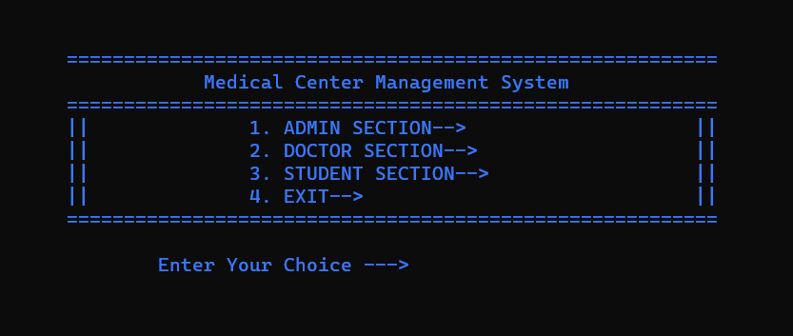

**ADMIN MENU**

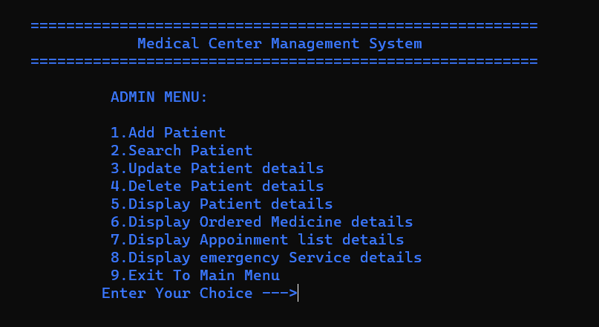

**Add Patient**

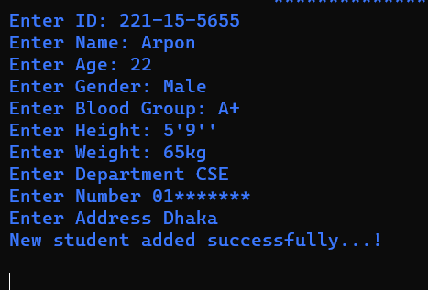

**Search Patient**

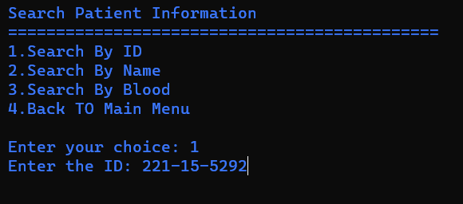

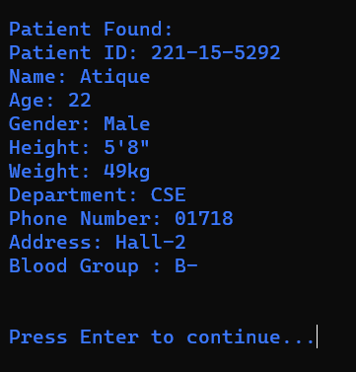

**Display Ordered Medicine Details**

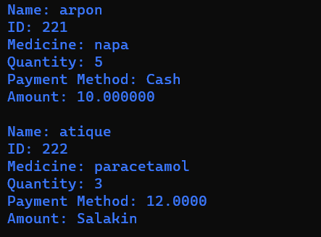

**Display Appointment List**

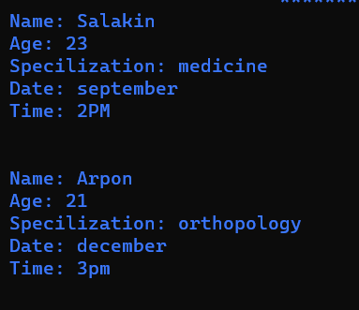

**Doctor MENU**

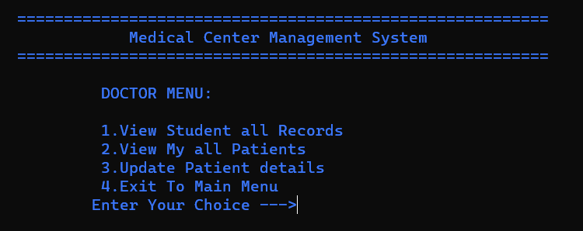

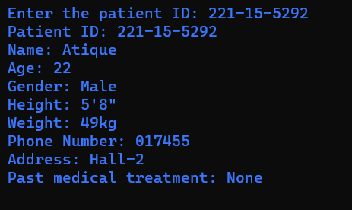 **View Student All Records**

**Student Menu**

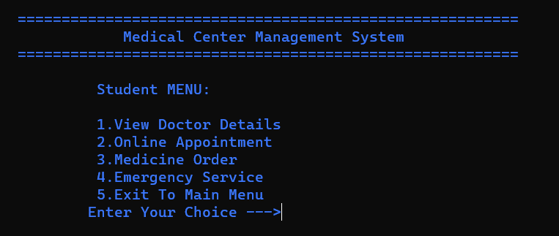

**View Doctor Details**

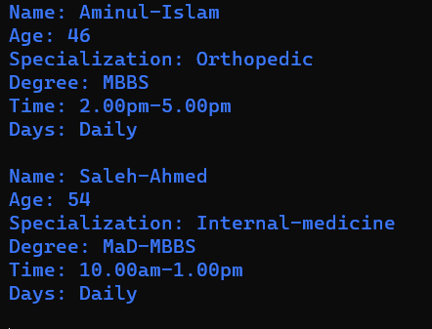

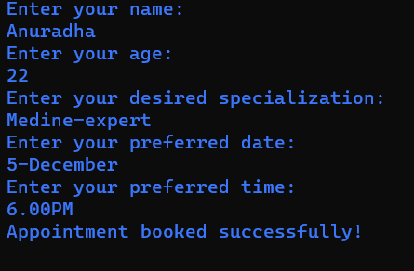 **Online Appointment**

**Medicine Order**

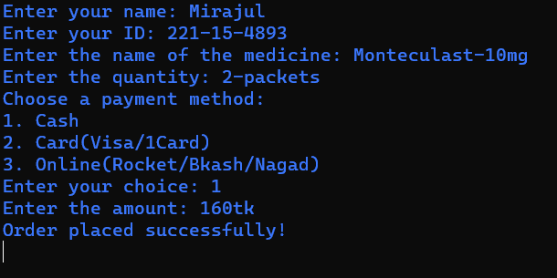

#### 5.2 Testing Implementation

This project was judged on the following set of criteria:

**Satisfying requirement specifications:** The project is said to be successful if it satisfies all the requirements such as functional and non-functional requirements.

**Unit Testing:** Conducted individual module testing to ensure each functioned correctly.Verified functionalities of patient management, scheduling, EHR handling, inventory, billing, and reporting.

**Integration Testing:** Tested interactions between modules to ensure seamless data flow and functionality.Checked the compatibility of linked list structures with file handling for data storage and retrieval.

**File Handling Validation:** Validated file read/write operations for accuracy and reliability.Ensured proper storage and retrieval of patient records, appointments, and other system data.

**Error Handling and Boundary Testing:** Tested system responses to invalid inputs and boundary conditions.Checked for proper error messages and system stability when handling unexpected scenarios.Checked encryption mechanisms and user authentication procedures. Ensured data security and proper access control measures were functioning as intended.

**CHAPTER 6**

### CONCLUSION AND FUTURE SCOPE

#### 6.1 Conclusion:

In culmination, the development of our Medical Center Management System marks a significant milestone in transforming healthcare administration within our university. Through the utilization of C programming language, linked lists, and file handling in Code Block Console, we've successfully crafted a robust system.

This endeavor aimed to streamline operations, enhance patient care, and optimize resource utilization. Challenges such as technical complexities and data security concerns were meticulously addressed, paving the way for a user-friendly interface and a cohesive system design.

The system's successful implementation signifies a leap towards efficient healthcare management, promising improved services and operational efficiency within our university's medical facilities. As we continue to refine and evolve this system, its impact will be instrumental in advancing the quality and accessibility of healthcare services for our institution.

**6.2 Goal**

Our primary goal in creating the Medical Center Management System was to revolutionize the way healthcare administration operates within our university. We aimed to develop a user-friendly, efficient system using C programming language, linked lists, and file handling in Code Block Console. The focus was on simplifying tasks, optimizing patient care, and maximizing resource utilization. We aimed to overcome technical challenges and ensure data security, culminating in a robust and accessible system.

Ultimately, our goal was to enhance the overall efficiency of our medical facilities, fostering an environment that prioritizes seamless operations and improved healthcare services for both staff and patients.

#### 6.3 Limitation

**Limited Scalability:** The system may face constraints in accommodating extensive future expansions due to its current design limitations.

**Dependency on Code Block Console:** Being developed specifically for Code Block Console in C, it may pose limitations in portability across different platforms or languages.

**Sole Reliance on File Handling:** Dependency on file handling for data storage may present scalability challenges with larger datasets and could potentially impact system performance.

**Restricted Functionality Scope:** While the system covers essential functionalities, it may lack advanced features present in more comprehensive management systems.

**Security Concerns:** Although encryption measures were implemented, the system might still face potential vulnerabilities, requiring continual monitoring and updates for robust security.

**Learning Curve for Users:** Staff unfamiliar with C programming or Code Block Console may face challenges in adapting to and effectively utilizing the system.

**Compatibility Issues:** Compatibility with newer operating systems or future technological advancements might require significant updates or modifications to the system.

#### 6.4 Scope for Further Developments

**Enhanced Features:** Plan to incorporate additional functionalities like analytics tools for better insights and decision-making.

**Improved User Interface:** Work on refining the interface for easier navigation and a more intuitive user experience.

**Cloud Integration:** Consider transitioning to cloud-based storage for scalability and easier access to data from various locations.

**Mobile Application Development:** Explore creating a mobile app version for increased accessibility and convenience for users.

**AI and Automation Integration:** Investigate integrating artificial intelligence for tasks like predictive analysis and automating routine processes.

**Enhanced Security Measures:** Strengthen security protocols to address evolving threats and ensure robust protection of sensitive data.

**Interoperability with Other Systems:** Aim to improve compatibility with other healthcare systems for seamless data exchange and collaboration.

These future scopes outline the potential areas for improvement and expansion of the Medical Center Management System, focusing on advancements in technology, user experience, data management, and security to meet evolving healthcare needs within our university.

.

**REFERENCES**

[1]. J. Kim, K. Lim and Y. Park, “Research on the development of a hybrid instructional model using information technologies: “Flipped Classroom”, International of Conference on Convergence Technology,

vol. 2, no. 1, 2013.

[2]. K. H. Bae, “A Study on Development and Application of Cooperative Learning Model for Interdisciplinary Approach in Curriculum Development”, The Journal of Korean society for educational technology, vol. 28, no. 4, 2012, pp. 907-924.

[3]. K. Inae, B. R. Lim and J. Y. Park, “Exploring the theoretical framework and teaching & learning strategies of Smart Learning: Using cases of university classrooms”, The Journal of Korean Association for Educational Methodology, vol. 24, no. 2, 2012, pp. 283-303.

1. Learn about Virtual learning environment, available at << https://en.wikipedia.org/wiki/Virtual_learning_environment/>>, last accessed on 06-11-2017 at 12:05pm.
2. Available at <<http://jaago.com.bd/online-school/>>; accessed on 14.11.2017, Time: 12:50pm.
3. Jiamao Liu, Junjie Wang and Ning Gu “Several Critical Problems in a Real-time Interactive Virtual

Classroom” IEEE International Conference. ©2003 IEEE

1. Google (2012) “Google for Education”; accessed on 05.01.2018, Time: 7.00pm