Week 7 - Network Architecture and Physical VLAN Integration
During Week 7, I focused on moving the AG-3 network from planning into physical VLAN integration. I reviewed two alternative architectures, prepared the Cisco switch for the project networks, assigned access ports, configured the pfSense trunk and carried out the first gateway and isolation tests.
- Prepared two alternative network architectures for comparison.
- Used a Cisco Catalyst 3560-CX for the physical VLAN test.
- Connected to the switch through PuTTY using the console interface.
- Created VLAN 10 Office, VLAN 20 Server, VLAN 30 Security, VLAN 40 Backup and VLAN 99 Management for the lab-stage design.
- Assigned project access ports and configured Gi0/13 as the 802.1Q trunk to pfSense.
- Verified the trunk and completed the first physical integration test.
- Confirmed that BKP01 could reach its own gateway at 10.20.40.1 while inter-VLAN communication still required firewall troubleshooting.

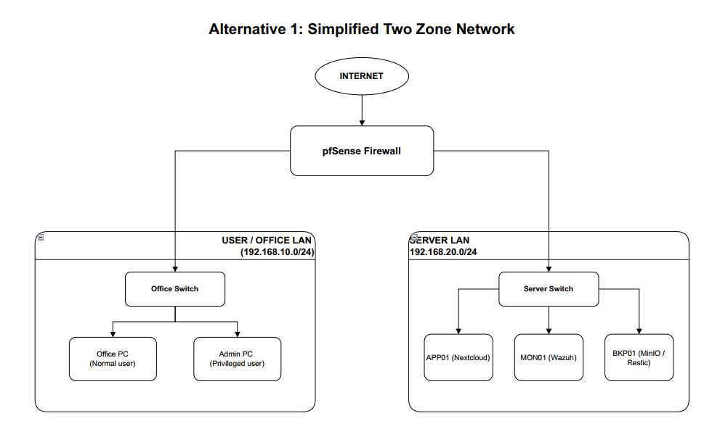
Figure 1. Week 7 - Alternative Architecture 1, simplified two-zone design.

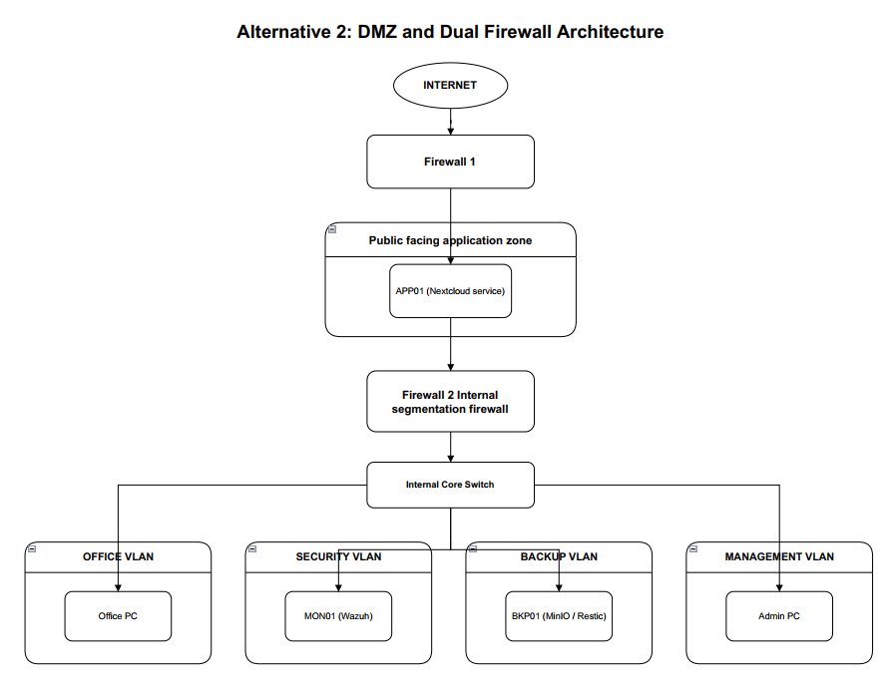
Figure 2. Week 7 - Alternative Architecture 2, DMZ and dual-firewall design.

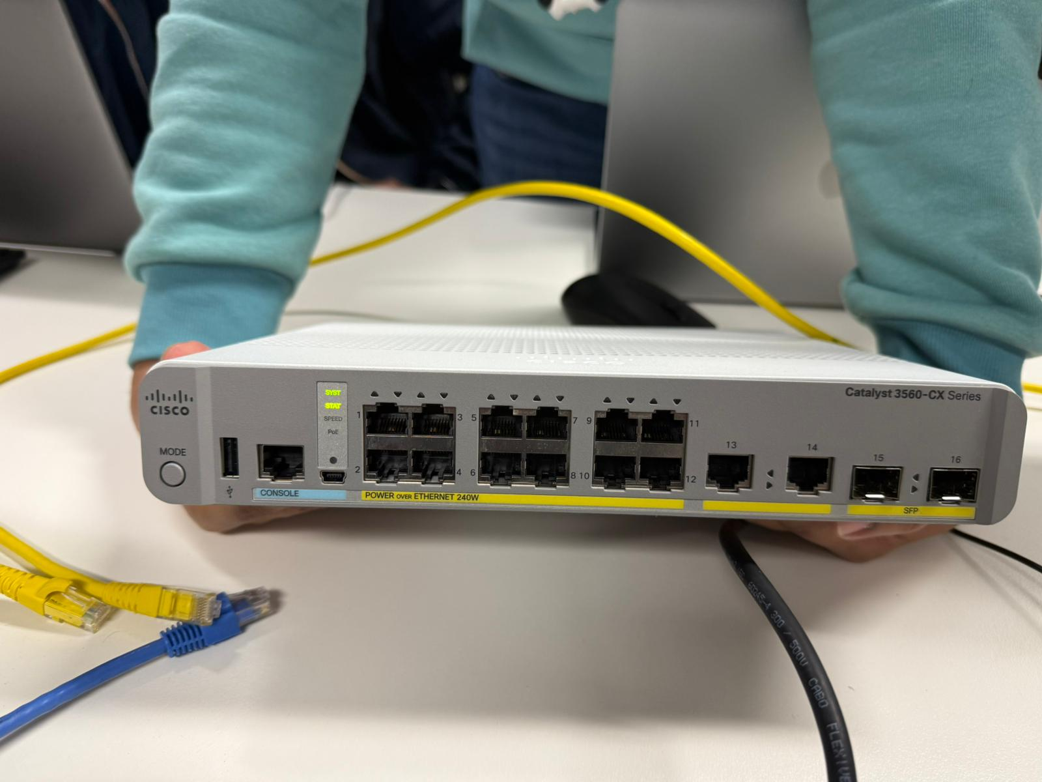
Figure 3. Week 7 - Cisco Catalyst 3560-CX used for the physical network test.
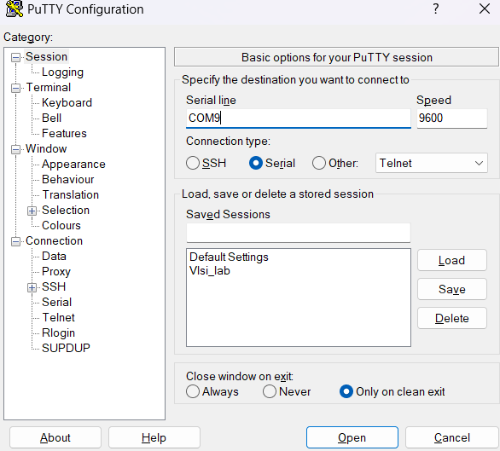
Figure 4. Week 7 - PuTTY serial console configured on COM9 at 9600 baud.
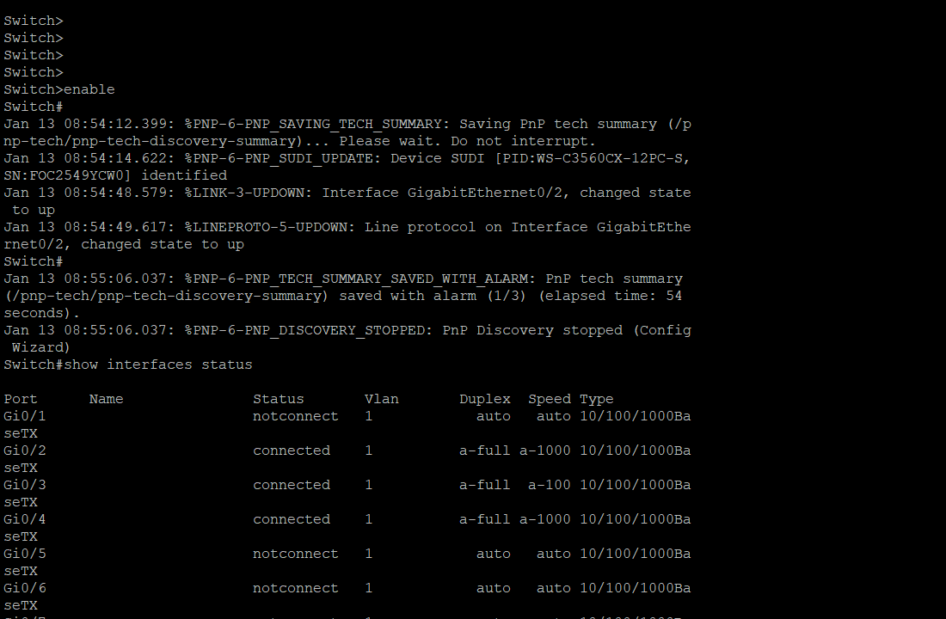
Figure 5. Week 7 - Cisco switch identification and physical interface status check.
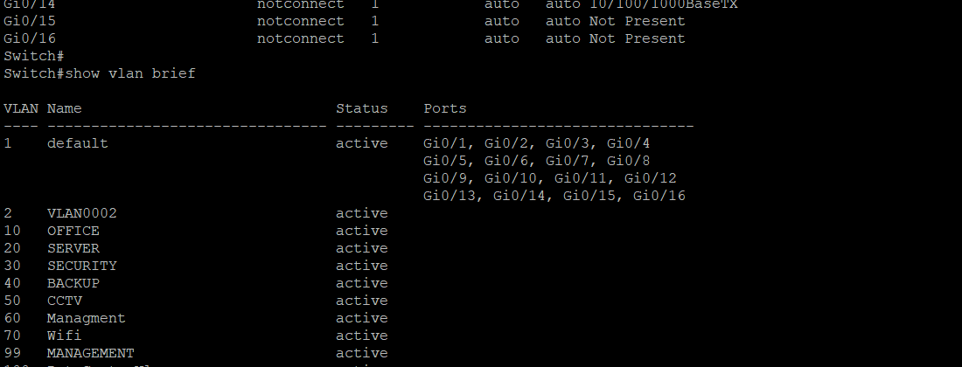
Figure 6. Week 7 - VLAN table showing the project VLANs created on the Cisco switch.

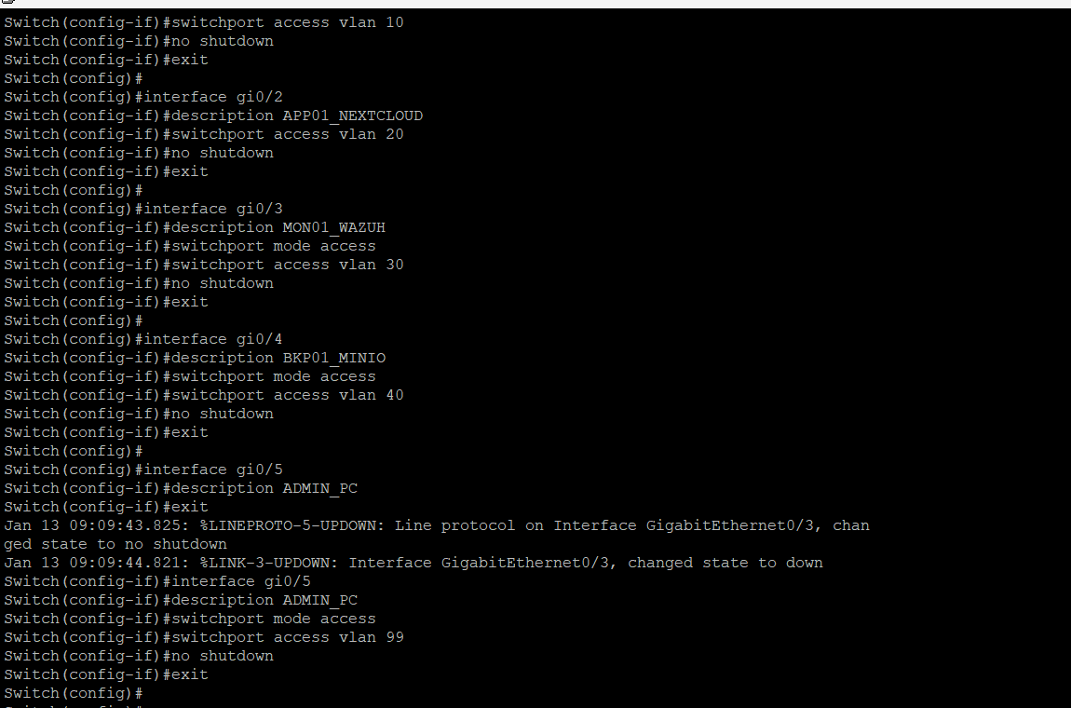
Figure 7. Week 7 - Access-port configuration for the Office, Server, Security, Backup and Management lab VLANs.

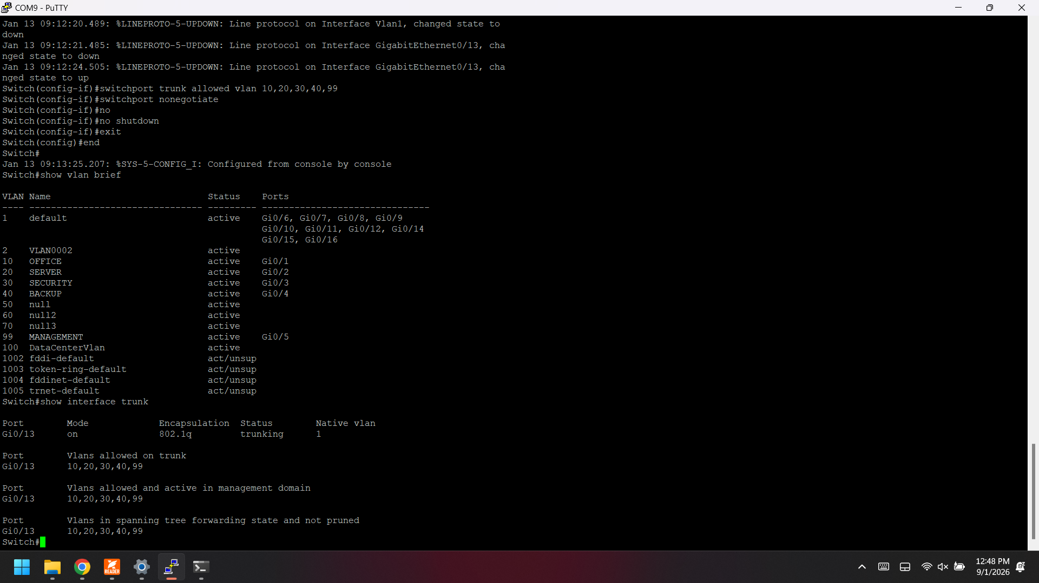
Figure 8. Week 7 - Gi0/13 configured as the trunk connection to pfSense.
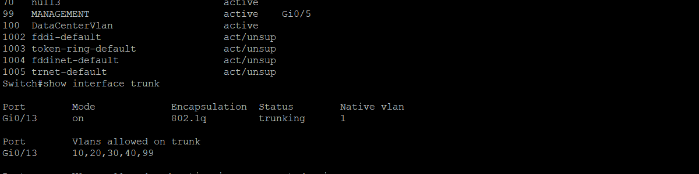
Figure 9. Week 7 - Trunk verification showing the allowed and active AG-3 VLANs.

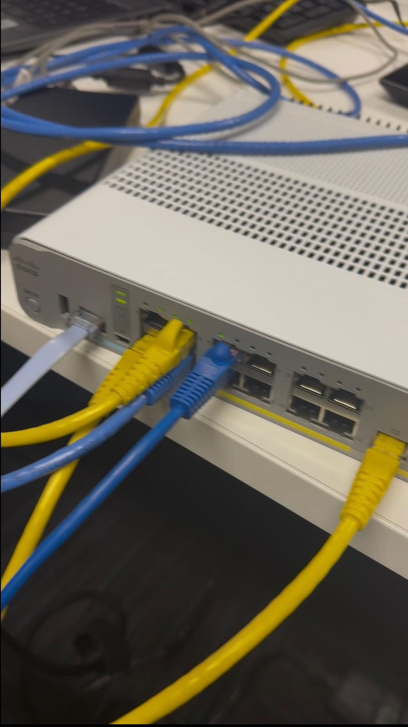
Figure 10. Week 7 - Physical cabling during the team integration test.
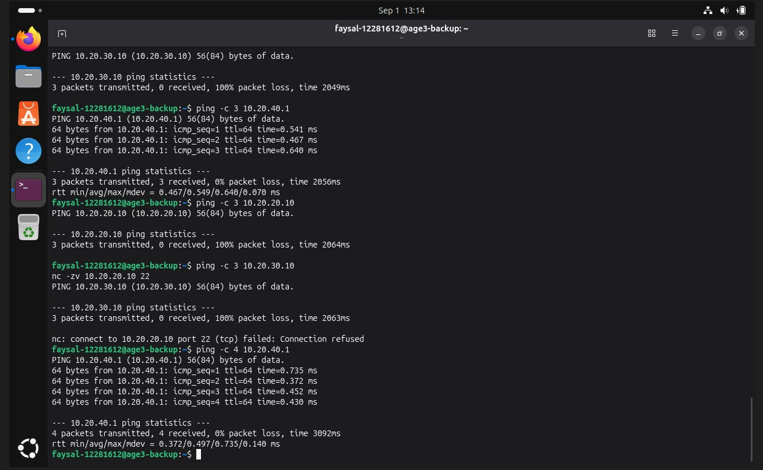
Figure 11. Week 7 - BKP01 gateway test. The host reached 10.20.40.1 while other inter-VLAN tests still required firewall checking.

Week 8 - pfSense Connectivity, Interface Checks and Design Refinement
During Week 8, I continued the pfSense integration work and checked the project VLAN interfaces in the home-lab environment. I also tested Internet access and server connectivity. At the same time, I developed the selected head-office network design in more detail so the logical design could match the project requirements.
- Confirmed the pfSense VLAN interfaces and gateway addressing from the console.
- Confirmed that pfSense could reach the Internet by pinging 8.8.8.8 with no packet loss.
- Checked the Windows test computer addressing and local pfSense LAN connection.
- Tested the Server VLAN gateway from the APP01 side and obtained a successful 10.20.20.1 ping after earlier failed attempts.
- Refined the final head-office design and removed unnecessary complexity from the final documentation.
- Expanded the design to include Office, Server, Security, Backup and Guest Wi-Fi networks with detailed device addressing.
- New firewall rule added that allows each subnet to ping the firewall itself for testing purposes.

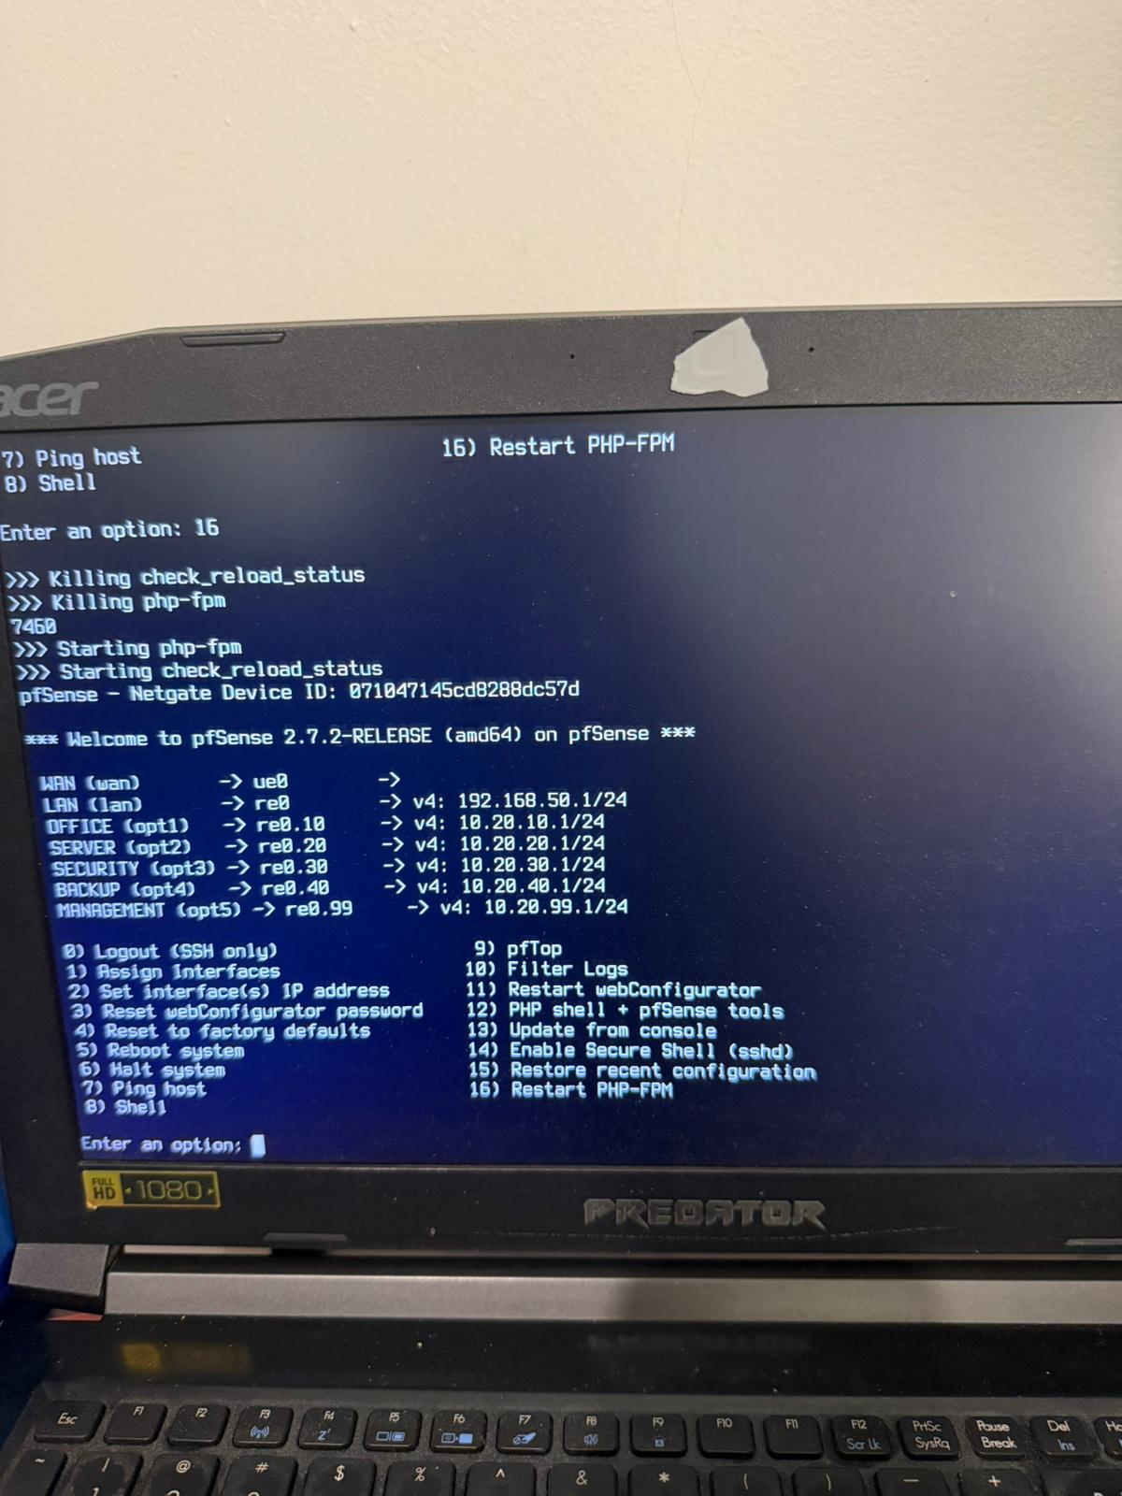
Figure 12. Week 8 - pfSense console showing the project VLAN interfaces and gateway addresses.

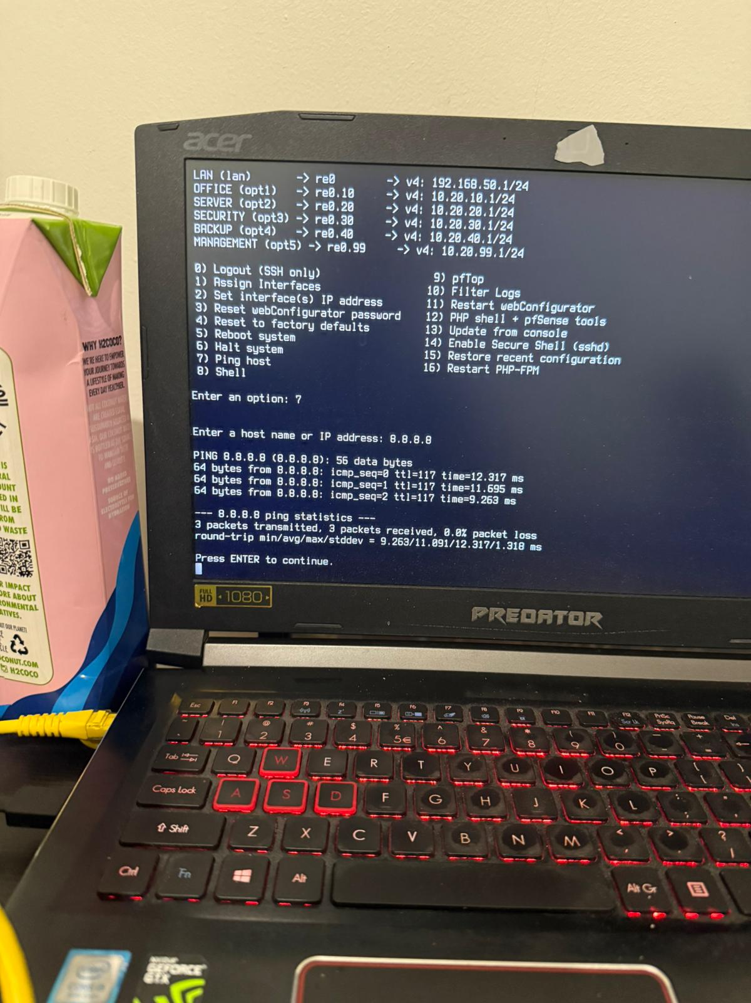
Figure 13. Week 8 - pfSense Internet connectivity test to 8.8.8.8 showing 0% packet loss.

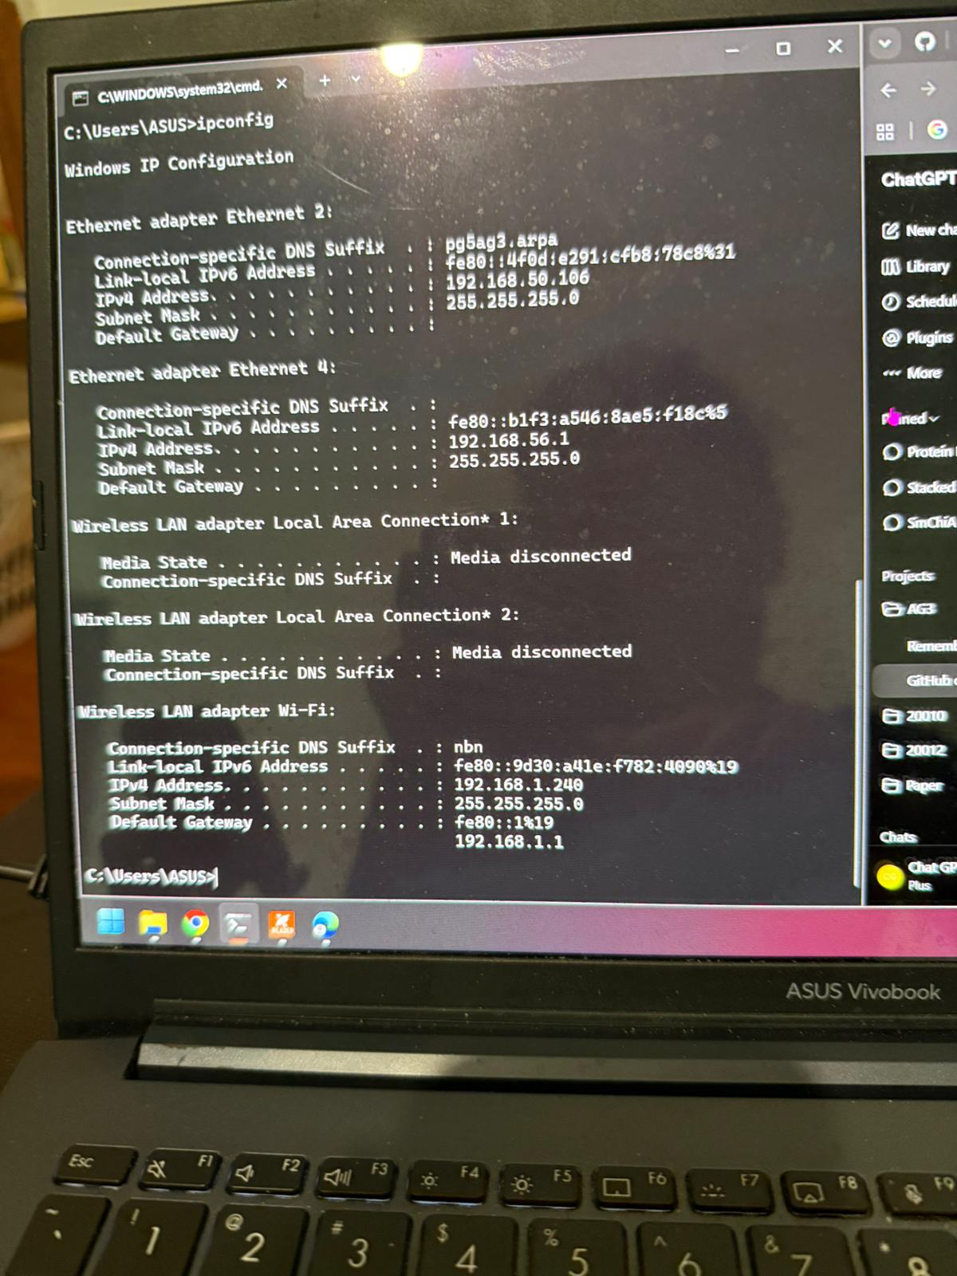
Figure 14. Week 8 - Windows ipconfig output used to verify the local test-machine addressing during integration.

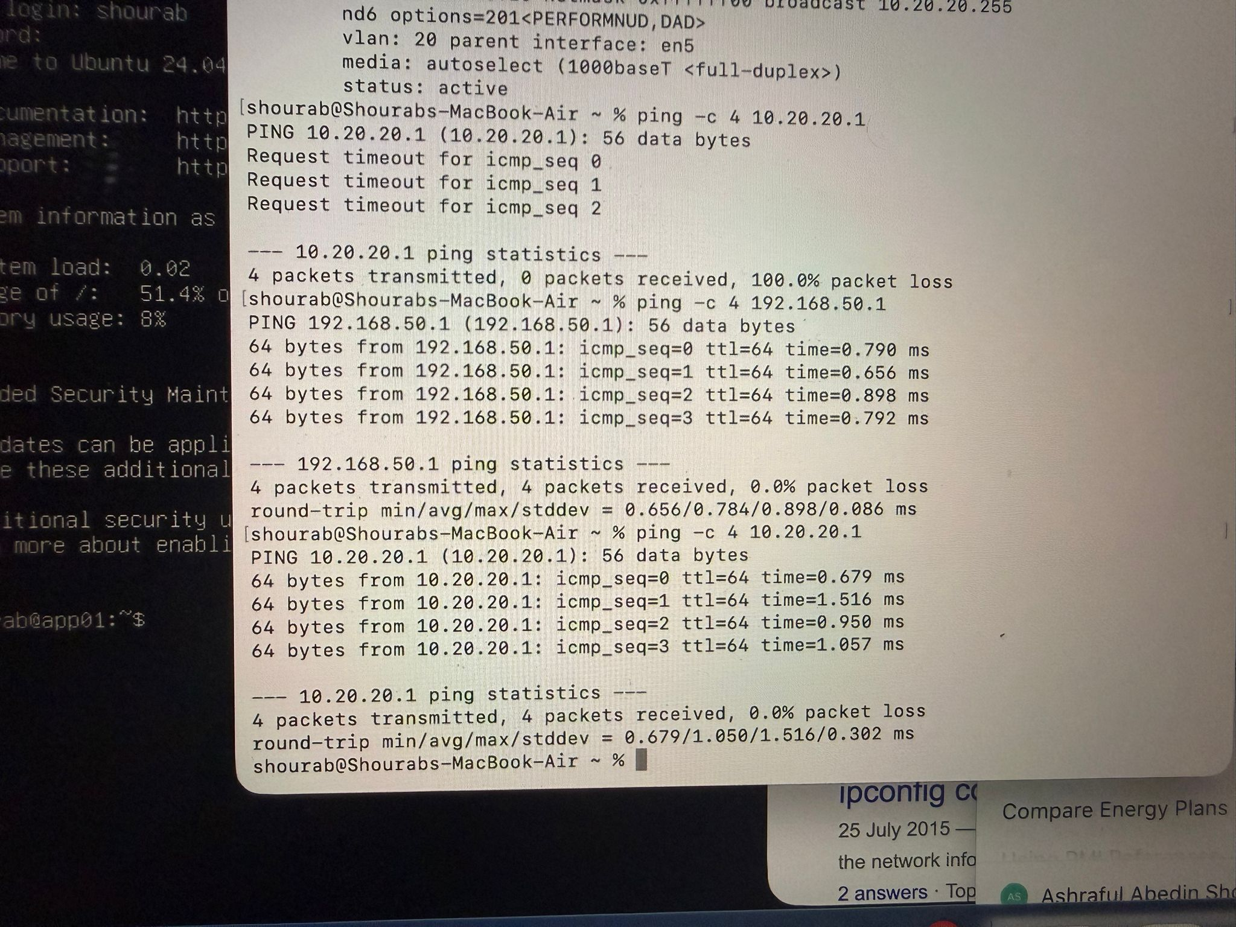
Figure 15. Week 8 - APP01-side test showing successful communication with the Server VLAN gateway 10.20.20.1.

Detailed network-design progress
The selected design was developed as a simplified single-head-office network. The final design documentation was kept separate from the smaller implementation environment. The final simplified design uses Office, Server, Security, Backup and Guest Wi-Fi networks. The Management network that appears in some earlier lab screenshots was later removed from the final simplified design.

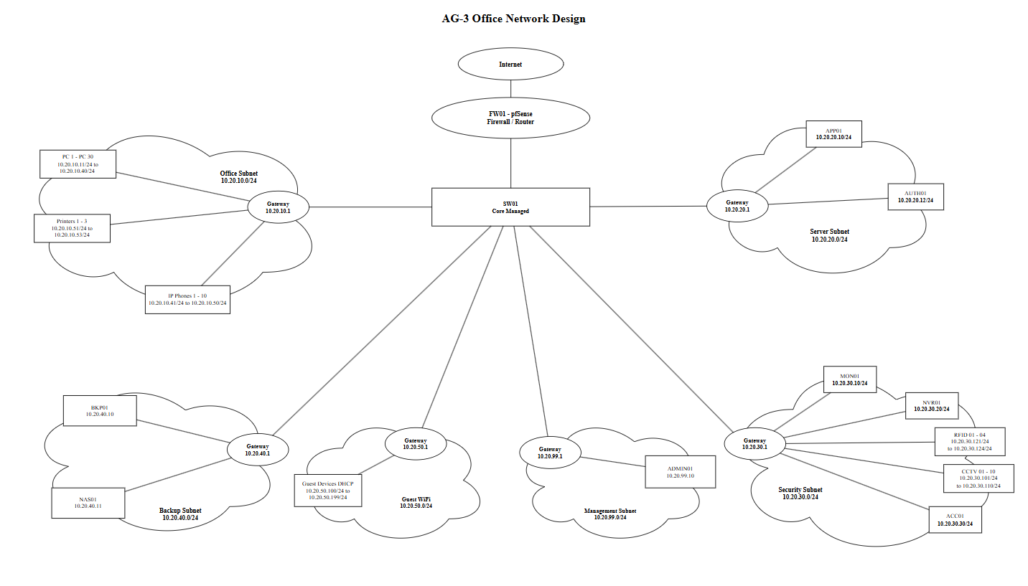
Figure 16. Week 8 - Final simplified AG-3 head-office overview without the Management subnet.

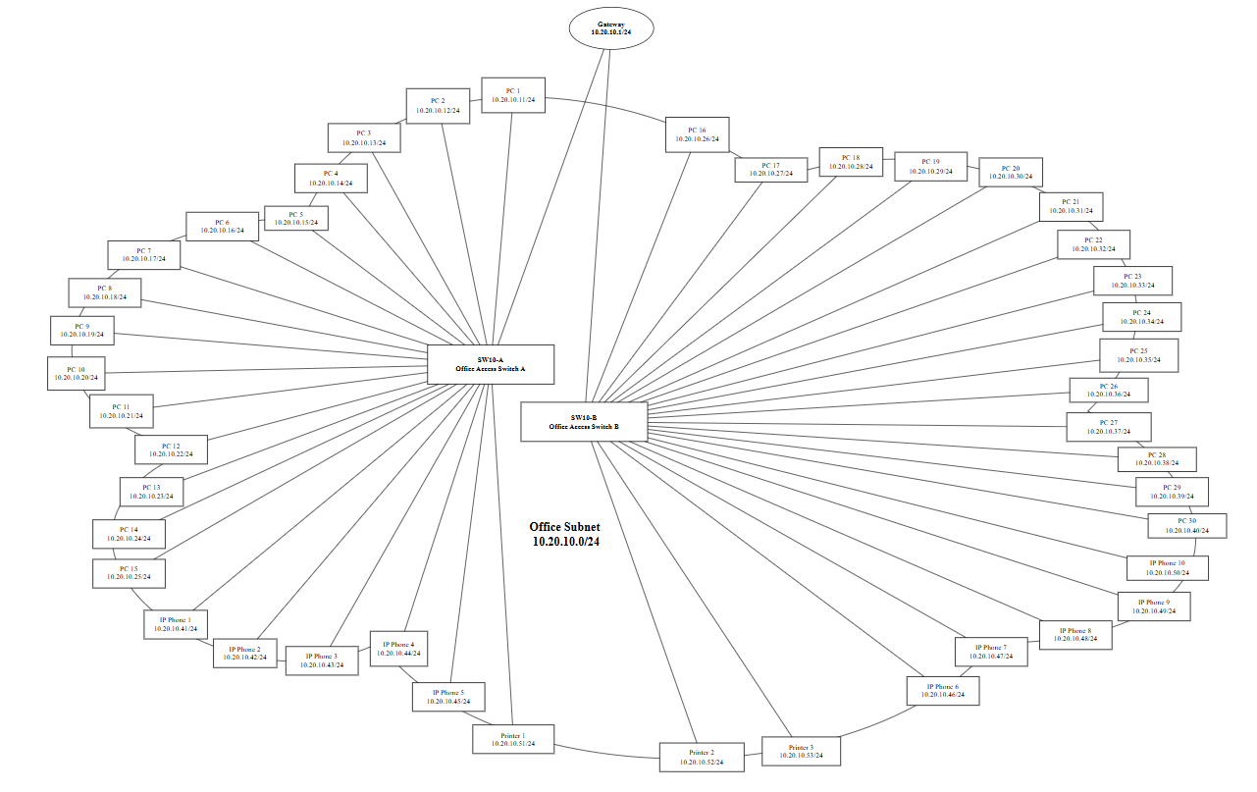
Figure 17. Week 8 - Detailed Office gateway design with PC 1 to PC 30, IP phones and printers assigned individual IP addresses.

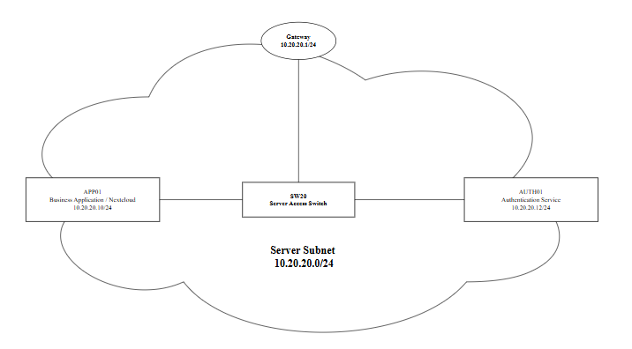
Figure 18. Week 8 - Detailed Server gateway design showing APP01 and AUTH01.
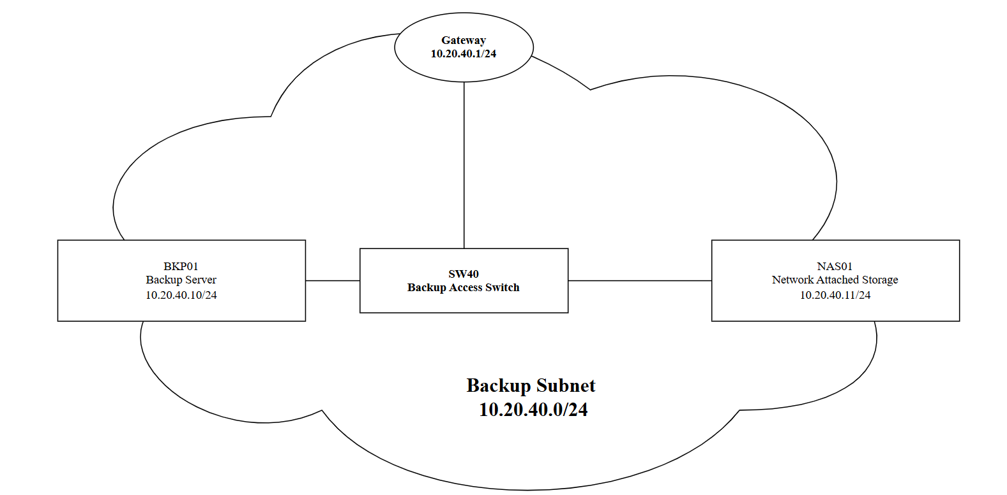
Figure 19. Week 8 - Detailed Backup gateway design showing BKP01 and NAS01.

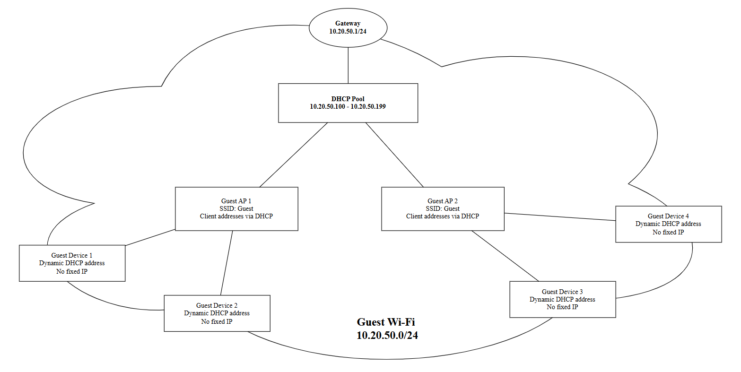
Figure 20. Week 8 - Detailed Guest Wi-Fi gateway design with the DHCP client range.

I focused on the Security VLAN because the connected security endpoint could not initially reach its own gateway at 10.20.30.1. I used routing, interface and packet-capture checks to identify whether the problem was on pfSense, the endpoint or the VLAN path.
- Checked the pfSense routing table and confirmed directly connected routes for the project VLANs.
- Captured the initial failure where the Security endpoint at 10.20.30.10 could not reach 10.20.30.1.
- Checked the pfSense Security interface re0.30 and confirmed VLAN 30, 10.20.30.1/24 and active status.
- Used tcpdump on the pfSense parent interface to confirm tagged VLAN 30 ARP traffic.
- Confirmed ARP requests and replies between 10.20.30.10 and 10.20.30.1.
- Retested from the Security endpoint and successfully reached 10.20.30.1 with 0% packet loss.

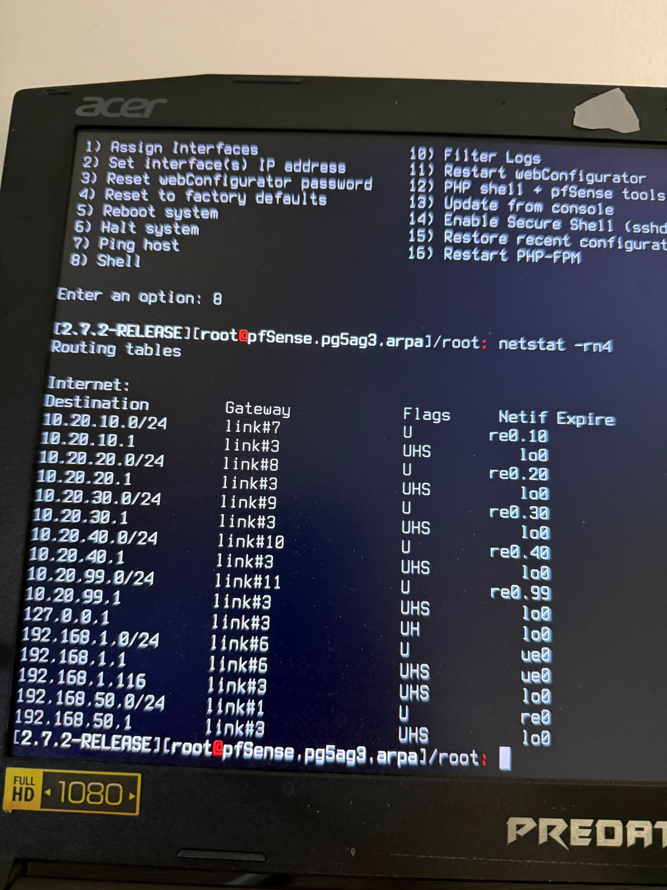
Figure 21. Week 8 - pfSense routing table showing the connected project VLAN routes.

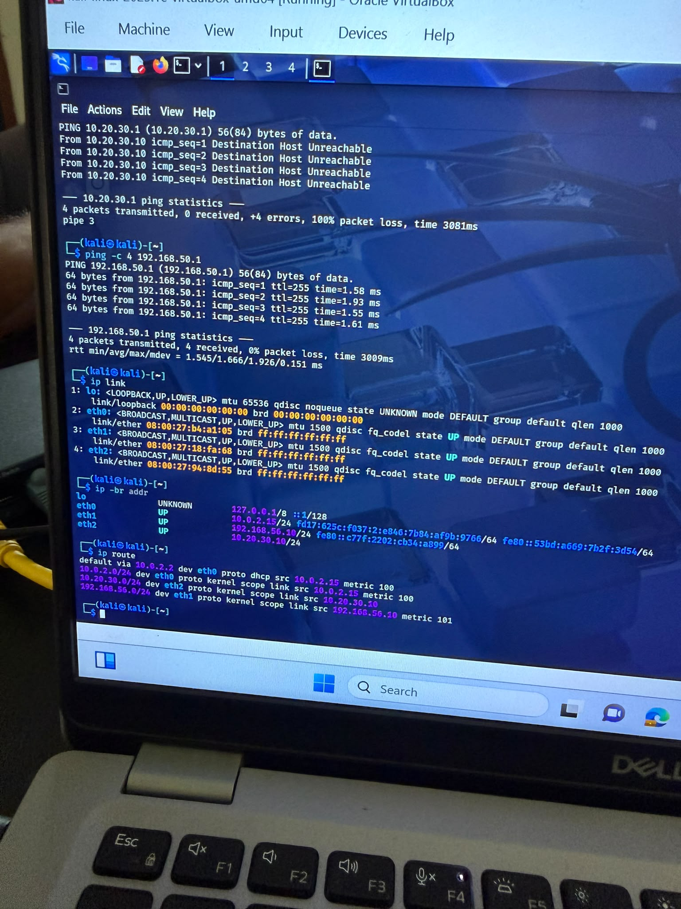
Figure 22. Week 8 - Initial Security VLAN failure. The endpoint at 10.20.30.10 could not reach gateway 10.20.30.1.

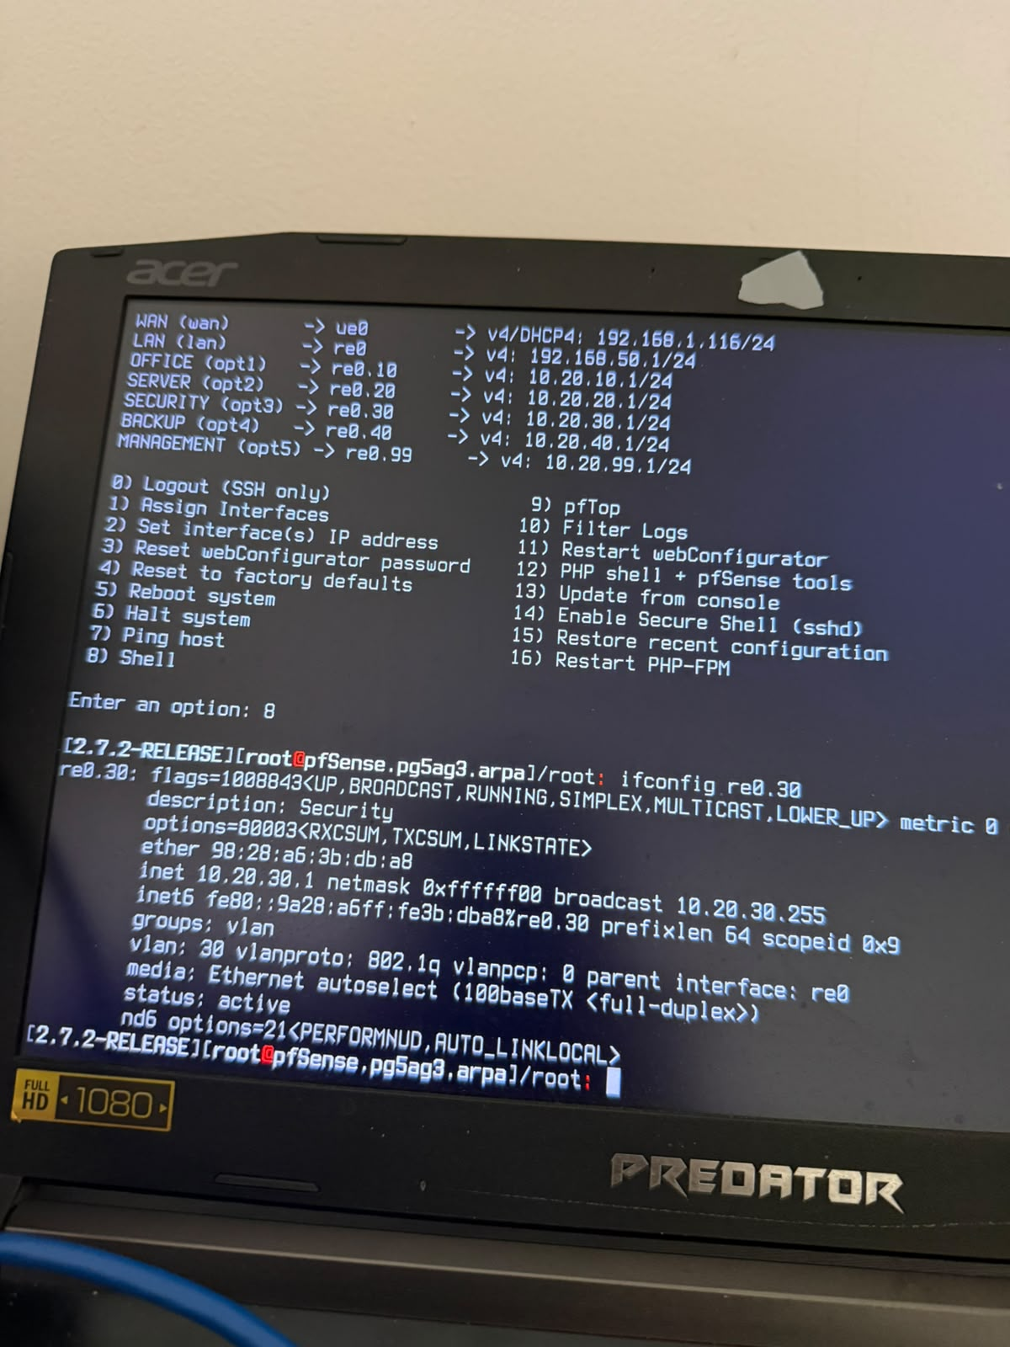
Figure 23. Week 8 - pfSense ifconfig output confirming re0.30, VLAN 30, address 10.20.30.1/24 and active link status.

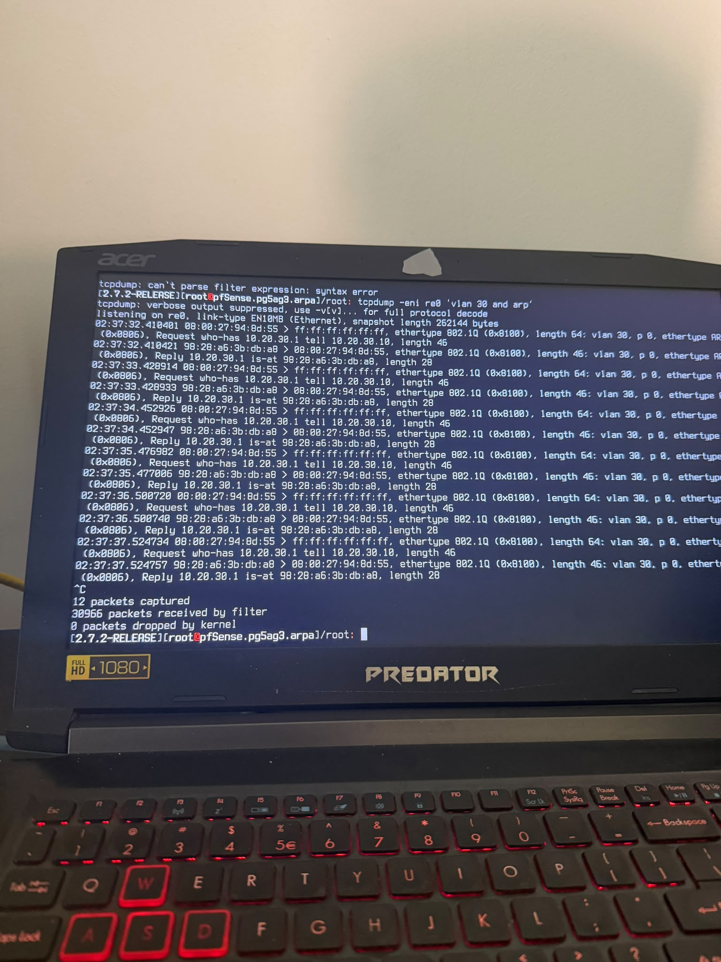
Figure 24. Week 8 - pfSense tcpdump showing tagged VLAN 30 ARP requests and replies between 10.20.30.10 and 10.20.30.1.

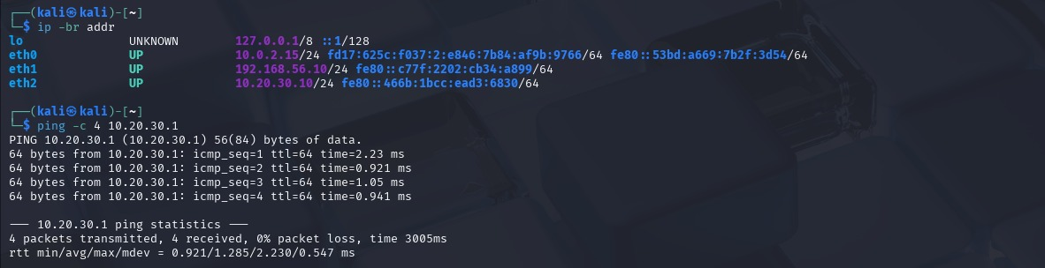
Figure 25. Week 8 - Final Security VLAN gateway test showing successful replies from 10.20.30.1 with 0% packet loss.

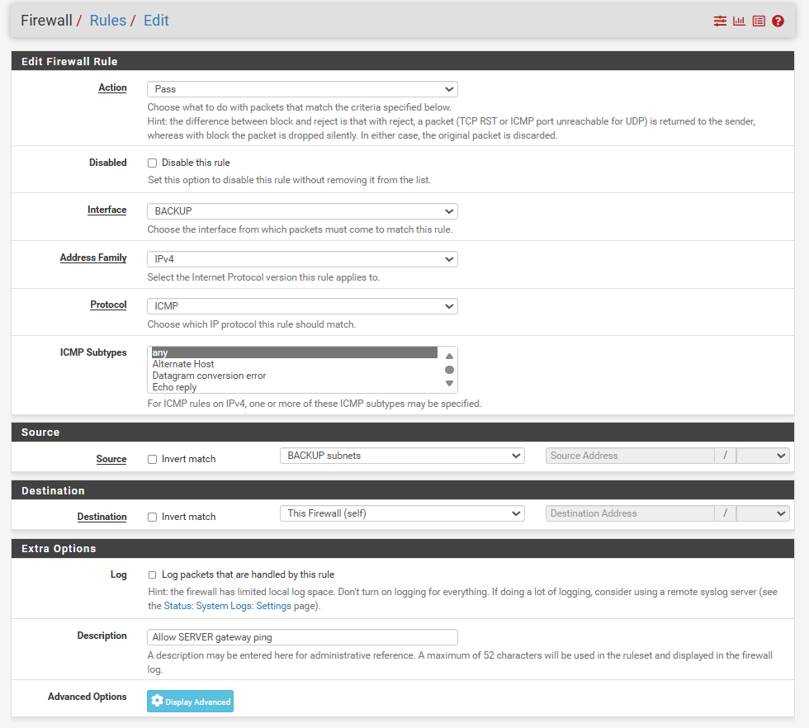
Figure 26. Week 8 – New firewall rule added that allows each subnet to ping the firewall itself for testing purposes.

Current Detailed Address Plan
The detailed head-office design now uses individual addresses instead of general labels such as PC, printer or camera. The main planned address allocations are shown below.
Network | Device / range | Address | Purpose
Office | Gateway | 10.20.10.1/24 | Office default gateway
Office | PC 1 - PC 30 | 10.20.10.11 - 10.20.10.40 | Employee computers
Office | IP Phone 1 - 10 | 10.20.10.41 - 10.20.10.50 | Office voice devices
Office | Printer 1 - 3 | 10.20.10.51 - 10.20.10.53 | Shared printers
Server | Gateway | 10.20.20.1/24 | Server default gateway
Server | APP01 | 10.20.20.10/24 | Business application / Nextcloud
Server | AUTH01 | 10.20.20.12/24 | Authentication service
Security | Gateway | 10.20.30.1/24 | Security default gateway
Security | MON01 | 10.20.30.10/24 | Security monitoring
Security | NVR01 | 10.20.30.20/24 | CCTV recording
Security | ACC01 | 10.20.30.30/24 | Access-control controller
Security | CCTV 1 - 10 | 10.20.30.101 - 10.20.30.110 | IP cameras
Security | RFID 1 - 4 | 10.20.30.121 - 10.20.30.124 | RFID access readers
Backup | Gateway | 10.20.40.1/24 | Backup default gateway
Backup | BKP01 | 10.20.40.10/24 | Backup server
Backup | NAS01 | 10.20.40.11/24 | Network attached storage
Guest Wi-Fi | Gateway | 10.20.50.1/24 | Guest default gateway
Guest Wi-Fi | DHCP clients | 10.20.50.100 - 10.20.50.199 | Guest devices

