6 High-level requirements and success criteria
This section explains what the system must do and how we will check it. First, we have listed the functional requirements. These are the actions that the system must perform. Second, we have listed the non-functional requirements. These describe recovery time, security, cost, usability and safety. Finally, each important requirement has a clear acceptance measure so the team can prove the result.

6.1 Functional requirements
ID | Requirement | Priority | Acceptance measure
FR-01 | Authenticate every named user before they can access the business records. | Must | An unauthenticated request is denied or moved to the login page.
FR-02 | Require TOTP (Time-based One-Time Password) and MFA (Multi-Factor Authentication) for normal and administrator accounts. | Must | Password-only login fails and a valid second factor succeeds.
FR-03 | Use roles so each user can access only the folders needed for the job. | Must | A restricted user cannot read an unauthorised folder.
FR-04 | Separate the office, server, security, backup and management networks. | Must | Approved traffic works while other inter-VLAN traffic is blocked and logged.
FR-05 | Apply and document a hardening baseline. | Must | The required operating system, application and management settings.
FR-06 | Collect login, firewall, system and file integrity events in one place. | Must | Wazuh will show the generated events with the correct source and time.
FR-07 | Create encrypted application backups at least every twenty-four hours. | Must | The scheduled job creates a new snapshot and records success.
FR-08 | Stop normal office users from reaching the backup repository. | Must | Direct network and credential access attempts are denied.
FR-09 | Check the backup repository and complete sample restores. | Must | Verification and sample-restore logs show a successful result.
FR-10 | Run a safe ransomware-loss simulation using synthetic data. | Stretch | Only the approved test folder changes and a monitoring alert is created.
FR-11 | Restore the priority records and portal from a clean snapshot. | Must | The files and application are restored and checked within the recovery targets.
FR-12 | Keep an offsite encrypted copy and an automated restore test. | Stretch | A separate copy exists and a scheduled validation report is produced.

6.2 Non-functional requirements
ID | Quality area | Target
NFR-01 | Recovery point objective | The maximum loss of priority business data will be twenty-four hours.
NFR-02 | Recovery time objective | Priority files will be restored within two hours and the full portal within four hours.
NFR-03 | Security | The system will use MFA (Multi-Factor Authentication), least privilege, encryption and isolated backup access.
NFR-04 | Usability | A normal user will be able to log in and retrieve a file by following a one-page guide.
NFR-05 | Cost | The MVP (Minimum Viable Product) will use free, community or evaluation tools and remain within the approved budget.
NFR-06 | Auditability | Security events, backups and recovery actions will contain a time and responsible user.
NFR-07 | Reproducibility | A second member will be able to rebuild or recover the system by following the repository instructions.
NFR-08 | Safety and privacy | Only synthetic data and a limited simulation folder will be used.

6.3 Definition of MVP (Minimum Viable Product) and stretch goals
The MVP is the minimum complete system that the group must deliver. Stretch goals will begin only after the MVP is stable. This helps us control the scope and finish the most important work first.
Category | Committed outcome
MVP (Minimum Viable Product) | A working environment with MFA (Multi-Factor Authentication), role access, hardening, network segmentation, Wazuh monitoring, encrypted isolated backups and a live timed recovery after a safe simulated loss.
Stretch 1 | A daily encrypted copy in a separate cloud account with independent credentials and retention.
Stretch 2 | Automatic backup checking and restore it to a temporary clean folder with an alert when it fails.
Stretch 3 | A short security awareness package and a continuity exercise for non-technical staff.
Stretch 4 | Repeatable configuration by using Ansible or another automation method.

7 Proposed solution and technical architecture

7.1 Selected solution
We will select a virtual open-source lab with an optional cloud backup copy. First, this option gives enough technical depth because the team must build several connected components. Second, it keeps the direct cost low because most tools are free or community based. Third, it allows the team to test the full process safely with synthetic data.
The main systems are pfSense, Nextcloud, Wazuh, Restic and MinIO. Each system has one clear job, but the final value comes from their integration. The office user will log in with MFA (Multi-Factor Authentication), access the portal through the firewall, create monitored events and rely on an isolated backup for recovery.

7.2 Logical architecture
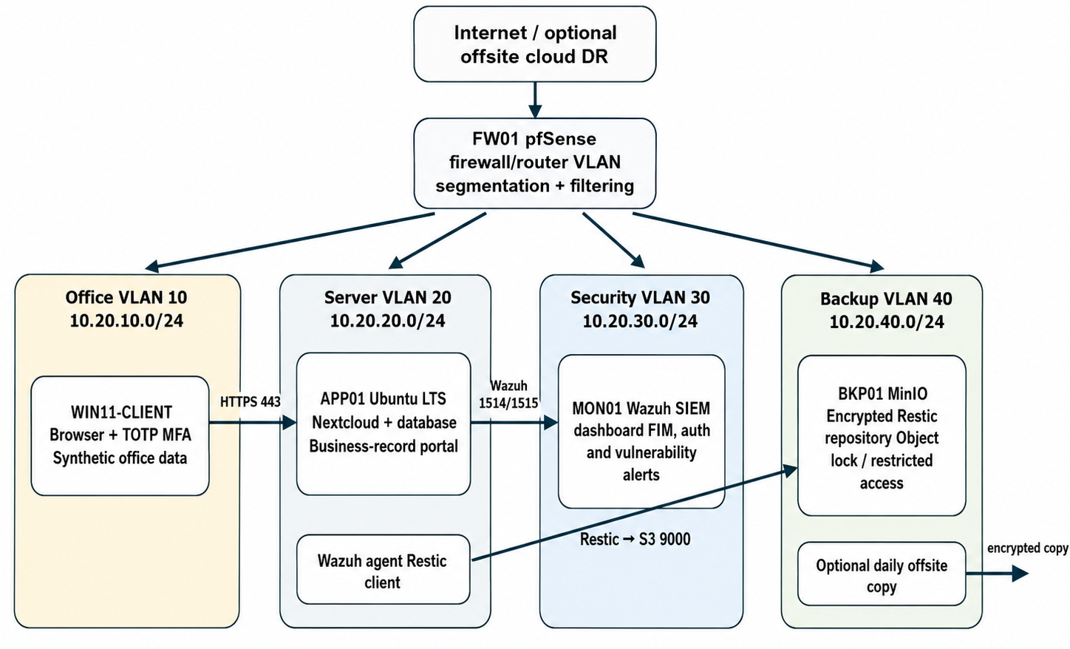
Figure 1. Proposed AG-3 logical architecture and network segmentation.
The above diagram shows the logical architecture of our AG-3 cyber resilience system. We divided the network into different VLANs so that each part of the system can work separately and securely. The pfSense firewall is placed in the center of the architecture. It controls all communication between the internet and the internal VLANs. It also decides which device can communicate with another device. (National Institute of Standards and Technology 2009; National Institute of Standards and Technology 2022; Netgate 2026).
The office VLAN 10 contains the Windows 11 client computer. This computer represents the normal office user of Plains Pastoral Co. The user accesses the business-record portal through a web browser. TOTP multi-factor authentication is also used during login. The client connects to the Nextcloud server through HTTPS port 443. This protects communication between the user and the server. (National Institute of Standards and Technology 2020).
The server VLAN 20 contains the Ubuntu application server. Nextcloud and its database are installed on this server. It stores the synthetic accounting, supplier and agribusiness records used in our project. A Wazuh agent and Restic client are also installed on this server. The Wazuh agent sends security information to the monitoring server, while Restic creates encrypted backups of the business data. (National Institute of Standards and Technology 2022).
The security VLAN 30 contains the Wazuh SIEM server. It receives security events from the application server and other connected systems through ports 1514 and 1515. Wazuh monitors login failures, file changes, vulnerabilities and other suspicious activities. This helps us detect a possible attack and understand what happened during the incident. (National Institute of Standards and Technology 2022).
The backup VLAN 40 contains the MinIO backup server. The Restic client sends encrypted backups to MinIO through S3 port 9000. Normal office users cannot directly access this VLAN. For this reason, ransomware on the office computer should not easily reach or damage the backup files. An optional encrypted offsite copy can also be created to protect the data if the local environment is completely lost. (National Institute of Standards and Technology 2020; National Institute of Standards and Technology 2022).
Finally, management VLAN 99 is used only for the administrator workstation and management interfaces. Access to this VLAN is restricted because it contains sensitive administrative services. Overall, this architecture uses segmentation, MFA, monitoring and isolated backup storage. These controls work together to protect the business system and allow us to recover the data after a simulated ransomware incident. (National Institute of Standards and Technology 2020; National Institute of Standards and Technology 2022).

7.3 Proposed components
Component | Purpose | Resources | Main control
FW01: pfSense | Routing, VLAN separation, firewall filtering and syslog. | 2 vCPU, 2 GB RAM | Management from VLAN 99 only and deny-by-default rules.
APP01: Ubuntu/Nextcloud | Business record portal and database. | 2–4 vCPU, 4–6 GB RAM | HTTPS, TOTP MFA, user groups, SSH keys and patching.
MON01: Wazuh | Central dashboard, file integrity, login and vulnerability monitoring. | 4 vCPU, 8 GB RAM | Agent authentication, dashboard roles and retained alerts.
BKP01: MinIO/Restic | Encrypted backup repository separated from normal users. | 2 vCPU, 4 GB RAM, 100+ GB | Dedicated credentials, backup VLAN and retention/versioning.
WIN11: CLIENT | Office endpoint and test workstation. | 2 vCPU, 4 GB RAM | Standard user, browser MFA and endpoint monitoring.
Cloud DR target: stretch | Second encrypted repository outside the local environment. | Small object-storage allocation | Separate account, daily copy and independent recovery test.

7.4 Proposed firewall policy
The firewall policy follows a minimum-access approach. We will allow only the traffic needed for the business and security process. Any other inter-VLAN traffic will be denied and logged.
Source | Destination | Service | Action | Reason
Office VLAN | APP01 | TCP 443 | Allow | Users need the business portal.
Office VLAN | BKP01, MON01 and management | Any | Block and log | Users must not directly access backup, security or administration systems.
APP01 | BKP01 | TCP 9000 | Allow | Restic needs the S3-compatible backup service.
APP01 and WIN11 | MON01 | 1514/1515 | Allow | Wazuh agent communication.
FW01 | MON01 | 514 | Allow | Central firewall syslog.
Management VLAN | Management interfaces | HTTPS/SSH | Allow | Restricted administration.
All VLANs | Any other inter-VLAN destination | Any | Deny and log | Default isolation.

7.5 Delivery and evaluation method
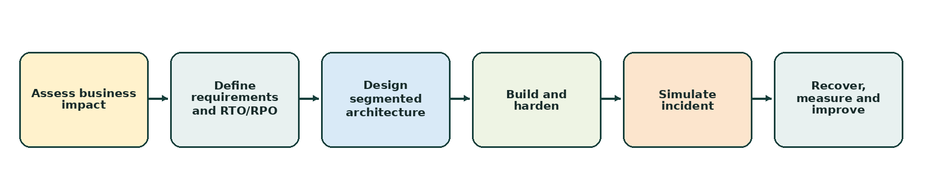
Figure 2. Iterative design, build and recovery-evaluation method.
First, we will confirm the business priorities, RTO (Recovery Time Objective), RPO (Recovery Point Objective) and main requirements. Then we will build the network and the first working path between the client and application. After that, identity, monitoring and backup will be added in small parts. Finally, the team will run the safe incident and recovery test, record the measured results and correct any failure before the demonstration.

8 Work decomposition and deliverables
The work breakdown structure divides the project into clear packages. Each package has a technical output and an owner. This makes the work easier to plan, review and prove.
WBS | Work package | Key tasks | Main deliverables
1.0 | Initiation and governance | Team charter; GitHub, Projects and Teams; AI log; mentor agreement. | Charter, tool setup, first risk register and approved scope.
2.0 | Business analysis and requirements | Stakeholders; business impact; RTO/RPO; requirements and acceptance criteria. | Requirements catalogue, traceability matrix and success criteria.
3.0 | Architecture and security design | Topology; IP plan; VLANs; firewall rules; identity, hardening and logging design. | Architecture diagram, IP plan and security design.
4.0 | Core environment build | Deploy pfSense, VMs and networks; make baseline snapshots and shared access. | Running virtual environment and configuration exports.
5.0 | Identity and application | Nextcloud, groups, roles, TOTP MFA, TLS and access testing. | Application configuration and access-test evidence.
6.0 | Monitoring and alerting | Deploy Wazuh, enroll agents, receive firewall logs and configure file monitoring. | Monitoring configuration and generated alert evidence.
7.0 | Backup and recovery | MinIO, Restic, scripts, schedule, retention, verification and runbook. | Backup scripts, repository evidence and recovery runbook.
8.0 | Security and recovery testing | Segmentation tests, safe file-change simulation, timed restore, hashes and file counts. | Test plan, logs, screenshots/video and measured results.
9.0 | Quality, risk and change | Peer review, risk updates, change decisions, secret checks and traceability review. | Risk register, quality checklist and approvals.
10.0 | Final communication | Final report, artefact pack, portfolio, live demo and recorded fallback. | Submission package and defended demonstration.

9 Delivery roadmap
The project will use incremental delivery. The team will not wait until the final weeks to connect the components. A basic working environment should appear early and more security controls will be added each week.
Time | Main work | Evidence or milestone
Weeks 1–2 | Confirm scenario, team tools, MVP, risks and first lab test. | Repo, Kanban, Teams, checklist and installed platform.
Weeks 3–4 | Complete proposal, requirements, acceptance criteria and first design. | Approved proposal, traceability draft and design decisions.
Weeks 5–6 | Build pfSense, VLANs, VMs and the first end-to-end client-to-portal path. | Running network skeleton and first connectivity evidence.
Weeks 7–8 | Complete Nextcloud roles, MFA, hardening and initial monitoring. | User access tests, hardening checklist and Wazuh events.
Week 9 | Complete backup automation, repository isolation and main monitoring rules. | Scheduled snapshot, denied office-to-backup access and alerts.
Weeks 10–11 | Run segmentation tests, safe simulation and timed recovery. | RTO/RPO results, hashes, logs and recovery evidence.
Week 12 | Fix defects, freeze MVP, complete report and rehearse the demo. | Completed acceptance register and evidence index.
Week 13 | Submit final artefacts and complete the live defence. | Final package, live demo and recorded fallback.

10 Team structure, roles and responsibilities

10.1 Proposed team roles
Member | Role | Technical responsibilities | Observable evidence
Ashraful Abedin Shourab (12298592) | Identity and application lead | Nextcloud, user accounts, role access, TOTP MFA, TLS and user-access tests. | Configuration, screenshots, commits and test evidence.
Akib Hossain (12304711) | Network architecture and planning lead | Requirements, architecture, IP plan, pfSense VLANs, firewall design, WBS and roadmap. | Diagrams, tables, exports, commits and network tests.
Sheikh Tanvi Mahmud (12297656) | Monitoring and hardening lead | Wazuh deployment, agents, system hardening, alerts, risk and quality evidence. | Wazuh screenshots, logs, checklist, commits and test results.
Md Mahafuz Faysal (12281612) | Backup, recovery and integration lead | Restic/MinIO, backup automation, verification, safe simulation and timed restore. | Scripts, snapshots, restore logs, hashes and recovery evidence.

10.2 RACI matrix
Deliverable / activity | Ashraful Abedin Shourab | Akib Hossain | Sheikh Tanvi Mahmud | Md Mahafuz Faysal | Mentor
Project proposal and requirements | C | A/R | C | C | I
Architecture and IP/firewall design | C | A/R | C | I | C
Application, user roles and MFA | A/R | C | C | I | C
Wazuh monitoring and hardening | C | C | A/R | I | C
Backup and recovery system | I | C | C | A/R | C
Safe ransomware-loss simulation | I | C | R | A/R | C
Acceptance testing and evidence | R | A/R | R | R | C
Risk and quality review | C | R | A/R | C | C
Final report and demonstration | R | R | R | A/R | C
R = Responsible, A = Accountable, C = Consulted and I = Informed.

10.3 Task leads for major deliverables
Major deliverable | Technical lead | Reviewers | Target
Requirements and traceability | Akib | All members | Week 4
Architecture, IP and firewall design | Akib | Tanvir and Shourab | Week 5
Application, roles and MFA | Shourab | Akib | Week 8
Monitoring and hardening | Tanvir | Akib | Week 9
Backup, recovery and simulation | Faysal | Tanvir and Shourab | Week 11
Final testing and evidence index | All members | Project mentor | Week 12
Final report and demonstration | Faysal / rotating leader | All members and mentor | Week 13

References used for this part
International Organization for Standardization 2018, ISO/IEC/IEEE 29148:2018 Systems and software engineering — Life cycle processes — Requirements engineering.
National Institute of Standards and Technology 2020, SP 800-207 Zero Trust Architecture.
National Institute of Standards and Technology 2022, SP 800-215 Guide to a Secure Enterprise Network Landscape.
National Institute of Standards and Technology 2009, SP 800-41 Rev. 1 Guidelines on Firewalls and Firewall Policy.
Netgate 2026, pfSense VLAN and firewall documentation.
Project Management Institute, Work Breakdown Structure, schedule management and responsibility assignment guidance.

