**Superstore Sales Performance Report (2011-2014)**

**Overview:**

The dashboard presents an interactive and visual summary of sales data, helping stakeholders make informed decisions quickly.

**Key Performance Indicators (KPIs):**

* **Year-on-Year Sales Performance:**  
  A consistent upward trend is observed in sales figures over recent years.
* **Sales Growth:**  
  Sales have shown a **21% year-on-year growth** for the **past two consecutive years**, indicating strong and sustained performance.
* **Order Volume:**  
  There is a **notable increase in Total Orders in 2014**, suggesting rising customer demand and improved market reach.

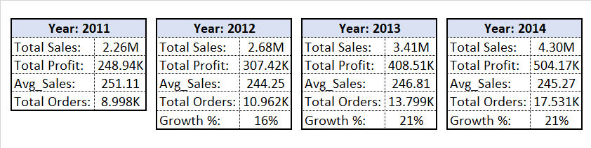

**Observations:**

* **Top Performing Markets:**  
  The **APAC, EU, and US** regions consistently ranked as the **top-performing markets** over the past three years, including **2014**, indicating strong and stable demand in these regions.
* **Product Category Performance (2014):**  
  The **Technology** category emerged as the **most ordered product category** in 2014, reflecting a continued shift toward tech-related purchases.
* **Monthly Sales Trends:**  
  Sales show **month-over-month (MoM) fluctuations**, with **noticeable peaks in June, August, and November**, suggesting possible seasonal campaigns, events, or promotional activities driving higher demand during these months.