**National Institute of Technology, Kurukshetra**



**Department of Computer Applications**

Semester long project

for

(MCA-104) Object Oriented Programming using Java

titled

**Quiz Application System**

**Submitted By**

Kushagra Mahajan (523110047)

Deepika Agrawal (523410006)

Bhawna Kushwaha (523110008)

Chetna Gupta (523410036)

*Under the guidance of*

**Dr Kapil**

**Declaration**

We hereby declare that this Project Report titled **"Quiz Application"** submitted to the Department of Computer Application, NIT Kurukshetra is a record of original work done by us under the guidance of Dr Kapil.

The information and data given in the report is authentic to the best of our knowledge.

This Project Report is not submitted to any other university or institution for the award of any degree, diploma or fellowship or published any time before.

-Kushagra Mahajan

-Bhawna Kushwaha

-Chetna Gupta

-Deepika Agrawal

**CERTIFICATE**

This is to certify that the project entitled, "**Quiz Application**" has been done by: Kushagra Mahajan, Chetna Gupta, Bhawana Kushwaha, Deepika Agrawal of Masters of Computer Applications (MCA) during Semester-II at NIT Kurukshetra under the supervision of Dr Kapil.

**ACKNOWLEDGEMENT**

We would like to express our special thanks of gratitude to our project guide Dr Kapil who gave us the golden opportunity to do this wonderful project which also helped us in doing a lot of research and we got to know about so many new things. We are really thankful for your encouragement, sir.

**Purpose**

The purpose of the quiz application is to provide users with an interactive platform to test their knowledge on various topics. The functionality includes:

1. **User Registration:** Users can register/login to access the quiz content.
2. **Rules:** Students has to follow some rules that will be displayed just after login.
3. **Question Display:** Questions are presented one at a time with multiple-choice answers.
4. **Answer Submission:** Users select their answers and submit them for evaluation.
5. **Scoring:** The application calculates and displays the user's score at the end of the quiz.
6. **Results:** Users receive immediate feedback on their performance.
7. **Timer:** Students will get 15 seconds for each question and when the time’s up, answers will be submitted automatically and next question will be displayed.

These functionalities combine to create an engaging and educational experience for users participating in the quiz application.

**Technologies Used**

1. **Java OOPs Concepts:**

* Utilized key OOPs principles including **inheritance**, **encapsulation**, **abstraction,** **polymorphism**, **objects**, **classes** and **interfaces** and to design a robust and maintainable quiz application.

1. **Java Swing and AWT:**

* **Java Swing:** Integrated Swing components to create a visually appealing and interactive user interface for the quiz application.
* **AWT (Abstract Window Toolkit):** Leveraged AWT for core GUI components, enhancing the user experience and ensuring platform independence.

**Functionalities**

1. **Object-Oriented Programming Concepts**
   * **Inheritance:** The class extends JFrame to inherit its properties and functionalities.
   * **Encapsulation:** The class encapsulates GUI components and functionality within a single unit. Data structures like arrays encapsulate the quiz questions, answers, and user responses.
   * **ActionListener Interface:** Implemented to handle button click events using actionPerformed() method.
2. **GUI Components**
   * **JFrame:** Used as the base for the window.
   * **JLabel:** Displayed text like "Simple Minds," "Enter your name," etc.
   * **JTextField:** Provided a text field for user input.
   * **JButton:** Created buttons for "Rules" and "Back" actions.
3. **Event Handling**
   * **ActionEvent:** Handled through actionPerformed() method to respond to button clicks.
   * **Button Actions:** When "Rules" button is clicked, the user's name is retrieved, and a new Rules object is created. When "Back" button is clicked, the Login window is hidden.
4. **Styling and Layout**
   * **Colors:** Used colors for backgrounds and text.
   * **Fonts:** Applied different fonts and font sizes for text elements.
   * **Layout Management:** Utilized null layout (setLayout(null)) for custom positioning of components.
5. **Quiz Logic**
   * **Question Handling:**Displays questions and answer options based on the current count.
   * **Timer:** Implements a countdown timer for each question.
   * **Scoring:**Calculates the final score based on user responses.
6. **User Interaction**
   * **User Response Tracking:**Records and processes user responses.
   * **User Interface:** Updates the interface based on user interactions and responses.

**Code**

**Login Page**

package quiz.applications;

import javax.swing.*;

import java.awt.event.*;

import java.awt.*;

public class Login extends JFrame implements ActionListener {

JButton proceed, back, register;

JTextField tf_username, tf_password;

Login() {

setTitle("Login Page");

getContentPane().setBackground(Color.WHITE);

setLayout(null);

JLabel image = new JLabel(new ImageIcon(ClassLoader.getSystemResource("icons/login.jpeg")));

image.setBounds(0, 0, 600, 500);

add(image);

JLabel heading = new JLabel("Simple minds");

heading.setBounds(750, 60, 300, 45);

heading.setFont(new Font("Viner Hand ITC", Font.BOLD, 40));

heading.setForeground(new Color(30, 144, 254));

add(heading);

JLabel name = new JLabel("Username");

name.setBounds(685, 150, 200, 25);

name.setFont(new Font("Arial", Font.BOLD, 18));

name.setForeground(new Color(30, 144, 254));

add(name);

tf_username = new JTextField();

tf_username.setBounds(800, 150, 300, 25);

tf_username.setFont(new Font("times New Roman", Font.BOLD, 18));

add(tf_username);

JLabel password = new JLabel("Password");

password.setBounds(685, 200, 200, 25);

password.setFont(new Font("Arial", Font.BOLD, 18));

password.setForeground(new Color(30, 144, 254));

add(password);

tf_password = new JTextField();

tf_password.setBounds(800, 200, 300, 25);

tf_password.setFont(new Font("times New Roman", Font.BOLD, 20));

add(tf_password);

proceed = new JButton("Proceed");

proceed.setBounds(775, 270, 120, 25);

proceed.setBackground(new Color(30, 144, 254));

proceed.setForeground(Color.WHITE);

proceed.addActionListener(this);

add(proceed);

back = new JButton("Back");

back.setBounds(955, 270, 120, 25);

back.setBackground(new Color(30, 144, 254));

back.setForeground(Color.WHITE);

back.addActionListener(this);

add(back);

JLabel newUser = new JLabel("New user? ");

newUser.setBounds(685, 330, 200, 25);

newUser.setFont(new Font("Arial", Font.BOLD, 14));

newUser.setForeground(new Color(30, 144, 254));

add(newUser);

register = new JButton("Register");

register.setBounds(770, 330, 120, 25);

register.setBackground(new Color(30, 144, 254));

register.setForeground(Color.WHITE);

register.addActionListener(this);

add(register);

setSize(1200, 500);

setLocation(200, 200);

setVisible(true);

}

void showPane() {

tf_password.setText("");

setVisible(true);

}

public void actionPerformed(ActionEvent ae) {

if (ae.getSource() == back) {

setVisible(false);

} else if (ae.getSource() == proceed) {

if (tf_username.getText().equals("")) {

JOptionPane.showMessageDialog(this, "Please enter username first!", "Error",JOptionPane.ERROR_MESSAGE);

} else if (tf_password.getText().equals("")) {

JOptionPane.showMessageDialog(this, "Please enter password!", "Error", JOptionPane.ERROR_MESSAGE);

} else {

try {

if (Credentials.validate(tf_username.getText(), tf_password.getText())) {

setVisible(false);

new Rules(tf_username.getText(), this);

} else {

JOptionPane.showMessageDialog(this, "Incorrect password!", "Error", JOptionPane.ERROR_MESSAGE);

}

} catch(FileDeletedException fdEx) {

JOptionPane.showMessageDialog(this, fdEx, "Error", JOptionPane.ERROR_MESSAGE);

} catch (UserDoesNotExistsException udeEx) {

JOptionPane.showMessageDialog(this, udeEx, "Error", JOptionPane.ERROR_MESSAGE);

}

}

} else if (ae.getSource() == register) {

setVisible(false);

new Register(this);

}

}

public static void main(String[] args) {

new Login();

}

}

**Register**

package quiz.applications;

import javax.swing.*;

import java.awt.*;

import java.awt.event.*;

public class Register extends JFrame {

Login login;

public Register(Login l) {

setTitle("Registration Form");

setSize(600, 500); // Set initial size

setLocation(400, 200); // Set location

login = l;

// Create main panel with GridBagLayout

JPanel mainPanel = new JPanel(new GridBagLayout());

GridBagConstraints gbc = new GridBagConstraints();

gbc.insets = new Insets(10, 10, 10, 10); // Padding

setContentPane(mainPanel);

// Create blue background panel

JPanel bluePanel = new JPanel(new GridBagLayout());

bluePanel.setBackground(new Color(30, 144, 254)); // Light blue color

JLabel usernameLabel = new JLabel("Username:");

JLabel passwordLabel = new JLabel("Password:");

JTextField usernameField = new JTextField(20);

// usernameField.setBounds(200,300,200,30);

JTextField passwordField = new JTextField(20);

// passwordField.setBounds(200,350,200,30);

JButton registerButton = new JButton("Register");

registerButton.addActionListener(new ActionListener() {

@Override

public void actionPerformed(ActionEvent e) {

if (usernameField.getText().equals("")) {

JOptionPane.showMessageDialog(registerButton, "Please enter username first!", "Error",

JOptionPane.ERROR_MESSAGE);

} else if (passwordField.getText().equals("")) {

JOptionPane.showMessageDialog(registerButton, "Please enter password!", "Error",

JOptionPane.ERROR_MESSAGE);

} else {

try {

if (Credentials.addUser(usernameField.getText(), passwordField.getText())) {

JOptionPane.showMessageDialog(registerButton, "User registered successfully!",

"Registration successful", JOptionPane.INFORMATION_MESSAGE);

setVisible(false);

login.showPane();

}

} catch (FileDeletedException fdEx) {

JOptionPane.showMessageDialog(registerButton, fdEx, "Error", JOptionPane.ERROR_MESSAGE);

} catch (UserAlreadyExistsException uaeEx) {

JOptionPane.showMessageDialog(registerButton, uaeEx, "Error", JOptionPane.ERROR_MESSAGE);

}

}

}

});

JLabel alreadyRegisteredLabel = new JLabel("Already registered?");

JButton loginButton = new JButton("Login");

// Add action listener for the login button

loginButton.addActionListener(new ActionListener() {

@Override

public void actionPerformed(ActionEvent e) {

setVisible(false);

l.showPane();

}

});

// Add components to bluePanel using GridBagConstraints

gbc.gridx = 0;

gbc.gridy = 0;

bluePanel.add(usernameLabel, gbc);

gbc.gridx = 1;

bluePanel.add(usernameField, gbc);

gbc.gridx = 0;

gbc.gridy = 1;

bluePanel.add(passwordLabel, gbc);

gbc.gridx = 1;

bluePanel.add(passwordField, gbc);

// Create panel for register and login button to set its size

JPanel buttonPanel = new JPanel(new FlowLayout(FlowLayout.CENTER));

buttonPanel.add(registerButton);

JPanel loginPanel = new JPanel(new FlowLayout(FlowLayout.LEFT));

loginPanel.add(alreadyRegisteredLabel);

loginPanel.add(loginButton);

// Add bluePanel and buttonPanel to mainPanel using GridBagConstraints

gbc.gridx = 0;

gbc.gridy = 0;

mainPanel.add(bluePanel, gbc);

gbc.gridy = 1;

mainPanel.add(buttonPanel, gbc);

// Add loginPanel to mainPanel using GridBagConstraints

gbc.gridy = 2;

mainPanel.add(loginPanel, gbc);

setVisible(true);

}

}

**Rules Page**

package quiz.applications;

import javax.swing.*;

import java.awt.*;

import java.awt.event.*;

public class Rules extends JFrame implements ActionListener {

String name;

JButton start, back;

*// Constructor for the Rules class*

Rules(String name) {

this.name = name;

*// Setting background color and layout*

getContentPane().setBackground(Color.WHITE);

setLayout(null);

*// Heading label*

JLabel heading = new JLabel("Welcome " + name + " to Simple Minds");

heading.setBounds(50, 20, 700, 30);

heading.setFont(new Font("Viner Hand ITC", Font.BOLD, 28));

heading.setForeground(new Color(30, 144, 254));

add(heading);

*// Rules label*

JLabel rules = new JLabel();

rules.setBounds(20, 90, 700, 350);

rules.setFont(new Font("Tahoma", Font.PLAIN, 16));

rules.setText(

"<html>" +

"1. You are trained to be a programmer and not a story teller, answer point to point" + "<br><br>" +

"2. Do not unnecessarily smile at the person sitting next to you, they may also not know the answer" + "<br><br>" +

"3. You may have lot of options in life but here all the questions are compulsory" + "<br><br>" +

"4. Crying is allowed but please do so quietly." + "<br><br>" +

"5. Only a fool asks and a wise answers (Be wise, not otherwise)" + "<br><br>" +

"6. Do not get nervous if your friend is answering more questions, may be he/she is doing Jai Mata Di" + "<br><br>" +

"7. Brace yourself, this paper is not for the faint hearted" + "<br><br>" +

"8. May you know more than what John Snow knows, Good Luck" + "<br><br>" +

"<html>"

);

add(rules);

*// Start button*

start = new JButton("Start");

start.setBounds(400, 500, 100, 30);

start.setBackground(new Color(30, 144, 254));

start.setForeground(Color.WHITE);

start.addActionListener(this);

add(start);

*// Back button*

back = new JButton("Back");

back.setBounds(250, 500, 100, 30);

back.setBackground(new Color(30, 144, 254));

back.setForeground(Color.WHITE);

back.addActionListener(this);

add(back);

*// Setting frame size, location, and visibility*

setSize(800, 650);

setLocation(350, 100);

setVisible(true);

}

*// ActionPerformed method to handle button clicks*

public void actionPerformed(ActionEvent ae) {

if (ae.getSource() == start) {

setVisible(false);

new Quiz(name);

} else {

setVisible(false);

}

}

*// Main method to test the Rules class*

public static void main(String[] args) {

new Rules("user");

}

}

**Quiz Question and its implementations**

getContentPane().setBackground(Color.WHITE);

setLayout(null);

*// Adding background image*

ImageIcon i1 = new ImageIcon(ClassLoader.getSystemResource("icons/quiz.jpg"));

JLabel image = new JLabel(i1);

image.setBounds(0, 0, 1440, 392);

add(image);

*// Question number label*

qno = new JLabel();

qno.setBounds(100, 450, 50, 30);

qno.setFont(new Font("Tahoma", Font.PLAIN, 24));

add(qno);

*// Question label*

question = new JLabel("");

question.setBounds(150, 450, 900, 30);

question.setFont(new Font("Tahoma", Font.PLAIN, 24));

add(question);

*// Questions and answers*

questions[0][0] = "Which is used to find and fix bugs in the Java programs.?";

*// ... (continue initializing other questions and answers)*

// Correct answers

answers[0][1] = "JDB";

*// ... (continue initializing other correct answers)*

*// Option buttons*

opt1 = new JRadioButton();

opt1.setBounds(170, 520, 700, 30);

opt1.setBackground(Color.WHITE);

opt1.setFont(new Font("Dialog", Font.PLAIN, 20));

add(opt1);

opt2 = new JRadioButton();

opt2.setBounds(170, 560, 700, 30);

opt2.setBackground(Color.WHITE);

opt2.setFont(new Font("Dialog", Font.PLAIN, 20));

add(opt2);

opt3 = new JRadioButton();

opt3.setBounds(170, 600, 700, 30);

opt3.setBackground(Color.WHITE);

opt3.setFont(new Font("Dialog", Font.PLAIN, 20));

add(opt3);

opt4 = new JRadioButton();

opt4.setBounds(170, 640, 700, 30);

opt4.setBackground(Color.WHITE);

opt4.setFont(new Font("Dialog", Font.PLAIN, 20));

add(opt4);

*// Grouping option buttons*

groupoptions = new ButtonGroup();

groupoptions.add(opt1);

groupoptions.add(opt2);

groupoptions.add(opt3);

groupoptions.add(opt4);

*// Next button*

next = new JButton("Next");

next.setBounds(1100, 550, 200, 40);

next.setFont(new Font("Tahoma", Font.PLAIN, 22));

next.setBackground(new Color(30, 144, 255));

next.setForeground(Color.WHITE);

next.addActionListener(this);

add(next);

*// Submit button*

submit = new JButton("Submit");

submit.setBounds(1100, 630, 200, 40);

submit.setFont(new Font("Tahoma", Font.PLAIN, 22));

submit.setBackground(new Color(30, 144, 255));

submit.setForeground(Color.WHITE);

submit.addActionListener(this);

add(submit);

*// Starting quiz*

start(count);

setVisible(true);

}

*// Action performed method*

public void actionPerformed(ActionEvent ae) {

if (ae.getSource() == next) {

// Handling next button click

repaint();

opt1.setEnabled(true);

opt2.setEnabled(true);

opt3.setEnabled(true);

opt4.setEnabled(true);

ans_given = 1;

if (groupoptions.getSelection() == null) {

useranswers[count][0] = "";

} else {

useranswers[count][0] = groupoptions.getSelection().getActionCommand();

}

if (count == 8) {

next.setEnabled(false);

submit.setEnabled(true);

}

count++;

start(count);

} else if (ae.getSource() == submit) {

// Handling submit button click

ans_given = 1;

if (groupoptions.getSelection() == null) {

useranswers[count][0] = "";

} else {

useranswers[count][0] = groupoptions.getSelection().getActionCommand();

}

for (int i = 0; i < useranswers.length; i++) {

if (useranswers[i][0].equals(answers[i][1])) {

score += 10;

} else {

score += 0;

}

}

setVisible(false);

new Score(name, score);

}

}

**Result Page**

package quiz.applications;

import java.awt.*;

import javax.swing.*;

import java.awt.event.*;

public class Score extends JFrame implements ActionListener {

*// Constructor for the Score class*

Score(String name, int score) {

// Setting frame bounds and background color

setBounds(400, 150, 750, 550);

getContentPane().setBackground(Color.WHITE);

setLayout(null);

*// Loading and scaling the image*

ImageIcon i1 = new ImageIcon(ClassLoader.getSystemResource("icons/score.png"));

Image i2 = i1.getImage().getScaledInstance(300, 250, Image.SCALE_DEFAULT);

ImageIcon i3 = new ImageIcon(i2);

JLabel image = new JLabel(i3);

image.setBounds(0, 200, 300, 250);

add(image);

*// Heading label*

JLabel heading = new JLabel("Thank you " + name + " for playing Simple Minds");

heading.setBounds(45, 30, 700, 30);

heading.setFont(new Font("Tahoma", Font.PLAIN, 26));

add(heading);

*// Score label*

JLabel lblscore = new JLabel("Your score is " + score);

lblscore.setBounds(350, 200, 300, 30);

lblscore.setFont(new Font("Tahoma", Font.PLAIN, 26));

add(lblscore);

*// Play Again button*

JButton submit = new JButton("Play Again");

submit.setBounds(380, 270, 120, 30);

submit.setBackground(new Color(30, 144, 255));

submit.setForeground(Color.WHITE);

submit.addActionListener(this);

add(submit);

*// Setting frame visibility*

setVisible(true);

}

*// ActionPerformed method to handle button click*

public void actionPerformed(ActionEvent ae) {

setVisible(false);

new Login();

}

*// Main method to test the Score class*

public static void main(String[] args) {

new Score("User", 0);

}

}

**Credentials**

package quiz.applications;

import java.io.File;

import java.io.FileWriter;

import java.util.Scanner;

import java.io.IOException;

public class Credentials {

    private static String path = "C:/Users/Public/Documents";

    private static String fileName = "DO_NOT_MODIFY.txt";

    static {

        try {

            File fcreate = new File(path + "/" + fileName);

            if (fcreate.createNewFile())

                System.out.println(

                        "A new (empty) file used (in future) to contain user IDs and their respective passwords has been created.");

            else

                System.out.println("Unable to create file to contain user IDs and their respective passwords. Possibly the file already exists in the system");

        } catch (IOException ioEx) {

            System.out.println("IOException occured while creating data file. Stack trace: ");

            ioEx.printStackTrace();

        } catch (Exception ex) {

            System.out.println("Unknown error occured while creating data file. Stack trace: ");

            ex.printStackTrace();

        }

    }

    static boolean addUser(String username, String password) throws FileDeletedException, UserAlreadyExistsException {

        try {

            File file = new File(path + "/" + fileName);

            if (!file.exists()) {

                throw new FileDeletedException();

            }

            Scanner reader = new Scanner(file);

            try {

                while (reader.hasNextLine()) {

                    if (username.equals(reader.nextLine()))

                        throw new UserAlreadyExistsException();

                    reader.nextLine();

                    reader.nextLine();

                }

            } finally {

                reader.close();

            }

            FileWriter writer = new FileWriter(file, true);

            try {

                writer.write(username + "\n" + password + "\n\n");

            } finally {

                writer.close();

            }

        } catch (IOException ioEx) {

            System.out.println("IOException occured in Credentials.addUser() method. Stack trace: ");

            ioEx.printStackTrace();

            return false;

        } catch (Exception ex) {

            throw ex;

        }

        return true;

    }

    static boolean validate(String username, String password) throws FileDeletedException, UserDoesNotExistsException {

        try {

            File file = new File(path + "/" + fileName);

            if (!file.exists()) {

                throw new FileDeletedException();

            }

            Scanner reader = new Scanner(file);

            try {

                while (reader.hasNextLine()) {

                    if (username.equals(reader.nextLine())) {

                        return password.equals(reader.nextLine());

                    }

                    reader.nextLine();

                    reader.nextLine();

                }

                throw new UserDoesNotExistsException();

            } finally {

                reader.close();

            }

        } catch (IOException ioEx) {

            System.out.println(

                    "IOException exception occured while validating the credentials in Credentials.validate() method. Stack trace: ");

            ioEx.printStackTrace();

        }

        return false; // dummy return value

    }

}

class FileDeletedException extends Exception {

    public String toString() {

        String message = "File could not be found at the expected location; must have been tampered/modified/deleted by the external sources.";

        return message;

    }

}

class UserAlreadyExistsException extends Exception {

    public String toString() {

        String message = "The username you\'re trying to add is already taken. Please try another username.";

        return message;

    }

}

class UserDoesNotExistsException extends Exception {

    public String toString() {

        String message = "The username you\'re trying to validate does not exist. Please register with this username first to be able to login.";

        return message;

    }

}

**Login Page**

1. **If username not entered.**

1. **Missing Password**

1. **Register?**

**4. If user already exists.**

**5. Data stored in form of text file**

**Rules Page**

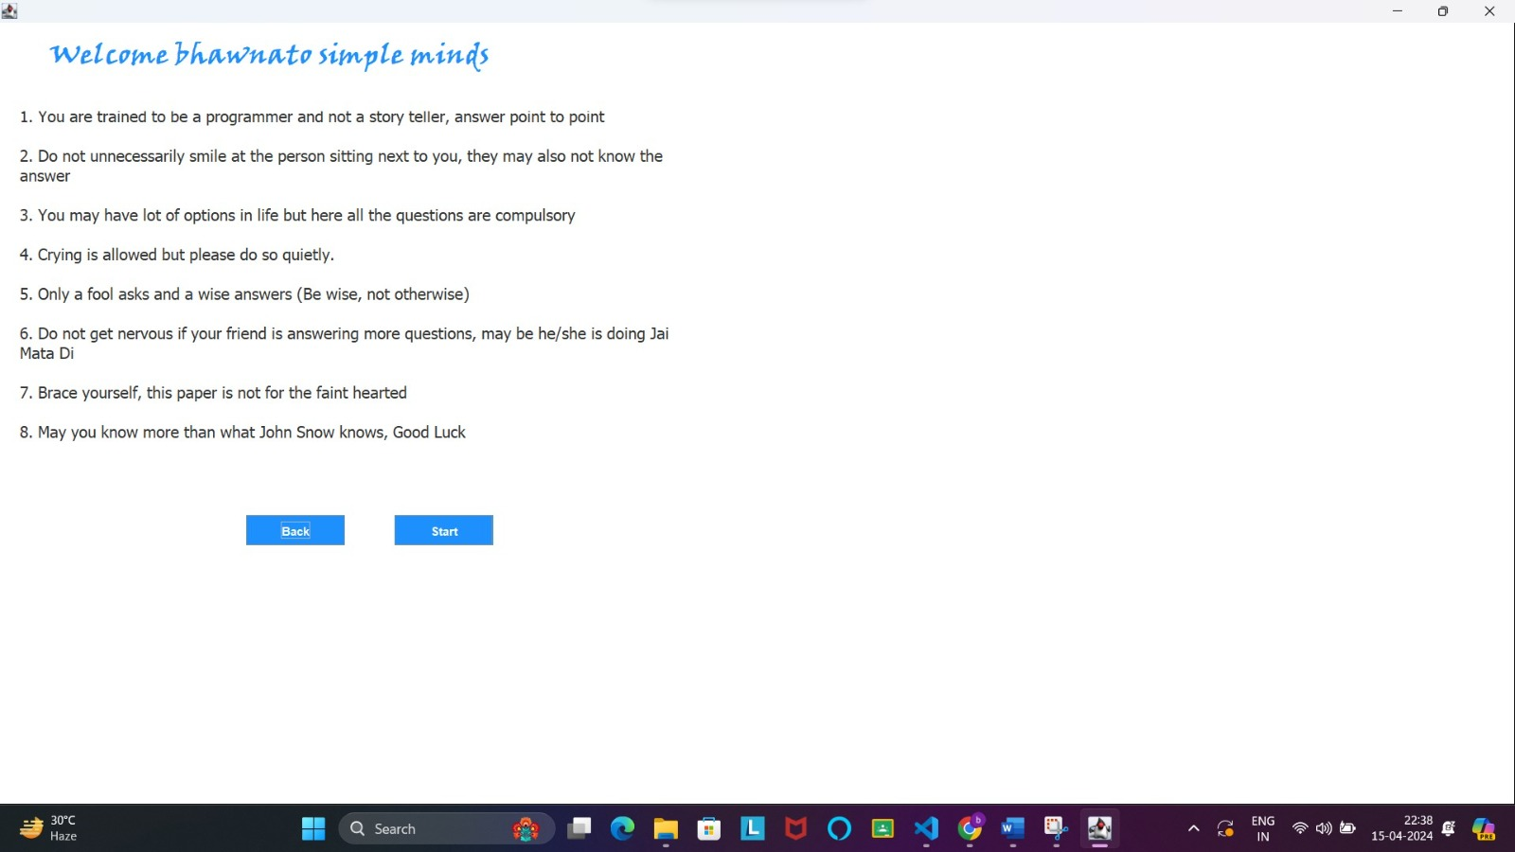

**Questions-**

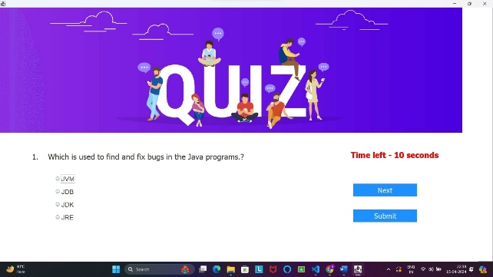 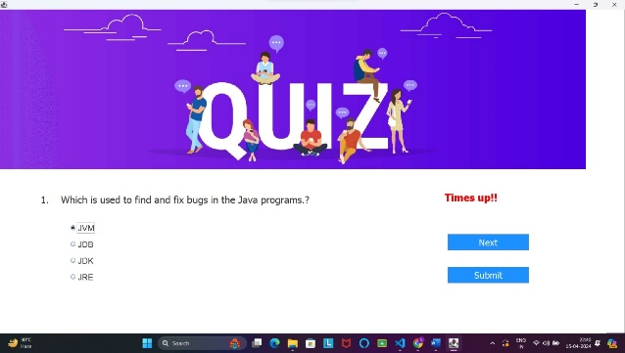

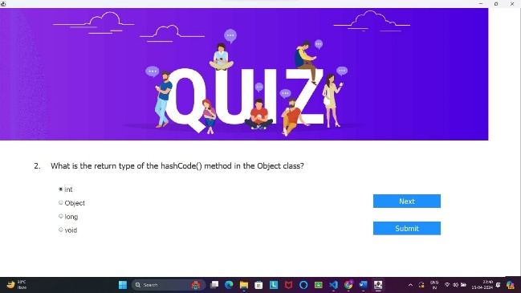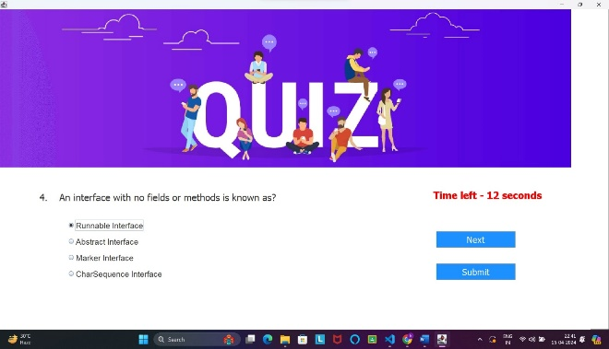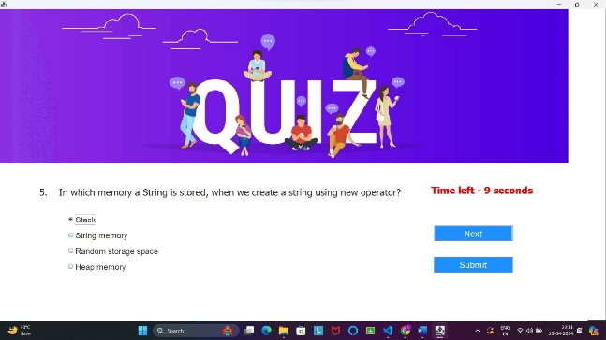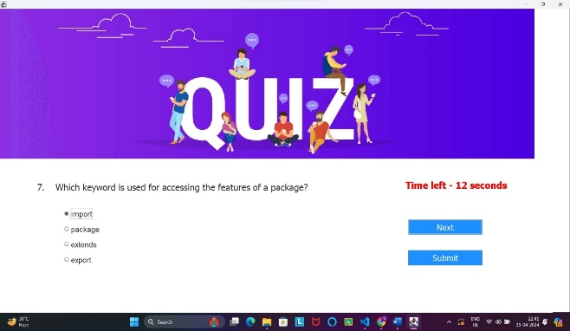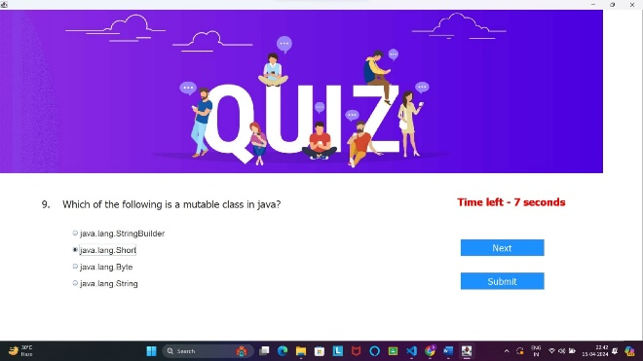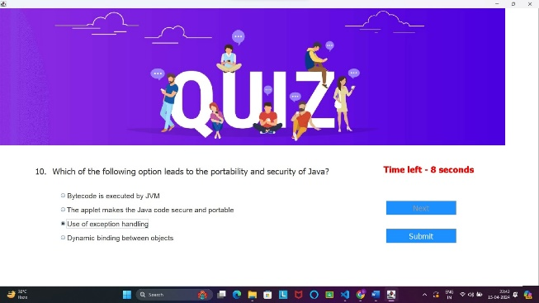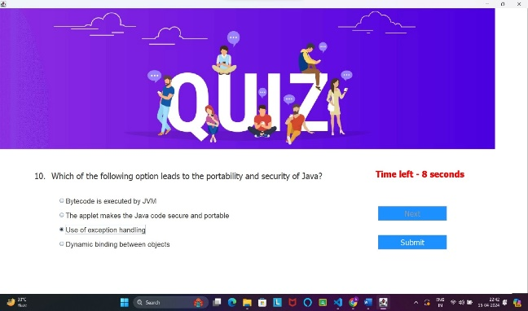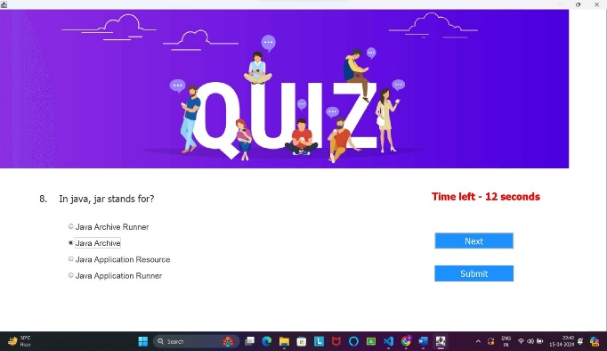

**Result-**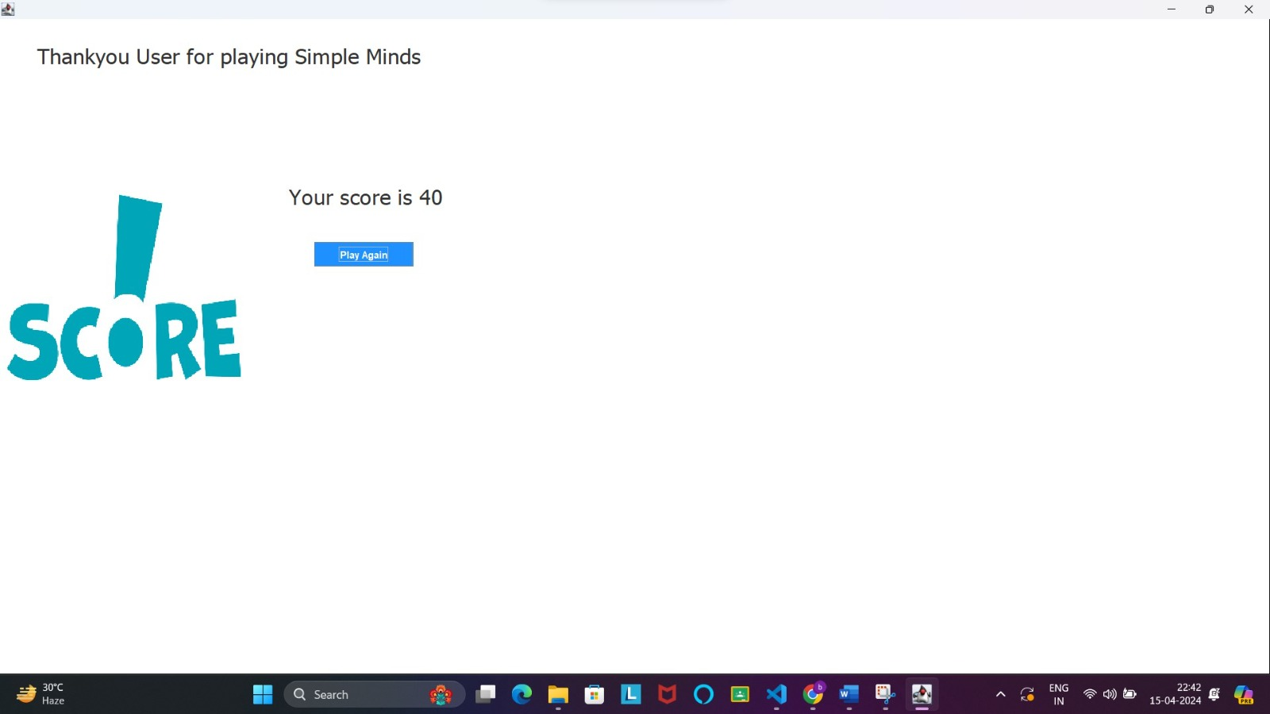

**Here’s a Class diagram for the above quiz**

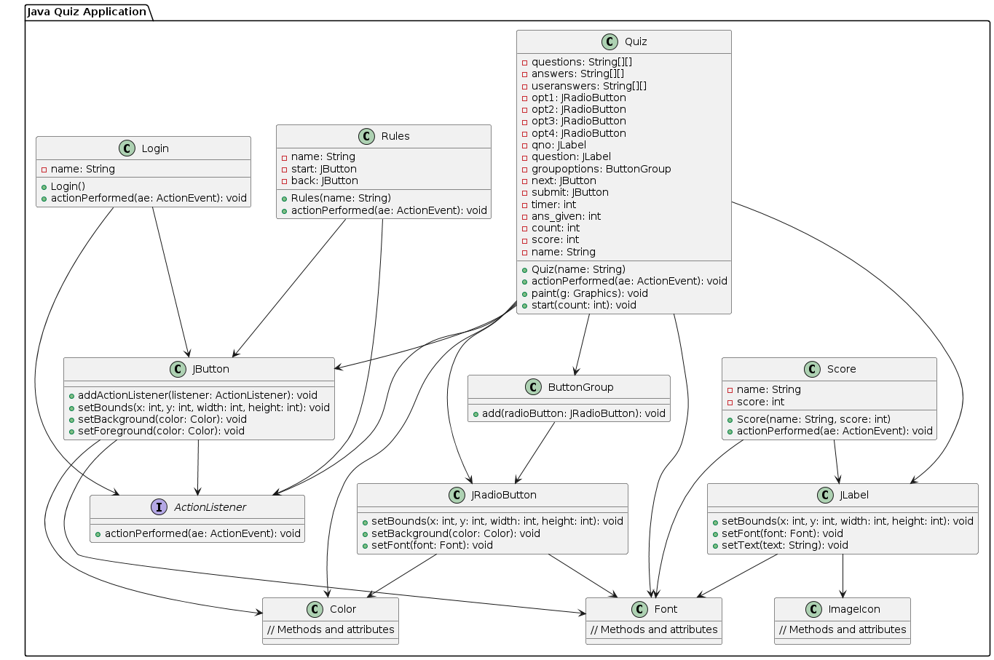

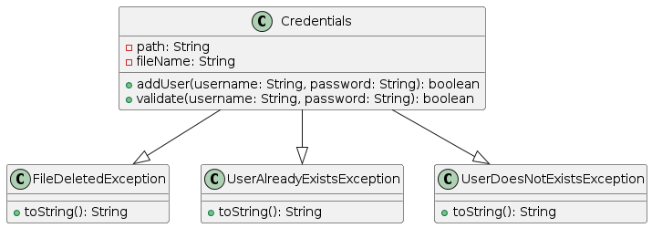

Class Diagram-

A class diagram is a type of diagram in the Unified Modeling Language (UML) that represents the structure and relationships of classes within a system or software application. It provides a visual representation of the classes, their attributes, methods, and the associations between them.