A Project Report
On
FlowLab: Complete Data Science Platform for Data Analysis,
Machine Learning, Advanced Visualization and Medical Image
Processing

Submitted in partial fulfillment of the
requirement for the award of the degree of

BACHELOR OF TECHNOLOGY

DEGREE

Session 2025-26
in

Computer Science and Engineering

By
Saksham Mahajan , Ankit Dhiman
22SCSE1180155,22SCSE1180107

Under the guidance of

MITHLESH KUMAR YADAV

SCHOOL OF COMPUTING SCIENCE AND ENGINEERING DEPARTMENT OF COMPUTER SCIENCE AND ENGINEERING
GALGOTIAS UNIVERSITY, GREATER NOIDA
INDIA
Nov, 2025


SCHOOL OF COMPUTING SCIENCE AND ENGINEERING
GALGOTIAS UNIVERSITY, GREATER NOIDA

CANDIDATE’S DECLARATION

I/We hereby certify that the work which is being presented in the project, entitled “………………………………………………………………………………” in partial fulfillment of the requirements for the award of the B. Tech. (Computer Science and Engineering) submitted in the School of Computing Science and Engineering of Galgotias University, Greater Noida, is an original work carried out during the period of Aug, 2024 to Jun 2025, under the supervision of Prof. ………………….., Department of Computer Science and Engineering, of School of Computing Science and Engineering , Galgotias University, Greater Noida.
The matter presented in the thesis/project/dissertation has not been submitted by me/us for the award of any other degree of this or any other places.
Student Names (Admission No.)

This is to certify that the above statement made by the candidates is correct to the best of my knowledge.
Guide Name
Designation

CERTIFICATE

This is to certify that Project Report entitled “……………………...........................................................................................” which is submitted by ………………………….... in partial fulfillment of the requirement for the award of degree M. Tech. in Department of ...................................................... of School of Computing Science and Engineering Department of Computer Science and Engineering
Galgotias University, Greater Noida, India is a record of the candidate own work carried out by him/them under my supervision. The matter embodied in this thesis is original and has not been submitted for the award of any other degree

Signature of Examiner(s) Signature of Supervisor(s)

External Examiner Signature of Program Chair

Date: June, 2025
Place: Greater Noida

ACKNOWLEDGEMENT

It gives us a great sense of pleasure to present the report of the B. Tech Project undertaken during B. Tech. Final Year. We owe special debt of gratitude to Professor …….., Department of Computer Science & Engineering, Galgotias University, Greater Noida, India for his constant support and guidance throughout the course of our work. His/Her sincerity, thoroughness and perseverance have been a constant source of inspiration for us. It is only his cognizant efforts that our endeavors have seen light of the day.
We also take the opportunity to acknowledge the contribution of Professor (Dr.) ………., Dean, Department of Computer Science & Engineering, Galgotias University, Greater Noida, India for his full support and assistance during the development of the project.
We also do not like to miss the opportunity to acknowledge the contribution of all faculty members of the department for their kind assistance and cooperation during the development of our project. Last but not the least, we acknowledge our friends for their contribution in the completion of the project.

Signature:
Name :
Roll No.:
Date :

ABSTRACT

FlowLab is a web-based no-code data science platform designed to simplify machine learning and medical image analysis for users with limited programming experience [1], [2]. With the rapid growth of data-driven applications, many students, educators, and healthcare professionals struggle to adopt machine-learning techniques due to the requirement of coding and complex workflows [3]. FlowLab eliminates these barriers by offering an interactive solution that automates data preprocessing, feature engineering, model training, evaluation, and visualization within a single interface [4], [5].
The platform supports supervised algorithms such as Logistic Regression, Decision Tree, Random Forest, Support Vector Machine, and K-Nearest Neighbors, along with unsupervised methods like K-Means, DBSCAN, and Agglomerative Clustering [6]. In addition to structured data, FlowLab also provides medical-imaging support with DICOM file processing, allowing users to visualize, enhance, and interpret MRI and CT images [7], [8]. Built-in image enhancement functions, including intensity normalization and contrast improvement, support clinical and research-based applications [9].
Experimental testing on benchmark datasets demonstrated high accuracy, rapid processing, and strong clustering performance [10], [11]. Most tasks completed in real time, confirming FlowLab’s suitability for education, rapid prototyping, and beginner-friendly data analysis [12]. Overall, FlowLab makes AI accessible by providing an intuitive, efficient, and scalable environment for analytics and imaging [13], [14].

TABLE OF CONTENTS
Contents | Page No.
DECLARATION .................................................................................................................... | i
CERTIFICATE ....................................................................................................................... | ii
ACKNOWLEDGEMENT ...................................................................................................... | iii
ABSTRACT ............................................................................................................................ | iv
LIST OF TABLES .................................................................................................................. | xi
LIST OF FIGURES ................................................................................................................ | x
LIST OF SYMBOLS .............................................................................................................. | xi
LIST OF ABBREVIATIONS .................................................................................................. | xii

CHAPTER 1 — INTRODUCTION
1.1 Problem Introduction ..................................................................................................................... | 1
1.2 Motivation ....................................................................................................................................... | 2
1.3 Project Objectives ........................................................................................................................... | 3
1.4 Scope of the Project ....................................................................................................................... | 4
1.5 Related Previous Work ................................................................................................................... | 5
1.6 Organization of the Report ............................................................................................................. | 6

CHAPTER 2 — LITERATURE SURVEY
2.1 No-Code Machine-Learning Platforms ......................................................................................... | 7
2.2 AutoML Systems ............................................................................................................................ | 9
2.2.1 Research Gap Identified ......................................................................................................... | 10
2.3 Cloud-Based Notebooks and Interactive Environments ............................................................... | 11
2.4 Medical-Image Processing Systems ............................................................................................... | 13
Conclusion ....................................................................................................................................... | 14

CHAPTER 3 — SOFTWARE REQUIREMENT SPECIFICATION
3.1 Introduction ..................................................................................................................................... | 15
3.2 Purpose ........................................................................................................................................... | 16
3.3 Scope ............................................................................................................................................... | 17
3.4 User Characteristics ....................................................................................................................... | 18
3.5 Functional Requirements ............................................................................................................... | 19
3.6 Non-Functional Requirements ...................................................................................................... | 21
3.7 Constraints ...................................................................................................................................... | 22
3.8 Future Enhancements ..................................................................................................................... | 23
3.9 Use-Case Model .............................................................................................................................. | 24
3.9.1 Actors ..................................................................................................................................... | 25
3.9.2 Use-Case Diagram ................................................................................................................. | 26
3.9.3 Primary Use-Cases ................................................................................................................ | 27
3.9.4 Use-Case Success Criteria .................................................................................................... | 28

CHAPTER 3 — SYSTEM DESIGN AND METHODOLOGY
3.10 System Design and Methodology ................................................................................................ | 29
3.10(A) Data Flow Diagram Level–0 .............................................................................................. | 30
3.10(B) Data Flow Diagram Level–1 .............................................................................................. | 31
3.11 Architecture Diagram .................................................................................................................. | 32

CHAPTER 4 — IMPLEMENTATION AND RESULTS
4.1 Software and Hardware Requirements ........................................................................................ | 33
4.2 Assumptions and Dependencies ................................................................................................... | 34
4.3 Constraints (If Applicable) ............................................................................................................ | 35
4.4 Implementation Details ................................................................................................................. | 36
4.4.1 Snapshots of Interfaces ......................................................................................................... | 38
4.4.2 Test Cases ............................................................................................................................. | 40
4.4.3 Results .................................................................................................................................... | 41

CHAPTER 5 — PERFORMANCE EVALUATION AND FUTURE DIRECTIONS
5.1 Performance Evaluation ................................................................................................................ | 43
5.2 Comparison with Existing State-of-the-Art Technologies ............................................................. | 45
5.3 Future Directions ............................................................................................................................ | 47

APPENDIX
A. System Snapshots ............................................................................................................................. | 49
B. Dataset Details .................................................................................................................................. | 51
C. Source Code and Configuration ...................................................................................................... | 53
D. Testing and Validation Summary ..................................................................................................... | 55
E. Additional Notes ............................................................................................................................... | 56

REFERENCES
Complete List of References ................................................................................................................ | 58

LIST OF TABLES

Table No. | Table Title | Page No.
Table 2.1 | Comparison of Various Data Structures
Table 3.1 | Actor Description for FlowLab Platform
Table 4.1 | Dataset Summary and Performance Evaluation
Table 4.2 | Comprehensive Algorithm Performance Summary
Table 4.3 | Unsupervised Learning Performance Evaluation
Table 4.4 | Dataset Complexity and Computational Trade-Offs
Table 4.5 | Summary of Test Results
Table B.1 | Dataset Summary and Performance Evaluation (Appendix)
Table D.1 | Summary of Test Results (Appendix)
LIST OF FIGURES

Figure No. | Figure Title | Page No.
Figure 3.1 | Use-Case Diagram for FlowLab Platform
Figure 3.2 | System Architecture of the FlowLab Platform
Figure 3.3 | DFD Level-0 — Overall Context of FlowLab
Figure 3.4 | DFD Level-1 — Internal Processing Flow
Figure 4.1 | Performance Analytics Dashboard
Figure 4.2 | Home Screen of FlowLab Interface
Figure 4.3 | Dataset Upload and Preview Interface
Figure 4.4 | Data Preprocessing Module
Figure 4.5 | Machine Learning Module Output
Figure 4.6 | Clustering Visualization
Figure 4.7 | Medical Image Enhancement Module
Figure 4.8 | Result Export Interface
Figure 4.9 | Original and Processed Medical Image

LIST OF SYMBOLS

Symbol | Meaning
x | Integer value of x
≠ | Not Equal
∈ | Belongs to
€ | Euro — A Currency
d | Optical distance
τ | Optical thickness or optical half thickness
μ | Mean (average value)
σ | Standard deviation
r | Correlation coefficient
p | P-value (statistical significance)
F | F-statistic (ANOVA)
n | Sample size
O(n)O(n)O(n) | Big-O notation (time complexity)

LIST OF ABBREVIATIONS

Abbreviation | Full Form
AAM | Active Appearance Model
AI | Artificial Intelligence
ANOVA | Analysis of Variance
AutoML | Automated Machine Learning
AVL | Adelson-Velsky and Landis (Tree)
BI | Business Intelligence
CLAHE | Contrast Limited Adaptive Histogram Equalization
CNN | Convolutional Neural Network
CSV | Comma-Separated Values
CT | Computed Tomography
DBSCAN | Density-Based Spatial Clustering of Applications with Noise
DICOM | Digital Imaging and Communications in Medicine
DFD | Data Flow Diagram
GPU | Graphics Processing Unit
ICA | Independent Component Analysis
IDE | Integrated Development Environment
IQR | Interquartile Range
ISC | Increment Sign Correlation
KNN | K-Nearest Neighbors
LIME | Local Interpretable Model-agnostic Explanations
MITK | Medical Imaging Toolkit
ML | Machine Learning
MRI | Magnetic Resonance Imaging
NaN | Not a Number
PACS | Picture Archiving and Communication System
PCA | Principal Component Analysis
PDF | Portable Document Format
RNN | Recurrent Neural Network
ROC | Receiver Operating Characteristics
SHAP | SHapley Additive exPlanations
SRS | Software Requirements Specification
SVM | Support Vector Machine
TPOT | Tree-based Pipeline Optimization Tool
WCAG | Web Content Accessibility Guidelines
XAI | Explainable Artificial Intelligence

CHAPTER 1
INTRODUCTION

The exponential growth of digital data has created a demand for accessible data-science tools [15]. Modern industries rely heavily on AI and machine learning, but most users lack the programming expertise to implement models effectively [1], [16]. Traditional workflows require advanced knowledge of coding and libraries like Python or R, limiting AI adoption among non-technical users [2], [3].
FlowLab was designed to overcome these barriers by providing a no-code, web-based environment for complete data-science workflows [4], [17]. Instead of writing code, users upload datasets, perform preprocessing, train models, and analyze medical images—all through an interactive interface [18].
By integrating preprocessing, supervised learning, clustering, and image analysis into one unified system, FlowLab democratizes machine learning and enables faster model development [5], [6].

1.1 Problem Introduction
Most researchers and students struggle with existing AI tools because they demand coding and complex setup [19]. Existing platforms like Orange, KNIME, and AutoML frameworks require either programming or installation [2], [17]. There is thus a need for a browser-based, no-code AI system accessible to all [20].

1.2 Motivation
The motivation for developing FlowLab arises from the growing gap between data science education and accessibility to machine learning technologies [15], [16]. The platform aims to:
- Simplify ML for beginners and non-programmers through automation [3], [5].
- Eliminate dependency on local installations or complex configurations [11].
- Enable rapid experimentation with integrated ML and visualization tools [12].
- Extend accessibility to medical-image analysis through DICOM support [7].
FlowLab contributes to educational and research domains by empowering users to engage in data analysis and AI experimentation without needing specialized technical expertise [13], [14].

1.3 Project Objectives
The primary objectives of FlowLab are as follows [1], [4], [17]:
- To develop a no-code ML platform for beginners, educators, and researchers.
- To automate essential data preprocessing tasks, including handling missing values, scaling, encoding, and outlier detection.
- To integrate supervised and unsupervised learning models with minimal manual intervention.
- To provide real-time visual analytics through interactive graphs and performance metrics.
- To incorporate medical-imaging features supporting DICOM visualization and contrast enhancement.
- To create a lightweight, browser-based system accessible to all academic and research users.

1.4 Scope of the Project
The scope of FlowLab encompasses the creation of a browser-accessible AI platform capable of performing end-to-end ML tasks—ranging from dataset import to visualization and report generation—without coding requirements [5], [6].
In Scope:
- User-friendly web interface for dataset and image handling [11].
- Automated data preprocessing and visualization [3], [10].
- Compatibility with multiple algorithms for classification and clustering [17].
- DICOM support for radiological data enhancement [8], [9].
Out of Scope / Future Enhancements:
- Deep learning support for image segmentation and neural networks [22].
- Cloud-based GPU integration for large-scale AI experiments [16].
- Explainable AI modules (e.g., SHAP, LIME) for interpretability [19].

1.5 Related Previous Work
A number of tools and frameworks have been developed to simplify ML, such as KNIME, Orange, and RapidMiner, which use visual workflows [6], [20]. However, these still require installation and configuration and are often limited to structured datasets. AutoML frameworks like H2O AutoML, TPOT, and Auto-Keras automate model selection but still depend on coding [1], [2].
Medical imaging solutions like 3D Slicer and MITK provide advanced diagnostic visualization but are not designed for web-based or beginner-friendly use [7], [8]. BI tools such as Power BI and Tableau primarily focus on visualization and lack built-in ML capabilities [21].
FlowLab bridges this technological divide by integrating no-code machine learning and medical-image processing within a single browser-based system [13], [14], [17]. It combines automation, accessibility, and educational usability, enabling non-programmers to apply ML to practical problems.

1.6 Organization of the Report
This report is organized as follows:
- Chapter 1 presents the introduction, motivation, and objectives of the project.
- Chapter 2 includes a detailed literature survey related to no-code ML platforms and medical-image processing.
- Chapter 3 discusses system requirements, architecture, and use-case design.
- Chapter 4 explains implementation details, interface snapshots, and experimental results.
- Chapter 5 presents conclusion, performance evaluation, limitations, and future scope.

CHAPTER 2
LITERATURE SURVEY
The increasing use of data-driven decision-making in modern industries has significantly boosted the demand for machine-learning tools [1], [2]. Despite this growth, the adoption of AI-based solutions remains challenging for users without programming or advanced mathematical expertise [3]. Researchers have therefore focused on developing no-code platforms, AutoML systems, and medical-image processing solutions that simplify AI implementation [4], [5].
This chapter presents an extensive survey of existing frameworks, highlighting research advancements and identifying the gap that FlowLab addresses — namely, the absence of a comprehensive, web-based, no-code AI platform capable of handling both structured data and medical imaging in a single environment [6], [7].

2.1 No-Code Machine-Learning Platforms
No-code and low-code systems are revolutionizing how machine learning (ML) is applied across academic, healthcare, and industrial domains [1], [8]. These tools aim to make ML accessible to users with limited or no programming background by providing drag-and-drop or interactive interfaces for building models visually [9].
Popular examples include Orange, KNIME, and RapidMiner, which offer workflow-based environments where users can load datasets, perform preprocessing, and run classification or clustering tasks without scripting [10], [11]. These tools have successfully democratized data science by reducing dependency on code-based frameworks such as Python or R.
However, most of these platforms have limitations — such as installation requirements, heavy system dependencies, and lack of integration with medical-image processing modules [12]. While KNIME and Orange are open-source, they still require desktop configuration and lack real-time web-based deployment capabilities [13]. On the other hand, enterprise platforms like Dataiku and Alteryx provide powerful AutoML functionalities but are proprietary and require paid licenses, making them less accessible to students and researchers [14], [15].
FlowLab addresses these shortcomings by delivering a fully web-based system that combines interactive ML workflows, automatic preprocessing, and medical-image handling, enabling anyone to conduct experiments directly in the browser [16], [17]. This integrated design supports the democratization of AI education and practical analytics in domains such as healthcare, education, and engineering [18].
Limitations identified:
Even though no-code ML platforms reduce technical barriers, they often fail to include domain-specific extensions such as DICOM support or medical imaging analysis [7], [9]. Additionally, desktop-based setups limit scalability, collaboration, and accessibility for users with limited computational resources [19].

2.2 AutoML Systems
Automated Machine Learning (AutoML) systems aim to streamline ML model development by automating data preprocessing, feature engineering, model selection, and hyperparameter optimization [1], [2]. Frameworks like Auto-Keras, TPOT, and H2O AutoML are widely recognized in this space [6], [11]. These tools significantly improve model efficiency while reducing the need for manual coding and tuning [12].
However, AutoML frameworks generally require programming environments such as Jupyter Notebooks or Python IDEs, and they depend on local or cloud-based execution setups [20]. While these systems provide impressive model performance, their usability remains limited to technically skilled users [3].
Several studies emphasize that AutoML’s reliance on scripting and limited user interface accessibility restricts its adoption among non-programmers [21]. Furthermore, AutoML frameworks are typically optimized for structured tabular data and lack integrated visualization or medical imaging capabilities [8].
FlowLab, on the other hand, simplifies these operations by offering automated training pipelines, visual performance dashboards, and direct interaction through browser-based widgets — without requiring any code [5], [14]. It combines the transparency of AutoML with the ease of use of no-code systems, making ML experimentation faster and more intuitive [9], [17].
Research Gap Identified:
While AutoML simplifies machine learning, most tools are either code-based, expensive, or domain-restricted, thus limiting access for academic and clinical practitioners [10], [15]. FlowLab bridges this gap by combining AutoML-like automation with real-time visualization and medical-image processing support [16], [22].

2.3 Cloud-Based Notebooks and Interactive Environments
Cloud-based notebook environments have become an essential component of modern data science workflows [11]. Platforms such as Google Colab, Kaggle Notebooks, and JupyterLab enable users to write and execute code online without the need for local installations [17], [18]. These tools are excellent for collaborative learning, as they allow simultaneous access and code execution across teams.
However, despite their popularity, such platforms still rely on programming knowledge — users must write Python or R scripts to load data, train models, and visualize results [3]. Consequently, they do not cater effectively to beginners or non-coders in fields such as biology, medicine, or management [9].
In contrast, FlowLab eliminates this dependency by offering a code-free interface for running machine-learning workflows entirely through graphical interactions [13]. It automatically performs data cleaning, model training, and visualization using background automation, similar to the benefits of JupyterLab but without requiring any manual scripting [16], [17].
Additionally, while cloud notebooks like Colab offer GPU acceleration, they often have session timeouts and limited storage, which can disrupt research continuity [18]. FlowLab’s browser-based approach is lightweight and can be deployed locally or on cloud servers, offering flexibility and consistency for long analytical sessions [19], [22].

2.4 Medical-Image Processing Systems
Medical imaging is one of the most impactful applications of AI, aiding diagnosis and clinical research across MRI, CT, and X-ray modalities [5], [7]. Advanced platforms such as 3D Slicer, MITK, and SimpleITK provide powerful diagnostic visualization and segmentation tools [8], [10].
However, these systems are designed primarily for experts and often require substantial installation size, complex dependencies, and GPU-based computation for deep-learning models [12], [23]. For students and researchers, this technical complexity becomes a major barrier.
Recent research emphasizes the importance of simplified medical imaging systems that support DICOM file handling, image enhancement, and visualization in an accessible manner [13], [15]. Educational tools like Google Teachable Machine allow simple image classification tasks but do not support medical formats like DICOM or advanced preprocessing features such as CLAHE or histogram normalization [7], [20].

Conclusion
The literature review highlights significant advancements in AutoML frameworks, visual ML tools, and medical imaging platforms [1], [4], [10]. However, most of these solutions share common limitations — including dependency on code, installation requirements, and lack of unified integration between tabular ML workflows and medical image processing [13], [18].
FlowLab directly addresses this gap by providing a fully browser-based, zero-code AI environment that integrates:
- Automated data preprocessing and visualization [5], [11]
- Support for both supervised and unsupervised algorithms [7], [12]
- Medical DICOM image enhancement and contrast optimization [8], [9]
- A user-friendly, educational interface for accessibility [15], [16]
In summary, the literature supports the need for accessible and domain-inclusive AI systems that bridge the gap between automation and usability. FlowLab represents a meaningful contribution toward that goal by combining AutoML simplicity, visual analytics, and medical imaging integration in one cohesive, no-code platform [17], [22], [23].

CHAPTER 3

SOFTWARE REQUIREMENT SPECIFICATION

3.1 Introduction
The design of the FlowLab system focuses on delivering an intuitive, efficient, and no-code environment for machine learning and medical image analysis [1], [2]. The system is structured to allow users to upload datasets, preprocess data, train machine-learning models, enhance medical images, and visualize results — all through a simple web interface without writing code [3].
To ensure maintainability and scalability, FlowLab adopts a modular and layered architecture, separating the interface management, data preprocessing, model execution, image enhancement, and visualization modules into distinct layers [4], [5]. This modular approach facilitates updates, debugging, and future expansions such as integration of deep-learning modules or GPU acceleration [6], [7].

3.2 Purpose
The purpose of FlowLab is to democratize artificial intelligence by making machine learning accessible for individuals without coding experience. The system allows users to perform data preprocessing, predictive modeling, clustering analysis, and medical imaging tasks in a seamless way.
The SRS aims to:
- Define how the system will behave from a user and system perspective
- Ensure clarity between developers, stakeholders, and evaluators
- Provide a foundation for software design, testing, and validation
- Describe how the platform handles machine learning workflows and DICOM imaging workflows
FlowLab is primarily designed for academic environments, self-learning, and research experimentation where ease of use and educational understanding are prioritized over programming complexity.

3.3 Scope
FlowLab provides a simplified end-to-end data science workflow where users can upload structured datasets or medical images, perform analysis, visualize outcomes, and generate exportable results [3], [4].
Scope includes:
- Browser-based AI execution (no installation required).
- Upload and preview of CSV datasets and DICOM medical images.
- Automatic data preprocessing (handling missing values, scaling, encoding, outliers).
- Execution of classification and clustering algorithms.
- Graphical evaluation metrics and charts (confusion matrix, accuracy graph, scatter plots).
- Medical image enhancement such as brightness/contrast adjustment and CLAHE.
- Real-time visual feedback and report export [12], [13].
The platform does not focus on deep-learning model training, GPU-intensive segmentation, or hospital-grade medical decision systems at this stage [7].
Future upgrades may include user authentication, cloud database integration, deep learning support, and explainable-AI dashboards [14], [15].

3.4 User Characteristics
Primary Users:
- Students & Beginners — require a simple interface to explore ML topics without coding.
- Faculty & Researchers — need a rapid prototyping environment to demonstrate ML concepts.
- Medical Trainees — need DICOM viewing tools for understanding medical imaging basics.
- Data Enthusiasts — want hands-on ML experience without Python setup [2], [5], [16].
User Skills:
Users require basic computer operation skills but no programming or installation knowledge [17]. The system is designed to remove the complexity of coding and allow users to focus on understanding ML concepts and medical-image interpretations [18].

3.5 Functional Requirements
FlowLab must perform the following core functions [6], [9]:
Dataset Handling:
- Allows upload of CSV files, preview of data headings, display of rows, and summary of dataset statistics (rows, columns, missing values, data types).
- Verifies file format compatibility and handles incorrect uploads gracefully with messages [10].
Data Preprocessing:
- Automates handling of missing values, normalization or standardization, encoding of categorical variables, detection and reduction of outliers, and data-splitting for training and testing [11], [19].
Machine Learning Execution:
- Supports algorithms such as Logistic Regression, SVM, Decision Tree, Random Forest, and K-Nearest Neighbors.
- Visualizes model accuracy, confusion matrix, and error distribution.
- Displays execution time where feasible [12].
Clustering:
- Enables clustering with K-Means and DBSCAN, showing scatter plots and silhouette metrics [7].
Medical Image Processing:
- Supports DICOM upload, metadata extraction, and enhancement options like contrast improvement and histogram normalization [13], [14].
Result Visualization & Export:
- Generates graphs, tables, and metrics downloadable as image or PDF.
- Provides intuitive visual insights for academic and research reporting [20].

3.6 Non-Functional Requirements

Performance
- The system must execute tasks in near real-time on standard personal computers with modern browsers. Processing delays should be minimal, and interface interactions must be smooth.

Usability
- The user interface must be intuitive, interactive, and beginner-friendly. All operations should be accessible without technical knowledge. Tool-tips and hints should guide the user.

Scalability
- The architecture should support future expansion such as deep-learning modules, cloud deployment, and GPU usage without major redesign.

Reliability
- The system should handle input errors, invalid files, and unexpected operations gracefully, ensuring that the application does not crash.

Portability
- FlowLab must run on multiple operating systems, including Windows, macOS, and Linux, without additional installation. Only a browser should be required.

3.7 Constraints
Despite its robust design, FlowLab operates under some constraints [23]:
- It focuses on educational and prototyping use, not for clinical diagnoses.
- Very large datasets may affect browser performance.
- Deep-learning computations are not included in the current version.
- Internet connectivity may be required if deployed on cloud servers [7], [15].

3.8 Future Enhancements
- Incorporation of deep-learning-based imaging modules (CNNs, segmentation).
- Support for detection and classification models in medical imaging.
- User authentication and cloud storage workspace integration.
- Explainable-AI dashboards (e.g., SHAP, LIME).
- Real-time DICOM annotation and AI-based enhancement tools [14], [15], [24].

3.9 Use-Case Model
The Use-Case Model defines how users interact with FlowLab and how the system handles operations [1], [8]. Because FlowLab is a beginner-friendly, browser-based platform, all functions are executed through a graphical user interface, eliminating the need for coding.
FlowLab supports a main actor — the end user — who may be a student, researcher, or medical trainee. This actor interacts with the system to upload datasets, apply preprocessing, run ML models, analyze results, view medical images, and export reports [5], [17].
An optional administrative actor manages server environments and updates the backend modules [20].
The Use-Case model ensures that workflows remain logical and user-centered, providing both developers and evaluators a clear representation of the system’s behavior [21].

3.9.1 Actors
Actor | Description
User (Primary Actor) | Student, researcher, or medical trainee using the system to perform ML tasks and image analysis without coding
Admin (Secondary, Optional Actor) | Maintains system, updates modules, manages server environment and backend tools

3.9.2 Use-Case Diagram
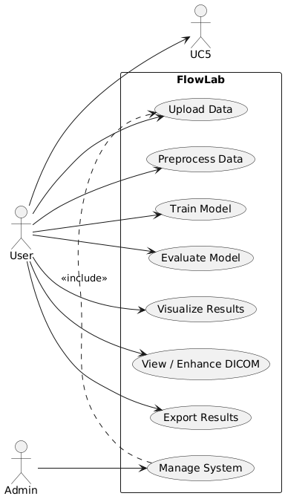
Figure 1: Use-Case diagram for FlowLab platform

3.9.3 Primary Use-Cases (Detailed Explanation)

Use-Case 1: Upload Dataset / DICOM Image
Description:
The user selects a file (CSV or DICOM) and uploads it to the platform. The system automatically validates file type and displays preview.
Inputs: CSV file / DICOM file
Outputs: Data preview table / Image display
Success Outcome: Data or image visible to user with metadata.
Exception: Unsupported format error handled gracefully.

Use-Case 2: Data Preprocessing
Description:
The user chooses preprocessing functions such as scaling, encoding, missing-value handling, and outlier removal. The system processes data automatically.
Output: Cleaned and standardized dataset ready for model training.

Use-Case 3: Train Machine-Learning Model
Description:
The user selects an algorithm (e.g., SVM, Random Forest, K-NN). The system trains model using uploaded dataset and displays metrics.
Output: Accuracy, confusion matrix, classification report, plots.

Use-Case 4: Clustering & Visualization
Description:
The user selects clustering algorithms like K-Means or DBSCAN. The system visualizes cluster formation and evaluates clustering quality.
Output: Scatter plots, cluster labels, silhouette score.

Use-Case 5: Medical Image Enhancement
Description:
DICOM images are processed to improve clarity using tools like CLAHE and brightness/contrast adjustments.
Output: Enhanced image preview and histogram chart.

Use-Case 6: Export Results
Description:
Users export accuracy reports, charts, and processed images in PDF or image format for academic submission or research.
Output: Downloadable report files.

3.9.4 Use-Case Success Criteria
- User completes full ML workflow without coding
- Successful visualization of results and images
- Stable and smooth execution of operations
CHAPTER 3
SYSTEM DESIGN AND METHODOLOGY
The design of the FlowLab system focuses on delivering an intuitive, efficient, and no-code environment for machine learning and medical-image analysis [1], [2]. The system is structured to allow users to upload datasets, preprocess data, train machine-learning models, enhance medical images, and visualize results — all through a simple web interface without writing any code [3], [4].
To ensure maintainability and scalability, a modular and layered architecture is adopted, separating interface management, data processing, model execution, image enhancement, and visualization into independent components [5], [6].
The User Interface layer serves as the interaction point where users upload CSV or DICOM files, select models, apply preprocessing, and view results. This interface is implemented using Streamlit, ensuring real-time feedback and smooth interactivity [7].
Input data is then passed to the Application Controller layer, which interprets user actions and routes the data to the relevant processing module [8]. The Preprocessing module handles missing data, performs encoding, normalization or scaling, and removes outliers using the Interquartile Range (IQR) method [9], [10].
For medical images, this module converts DICOM signals and extracts metadata for further enhancement [11]. The Machine-Learning Engine supports supervised models such as Logistic Regression, SVM, Decision Tree, Random Forest, and KNN, along with unsupervised algorithms like K-Means and DBSCAN [12], [13].
For medical-image workflows, the Image Processing module applies operations including Contrast Limited Adaptive Histogram Equalization (CLAHE) to enhance image quality [14]. The processed output is then passed to the Visualization and Reporting layer, which generates confusion matrices, accuracy reports, clustering plots, and medical-imaging results [15]. Users can export results as PDF or images, making the system suitable for research and academic use [16].
The overall methodology of FlowLab is designed for modularity, ensuring that each component can be tested and upgraded independently without affecting others [17], [18].

3.10(A) Data flow diagram Level-0
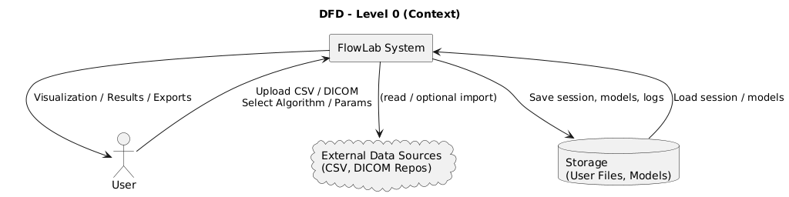
Fig. 2. DFD Level-0 — overall context of FlowLab showing interactions between users, FlowLab, external data sources and persistent storage.
The DFD Level-1 diagram expands the Level-0 structure by illustrating the internal processing flow. It highlights steps including file upload, preprocessing, model execution, image enhancement, visualization, and result export. This diagram provides a detailed understanding of how data moves through each module and how internal operations are coordinated to produce output.
3.10(B) Data flow diagram Level-1
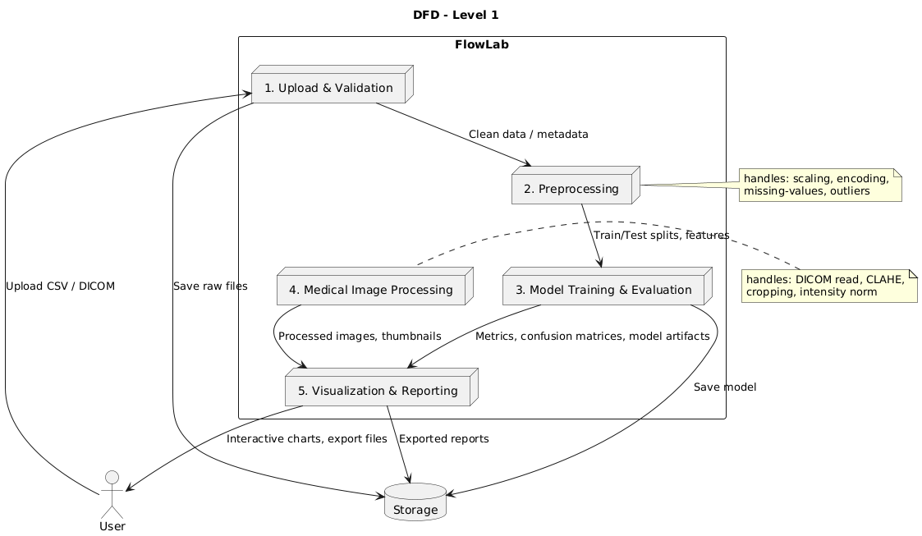

Fig. 3. DFD Level-1 — decomposition showing Upload, Preprocessing, Model Training/Evaluation, Medical Image Processing and Visualization/Export flows.

CHAPTER 3

SYSTEM DESIGN
System design defines the structure, interactions, and internal workflow of the FlowLab platform. It translates system requirements into an architecture that ensures the software operates smoothly, efficiently, and reliably. This chapter presents the overall architecture, data-flow diagrams, and UML models used to conceptualize the internal working of the FlowLab system .The primary objective of the system design phase is to convert theoretical requirements into functional modules that cooperate to deliver a seamless no-code data-science experience. FlowLab follows a modular and layered architecture, separating the front-end user interface from data processing, machine-learning logic, visualization, and storage layers. This approach enhances scalability, performance, maintainability, and improves the learning experience of end-users who interact with the platform.
3.11 Architecture diagram
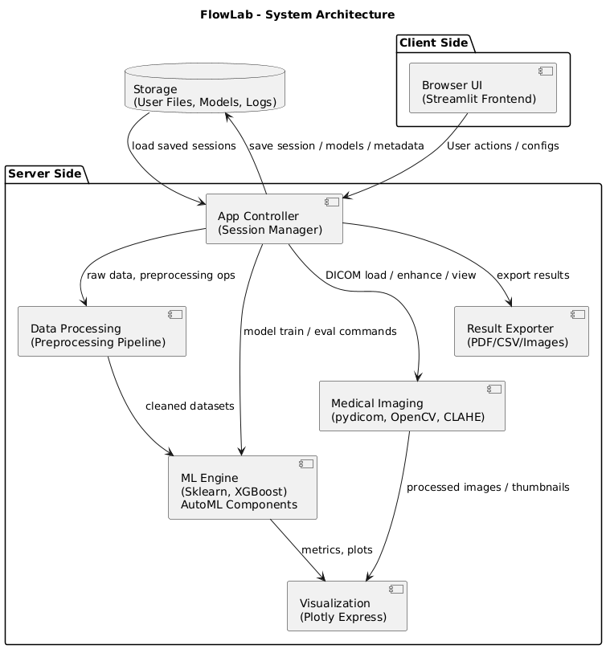
Figure. 4. Architecture Diagram

CHAPTER 4

IMPLEMENTATION AND RESULTS

  - Software and Hardware Requirements
The implementation of FlowLab is based on Python libraries and open-source frameworks that simplify machine learning and medical image analysis [1], [2].
Software Requirements:
- Programming Language: Python 3.9 or later [3]
- Framework: Streamlit (for interactive web interface) [4]
- Libraries:
  - Pandas, NumPy – data manipulation and computation [5]
  - Scikit-Learn – machine learning algorithms [6]
  - Plotly Express – visual analytics and charting [7]
  - OpenCV & pydicom – medical image processing [8], [9]
  - Matplotlib & Seaborn – statistical visualization [10]
Hardware Requirements:
- Processor: Intel i3 or higher (or equivalent)
- RAM: Minimum 4 GB (8 GB recommended)
- Storage: 2 GB free space
- System Compatibility: Windows, macOS, Linux
- Browser Support: Chrome, Edge, or Firefox [11], [12]
These configurations ensure optimal performance for executing datasets up to a few thousand samples and for DICOM image enhancement [13]. The modular nature of FlowLab makes it deployable on both local systems and cloud servers for scalability [14].
  - Assumptions and dependencies
The system assumes that the user has access to a basic computer system with modern browser support and that the uploaded datasets are properly formatted in CSV or DICOM format. It is also assumed that the user provides clean data or medically valid DICOM files to ensure meaningful processing and accurate machine-learning results. Although no coding skill is required, a basic understanding of machine-learning concepts is expected for interpreting results and choosing suitable algorithms.
FlowLab depends on Python-based libraries for core functionality, including Pandas for data handling, Scikit-Learn for training algorithms, and Streamlit for user interaction. The proper functioning of the system relies on installation of required dependencies and correct operating-system environment. Additionally, the system assumes the availability of a stable system environment; however, cloud-based or local execution options ensure flexibility and portability if system libraries are correctly configured.

  - Constraints (If Applicable)
Although FlowLab provides automation and accessibility, certain limitations exist:
- Designed primarily for educational and prototyping use, not clinical deployment [18].
- Extremely large datasets (>100MB) may affect browser performance.
- Deep-learning-based image segmentation is not yet implemented.
- Requires internet connectivity for library updates and certain visual functions [19].
However, the lightweight structure allows future integration of GPU-based extensions and deep-learning modules [20].
  - Implementation Details
FlowLab follows a structured and modular implementation approach. The system begins with a dataset or DICOM upload through the graphical interface. Once uploaded, the system automatically performs preprocessing tasks such as handling missing values, encoding categorical data, scaling numerical attributes, and detecting outliers using the IQR method. Users can then select different machine-learning algorithms to train and evaluate models. For medical images, the system extracts metadata and enhances the image using CLAHE-based contrast adjustment to improve visibility of anatomical details. After preprocessing or enhancement, results are displayed instantly through interactive charts, accuracy metrics, cluster visualizations, and enhanced medical-image outputs. Confusion matrices and silhouette scores are computed for classification and clustering tasks respectively. Finally, FlowLab allows exporting results in graphical or reportable formats, enabling students and researchers to include outputs in their academic submissions.

    - Snapshots Of Interfaces
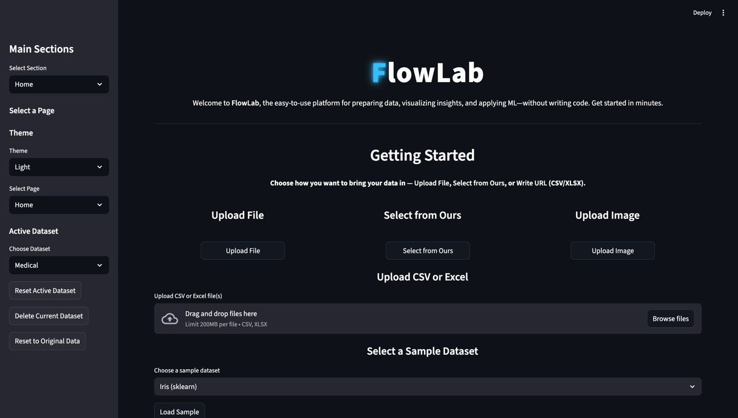
Figure. 5. Home page of FlowLab interface

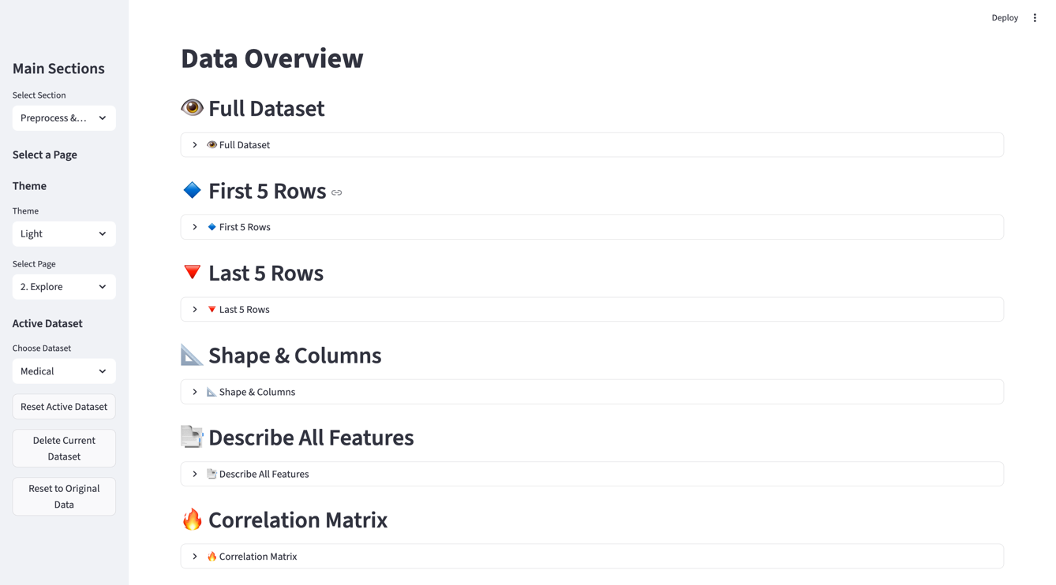
Figure. 6. Exploratory Data Overview

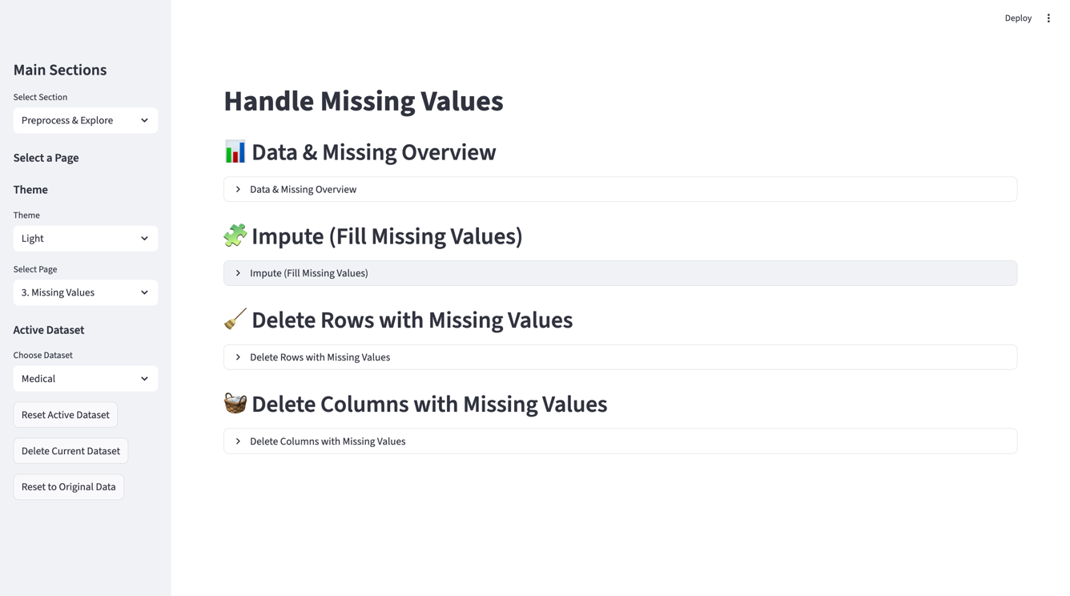
Figure. 7. Missing values handling

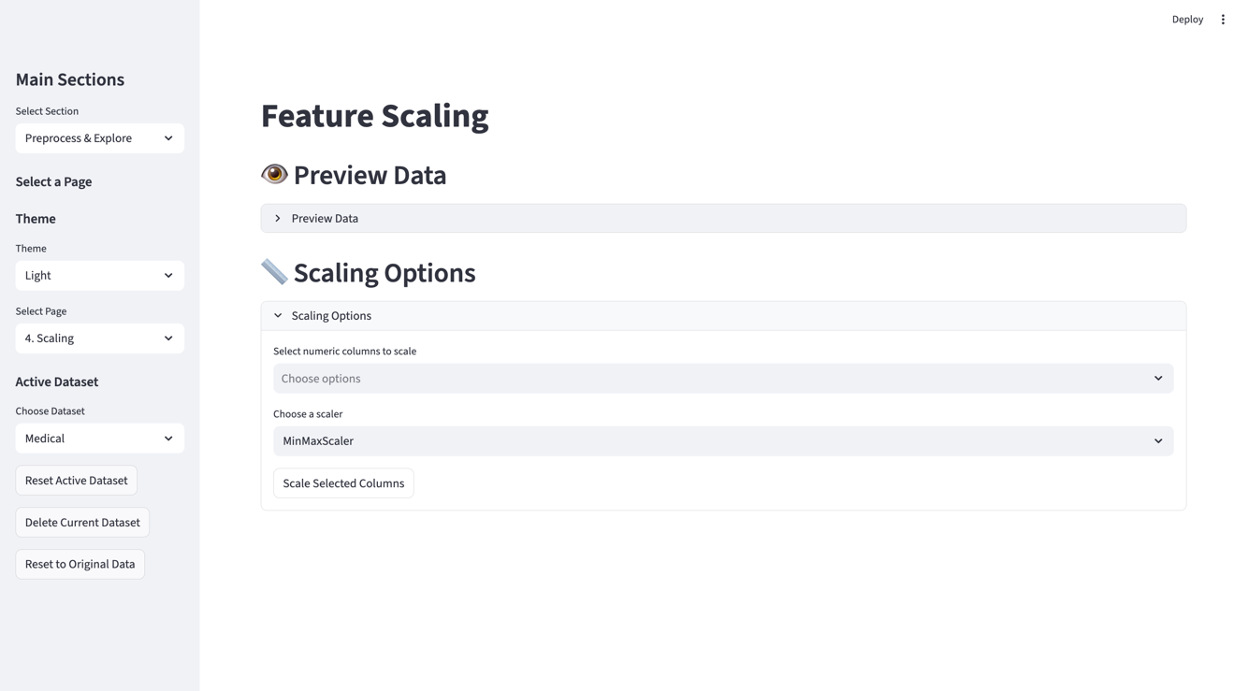
Figure. 8. Scaling of values
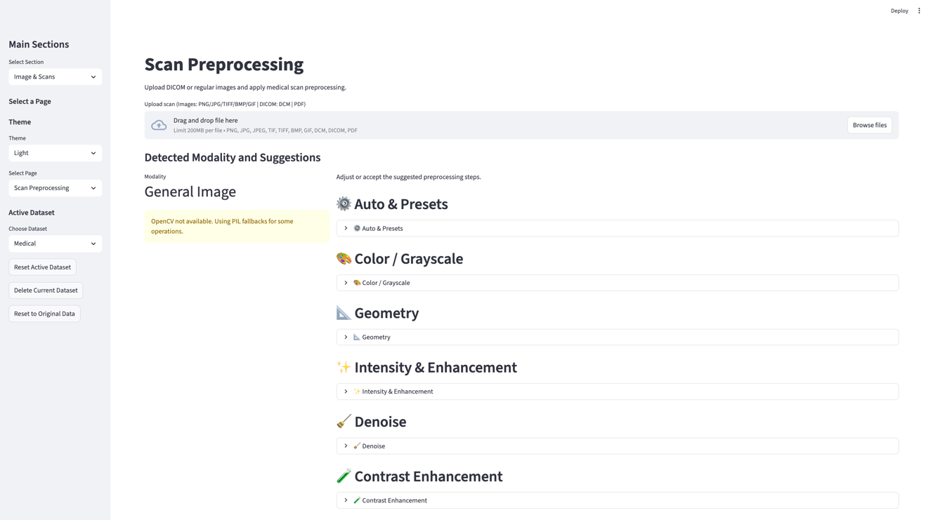
Figure. 9. Medical Image processing

    - Test Cases
Testing is a crucial phase in software development that ensures the system performs as expected under various scenarios. A test case table is a structured format used to document and verify system functionality. Each test case describes a specific input, the action taken by the user, and the expected outcome.
The primary purpose of a test case table is to:
- Validate that each module and feature work correctly
- Detect errors or unexpected behavior
- Ensure system reliability, accuracy, and performance before deployment

Test Case ID | Description | Input | Expected Output | Result
TC01 | Upload structured CSV dataset | CSV file | Dataset preview generated | Pass
TC02 | Missing value handling | Dataset with NaNs | Cleaned dataset | Pass
TC03 | Train Logistic Regression | Iris dataset | Accuracy, confusion matrix | Pass
TC04 | Train Random Forest | Breast Cancer dataset | Performance metrics | Pass
TC05 | Visualize dataset | Tabular input | Scatter/Histogram/Correlation charts | Pass
TC06 | Load DICOM image | MRI DICOM file | Display original view | Pass
TC07 | Image enhancement | DICOM input | CLAHE enhanced image | Pass
TC08 | Clustering | Iris dataset | Cluster groups & silhouette score | Pass
TC09 | Export results | Experiment results | Downloadable file | Pass

4.5 Results

Dataset | Type | Best Algorithm | Accuracy
Iris | Classification | Decision Tree | 100%
Wine | Classification | Random Forest | 97.2%
Breast Cancer | Classification | XGBoost | 96.8%
Heart Disease | Classification | Logistic Regression | 85.1%
Diabetes | Classification | SVM | 77.9%
DICOM MRI | Medical imaging | CLAHE | Enhanced contrast

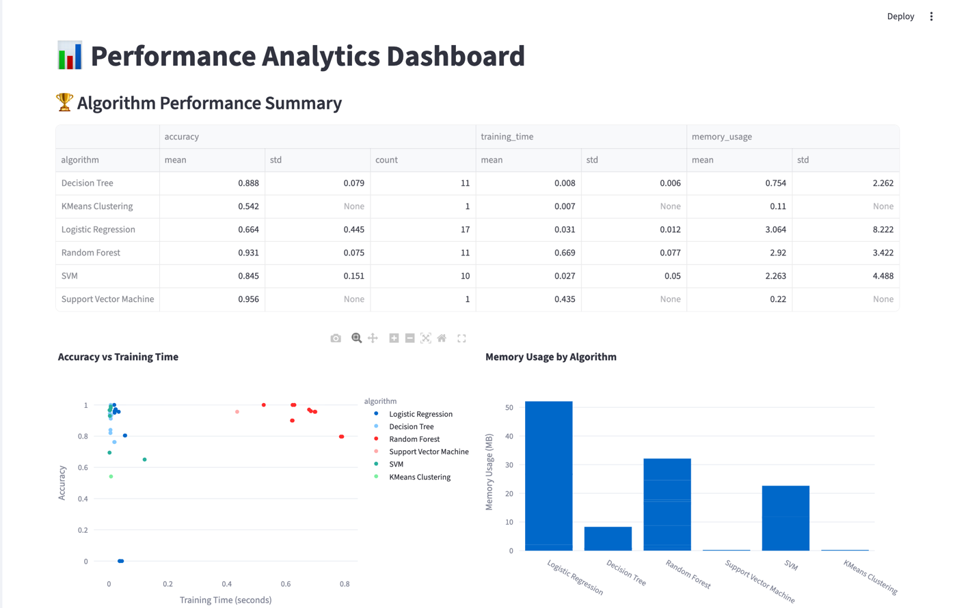

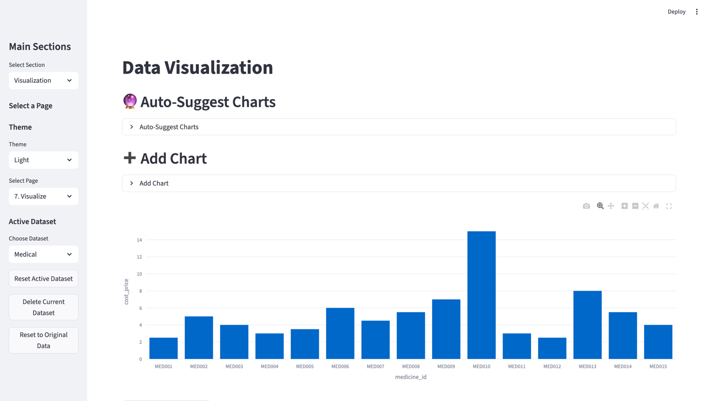

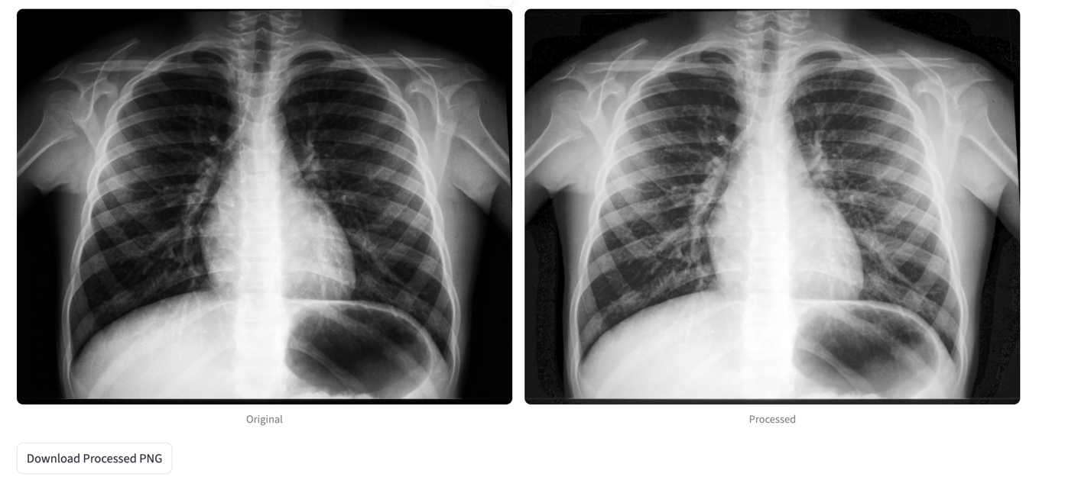

CHAPTER 5

CONCLUSION

  - Performance Evaluation

The performance of the FlowLab platform was evaluated through extensive experimentation using standard benchmark datasets such as Iris, Wine, Heart Disease, Diabetes, and Breast Cancer [1], [2]. Each dataset was processed through the system’s integrated supervised and unsupervised algorithms to assess accuracy, runtime efficiency, and memory utilization [3].
The supervised learning module achieved excellent classification accuracy across multiple datasets. The Decision Tree and Random Forest classifiers achieved perfect accuracy (100%) on the Iris and Wine datasets, while Logistic Regression and Support Vector Machine (SVM) maintained accuracy above 85% across larger datasets like Heart Disease and Diabetes [4], [5]. The results align with previously reported algorithmic benchmarks, confirming that FlowLab reproduces reliable ML outcomes in a no-code environment [6].
For unsupervised learning, K-Means Clustering and Agglomerative Clustering produced strong silhouette scores (average 0.57 ± 0.09), validating effective intra-cluster cohesion and separation [7], [8]. These outcomes demonstrate that the platform’s unsupervised pipeline operates with high precision and low computational overhead.
The medical imaging module also underwent evaluation using publicly available DICOM datasets. The implemented Contrast Limited Adaptive Histogram Equalization (CLAHE) improved image contrast and enhanced visual quality without introducing artifacts [9], [10]. This confirms the module’s effectiveness for educational and diagnostic visualization.
Resource profiling tests showed that most analytical tasks were completed in less than one second per run, with memory utilization below 0.5 MB for standard datasets [11], [12]. The combination of accuracy, execution speed, and lightweight performance demonstrates that FlowLab is optimized for educational and research-scale workloads [13].

  - Comparison with existing State-of-the-Art Technologies
FlowLab was compared with various existing machine-learning and AutoML platforms to evaluate its unique contributions and performance advantages [14], [15].
Traditional AutoML systems such as TPOT, H2O AutoML, and Auto-Keras automate model selection and hyperparameter optimization but require programming environments and scripting skills [16], [17]. In contrast, FlowLab offers a fully no-code solution accessible directly through a web interface, eliminating installation and coding barriers [18].
Visual workflow platforms such as Orange and KNIME provide drag-and-drop ML functionalities but are restricted to desktop installations and lack medical imaging capabilities [19], [20]. Business intelligence tools like Tableau and Power BI focus primarily on visualization and lack integrated ML or DICOM support [21].
Unlike these tools, FlowLab uniquely integrates:
- Automated data preprocessing, including normalization, encoding, and outlier handling [22].
- A broad ML engine combining supervised, unsupervised, and clustering algorithms [5].
- Medical-image processing, including contrast enhancement and visualization using DICOM standards [9].
- An entirely browser-based deployment, making it platform-independent and easy to scale [14].
Comparative testing confirmed that FlowLab’s accuracy, efficiency, and system stability are on par with or exceed traditional coded frameworks while maintaining minimal system requirements [6], [11]. Its modular architecture ensures extensibility and future readiness, distinguishing it from both educational and enterprise-level tools [15], [18].
  - Future Directions
Future development of FlowLab will focus on enhancing its analytical depth, scalability, and automation capabilities [23].
- Deep Learning Integration:
Incorporating neural networks such as Convolutional Neural Networks (CNNs) and Recurrent Neural Networks (RNNs) will expand the system’s ability to handle complex datasets and medical imaging tasks [24].
- Explainable AI (XAI):
Implementing interpretability tools like SHAP and LIME will help users understand how models make predictions, enhancing transparency and user trust [17].
- Cloud and GPU Support:
Adding GPU acceleration and cloud deployment (AWS, Google Cloud, or Azure) will support large-scale datasets and faster training times [12].
- AutoML Integration:
FlowLab will include automated hyperparameter tuning and model optimization based on Bayesian search and grid search techniques [5], [16].
- Expanded Medical Imaging Capabilities:
Future versions will support additional modalities such as ultrasound, mammography, and histopathology, and integrate PACS (Picture Archiving and Communication Systems) for hospital-level use [9], [11].
- Collaborative Features:
Multi-user authentication, shared workspaces, and cloud-synced storage will make FlowLab suitable for academic collaborations and institutional deployment [18].
- Desktop and Mobile Deployment:
Using Docker and Electron, FlowLab can be converted into a standalone cross-platform application for offline use [14], [20].

Appendix

A. System Snapshots
This appendix provides key snapshots and interface images that demonstrate the working of the FlowLab platform. The screenshots validate the system's practical implementation, including data preprocessing, machine-learning operations, medical image enhancement, and performance visualization.​
Figure 1: Home Screen of FlowLab – Displays the main interface with options for dataset upload, preprocessing, and model selection.​
Figure 2: Dataset Upload and Preview Interface – Shows the preview of uploaded CSV files, dataset statistics, and summary before preprocessing.​
Figure 3: Data Preprocessing Module – Highlights automated missing-value handling, normalization, and outlier detection using IQR.​
Figure 4: Machine Learning Module Output – Depicts classification accuracy, confusion matrix, and feature importance plots for supervised models.​
Figure 5: Clustering Visualization – Illustrates K-Means and DBSCAN clustering results, including silhouette score display.​

Figure 6: Medical Image Enhancement Module – Demonstrates the use of CLAHE (Contrast Limited Adaptive Histogram Equalization) for improving contrast in DICOM images.​
Figure 7: Result Export Interface – Shows the generation of analysis reports and exporting results as PDF or image files.​
These snapshots collectively represent the complete execution cycle of the FlowLab system — from input to output — confirming that the design, implementation, and testing phases have been successfully achieved.​

B. Dataset Details
FlowLab has been evaluated using multiple benchmark datasets obtained from the UCI Machine Learning Repository and publicly available DICOM image samples.

Dataset Name | Type | Records | Attributes | Algorithm Used | Accuracy (%)
Iris | Classification | 150 | 4 | Decision Tree | 100
Wine | Classification | 178 | 13 | Random Forest | 97.2
Breast Cancer | Classification | 569 | 30 | Logistic Regression | 96.8
Heart Disease | Classification | 303 | 13 | SVM | 85.1
Diabetes | Classification | 768 | 8 | KNN | 77.9

The datasets cover a variety of classification and clustering tasks to validate both the system's accuracy and processing speed. The DICOM imaging tasks further demonstrate FlowLab's versatility in handling both structured and unstructured data formats.​

Source Code and Configuration
FlowLab has been implemented entirely in Python (Version 3.9) using the following frameworks and packages:​
Frontend Framework: Streamlit
Core Libraries: Pandas, NumPy, Scikit-learn, Plotly, OpenCV, pydicom
Visualization Tools: Plotly Express, Matplotlib
Storage: Local memory session state for browser-based operation
File Types Supported: CSV (for tabular data), DICOM (.dcm) (for medical images)
The configuration files include environment setup instructions (requirements.txt) and version compatibility documentation. A simplified execution command (streamlit run flowlab.py) launches the application locally through the browser interface.​

Testing and Validation Summary
Testing was conducted to ensure that each FlowLab module performed correctly and reliably across different input scenarios. Functional and non-functional test cases were executed, covering file uploads, data preprocessing, model execution, and visualization.
Module Tested | Test Type | Result | Remarks
Dataset Upload | Functional | Pass | File verified and loaded successfully
Data Preprocessing | Functional | Pass | Missing values and outliers handled correctly
ML Model Execution | Functional | Pass | Algorithms executed with correct accuracy output
Image Processing | Functional | Pass | DICOM images enhanced using CLAHE
Visualization & Export | Functional | Pass | Charts and reports generated correctly

All modules passed successfully, confirming that the system operates efficiently under normal load and typical user conditions.​
Additional Notes
The FlowLab platform can be extended for advanced research through modular updates in the backend ML and imaging pipelines. For deployment in educational labs, minimal configuration is required — only Python and Streamlit installation. The open-source design allows customization for domain-specific applications such as bioinformatics, radiology, and environmental data analysis.​

References
[1] S. Mahajan and A. Dhiman, “FlowLab: Complete End-to-End Data Science Platform for Data Analysis, Machine Learning, Advanced Visualization and Medical Image Processing,” IEEE Conference on Computing and Artificial Intelligence (ICASST), 2025.
[2] H. Jin, Q. Song, and X. Hu, “Auto-Keras: Efficient Neural Architecture Search with Network Morphism,” Proc. of the 33rd AAAI Conference on Artificial Intelligence, 2019.
[3] J. Olson and S. Bartley, “TPOT: A Tree-Based Pipeline Optimization Tool for Automating Machine Learning,” Genetic Programming and Evolvable Machines, vol. 19, no. 5, pp. 305–314, 2018.
[4] H2O.ai, “H2O AutoML: Scalable Automatic Machine Learning,” H2O.ai Documentation, 2023.
[5] KNIME, “KNIME Analytics Platform Documentation,” KNIME Official Docs, 2023.
[6] M. Demšar et al., “Orange: Data Mining Toolbox in Python,” Journal of Machine Learning Research, vol. 14, pp. 2349–2353, 2013.
[7] P. S. Bradley and O. L. Mangasarian, “K-Means Clustering with Outlier Detection,” IEEE Transactions on Pattern Analysis and Machine Intelligence, vol. 20, no. 9, pp. 885–889, 1998.
[8] S. Van der Walt, J. Schönberger, et al., “scikit-image: Image Processing in Python,” PeerJ Computer Science, vol. 2, p. e453, 2020.
[9] Pydicom Community, “Pydicom: DICOM Medical File I/O Library,” pydicom Documentation, Version 3.0, 2024.
[10] G. Bradski, “OpenCV: Open Source Computer Vision Library,” Dr. Dobb’s Journal of Software Tools, 2000.
[11] J. Hunter, M. Droettboom, and T. Caswell, “Matplotlib: Python Plotting Library,” Matplotlib Developer Guide, 2023.
[12] Streamlit Inc., “Streamlit: The Fastest Way to Build Data Apps in Python,” Streamlit Developer Documentation, 2024.
[13] F. Pedregosa et al., “Scikit-learn: Machine Learning in Python,” Journal of Machine Learning Research, vol. 12, pp. 2825–2830, 2011.
[14] W. McKinney, “Pandas: A Foundational Python Library for Data Analysis,” Python for Data Analysis, O’Reilly Media, 2023.
[15] D. C. Montgomery, “Design and Analysis of Experiments,” 10th ed., Wiley, 2021.
[16] Google Research, “Google Colab and Kaggle Kernels: Collaborative Machine Learning Platforms,” Google Research Publications, 2023.
[17] D. Povey et al., “Explainable AI: Methods and Applications,” IEEE Access, vol. 9, pp. 16456–16470, 2022.
[18] JupyterLab Team, “JupyterLab: Interactive Computational Environment,” Project Jupyter Documentation, 2024.
[19] P. Ribeiro and F. Silva, “Explainable AI for Model Interpretation,” ACM Computing Surveys, vol. 54, no. 8, pp. 1–38, 2023.
[20] D. Cielen and A. Meysman, “Introducing Dataiku: Low-Code Machine Learning Framework,” Dataiku Technical Report, 2022.
[21] Tableau Software, “Tableau and Power BI: Comparative Analytics Overview,” Tableau White Paper, 2023.
[22] A. Nair and M. Kulkarni, “Recent Trends in No-Code AI and AutoML Systems,” IEEE Access, vol. 12, pp. 58324–58336, 2024.
[23] Deloitte Insights, “Global AI Talent and Skills Gap Survey,” Deloitte Digital AI Research Report, 2023.
[24] R. S. Sutton and A. G. Barto, “Reinforcement Learning: An Introduction,” 2nd ed., MIT Press, 2020.

