**In the Model First Approach, we first create the Entity Model**. That is we create  
**1.** Entities  
**2.** Relationships between entities  
**3.** Inheritance hierarchies etc.  
  
**We do all this directly on the design surface of the EDMX file**. We will be continuing with the same example that we started in

**Step 1:** First delete the **"EmployeeModel.edmx"** file from the existing solution  
  
**Step 2:** Add a new **"ADO.NET Entity Data Model"** file with name = **EmployeeModel.**  
  
**Step 3:** On **"Choose Model Contents"** screen, select **"Empty Model"** and click **"Finish"**   
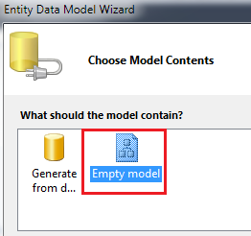  
  
**Step 4:** At this point, we have a blank **EmployeeModel.edmx** file added to the solution. Now, right click on the designer surface and then select : **Add - Entity**. Set,   
Entity Name = Department  
Base Type = None  
Entity Set = Departments  
Create Key property = Select the check box  
Property Name = Id  
Property Type = Int32  
  
Finally click **OK**.   
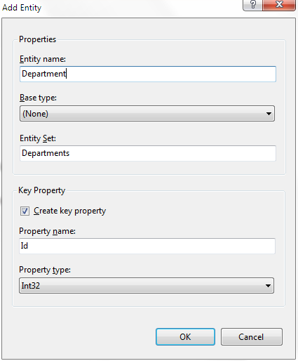  
  
**Step 5:** Right click on **"Department"** entity and select **"Add - Scalar Property"**. Change the property name to **"Name"**. Right click on the **"Name"** property that we just added and select **"properties"** from the context menu. Notice that the **"Type"** of **"Name"** property is set to **"String"**.  
  
**Step 6:** Similarly add **"Location"** property for the **"Department"** entity. At this point, the **"Department"** entity should look as shown below.   
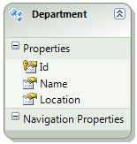  
  
**Step 7:** Add **"Employee"** entity and the following scalar properties.  
FirstName (Type = string)  
LastName (Type = string)  
Gender (Type = string)  
Salary (Type = int)  
  
**Step 8:** At this point, **Department** and **Employee** entities should look as shown below.   
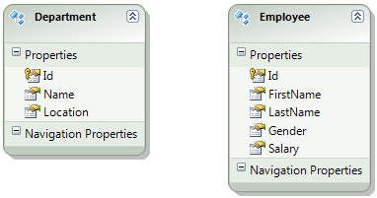  
  
**Step 9:** We need to add **"Employees"** navigation property for the **"Department"** entity, and **"Department"** navigation property for the **"Employee"** entity. To do this, right click on the design surface and select **"Add - Association"**. In the **"Add Association"** window, set values as shown in the image below and click **"OK"**   
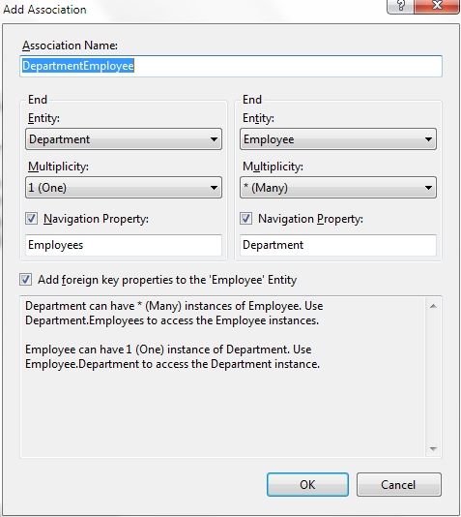  
  
**Step 10:** At this point, we should have the following created.  
**a)** Employees navigation property in the Department entity  
**b)** Department navigation property in the Employee entity  
**c)** DepartmentId scalar property   
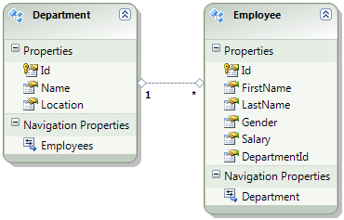  
  
**Step 11:** Right click on the design surface, and select **"Genedrate Database from Model..."** option  
  
**Step 12:** On **"Choose Your Data Connection"** screen, click **"Next"**  
  
**Step 13:** At this point, we should have the required SQL generated to create   
**a)** Departments table  
**b)** Employees table  
**c)** Primary key constraints for Departments and Employees tables  
**d)** Foreign key constraint  
**e)** Indexes  
  
**Step 14:** Click **Finish.** Now, we should have **"EmployeeModel.edmx.sql"** file generated with the required SQL. If you already have **"Departments"** and **"Employees"** tables in the database, delete them. Right click on the file and select **"Execute SQL"** option from the context menu.  
  
**Step 15:** Populate the **"Departments"** and **"Employees"** tables with sample data using the script below.

Insert into Departments values ('IT', 'New York')

Insert into Departments values ('HR', 'London')

Insert into Departments values ('Payroll', 'Sydney')

Insert into Employees values ('Mark', 'Hastings', 'Male', 60000, 1)

Insert into Employees values ('Steve', 'Pound', 'Male', 45000, 3)

Insert into Employees values ('Ben', 'Hoskins', 'Male', 70000, 1)

Insert into Employees values ('Philip', 'Hastings', 'Male', 45000, 2)

Insert into Employees values ('Mary', 'Lambeth', 'Female', 30000, 2)

Insert into Employees values ('Valarie', 'Vikings', 'Female', 35000, 3)

Insert into Employees values ('John', 'Stanmore', 'Male', 80000, 1)

**Step 16:** Run the application by pressing **CTRL + F5.** We will get the following runtime error.  
The specified default EntityContainer name 'EmployeeDBContext' could not be found in the mapping and metadata information.  
Parameter name: defaultContainerName  
  
**Step 17:** Open **WebForm1.aspx** in source mode, and set **ConnectionString** and **DefaultContainerName** properties of **EntityDataSource** control as shown below.

<asp:EntityDataSourceID="EntityDataSource1"runat="server"

ConnectionString="name=EmployeeModelContainer"

DefaultContainerName="EmployeeModelContainer"

EnableFlattening="False"

EntitySetName="Departments"Include="Employees">

</asp:EntityDataSource>

At this point we should get the output we expect.