SOA: SOA provides an approach based on open standards and

generic messages that aren’t specific to any platform or programming language. As a result, you can

achieve a high degree of loose coupling and interoperability across platforms and technologies.

**Service-oriented architecture (SOA)**

* WCF : windows communication foundation.
  + network distributed system
* Interoperability is the fundamental characteristics of WCF. It is unified programming model provided in .Net Framework 3.0. WCF is a combined features of Web Service, Remoting, MSMQ and COM+. WCF provides a common platform for all .NET communication.

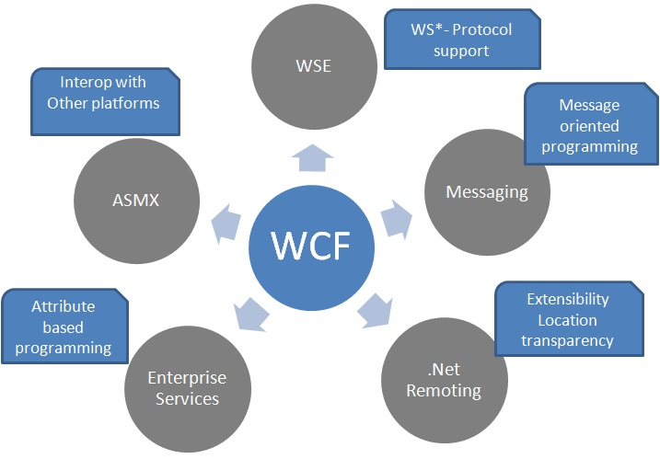

**Advantage**

1. WCF is interoperable with other services when compared to .Net Remoting,where the client and service have to be .Net.
2. WCF services provide better reliability and security in compared to ASMX web services.
3. In WCF, there is no need to make much change in code for implementing the security model and changing the binding. Small changes in the configuration will make your requirements.
4. WCF has integrated logging mechanism, changing the configuration file settings will provide this functionality. In other technology developer has to write the code.

**Disadvantage**

Making right design for your requirement is little bit difficult. I will try to help you on solving these difficulties in the following article.

TIPS:

* Always create the service with Interface->Implementation format, mention the contract in Interface.
* Define the service in Class library and refer the class library in Host project. Don’t use service class in host project.
* Change the instance mode to per call as default.
* Always catch exception using try/catch block and throw exception using FaultException < T >.
* Logging and Include exception should be enable while compiling the project in debug mode. While in production deployment disable the logging and Include exception details.

F stands for Windows Communication Foundation. It is Microsoft's latest technology that enables applications in a distributed environment to communicate with each other.WCF is Microsoft's unified programming model for building service-oriented applications. It enables developers to build secure, reliable, transacted solutions that integrate across platforms and interoperate with existing.

WCF is an umbrella technology that covers ASMX web services, .NET remoting, WSE, Enterprise Service, and System.Messaging. It is designed to offer a manageable approach to distributed computing, broad interoperability, and direct support for service orientation. WCF supports many styles of distributed application development by providing a layered architecture.

## ABC of Windows Communication Foundation

What are the ABCs of WCF? "ABC" stands for address, binding and contract.

## Address (Where)

It specifies the location of the service means, where the service is hosted. The service hosting URL may be like http://server/wcfService. Clients will use this location to communicate with your service.

## Binding (How)

It specifies how the client will communicate to the service. We have different protocols (like http,tcp,named pipe,msmq) for the WCF to communicate to the client.

## Contract (What)

It specifies what the service will do. For this purpose we have different contract like as Data Contract, Operation Contract, Message Contract, Fault Contract. I will discuss all these later.

## WCF Hosting

A WCF service is a component that can be called by other applications. It must be hosted in an environment in order to be discovered and used by others. The WCF host is an application that controls the lifetime of the service. With .NET 3.0 and beyond, there are several ways to host the service.

## Self hosting

A WCF service can be self-hosted, which means that the service runs as a standalone application and controls its own lifetime. This is the most flexible and easiest way of hosting a WCF service, but its availability and features are limited.

## Windows services hosting

A WCF service can also be hosted as a Windows service. A Windows service is a process managed by the operating system and it is automatically started when Windows is started (if it is configured to do so). However, it lacks some critical features (such as versioning) for WCF services.

## IIS hosting

A better way of hosting a WCF service is to use IIS. This is the traditional way of hosting a web service. IIS, by nature, has many useful features, such as process recycling, idle shutdown, process health monitoring, message-based activation, high availability, easy manageability, versioning, and deployment scenarios. All of these features are required for enterprise-level WCF services.

## Windows Activation Services hosting

The IIS hosting method, however, comes with several limitations in the service-orientation world; the dependency on HTTP is the main culprit. With IIS hosting, many of WCF's flexible options can't be utilized. This is the reason why Microsoft specifically developed a new method, called Windows Activation Services, to host WCF services.

Windows Process Activation Service (WAS) is the new process activation mechanism for Windows Server 2008 that is also available on Windows Vista. WAS hosting is possible only with IIS 7.0.Additional WCF components also plug into WAS to provide message-based activation over the other protocols that WCF supports, such as TCP, MSMQ, and named pipes. This allows applications that use the non-HTTP communication protocols to use the IIS features such as process recycling, rapid fail protection, and the common configuration systems that were only available to HTTP-based applications.

Introducing the ABCs of WCF

The *address* specifies where the messages can be sent (or where the service lives).

 The *binding* describes how to send the messages.

 The *contract* describes what the messages should contain.