**Web Service**

**1. What is Web service?**

Web Services are applications that provide services on the internet. Web services allow for programmatic access of business logic over the Web. Web services typically rely on XML-based protocols, messages, and interface descriptions for communication and access. SOAP over HTTP is the most commonly used protocol for invoking Web services. SOAP defines a standardized format in XML which can be exchanged between two entities over standard protocols such as HTTP.

Example: Google search engine's web service, e.g., allows other applications to delegate the task of searching over the internet to Google web service and use the result produced by it in their own applications.

**2. What is UDDI?**

UDDI - Universal Description, Discovery and Integration. It is an XML-based standard for describing, publishing, and finding Web services. It is platform independent, open framework and specification for a distributed registry of Web services

**3. What is DISCO?**

DISCO is the abbreviated form of Discovery. It is basically used to club or group common services together on a server and provides links to the schema documents of the services it describes may require.

**4. What is the use of Disco.exe?**

The Web Services Discovery tool discovers the URLs of XML Web services located on a Web server and saves documents related to each XML Web service on a local disk.

**5. What are the uses of Web service?**

* Application integration Web services within an intranet are commonly used to integrate business applications running on different platforms.

For example, a .NET client running on Windows 2000 can easily invoke a Java Web service running on a mainframe or Unix machine to retrieve data from a legacy application.

* Business integration Web services allow trading partners to engage in e-business allowing them to leverage the existing Internet infrastructure. Organizations can send electronic purchase orders to suppliers and receive electronic invoices. Doing e-business with Web services means a low barrier to entry because Web services can be added to existing applications running on any platform without changing legacy code.
* Commercial Web services focus on selling content and business services to clients over the Internet similar to familiar Web pages. Unlike Web pages, commercial Web services target applications as their direct users.

**6. What is WSDL?**

The Web Services Description Language (WSDL) is a particular form of an XML Schema, developed by Microsoft and IBM for the purpose of defining the XML message, operation, and protocol mapping of a web service accessed using SOAP or other XML protocol.

WSDL describes the details such as

* Where we can find the Web Service (its URI)?
* What are the methods and properties that service supports?
* Data type support.
* Supported protocols

**7. How to create a web service?**

This sample explains about the creation of sample web service and consuming it.

**Step 1**: Create a new web service by clicking **File->New->WebSite** and select **"ASP.Net Web Service"**

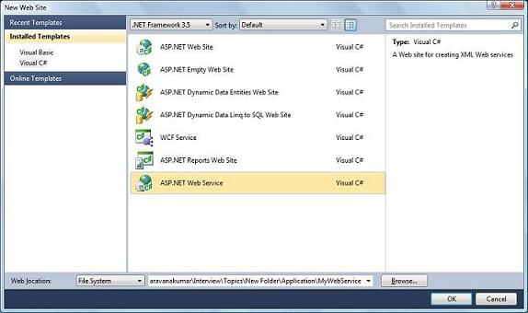

**Step 2:**

Create a class and methods which is need to be exposed as service. Decorate the class with "WebService" and methods with "WebMethod" attribute.

[WebService(Namespace = "http://tempuri.org/")]

[WebServiceBinding(ConformsTo = WsiProfiles.BasicProfile1_1)]

// To allow this Web Service to be called from script,

//using ASP.NET AJAX, uncomment the following line.

// [System.Web.Script.Services.ScriptService]

public class Service : System.Web.Services.WebService

{

public Service () {

//Uncomment the following line if using designed components

//InitializeComponent();

}

[WebMethod]

public string HelloWorld() {

return "Hello World";

}

[WebMethod ]

public string SayHello(string name) {

return "Hello " + name;

}

}

**Step 3:**

Run the web service

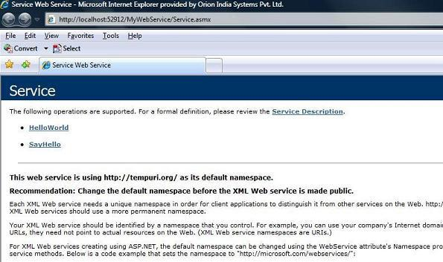

**Step 4**: Create the client application to consume the service by clicking File->New->Project and select the Console Application.

**Step 5**: Right click the project file and select "Add Service Reference"

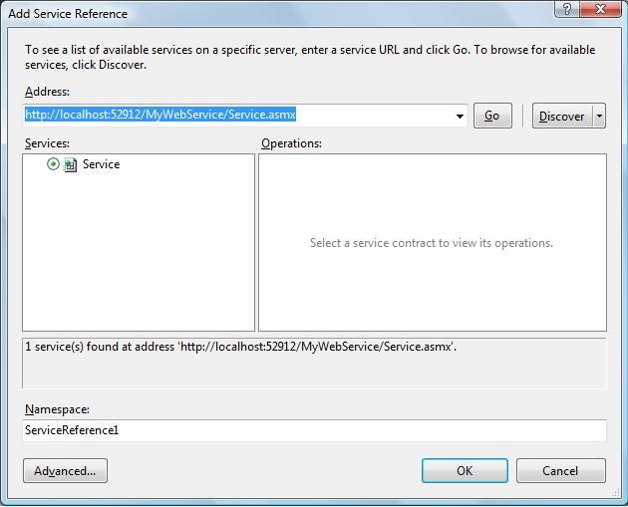

**Step 6:**

Create a new instance for proxy class and call the web method "SayHello"

class Program

{

static void Main(string[] args)

{

ServiceReference1.ServiceSoapClient proxy = new

ServiceReference1.ServiceSoapClient();

Console.WriteLine(proxy.SayHello("Ram"));

Console.ReadLine();

}

}

**Step 7:**

Output window are shown

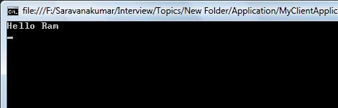

**8. What is difference between Add Reference and Add Service reference?**

Add Reference is used to add the .Net assemblies and COM components to the project files, where as Add Service Reference is used to create a proxy for the web service.

**9. What is the transport protocol you use to call a Web service?**

SOAP (Simple Object Access Protocol) is the preferred protocol.

**10. Where on the Internet would you look for Web services?**

http://www.uddi.org

**11. To test a Web Service you must create a windows application or web application to consume this service? It is True/False?**

Every web service by default generates a test page, we need not create or consume the Web service in order to test it.

**12. When would you use .NET Remoting and when Web services?**

When both service and client are .Net platform, .Net remoting will be more efficient where are if both server and client are different platform use web service for communication

**13. A Web service can only be written in .NET True or False?**

False

**14. How to implement security to the web service?**

WS-Security (Web Services Security) is a communications protocol providing a means for applying security to Web services.

The protocol contains specifications on how integrity and confidentiality can be enforced on Web services messaging. The WSS protocol includes details on the use of SAML and Kerberos, and certificate formats such as X.509

WS-Security describes how to attach signatures and encryption headers to SOAP messages. In addition, it describes how to attach security tokens, including binary security tokens such as X.509 certificates and Kerberos tickets, to messages.

WS-Security incorporates security features in the header of a SOAP message, working in the application layer. Thus it ensures end-to-end security.