- What is Name Service?
Ans:- A naming service maintains a set of bindings. Bindings relate names to objects.
Clients use the naming service to locate objects by name.

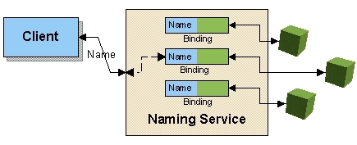

- Name some of the naming services:
Ans:-
- COS (Common Object Services) Naming: The naming service for CORBA applications; allows applications to store and access references to CORBA objects.
- DNS (Domain Name System): The Internet's naming service; maps people-friendly names (such aswww.etcee.com) into computer-friendly IP (Internet Protocol) addresses such as (207.69.175.36).
- LDAP, Lightweight Directory Access Protocol, is an Internet protocol that email and other programs use to look up information from a server.
- NIS (Network Information System) and NIS+: NIS (Network Information System) is a network naming and administration system for smaller networks that was developed by Sun Microsystems. NIS+ is a later version that provides additional security and other facilities. Using NIS, each host client or server computer in the system has knowledge about the entire system. A user at any host can get access to files or applications on any host in the network with a single user identification and password. NIS is similar to the Internet's domain name system (DNS) but somewhat simpler and designed for a smaller network. It's intended for use on local area networks.
- What is the primary function of Naming Service?
Ans:- The primary function of a naming system is to bind names to objects and to look up objects by name.
- What is JNDI ?
Ans:- The Java Naming and Directory Interface (JNDI) is a Java API for a directory service that allows Java software clients to discover and look up data and objects via a name. Like all Java APIs that interface with host systems, JNDI is independent of the underlying implementation.

JNDI is an API specified in Java technology that provides naming and directory functionality to applications written in the Java programming language. It is designed especially for the Java platform using Java's object model. Using JNDI, applications based on Java technology can store and retrieve named Java objects of any type. In addition, JNDI provides methods for performing standard directory operations, such as associating attributes with objects and searching for objects using their attributes.
JNDI is also defined independent of any specific naming or directory service implementation. It enables applications to access different, possibly multiple, naming and directory services using a common API. Different naming and directory service providers can be plugged in seamlessly behind this common API. This enables Java technology-based applications to take advantage of information in a variety of existing naming and directory services, such as LDAP, NDS, DNS, and NIS(YP), as well as enabling the applications to coexist with legacy software and systems.
Using JNDI as a tool, you can build new powerful and portable applications that not only take advantage of Java's object model but are also well-integrated with the environment in which they are deployed.

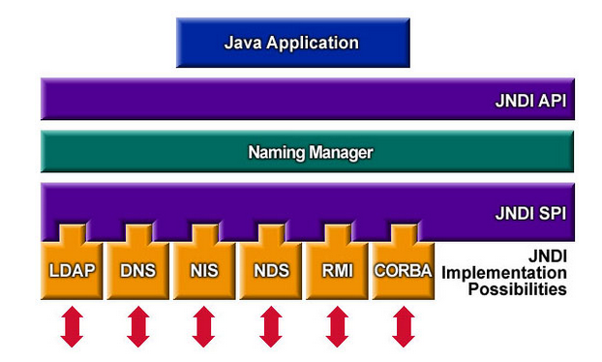

- Name the classes and interfaces in JNDI API along with the methods
Ans:
Context
This interface represents a naming context, which consists of a set of name-to-object bindings. It contains methods for examining and updating these bindings.
void bind(String name, Object obj)
throws NamingException

Binds a name to an object.

void rebind(String name,Object obj)
throws NamingException

Binds a name to an object, overwriting any existing binding.

void unbind(String name)
throws NamingException
Unbinds the named object. See unbind(Name) for details.

void rename(String oldName,
String newName)
throws NamingException
Binds a new name to the object bound to an old name, and unbinds the old name.

InitialContext

public class InitialContext
extends Object
implements Context
This class is the starting context for performing naming operations.
All naming operations are relative to a context. The initial context implements the Context interface and provides the starting point for resolution of names.
When the initial context is constructed, its environment is initialized with properties defined in the environment parameter passed to the constructor, and in any application resource files.

