One of the primary concerns of mappings between a database and your Java application is performance.
Caching is all about application performance optimization and it sits between your application and the database to avoid the number of database hits as many as possible to give a better performance for performance critical applications.
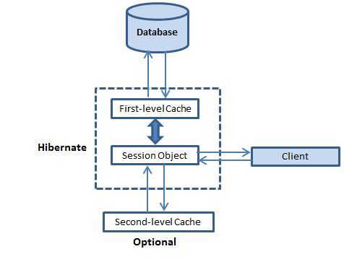
Caching is widely used for optimizing database applications. A cache is designed to reduce traffic between your application and the database by conserving data already loaded from the database. Database access is necessary only when retrieving data that is not currently available in the cache. The application may need to empty (invalidate) the cache from time to time if the database is updated or modified in some way, because it has no way of knowing whether the cache is up to date.

Hibernate Caching
Hibernate uses three different caches for objects: first-level cache , second-level cache and Query cache.

