- INTRODUCTION

The Adaptive Learning Systems (ALS) best depicts the role that technology can play in correcting problems that are faced in today’s educational means. Experience proves that the best way to avoid a mismatch between supply and demand is to deploy technology in response to clearly articulated needs .This project is designed to facilitate the development of technology that will adapt knowledge to the needs of learners.
The four aspects that would be addressed are content management, access to study material, system security and tracking student activity boards. The software tracks students’ work, tailoring feedback and hints along the way. By collecting information on a particular student's performance, the software can make inferences about strengths and weaknesses, and can suggest additional work.
The motivation of this project is to allow electronic education to incorporate the value of the interactivity afforded to a student by a machine that imitates the behavior of an actual human tutor. The technology encompasses aspects derived from various fields of study including computer science, education, and psychology. Thus the adaptive educational hypermedia focuses on providing a unique user experience in real time.

  - AIM AND OBJECTIVES
Aim:
The Adaptive Learning System aims at developing a computer-based learning method to provide an adaptive learning experience for students around the world.
Objectives:
- To replace the traditional teaching methods.
- To eliminate the need to travel to distant places to study.
- To allow students to learn when convenient wherein one is not tied to class meeting times.
- Spread training over extended periods of time.
- To help students learn the unknown and skip what they know.

2.0 LITERATURE SURVEY

Shipin Chen, Jianping Zhang, “Ability Assessment Based on CAT in Adaptive Learning System ”, vol.1, pp.88-91,dec 2008
ABSTRACT
Ability level of learner is the important dimension of adaptation in adaptive learning system. There are great differences in the capacity dimensions between different learners. Even for each specific learner, his ability level changes in the learning process. In order to more effectively evaluate the learner's ability level and to support the personalized learning, we integrate the computerized adaptive testing (CAT) module into adaptive learning system in this paper. We put forward the architecture of integrating computerized adaptive testing module into adaptive learning system, and analyze the algorithms of adaptive testing based on item response theory and three parameters logistic (3PL) model
- Siadaty, M. Taghiyareh, F. Univ. of Tehran, Tehran “Pedagogically Adaptive Learning System based on Learning Styles”, pp.616-618, july 2007.
ABSTRACT
One of the most contemporary research ideas for adaptive Web-based educational systems is personalizing the educational contents, based on users' learning styles. Moreover, it is not the technology that students learn from, but its role should be elucidated as a means to enhance learning. By our proposed adaptive e-learning framework, we attempt to bridge in the gap between pedagogy and technology, emerging in recent Web-based learning environments. This framework provides learners with pedagogically personalized learning contents based on their learning styles. Findings of the study indicate differences in performance between matched and non-matched students in one case of the study and in the other case, demonstrate no significant difference. Although these results pertain to an undergraduate educational session, however our proposed framework is general enough to be applied to effective and efficient pedagogy in any area at any level.
- Ruspini, E. H. Thomere, J. Wolverton, M. Artificial Intelligence center, SRI Int, Menlo Park, CA, USA, “Database editing metrics for pattern matching ”, pp.31-38,nov 2004.
ABSTRACT
Pattern matching techniques are important tools to treat problems in several fields like information retrieval and pattern recognition. The paper introduces a family metrics to measure the degree of qualitative match between a database and a pattern, i.e. an elastic constraint on database objects and their relations. The degree of matching between database and patterns is determined by means of similarity measures that gauge the resemblance between pairs of objects. Pattern matching procedures are important in homeland security and crime prevention because the underlined problems require discovery, in large databases, of instances of patterns known to be associated with illegal activities.

Liu Xiaojun; Han Huabing; Electron. Technol. Room, Chinese People's Armed Police Forces Acad., Langfang, China, “The design and realization of web-based adaptive learning system”, pp. 468 – 471, 30-31 May 2010.
ABSTRACT
Based on the item response theory, this paper constructs a web-based adaptive learning system. The system plans learning activities for learners, defines the learning space according to learners' actual situation, tracks learners' ability under the theory of item response, selects adaptively the learning units and realizes the learner-centered learning form characterized by personalization and individualization.

- EXISTING SYSTEM

The traditional classroom means of learning has been implemented since ages around the world using the “one size fits all” approach. However there are many shortcomings that the traditional means of education face like:
- The need to being tied to fixed class timings.
- The need to travel to distant places.
- The need to finish the portion in a fixed amount of time.
- The disability to deal with different students in a different manner.

Whilst electronic learning and web-based education provide more expedient virtual access to the learners around the world, there are various shortcomings that these posses too like:
- The need of a tutor to be present at the other end.
- As virtual classrooms are again an extension of the actual classroom the tutor cannot give his complete attention to one particular student.
- The need to being tied to fixed class timings.
- The tutor is possible to interact with only a limited number of students at the same time.
The main problem with pre recorded videos is that the student cannot have an interactive session.
To overcome all these problems we have come up with “Adaptive Learning System”.

- PROBLEM STATEMENT

The Adaptive Learning System is used to create a student centric system in which the system adapts to the needs of the users. The user can either access data in the plain textual format by just typing the word to be searched or else can learn textual data using activities. These activities help to check whether the student is clear about the concept. The student can also appear for various levels of test and evaluate the subject in which the student is weak in and take necessary tutorials for the same.

- SCOPE OF THE PROJECT

The proposed Adaptive Learning System aims to promote development of net-centric, Web-based instructional systems. The overarching goal is to hasten the development of a learning infrastructure that permits education and training to be pervasive and precisely tailored to the needs of educators and learners. Any user who has net connection and a microphone can use the system for learning at any point of time.

Business Goals:
- To make high-quality instructional content more affordable.
- To adapt instruction to the end-user requirements.
- To make high-quality instructional content more available.
Technical Goals:
- To increase the capacity and usability of instructional content production technology
- To improve the precision and context-sensitivity of search and retrieval technology
- To improve quality of service levels in distributed instructional systems

- CONSTRAINTS OF THE PROJECT

Business Constraints:
- Net connection is required to use the Adaptive Learning System.
- Microphone/speakers are required.
- The system lacks human instinct.

Technical Constraints:
- Adobe Flash must be installed to use the software.

- PROPOSED SYSTEM

The Adaptive Learning System is being developed to provide the student with the most suitable, individually planned sequence of knowledge units to learn and sequence of learning tasks (examples, questions, problems, etc.) to work with. In other words, it helps the student to find an "optimal path" through the learning material. It will integrate the theories and technologies such as artificial intelligence, network communication, item response theory and adaptive test all together. The system will be a real distance adaptive hypermedia learning system, which can organize and present the proper content most suitable for the student’s current level of knowledge and ability according to the individual characteristics.
The system deals with students' final answers to educational problems (which can range from a simple question to a complex programming problem) no matter how these answers were obtained. Unlike non-intelligent checkers which can tell no more than whether the solution is correct, the system can tell exactly what is wrong or incomplete and which missing or incorrect piece of knowledge may be responsible for the error.The system can provide the student with extensive error feedback and update the student. The most sophisticated adaptation techniques.
(Intelligent analysis of student solutions, interactive problem solving support, and example-based problem solving) require more advanced AI-techniques that typically are used in Adaptive Learning Systems (e.g., rule-based or case-based reasoning).

- METHODOLOGY

The adaptive Learning System uses object oriented approach. Object oriented programming (OOP) is a programming paradigm that uses the objects – data structures consisting of data fields and methods together with their interaction- to design applications and computer programs.
The project also covers areas of artificial intelligence and uses algorithms like rule based reasoning, item response theory and pattern matching.

- REQUIREMENTS GATHERING AND PLANNING

  - REQUIREMENTS ELICITATION
    - USE CASE DIAGRAM AND DESCRIPTION

- Administrator:
The administrator is the one who maintains the database by updating, adding or deleting the data. The administrator has a user Id and password to log in.

- Student:
The student can either be a registered student or a non registered student. Non registered students can only access textual data whereas a registered student can access textual data as well as learn something new through activities. A registered student can also appear for various test and learn from the mistakes.

- System:
The system validates the user using the user ID and password. The system also provides various test and activities and based on it the system evaluates the user’s behavior and performance and provides the necessary study material.

  - FEASIBILITY STUDY
    - TECHNICAL FEASIBILITY

Hardware requirements:
- A personal computer with minimal configuration as
RAM: 256/512 MB
Hard Disk: 40 GB
- A microphone/speakers
- Internet connection

Software requirements:
- Adobe Flash

    - ECONOMIC FEASIBILITY

Cost analysis:

Benefit analysis:

  - REQUIREMENTS ANALYSIS
    - FLOW CHART

  - TIMELINE CHARTS

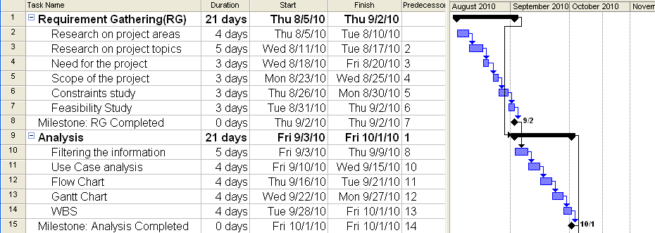
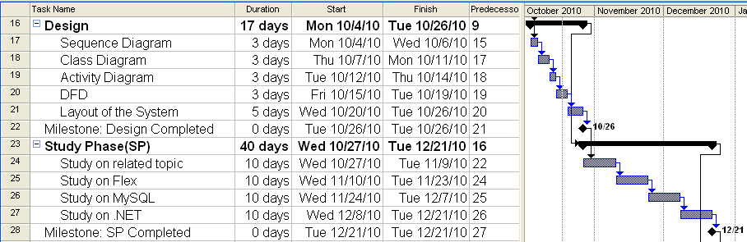
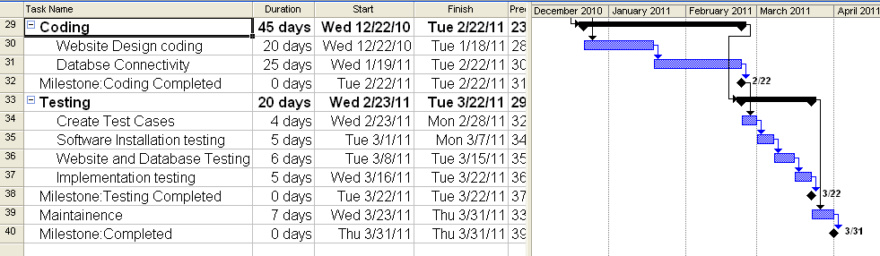

  - W.B.S. CHART
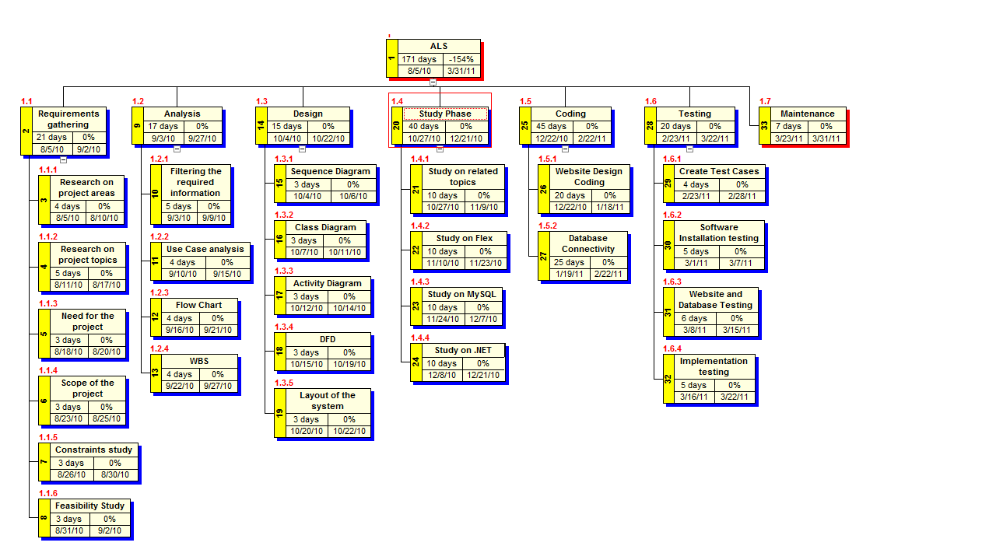

- ANALYSIS
  - ER DIAGRAM

DATA DICTIONARY

USER
Data Item | Data Type | Constraints
User_ID | varchar | Primary key
Password | varchar | Not null
Uname | varchar | Not null
Sex | varchar | Not null
Age | int | Not null

TEST
Data Item | Data Type | Constraints
Test_id | int | Primary key
Level | int | Not null

QUESTION
Data Item | Data Type | Constraints
Q_id | int | Primary key
Quest | varchar | Not null
Opt 1 | varchar | Not null
Opt 2 | varchar | Not null
Opt 3 | varchar | Not null
Opt 4 | varchar | Not null
Corect Opt | varchar | Not null

DOUBT
Data Item | Data Type | Constraints
Doubt_id | int | Primary key
d_ Data | varchar | Not null

EVALUATION
Data Item | Data Type | Constraints
eval_no | int | Primary key
time | int | Not null
scroll_status | varchar | Not null
change_option | varchar | Not null

TEXT BASED
Data Item | Data Type | Constraints
Text_id | int | Primary key
Data_item | varchar | Not null

ACTIVITY BASED
Data Item | Data Type | Constraints
act_id | int | Primary key
act_item | varchar | Not null
  - ACTIVITY DIAGRAM

Non-Registered Users

  - DATA FLOW DIAGRAM

- DESIGN
  - UI DESIGN(LAYOUT)/SNAPSHOTS

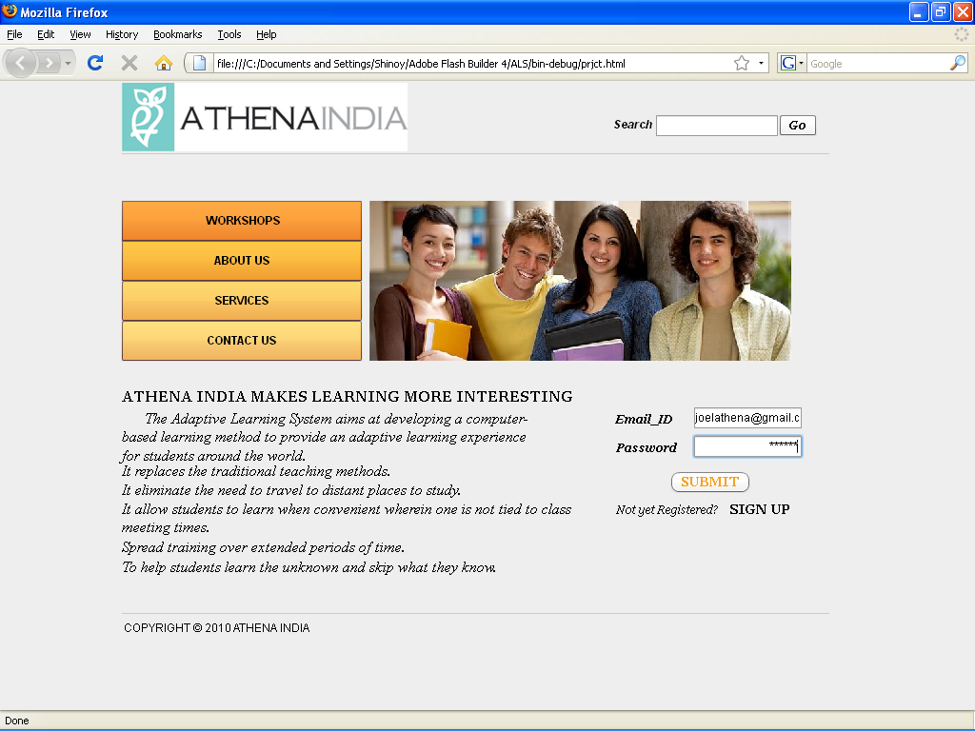

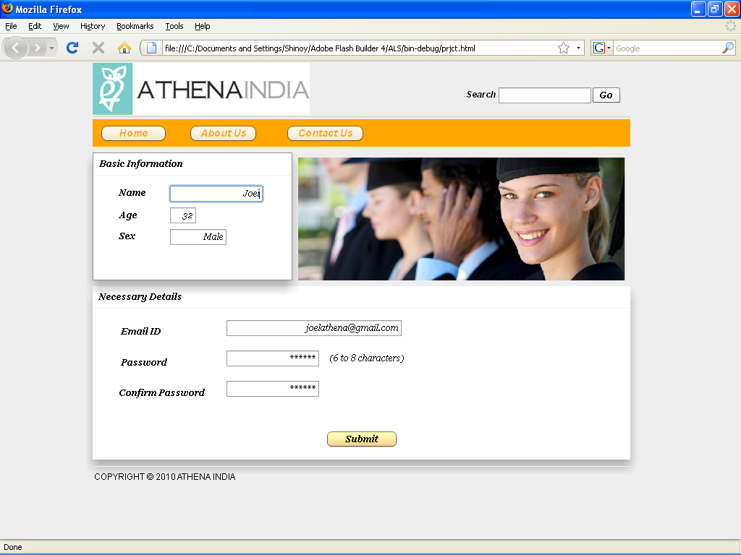

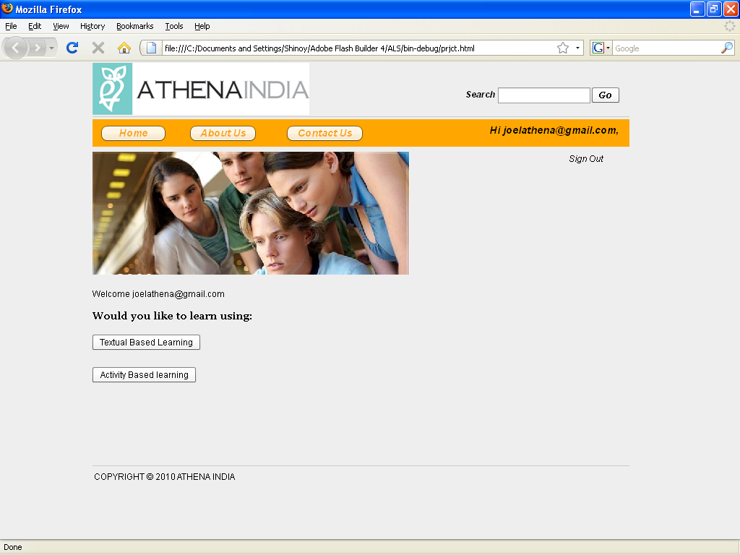

- APPENDIX

AI Artificial Intelligence.
ALS Adaptive Learning System.
Decentralized The process of dispersing decision making closer to the people
Hypermedia The use of graphics, audio, video, plain text and hyperlinks intertwine to create a generally non-linear medium of information.
Paradigm An example or pattern, distinct concept.
Pervasive Extensive, spread throughout

- BIBLIOGRAPHY AND REFERENCES

IEEE References

Shipin Chen, Jianping Zhang, “Ability Assessment Based on CAT in Adaptive Learning System ”, vol.1, pp.88-91,dec 2008
- Siadaty, M. Taghiyareh, F. Univ. of Tehran, Tehran “Pedagogically Adaptive Learning System based on Learning Styles”, pp.616-618, july 2007.
- Liu Xiaojun; Han Huabing; Electron. Technol. Room, Chinese People's Armed Police Forces Acad., Langfang, China, “The design and realization of web-based adaptive learning system”, pp. 468 – 471, 30-31 May 2010.
- Ruspini, E. H. Thomere, J. Wolverton, M. Artificial Intelligence center, SRI Int, Menlo Park, CA, USA, “Database editing metrics for pattern matching ”, pp.31-38,nov 2004.

Websites
[1] www.google.com
[2] www.wikipedia.com
[3] www.java2s.com
[4] www.adaptivelearning.com

