Entity

An entity can be a real-world object, either animate or inanimate, that can be easily identifiable. For example, in a school database, students, teachers, classes, and courses offered can be considered as entities. All these entities have some attributes or properties that give them their identity.

## Attributes

Entities are represented by means of their properties, called **attributes**. All attributes have values. For example, a student entity may have name, class, and age as attributes.

### **Types of Attributes**

* **Simple attribute** − Simple attributes are atomic values, which cannot be divided further. For example, a student's phone number is an atomic value of 10 digits.
* **Composite attribute** − Composite attributes are made of more than one simple attribute. For example, a student's complete name may have first_name and last_name.
* **Derived attribute** − Derived attributes are the attributes that do not exist in the physical database, but their values are derived from other attributes present in the database. For example, average_salary in a department should not be saved directly in the database, instead it can be derived. For another example, age can be derived from data_of_birth.
* **Single-value attribute** − Single-value attributes contain single value. For example − Social_Security_Number.
* **Multi-value attribute** − Multi-value attributes may contain more than one values. For example, a person can have more than one phone number, email_address, etc.

These attribute types can come together in a way like −

* simple single-valued attributes
* simple multi-valued attributes
* composite single-valued attributes
* composite multi-valued attributes

### **Entity-Set and Keys**

Key is an attribute or collection of attributes that uniquely identifies an entity among entity set.

For example, the roll_number of a student makes him/her identifiable among students.

* **Super Key** − A set of attributes (one or more) that collectively identifies an entity in an entity set.
* **Candidate Key** − A minimal super key is called a candidate key. An entity set may have more than one candidate key.
* **Primary Key** − A primary key is one of the candidate keys chosen by the database designer to uniquely identify the entity set.

## Relationship

The association among entities is called a relationship. For example, an employee **works_at** a department, a student **enrolls** in a course. Here, Works_at and Enrolls are called relationships.

### **Relationship Set**

A set of relationships of similar type is called a relationship set. Like entities, a relationship too can have attributes. These attributes are called **descriptive attributes**.

### **Degree of Relationship**

The number of participating entities in a relationship defines the degree of the relationship.

* Binary = degree 2
* Ternary = degree 3
* n-ary = degree

### **Mapping Cardinalities**

**Cardinality** defines the number of entities in one entity set, which can be associated with the number of entities of other set via relationship set.

* **One-to-one** − One entity from entity set A can be associated with at most one entity of entity set B and vice versa.

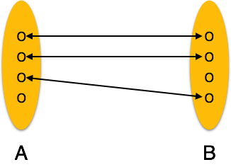

* **One-to-many** − One entity from entity set A can be associated with more than one entities of entity set B however an entity from entity set B, can be associated with at most one entity.

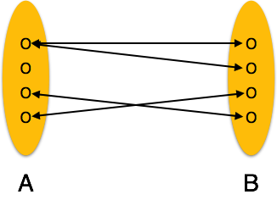

* **Many-to-one** − More than one entities from entity set A can be associated with at most one entity of entity set B, however an entity from entity set B can be associated with more than one entity from entity set A.

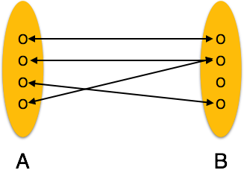

* **Many-to-many** − One entity from A can be associated with more than one entity from B and vice versa.

