SSIS

DIM DATE-

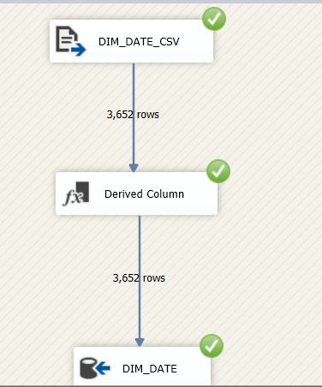

SELECT * FROM [adventureworksdw2014_purchasing].[dbo].[DimDate]

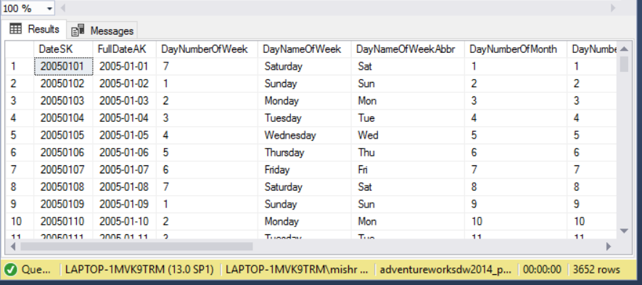

ROW COUNT - 3652

DIM SCRAPREASON -

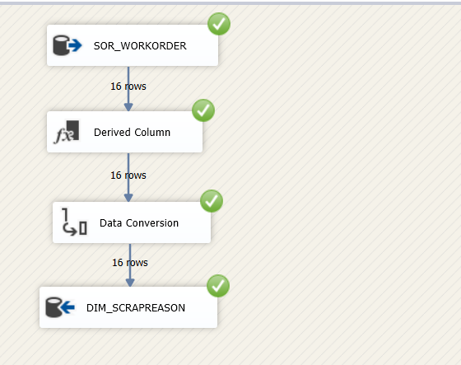

SELECT * FROM [adventureworksdw2014_purchasing].[dbo].[DimScrapReason]

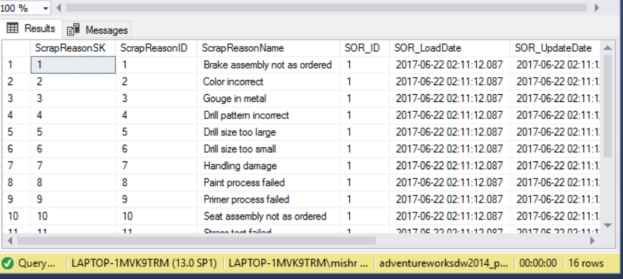

ROW COUNT - 16

DIM SHIPMETHOD -

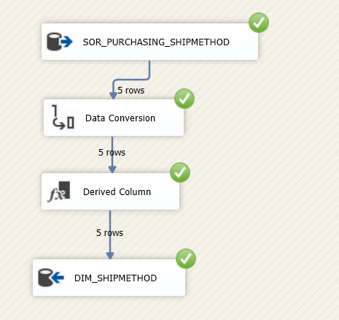

SELECT * FROM [adventureworksdw2014_purchasing].[dbo].[DimShipMethod]

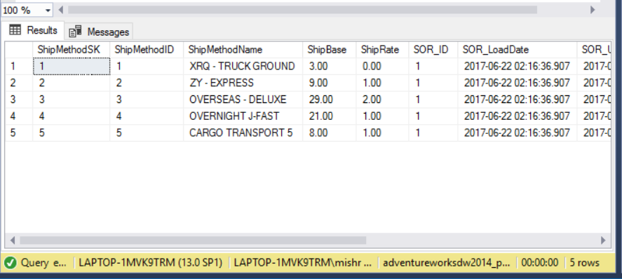

ROW COUNT - 5

DIM SALES TERRITORY-

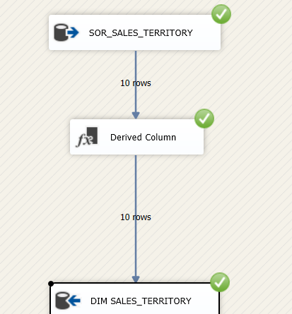

SELECT * FROM FROM [adventureworksdw2014_purchasing].[dbo].[DimSalesTerritory]

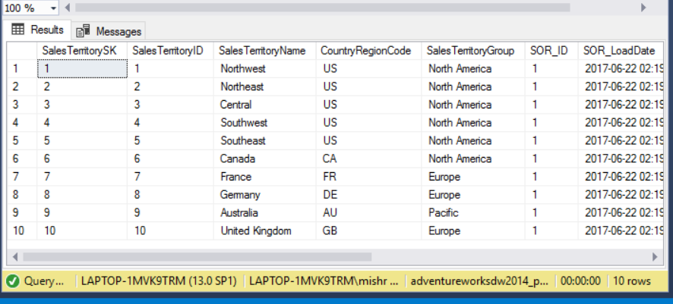

ROW COUNT - 10

DIM LOCATION

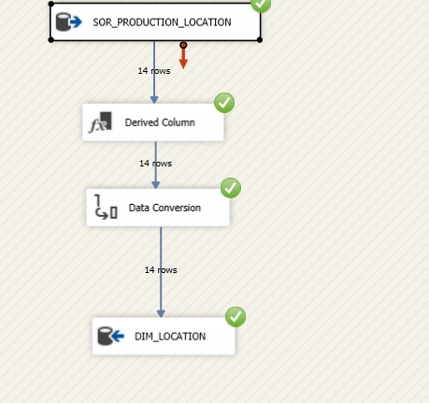

SELECT * FROM [adventureworksdw2014_purchasing].[dbo].[DimLocation]

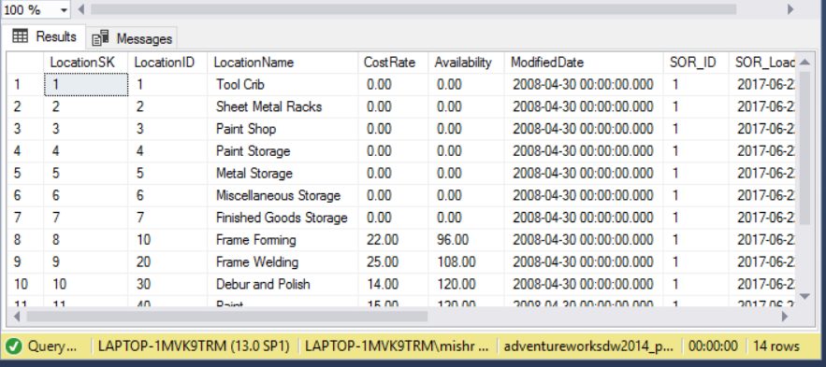

ROW COUNT - 14

DIMPRODUCT-

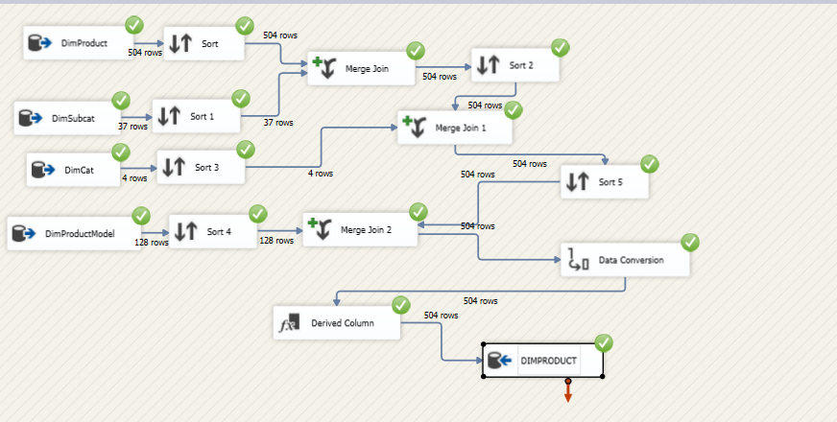

SELECT * FROM [adventureworksdw2014_purchasing].[dbo].[DimProducts]

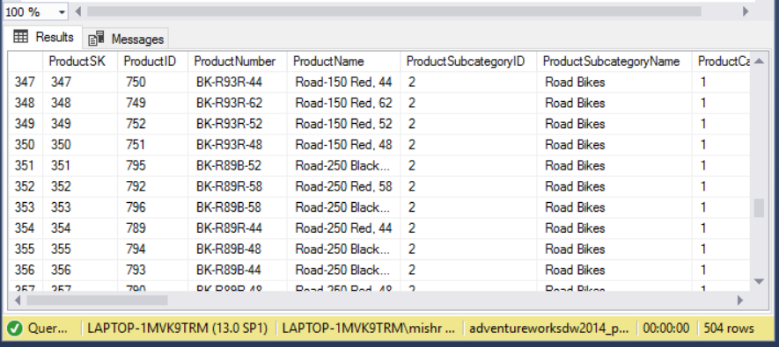

ROW COUNT - 504

DIM.PRODUCTPURCHASE -

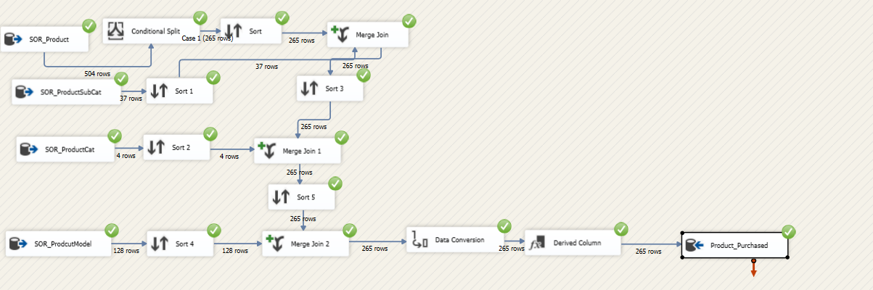

SELECT * FROM [adventureworksdw2014_purchasing].[dbo].[DimProducts_Purchased]

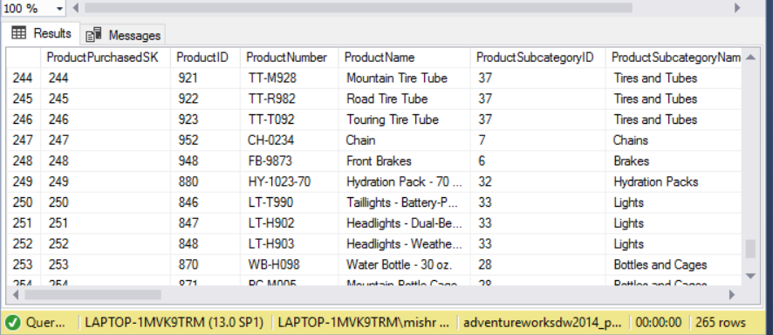

ROW COUNT - 265

DIM VENDOR -

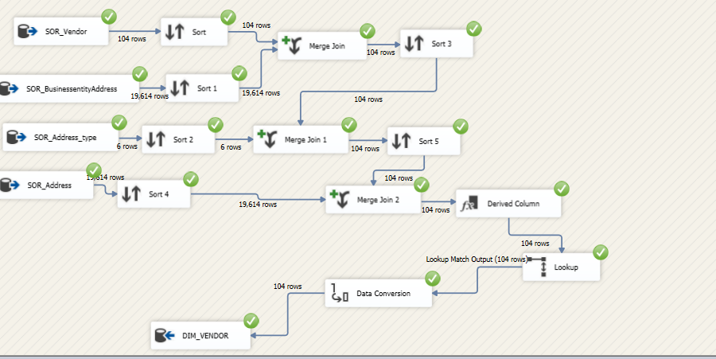

SELECT * FROM [adventureworksdw2014_purchasing].[dbo].[DimVendors]

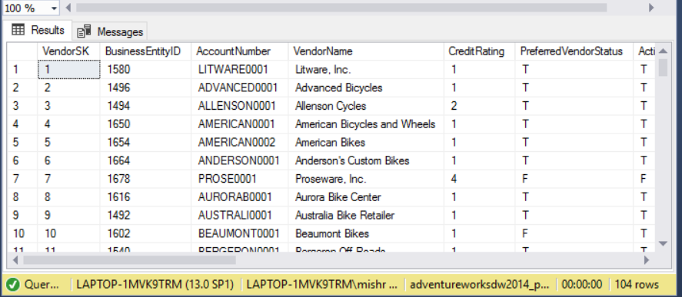

ROW COUNTS - 104

DIM VENDORCONTACT

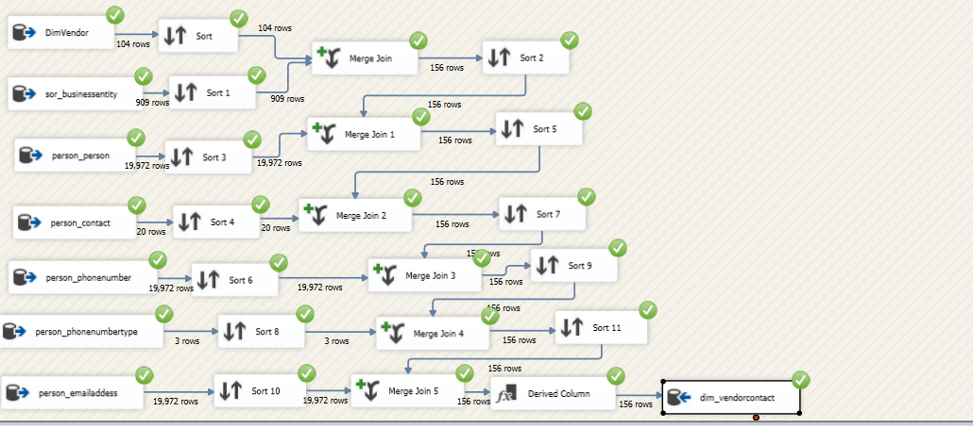

SELECT * FROM [adventureworksdw2014_purchasing].[dbo].[DimVendorContacts]

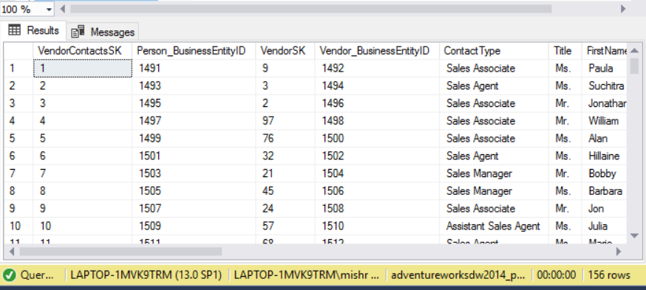

ROW COUNT - 156

DIM PRODUCT VENDOR

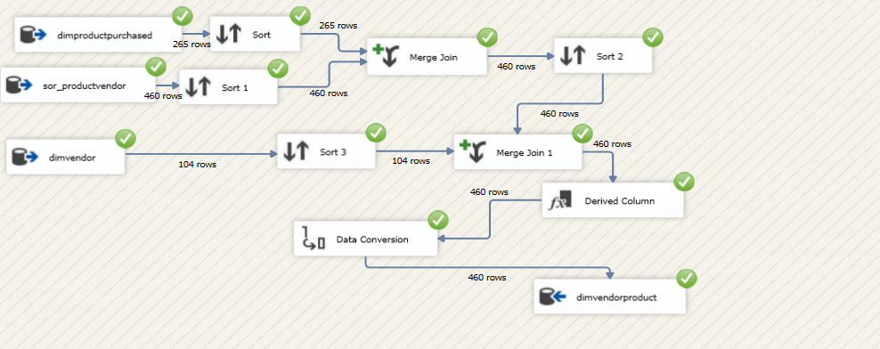

SELECT * FROM [adventureworksdw2014_purchasing].[dbo].[DimProductVendor]

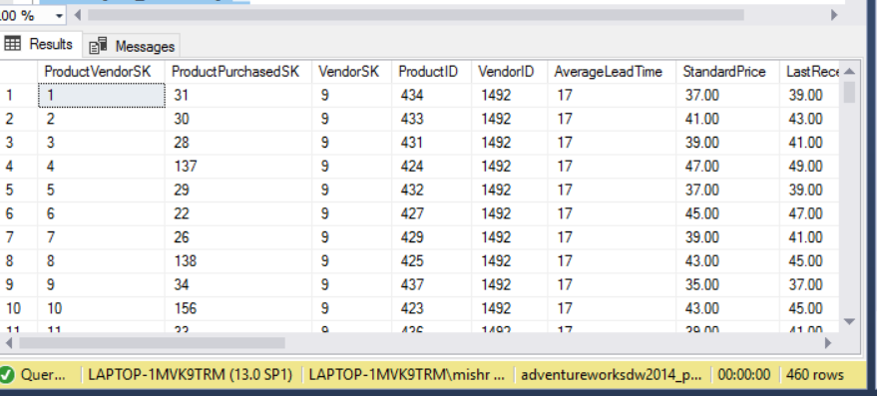

ROW COUNT - 460

DIM EMPLOYEE

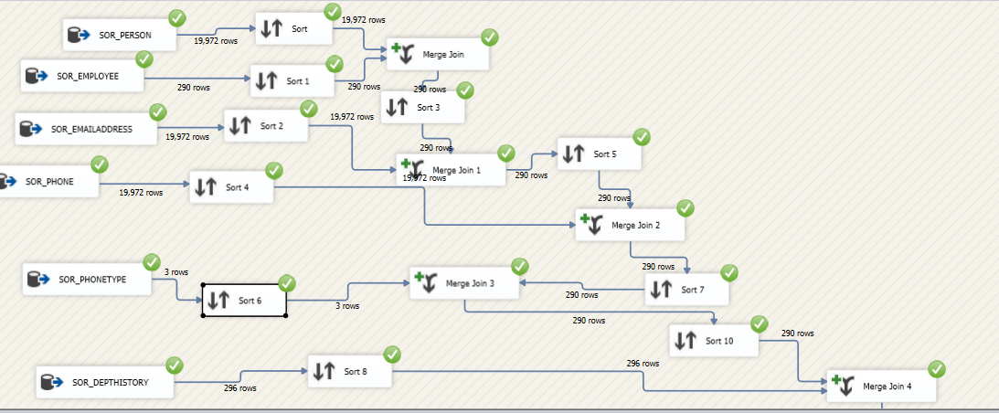

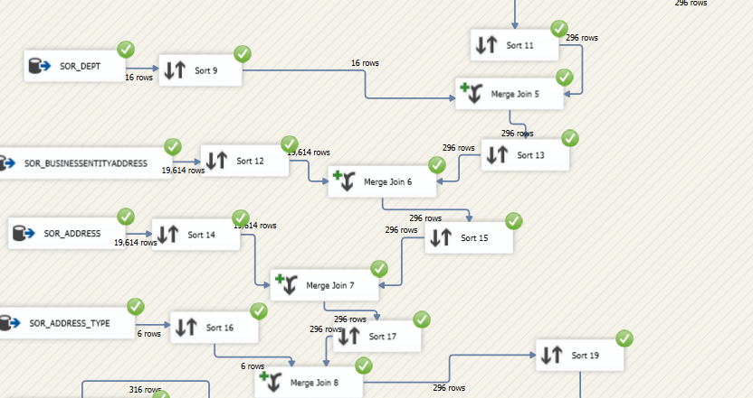

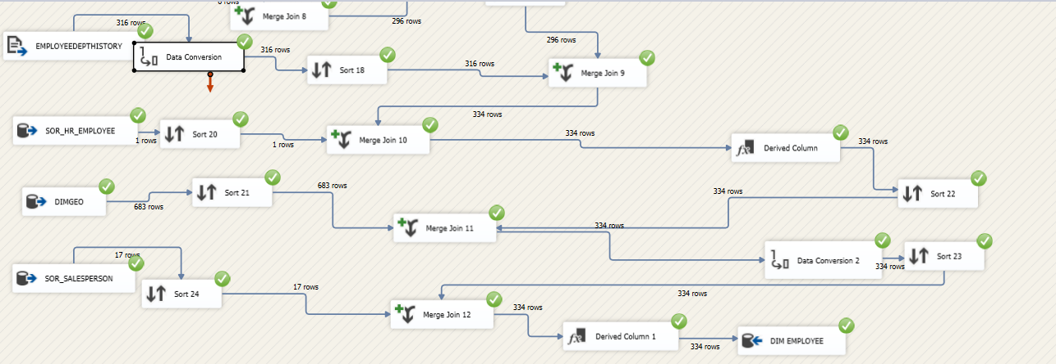

SELECT * FROM [adventureworksdw2014_purchasing].[dbo].[DimEmployee]

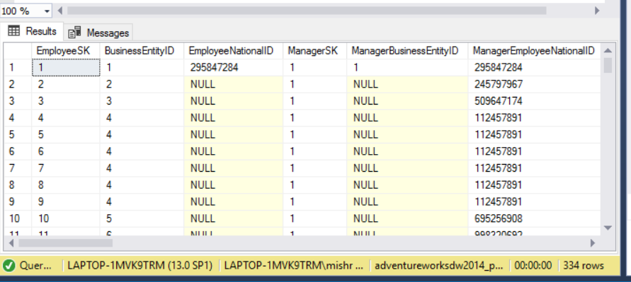

ROW COUNT - 334

FACT_WORKORDER AND DIM_WORKORDER_REJECT

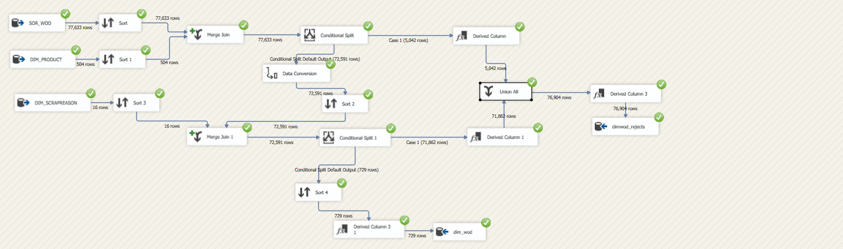

SELECT *FROM [adventureworksdw2014_purchasing].[dbo].[Fact_WorkOrder]

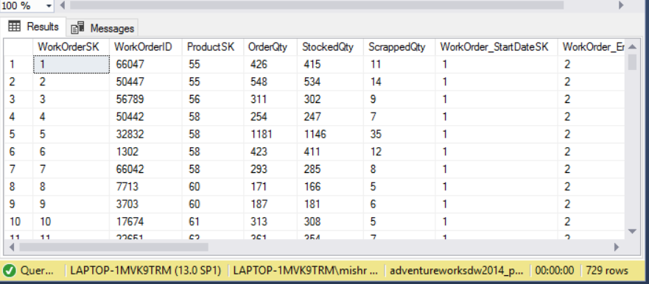

ROW COUNTS - 729(WORK ORDER)

SELECT * FROM [adventureworksdw2014_purchasing].[dbo].[Fact_WorkOrder_Rejects]

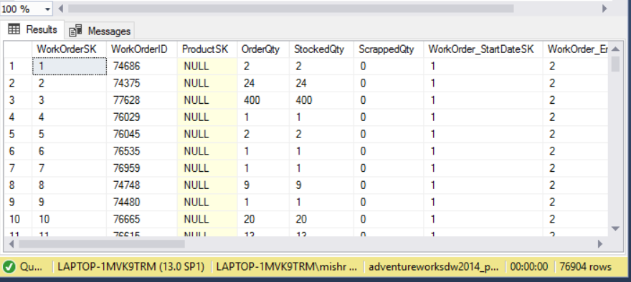

ROW COUNT - 76904 (WORK_ORDER_REJECT)

FACT_WORK_ORDER_ROUTING/WORK_ORDER_ROUTING_REJECT

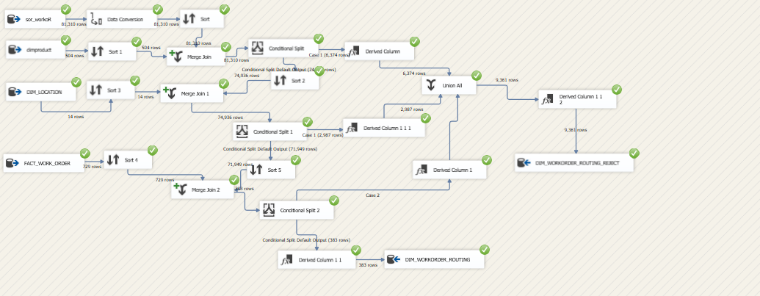

SELECT * FROM [adventureworksdw2014_purchasing].[dbo].[Fact_WorkOrderRouting]

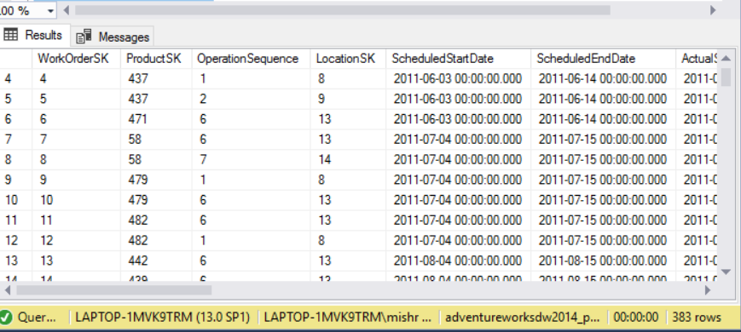

ROW COUNT - 383

SELECT * FROM [adventureworksdw2014_purchasing].[dbo].[Fact_WorkOrderRouting_Rejects]

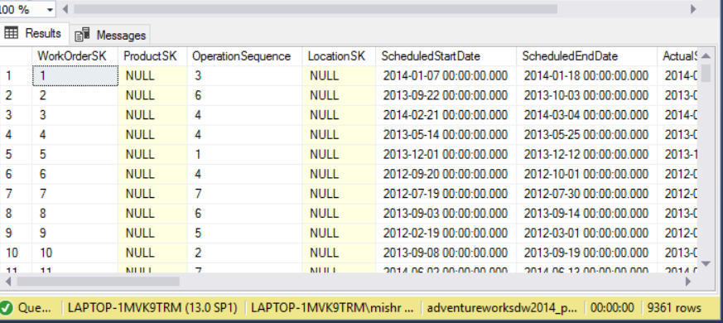

FACT_PURCHASE/PURCHASE_REJECTS

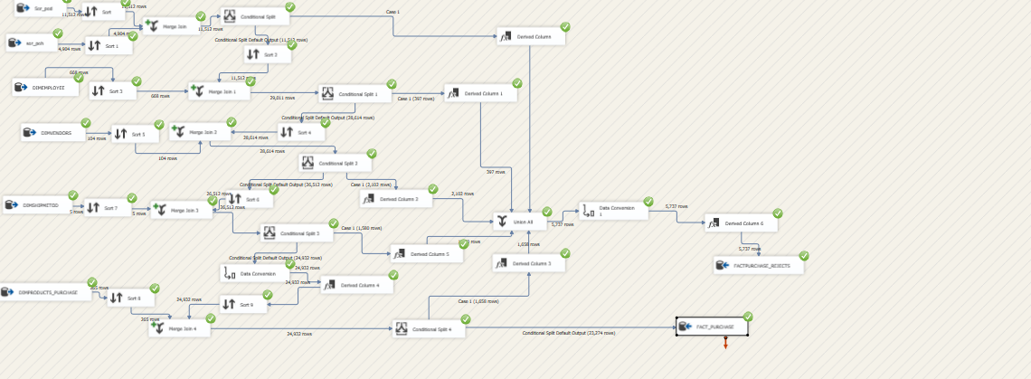

SELECT * FROM [adventureworksdw2014_purchasing].[dbo].[FactPurchases]

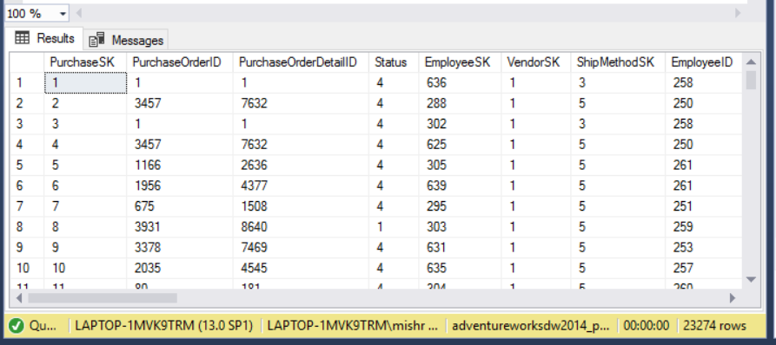

ROW COUNTS - 23274

SELECT * FROM FROM [adventureworksdw2014_purchasing].[dbo].[FactPurchases_rejects]

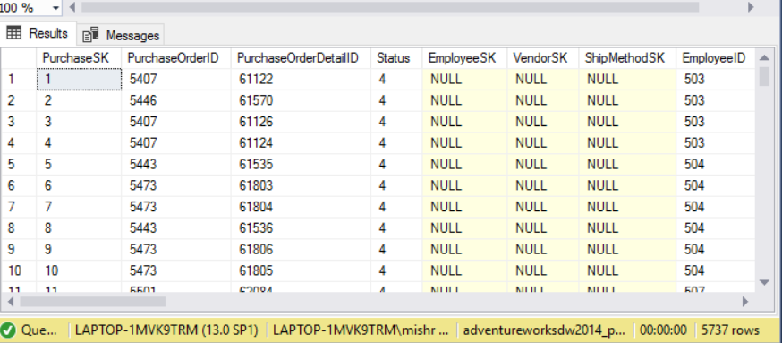

ROW COUNT - 5737

LISTPRICE-SCD

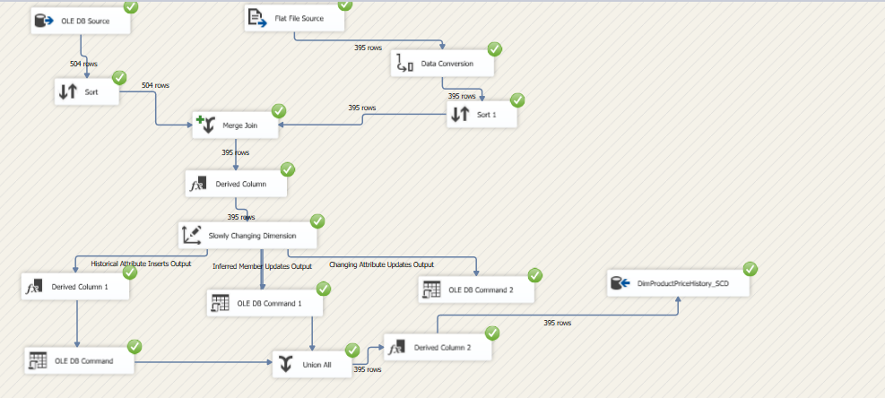

SELECT * FROM [adventureworksdw2014_purchasing].[dbo].[DimProductPriceHistory_SCD]

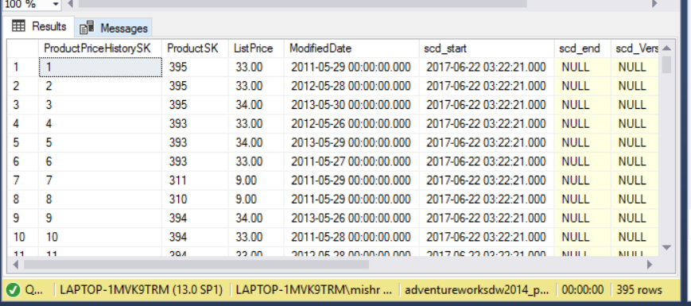

ROW COUNT - 395

DimProductCostHistory_SCD

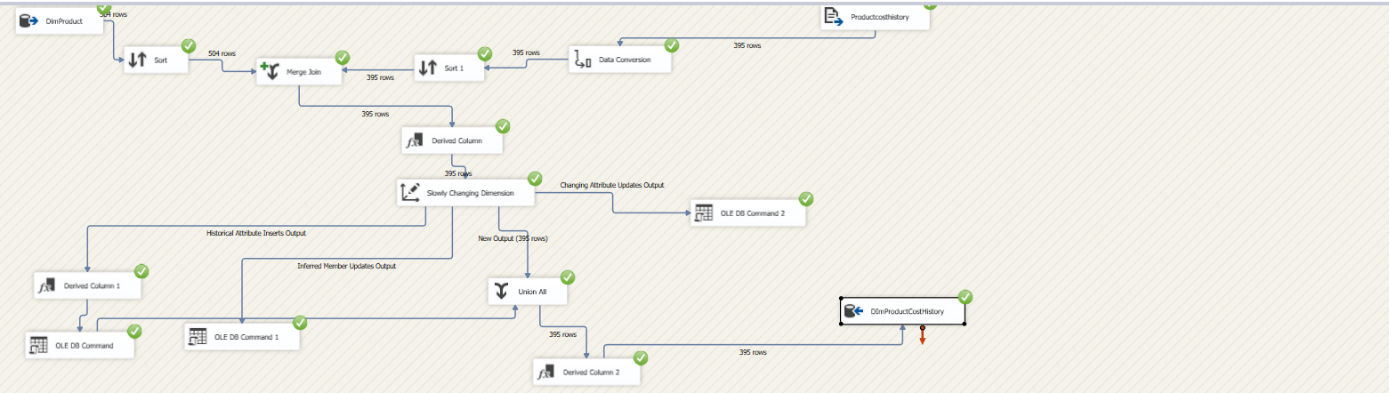

SELECT * FROM [adventureworksdw2014_purchasing].[dbo].[DimProductCostHistory_SCD]

ROW COUNT - 395

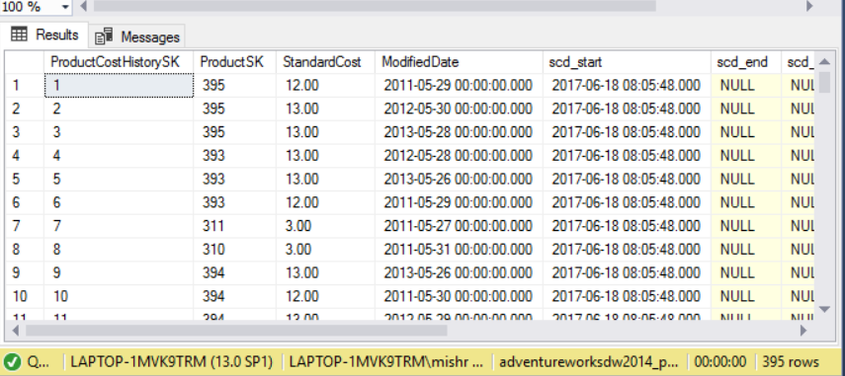

ROW COUNT - 395

REJECT CODE -

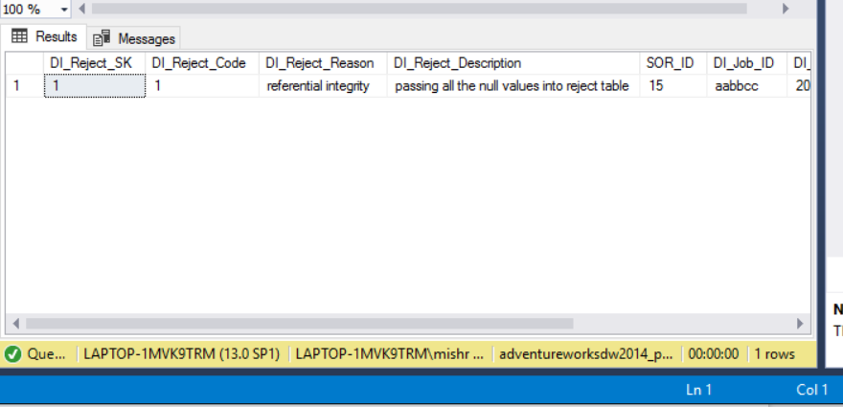

ROW COUNT - 1