REC-CIS

GE23131-Programming Using C-2024

Status Finished

Started Monday, 23 December 2024, 5:33 PM

Completed Monday, 28 October 2024, 9:08 AM

Duration 56 days 8 hours

Question 1

Correct

Marked out of 3.00

Flag question

Question textWrite a program to read two integer values and print true if both the numbers end with the same digit, otherwise print false. Example: If 698 and 768 are given, program should print true as they both end with 8. Sample Input 1 25 53 Sample Output 1 false Sample Input 2 27 77 Sample Output 2 true

Answer:(penalty regime: 0 %)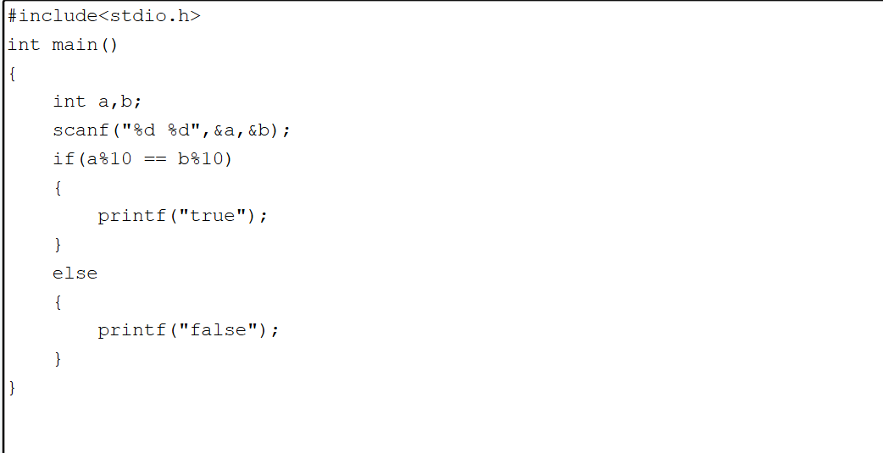

#include<stdio.h>

int main()

{

int a,b;

scanf("%d %d",&a,&b);

if(a%10 == b%10)

{

printf("true");

}

else

{

printf("false");

}

}

Feedback

Input Expected Got

25 53

false

false

27 77

true

true

Passed all tests!

Question 2

Correct

Marked out of 5.00

Flag question

Question text

Objective

In this challenge, we're getting started with conditional statements.

Task

Given an integer, n, perform the following conditional actions:

· If n is odd, print Weird

· If n is even and in the inclusive range of 2 to 5, print Not Weird

· If n is even and in the inclusive range of 6 to 20, print Weird

· If n is even and greater than 20, print Not Weird

Complete the stub code provided in your editor to print whether or not n is weird.

Input Format

A single line containing a positive integer, n.

Constraints

· 1 < n < 100

Output Format

Print Weird if the number is weird; otherwise, print Not Weird.

Sample Input 0

3

Sample Output 0

Weird

Sample Input 1

24

Sample Output 1

Not Weird

Explanation

Sample Case 0: n = 3

n is odd and odd numbers are weird, so we print Weird.

Sample Case 1: n = 24

n > 20 and n is even, so it isn't weird. Thus, we print Not Weird.

Answer:(penalty regime: 0 %)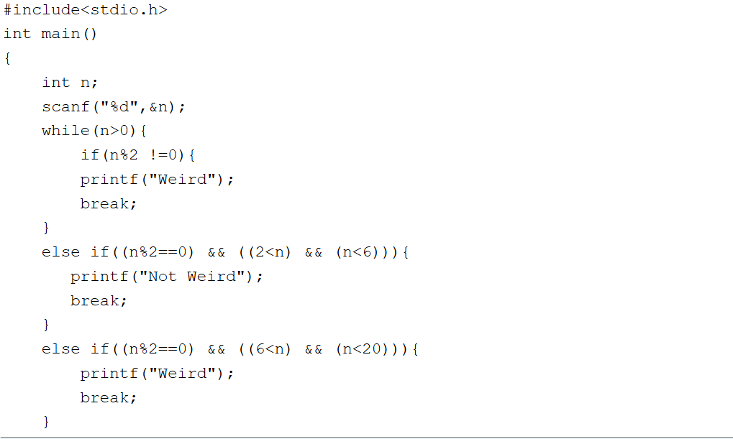

#include<stdio.h>

int main()

{

int n;

scanf("%d",&n);

while(n>0){

if(n%2 !=0){

printf("Weird");

break;

}

else if((n%2==0) && ((2<n) && (n<6))){

printf("Not Weird");

break;

}

else if((n%2==0) && ((6<n) && (n<20))){

printf("Weird");

break;

}

else if ((n%2==0) && (n>20)){

printf("Not Weird");

break;

}

}

}

Feedback

Input Expected Got

3

Weird

Weird

24

Not Weird

Not Weird

Passed all tests!

Question 3

Correct

Marked out of 7.00

Flag question

Question textThree numbers form a Pythagorean triple if the sum of squares of two numbers is equal to the square of the third. For example, 3, 5 and 4 form a Pythagorean triple, since 3\*3 + 4\*4 = 25 = 5\*5 You are given three integers, a, b, and c. They need not be given in increasing order. If they form a Pythagorean triple, then print "yes", otherwise, print "no". Please note that the output message is in small letters. Sample Input 1 3 5 4 Sample Output 1 yes Sample Input 2 5 8 2 Sample Output 2 no

Answer:(penalty regime: 0 %)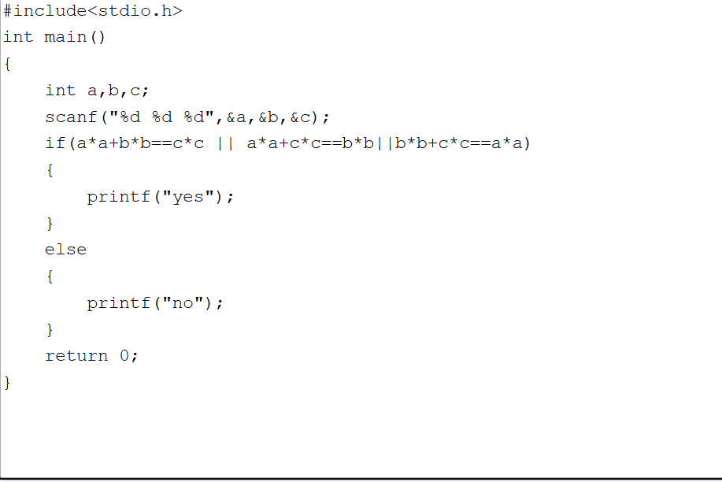

#include<stdio.h>

int main()

{

int a,b,c;

scanf("%d %d %d",&a,&b,&c);

if(a\*a+b\*b==c\*c || a\*a+c\*c==b\*b||b\*b+c\*c==a\*a)

{

printf("yes");

}

else

{

printf("no");

}

return 0;

}

Feedback

Input Expected Got

3

5

4

yes

yes

5

8

2

no

no

Passed all tests!

BlocksSkip Quiz navigation

Quiz navigation

Show one page at a time

Blocks