Skip to main content

REC-CIS

GE23131-Programming Using C-2024

Status Finished

Started Monday, 23 December 2024, 5:33 PM

Completed Tuesday, 29 October 2024, 9:06 AM

Duration 55 days 8 hours

Question 1

Correct

Marked out of 3.00

Flag question

Question text

Write a program that determines the name of a shape from its number of sides. Read the number of sides from the user and then report the appropriate name as part of a meaningful message. Your program should support shapes with anywhere from 3 up to (and including) 10 sides. If a number of sides outside of this range is entered then your program should display an appropriate error message.

Sample Input 1

3

Sample Output 1

Triangle

Sample Input 2

7

Sample Output 2

Heptagon

Sample Input 3

11

Sample Output 3

The number of sides is not supported.

Answer:(penalty regime: 0 %)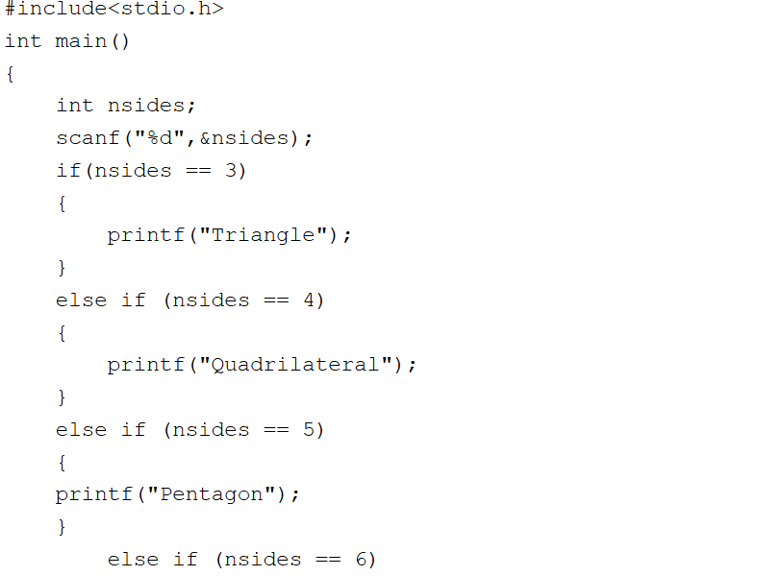

#include<stdio.h>

int main()

{

int nsides;

scanf("%d",&nsides);

if(nsides == 3)

{

printf("Triangle");

}

else if (nsides == 4)

{

printf("Quadrilateral");

}

else if (nsides == 5)

{

printf("Pentagon");

}

else if (nsides == 6)

{

printf("Hexagon");

}

else if(nsides == 7)

{

printf("Heptagon");

}

else if(nsides == 8)

{

printf("Octagon");

}

else if(nsides == 9)

{

printf("Nonagon");

}

else if(nsides == 10)

{

printf("Decagon");

}

else

{

printf("The number of sides is not supported.");

}

}

Feedback

Input Expected Got

3

Triangle

Triangle

7

Heptagon

Heptagon

11

The number of sides is not supported.

The number of sides is not supported.

Passed all tests!

Question 2

Correct

Marked out of 5.00

Flag question

Question text

The Chinese zodiac assigns animals to years in a 12-year cycle. One 12-year cycle is shown in the table below. The pattern repeats from there, with 2012 being another year of the Dragon, and 1999 being another year of the Hare.

Year Animal

2000 Dragon

2001 Snake

2002 Horse

2003 Sheep

2004 Monkey

2005 Rooster

2006 Dog

2007 Pig

2008 Rat

2009 Ox

2010 Tiger

2011 Hare

Write a program that reads a year from the user and displays the animal associated with that year. Your program should work correctly for any year greater than or equal to zero, not just the ones listed in the table.

Sample Input 1

2004

Sample Output 1

Monkey

Sample Input 2

2010

Sample Output 2

Tiger

Answer:(penalty regime: 0 %)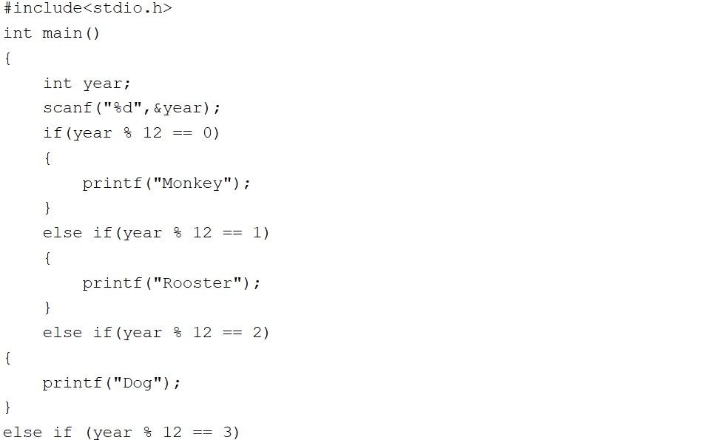

#include<stdio.h>

int main()

{

int year;

scanf("%d",&year);

if(year % 12 == 0)

{

printf("Monkey");

}

else if(year % 12 == 1)

{

printf("Rooster");

}

else if(year % 12 == 2)

{

printf("Dog");

}

else if (year % 12 == 3)

{

printf("Pig");

}

else if (year % 12 == 4)

{

printf("Rat");

}

else if (year % 12 == 5)

{

printf("Ox");

}

else if (year % 12 == 6)

{

printf("Tiger");

}

else if (year % 12 == 7)

{

printf("Hare");

}

else if (year % 12 == 8)

{

printf("Dragon");

}

else if (year % 12 == 9)

{

printf("Snake");

}

else if (year % 12 == 10)

{

printf("Horse");

}

else

{

printf("Sheep");

}

}

Feedback

Input Expected Got

2004

Monkey

Monkey

2010

Tiger

Tiger

Passed all tests!

Question 3

Correct

Marked out of 7.00

Flag question

Question text

Positions on a chess board are identiﬁed by a letter and a number. The letter identiﬁes the column, while the number identiﬁes the row, as shown below:

Write a program that reads a position from the user. Use an if statement to determine if the column begins with a black square or a white square. Then use modular arithmetic to report the color of the square in that row. For example, if the user enters a1 then your program should report that the square is black. If the user enters d5 then your program should report that the square is white. Your program may assume that a valid position will always be entered. It does not need to perform any error checking.

Sample Input 1

a 1

Sample Output 1

The square is black.

Sample Input 2

d 5

Sample Output 2

The square is white.

Answer:(penalty regime: 0 %)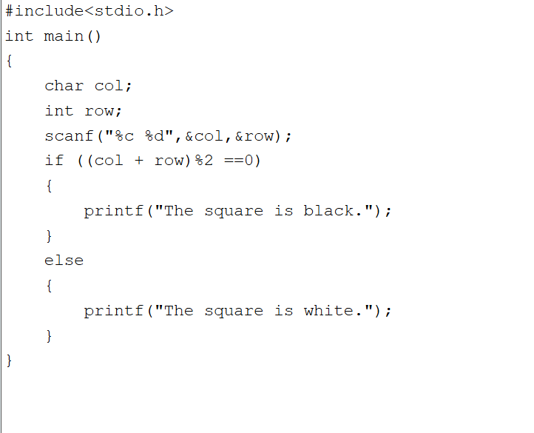

#include<stdio.h>

int main()

{

char col;

int row;

scanf("%c %d",&col,&row);

if ((col + row)%2 ==0)

{

printf("The square is black.");

}

else

{

printf("The square is white.");

}

}

Feedback

Input Expected Got

a 1

The square is black.

The square is black.

d 5

The square is white.

The square is white.

Passed all tests!