REC-CIS

GE23131-Programming Using C-2024

Status Finished

Started Tuesday, 24 December 2024, 6:32 PM

Completed Tuesday, 24 December 2024, 6:51 PM

Duration 19 mins 18 secs

Question 1

Correct

Marked out of 1.00

Flag question

Question text

Given a string, s, consisting of alphabets and digits, find the frequency of each digit in the given string.

Input Format

The first line contains a string, num which is the given number.

Constraints

1 ≤ len(num) ≤ 1000

All the elements of num are made of English alphabets and digits.

Output Format

Print ten space-separated integers in a single line denoting the frequency of each digit from 0 to 9.

Sample Input 0

a11472o5t6

Sample Output 0

0 2 1 0 1 1 1 1 0 0

Explanation 0

In the given string:

· 1 occurs two times.

· 2, 4, 5, 6 and 7 occur one time each.

The remaining digits 0, 3, 8 and 9 don't occur at all.

Answer:(penalty regime: 0 %)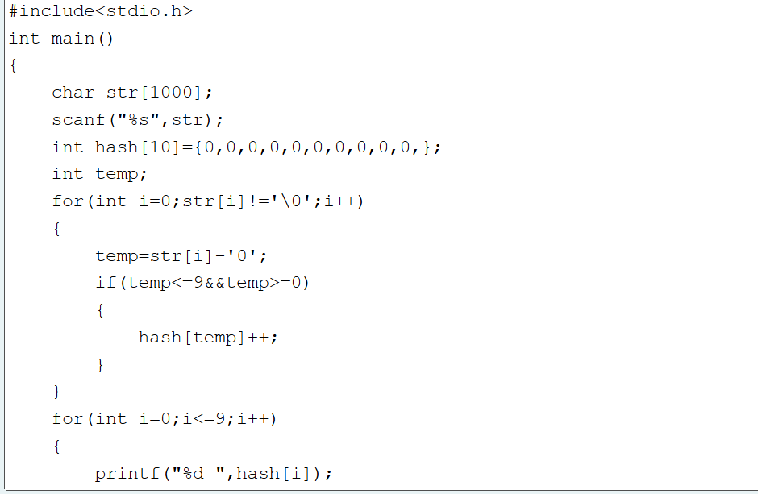

#include<stdio.h>

int main()

{

char str[1000];

scanf("%s",str);

int hash[10]={0,0,0,0,0,0,0,0,0,0,};

int temp;

for(int i=0;str[i]!='\0';i++)

{

temp=str[i]-'0';

if(temp<=9&&temp>=0)

{

hash[temp]++;

}

}

for(int i=0;i<=9;i++)

{

printf("%d ",hash[i]);

}

return 0;

}

Feedback

Input Expected Got

a11472o5t6

0 2 1 0 1 1 1 1 0 0

0 2 1 0 1 1 1 1 0 0

lw4n88j12n1

0 2 1 0 1 0 0 0 2 0

0 2 1 0 1 0 0 0 2 0

1v88886l256338ar0ekk

1 1 1 2 0 1 2 0 5 0

1 1 1 2 0 1 2 0 5 0

Passed all tests!

Question 2

Correct

Marked out of 1.00

Flag question

Question text

Today, Monk went for a walk in a garden. There are many trees in the garden and each tree has an English alphabet on it. While Monk was walking, he noticed that all trees with vowels on it are not in good state. He decided to take care of them. So, he asked you to tell him the count of such trees in the garden.

Note: The following letters are vowels: 'A', 'E', 'I', 'O', 'U', 'a', 'e', 'i', 'o' and 'u'.

Input:

The first line consists of an integer T denoting the number of test cases.

Each test case consists of only one string, each character of string denoting the alphabet (may be lowercase or uppercase) on a tree in the garden.

Output:

For each test case, print the count in a new line.

Constraints:

1 ≤ T ≤ 10

1 ≤ length of string ≤ 105

SAMPLE INPUT

2

nBBZLaosnm

JHkIsnZtTL

SAMPLE OUTPUT

2

1

Explanation

In test case 1, a and o are the only vowels. So, count=2

Answer:(penalty regime: 0 %)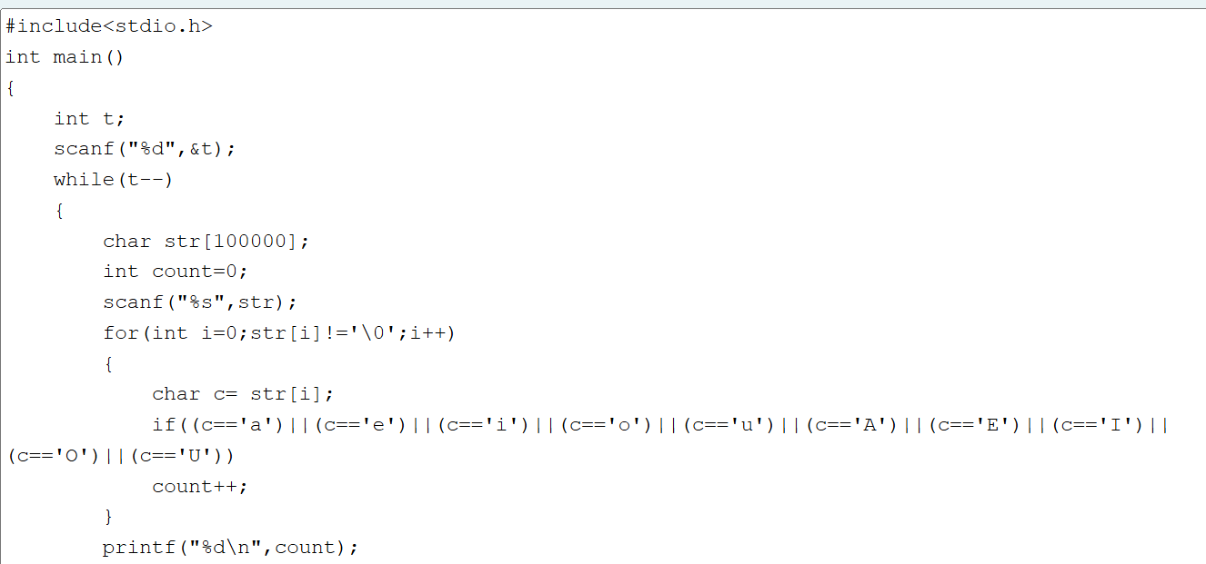

#include<stdio.h>

int main()

{

int t;

scanf("%d",&t);

while(t--)

{

char str[100000];

int count=0;

scanf("%s",str);

for(int i=0;str[i]!='\0';i++)

{

char c= str[i];

if((c=='a')||(c=='e')||(c=='i')||(c=='o')||(c=='u')||(c=='A')||(c=='E')||(c=='I')||(c=='O')||(c=='U'))

count++;

}

printf("%d\n",count);

}

return 0;

}

Feedback

Input Expected Got

2

nBBZLaosnm

JHkIsnZtTL

2

1

2

1

2

nBBZLaosnm

JHkIsnZtTL

2

1

2

1

Passed all tests!

Question 3

Correct

Marked out of 1.00

Flag question

Question text

Given a sentence, s, print each word of the sentence in a new line.

Input Format

The first and only line contains a sentence, s.

Constraints

1 ≤ len(s) ≤ 1000

Output Format

Print each word of the sentence in a new line.

Sample Input 0

This is C

Sample Output 0

This

is

C

Explanation 0

In the given string, there are three words ["This", "is", "C"]. We have to print each of these words in a new line.

Answer:(penalty regime: 0 %)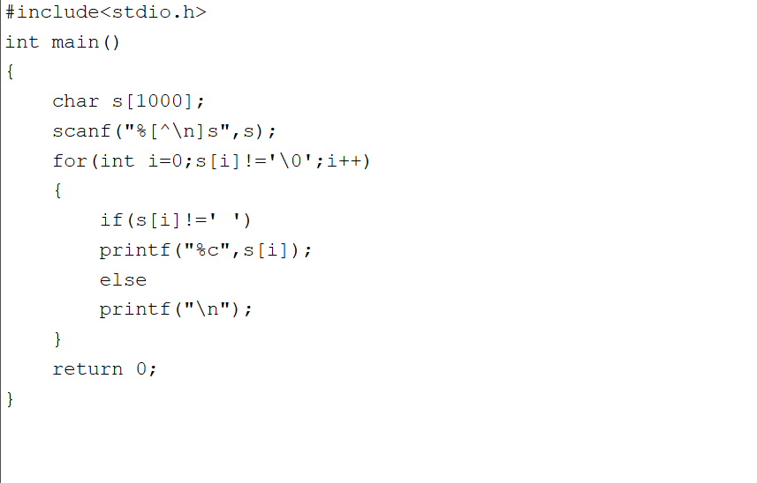

#include<stdio.h>

int main()

{

char s[1000];

scanf("%[^\n]s",s);

for(int i=0;s[i]!='\0';i++)

{

if(s[i]!=' ')

printf("%c",s[i]);

else

printf("\n");

}

return 0;

}

Feedback

Input Expected Got

This is C

This

is

C

This

is

C

Learning C is fun

Learning

C

is

fun

Learning

C

is

fun

Passed all tests!

Question 4

Correct

Marked out of 1.00

Flag question

Question text

Input Format

You are given two strings, a and b, separated by a new line. Each string will consist of lower case Latin characters ('a'-'z').

Output Format

In the first line print two space-separated integers, representing the length of a and b respectively.

In the second line print the string produced by concatenating a and b (a + b).

In the third line print two strings separated by a space, a' and b'. a' and b' are the same as a and b, respectively, except that their first characters are swapped.

Sample Input

abcd

ef

Sample Output

4 2

abcdef

ebcd af

Explanation

a = "abcd"

b = "ef"

|a| = 4

|b| = 2

a + b = "abcdef"

a' = "ebcd"

b' = "af"

Answer:(penalty regime: 0 %)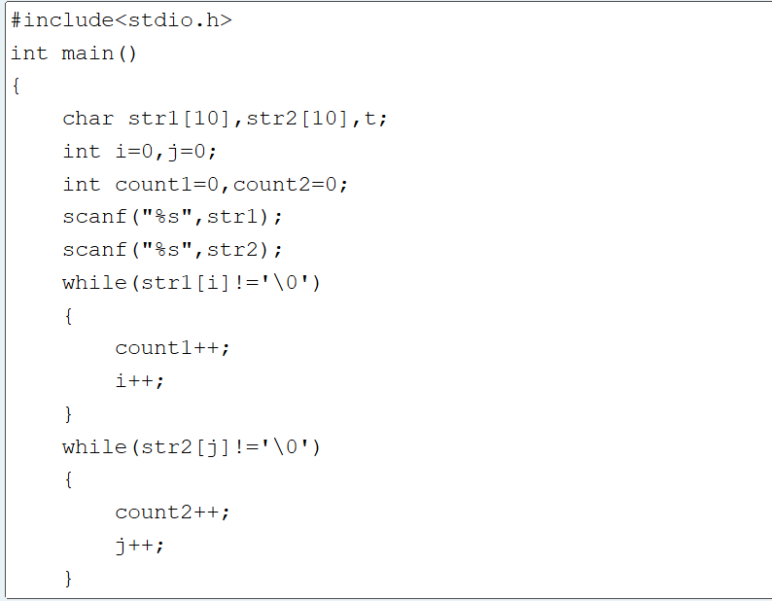

#include<stdio.h>

int main()

{

char str1[10],str2[10],t;

int i=0,j=0;

int count1=0,count2=0;

scanf("%s",str1);

scanf("%s",str2);

while(str1[i]!='\0')

{

count1++;

i++;

}

while(str2[j]!='\0')

{

count2++;

j++;

}

printf("%d %d\n",count1,count2);

printf("%s%s\n",str1,str2);

t=str1[0];

str1[0]=str2[0];

str2[0]=t;

printf("%s %s",str1,str2);

return 0;

}

Feedback

Input Expected Got

abcd

ef

4 2

abcdef

ebcd af

4 2

abcdef

ebcd af

Passed all tests!

BlocksSkip Quiz navigation

Quiz navigation

Show one page at a time

Blocks