Skip to main content

REC-CIS

GE23131-Programming Using C-2024

Status Finished

Started Monday, 13 January 2025, 10:52 AM

Completed Monday, 13 January 2025, 11:00 AM

Duration 8 mins 31 secs

Question 1

Correct

Marked out of 1.00

Flag question

Question text

Given an array of integers, reverse the given array in place using an index and loop rather than a built-in function.

Example

arr = [1, 3, 2, 4, 5]

Return the array [5, 4, 2, 3, 1] which is the reverse of the input array.

Function Description

Complete the function reverseArray in the editor below.

reverseArray has the following parameter(s):

int arr[n]: an array of integers

Return

int[n]: the array in reverse order

Constraints

1 ≤ n ≤ 100

0 < arr[i] ≤ 100

Input Format For Custom Testing

The first line contains an integer, n, the number of elements in arr.

Each line i of the n subsequent lines (where 0 ≤ i < n) contains an integer, arr[i].

Sample Case 0

Sample Input For Custom Testing

5

1

3

2

4

5

Sample Output

5

4

2

3

1

Explanation

The input array is [1, 3, 2, 4, 5], so the reverse of the input array is [5, 4, 2, 3, 1].

Sample Case 1

Sample Input For Custom Testing

4

17

10

21

45

Sample Output

45

21

10

17

Explanation

The input array is [17, 10, 21, 45], so the reverse of the input array is [45, 21, 10, 17].

Answer:(penalty regime: 0 %)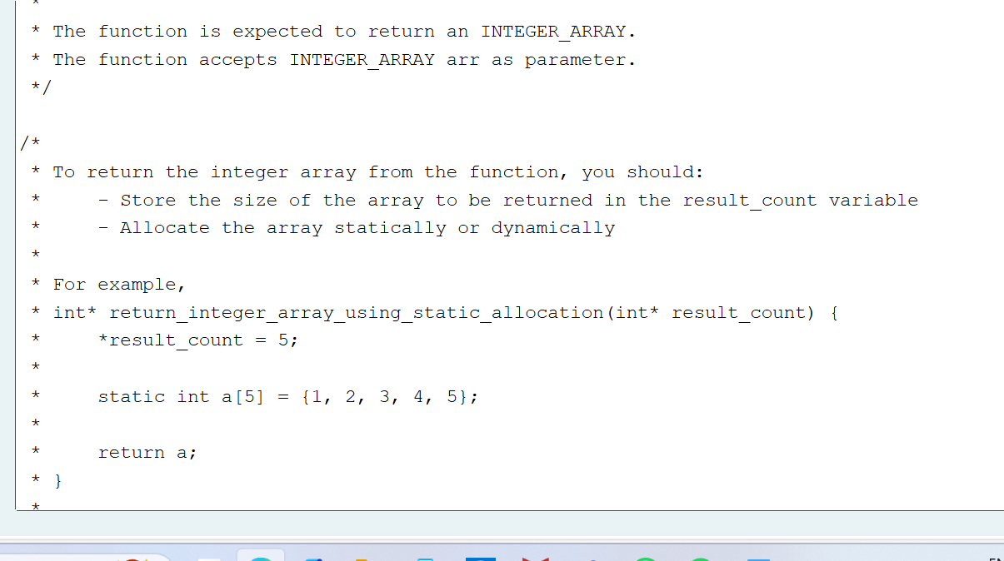

/*

* Complete the 'reverseArray' function below.

*

* The function is expected to return an INTEGER_ARRAY.

* The function accepts INTEGER_ARRAY arr as parameter.

*/

/*

* To return the integer array from the function, you should:

* - Store the size of the array to be returned in the result_count variable

* - Allocate the array statically or dynamically

*

* For example,

* int* return_integer_array_using_static_allocation(int* result_count) {

* *result_count = 5;

*

* static int a[5] = {1, 2, 3, 4, 5};

*

* return a;

* }

*

* int* return_integer_array_using_dynamic_allocation(int* result_count) {

* *result_count = 5;

*

* int *a = malloc(5 * sizeof(int));

*

* for (int i = 0; i < 5; i++) {

* *(a + i) = i + 1;

* }

*

* return a;

* }

*

*/

int* reverseArray(int arr_count, int *arr, int *result_count) {

*result_count=arr_count;

int*result=(int *)malloc(arr_count* sizeof(int));

for(int i=0;i<arr_count;i++)

{

result[i]=arr[arr_count-1-i];

}

return result;

}

Feedback

Test Expected Got

int arr[] = {1, 3, 2, 4, 5};

int result_count;

int* result = reverseArray(5, arr, &result_count);

for (int i = 0; i < result_count; i++)

printf("%d\n", *(result + i));

5

4

2

3

1

5

4

2

3

1

Passed all tests!

Question 2

Correct

Marked out of 1.00

Flag question

Question text

An automated cutting machine is used to cut rods into segments. The cutting machine can only hold a rod of minLength or more, and it can only make one cut at a time. Given the array lengths[] representing the desired lengths of each segment, determine if it is possible to make the necessary cuts using this machine. The rod is marked into lengths already, in the order given.

Example

n = 3

lengths = [4, 3, 2]

minLength = 7

The rod is initially sum(lengths) = 4 + 3 + 2 = 9 units long. First cut off the segment of length 4 + 3 = 7 leaving a rod 9 - 7 = 2. Then check that the length 7 rod can be cut into segments of lengths 4 and 3. Since 7 is greater than or equal to minLength = 7, the final cut can be made. Return "Possible".

Example

n = 3

lengths = [4, 2, 3]

minLength = 7

The rod is initially sum(lengths) = 4 + 2 + 3 = 9 units long. In this case, the initial cut can be of length 4 or 4 + 2 = 6. Regardless of the length of the first cut, the remaining piece will be shorter than minLength. Because n - 1 = 2 cuts cannot be made, the answer is "Impossible".

Function Description

Complete the function cutThemAll in the editor below.

cutThemAll has the following parameter(s):

int lengths[n]: the lengths of the segments, in order

int minLength: the minimum length the machine can accept

Returns

string: "Possible" if all n-1 cuts can be made. Otherwise, return the string "Impossible".

Constraints

· 2 ≤ n ≤ 105

· 1 ≤ t ≤ 109

· 1 ≤ lengths[i] ≤ 109

· The sum of the elements of lengths equals the uncut rod length.

Input Format For Custom Testing

The first line contains an integer, n, the number of elements in lengths.

Each line i of the n subsequent lines (where 0 ≤ i < n) contains an integer, lengths[i].

The next line contains an integer, minLength, the minimum length accepted by the machine.

Sample Case 0

Sample Input For Custom Testing

STDIN Function

----- --------

4 → lengths[] size n = 4

3 → lengths[] = [3, 5, 4, 3]

5

4

3

9 → minLength= 9

Sample Output

Possible

Explanation

The uncut rod is 3 + 5 + 4 + 3 = 15 units long. Cut the rod into lengths of 3 + 5 + 4 = 12 and 3. Then cut the 12 unit piece into lengths 3 and 5 + 4 = 9. The remaining segment is 5 + 4 = 9 units and that is long enough to make the final cut.

Sample Case 1

Sample Input For Custom Testing

STDIN Function

----- --------

3 → lengths[] size n = 3

5 → lengths[] = [5, 6, 2]

6

2

12 → minLength= 12

Sample Output

Impossible

Explanation

The uncut rod is 5 + 6 + 2 = 13 units long. After making either cut, the rod will be too short to make the second cut.

Answer:(penalty regime: 0 %)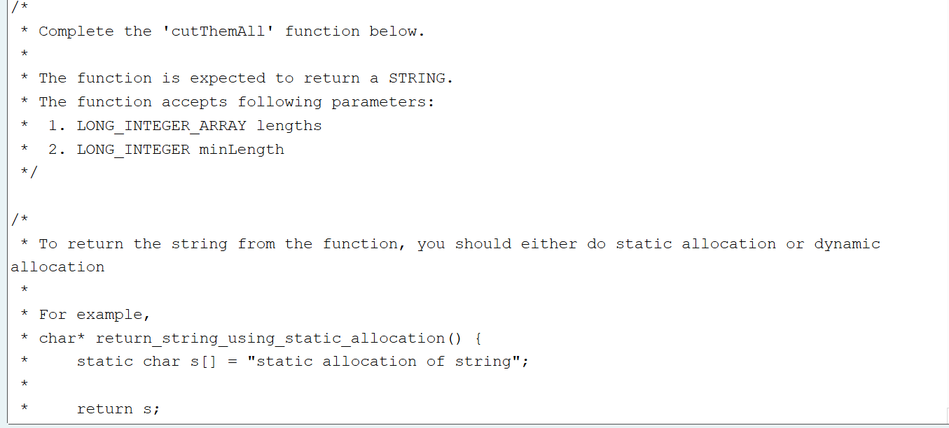

/*

* Complete the 'cutThemAll' function below.

*

* The function is expected to return a STRING.

* The function accepts following parameters:

* 1. LONG_INTEGER_ARRAY lengths

* 2. LONG_INTEGER minLength

*/

/*

* To return the string from the function, you should either do static allocation or dynamic allocation

*

* For example,

* char* return_string_using_static_allocation() {

* static char s[] = "static allocation of string";

*

* return s;

* }

*

* char* return_string_using_dynamic_allocation() {

* char* s = malloc(100 * sizeof(char));

*

* s = "dynamic allocation of string";

*

* return s;

* }

*

*/

char* cutThemAll(int lengths_count, long *lengths, long minLength) {

int s=0;

for(int i=0;i<lengths_count-1;i++)

{

s+=*(lengths+i);

}

if(s>=minLength){

return "Possible";

}

else{

return "Impossible";

}

}

Feedback

Test Expected Got

long lengths[] = {3, 5, 4, 3};

printf("%s", cutThemAll(4, lengths, 9))

Possible

Possible

long lengths[] = {5, 6, 2};

printf("%s", cutThemAll(3, lengths, 12))

Impossible

Impossible

Passed all tests!

BlocksSkip Quiz navigation

Quiz navigation

Show one page at a time

Blocks