Trader Performance vs. Market Sentiment
Bitcoin Fear & Greed Index × Hyperliquid Historical Trade Data
Data period analyzed: May 1, 2023 – May 1, 2025
211,218 trades · 104,402 realized (closed-PnL) trades · 32 accounts · 246 traded assets

1. Executive Summary
This report analyzes 32 Hyperliquid trader accounts across roughly 500 trading days, matched by calendar date to the Bitcoin Fear & Greed Index. The goal is to quantify how trader behavior and profitability shift with market sentiment, and to translate that into practical trading-strategy guidance.
Key findings:
- Traders as a group were profitable in every sentiment regime, but performance and behavior differ sharply by regime. Overall win rate across 104,402 closed trades was 83.2%, with total realized PnL of $10.25M.
- Extreme Greed produced the best per-trade economics: 89.2% win rate and $130 average PnL per trade — the highest of any regime — despite traders taking smaller position sizes ($3,112 avg).
- Fear was the most active and second-most profitable regime overall ($3.36M total PnL, 87.3% win rate) and traders used their largest average position size ($7,816) here.
- Extreme Fear is the outlier to treat with caution: it shows the highest PnL-per-day and trades-per-day, but this is based on only 14 calendar days concentrated in a handful of dates in early 2025, and is driven by a small number of accounts — not a robust regime-level signal.
- Traders are structurally contrarian: 68.8% of new positions opened during Extreme Fear are Longs, flipping to 57.7% Shorts during Greed — i.e., traders buy fear and sell greed, a pattern consistent with the strongest win rates observed.
- Sentiment score and daily PnL are weakly negatively correlated (r ≈ -0.10 same-day, r ≈ -0.13 next-day), meaning that as fear deepens, aggregate trader profitability tends to modestly increase — reinforcing the contrarian-edge finding.

2. Data & Methodology

2.1 Datasets
- Bitcoin Fear & Greed Index: daily sentiment classification (Extreme Fear, Fear, Neutral, Greed, Extreme Greed) and 0–100 score, Feb 2018 – May 2025 (2,644 days).
- Hyperliquid historical trades: 211,224 executions across 32 accounts and 246 symbols, May 2023 – May 2025, including execution price, size (tokens & USD), side, direction (open/close, long/short), closed PnL, and fees.

2.2 Approach
- Trade timestamps were normalized to calendar date (IST) and left-joined to the daily sentiment classification. Only 6 of 211,224 trades (<0.01%) failed to match a sentiment date and were dropped.
- "Performance" metrics use the 104,402 trades with non-zero Closed PnL (i.e., position-closing trades where a realized gain/loss exists). "Activity" metrics (trade counts, size, side mix) use all 211,218 matched trades.
- Because the five sentiment regimes span very different numbers of calendar days in this dataset (Extreme Fear = 14 days vs. Greed = 193 days), day-normalized metrics (per-day PnL, per-day trade count) are reported alongside totals to avoid misreading a data-sparse regime as a stronger effect than it is.

3. Performance by Market Sentiment

3.1 Realized PnL & Win Rate
Sentiment | Closed Trades | Total PnL | Avg PnL / Trade | Win Rate
Extreme Fear | 10,406 | $739,110 | $71.03 | 76.2%
Fear | 29,808 | $3,357,155 | $112.63 | 87.3%
Neutral | 18,159 | $1,292,921 | $71.20 | 82.4%
Greed | 25,176 | $2,150,129 | $85.40 | 76.9%
Extreme Greed | 20,853 | $2,715,171 | $130.21 | 89.2%
Table 1. Realized trading performance by sentiment regime (closed-PnL trades only).
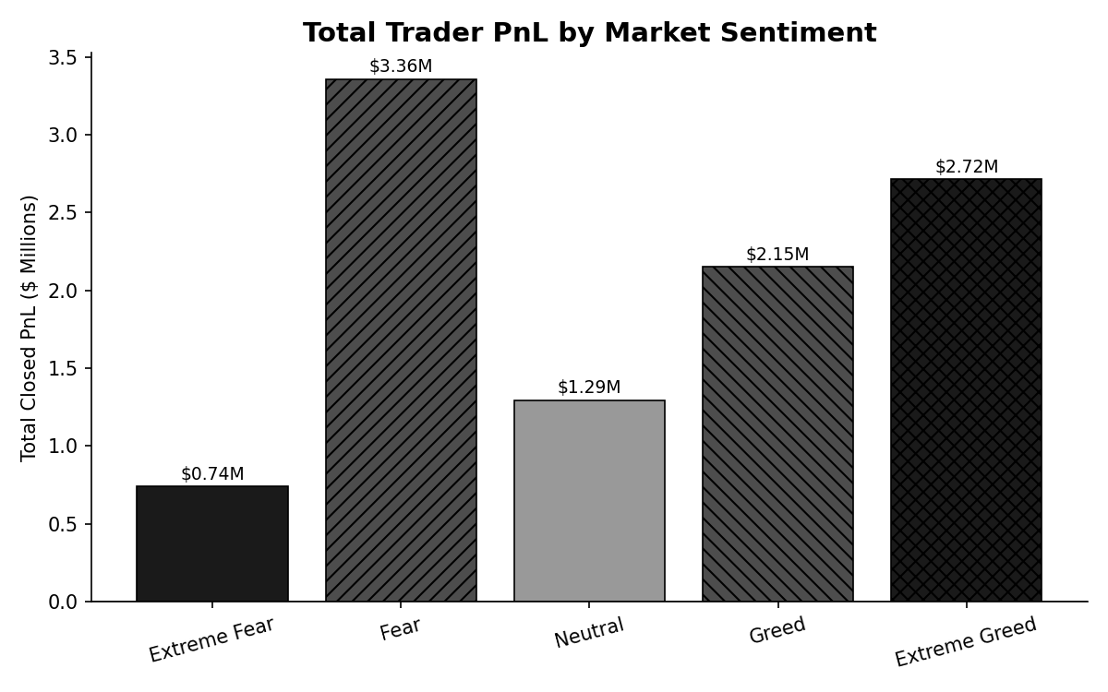
Figure 1. Total realized PnL by market sentiment. Fear and Extreme Greed generated the largest aggregate profits.
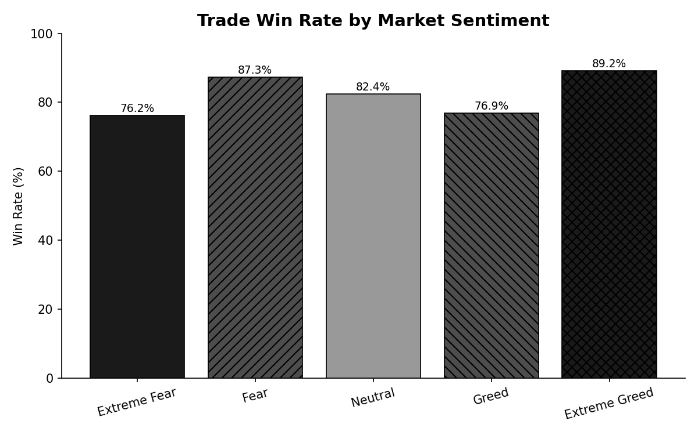
Figure 2. Win rate by market sentiment. Extreme Greed and Fear show the highest share of profitable trades.
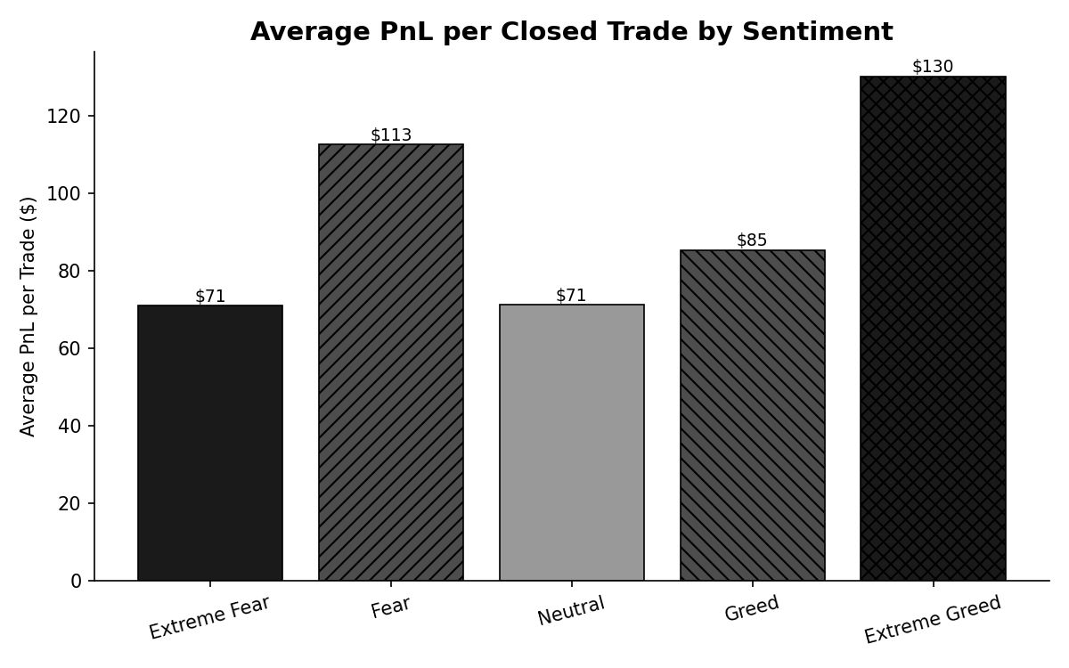
Figure 3. Average PnL per closed trade — the clearest efficiency measure, unaffected by trade-count differences across regimes.
The per-trade economics tell the most consistent story: Extreme Greed ($130.21) and Fear ($112.63) are the two most efficient regimes on a per-trade basis, while Neutral and Extreme Fear trail. This suggests traders extract the most value at emotional extremes — deep pessimism and outright euphoria — rather than in ambiguous, range-bound sentiment.

3.2 A Closer Look at the Sentiment Spectrum
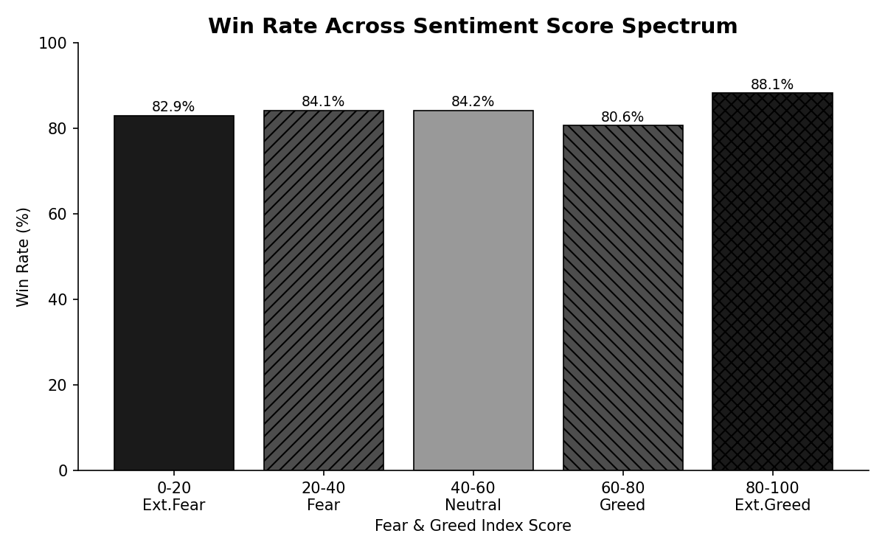
Figure 4. Win rate plotted against the raw 0–100 Fear & Greed score (binned). The pattern is broadly U/W-shaped: performance is stronger at both tails of the index than in the 60–80 (Greed) band.
Win rate dips to its lowest point in the 60–80 "Greed" band (80.6%) before climbing again into Extreme Greed (88.1%) — consistent with a market where moderate optimism produces more false signals and choppier outcomes than either capitulation or euphoric blow-off phases.

4. Trader Behavior by Sentiment

4.1 Positioning Bias — Contrarian Behavior
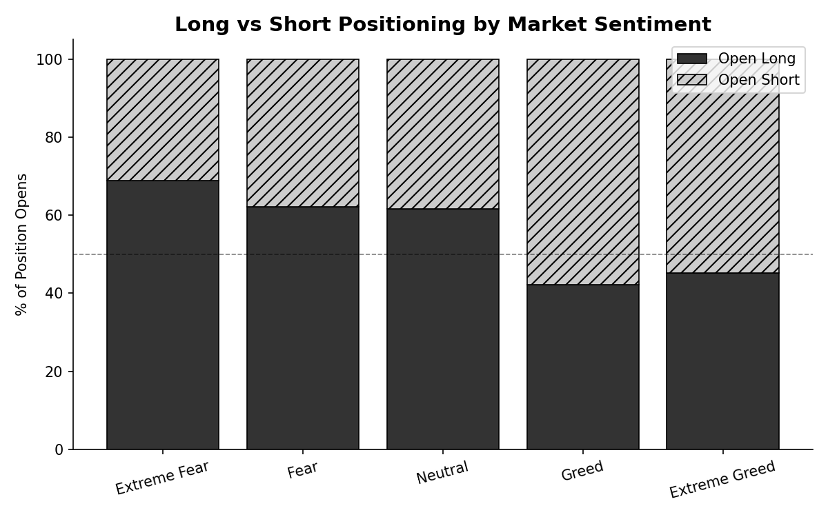
Figure 5. Share of new positions opened Long vs. Short, by sentiment regime.
Sentiment | % Opened Long | % Opened Short
Extreme Fear | 68.8% | 31.2%
Fear | 62.1% | 37.9%
Neutral | 61.7% | 38.3%
Greed | 42.3% | 57.7%
Extreme Greed | 45.1% | 54.9%
Table 2. Long/short positioning skew by sentiment.
These accounts behave as net contrarians: long positioning peaks during Extreme Fear (68.8%) and falls steadily as sentiment rises, flipping to a short bias once sentiment crosses into Greed territory. This "buy fear, sell greed" pattern lines up with the win-rate data above — the regimes where traders lean hardest into contrarian positioning (Extreme Fear, Fear, Extreme Greed) are also where win rates are highest.

4.2 Risk Appetite — Position Sizing
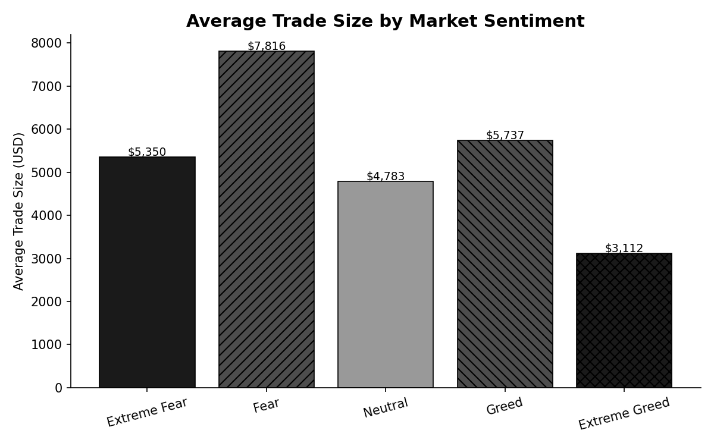
Figure 6. Average trade size (USD) by sentiment.
Traders size up meaningfully during Fear ($7,816 average) — their largest average ticket of any regime — and size down during Extreme Greed ($3,112, the smallest). This is a healthy risk pattern: larger, more deliberate positions during high-conviction contrarian entries (Fear), and smaller, more tactical positions when chasing an already-extended rally (Extreme Greed).

4.3 Activity Levels
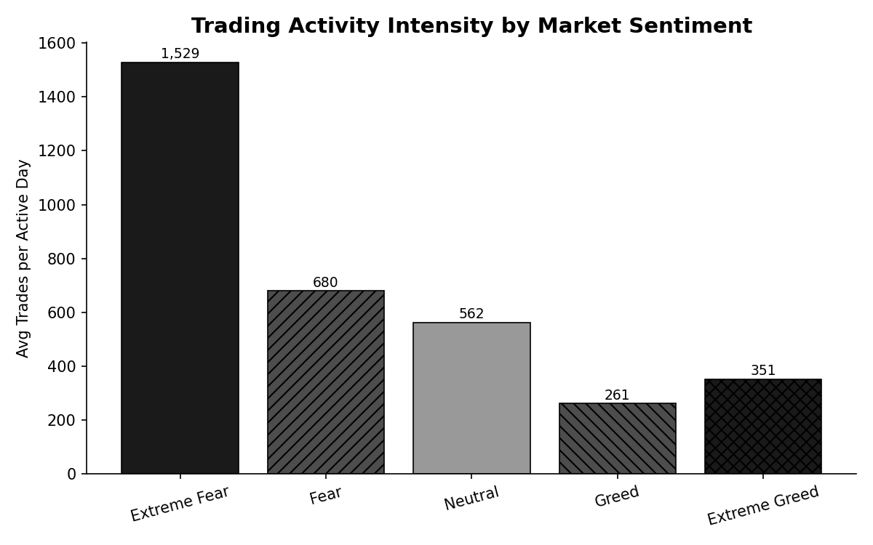
Figure 7. Average number of trades per active trading day, by sentiment.
Trading intensity is highest during Fear/Extreme Fear and lowest during Greed. Note the Extreme Fear figure (1,529 trades/day) is based on only 14 calendar days concentrated around a few sharp risk-off events (late Feb–early Mar 2025, early Apr 2025) and should be treated as a small-sample signal rather than a stable regime characteristic — see Section 6.

5. Bitcoin-Specific & Cross-Asset Patterns

5.1 BTC Trades Only
Sentiment | BTC Trades | BTC Total PnL | BTC Win Rate
Extreme Fear | 667 | $3,057 | 81.4%
Fear | 4,342 | $482,650 | 87.6%
Neutral | 1,812 | $165,980 | 86.3%
Greed | 3,209 | $115,475 | 75.0%
Extreme Greed | 979 | $100,883 | 84.6%
Table 3. BTC-only performance by sentiment — since the index itself tracks Bitcoin sentiment, this isolates the asset the signal is designed for.
BTC trades mirror the portfolio-wide pattern: Fear is by far the most profitable regime for BTC specifically ($482,650, 87.6% win rate), reinforcing that the Fear & Greed Index has genuine signal value for the asset it measures, not just as a proxy for broader crypto-market mood.

5.2 Asset-Level Winners and Losers (All Sentiment Regimes)
Top performers | Total PnL | Bottom performers | Total PnL
@107 (perp) | $2,783,913 | TRUMP | -$364,825
HYPE | $1,948,485 | FARTCOIN | -$100,687
SOL | $1,639,556 | ADA | -$28,113
ETH | $1,319,979 | IO | -$21,894
BTC | $868,045 | PAXG | -$18,689
Table 4. Most and least profitable traded assets across the full dataset.
Losses are heavily concentrated in narrative/meme-driven and newly-launched tokens (TRUMP, FARTCOIN), which is consistent with these assets carrying higher volatility and weaker fundamentals-based signal — sentiment-driven contrarian strategies calibrated on BTC do not necessarily transfer well to them.

6. Robustness Check: Handling Small-Sample Regimes
Sentiment | Calendar Days in Sample | Total PnL / Day | Trades / Day
Extreme Fear | 14 | $52,794 | 1,529
Fear | 91 | $36,892 | 680
Neutral | 67 | $19,297 | 562
Greed | 193 | $11,141 | 261
Extreme Greed | 114 | $23,817 | 351
Table 5. Day-normalized metrics. Extreme Fear's totals rest on far fewer observation days than other regimes.
Extreme Fear occurred on only 14 of the ~500 days covered by the trade data, and 3 of those days (Mar 4–5 and Feb 28, 2025) account for the majority of that regime's profit. Two accounts contributed over 60% of Extreme Fear PnL. We recommend treating the Extreme Fear "per-day" outperformance as directional rather than statistically robust, and prioritizing the Fear, Greed, and Extreme Greed comparisons — each backed by 90+ calendar days — for strategy decisions.
A secondary check — regressing next-day aggregate PnL against the prior day's sentiment score — found a similar-direction relationship (r ≈ -0.13): the more fearful the prior day, the higher the following day's aggregate PnL, though the correlation is weak, indicating sentiment is one input among many rather than a stand-alone predictor.

7. Strategic Recommendations
- Lean into contrarian entries at sentiment extremes. Both the Long-bias-in-Fear and Short-bias-in-Greed behaviors coincide with this dataset's highest win rates (Extreme Greed 89.2%, Fear 87.3%). A rules-based contrarian overlay — scaling into longs as the index falls below ~25 and trimming/shorting as it rises above ~75 — is supported by the data.
- Size positions by regime, not just conviction. The data shows disciplined traders already do this (largest average size in Fear, smallest in Extreme Greed). Formalizing this — larger allocations to high-conviction Fear entries, smaller tactical size for Greed-chasing trades — should improve risk-adjusted returns.
- Be selective about which assets receive a sentiment-based strategy. BTC, ETH, SOL, and HYPE show sentiment-performance patterns worth trading systematically. Meme/narrative tokens (TRUMP, FARTCOIN) were net losers regardless of regime and are poor candidates for a sentiment-driven approach.
- Treat the 60–80 ("Greed") band as the highest-risk zone. It shows the lowest win rate (80.6%) across the sentiment spectrum — likely reflecting choppy, trend-uncertain conditions. Consider tighter risk controls or reduced size specifically in this band, rather than treating all "positive sentiment" days uniformly.
- Collect more Extreme Fear observations before relying on it operationally. With only 14 days in-sample and result concentration in 2–3 accounts and 3 dates, any Extreme-Fear-specific rule should be paper-traded and monitored rather than deployed at full size.
- Track prior-day sentiment, not just same-day. The lag correlation (r ≈ -0.13) was slightly stronger than the same-day correlation, suggesting sentiment shifts take a day to fully show up in trader outcomes — useful for setting next-session risk parameters rather than reacting intraday.

8. Limitations
- The dataset covers 32 accounts only — likely a specific cohort (possibly identified/selected traders) rather than a random market sample, so results may not generalize to the broader trader population.
- Sentiment is measured daily and matched at the calendar-date level; intraday sentiment shifts are not captured, and the Fear & Greed Index itself is a composite of multiple indicators (volatility, momentum, social media, surveys, dominance) that isn't Bitcoin-price alone.
- Correlation, not causation: profitable trading during certain sentiment regimes may reflect broader market conditions (e.g., trending vs. choppy price action) that happen to coincide with those sentiment readings, rather than sentiment directly causing better decisions.

