
SVKM's NMIMS (Deemed-to-be University)
Mukesh Patel School of Technology Management & Engineering
Vile Parle (West), Mumbai - 400 056
A Machine Learning Group Activity Report on
DemandIQ
Machine Learning for Product Demand and Stockout Risk Prediction
Course: Machine Learning
B.Tech , Semester V | Academic Year 2026-27
Submitted by
Name | Roll No.
Yash Shah | L056
Mahak Wadhawan | L074
Yash Patil | L043
Varshita Vaan | L069

Under the guidance of
Prof. Abhay Kolhe
Department of Computer Science Engineering and Data Science, MPSTME
Date of Submission: 21 /10 / 2026

Declaration
We, the undersigned students of B.Tech Semester V, Mukesh Patel School of Technology Management & Engineering, SVKM's NMIMS, Mumbai, declare that this report titled "DemandIQ: Machine Learning for Product Demand and Stockout Risk Prediction" is a record of the work carried out by us as part of the Machine Learning group activity during the academic year 2026-27. The data used is publicly available, all sources of information have been acknowledged in the References section, and the code and results presented here were produced by our team.
Place: Mumbai
Date: 21 /10 / 2026
Table 1. Declaration signatures
Name | Roll No. | Signature
Yash Shah | L056
Varshita Vaan | L069
Yash Patil | L043
Mahak Wadhawan | L074

Individual Contribution
The table below lists the main responsibility of each member. All four members took part in the weekly reviews, testing of the pipeline and proof-reading of this report.

Table 2. Individual contribution of team members
Name | Roll No. | Specific tasks handled
Yash Shah | L056 | Problem framing and objectives; literature survey (20 books, 15 papers); research gaps; report writing and formatting; project coordination
Varshita Vaan | L069 | Demand forecasting models (baselines, Ridge, Random Forest, Gradient Boosting); hyper-parameter tuning; quantile models; model evaluation
Yash Patil | L043 | Data cleaning and merging; feature engineering; K-Means store segmentation; inventory simulation (digital twin); reorder-policy comparison
Mahak Wadhawan | L074 | Stockout-risk classifier; SHAP explainability; Streamlit dashboard and what-if simulator; figures and presentation

Table of Contents
Declaration i
Individual Contribution i
Table of Contents ii
List of Figures iv
List of Tables v
1. Abstract 1
2. Introduction 1
2.1 Background and motivation 1
2.2 Application domain 2
2.3 Objectives 2
2.4 Organization of the report 2
3. Literature Survey 3
3.1 Scope and method 3
3.2 Synthesis of the literature 4
4. Research Gaps 6
5. Problem Definition 7
5.1 Problem statement 7
5.2 Formal definition 7
5.3 Scope and assumptions 7
5.4 Success criteria 8
6. System Design and Methodology 9
6.1 Overall architecture 9
6.2 Dataset selection 9
6.3 Data preprocessing and feature engineering 10
6.4 Model selection 11
6.5 Model training 11
6.6 Inventory replay and reorder logic 12
6.7 Evaluation metrics 13
7. Results and Discussion 14
7.1 What the data shows 14
7.2 Store segments 15
7.3 Demand forecasting results 15
7.4 Stockout-risk results 17
7.5 From prediction to decision: ordering policies 19
7.6 Explaining the models 20
7.7 Interactive dashboard 22
7.8 Comparison with the literature 22
7.9 Limitations 23
8. Conclusion 24
9. Future Scope 25
10. References 26
Appendix A. Hyper-parameter settings 28
Appendix B. Code structure and key snippet 29
Appendix C. Dashboard screenshots 30
Appendix D. Additional figures 33
Appendix E. Ethics, bias and reproducibility 35

List of Figures
Fig. 1. System architecture of DemandIQ (numbers match the pipeline scripts). 9
Fig. 2. Choosing the number of store segments: elbow curve and silhouette score. 11
Fig. 3. Loss curve of the Gradient Boosting demand model on training and validation data. 12
Fig. 4. Weekly average sales per open store, with validation and test windows shaded. 14
Fig. 5. Average sales by weekday with and without a promotion. 14
Fig. 6. Monthly seasonality (left) and holiday effects on Monday-Friday sales (right). 14
Fig. 7. Profile of each K-Means segment as a z-score against the average store. 15
Fig. 8. Test MAPE and R² of all demand models (grey = baselines). 16
Fig. 9. Forecast, actual sales and P10-P90 range for three stores in the test window. 16
Fig. 10. Error analysis: forecast vs actual, MAPE by store segment and by weekday. 17
Fig. 11. Replayed stock for store 262 under the manager rule; triangles mark stockout days. 17
Fig. 12. ROC and precision-recall curves of the stockout classifiers (test window). 18
Fig. 13. Confusion matrix of Gradient Boosting and calibration of predicted probabilities. 18
Fig. 14. Actual stockout rate in each predicted risk level. 18
Fig. 15. Stockout days, fill rate, stock held and total cost for policies A, B and C. 19
Fig. 16. Where the money goes: lost sales, holding and ordering cost by policy. 19
Fig. 17. Trade-off between stock held and stockout days for many buffer and service-level settings. 20
Fig. 18. Global SHAP importance of the demand model (mean absolute contribution). 20
Fig. 19. Local SHAP explanation of a single forecast (store 262, a promotion Monday). 21
Fig. 20. Model-estimated promotion uplift by store segment (what-if, test sample). 21
Fig. 21. SHAP summary of the stockout-risk model (each dot is one store-evening). 22
Fig. 22. Dashboard overview page. 30
Fig. 23. What-if simulator: a promotion switched on for one store-day. 31
Fig. 24. "Why this forecast?" page with the SHAP waterfall and a plain-language summary. 31
Fig. 25. Stockout risk and reorder list with the order calculator. 32
Fig. 26. SHAP beeswarm of the demand model: colour = feature value, position = push on the forecast. 33
Fig. 27. The 935 stores in the four K-Means segments (first two principal components). 33
Fig. 28. Distribution of store average sales by Rossmann store type. 33
Fig. 29. Stock of store 262 under policies A and C during the test window. 34

List of Tables
Table 1. Declaration signatures i
Table 2. Individual contribution of team members i
Table 3. Where DemandIQ applies 2
Table 4. Reference books consulted and what each contributed to DemandIQ 3
Table 5. Comparison of reviewed research papers 4
Table 6. Research gaps identified and DemandIQ's response 6
Table 7. Learning tasks in DemandIQ 7
Table 8. Target metrics fixed before modelling 8
Table 9. Main columns of the Rossmann dataset 9
Table 10. Time-based data split for the demand model 10
Table 11. Feature groups used by the demand model 10
Table 12. Candidate models and the reason for each 11
Table 13. Evaluation metrics and why they suit the problem 13
Table 14. Demand models: validation MAPE and test-window results (1 Jun - 31 Jul 2015) 15
Table 15. Stockout-risk classifiers on the test window (positive rate 16.1%) 17
Table 16. Ordering policies replayed on the test window (935 stores, June-July 2015) 19
Table 17. DemandIQ compared with related work 22
Table 18. Objectives against results 24
Table 19. Final hyper-parameters 28
Table 20. Grid search results on the validation window (best number of trees per setting) 28
Table 21. Choosing the emergency-order threshold on the validation window (policy C) 28
Table 22. Project files 29

1. Abstract
Retailers lose money in two ways: when a shelf runs empty the sale is lost, and when too much stock is held, cash is tied up and goods age on the shelf. Both problems come from not knowing tomorrow's demand. This project builds DemandIQ, a classical machine-learning system (no deep learning) that forecasts daily demand, predicts the probability of a stockout in the next three days, recommends how much to reorder, and explains every prediction. We use the public Rossmann Store Sales dataset (1,017,209 store-days, 1,115 German drugstores, 2013-2015), keep the 935 stores with a complete history, and split the data strictly by time. K-Means groups the stores into four behavioural segments. For demand, a tuned Gradient Boosting regressor reaches a test MAPE of 7.96% and R² of 0.941, against 10.22% for a store-weekday-promotion average baseline. Because Rossmann does not publish stock levels, we replay a realistic ordering process over the real sales, calibrated to the 8.3% worldwide out-of-stock rate, to obtain stock and stockout labels. A Gradient Boosting classifier predicts three-day stockout risk with ROC-AUC 0.873. On the held-out June-July 2015 window, ordering with DemandIQ's forecast and risk alerts cuts stockout days from 7.51% to 1.50% and total inventory cost by 63% compared with a manager's rule of thumb. SHAP explanations and a Streamlit what-if dashboard make each number traceable. The main lesson is that a forecast creates value only when it is turned into an explained ordering decision.
Keywords: demand forecasting, stockout prediction, gradient boosting, random forest, K-Means, SHAP, inventory optimisation, explainable machine learning.

2. Introduction

2.1 Background and motivation
Every shop, warehouse and online seller faces the same question every week: how much of each product should be kept in stock? If too little is kept, the product runs out (a stockout), the customer leaves without buying and often goes to a competitor. If too much is kept (overstock), money is locked in goods that sit on the shelf, take up space and may expire. A worldwide study of grocery retail found that on an average day about 8.3% of items were out of stock [1], and that a large share of shoppers who meet an empty shelf buy elsewhere or not at all.
Both problems have one root cause: demand for tomorrow is not known. Small and mid-sized stores usually order by habit ("order what we sold last month, plus a bit"). Such rules ignore promotions, holidays and weekday patterns, so they run short exactly when demand jumps. Modern forecasting software uses machine learning [2], [3], but often gives only a number. A manager who cannot see why the system predicts 137 units tends not to trust it, and a prediction that is not trusted changes nothing. Finally, even a perfect forecast is not yet a decision: the manager still has to work out how much to order given current stock and delivery time [4], [5].

2.2 Application domain
We work with daily store-level sales from Rossmann, a large German drugstore chain, which released two and a half years of data for a public forecasting competition [6]. The same pipeline transfers to any business that holds physical stock:
Table 3. Where DemandIQ applies
Sector | How DemandIQ helps
Supermarkets and drugstores | Daily demand per store; flag stores likely to run out before the next truck
E-commerce and D2C brands | Test a planned discount in the what-if tool before the sale goes live
Pharmacies | Keep critical medicines in stock without over-ordering items that expire
FMCG distributors | Plan replenishment across many outlets around festival and promotion peaks
Restaurants and food service | Forecast ingredient use to cut spoilage and avoid peak-hour shortages

2.3 Objectives
The project has four objectives, each producing a visible output and each building on the one before:
- O1 - Predict demand. Forecast daily sales for every store for the next seven days from calendar, promotion, holiday, store and sales-history information, with a P10-P90 uncertainty range.
- O2 - Predict stockout risk. Combine the forecast with current stock and incoming deliveries to give the probability that the store runs out within three days, shown as LOW, MEDIUM or HIGH.
- O3 - Recommend how much to order. Turn the forecast and its uncertainty into an order-up-to level and an order quantity, and trigger an emergency order when risk is high.
- O4 - Explain and allow what-if testing. Show which factors pushed each forecast and risk score up or down (SHAP), and let the user change promotion, holiday, competition or price to see the model's response.
A fifth, supporting objective is to group the 935 stores into a small number of segments with K-Means, so that managers can see which kinds of stores react strongly to promotions.

2.4 Organization of the report
Section 3 surveys the literature (20 reference books and 15 research papers) and Section 4 lists the research gaps. Section 5 defines the problem formally. Section 6 describes the dataset, features, models, training and metrics. Section 7 presents and discusses the results, Section 8 concludes and Section 9 outlines future work. The appendices give hyper-parameters, code structure, the dashboard and notes on ethics and reproducibility.

3. Literature Survey

3.1 Scope and method
We studied the problem from two kinds of sources. First, 20 reference books gave us the foundations: forecasting practice, inventory theory, machine-learning algorithms, explainability and causal reasoning. Second, 15 peer-reviewed research papers, most from 2019-2026, show what current systems achieve and where they stop. Papers were selected if they addressed at least one of our four objectives. Table 4 summarizes the books and Table 5 compares the papers.
Table 4. Reference books consulted and what each contributed to DemandIQ
Ref. | Book | Concepts used in this project
[7] | Hyndman & Athanasopoulos, Forecasting: Principles and Practice (2021) | Time-based splits, naive and seasonal baselines, MAPE/RMSE, prediction intervals
[8] | Box, Jenkins, Reinsel & Ljung, Time Series Analysis (2015) | Autocorrelation and lag structure behind our 7/14/28-day lag features
[9] | Gilliland, The Business Forecasting Deal (2010) | Forecast value added: always compare against a naive baseline
[4] | Silver, Pyke & Thomas, Inventory and Production Management (2017) | Periodic-review order-up-to (R, S) policy; safety stock with lead-time variability
[5] | Chopra & Meindl, Supply Chain Management (2016) | Cycle service level, cost of stockouts versus holding cost
[10] | Nahmias & Olsen, Production and Operations Analysis (2015) | Newsvendor logic and the z-value for a target service level
[11] | Zipkin, Foundations of Inventory Management (2000) | Inventory position = on hand + on order; lost-sales systems
[12] | Axsäter, Inventory Control (2015) | Stochastic lead times and their effect on stockout risk
[13] | Winston, Operations Research (2004) | Simulation as a tool to compare policies under uncertainty
[14] | Hastie, Tibshirani & Friedman, Elements of Statistical Learning (2009) | Bagging, random forests, gradient boosting, bias-variance trade-off
[15] | James, Witten, Hastie & Tibshirani, Intro. to Statistical Learning (2021) | Ridge regression, logistic regression, K-Means, validation
[16] | Bishop, Pattern Recognition and Machine Learning (2006) | Probabilistic view of classification and calibrated probabilities
[17] | Murphy, Probabilistic Machine Learning (2022) | Quantile (pinball) loss and predictive uncertainty
[18] | Géron, Hands-On Machine Learning (2022) | Scikit-learn pipelines, grid search, ROC/PR curves in practice
[19] | Kuhn & Johnson, Applied Predictive Modeling (2013) | Data splitting, resampling and model comparison discipline
[20] | Kuhn & Johnson, Feature Engineering and Selection (2019) | Encoding categories, rolling statistics, avoiding leakage
[21] | He & Ma (Eds.), Imbalanced Learning (2013) | Class weights, PR-AUC and threshold tuning for rare stockouts
[22] | Molnar, Interpretable Machine Learning (2022) | SHAP, partial dependence and ICE; limits of explanations
[23] | Pearl, Glymour & Jewell, Causal Inference in Statistics (2016) | Why a what-if on a predictive model is not a causal effect
[24] | Provost & Fawcett, Data Science for Business (2013) | Framing ML around a business decision and expected value

The 15 research papers are compared in Table 5 in the format Author/Year | Technique | Dataset | Metrics/Results | Limitations.

Table 5. Comparison of reviewed research papers
Ref. | Author / Year | Technique | Dataset | Metrics / Results | Limitations
[25] | Seyedan & Mafakheri, 2020 | Survey: time series, clustering, KNN, NN, SVR | Review of published studies | Taxonomy of big-data forecasting methods for supply chains | No empirical comparison; no stock decision
[3] | Makridakis et al., 2022 | M5 competition; mostly LightGBM ensembles won | 42,840 Walmart series with prices and calendar | ML methods beat statistical benchmarks | Accuracy only; large ensembles hard to explain
[26] | Ke et al., 2017 | Gradient boosting with GOSS and EFB | Public benchmark datasets | Up to 20x faster training at similar accuracy | Algorithm paper; no retail evaluation
[27] | Gür Ali et al., 2009 | Regression trees with promotion features | SKU-store sales, European grocer | Big gains during promotions; pooling SKUs helps | Older data; no inventory link
[28] | Huber & Stuckenschmidt, 2020 | ML vs established methods; special-day features | Daily sales of a bakery chain | ML wins; calendar special days matter | One retailer; forecast only
[29] | Spiliotis et al., 2022 | Croston-type vs ML with cross-learning | Daily intermittent SKU demand | Some ML beat Croston in accuracy and bias | No explanation; accuracy only
[30] | Lim et al., 2021 | Temporal Fusion Transformer (deep learning) | Retail, electricity, traffic sets | About 7% lower P50 and 9% lower P90 loss | Heavy model, GPU; hard for managers
[31] | Liu et al., 2025 | Classical ML classifiers, class imbalance | 1.6 M+ retailer SKUs | Stock level, 3-month forecast, recent sales are top predictors | Global importance only; no order size
[32] | Theodorou et al., 2025 | Forecasts + inventory simulation | M5 Walmart data | Accuracy-cost link can be weak | Simulated stock; no explanation
[33] | Bertsimas & Kallus, 2020 | Prescriptive analytics (kNN, trees, kernels) | Media distributor, ~1 bn units/yr | Data-driven decisions beat predict-then-optimise | Mathematically heavy to audit
[34] | Ban & Rudin, 2019 | Feature-based (big data) newsvendor | Hospital nurse staffing | 23-24% lower cost than benchmark | Single period; not retail stores
[35] | Lundberg & Lee, 2017 | SHAP additive feature attribution | Benchmark models | Unique, consistent per-prediction attributions | Describes the model, not causality
[36] | Mishra et al., 2026 | LightGBM + PFI, PDP, SHAP, ICE | UCI Online Retail II, 41 features | RMSE 33.71, R² 0.243 (SKU-day) | Explanations stop at forecast
[37] | Rožanec et al., 2022 | Knowledge-graph enriched XAI | Real demand-forecasting case | Links drivers to news and external data | Complex set-up; no stock decision
[38] | Chernozhukov et al., 2018 | Double/debiased ML, cross-fitting | Econometric examples | Valid effect estimates where naive ML is biased | Needs causal design; not a forecaster

3.2 Synthesis of the literature
Machine learning forecasts retail demand well. Surveys show a clear move from classical time-series models to data-driven methods [25], [2]. In the M5 competition on Walmart data, machine-learning methods, most of them built on LightGBM, beat the statistical benchmarks [3]. Gradient-boosted trees are the workhorse for this kind of tabular data and LightGBM trains much faster than older boosting at similar accuracy [26]. Three findings shaped our features: promotions need explicit features [27], calendar special days behave differently from normal days [28], and training one model across many series (cross-learning) helps [29]. The textbook advice to split by time and always report a naive baseline [7], [9] guided our evaluation. Deep models such as the Temporal Fusion Transformer [30] are accurate but heavy, and the brief for this course was classical machine learning, so we did not use them.
Stockout prediction is studied much less than forecasting. Liu et al. trained classical models on over 1.6 million SKUs and found stock level and the near-term forecast to be the strongest predictors [31]. This directly supports our design, where the risk model sees current stock, deliveries due and the forecast. Their output is a prediction plus a global feature ranking, not an item-level reason or an order quantity. Because stockouts are rare, imbalance has to be handled with class weights, PR-AUC and threshold tuning [21].
Accuracy is not the same as a good decision. Theodorou et al. showed on M5 data that the most accurate forecast is not always the cheapest to stock against [32]. Prescriptive methods [33], [34] optimise the order directly and report large savings, but they are hard for a store manager to check. Inventory theory offers a transparent alternative: a periodic-review order-up-to policy whose safety stock covers both forecast error and late deliveries [4], [10], [12]. We keep this readable rule and feed it with machine-learning forecasts and quantiles.
Explanations usually stop at the forecast. SHAP gives each feature a fair share of an individual prediction [35] and has an exact, fast version for tree models [39]. The closest work to ours, Mishra et al., combines LightGBM with four explanation layers [36]; Rožanec et al. enrich explanations with external knowledge [37]. In both, the explanation is attached to the forecast only. Finally, a what-if result shows what the model learned, not what would really happen: naive machine-learning effect estimates are biased [38], and causal claims need a causal design [23]. We therefore label every what-if output as model behaviour.

4. Research Gaps
Reading the books and papers side by side, we found six gaps. Each is tied to specific sources and to the way DemandIQ responds to it.
Table 6. Research gaps identified and DemandIQ's response
ID | Gap | Evidence | DemandIQ response
G1 | Forecasting, stockout risk and ordering are studied separately | [31] predicts stockouts; [36], [37] explain forecasts; [33], [34] prescribe orders | One pipeline: forecast → risk → order quantity (O1-O3)
G2 | Explanations end at the forecast | [36], [37] explain forecasts; [31] gives global importance only | SHAP for both the demand and the risk model, plus plain-language reasons (O4)
G3 | Forecast accuracy is not decision quality | [32] finds a weak accuracy-cost link | Judge policies on stockout days, fill rate, stock held and cost, not only MAPE
G4 | What-if output is easily misread as causal | [38], [23] | Every what-if is labelled as model behaviour; price uses a stated elasticity
G5 | One policy is applied to very different stores | [36] finds opposite feature effects across product groups | K-Means store segments; promotion uplift shown per segment
G6 | No public retail data contains stock on hand | [3], [6] publish sales only | Calibrated inventory replay over real demand, matched to the 8.3% out-of-stock rate of [1]

5. Problem Definition

5.1 Problem statement
Design an explainable, classical machine-learning system that predicts short-term demand for each store from past sales, promotion, holiday, store and seasonality data; identifies stores at risk of stockout in the next three days; recommends how much to reorder; and shows the reasons behind each prediction, with a what-if tool to test how promotion, holidays, competition or price would change demand.

5.2 Formal definition
For store s on day t let x(s,t) be the feature vector known in advance (calendar, promotion, holidays, store profile and sales history that is at least seven days old). The project contains four learning tasks:
Table 7. Learning tasks in DemandIQ
Task | Type | Input | Output
T1 Demand forecast | Regression | x(s,t), 27 features | Sales y(s,t); quantiles q0.1 and q0.9
T2 Stockout risk | Binary classification | Stock state, deliveries due, forecasts (13 features) | P(stockout on any of days t+1..t+3)
T3 Reorder | Decision rule on T1/T2 | Forecasts, uncertainty, inventory position | Order quantity Q(s,t) >= 0
T4 Store segments | Clustering (unsupervised) | 6 store traits | Segment label 0-3

The demand model learns f such that ŷ(s,t) = f(x(s,t)) minimizes squared error on log(1 + sales), which is close to minimizing percentage error. The risk model learns g such that p(s,t) = g(z(s,t)) estimates the probability of a stockout, where z describes the inventory state in the evening of day t.

5.3 Scope and assumptions
- Demand is modelled at store-day level, the finest level Rossmann publishes. Sales values are treated as units.
- Closed days have zero demand; the store's opening calendar and promotion plan are known in advance.
- Rossmann has no stock data. Stock is simulated by replaying a periodic-review ordering process over the real daily sales: orders on Monday and Thursday, two-day lead time, 15% of deliveries one day late and 5% two days late, unmet demand is lost.
- Costs: a lost sale costs 30% of its value (lost margin), holding costs 0.07% of value per day (about 25% a year), a regular delivery costs EUR 25 and an emergency next-day delivery EUR 75.
- Rossmann has no prices. The price lever in the what-if tool therefore uses a stated elasticity, not a learned one.

5.4 Success criteria
Table 8. Target metrics fixed before modelling
Objective | Metric | Target
O1 Demand | Test MAPE / R² | MAPE below 10% and below the best baseline; R² above 0.90
O1 Uncertainty | P10-P90 coverage | Close to 80% of test days
O2 Risk | ROC-AUC / PR-AUC | ROC-AUC above 0.85; PR-AUC at least 2x the positive rate
O3 Ordering | Stockout days, cost | At least 30% fewer stockout days than the manager rule, at lower total cost
O4 Explain | SHAP additivity; dashboard | Contributions add up to the prediction; answers in about 2 seconds

6. System Design and Methodology

6.1 Overall architecture
Fig. 1 shows the full pipeline. Raw data is cleaned and turned into features; stores are segmented; a regression model forecasts demand; an inventory replay produces stock levels on which a classifier learns stockout risk; a decision rule converts forecasts and risk into orders; SHAP explains both models; and a Streamlit dashboard puts everything in front of the user. Each block is one Python script, run in order by run_all.py.
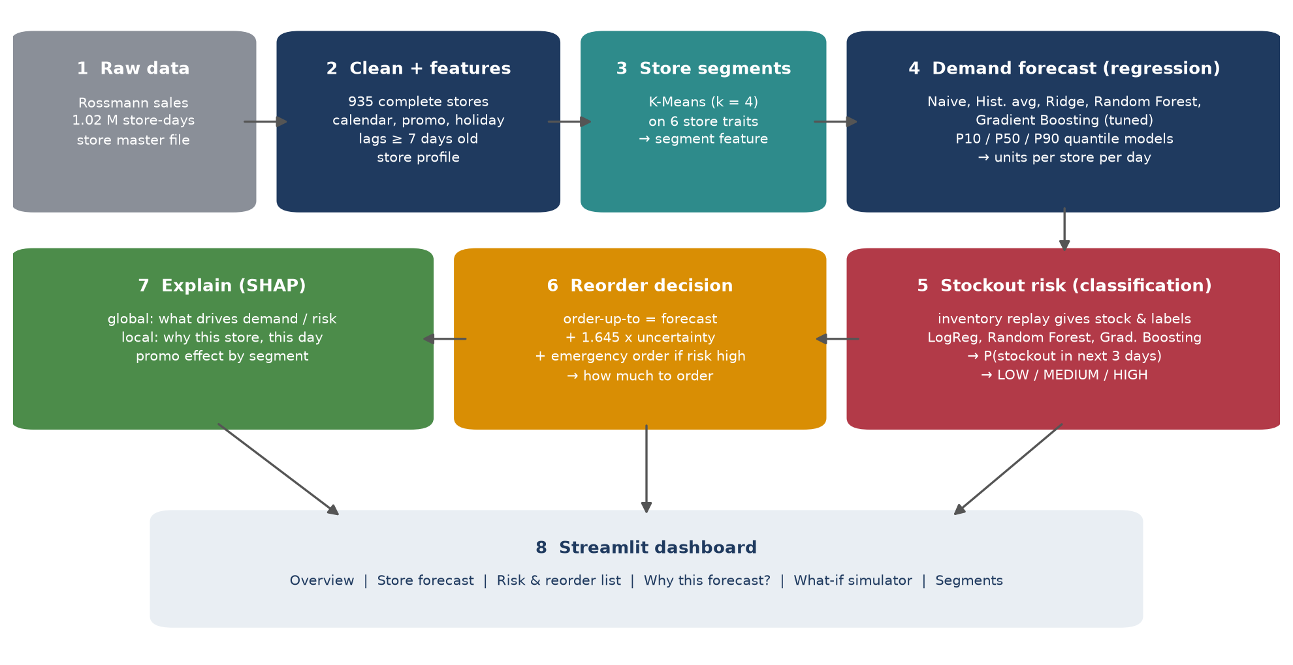
Fig. 1. System architecture of DemandIQ (numbers match the pipeline scripts).

6.2 Dataset selection
Source. Rossmann Store Sales [6], a public dataset released by the German drugstore chain Rossmann. It has 1,017,209 daily records for 1,115 stores from 1 January 2013 to 31 July 2015 and a separate store master file.
Why this dataset. It is real retail data (not synthetic), large enough for machine learning, contains exactly the drivers named in our objectives (promotions, state and school holidays, weekday, season, competition, store format), is freely downloadable, and is a well-known benchmark, so results can be compared with others.
Table 9. Main columns of the Rossmann dataset
Column | Meaning
Store, Date, DayOfWeek | Store identifier (1-1115) and trading date
Sales | Daily sales - the demand we forecast (target)
Customers, Open | Number of customers; 1 if the store traded that day
Promo / Promo2 | Daily promotion running; store takes part in a continuing loyalty promotion
StateHoliday, SchoolHoliday | Public holiday type (none, public, Easter, Christmas); schools closed
StoreType, Assortment | Store format (a-d) and range carried (basic, extra, extended)
CompetitionDistance, ...Since | Metres to the nearest competitor and when it opened

Class distribution. For the regression target, daily sales have a mean of 7,006 and a median of 6,411 (right-skewed, so we model log sales). Promotions run on 44.7% of open days and lift average sales by 39.8%. For the classification target, a stockout within three days occurs in 18.6% of store-evenings, so the classes are imbalanced roughly 1:4.
Split strategy. Because this is a time series, rows are never shuffled. We split by date (Table 10). Hyper-parameters are chosen on the validation window only; the test window is used once, at the end. Store profile statistics are computed on the training window only.
Table 10. Time-based data split for the demand model
Split | Period | Rows | Used for
Training | 2013-02-15 to 2015-03-31 | 603,437 | Fitting the models
Validation | 2015-04-01 to 2015-05-31 | 44,335 | Tuning and model selection
Test (held out) | 2015-06-01 to 2015-07-31 | 49,268 | Final, one-time evaluation

6.3 Data preprocessing and feature engineering
Cleaning. (i) 180 stores were closed for refurbishment for six months in 2014; their histories have a hole that breaks lag features and the stock simulation, so we keep the 935 stores with a complete record. (ii) 54 days marked open with zero sales were treated as closed. (iii) Each store was re-indexed to a full calendar, so that "seven days ago" always means seven calendar days. (iv) Missing competitor distances (3 stores in the master file) were filled with the median; missing competitor opening dates were treated as long-established competitors. (v) Closed days are kept in the calendar for the simulation but excluded from model training, giving 732,379 trading days.
Encoding. Store type, assortment, holiday type and segment are small categories and are given as integer codes to the tree models; the Ridge and Logistic Regression models use one-hot encoding and standardised numeric features, with median imputation for missing lags.
Features. We built 27 features in five groups (Table 11). The key design rule is that every sales-history feature is at least seven days old. This prevents leakage and also means one model can forecast any of the next seven days, which is exactly what an order covering the next few days needs [20].
Table 11. Feature groups used by the demand model
Group | Features | Why
Calendar | day of week, day of month, month, week of year, year | Weekly and yearly seasonality, pay-day effects
Promotion | Promo, Promo2 active this month | Promotions lift sales by about 40%
Holidays | school holiday, public holiday type, store closed yesterday / tomorrow | Shopping shifts around closures
Store profile | store type, assortment, segment, Promo2, competitor distance and age, store average, store-weekday average, store promo lift | Stores differ by a factor of five in size
Sales history | sales 7, 14, 28 days ago; mean of 7 and 28 days and 28-day std (all ending 7 days ago); trend ratio | Recent level and momentum

Store segmentation (K-Means). For each store we compute six traits on the training window: average daily sales, promotion uplift, day-to-day volatility (coefficient of variation), Saturday-to-weekday sales ratio, December uplift and log competitor distance. After standardising, K-Means [40] is run for k = 2 to 8. The silhouette score [41] is low for every k (0.18-0.25), which shows that stores form a continuum rather than sharply separated groups; we choose k = 4 where the elbow flattens and the groups are easy to name and act on (Fig. 2). The segment number becomes a feature of both models.
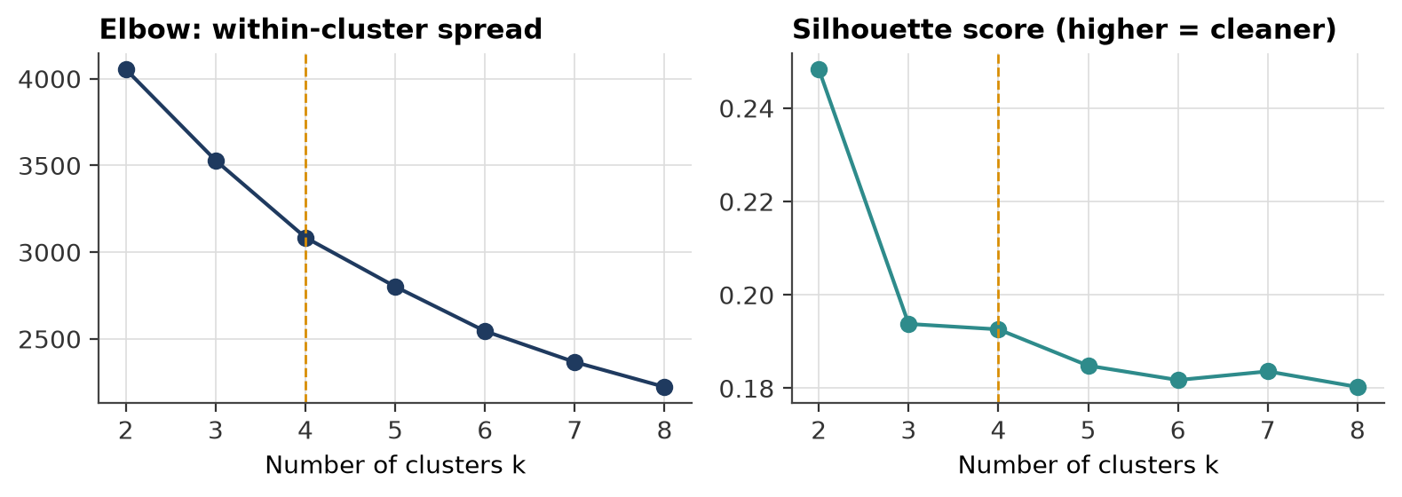
Fig. 2. Choosing the number of store segments: elbow curve and silhouette score.

6.4 Model selection
For each task we start from a simple baseline and add complexity only if it pays off, as recommended by [9] and [19].
Table 12. Candidate models and the reason for each
Task | Model | Why it was chosen
Demand | Naive (same day last week) | Simplest possible forecast; any model must beat it
Demand | Historical average | Store x weekday x promotion average - what an experienced manager would estimate
Demand | Ridge regression | Linear, fast, easy to explain; tests whether interactions are needed
Demand | Random Forest [42] | Bagged trees capture interactions and are robust to outliers
Demand | Gradient Boosting [43], [26] | Histogram-based boosting (LightGBM-style) - state of the art on tabular retail data [3]
Demand | Quantile Gradient Boosting [44] | Same model with pinball loss gives P10 and P90 for safety stock
Risk | Manager rule of thumb | "Worry if stock + deliveries cover less than the coming days" - baseline
Risk | Logistic Regression | Linear and interpretable; class-weighted for imbalance
Risk | Random Forest / Gradient Boosting | Non-linear, handle interactions such as promotion x low stock
Segments | K-Means | Simple, fast, centroids are easy to read as store profiles

Key hyper-parameters. Gradient Boosting (demand): learning rate 0.08, 400 trees, 127 leaves per tree, at least 40 samples per leaf, L2 penalty 0.0. Random Forest: 120 trees, at least 5 samples per leaf, 50% of features and 30% of rows per tree. Ridge: alpha = 1. Risk Gradient Boosting: 300 trees, learning rate 0.05, 31 leaves, 50 samples per leaf. Full settings are listed in Appendix A.

6.5 Model training
Set-up. Python 3 with pandas, NumPy, scikit-learn [45], SHAP and Matplotlib; the dashboard uses Streamlit. Everything runs on an ordinary laptop CPU (no GPU); the full pipeline takes about eight minutes. A fixed random seed (42) makes every run reproducible.
Loss functions. Demand models minimise squared error on log(1 + sales), so a 10% miss costs the same for a small and a large store. Quantile models minimise the pinball loss at 0.1 and 0.9. Classifiers minimise log-loss (binary cross-entropy). Gradient boosting fits each new tree to the gradient of the loss (it has no separate optimiser such as Adam); trees play the role of epochs.
Hyper-parameter tuning. A grid search over tree size (31, 63, 127 leaves) and L2 penalty (0, 1) was run on the training window and scored on the validation window every 50 trees, using RMSPE. The best setting was then refitted on training + validation data and scored once on the test window.
Overfitting control. Time-based validation, a minimum leaf size, L2 regularisation and choosing the number of trees from the validation loss curve (Fig. 3). The validation loss flattens after about 200 trees while the training loss keeps falling slowly, so more trees would only memorise the past.
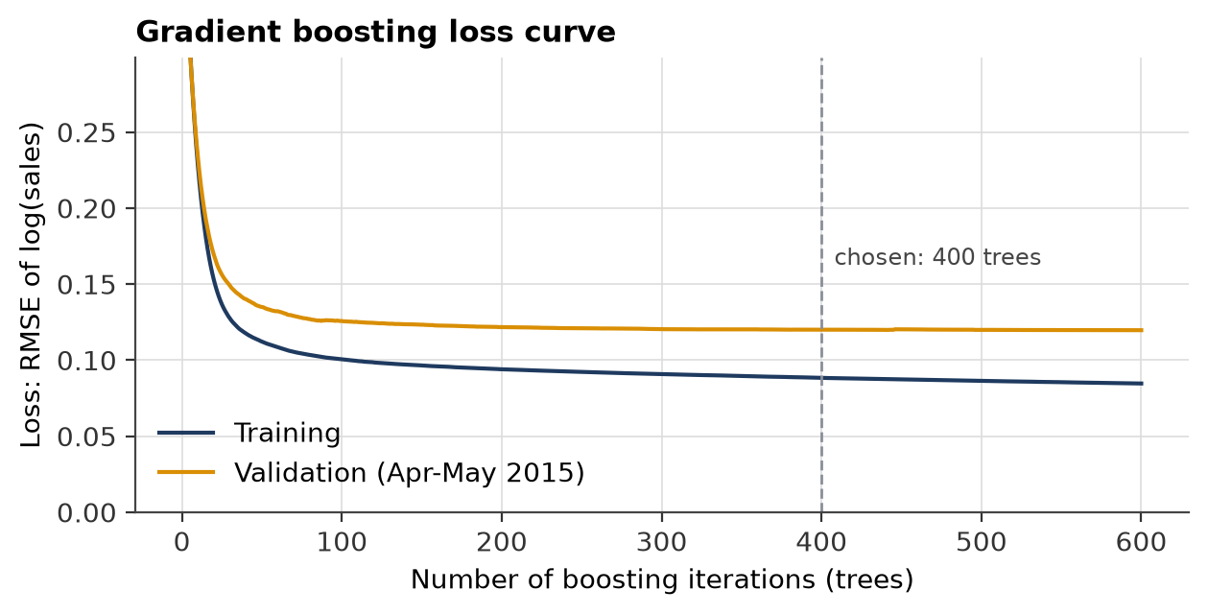
Fig. 3. Loss curve of the Gradient Boosting demand model on training and validation data.
Honest forecasts for the risk model. The risk classifier uses the demand forecast as an input. If it were trained on forecasts the demand model had already seen, it would learn that forecasts are always right. We therefore train a separate demand model on data up to June 2014 to forecast July 2014 - March 2015 (the risk model's training window); the validation and test windows get forecasts from models trained only on earlier data.

6.6 Inventory replay and reorder logic
Rossmann does not record stock, so we rebuild it [13]. Every evening on Monday and Thursday the store orders up to a target level S; the delivery arrives two days later, or later if the supplier is late. Each day, customers buy min(stock, demand); unmet demand is lost and the day is a stockout day. Three ordering policies are compared:
- A. Manager rule - S = (average daily sales of the last 4 weeks + 20%) x trading days to cover. With the +20% buffer this policy produces 8.6% stockout days over the whole period, close to the 8.3% measured in real stores [1], so it is a realistic baseline. Its stockout labels train the risk model.
- B. DemandIQ forecast - the textbook periodic-review policy [4] fed with the ML forecast:
S = Σ F(d) + E[delay] · F̄ + z · √( Σ σ(d)² + F̄² · Var[delay] )
where F(d) is the forecast for each day d until the next delivery, F̄ the average daily forecast, σ(d) = (P90 - P10) / 2.563 the forecast uncertainty from the quantile models, E[delay] = 0.25 days and Var[delay] = 0.29 come from the supplier lateness, and z = 1.645 targets a 95% cycle service level [10]. The order quantity is Q = max(0, S - stock on hand - stock on order).
- C. DemandIQ + risk alerts - policy B, plus: on non-ordering days, if the risk classifier gives a probability above a threshold, place an emergency order that arrives the next morning. The threshold (0.15) is chosen on the validation window by lowest total cost.
All policies face exactly the same demand and the same random supplier delays, so differences come only from the ordering decisions.

6.7 Evaluation metrics
Table 13. Evaluation metrics and why they suit the problem
Metric | Used for | Why it suits the problem
MAPE, WAPE | Demand | Percentage error is comparable across small and large stores; WAPE weights big stores more
RMSE, MAE, R² | Demand | Penalise large misses (RMSE); R² shows share of variation explained
Bias | Demand | Systematic over- or under-forecasting drives over- or under-stocking
P10-P90 coverage | Uncertainty | A good 80% interval should contain about 80% of actual days
ROC-AUC | Risk | How well the model ranks risky above safe stores, independent of threshold
PR-AUC, precision, recall, F1 | Risk | Focus on the rare positive class; recall = stockouts caught
Calibration, Brier score | Risk | Whether "70% risk" really means about 70%
Stockout days, fill rate, stock held, cost | Policies | What the business actually feels [32]

7. Results and Discussion

7.1 What the data shows
Fig. 4 shows weekly average sales over the whole period. Three patterns stand out: a strong Christmas peak each year, a zig-zag because promotions run every second week, and no long-term trend. Fig. 5 confirms that promotions lift sales on every weekday, and Fig. 6 shows the yearly cycle and the extra demand on school holidays and before public holidays.
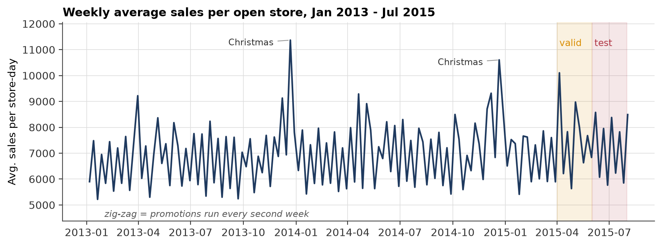
Fig. 4. Weekly average sales per open store, with validation and test windows shaded.
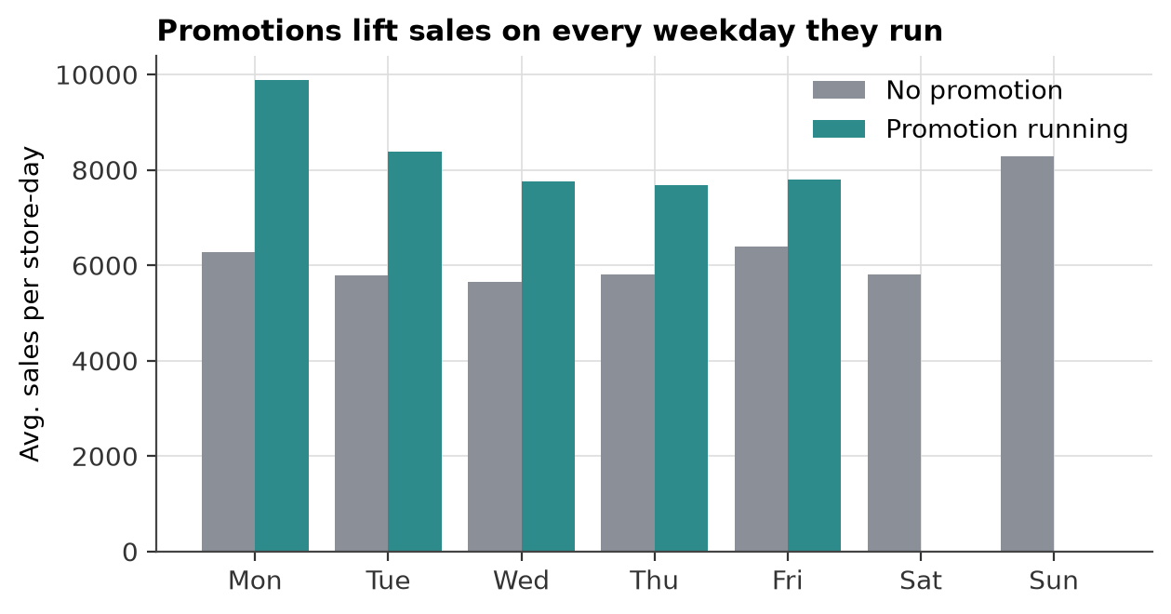
Fig. 5. Average sales by weekday with and without a promotion.
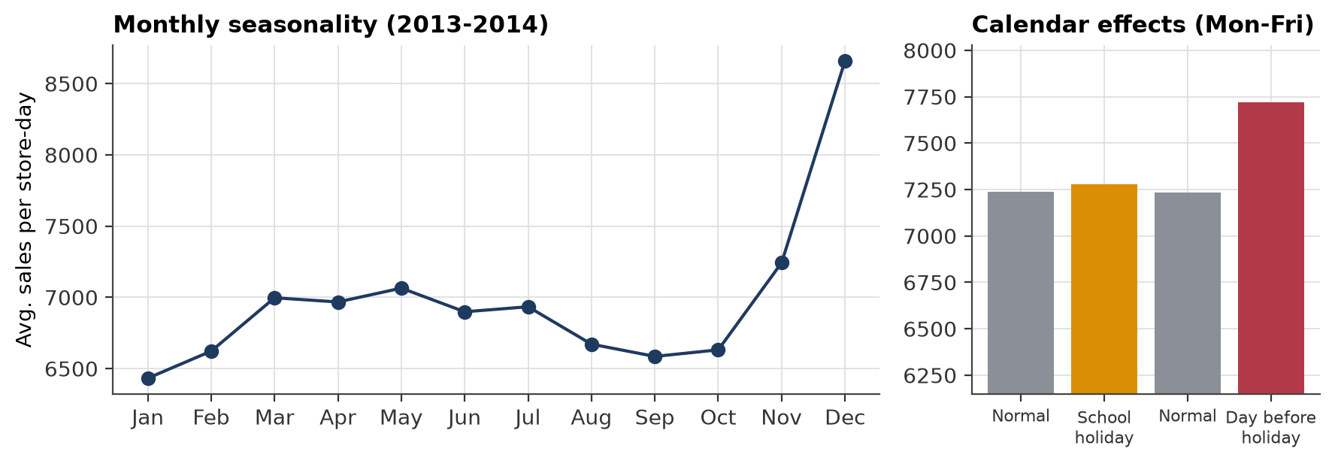
Fig. 6. Monthly seasonality (left) and holiday effects on Monday-Friday sales (right).

7.2 Store segments
K-Means produced four segments (Fig. 7). High-volume flagships (192 stores) sell about 9,292 a day, are steady and face close competitors. Promotion-driven stores (138) gain 72% on promotion days, against 28% for flagships, and are the most volatile. Weekend & seasonal shoppers (284) sell well on Saturdays and in December. Steady neighbourhood stores (321) are close to the average on every trait. The practical message is that one promotion plan or one safety buffer does not fit all stores.
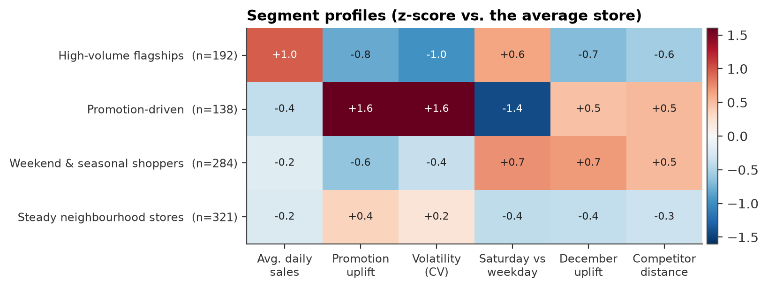
Fig. 7. Profile of each K-Means segment as a z-score against the average store.

7.3 Demand forecasting results
Table 14. Demand models: validation MAPE and test-window results (1 Jun - 31 Jul 2015)
Model | Valid MAPE | Test MAPE | WAPE | RMSE | MAE | R² | Bias | Train (s)
Naive (same day last week) | 28.95% | 31.55% | 30.78% | 2,804 | 2,216 | 0.213 | -1.34% | 0
Historical average | 12.09% | 10.22% | 10.03% | 1,040 | 722 | 0.892 | -2.00% | 0
Ridge regression | 13.46% | 12.40% | 12.83% | 2,108 | 924 | 0.555 | +1.05% | 5
Random Forest | 9.52% | 8.15% | 7.90% | 814 | 569 | 0.934 | -1.00% | 97
Gradient Boosting | 8.86% | 7.96% | 7.58% | 768 | 545 | 0.941 | +0.40% | 47

Table 14 and Fig. 8 compare the models. The naive forecast is poor (31.5%) because last week's same day often had the opposite promotion status. The historical average is a strong baseline (10.22%), showing how regular store demand is. Ridge regression (12.4%) is worse than the baseline: a linear model cannot express interactions such as "promotion on a Monday in a promotion-driven store". Both tree ensembles beat the baseline clearly. Gradient Boosting had the best validation score (8.86%) and was therefore selected before the test window was opened. On the test window it reaches 7.96% MAPE and R² = 0.941, a 22% reduction in error against the baseline.
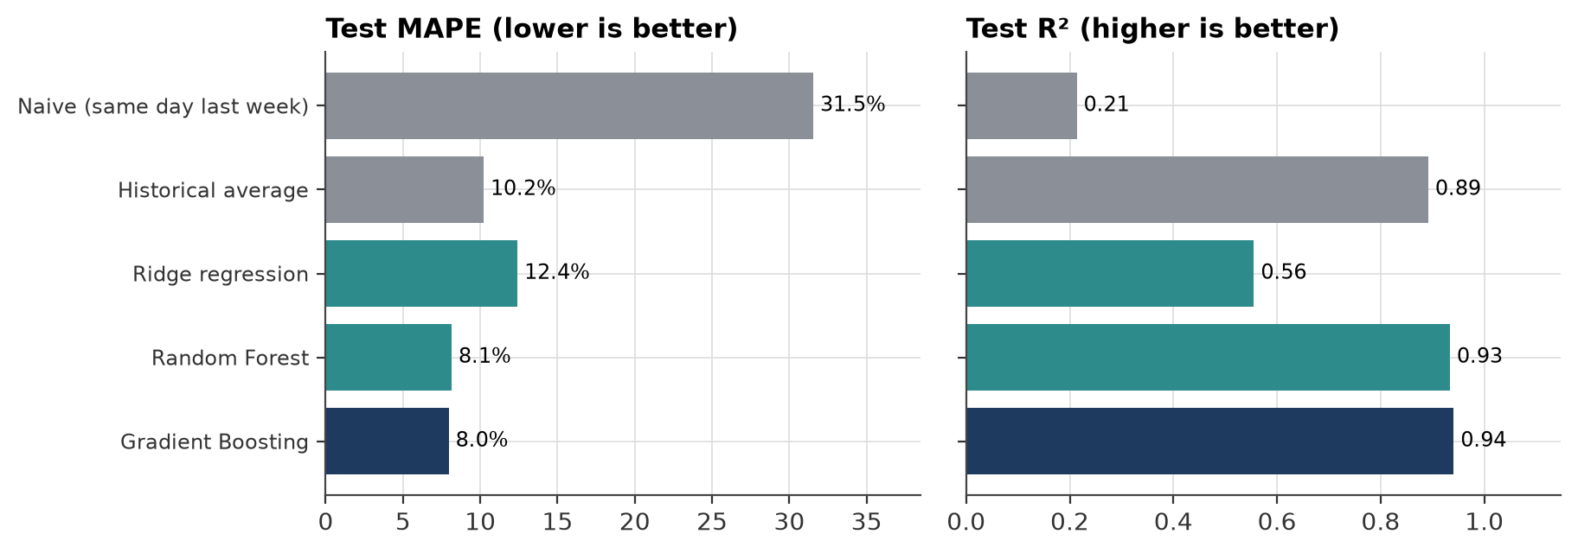
Fig. 8. Test MAPE and R² of all demand models (grey = baselines).
Gradient Boosting is also the best model on the test window. The validation window has a higher error than the test window for every model because it contains Easter and the May public holidays, which are rare in the training data.
Fig. 9 plots the forecast against actual sales for three stores, with the P10-P90 band. The model follows the promotion weeks and the Monday peaks closely. The P10-P90 band contains 72.9% of test days, a little below the 80% target, so the intervals are slightly too narrow; the safety-stock formula with z = 1.645 compensates for this.
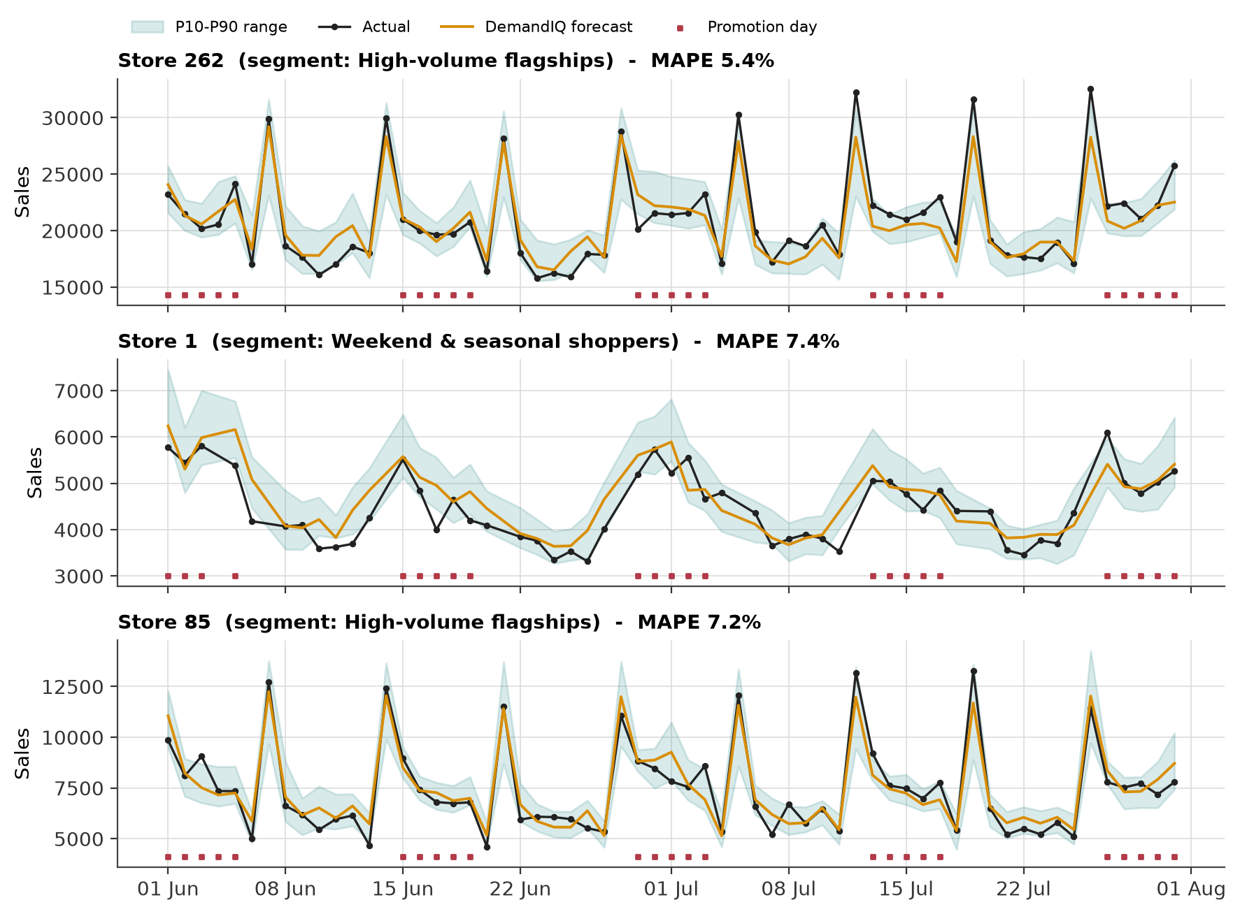
Fig. 9. Forecast, actual sales and P10-P90 range for three stores in the test window.
Error analysis. Fig. 10 shows where the model fails. Points lie close to the diagonal; the largest misses are a few very high days (store events not in the data). Error is similar across segments and highest on Sundays, when only a handful of stores trade and history is thin.
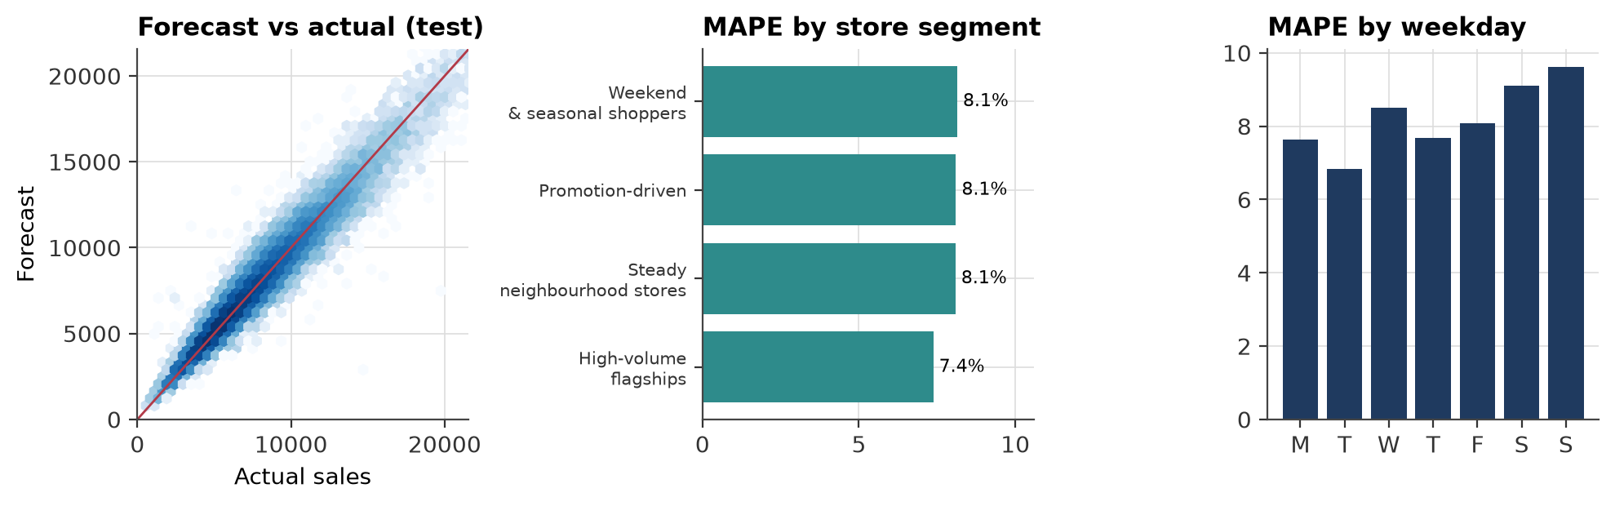
Fig. 10. Error analysis: forecast vs actual, MAPE by store segment and by weekday.

7.4 Stockout-risk results
The manager-rule replay produces 8.57% stockout days overall: 14.1% on promotion days against 4.0% on other days, because a four-week average does not anticipate a promotion week. Fig. 11 shows one store's replayed stock.
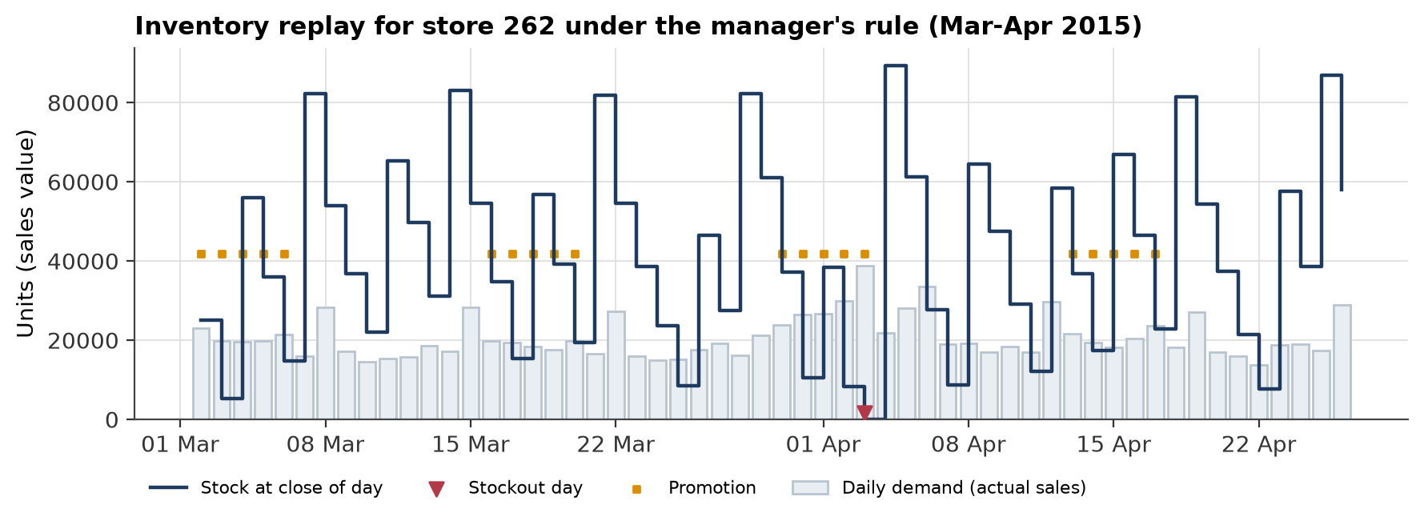
Fig. 11. Replayed stock for store 262 under the manager rule; triangles mark stockout days.
Table 15. Stockout-risk classifiers on the test window (positive rate 16.1%)
Model | ROC-AUC | PR-AUC | Precision | Recall | F1 | Brier | Threshold
Manager rule of thumb | 0.563 | 0.197 | 0.20 | 0.55 | 0.30 | 0.239 | 0.33
Logistic Regression | 0.849 | 0.492 | 0.39 | 0.77 | 0.52 | 0.159 | 0.50
Random Forest | 0.875 | 0.634 | 0.56 | 0.53 | 0.55 | 0.122 | 0.61
Gradient Boosting | 0.873 | 0.610 | 0.50 | 0.60 | 0.55 | 0.098 | 0.30

The rule of thumb is barely better than chance (ROC-AUC 0.563) because most stockouts are caused by promotions and late deliveries, which it ignores. All three learned models do far better. Random Forest and Gradient Boosting are almost tied (ROC-AUC 0.875 and 0.873); we use Gradient Boosting because its probabilities are better calibrated (Brier 0.098) and it is fast enough to score every store each evening. PR-AUC of 0.610 is more than three times the 16% base rate. At the threshold chosen on validation (0.30) the model catches 5,255 of 8,743 stockouts (recall 60%) with precision 50% (Figs. 12 and 13).
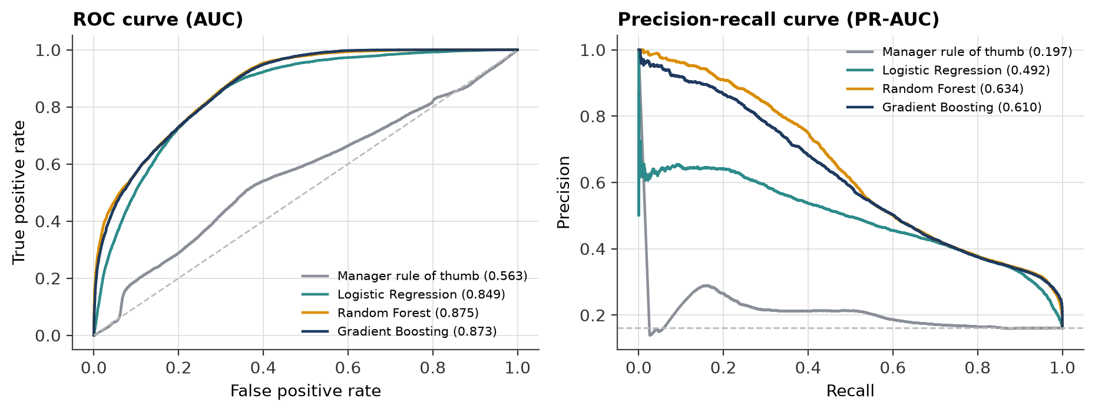
Fig. 12. ROC and precision-recall curves of the stockout classifiers (test window).
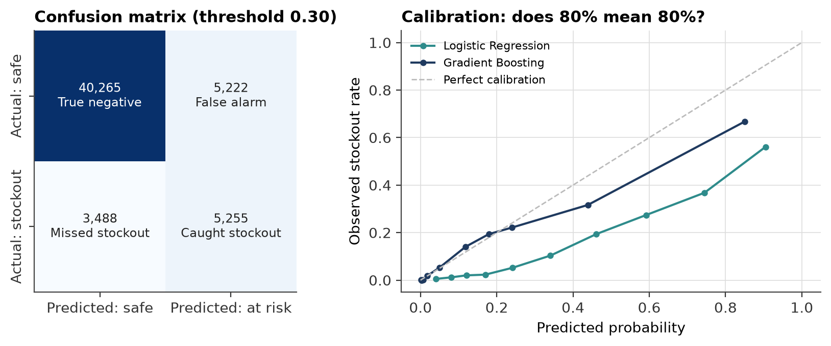
Fig. 13. Confusion matrix of Gradient Boosting and calibration of predicted probabilities.
For managers, probabilities are grouped into three levels (Fig. 14). Stores marked HIGH actually ran out 60% of the time, MEDIUM 25% and LOW only 6%, while LOW covers 70% of store-days. A manager can therefore ignore most stores on most days and focus on the short HIGH list.
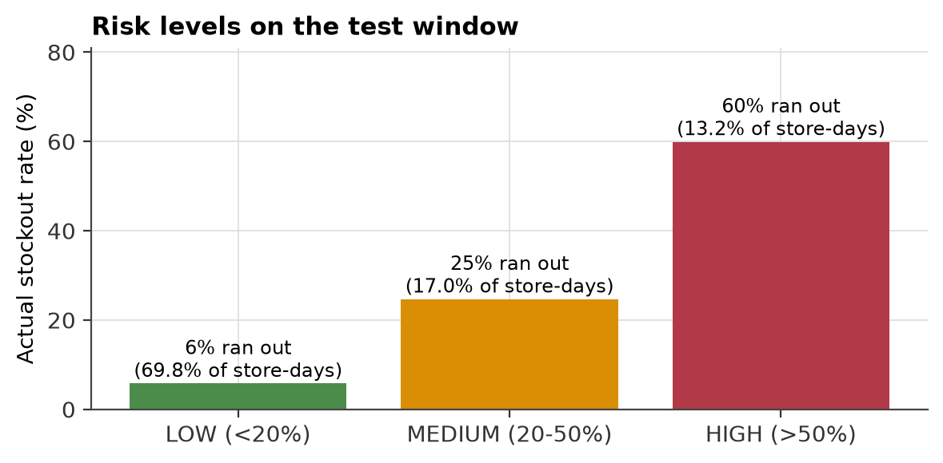
Fig. 14. Actual stockout rate in each predicted risk level.

7.5 From prediction to decision: ordering policies
Table 16. Ordering policies replayed on the test window (935 stores, June-July 2015)
Policy | Stockout days | Fill rate | Stock (days) | Emergency orders | Cost (EUR M) | vs A
A. Manager rule | 7.51% | 96.57% | 1.93 | 0 | 4.61 | +0.0%
B. DemandIQ forecast | 2.66% | 98.82% | 2.15 | 0 | 2.27 | -50.7%
C. DemandIQ + risk alerts | 1.50% | 99.58% | 2.32 | 2,380 | 1.69 | -63.4%

Table 16 and Fig. 15 give the result that matters most. Feeding the ML forecast into a standard order-up-to rule (policy B) cuts stockout days from 7.51% to 2.66% and raises the fill rate to 98.82%. Adding risk-triggered emergency orders (policy C) brings stockout days down to 1.50%, a 80% reduction, and total cost falls by 63%. The extra stock needed is modest (1.93 to 2.32 days of sales), and the cost breakdown (Fig. 16) shows that lost margin, not holding, dominates the manager's cost.
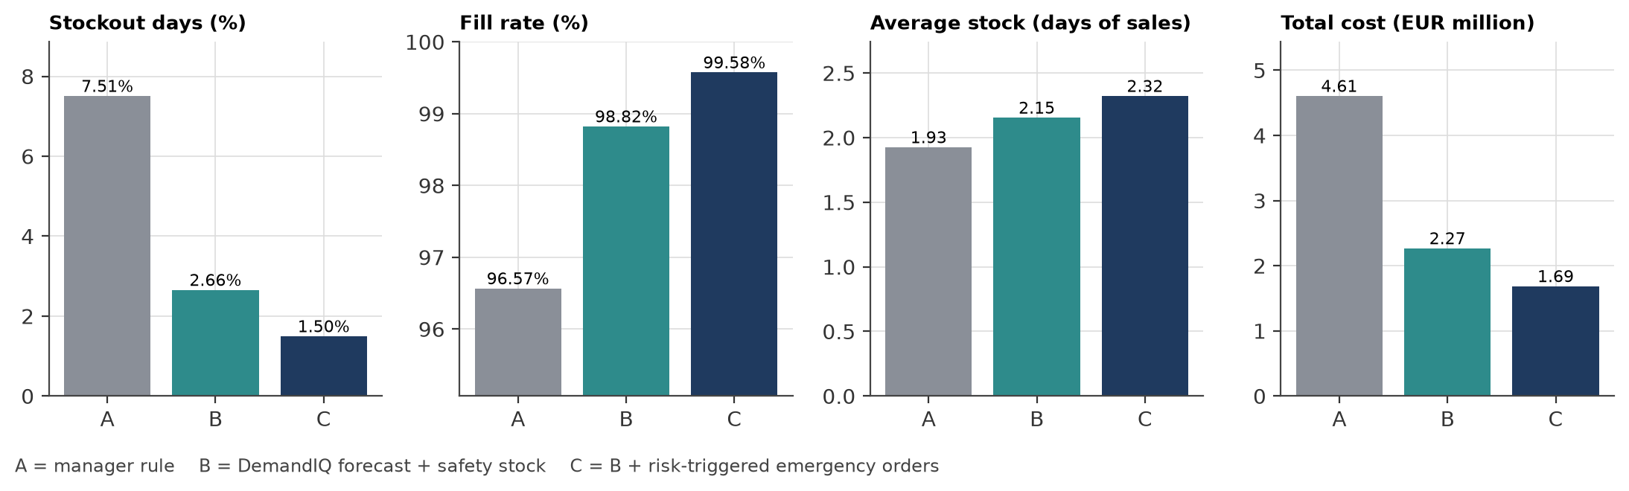
Fig. 15. Stockout days, fill rate, stock held and total cost for policies A, B and C.
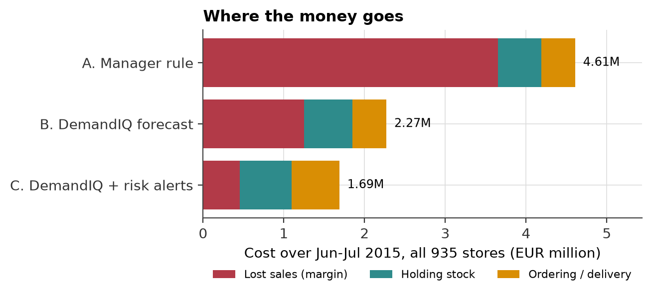
Fig. 16. Where the money goes: lost sales, holding and ordering cost by policy.
Is this only "more stock"? A fair critic could say the manager would also do better with a bigger buffer. Fig. 17 answers this by replaying each policy at many settings. For every level of stock held, the DemandIQ curve lies below the manager's curve: the same stock is simply placed on the right days (before promotions and holidays). The gap closes only when both hold so much stock that shelf capacity becomes the limit. This addresses gap G3: the benefit comes from better decisions, not just from a lower forecast error.
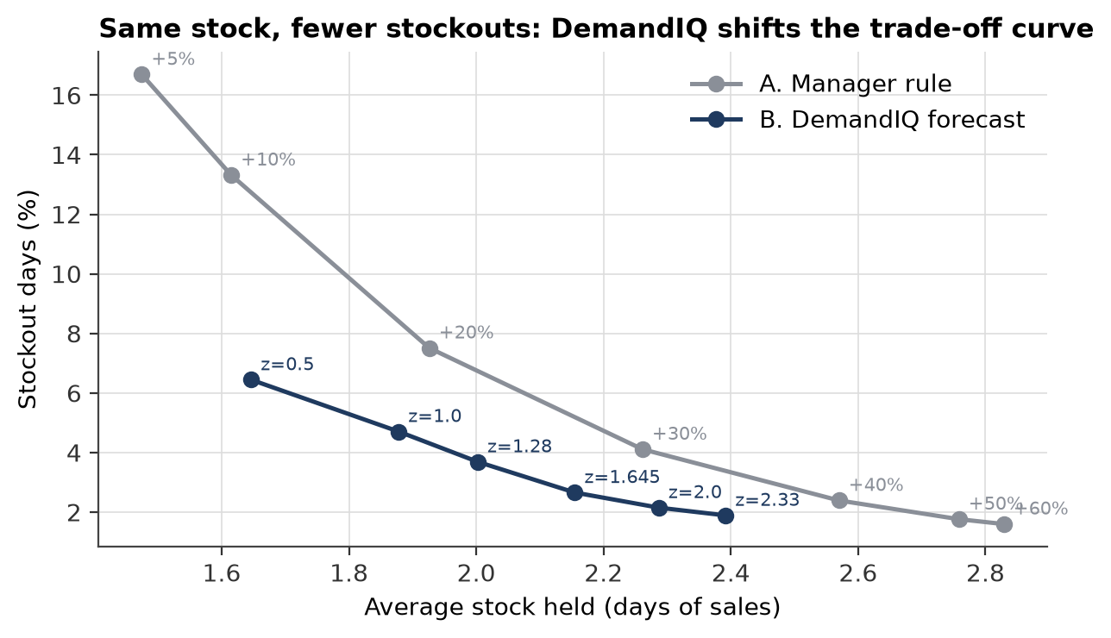
Fig. 17. Trade-off between stock held and stockout days for many buffer and service-level settings.

7.6 Explaining the models
SHAP values were computed exactly with TreeSHAP [39]; the contributions add up to the model output for every row (largest difference 3.0e-14). Globally (Fig. 18), the strongest drivers of the demand forecast are store's usual sales for this weekday, promotion today, avg. sales, 4 weeks ago window and day of month. The beeswarm view in Appendix D shows the direction: promotion days push the forecast up, stores with high usual weekday sales get high forecasts, and the start of the month and the day after a closure carry extra demand.
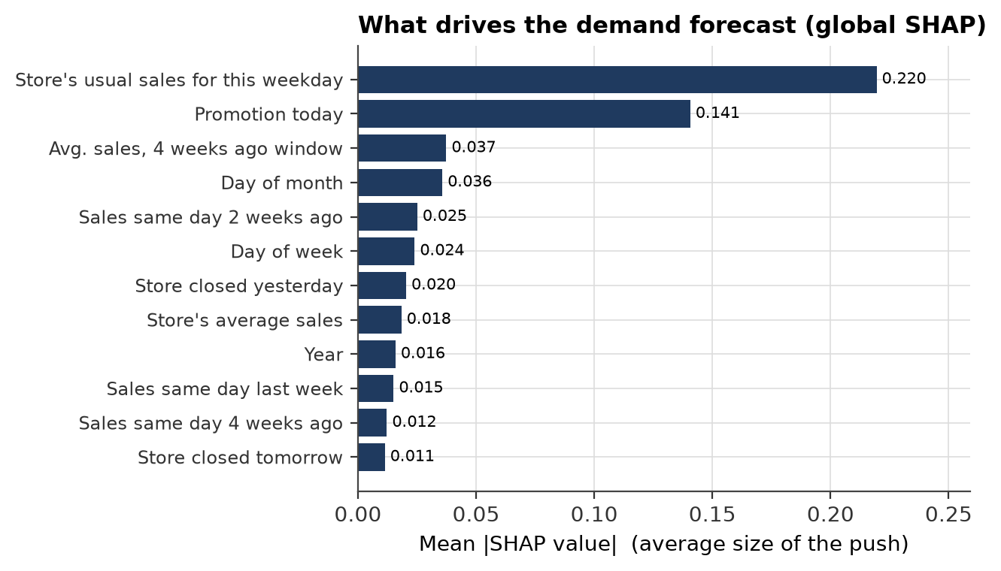
Fig. 18. Global SHAP importance of the demand model (mean absolute contribution).
Locally, Fig. 19 explains one forecast in the way a manager would read it: starting from the average store-day, each bar shows how much one fact pushed this forecast up (red) or down (blue). In the dashboard the same chart is turned into a sentence such as "pushed up by the promotion and the store's usual Monday sales; pulled down by school holidays".
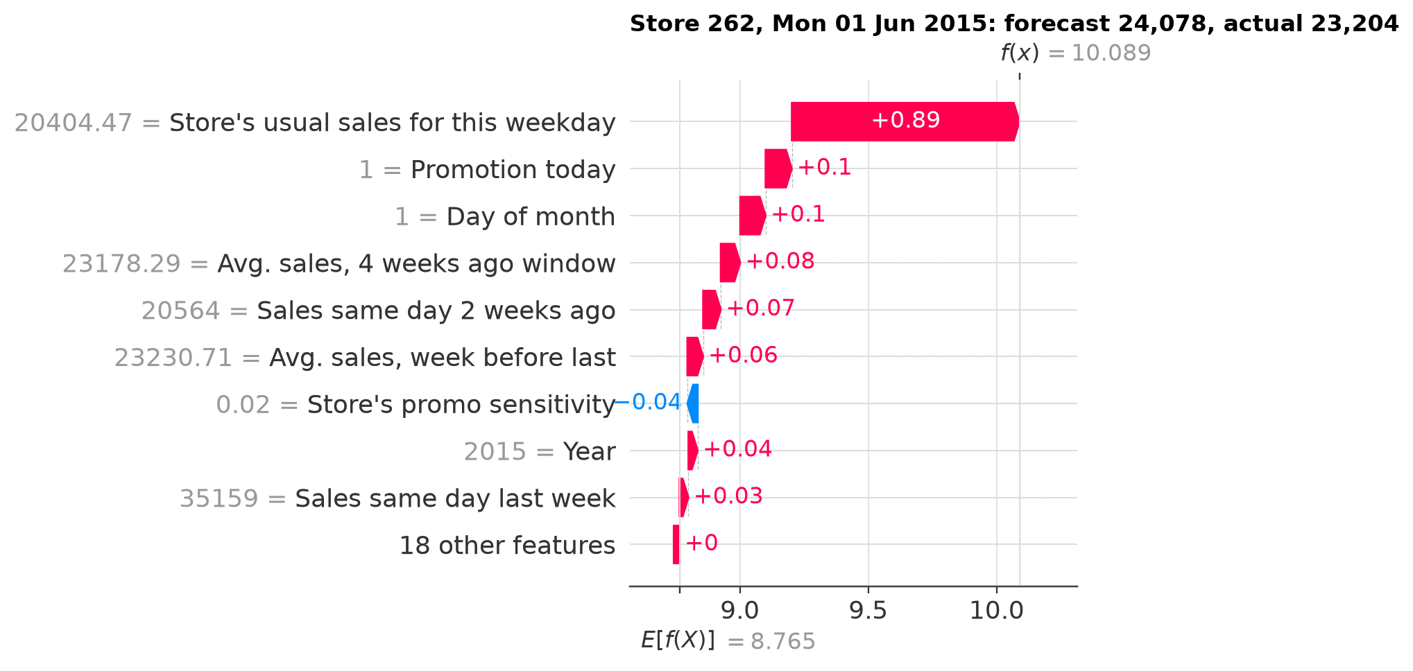
Fig. 19. Local SHAP explanation of a single forecast (store 262, a promotion Monday).
Fig. 20 uses the model as a what-if engine: for every store-day in the test sample we switch the promotion on and off and record the change. The modelled uplift ranges from 29% (High-volume flagships) to 45% (Promotion-driven), which confirms gap G5: a single promotion plan is not right for every store type.
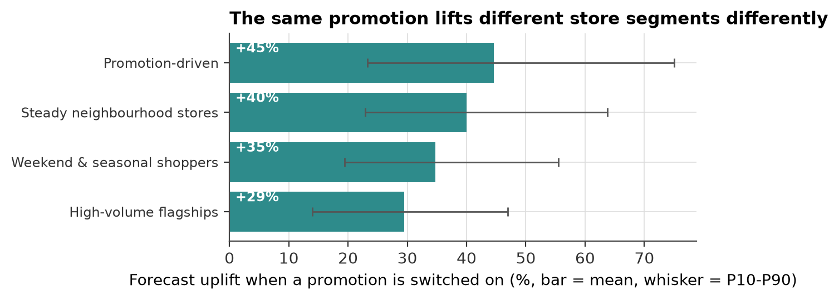
Fig. 20. Model-estimated promotion uplift by store segment (what-if, test sample).
For the risk model (Fig. 21) the most important inputs are cover ratio (stock+due / forecast), stock on hand (days) and promotion days ahead, in line with Liu et al. [31]. Low cover and an upcoming promotion raise risk; a delivery due in the next three days lowers it. Because explanations exist for the risk score too, the manager sees not only that a store is HIGH risk but why, which answers gap G2.
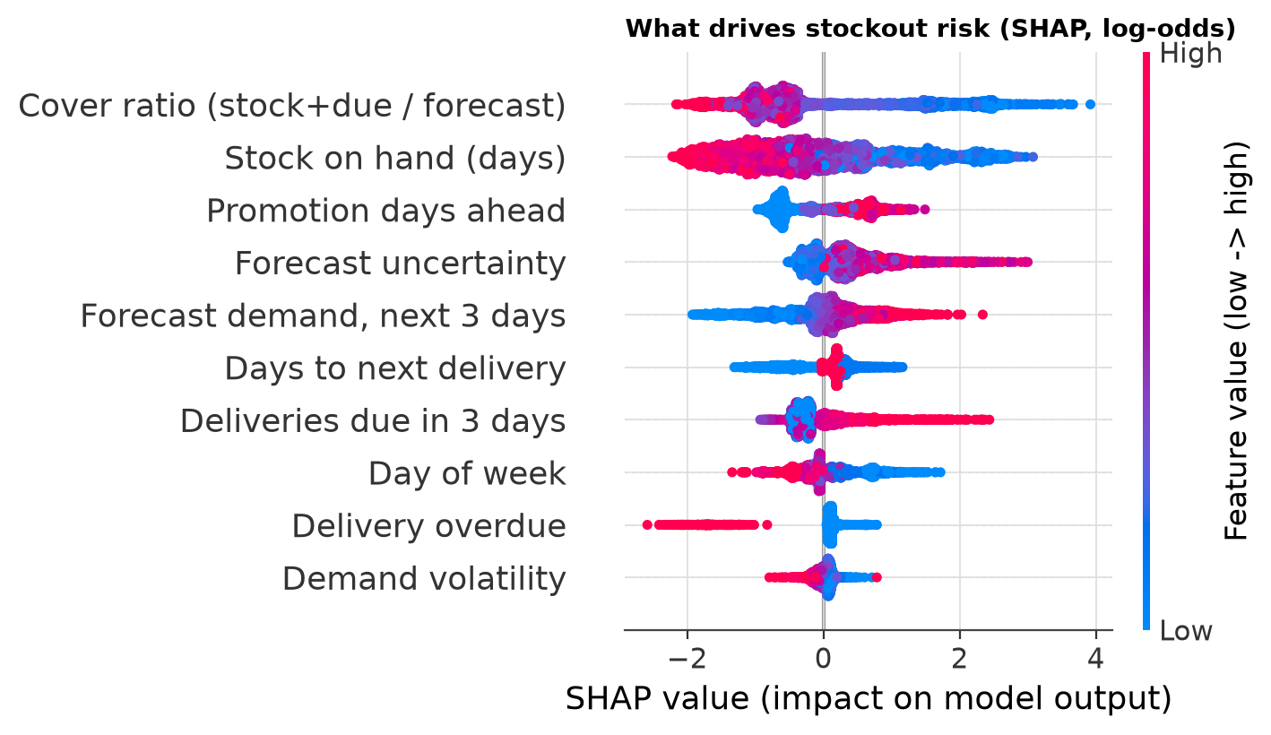
Fig. 21. SHAP summary of the stockout-risk model (each dot is one store-evening).

7.7 Interactive dashboard
The Streamlit dashboard has six pages: an overview of results; a store forecast page with the P10-P90 band; a ranked risk and reorder list with an order calculator; a "Why this forecast?" page with the SHAP waterfall and a plain-language summary; a what-if simulator (promotion, school holiday, closure, competitor distance and price with a user-set elasticity); and the store segments. Every what-if screen carries the warning that the result is model behaviour, not proof of cause and effect. Screenshots are given in Appendix C.

7.8 Comparison with the literature
Direct comparison is difficult because studies use different data and horizons, so Table 17 should be read as a sense check rather than a ranking.
Table 17. DemandIQ compared with related work
Study | Task / data | Reported result | DemandIQ
Mishra et al. [36] | SKU-day demand, Online Retail II | R² 0.243 | R² 0.941 at store-day level (less intermittent)
Huber & Stuckenschmidt [28] | Bakery daily demand | ML beats established methods | Boosting beats historical average by 22%
Liu et al. [31] | Stockout classification, 1.6 M SKUs | Stock and near-term forecast most important | Same top drivers; ROC-AUC 0.873
Theodorou et al. [32] | M5 + inventory simulation | Accuracy-cost link weak | Decision layer (risk alerts) adds a further cost cut beyond the forecast
Ban & Rudin [34] | Feature-based newsvendor | 23-24% lower cost | 63% lower cost vs manager rule (replayed stock)

Our store-level accuracy is higher than SKU-level studies because daily store totals are smoother than single-product demand; this is a property of the data, not a claim that our model is stronger.

7.9 Limitations
- Simulated inventory. Stock and stockouts come from a calibrated replay, not from real stock counts. The relative ranking of policies is reliable because all face the same demand and delays, but absolute savings would differ in a real store.
- Store level, not product level. Rossmann reports total sales per store; real ordering happens per product.
- No price data. The price lever uses an assumed elasticity (default -1.5, adjustable). Bijmolt et al. report an average brand-level elasticity of about -2.6 [46]; whole-store demand is usually less elastic.
- Narrow intervals. P10-P90 covers 72.9% instead of 80%.
- Moving holidays. Easter and other moving holidays appear only twice in the training data, which raises error in April and May.
- Censored demand. When the shelf is empty, recorded sales understate true demand; our replay treats recorded sales as demand.

8. Conclusion
DemandIQ shows that a small set of classical machine-learning models, chained together, can take a retailer from raw sales history to an explained ordering decision. Against the objectives set in Section 2.3:
Table 18. Objectives against results
Objective | Target | Achieved | Status
O1 Predict demand | MAPE < 10%, R² > 0.90 | MAPE 7.96%, R² 0.941 | Met
O1 Uncertainty | ~80% coverage | 72.9% | Partly met
O2 Stockout risk | ROC-AUC > 0.85 | ROC-AUC 0.873, PR-AUC 0.610 | Met
O3 Reorder | >= 30% fewer stockout days, lower cost | 80% fewer, cost -63% | Met
O4 Explain + what-if | Exact SHAP; dashboard | Exact TreeSHAP for both models; 6-page dashboard | Met

The most important finding is that the decision layer matters as much as the forecast. A better forecast alone already removes most of the manager's stockouts; letting the risk classifier trigger emergency orders removes a further share, and in total stockout days fall from 7.51% to 1.50%. Because every forecast and every risk score comes with its SHAP explanation, and because what-if results are clearly labelled, the system is something a manager can question and therefore trust.

9. Future Scope
- Real stockout labels. Validate the inventory replay on a dataset with recorded stockouts, such as FreshRetailNet-50K, and move from store level to product (SKU) level.
- Indian retail and festivals. Add a Diwali/Eid/Christmas festival calendar and test on Indian retail or apparel data, where festival peaks are sharper.
- Causal price effect. Estimate the effect of price with double/debiased machine learning [38] once price data is available, instead of an assumed elasticity.
- Better intervals. Calibrate the P10-P90 band with conformal prediction so that coverage reaches 80%.
- Deployment. Schedule the pipeline to retrain weekly, send the HIGH-risk list to managers each evening, and log their decisions to measure real impact.

10. References
[1] T. W. Gruen, D. S. Corsten, and S. Bharadwaj, Retail Out-of-Stocks: A Worldwide Examination of Extent, Causes and Consumer Responses. Washington, DC, USA: Grocery Manufacturers of America, 2002.
[2] R. Fildes, S. Ma, and S. Kolassa, "Retail forecasting: Research and practice," Int. J. Forecast., vol. 38, no. 4, pp. 1283-1318, 2022.
[3] S. Makridakis, E. Spiliotis, and V. Assimakopoulos, "M5 accuracy competition: Results, findings, and conclusions," Int. J. Forecast., vol. 38, no. 4, pp. 1346-1364, 2022, doi: 10.1016/j.ijforecast.2021.11.013.
[4] E. A. Silver, D. F. Pyke, and D. J. Thomas, Inventory and Production Management in Supply Chains, 4th ed. Boca Raton, FL, USA: CRC Press, 2017.
[5] S. Chopra and P. Meindl, Supply Chain Management: Strategy, Planning, and Operation, 6th ed. Boston, MA, USA: Pearson, 2016.
[6] Rossmann, "Rossmann Store Sales," Kaggle competition dataset, 2015. [Online]. Available: https://www.kaggle.com/c/rossmann-store-sales
[7] R. J. Hyndman and G. Athanasopoulos, Forecasting: Principles and Practice, 3rd ed. Melbourne, Australia: OTexts, 2021.
[8] G. E. P. Box, G. M. Jenkins, G. C. Reinsel, and G. M. Ljung, Time Series Analysis: Forecasting and Control, 5th ed. Hoboken, NJ, USA: Wiley, 2015.
[9] M. Gilliland, The Business Forecasting Deal: Exposing Myths, Eliminating Bad Practices, Providing Practical Solutions. Hoboken, NJ, USA: Wiley, 2010.
[10] S. Nahmias and T. L. Olsen, Production and Operations Analysis, 7th ed. Long Grove, IL, USA: Waveland Press, 2015.
[11] P. H. Zipkin, Foundations of Inventory Management. Boston, MA, USA: McGraw-Hill, 2000.
[12] S. Axsäter, Inventory Control, 3rd ed. Cham, Switzerland: Springer, 2015.
[13] W. L. Winston, Operations Research: Applications and Algorithms, 4th ed. Belmont, CA, USA: Thomson Brooks/Cole, 2004.
[14] T. Hastie, R. Tibshirani, and J. Friedman, The Elements of Statistical Learning: Data Mining, Inference, and Prediction, 2nd ed. New York, NY, USA: Springer, 2009.
[15] G. James, D. Witten, T. Hastie, and R. Tibshirani, An Introduction to Statistical Learning, 2nd ed. New York, NY, USA: Springer, 2021.
[16] C. M. Bishop, Pattern Recognition and Machine Learning. New York, NY, USA: Springer, 2006.
[17] K. P. Murphy, Probabilistic Machine Learning: An Introduction. Cambridge, MA, USA: MIT Press, 2022.
[18] A. Géron, Hands-On Machine Learning with Scikit-Learn, Keras, and TensorFlow, 3rd ed. Sebastopol, CA, USA: O'Reilly Media, 2022.
[19] M. Kuhn and K. Johnson, Applied Predictive Modeling. New York, NY, USA: Springer, 2013.
[20] M. Kuhn and K. Johnson, Feature Engineering and Selection: A Practical Approach for Predictive Models. Boca Raton, FL, USA: CRC Press, 2019.
[21] H. He and Y. Ma, Eds., Imbalanced Learning: Foundations, Algorithms, and Applications. Hoboken, NJ, USA: Wiley-IEEE Press, 2013.
[22] C. Molnar, Interpretable Machine Learning: A Guide for Making Black Box Models Explainable, 2nd ed. 2022. [Online]. Available: https://christophm.github.io/interpretable-ml-book/
[23] J. Pearl, M. Glymour, and N. P. Jewell, Causal Inference in Statistics: A Primer. Chichester, U.K.: Wiley, 2016.
[24] F. Provost and T. Fawcett, Data Science for Business. Sebastopol, CA, USA: O'Reilly Media, 2013.
[25] M. Seyedan and F. Mafakheri, "Predictive big data analytics for supply chain demand forecasting: Methods, applications, and research opportunities," J. Big Data, vol. 7, Art. no. 53, 2020, doi: 10.1186/s40537-020-00329-2.
[26] G. Ke, Q. Meng, T. Finley, T. Wang, W. Chen, W. Ma, Q. Ye, and T.-Y. Liu, "LightGBM: A highly efficient gradient boosting decision tree," in Proc. Adv. Neural Inf. Process. Syst. (NIPS), vol. 30, 2017, pp. 3146-3154.
[27] Ö. Gür Ali, S. Sayın, T. van Woensel, and J. Fransoo, "SKU demand forecasting in the presence of promotions," Expert Syst. Appl., vol. 36, no. 10, pp. 12340-12348, 2009, doi: 10.1016/j.eswa.2009.04.052.
[28] J. Huber and H. Stuckenschmidt, "Daily retail demand forecasting using machine learning with emphasis on calendric special days," Int. J. Forecast., vol. 36, no. 4, pp. 1420-1438, 2020, doi: 10.1016/j.ijforecast.2020.02.005.
[29] E. Spiliotis, S. Makridakis, A.-A. Semenoglou, and V. Assimakopoulos, "Comparison of statistical and machine learning methods for daily SKU demand forecasting," Oper. Res. Int. J., vol. 22, no. 3, pp. 3037-3061, 2022, doi: 10.1007/s12351-020-00605-2.
[30] B. Lim, S. Ö. Arık, N. Loeff, and T. Pfister, "Temporal fusion transformers for interpretable multi-horizon time series forecasting," Int. J. Forecast., vol. 37, no. 4, pp. 1748-1764, 2021.
[31] Y. Liu, D. Kalaitzi, M. Wang, and C. Papanagnou, "A machine learning approach to inventory stockout prediction," J. Digit. Econ., vol. 4, pp. 144-155, 2025, doi: 10.1016/j.jdec.2025.06.002.
[32] E. Theodorou, E. Spiliotis, and V. Assimakopoulos, "Forecast accuracy and inventory performance: Insights on their relationship from the M5 competition data," Eur. J. Oper. Res., vol. 322, no. 2, pp. 414-426, 2025, doi: 10.1016/j.ejor.2024.12.033.
[33] D. Bertsimas and N. Kallus, "From predictive to prescriptive analytics," Manage. Sci., vol. 66, no. 3, pp. 1025-1044, 2020, doi: 10.1287/mnsc.2018.3253.
[34] G.-Y. Ban and C. Rudin, "The big data newsvendor: Practical insights from machine learning," Oper. Res., vol. 67, no. 1, pp. 90-108, 2019, doi: 10.1287/opre.2018.1757.
[35] S. M. Lundberg and S.-I. Lee, "A unified approach to interpreting model predictions," in Proc. Adv. Neural Inf. Process. Syst. (NIPS), vol. 30, 2017, pp. 4765-4774.
[36] L. N. Mishra, B. Senapati, S. K. Nayak, and A. J. Rangari, "Explainable retail demand forecasting: A hybrid LightGBM-SHAP framework for inventory optimization," IEEE Access, vol. 14, pp. 43613-43633, 2026, doi: 10.1109/ACCESS.2026.3675540.
[37] J. M. Rožanec, B. Fortuna, and D. Mladenić, "Knowledge graph-based rich and confidentiality preserving explainable artificial intelligence (XAI)," Inf. Fusion, vol. 81, pp. 91-102, 2022, doi: 10.1016/j.inffus.2021.11.015.
[38] V. Chernozhukov, D. Chetverikov, M. Demirer, E. Duflo, C. Hansen, W. Newey, and J. Robins, "Double/debiased machine learning for treatment and structural parameters," Econom. J., vol. 21, no. 1, pp. C1-C68, 2018.
[39] S. M. Lundberg, G. Erion, H. Chen, A. DeGrave, J. M. Prutkin, B. Nair, R. Katz, J. Himmelfarb, N. Bansal, and S.-I. Lee, "From local explanations to global understanding with explainable AI for trees," Nat. Mach. Intell., vol. 2, no. 1, pp. 56-67, 2020.
[40] J. MacQueen, "Some methods for classification and analysis of multivariate observations," in Proc. 5th Berkeley Symp. Math. Statist. Probab., vol. 1, 1967, pp. 281-297.
[41] P. J. Rousseeuw, "Silhouettes: A graphical aid to the interpretation and validation of cluster analysis," J. Comput. Appl. Math., vol. 20, pp. 53-65, 1987.
[42] L. Breiman, "Random forests," Mach. Learn., vol. 45, no. 1, pp. 5-32, 2001.
[43] J. H. Friedman, "Greedy function approximation: A gradient boosting machine," Ann. Statist., vol. 29, no. 5, pp. 1189-1232, 2001.
[44] R. Koenker and G. Bassett, "Regression quantiles," Econometrica, vol. 46, no. 1, pp. 33-50, 1978.
[45] F. Pedregosa et al., "Scikit-learn: Machine learning in Python," J. Mach. Learn. Res., vol. 12, pp. 2825-2830, 2011.
[46] T. H. A. Bijmolt, H. J. van Heerde, and R. G. M. Pieters, "New empirical generalizations on the determinants of price elasticity," J. Mark. Res., vol. 42, no. 2, pp. 141-156, 2005.

Appendix A. Hyper-parameter settings
Table 19. Final hyper-parameters
Model | Settings
Gradient Boosting (demand) | HistGradientBoostingRegressor; loss = squared error on log(1+sales); learning_rate 0.08; max_iter 400; max_leaf_nodes 127; min_samples_leaf 40; l2_regularization 0.0
Quantile models | Same as above with loss = quantile, quantile = 0.1 and 0.9
Random Forest (demand) | n_estimators 120; min_samples_leaf 5; max_features 0.5; max_samples 0.3
Ridge regression | alpha 1.0; one-hot categories; median imputation; standard scaling
Gradient Boosting (risk) | HistGradientBoostingClassifier; max_iter 300; learning_rate 0.05; max_leaf_nodes 31; min_samples_leaf 50; l2_regularization 1.0; threshold tuned on validation (max F1)
Random Forest (risk) | n_estimators 200; min_samples_leaf 20; max_features 0.5; class_weight balanced_subsample
Logistic Regression | class_weight balanced; standard scaling; max_iter 2000
K-Means | k = 4; n_init 50; standardised features; random_state 42
Inventory replay | Review Mon & Thu; lead time 2 days; 15% one day late, 5% two days late; shelf capacity 6 days; manager buffer +20%; z = 1.645; emergency lead time 1 day; emergency threshold 0.15

Table 20. Grid search results on the validation window (best number of trees per setting)
Leaves | Min leaf | L2 | Best trees | Valid RMSPE | Valid MAPE
127 | 40 | 0.0 | 400 | 0.1190 | 8.86%
63 | 40 | 1.0 | 350 | 0.1192 | 8.89%
63 | 40 | 0.0 | 400 | 0.1198 | 8.92%
31 | 40 | 1.0 | 400 | 0.1201 | 8.98%
31 | 40 | 0.0 | 450 | 0.1204 | 8.99%
127 | 40 | 1.0 | 300 | 0.1224 | 9.10%

Table 21. Choosing the emergency-order threshold on the validation window (policy C)
Threshold | Stockout days | Emergency orders | Total cost (EUR M)
0.1 | 2.64% | 2,273 | 2.003
0.15 | 2.67% | 2,039 | 1.992
0.2 | 2.74% | 1,743 | 2.001
0.3 | 3.10% | 989 | 2.147
0.4 | 3.42% | 353 | 2.422
0.5 | 3.52% | 109 | 2.508
0.6 | 3.55% | 53 | 2.530

Appendix B. Code structure and key snippet
The project is organised as one script per pipeline step. Running python src/run_all.py rebuilds every table and figure in this report; streamlit run app/app.py opens the dashboard.
Table 22. Project files
File | Purpose
src/config.py | All settings: dates, costs, lead time, palette
src/step1_prepare_data.py | Cleaning, calendar re-indexing, 27 features, EDA figures
src/step2_store_segments.py | K-Means store segmentation
src/step3_demand_model.py | Baselines, Ridge, Random Forest, Gradient Boosting, quantiles, tuning
src/inventory.py | Inventory replay and the three ordering policies
src/step4_stockout_model.py | Risk dataset, four classifiers, ROC/PR/calibration
src/step5_reorder_policies.py | Policy comparison, threshold tuning, trade-off curve, reorder list
src/step6_explain.py | SHAP global and local explanations, promotion uplift by segment
app/app.py | Streamlit dashboard with what-if simulator

The order-up-to rule at the heart of policy B (from src/inventory.py):
f_sum = p.fc[:, sl].sum(1) # forecast until next delivery
f_day = f_sum / np.maximum(p.open[:, sl].sum(1), 1)
var = (p.sigma[:, sl] ** 2).sum(1) + f_day ** 2 * DELAY_VAR
S = f_sum + DELAY_MEAN * f_day + SERVICE_LEVEL_Z * np.sqrt(var)
q = np.maximum(0, S - on_hand - pending) # order quantity

Appendix C. Dashboard screenshots
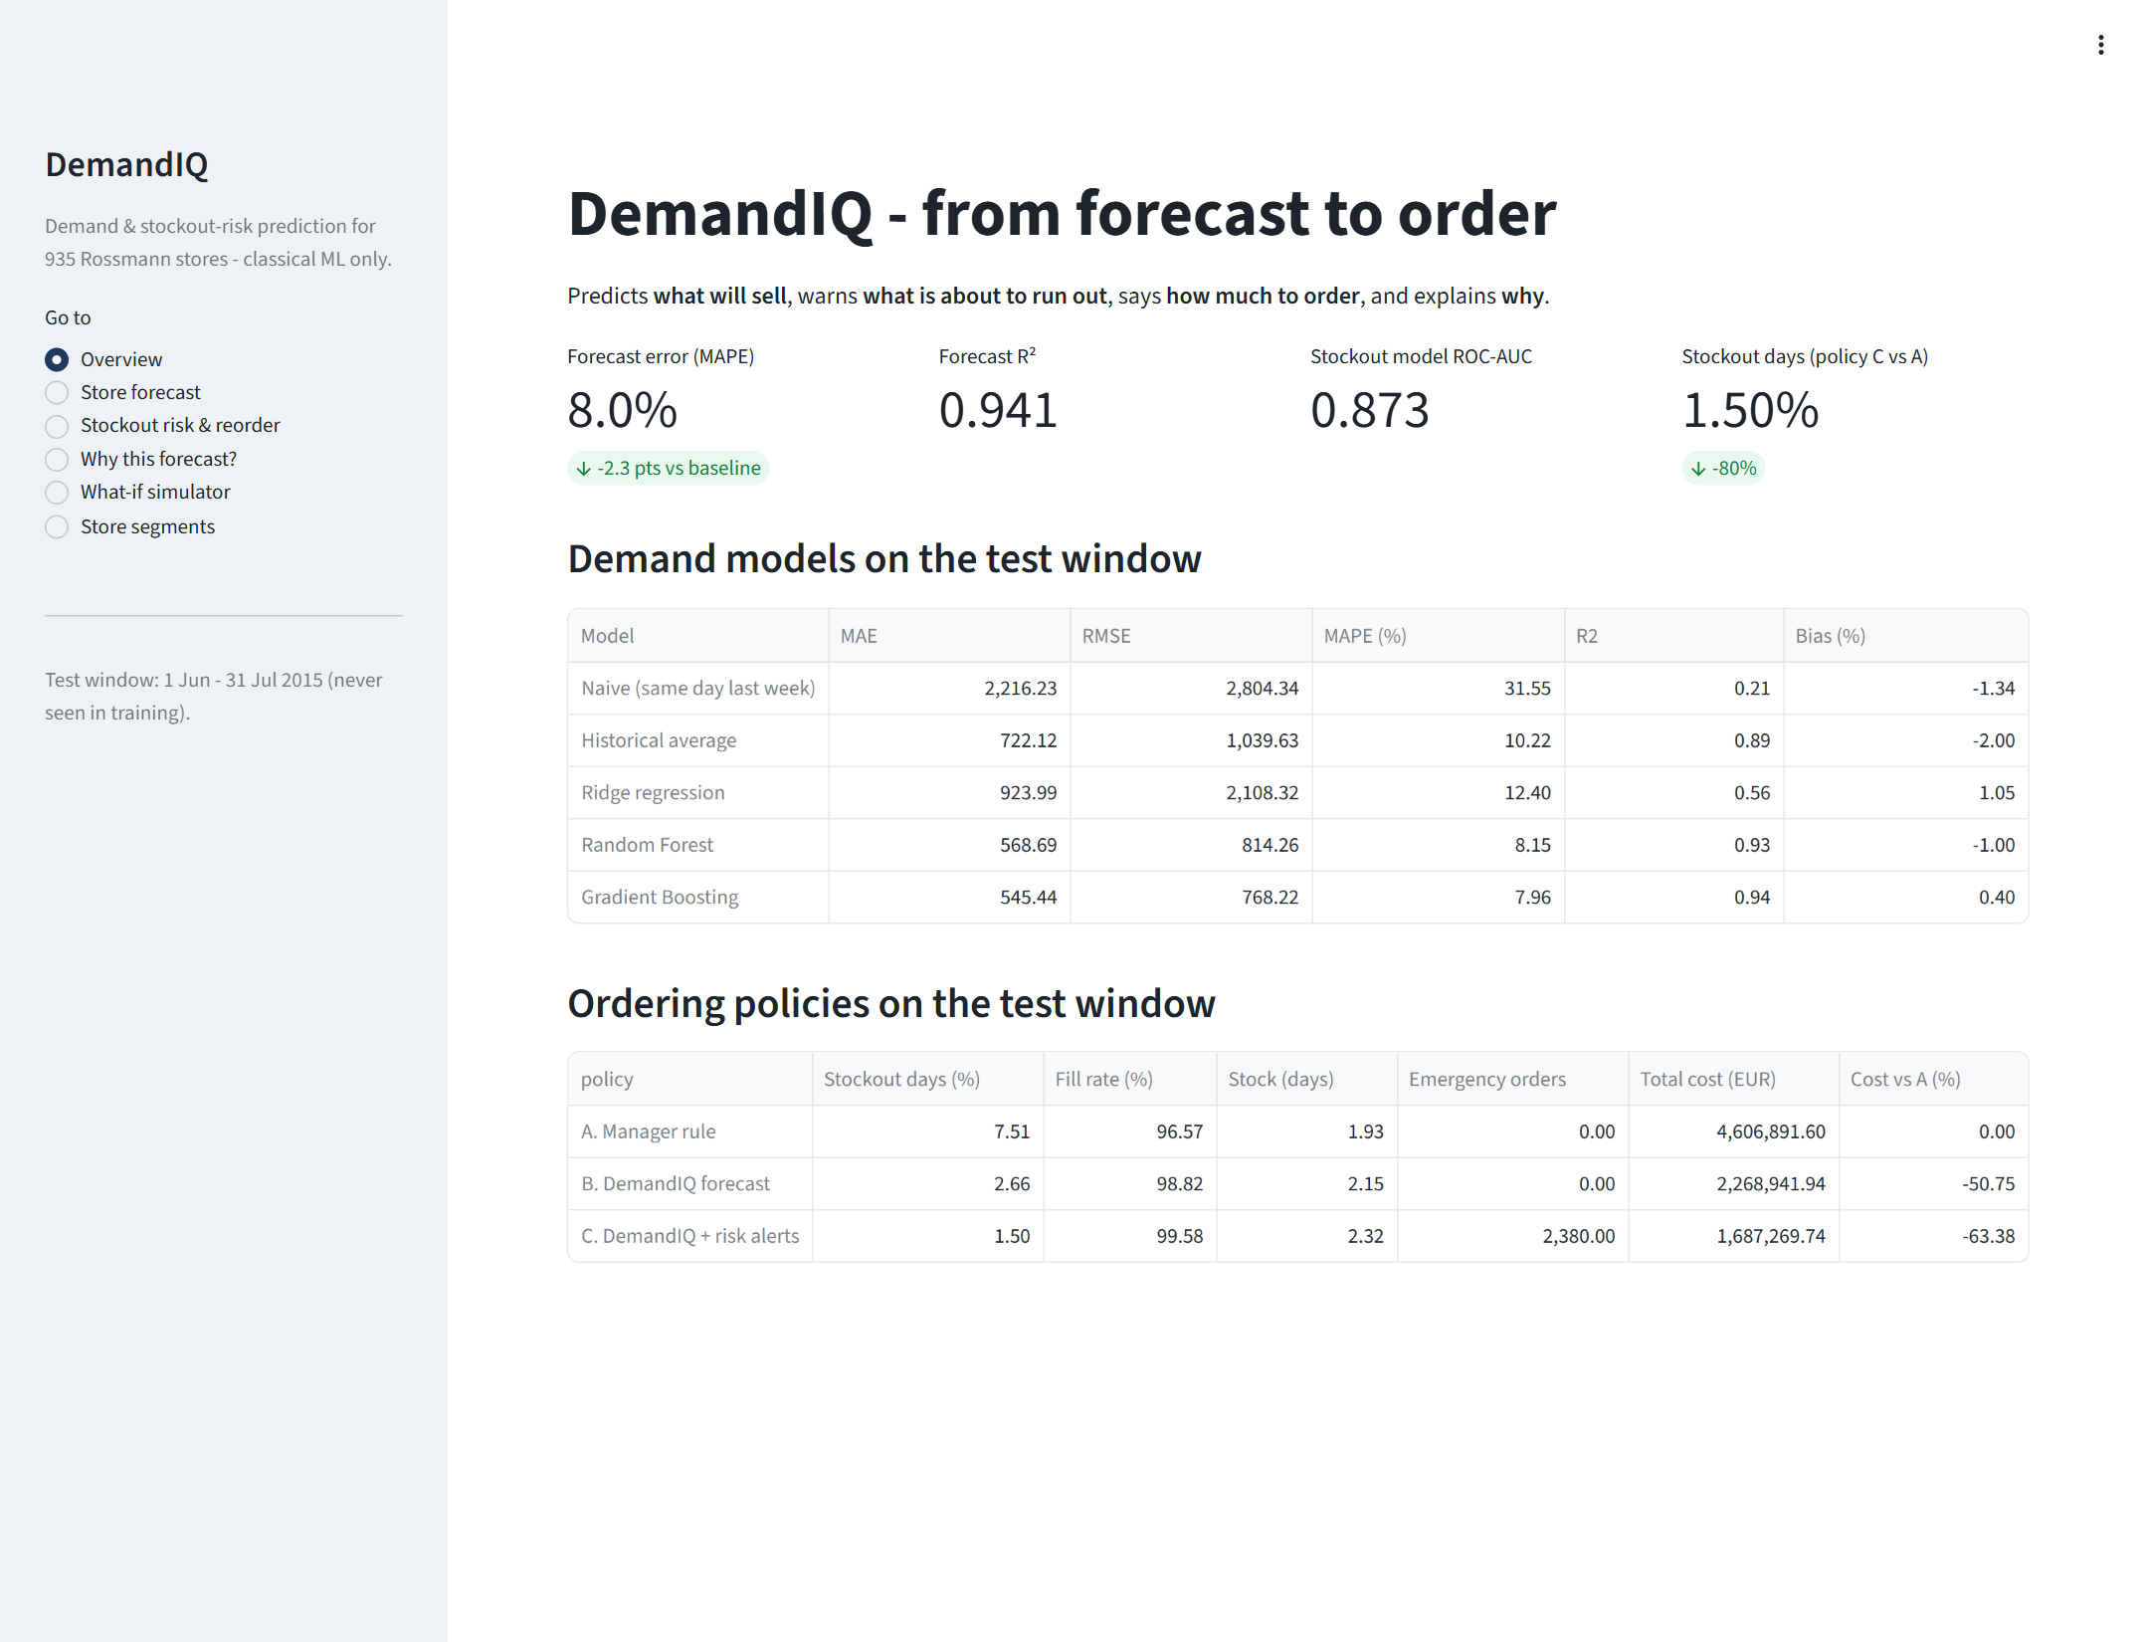
Fig. 22. Dashboard overview page.
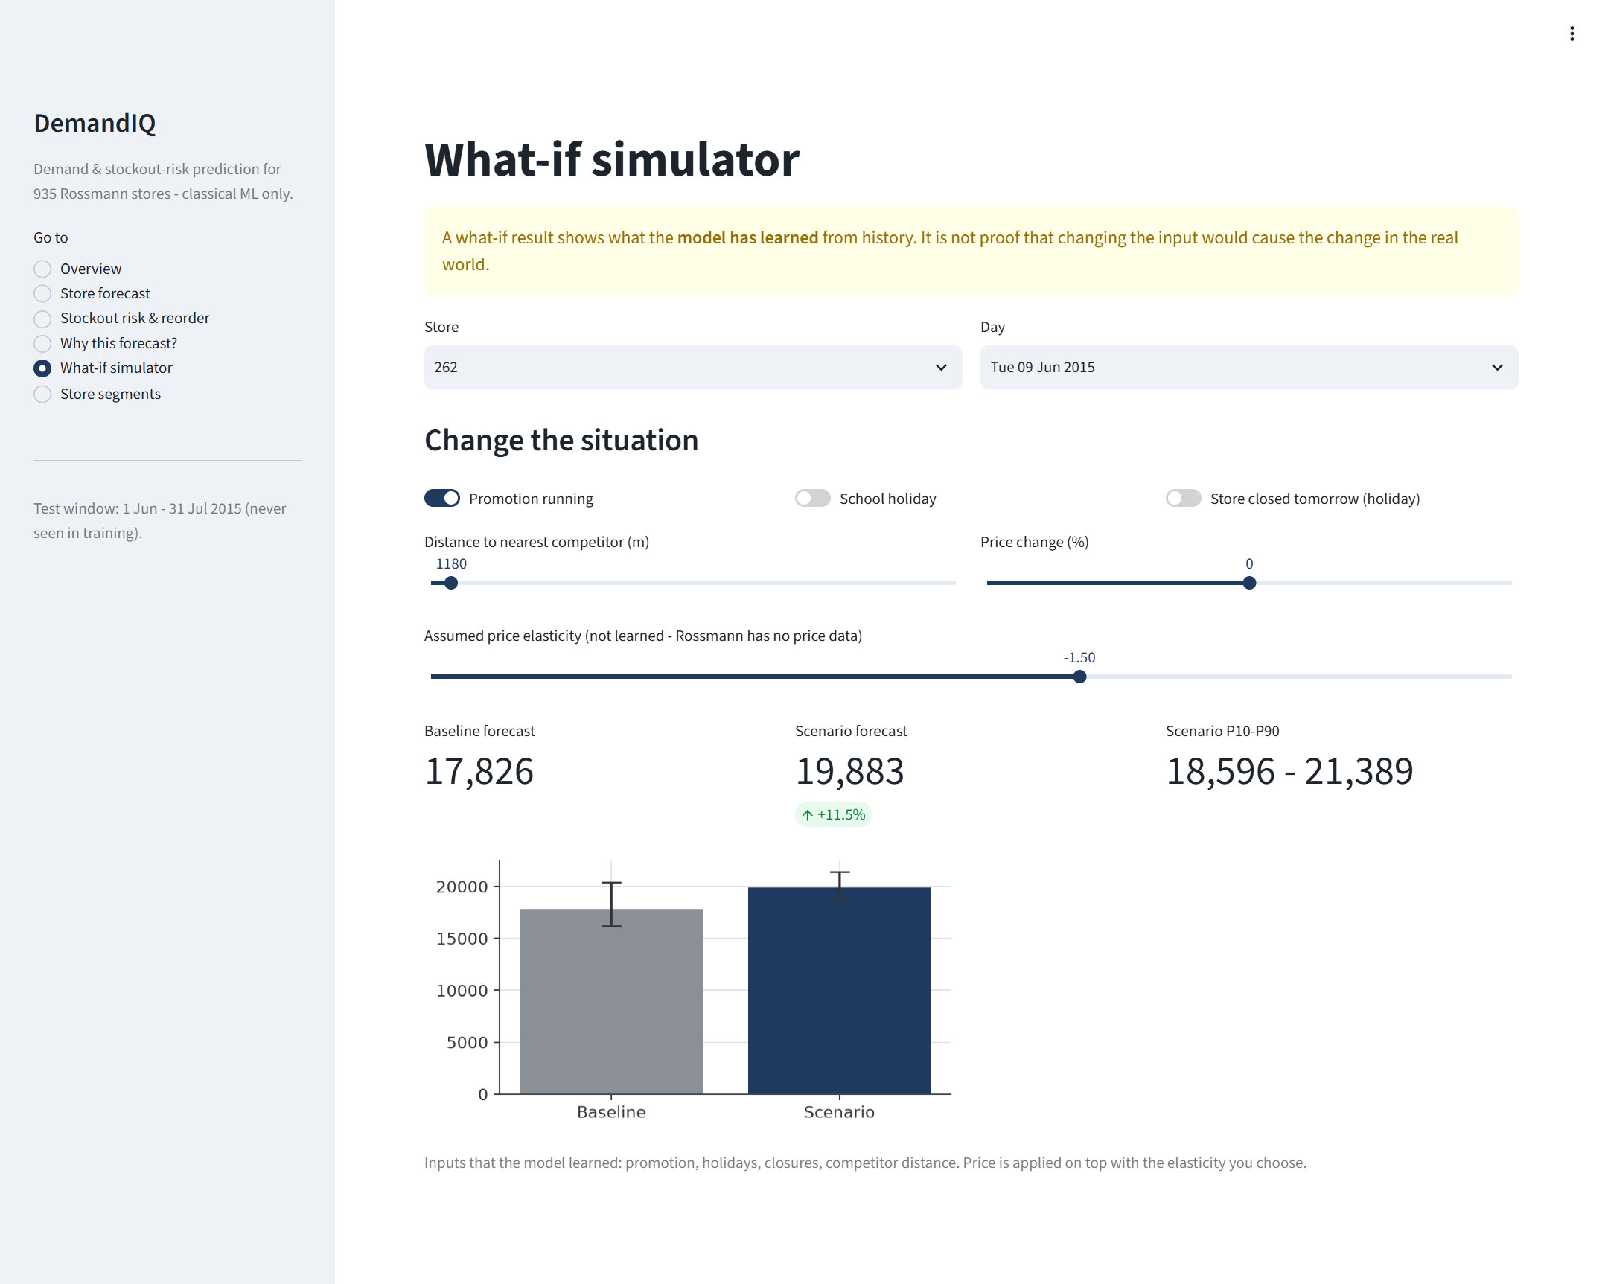
Fig. 23. What-if simulator: a promotion switched on for one store-day.
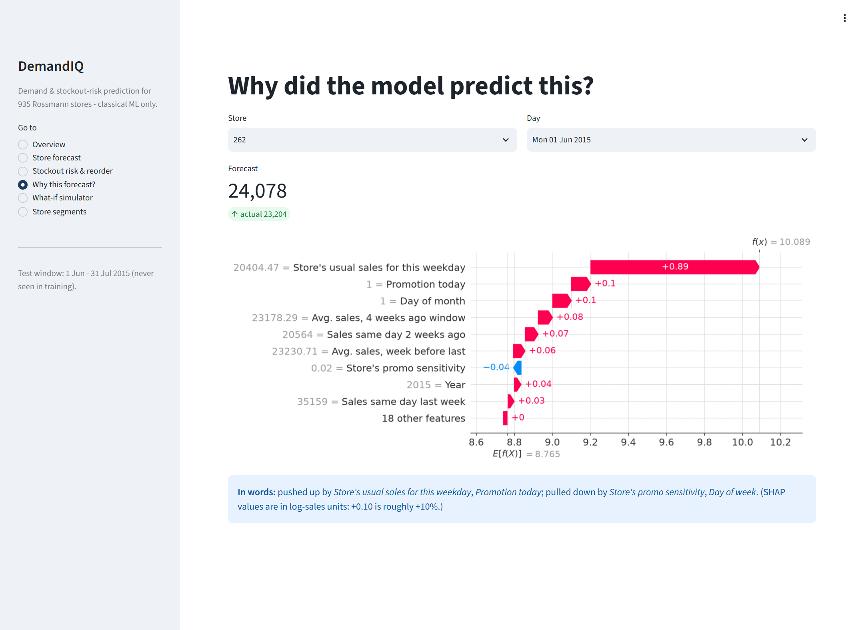
Fig. 24. "Why this forecast?" page with the SHAP waterfall and a plain-language summary.
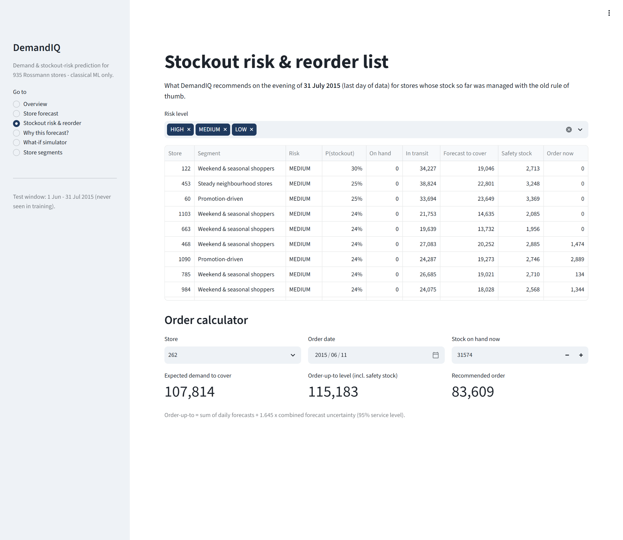
Fig. 25. Stockout risk and reorder list with the order calculator.

Appendix D. Additional figures
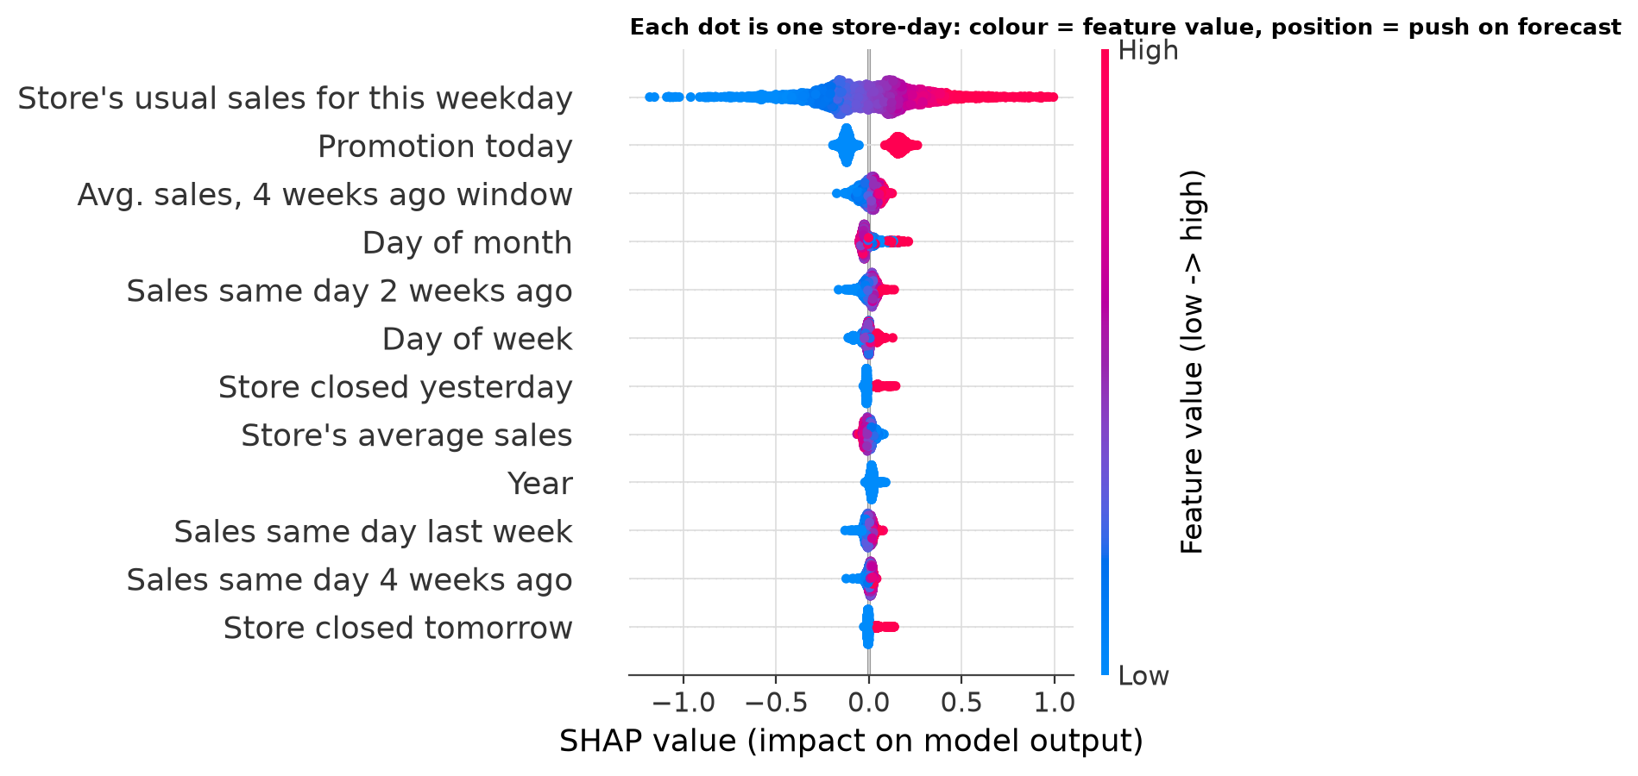
Fig. 26. SHAP beeswarm of the demand model: colour = feature value, position = push on the forecast.
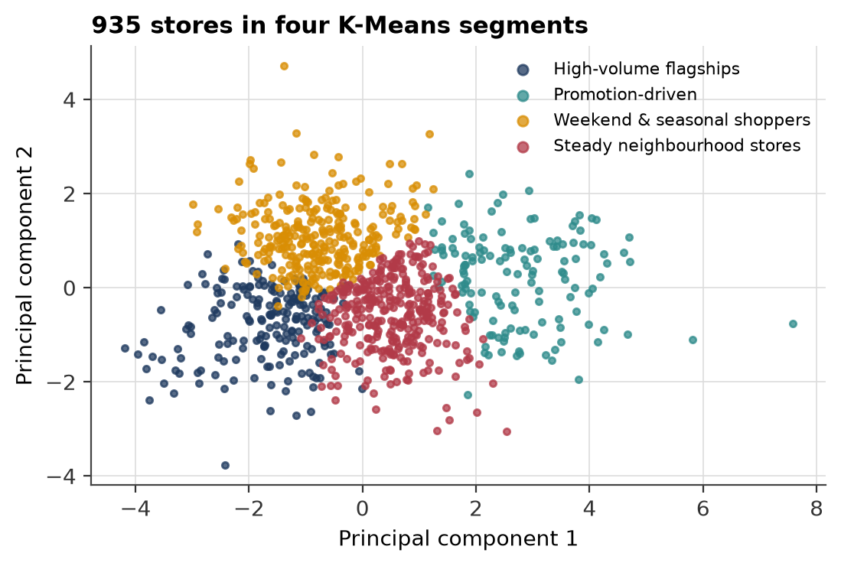
Fig. 27. The 935 stores in the four K-Means segments (first two principal components).
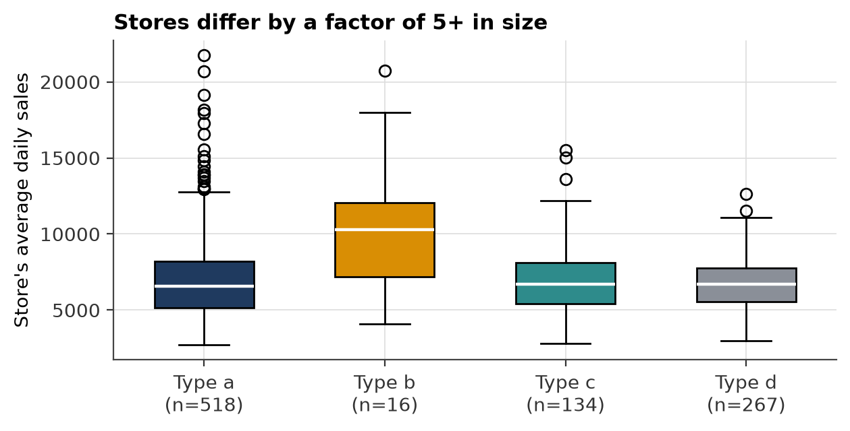
Fig. 28. Distribution of store average sales by Rossmann store type.
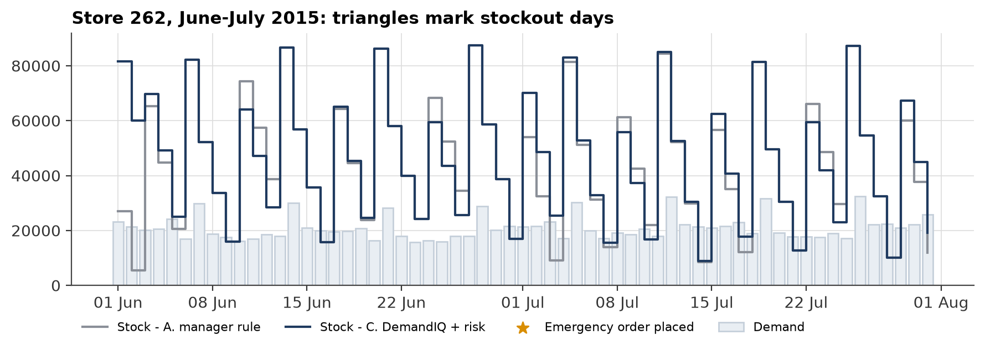
Fig. 29. Stock of store 262 under policies A and C during the test window.

Appendix E. Ethics, bias and reproducibility
- Privacy. The data is public and aggregated per store and day; it contains no customer-level or personal information.
- Fairness and bias. Error was checked across store segments and weekdays (Fig. 10); no segment is served noticeably worse. A forecast that systematically under-predicts small stores would starve them of stock, so this check should be repeated whenever the model is retrained.
- Responsible use. What-if results are labelled as model behaviour, and the price lever is labelled as an assumption. Recommendations support, not replace, the store manager.
- Reproducibility. Fixed seed 42; all settings in src/config.py; the Rossmann data is downloadable from Kaggle; python src/run_all.py regenerates every number and figure in this report.
- Originality. The written report is to be checked for similarity (target under 10%) before submission.

