Factory-to-Customer Shipping Route Efficiency Analysis
Nassau Candy Distributor · Research Paper: EDA, Insights and Recommendations
Data: 10,194 order lines, 8,549 orders, orders placed 02 Jan 2024 – 31 Dec 2025

Abstract
This study turns Nassau Candy's order and shipment records into route-level logistics intelligence. Each route is defined as origin factory → customer state (or region). Lead time, volume, variability, delay frequency and an efficiency score are measured for every route. A data-quality issue was found and corrected first: recorded ship dates carry a whole-year offset that inflates raw lead times to 904–1,642 days. After correction, the average lead time is 4.29 days (median 4), and 24.7% of shipments exceed 5 days. Ship mode is the dominant driver of lead time (Same Day 0.38 d to Standard 5.32 d). Distance and region have little or no measurable effect once mode is controlled for. The most important operational signal is a broad deterioration in 2025: average lead time rose 0.38 days, and the delay rate went from 18.1% to 29.3%, in every ship mode. That points to a processing (order-to-dispatch) constraint rather than a route or carrier problem. Recommendations focus on dispatch capacity, the Standard Class service promise, and targeted fixes for a small set of high-volume, high-delay states.

1. Background and Problem Statement
Nassau Candy ships confectionery from five factories to customers across the United States and Canada. Shipping efficiency drives customer satisfaction, delays raise operating cost, and inefficient routes limit scalability. The business has rich order data but no route-level view of efficiency, so logistics decisions have been reactive. This project answers:
- Which factory-to-customer routes are consistently efficient, and which are frequently delayed?
- How does shipping performance vary by region, state and ship mode?
- Where are the geographic bottlenecks?
- What cost-time trade-offs exist between standard and expedited shipping?

2. Data
The dataset holds 10,194 order lines with 18 fields: order/ship dates, ship mode, customer geography (country, region, state/province, city, postal code), product, division, sales, units, cost and gross profit. It covers 5,044 customers in 542 cities across 59 states/provinces, with total sales of $141,784 and gross profit of $93,443. Factory location is not in the order data. It was attached with the product → factory mapping and factory coordinates from the project brief, so each order line has an origin. Factory-to-customer distance was estimated as the great-circle distance from the factory to the customer state's centroid.
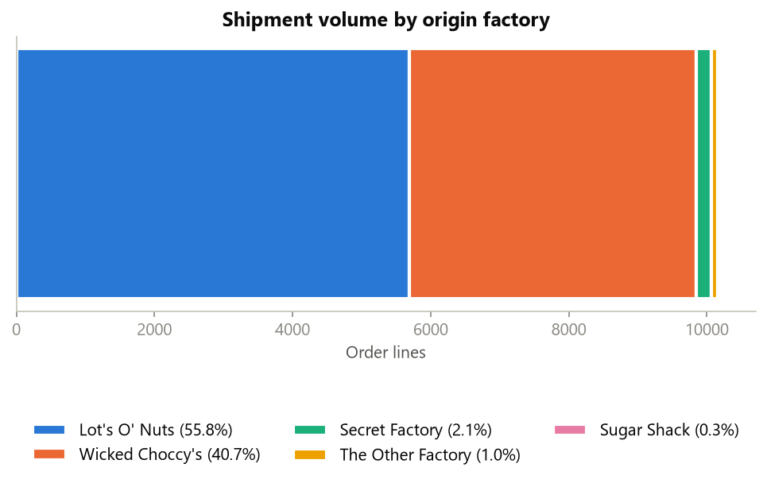
Figure 1. Two chocolate factories originate 96.6% of all shipments.

3. Data Cleaning and Validation
- Date validation: both date fields parsed as DD-MM-YYYY; 0 invalid dates.
- Missing shipment records: 0 rows missing order ID, ship mode, state or product; 0 exact duplicates.
- Negative / invalid lead times: 0 negative; 0 implausible after correction.
- Geographic standardisation: text fields trimmed and whitespace-normalised; every state/province mapped to a code and centroid; product-name inconsistency fixed ("Wonka Bar -Scrumdiddlyumptious").
- Factory mapping: all 10,194 lines mapped to an origin factory (0 unmapped).

3.1 Lead-time correction (key data-quality finding)
Raw Ship Date − Order Date ranges from 904 to 1,642 days (2.5–4.5 years), which is not plausible for confectionery distribution. The values fall in three tight clusters starting at 904, 1,269 and 1,634 days, exactly 365 days apart (Figure 2). That pattern is a systematic year offset in the recorded ship dates, not real transit time. Removing the whole-year block, (raw − 904) mod 365, leaves a 0–11 day lead time. This value is cleanly ordered by service level (Figure 3): Same Day 0–2 days, First Class 1–4, Second Class 1–6, Standard Class 3–8. This structure would be very unlikely if the correction were wrong, so the corrected value is used as Shipping Lead Time throughout. The raw value is kept in the cleaned dataset for audit. Nassau Candy should fix the ship-date recording at source.
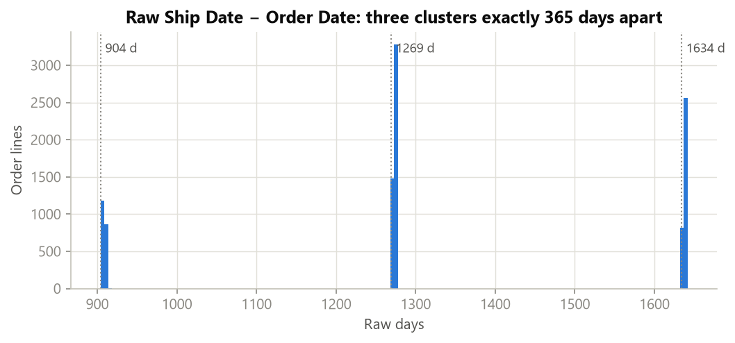
Figure 2. Raw lead times sit in three year-offset clusters.
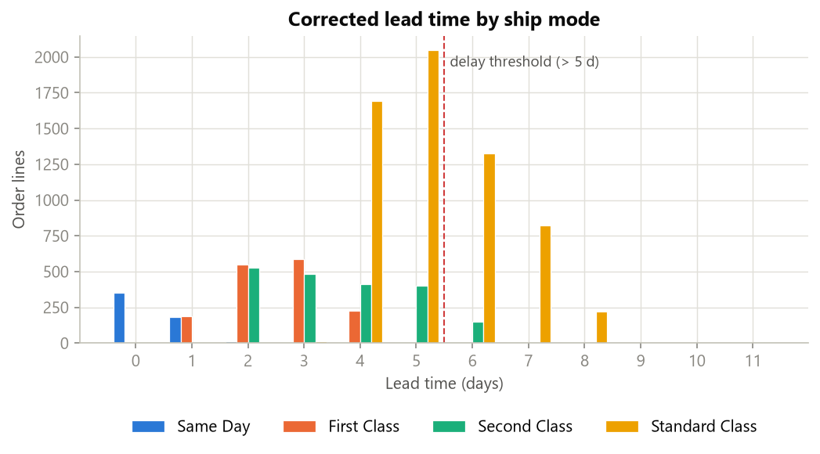
Figure 3. After correction, lead time separates cleanly by ship mode.

4. Feature Engineering and KPIs
KPI | Definition
Shipping Lead Time | Ship Date − Order Date (year-offset corrected), days
Average Lead Time | Mean lead time per route
Route Volume | Number of order lines per route
Lead-Time Variability | Standard deviation of lead time per route
Delay Frequency | % of shipments with lead time > 5 days (adjustable in dashboard)
Route Efficiency Score | 100 × (slowest avg − route avg) / (slowest avg − fastest avg); 100 = fastest ranked route
Mode-Adjusted Delay | Lead time − mean lead time of the same ship mode; isolates geography from service-level mix
Bottleneck Index | Share of volume × delay rate, scaled to 100; flags high-volume, high-delay states

Routes are defined as Factory → Customer State (196 routes) and Factory → Customer Region (20 routes). Rankings use only routes with at least 20 shipments (75 state-level routes) so a handful of orders cannot dominate the leaderboard. Ship modes are also grouped as Standard (Standard Class) and Expedited (Same Day, First, Second Class).

5. Exploratory Data Analysis
Overall average lead time is 4.29 days (σ = 1.80). 24.7% of shipments exceed 5 days. Standard Class carries 60.0% of volume and accounts for 94.1% of all delayed shipments. Volume is heavily concentrated: Lot's O' Nuts and Wicked Choccy's originate 96.6% of order lines, and the Sugar Shack, Secret Factory and The Other Factory product lines are niche. Volume peaks in September and in November–December.

5.1 A system-wide slowdown in 2025
Average lead time rose from 4.07 days (2024) to 4.45 days (2025), and the delay rate went from 18.1% to 29.3%. The increase appears in every ship mode (Figure 4): Same Day 0.03 → 0.59 d, Standard 5.01 → 5.54 d. Second Class delays jumped from 0.9% to 12.1%. The ship-mode mix did not cause this: 2025 actually shifted slightly toward faster modes. Applying the 2024 mode mix to 2025 performance still gives 4.55 days. The year effect on mode-adjusted delay is highly significant (Mann-Whitney p < 0.001). Because the slowdown is uniform across modes, regions and factories, the likely cause is order-processing or dispatch capacity, not specific routes or carriers.
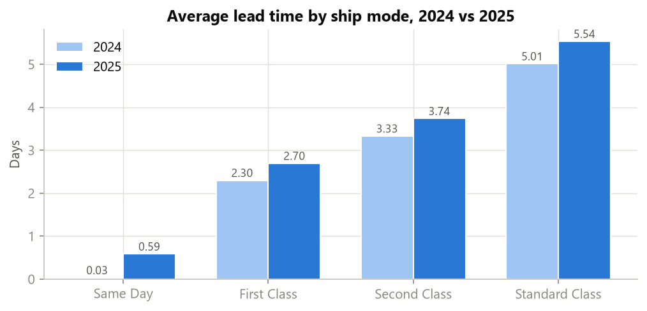
Figure 4. Every ship mode slowed in 2025.
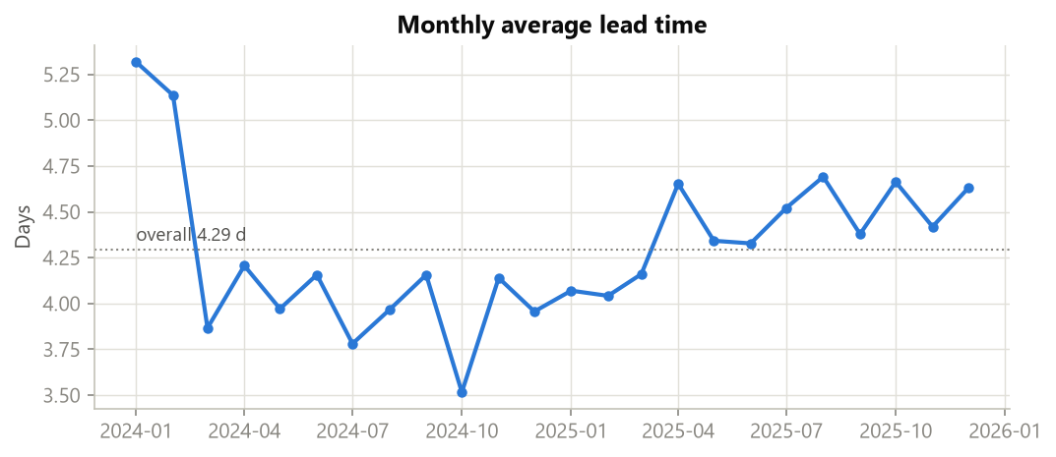
Figure 5. Monthly average lead time drifts upward through 2025.

6. Route Efficiency Benchmarking
Figure 6 and the tables below rank the 75 state-level routes with ≥ 20 shipments. The fastest route (Lot's O' Nuts → Ontario) averages 3.36 days. The slowest (Wicked Choccy's → Indiana) averages 5.04 days, with 46% of shipments delayed. The full range across ranked routes is only 1.68 days, so route differences are real but modest next to the 4.9-day gap between ship modes.
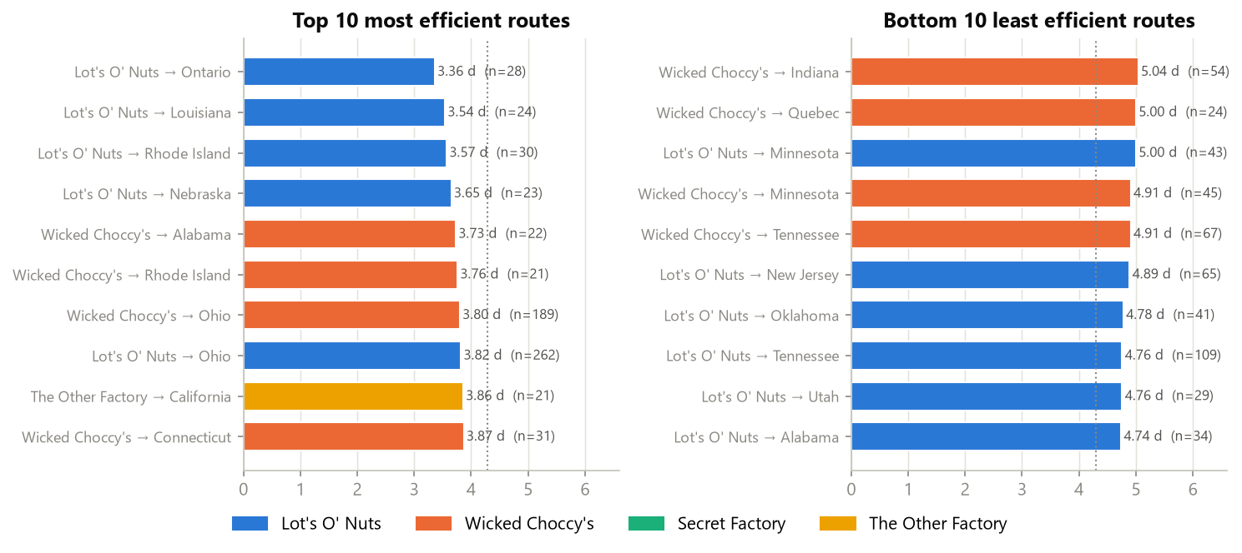
Figure 6. Top and bottom 10 factory → state routes (≥ 20 shipments).

Top 10 most efficient routes
Rank | Route (State) | Shipments | Avg Lead Time | Lead Time Std | Delay Frequency % | Efficiency Score
1 | Lot's O' Nuts → Ontario | 28 | 3.36 | 1.17 | 0.0% | 100
2 | Lot's O' Nuts → Louisiana | 24 | 3.54 | 1.68 | 4.2% | 89
3 | Lot's O' Nuts → Rhode Island | 30 | 3.57 | 1.75 | 16.7% | 88
4 | Lot's O' Nuts → Nebraska | 23 | 3.65 | 1.52 | 0.0% | 82
5 | Wicked Choccy's → Alabama | 22 | 3.73 | 1.51 | 9.1% | 78
6 | Wicked Choccy's → Rhode Island | 21 | 3.76 | 1.63 | 23.8% | 76
7 | Wicked Choccy's → Ohio | 189 | 3.80 | 1.96 | 17.5% | 74
8 | Lot's O' Nuts → Ohio | 262 | 3.82 | 1.98 | 22.9% | 73
9 | The Other Factory → California | 21 | 3.86 | 1.70 | 19.1% | 70
10 | Wicked Choccy's → Connecticut | 31 | 3.87 | 2.34 | 25.8% | 69

Bottom 10 least efficient routes
Rank | Route (State) | Shipments | Avg Lead Time | Lead Time Std | Delay Frequency % | Efficiency Score
75 | Wicked Choccy's → Indiana | 54 | 5.04 | 1.61 | 46.3% | 0
74 | Wicked Choccy's → Quebec | 24 | 5.00 | 1.29 | 20.8% | 2
73 | Lot's O' Nuts → Minnesota | 43 | 5.00 | 1.40 | 25.6% | 2
72 | Wicked Choccy's → Minnesota | 45 | 4.91 | 1.94 | 37.8% | 8
71 | Wicked Choccy's → Tennessee | 67 | 4.91 | 1.37 | 35.8% | 8
70 | Lot's O' Nuts → New Jersey | 65 | 4.89 | 1.67 | 40.0% | 9
69 | Lot's O' Nuts → Oklahoma | 41 | 4.78 | 1.91 | 41.5% | 15
68 | Lot's O' Nuts → Tennessee | 109 | 4.76 | 1.56 | 33.9% | 16
67 | Lot's O' Nuts → Utah | 29 | 4.76 | 1.30 | 27.6% | 17
66 | Lot's O' Nuts → Alabama | 34 | 4.74 | 1.52 | 29.4% | 18

6.1 Region-level routes
Factory → Region routes with meaningful volume all fall between 4.21 and 4.45 days. The very small Sugar Shack and The Other Factory flows sit at both extremes only because of low volume.
Rank | Route (Region) | Shipments | Avg Lead Time | Lead Time Std | Delay Frequency % | Efficiency Score
1 | The Other Factory → Gulf | 19 | 3.63 | 1.95 | 21.1% | 100
2 | Secret Factory → Interior | 45 | 3.87 | 1.68 | 15.6% | 83
3 | Secret Factory → Pacific | 63 | 3.97 | 1.83 | 20.6% | 75
4 | The Other Factory → Pacific | 32 | 4.00 | 1.73 | 21.9% | 73
5 | The Other Factory → Interior | 11 | 4.00 | 1.13 | 9.1% | 73
6 | Sugar Shack → Interior | 8 | 4.00 | 1.58 | 25.0% | 73
7 | The Other Factory → Atlantic | 38 | 4.13 | 1.88 | 23.7% | 63
8 | Lot's O' Nuts → Atlantic | 1,661 | 4.21 | 1.81 | 23.1% | 58
9 | Secret Factory → Atlantic | 72 | 4.21 | 1.66 | 22.2% | 58
10 | Lot's O' Nuts → Pacific | 1,813 | 4.24 | 1.85 | 25.3% | 56
11 | Wicked Choccy's → Atlantic | 1,197 | 4.28 | 1.79 | 23.3% | 53
12 | Lot's O' Nuts → Gulf | 897 | 4.28 | 1.81 | 24.3% | 52
13 | Wicked Choccy's → Gulf | 663 | 4.33 | 1.79 | 25.9% | 49
14 | Sugar Shack → Pacific | 3 | 4.33 | 0.47 | 0.0% | 49
15 | Wicked Choccy's → Pacific | 1,342 | 4.35 | 1.82 | 25.6% | 48
16 | Secret Factory → Gulf | 37 | 4.35 | 1.51 | 18.9% | 47
17 | Lot's O' Nuts → Interior | 1,321 | 4.36 | 1.71 | 24.4% | 47
18 | Wicked Choccy's → Interior | 950 | 4.45 | 1.77 | 28.2% | 40
19 | Sugar Shack → Gulf | 4 | 4.75 | 1.09 | 25.0% | 18
20 | Sugar Shack → Atlantic | 18 | 5.00 | 1.70 | 50.0% | 0

6.2 Distance does not explain lead time
Great-circle distance from factory to customer has essentially no relationship with lead time (order-line Spearman ρ = 0.003; route-level ρ = -0.16). For example, Lot's O' Nuts (Arizona) → Ontario is one of the fastest routes despite ~3,000 km. Lead time here measures order-to-dispatch time, which depends on processing and service level, not on transit distance.
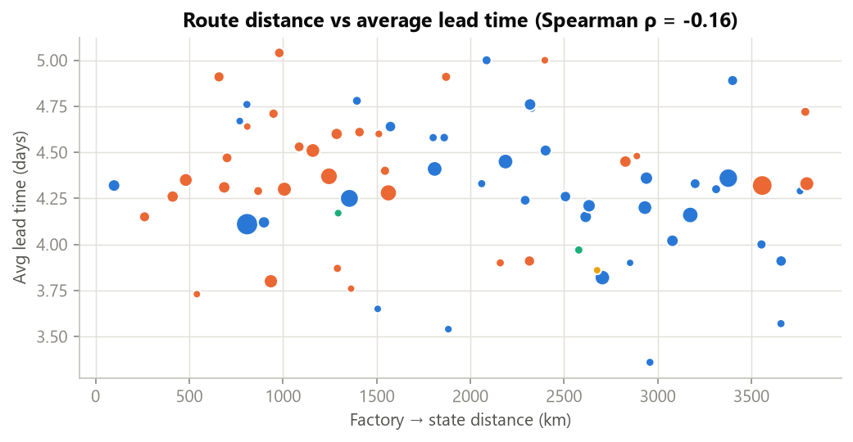
Figure 7. No distance-lead-time relationship across routes.

7. Geographic Bottleneck Analysis
Regional averages are tightly clustered: Atlantic 4.24 d, Pacific 4.27 d, Gulf 4.30 d, Interior 4.38 d. After controlling for ship mode, region differences are not statistically significant (Kruskal-Wallis p = 0.092). Differences between states with ≥ 50 shipments are significant (p < 0.001). A few states are consistently slower than their ship-mode mix would predict (Figure 8): Minnesota (+0.43 d), Missouri (+0.41 d), Utah (+0.36 d), Oklahoma (+0.31 d), Indiana (+0.20 d). The fastest are Ontario (-1.13 d), Pennsylvania (-0.19 d), Colorado (-0.16 d), Massachusetts (-0.14 d), Wisconsin (-0.14 d).
Region | Shipments | Avg Lead Time | Lead Time Std | Delay Frequency % | Mode-Adjusted Delay
Atlantic | 2,986 | 4.24 | 1.80 | 23.3% | -0.030
Gulf | 1,620 | 4.30 | 1.80 | 24.8% | -0.010
Interior | 2,335 | 4.38 | 1.73 | 25.7% | +0.030
Pacific | 3,253 | 4.27 | 1.84 | 25.2% | +0.020

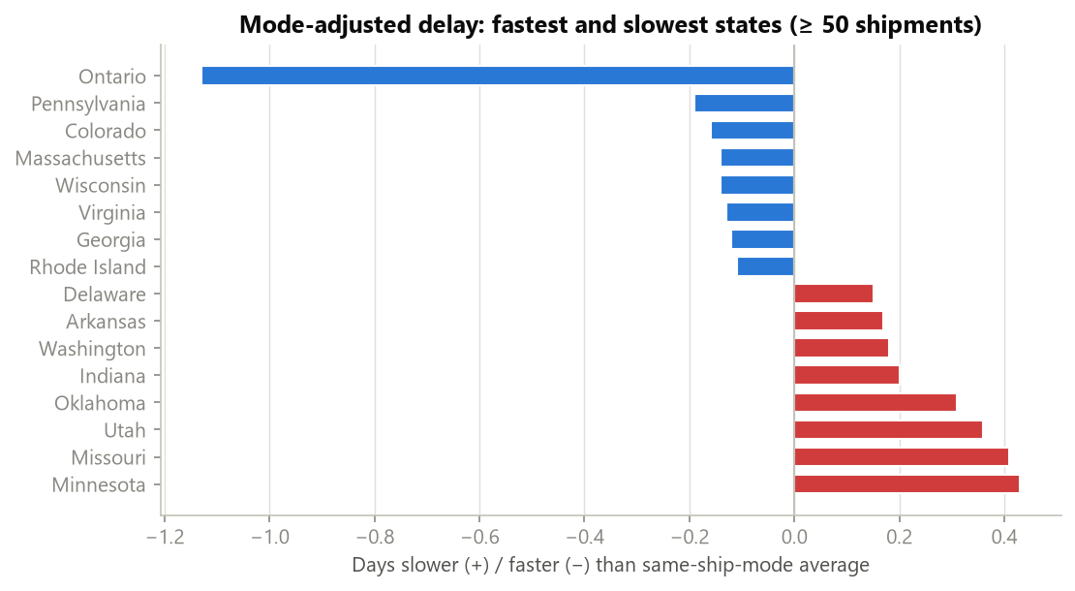
Figure 8. States slower (red) or faster (blue) than their ship-mode mix predicts.
Congestion-prone states combine above-median volume with above-median lead time or delay rate. 17 states meet this definition. Ranked by Bottleneck Index, the top five are New York, Washington, Illinois, Florida, Michigan. They hold large customer bases, so their delays affect the most customers.
State/Province | Shipments | Avg Lead Time | Delay Frequency % | Mode-Adjusted Delay | Bottleneck Index
New York | 1,128 | 4.37 | 27.6% | +0.09 | 65
Washington | 506 | 4.38 | 27.9% | +0.18 | 30
Illinois | 492 | 4.45 | 23.8% | +0.14 | 25
Florida | 383 | 4.28 | 27.4% | +0.02 | 22
Michigan | 255 | 4.36 | 32.2% | -0.05 | 17
Arizona | 224 | 4.37 | 31.2% | +0.13 | 15
Tennessee | 183 | 4.81 | 35.0% | +0.12 | 13
North Carolina | 249 | 4.32 | 24.5% | -0.00 | 13
Indiana | 149 | 4.71 | 34.2% | +0.20 | 11
New Jersey | 130 | 4.75 | 35.4% | +0.10 | 10

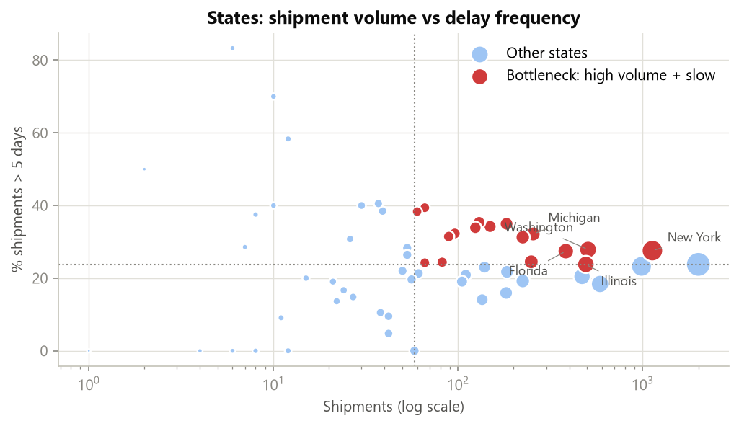
Figure 9. High-volume, high-delay states (red) are the congestion-prone markets.
Comparing the two chocolate factories within the same state (both with ≥ 30 shipments, 25 states), Wicked Choccy's is on average +0.05 days mode-adjusted versus Lot's O' Nuts. Factory-level differences overall are not significant (p = 0.273).

8. Ship Mode Performance and Cost-Time Trade-off
Ship Mode | Shipments | Avg Lead Time | Lead Time Std | Delay Frequency % | Avg Sales / Order Line | Gross Profit
Same Day | 547 | 0.38 | 0.53 | 0.0% | $13.00 | $4,701
First Class | 1,548 | 2.55 | 0.89 | 0.0% | $13.77 | $14,011
Second Class | 1,979 | 3.57 | 1.28 | 7.5% | $14.08 | $18,307
Standard Class | 6,120 | 5.32 | 1.13 | 38.8% | $13.97 | $56,424

Ship mode explains most of the variation in lead time (Kruskal-Wallis p < 0.001). Expedited modes average 2.75 days with a 3.6% delay rate. Standard averages 5.32 days, and 38.8% of its shipments exceed 5 days. Standard Class is also the most variable mode for its service window: it spans 3–8 days, so a customer cannot be given a reliable promise.
Cost-time trade-off (descriptive). The dataset has no freight-cost field, so the trade-off is read from order economics. Average sales per order line are nearly identical across modes ($13.00–$14.08), and so are gross profit per line ($8.59–$9.25) and margin (66.5–66.5%). Faster modes are not being used for higher-value orders, so any premium paid for expedited shipping is not offset by higher revenue per line. Moving an order from Standard to Second Class saves about 1.8 days. Moving it to First Class saves about 2.8 days and removes almost all delay risk. The case for upgrading therefore depends on carrier rates, which should be added to the data.

9. Key Insights
- Data integrity: ship dates carry a systematic year offset. Raw lead times are unusable until this is corrected.
- Service level drives speed: ship mode explains most of the variation; Standard Class (60% of volume) produces 94% of delays.
- 2025 deterioration: +0.38 days on average and +11.2 pp delay rate, across every mode. This is a process-capacity signal.
- Geography matters little: distance and region have no meaningful effect once mode is controlled; route differences span well under one day.
- Targeted bottlenecks: New York, Washington, Illinois combine high volume with elevated delay; Minnesota, Missouri, Utah are consistently slower than their mode mix predicts.
- Concentration risk: 97% of volume depends on two chocolate factories.

10. Recommendations
- Fix ship-date capture at source. Validate that Ship Date ≥ Order Date and within 30 days at entry, and backfill corrected dates so future reporting is reliable.
- Investigate the 2025 dispatch slowdown. Audit order-to-dispatch capacity (picking, packing, staffing, cut-off times) at Lot's O' Nuts and Wicked Choccy's, which handle 97% of volume. Prioritise the September and November–December peaks.
- Tighten the Standard Class promise. Set a ≤ 5-day SLA and track delay frequency weekly. Cutting Standard Class delays by half would lower the overall delay rate by about 12 percentage points.
- Restore true Same Day service. Same Day averaged 0.59 days in 2025 (vs 0.03 in 2024). A premium service that slips undermines its value.
- Target bottleneck states. Review carrier performance, cut-off times and order batching for New York, Washington, Illinois, Florida, Michigan. Consider a regional stocking point for high-volume Pacific/Atlantic demand.
- Use the dashboard operationally. Review the route leaderboard and bottleneck map monthly and adjust the delay threshold to match the SLA in force.
- Enrich the data. Add freight cost, carrier, delivery date and warehouse to enable true cost-time and end-to-end delivery analysis.

11. Limitations
- The lead-time correction assumes the year offset is a recording artefact. The clean ship-mode ordering strongly supports this, but it should be confirmed with Nassau Candy's operations team.
- Lead time measures order-to-ship (dispatch) time, not delivery to the customer; there is no delivery date.
- No freight cost or carrier field, so the cost-time analysis is descriptive only.
- Distance uses state centroids rather than exact customer addresses.
- Several factory flows (Sugar Shack, The Other Factory, Secret Factory) have low volume; their route-level estimates are noisy and are excluded from rankings below the minimum-shipment rule.

12. Conclusion
Once the ship-date offset is corrected, Nassau Candy's shipping performance is mostly a story of service level and process capacity, not geography. Routes differ by less than a day, while ship mode separates outcomes by five. The clearest action point is the 2025 slowdown across the whole network. The dashboard built alongside this paper gives the team a live view of route efficiency, geographic bottlenecks and ship-mode performance, so logistics decisions can move from reactive to data-driven.

Appendix: Deliverables
- Streamlit dashboard: app.py (run: streamlit run app.py)
- Analysis pipeline: analysis.py; report generator: build_report.py
- KPI tables: reports/tables/*.csv (route, state, region, ship-mode KPIs; bottlenecks; cleaned data)
- Figures: reports/figures/*.png

