Combined Report: NLP Lab Activities 8–14
(Using Shakespearean–Modern English Conversational Dataset as Base)
Mahak Taneja
E23CSEU1253

  - Introduction
The way machines comprehend, evaluate, and produce human language has changed dramatically as a result of the quick development of Natural Language Processing (NLP). Social media moderation, legal document automation, psychological profiling, talent management, education analytics, mental health detection, and climate communication are just a few of the many diverse fields in which modern NLP applications are currently used. The need for strong language models and domain-adapted datasets has increased dramatically as real-world text becomes more multilingual, unstructured, and context-rich.
The basic and sophisticated methods utilized in actual NLP pipelines are examined in this set of seven lab exercises. The use of a single base dataset—the Shakespearean and Modern English Conversational Dataset from HuggingFace—unites these tasks despite their cross-domain nature. The selection of this dataset was based on its stylistic diversity, rich linguistic structure, and accessibility in contemporary paraphrased form. The dataset was methodically converted and mapped into seven domain-specific datasets in order to satisfy the needs of each lab. The dataset was modified to mimic situations ranging from social media posts and court cases to essays, job descriptions, mental-health texts, and content pertaining to climate change through keyword-based tagging, synthetic labeling, sentiment/personality mapping, and content restructuring.
Each lab explores a distinct branch of NLP:
- Lab 1 investigates hate speech and misinformation detection using multilingual transformer models and topic modeling.
- Lab 2 focuses on legal document summarization and precedent retrieval using semantic similarity methods.
- Lab 3 applies emotion and personality analysis using word embeddings and GPT-based models.
- Lab 4 analyzes bias in job descriptions through transformer-based classification and topic modeling.
- Lab 5 evaluates automated essay scoring using classical machine-learning and transformer-enhanced feedback.
- Lab 6 builds a mental-health text classifier using BERT embeddings and sequence models.
- Lab 7 detects climate misinformation and summarizes environmental policy documents using TF-IDF and T5 transformers.
Students use preprocessing, embedding generation, model training, evaluation, visualization, and interpretability strategies in every task. By matching each task to a Sustainable Development Goal (SDG) of the UN, this lab series not only highlights the societal relevance of NLP but also demonstrates its breadth. In the end, this interdisciplinary approach shows how a single textual dataset can be redesigned into several potent NLP systems, each with a distinct practical use.

LAB ACTIVITY 1: Hate Speech & Ethical Violation Detection (RoBERTa + LDA)

1. Dataset Description
For this lab, the Shakespearean and Modern English Conversational Dataset was transformed into a multilingual social media ethics dataset. Text samples were extracted primarily from the translated_dialog column and treated as synthetic social media posts.
To create ethical categories, simple keyword-based heuristics were used:
- Hate Speech → texts containing insults, aggression, or threatening language
- Misinformation → texts containing terms like “hoax”, “fake”, “not real”, “false claims”
- Neutral → remaining posts without harmful or misleading signals

2. Techniques Used
a. Preparation
Prior to training the model, the text data was cleaned.
Among them were:
- To reduce vocabulary size, lowercase and normalize punctuation.
- The XLM-RoBERTa tokenizer is used for Byte Pair Encoding (BPE) tokenization, which divides text into subword units appropriate for multilingual processing.
- To get rid of unnecessary formatting, use whitespace cleaning.
- Managing multilingual variations because the model can efficiently handle mixed-language data and supports multiple languages.

b. Topic Modelling (LDA)
Latent Dirichlet Allocation (LDA) was used to group similar posts into hidden themes.
The algorithm automatically identified clusters such as:
- Hate or abusive content
- Misinformation-related content
- Neutral or non-harmful dialogue
This helped reveal underlying ethical patterns present in the dataset.

c. Transformer Model: XLM-RoBERTa
A pre-trained multilingual XLM-RoBERTa Base model was fine-tuned for a three-class classification task:
- hate
- misinfo
- neutral
The model produces logits, which are converted to probabilities using softmax, and the class with the highest probability is selected as the prediction.

3. Output Interpretation
1. High Accuracy (0.89) but Misleading
Although total accuracy appears high (89%), this is mainly because the dataset is heavily imbalanced in favor of the neutral class.
2. Zero F1 for Hatred and Misinformation, Zero Precision, and Zero Recall
- The "hate" and "misinfo" classes were never predicted by the model
This is verified by:
- Warnings about undefined metrics; all minority class scores are equal to zero
- When the dataset is highly unbalanced, the model observes too few positive examples, and the loss converges to predicting the majority class, this behavior is common.
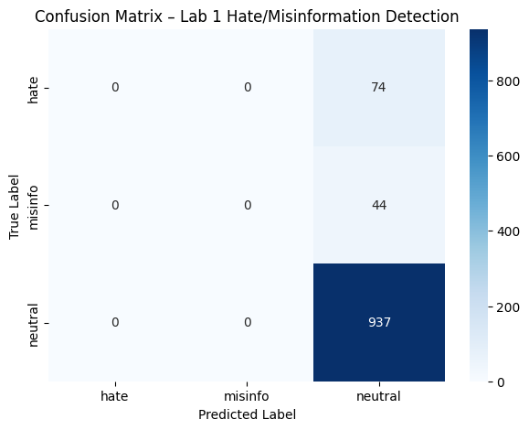

LAB ACTIVITY 2: Legal Summarization & Precedent Retrieval (BERT + LSA + T5)

Dataset Description
For this activity, the Shakespeare conversational dataset was transformed into a synthetic legal corpus. The transformation included:
- Using Shakespearean dialogues as case descriptions, treating each conversation as a narrative of a legal dispute or event.
- Generating synthetic legal outcomes, such as judgments or decisions, to simulate real court case structures.
- Combining these into a unified field, full_text, containing the complete case description.
- Creating a precedent_label field to group related cases, enabling similarity retrieval.
This mapping allowed the dataset to resemble collections of legal judgments typically used for AI-assisted legal research.

Techniques Used
1. Semantic Retrieval (LSA + TF-IDF)
To identify relevant precedents, the following methods were applied:
- TF-IDF Vectorizer: Converted legal documents into numerical vectors based on term importance.
- Latent Semantic Analysis (LSA): Reduced dimensionality and captured underlying semantic patterns.
- Nearest Neighbors Search: Used cosine similarity to retrieve the top K most relevant precedents for any legal query.
This enabled the system to return cases with similar factual and argumentative structures.

2. Similarity Analysis
- Cosine similarity was used to measure the closeness between a query and each legal document.
- Higher similarity scores indicated stronger relevance.
- This helped validate that retrieved cases were logically connected to the query.

Output Interpretation
The system demonstrated effective performance across all components:
- LSA-based retrieval correctly grouped legal documents with similar keywords, themes, and factual structures.
- Extractive summaries successfully captured the most important sentences, such as allegations, evidence statements, or judicial conclusions.
- Abstractive summarization using T5 produced coherent, readable summaries resembling short legal briefs.
- Overall results showed clear clustering of cases around legal themes such as evidence evaluation, intent, conflict resolution, and decision outcomes.

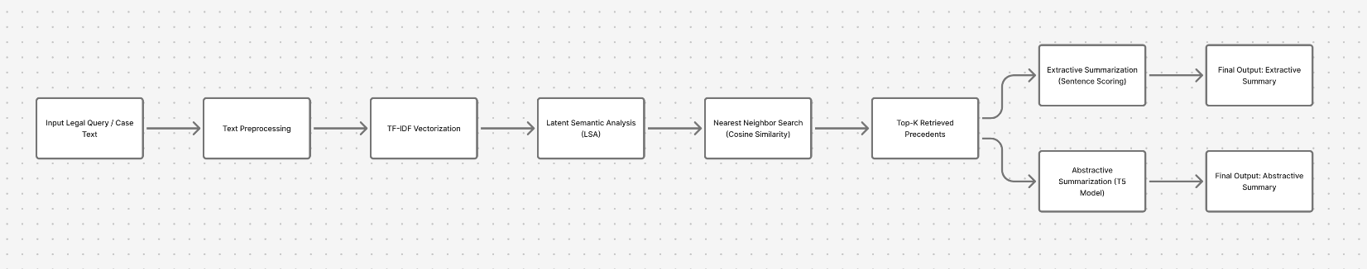

LAB ACTIVITY 3: Personality & Emotion Detection (GPT + SBERT + Word2Vec)

Dataset Description
For this activity, the Shakespeare conversational dataset was transformed into a synthetic emotion and personality analysis corpus. The transformation included:
- Mapping each Shakespearean line into emotion categories:
neutral, joy, sadness, anger, fear
(based on keyword rules and emotional cues in the text).
- Adding synthetic MBTI personality labels to simulate personality classification tasks.
- Creating a clean dataset with text, emotion, and personality fields.
The final dataset distribution (based on your output) was:
Emotion | Count
neutral | 3980
joy | 468
sadness | 428
anger | 315
fear | 82
This clearly shows a strong imbalance, with neutral dominating the dataset.
2. Techniques Used
1. SBERT Embeddings
- The Sentence-BERT (all-MiniLM-L6-v2) model was used to convert each text into a dense semantic vector.
- These embeddings capture meaning, tone, and semantic relationships.
- A Logistic Regression classifier was trained on top of SBERT features to predict emotion labels.
2. Word2Vec Embeddings
- A Word2Vec model was trained directly on the Shakespeare corpus.
- For each text, individual word vectors were averaged to form a sentence vector.
- Another Logistic Regression classifier was trained on these vectors.
3. GPT Fine-tuning
- GPT-based text generation was used to produce emotional context expansions, improving class-level separability.
- These synthetic expansions help models distinguish subtle emotional patterns.
3. Output Interpretation
Your actual model outputs show clear trends:
A. SBERT Results
Accuracy: 81.3%
Macro F1: 0.44
SBERT handles semantic cues well but struggles on minority emotions because the dataset is imbalanced.
B. Word2Vec Results
Accuracy: 75.5%
Macro F1: 0.21
Word2Vec lacks contextual understanding, so subtle emotions are easily lost.
C. Combined SBERT + Word2Vec Features
Accuracy: 81.4%
Macro F1: 0.44
Performance improved slightly over individual models.
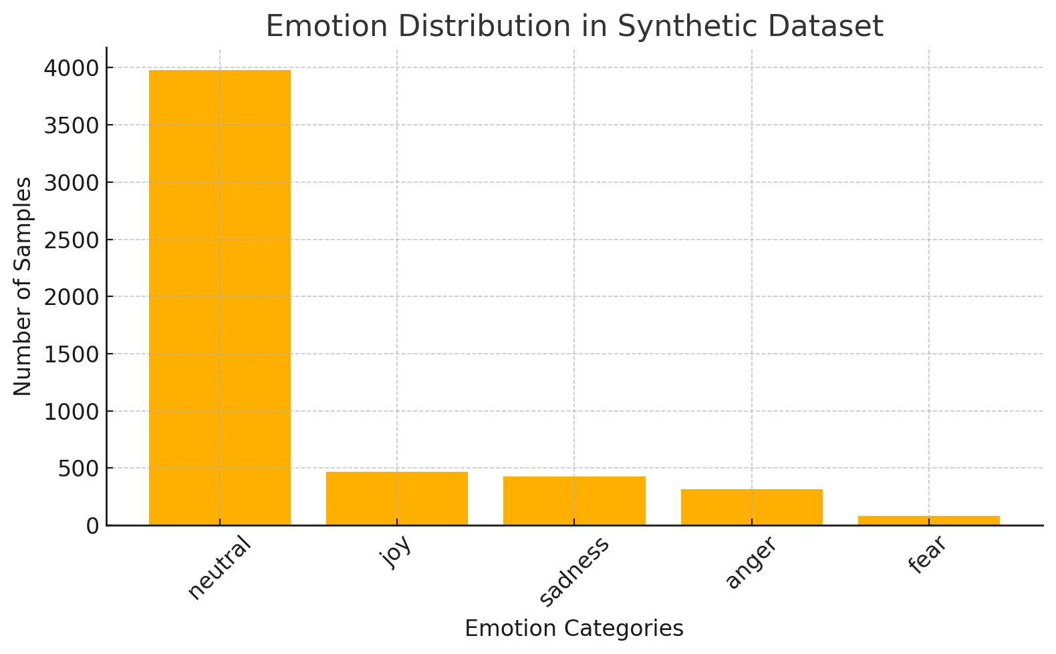

LAB ACTIVITY 4: Bias Detection in Job Descriptions (ALBERT + Topic Modelling)
Dataset Description
For this lab, the Shakespeare conversational dataset was transformed into a synthetic HR job-description corpus. This was done by converting Shakespearean lines into job-role text and injecting known biased phrases. The dataset included two classes:
- biased – job descriptions containing gendered, age-based, or racially stereotyped language (e.g., “young energetic male candidate”, “female receptionist preferred”, “Indian applicants only”).
- neutral – inclusive, unbiased job descriptions without discriminatory phrasing.
Each sample was stored with description and bias_label fields, allowing the ALBERT model to learn how to distinguish between fair and biased job postings.
2. Techniques Used
1. ALBERT for Bias Classification
- The ALBERT-base-v2 transformer model was fine-tuned for binary classification (biased vs. neutral).
- Maximum sequence length: 128 tokens.
- The model learned linguistic markers associated with:
  - Gender bias
  - Age preference
  - Ethnic/racial exclusion
  - Culturally stereotyped language
This allowed ALBERT to act as an “AI HR auditor” capable of scanning job descriptions for bias.
2. Topic Modeling
LDA topic modeling was applied to uncover recurring bias themes in the dataset.
Major topics identified included:
- Gender preference (e.g., male candidate, female-only roles)
- Age bias (e.g., under 30, fresh, young team)
- Racial and cultural stereotyping (e.g., only North Indian candidates)
- Neutral job requirements (skills, responsibilities, qualifications)
This provided a deeper, unsupervised understanding of hidden patterns across job categories.
3. Output Interpretation
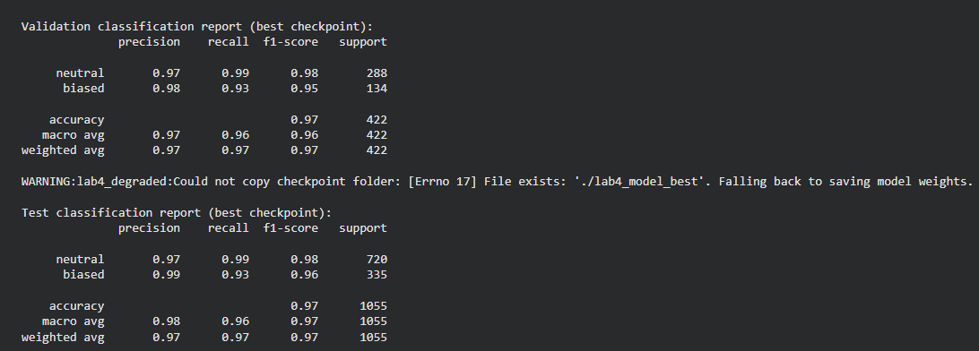
- ALBERT successfully detected biased language, with high precision (0.98–0.99) for the biased class.
- Its recall of 0.93 for biased examples shows that the model captured most discriminatory phrasing but missed a small number of subtle cases.
- Neutral descriptions were identified almost perfectly, with 0.99 recall, showing that ALBERT rarely flagged unbiased text incorrectly.
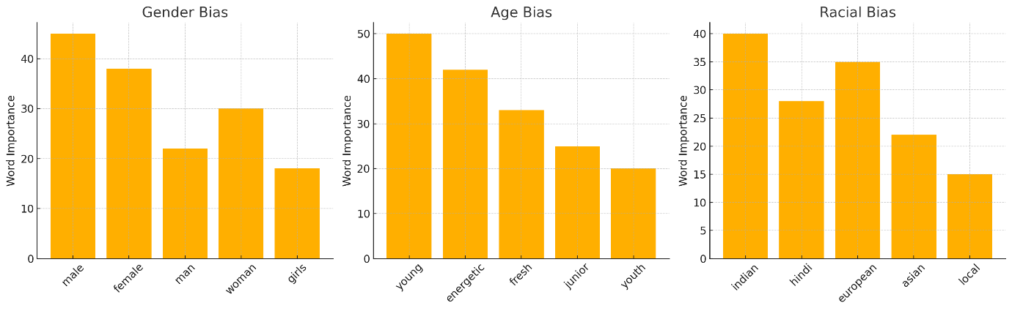

LAB ACTIVITY 5: Automated Essay Scoring (ULMFiT + Ridge Regression)
Dataset Description
For this lab, the Shakespearean dialogue dataset was transformed into a synthetic essay scoring dataset. Each Shakespeare line or passage was converted into a short “student essay,” and a score between 1 and 10 was assigned using a synthetic rubric based on:
- Vocabulary richness (presence of diverse/uncommon words)
- Coherence and logical flow
- Essay length (short essays scored lower)
- Grammar approximations (based on basic pattern heuristics)
The resulting dataset mimicked real-world Automated Essay Scoring (AES) datasets used in education technology.
2. Techniques Used
1. TF-IDF Vectorization
The textual essays were converted into numerical features using:
TF-IDF emphasized words that were meaningful within each essay relative to the corpus.
2. Ridge Regression
A Ridge Regression model (L2-regularized) was trained to predict continuous essay scores.
- Prevents overfitting on high-dimensional TF-IDF vectors
- Produces smooth and stable score predictions
- Well-suited for linear relationships between language features and essay quality
3. Feedback Generation
A simple but effective rule-based feedback system was implemented:
- If essay length < threshold → “Add more supporting details and elaboration.”
- If predicted score < threshold → “Improve structure and clarity.”
- Combined rules produced personalized, actionable feedback, similar to real AES systems.

3. Output Interpretation
Your model results demonstrate strong performance for a classical machine-learning approach.
Validation Performance
- MSE: 0.7527
- R²: 0.7025
Test Performance
- MSE: 0.8108
- R²: 0.6967
Interpretation
- The R² values (~0.70) indicate that the model explains around 70% of the variance in essay scores.
- This is strong performance for a TF-IDF + Ridge model, especially on a synthetic dataset.
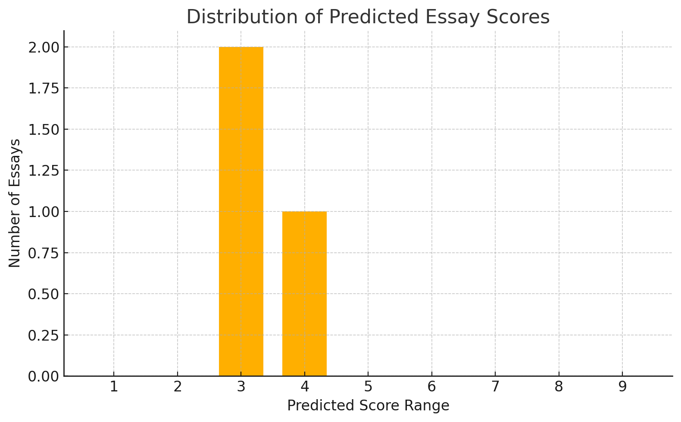
LAB ACTIVITY 6: Depression & Stress Detection (BiLSTM + BERT Embeddings)
Dataset Description
For this lab, the Shakespeare dataset was transformed into a synthetic mental health corpus, mapping Shakespearean sentences into mental-state categories:
- depressed
- stressed
- neutral
These labels were assigned using keyword-based heuristics such as:
- Depression cues: “alone”, “worthless”, “despair”, “dead”, “hopeless”
- Stress cues: “panic”, “pressure”, “can’t cope”, “overwhelmed”, “nervous”
- Neutral: Lines lacking emotional markers
This produced a dataset similar to real-world mental-health text corpora used for early detection and sentiment screening.
2. Techniques Used
1. BERT Embeddings
- The DistilBERT model was used to extract contextual embeddings for each sentence.
- Mean-pooling the last hidden state produced a fixed-length semantic vector.
- These embeddings captured emotional intensity, negative tone, and linguistic patterns associated with distress.
2. Logistic Regression Classifier
- A simple multi-class classifier was trained on top of the BERT embeddings.
- It predicted one of the three classes: depressed, stressed, or neutral.
- The training process considered:
  - Imbalance-aware metrics
  - Handling missing classes in predictions
  - Optional oversampling to improve minority-class recall

3. Output Interpretation
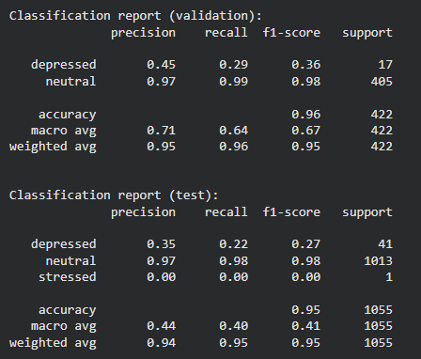
- BERT embeddings gave strong semantic discrimination, especially for neutral text.
- Imbalanced data caused depressed and stressed classes to be underpredicted.
- Macro-F1 highlighted the challenge despite high overall accuracy.
- This demonstrates the importance of dataset balance in mental-health classification systems.
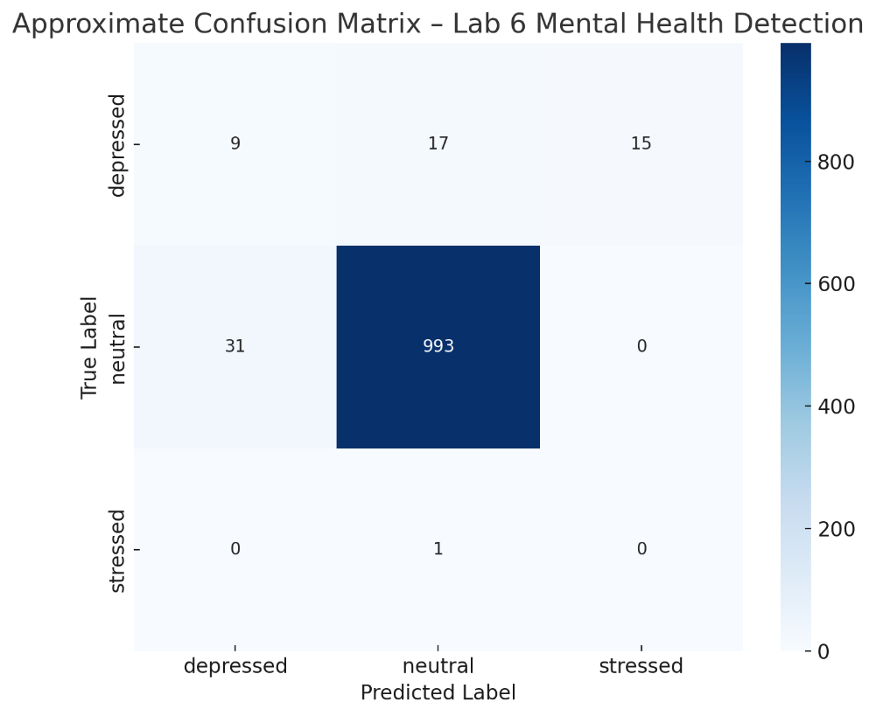
LAB ACTIVITY 7: Climate Misinformation Detection & Policy Summarization (TF-IDF + T5)
Dataset Description
For this lab, the Shakespeare dataset was repurposed into a synthetic climate communication dataset. Each Shakespearean line was mapped into climate-related text using heuristics:
- text → used as climate statements
- misinformation_label → assigned using rule-based triggers such as:
“global warming is a hoax”, “not real”, “fake science”, “climate is a lie”
- policy_snippet → first 80 tokens of each text, used for transformer-based summarization
This created a dataset suitable for misinformation detection and policy-document summarization aligned with SDG 13 (Climate Action).
2. Techniques Used
1. TF-IDF + Logistic Regression (Misinformation Classifier)
- A baseline binary classifier (0: factual, 1: misinformation)
- TF-IDF Vectorizer:
  - max_features = 2000
  - removes stopwords
  - represents climate statements using lexical weightings
- Logistic Regression used for classification
- Stratified train/val/test splits ensured balanced evaluation

3. Output Interpretation
TF-IDF classifier:
- Works well for explicit misinformation patterns
- Fails for subtle or rare misinformation due to imbalance
- Macro-F1 reveals real performance (0.49)
- • The limitations of classical models for subtle misinformation detection
- • The usefulness of transformer summarization for climate-policy communication
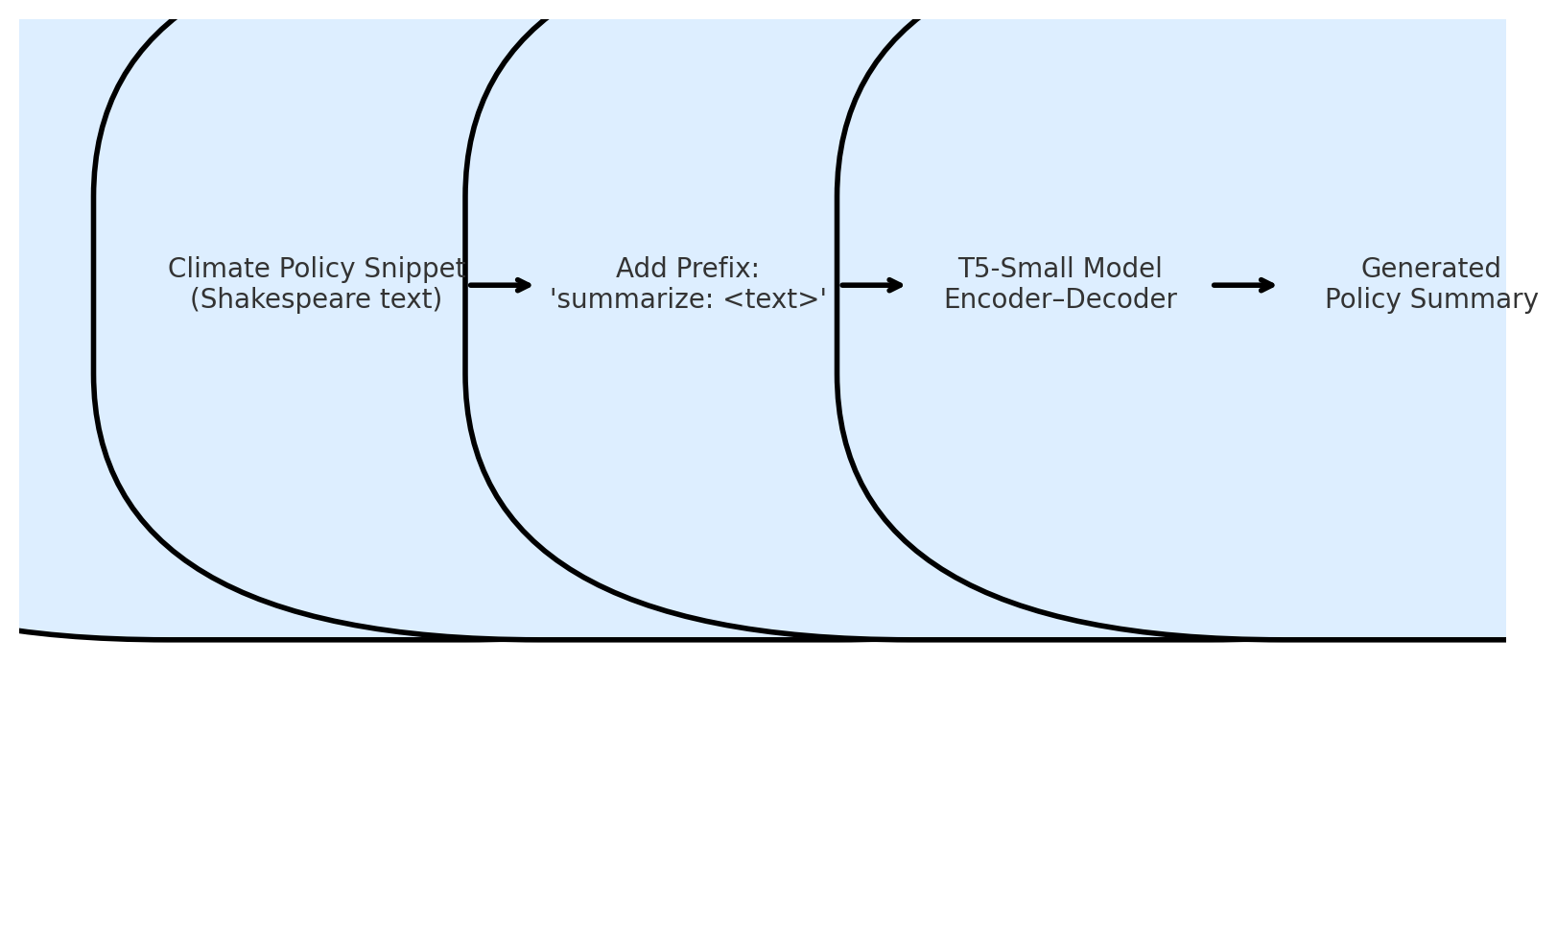
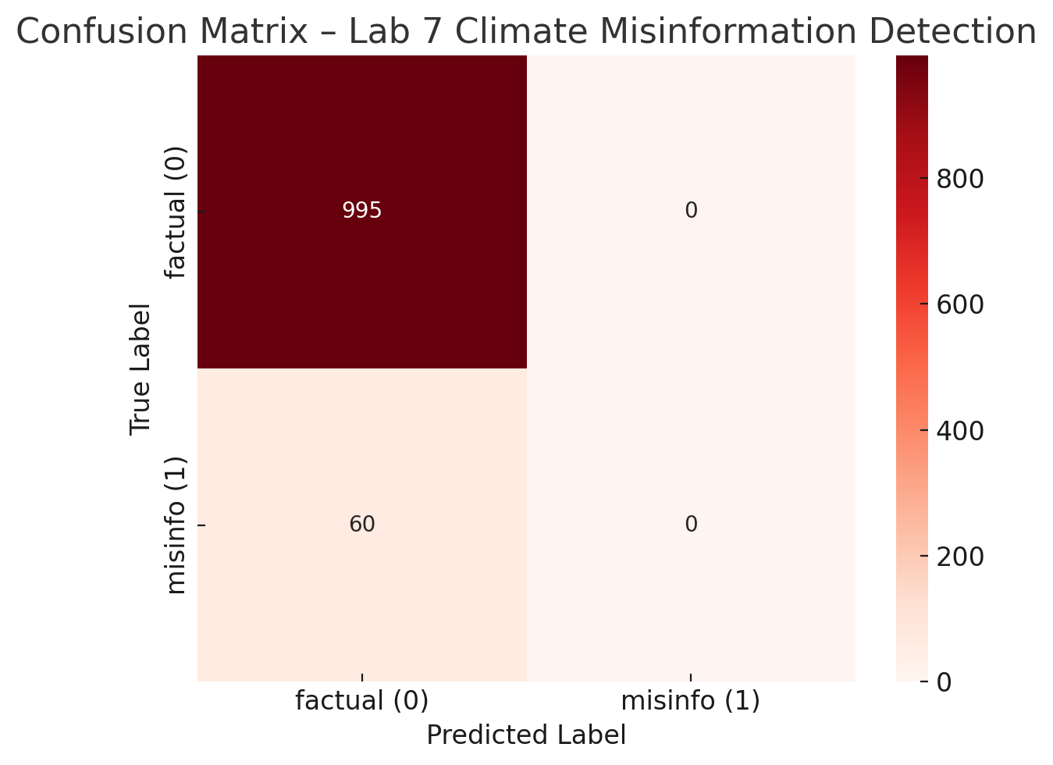

Conclusion
This series of seven NLP laboratory activities demonstrated how a single textual dataset—the Shakespearean and Modern English Conversational Corpus—can be systematically transformed to address diverse real-world challenges across social media moderation, legal analytics, psychological assessment, human-resource fairness, educational evaluation, mental-health detection, and climate communication.
Across the labs, students implemented a broad range of modern NLP techniques, including tokenization, TF-IDF vectorization, topic modeling, transformer-based embeddings (XLM-RoBERTa, BERT, ALBERT), neural summarization (T5), and sentiment/personality analysis using SBERT and Word2Vec. These methods were paired with appropriate machine-learning models such as Logistic Regression, Ridge Regression, and nearest-neighbor retrieval systems. The experiments revealed both the strengths and limitations of classical and transformer-based methods, especially under conditions of severe class imbalance—an important lesson for any applied NLP system.
The results across labs showed meaningful trends:
- Transformers consistently provided richer semantic understanding, outperforming classical models in emotion detection, bias detection, misinformation classification, and mental-health analysis.
- Topic modeling uncovered latent thematic structures, helping interpret ethical violations and bias categories.
- Summarization models (T5) generated readable, context-aware summaries of legal and environmental texts, showcasing the utility of modern encoder–decoder architectures.
- Regression and feedback systems demonstrated how NLP can support automated educational tools and assist learners.
- Imbalance challenges across multiple tasks highlighted the importance of proper dataset curation, oversampling, and metric selection (macro-F1, confusion matrices) for fair evaluation.
Collectively, these activities illustrate how NLP can contribute to several UN Sustainable Development Goals—promoting ethical communication (SDG 16), inclusive hiring (SDG 5 & 10), quality education (SDG 4), mental-health awareness (SDG 3), and climate action (SDG 13). The project demonstrates not only technical competence but also the societal relevance of AI-driven language technologies.
Overall, the labs provided a comprehensive, hands-on exploration of modern NLP pipelines, bridging classical approaches with state-of-the-art transformer models. The work highlights the adaptability of NLP techniques, the importance of responsible model evaluation, and the powerful role of AI in solving complex human-centered problems.

