MINI PROJECT-I

(2021-2022)

**Synopsis**

**ACKNOWLEDGEMENT**

I would like to express my social thanks of gratitude to my CSE department as well as our mentor Mr. Sharad Gupta who gave me the golden opportunity to do this wonderful project on the topic Social media which also helped me in doing a lot of research and I come to know about so many new things.

I new really thankful to them.

Secondly, I would also like a thank my team members who helped me a lot in finishing a project within the limited period of time.

It helped me increase my knowledge and skills.

Team Members

Mahak Agrawal (UniversityRollNo-191500432)

Dimpal Agrawal

(UniversityRollNo-191500268)

Palak Bansal (UniversityRollNo-191500524)

Supervised By Mr.Sharad Gupta

Technical Trainer

Department of Computer Science Engineering & Applications

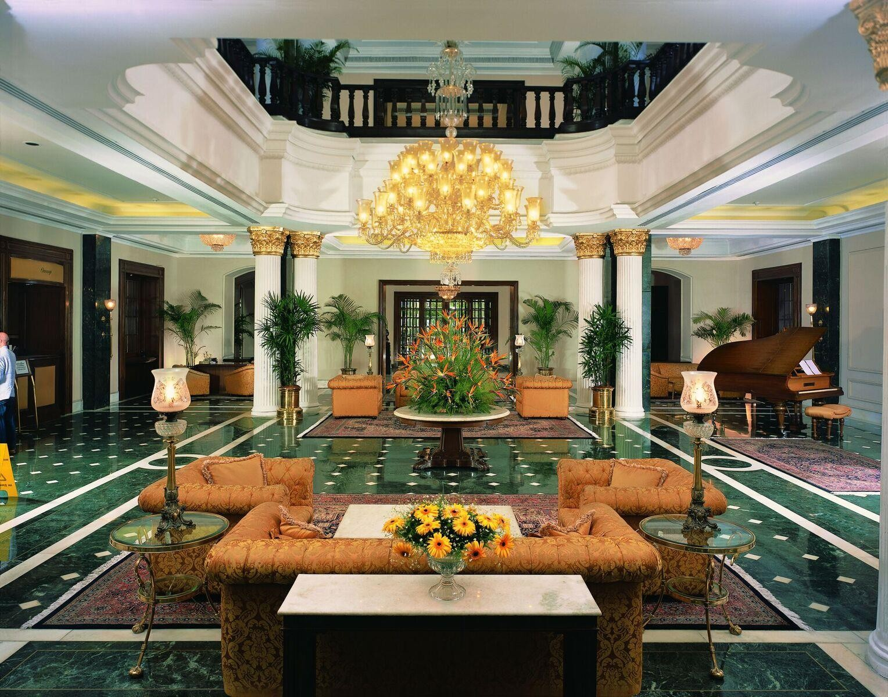

**SOCIAL**

**MEDIA WEBSITE**

PROJECT SYNOPSIS

INTRODUCTION

Social media refers to the means of interactions among people in which they create, share, and/or exchange information and ideas in virtual communities and networks. The Office of Communications and Marketing manages the main Facebook, Twitter, Instagram, LinkedIn and YouTube accounts. The “Social Media” has been developed to override the problems prevailing in the practicing manual system. This software is supported to eliminate and in some cases reduce the hardships faced by this existing system. Moreover this system is designed for the particular need of the company to carry out operations in a smooth and effective manner.

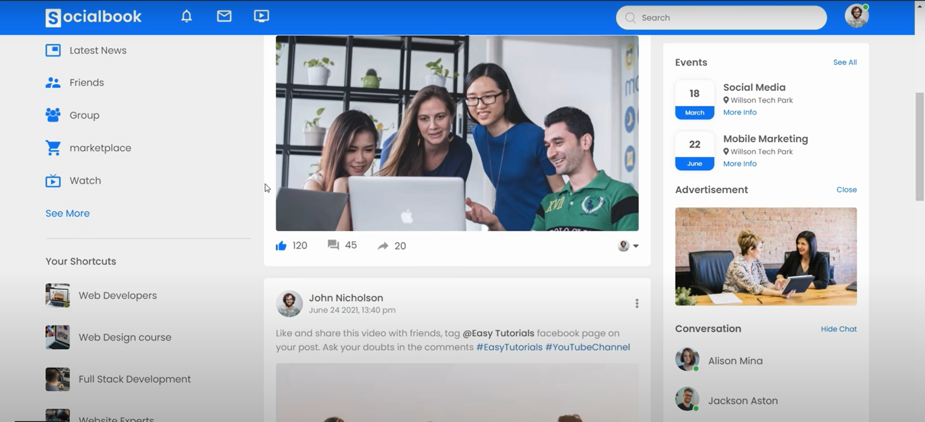

# Main objective of project

The main objective of the Project on social media is to manage the details of users, friends, posts, shares, Photos. It manages all the information about users, videos, photos, users. The project is totally build at administrative end and thus only the administrator is guaranteed the access. The purpose of the project is to build an application program to reduce the manual work for managing the users, friends, videos, posts. It tracks all the details about the posts, shares, photos.

The limited time and resources have restricted us to in corporate, in this project, only a main activities that are performed in a **Social Media**, but at most care will be taken to make the system efficient and user friendly

Our project will be designed to computerize the following functions :

* Provides the searching facilities based on various factors. such as users, posts, shares.
* It tracks all the information of friends, videos, shares etc.
* Manage the information of friends.
* Shows the information and description of the users, posts.
* To increase efficiency of managing the users, friends.

# Advantages and working methodology

We will design the given proposed system by using HTML, CSS, JavaScript.

#### You reach large audiences

#### You have a direct connection with your audience

#### You can create organic content

#### You have access to paid advertising services

#### You build your brand

**Working methodology**

* Advertising: Buying advertising on social media is a fantastic method to promote and grow a company.
* Listening and Engagement: Keeping track of the feedback of users, customers, and others who have to say about your content, brands, and other company assets. This could need the use of a social media interaction tool.
* Planning and Publishing: Businesses should make preparations for their content be it photo dumps, an engaging video, the script and choose when it will be made available on the platform.

# Details of hardware and software

We will be using the following hardware and software's:

* Visual studio code: development Environment.
* Github : we will use github to store our code and then publish it publicly.
* Technology Implemented: Front-End Technologies.
* Web Browser: Chrome/Firefox.
* Hardware Devices: Computer System
* Hard disk: 64GB.
* RAM:4+GB
* Operating system: Windows7/8/10/11

# Contribution of each team member

* Mahak Agrawal(191500432):ideas of developing a project plan, managing deliverables according to the plan. ,working on the coding and design, documenting the project.
* Palak Bansal(191500524):contributingtoprojectobjectives,workingoncodinganddesign, approving changes to the project.
* Dimpal Agrawal(191500268):approvingprojectdeliverables,suggestingtheprojectgoals, codinganddesign,Workingwithotherteammemberstoexpandtheprojectobjectives.

# Conclusion

This project is designed to meet the requirements of Social Media. To design the

project we will be using HTML, CSS, JavaScript .

Overall the project teaches us the essential skills like :

* InFront-enddevelopmentyourjobisneverfinisheduntilthelaststonehasbeenlaid.
* Over thetimetheneedstosatisfytheprojectsobjectiveincreases,andsuccessinonearea

turns into opportunities in others

Thegreatesttalentthatwecanbringtothetableisanunderstandingofhowthiscrazythingcalled frontend development comes together over time

# References

* You-tube
* Git-hub
* [www.google.com](http://www.google.com/)
* [https://stackoverflow.com](https://stackoverflow.com/)
* Wikipedia
* Full stack developer—Chris Northwood
* Full stack for web devlopers—Ravi kant soni

