**PROJECT TITLE:**

PRODUCTION DEMAND PRDICTION USING MACHINE LEARNING

**PROBLEM DEFINITION:**

* A product company plans to offer discounts on its product during the upcoming holiday season. The company wants to find the price at which its product can be a better deal compared to its competitors. For this task, the company provided a dataset of past changes in sales based on price changes. You need to train a model that can predict the demand for the product in the market with different price segments.

**PRE-PROCESSING:**

**STEPS:**

1. **DATA CLEANING**
2. **HANDLE MISSING VALUES**
3. **CATEGORICAL TO NUMERICAL REPRESENTATIONS.**

**DATA CLEANING:**

Data cleaning is the process of fixing or removing incorrect, corrupted, incorrectly formatted, duplicate, or incomplete data within a dataset. When combining multiple data sources, there are many opportunities for data to be duplicated or mislabeled.

**HANDLE MISSING VALUES:**

1. Deleting Rows with missing values
2. Impute missing values for continuous variable
3. Impute missing values for categorical variable
4. Other Imputation Methods
5. Using Algorithms that support missing values
6. Prediction of missing values
7. Imputation using Deep Learning Library — Datawig

**CATEGORICAL TO NUMERICAL REPRESENTATIONS:**

1. cat.codes Attribute
2. replace
3. Label Encoder

**ALGORITHM:**

1. **ARIMA**
2. **Prophet**

**ARIMA:**

ARIMA stands for Autoregressive Integrated Moving Average Model. It belongs to a class of models that explains a given time series based on its own past values -i.e.- its own lags and the lagged forecast errors. The equation can be used to forecast future values. Any ‘non-seasonal’ time series that exhibits patterns and is not a random white noise can be modeled with ARIMA models.

So, ARIMA, short for AutoRegressive Integrated Moving Average, is a forecasting algorithm based on the idea that the information in the past values of the time series can alone be used to predict the future values.

ARIMA Models are specified by three order parameters: (p, d, q),

where,

p is the order of the AR term

q is the order of the MA term

d is the number of differencing required to make the time series stationary

AR(p) Autoregression – a regression model that utilizes the dependent relationship between a current observation and observations over a previous period. An auto regressive (AR(p)) component refers to the use of past values in the regression equation for the time series.

I(d) Integration – uses differencing of observations (subtracting an observation from observation at the previous time step) in order to make the time series stationary. Differencing involves the subtraction of the current values of a series with its previous values d number of times.

MA(q) Moving Average – a model that uses the dependency between an observation and a residual error from a moving average model applied to lagged observations. A moving average component depicts the error of the model as a combination of previous error terms. The order q represents the number of terms to be included in the model.

Types of ARIMA Model

ARIMA : Non-seasonal Autoregressive Integrated Moving Averages

SARIMA : Seasonal ARIMA

SARIMAX : Seasonal ARIMA with exogenous variables

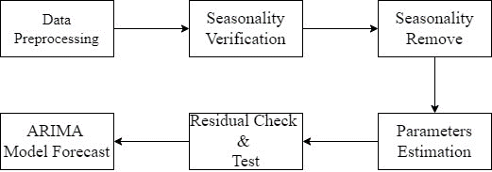

**Prophet:**

Prophet is a procedure for forecasting time series data based on an additive model where non-linear trends are fit with yearly, weekly, and daily seasonality, plus holiday effects. It works best with time series that have strong seasonal effects and several seasons of historical data. Prophet is robust to missing data and shifts in the trend, and typically handles outliers well.

Y(t) = g(t) + s(t) + h(t) + E(t)

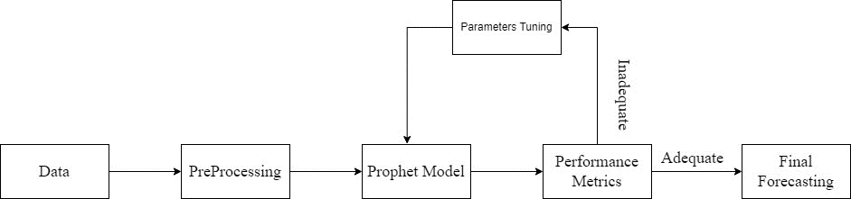

**PROJECT WORKFLOW:**

