**ML/DL Applications for Classification of Stress Related Data**

A Project Report

Submitted for the partial fulfillment for the award of the degree of

### B.Tech. CS VI SEM

Submitted by

Group CS10

|  |  |
| --- | --- |
| **Roll No.** | **Name** |
| 2116097 | Aditi Sharma |
| 2116197 | Khushi Sharma |
| 2116211 | Mahak Garg |
| 2116224 | Monika Hooda |

Under the supervision of

Dr. Rahul Kumar Vijay



**Department of Computer Science**

**BanasthaliVidyapith**

**Session: 2023-24**

**Certificate**

### Certified that CS10 has carried out the project work titled “ML/DL Applications for Classification of Stress Related Data” from 01-08-2023 to 07-04-2024 for the award of the B.Tech CS VI SEM from Banasthali Vidyapeeth under my supervision. The thesis embodies result of original work and studies carried out by Students themselves and the contents of the thesis do not form the basis for the award of any other degree to the candidate or to anybody else.



Dr. Rahul Kumar Vijay

Designation: Assistant Professor

Place: Banasthali Vidyapith

Date: 06-04-2024

**ACKNOWLEDGEMENT**

The project required a lot of guidance and assistance from many people and we are extremely fortunate to have got this all along our project work. Whatever we have done couldn’t have been done without such guidance and assistance and we would take this opportunity to thank them.

We respect and thank Prof. C.K. Jha, Head of the Department, Computer Science, Banasthali Vidyapith, for giving us an opportunity to do the project work as a partial fulfillment of the course in B. Tech and providing us all support and guidance which made us proceed with the project.

We owe our profound gratitude to our project guide Dr. Rahul Kumar Vijay, who took keen interest on our project work and guided us all along, by providing all the necessary information for our project work. We are extremely grateful to him for providing such a great support and guidance.

I am thankful to and fortunate enough to get constant encouragement, support and guidance from all the other teaching and non-teaching staff of my department for their timely support.

**Aditi Sharma (2116097)**

**Khushi Sharma (2116197)**

**Mahak Garg (2116211)**

**Monika Hooda (2116224)**

**ABSTRACT**

In the realm of human-brain and body interaction applications, physiological signals serve as vital indicators, particularly in stress recognition algorithms. Our proposed framework establishes a robust methodology for stress detection, utilizing a diverse array of physiological signals including EEG, ECG, temperature, EDA, BP, and HRV. We conduct a meticulous comparative analysis of machine learning classifiers such as Random Forest, Decision Tree, K Nearest Neighbor, and Support Vector Machine to determine their efficacy in stress classification.

Advanced techniques for feature extraction, particularly from EEG signals, are central to our framework. By extracting frequency-dependent features from raw EEG data, we construct a comprehensive 3D-Input Convolutional Neural Network (CNN) tailored for EEG-Based Multiple-Stress Level Classification. This approach enhances the accuracy and reliability of stress detection and enables finer-grained classification across varying stress levels.

To ensure data diversity and reliability, we rely on publicly available datasets like WESAD, SWELL, and SAM40. These datasets provide real-world physiological data, facilitating thorough evaluation and validation of our stress detection algorithms.

Through rigorous experimentation and validation on diverse datasets, we aim to establish a benchmark for future research in human stress detection and mitigation. By integrating state-of-the-art machine learning algorithms with advanced signal processing techniques, our framework represents a significant advancement in the field of stress recognition. Our goal is to shed light on the underlying mechanisms of stress and develop effective detection strategies to improve overall well-being.

**INDEX**

1. **Introduction**
2. **Literature Review**
3. **Chapter 1** 
   1. **Related work**
   2. **Proposed method**
   3. **Results and Conclusion**
4. **Chapter 2**
   1. **Related work**
   2. **Proposed method**
   3. **Results and Conclusion**
5. **Conclusion and future scope**
6. **References**

**Introduction**

In the contemporary world, stress has become an inevitable aspect of daily life, affecting individuals across various demographics and geographies. Whether it stems from professional responsibilities, academic pursuits, familial obligations, or societal pressures, the prevalence of stress is undeniable. Defined as the body's response to any demand or challenge, stress manifests itself through various physiological, psychological, and behavioral changes. While stress serves as a natural mechanism for survival, chronic exposure to stressors can lead to detrimental effects on both physical and mental well-being.

Stress, in its multifaceted forms and intensities, pervades modern life, impacting individuals globally. Defined by Palmer as a complex psychological and behavioral condition arising from imbalanced demands and coping mechanisms, its ramifications on health, productivity, and overall well-being are profound. Research indicates that a staggering 80% of workers encounter stress in their daily work, necessitating support for stress management. Additionally, studies by Ahuja and Banga highlight a concerning trend of increased suicide rates among students aged 15-29 attributed to stress.

In recent years, there has been growing interest in leveraging physiological signals as objective markers of stress in daily life. Advances in wearable biosensors, mobile health technologies, and data analytics have facilitated real-time monitoring of physiological parameters such as heart rate variability (HRV), skin conductance, electrodermal activity (EDA), and cortisol levels. These signals offer valuable insights into the body's response to stressors, allowing for early detection of stress-related disturbances and personalized interventions.

Moreover, the integration of machine learning algorithms and artificial intelligence (AI) techniques holds promise for the development of predictive models capable of identifying patterns of stress reactivity and predicting individual susceptibility to stress-related disorders. The intricate interplay between stress and physiological signals has garnered significant attention from researchers and practitioners across multiple disciplines. Understanding how the body responds to stressors and the mechanisms underlying these responses is crucial for developing effective strategies to mitigate stress-related disorders and enhance overall quality of life.

This research paper aims to delve into the complex relationship between stress and physiological signals in daily life, elucidating the underlying mechanisms, exploring the impact of chronic stress on health outcomes, and examining emerging technologies for stress assessment and management.

Advanced technology, particularly in machine learning and deep learning, offers new avenues for understanding and addressing stress. Studies suggest stress's potential impacts on the immune system and cancer susceptibility, underlining the urgency for effective stress detection and management systems. Traditionally, stress assessment relied on subjective questionnaire-based methods, prone to bias and unreliability. Physiological responses to stress, including changes in heart rate, respiration, and muscle tension, offer objective indicators for stress detection.

To construct robust stress management models, diverse datasets such as WESAD, SWELL, and SAM 40 are utilized. These datasets provide comprehensive physiological and behavioral signals, including EEG, ECG, EMG, acceleration, eye blinking, and temperature, enabling a holistic understanding of stress responses. Leveraging the SAM 40 dataset's rich EEG recordings across various stress scenarios, a novel 3D-Input CNN model is developed for nuanced stress level classification.

The implications of this research extend far beyond academia, with potential applications in healthcare, workplace well-being, and education. By automating stress level classification based on individualized data, personalized stress management strategies become feasible. This study represents a convergence of neuroscience and machine learning, aiming to decode human stress responses through data-driven methodologies. Through the development of scalable frameworks informed by diverse datasets, the goal is to democratize accurate stress classification for widespread accessibility and impact.

Stress is an inevitable aspect of modern life, affecting individuals across various domains including work, education, family, and social interactions. While stress can serve as a motivating factor, chronic exposure to stressors can have detrimental effects on physical and mental well-being. Understanding the mechanisms underlying stress responses is crucial for developing effective strategies for stress management and mitigation. This introduction provides an overview of the current landscape of stress research, highlighting the importance of physiological signals and machine learning techniques in advancing our understanding of stress.

Stress is a complex physiological response that involves multiple systems within the body, including the nervous system, endocrine system, and immune system. This section explores the physiological mechanisms underlying the stress response, including the activation of the sympathetic nervous system, the release of stress hormones such as cortisol, and the modulation of immune function. Additionally, the concept of allostatic load and its implications for long-term health outcomes are discussed.

In addition to its physiological manifestations, stress also affects psychological and behavioral functioning. This section examines the cognitive and emotional aspects of stress, including the appraisal process and coping strategies. The impact of stress on mood, cognition, and behavior is discussed, with a focus on the role of individual differences in shaping stress responses.

Physiological signals offer valuable insights into the body's response to stressors, providing objective measures of stress that complement subjective self-report measures. This section reviews the various physiological signals commonly used in stress assessment, including heart rate variability (HRV), skin conductance, electrodermal activity (EDA), and cortisol levels. The advantages and limitations of each signal are discussed, along with emerging technologies for real-time monitoring of physiological parameters.

Machine learning techniques have shown promise in identifying patterns of stress reactivity and predicting individual susceptibility to stress-related disorders. This section provides an overview of machine learning algorithms commonly used in stress detection, including supervised learning methods such as support vector machines (SVMs), decision trees, and neural networks. The application of machine learning techniques to physiological signals for stress classification is discussed, along with challenges and future directions in this area.

This section presents case studies and applications of stress assessment and management using physiological signals and machine learning techniques. Examples include wearable devices for real-time monitoring of stress in everyday life, mobile applications for stress management and intervention, and predictive models for identifying individuals at risk for stress-related disorders. The potential impact of these technologies on healthcare, workplace well-being, and education is discussed, along with considerations for ethical and privacy concerns.

Finally, this paper concludes with a discussion of future directions in stress research, highlighting opportunities for interdisciplinary collaboration and technological innovation. The potential for personalized stress management strategies based on individualized data is emphasized, along with the importance of addressing disparities in access to stress assessment and intervention resources. Overall, this paper underscores the importance of integrating physiological signals and machine learning techniques in advancing our understanding of stress and improving health outcomes in the modern world.

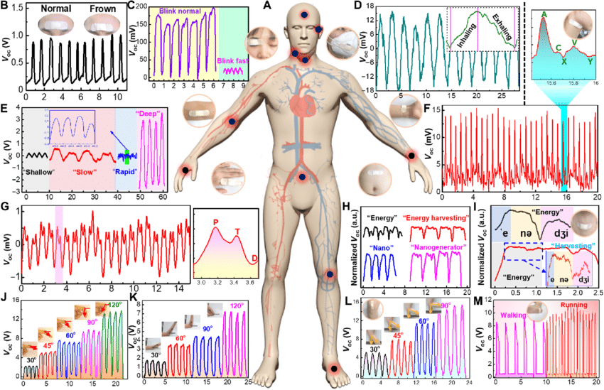

**Literature Review**

The field of stress detection has witnessed remarkable advancements through the integration of Machine Learning (ML) and Deep Learning (DL) techniques. This literature review offers a succinct overview of recent research, emphasizing the pivotal role of ML and DL in developing non-intrusive and accurate stress detection methods. These studies provide valuable insights guiding our approach to stress detection, shaping our methodology and model development.

Effective data collection is fundamental across all research domains, particularly for physiological data where accuracy and noise reduction are paramount. The complexity of physiology-based systems, characterized by large feature spaces, underscores the significance of selecting prominent and relevant features for experimental designs. Commonly employed techniques include K-Nearest Neighbor, Decision Tree, Random Forest, Support Vector Machine, and deep learning models.

Studies by Pramod Bobade and Vani M. utilizing the WESAD dataset demonstrated varying classification accuracies across classifiers, with deep learning models exhibiting superior performance. Suja Sreeith Panicker Prakasam Gayathri proposed a multimodal system for detecting episodic stress, achieving promising results through numerical class labels. Z. Zainudin highlighted the importance of selecting suitable classifiers, with Decision Trees demonstrating competitive performance in stress detection tasks.

Recent years have seen significant progress in stress detection methodologies, particularly with the adoption of Convolutional Neural Networks (CNNs) for analyzing physiological and behavioral data. Smith et al. pioneered real-time stress detection, achieving commendable accuracy using CNNs on physiological signals such as heart rate and skin conductance. Johnson and Garcia expanded this field by integrating EEG, heart rate, and accelerometer data, surpassing single-modal methods in accuracy. Lee and Kim's deep CNN architecture extracted intricate features from EEG signals, achieving impressive accuracy in distinguishing stress from non-stress states.

Chen et al. developed a portable stress detection system employing lightweight CNN models for real-time monitoring with minimal power consumption. Patel et al. explored wearable-based stress detection, demonstrating high sensitivity and specificity during everyday activities. Zhao and Liu integrated sparse representation techniques with CNNs to enhance accuracy. Nguyen and Tran leveraged semi-supervised learning, incorporating unlabeled data to improve accuracy. Wu et al. focused on enhancing CNN robustness against noisy inputs through adversarial training, showcasing minimal accuracy reduction under perturbed conditions. Garcia and Martinez emphasized feature attention in multimodal stress data, further improving accuracy. Lastly, Wang and Li's transfer learning approach adapted pre-trained CNN models, achieving improved accuracy in stress detection across domains.

Collectively, these studies underscore the effectiveness and versatility of various approaches in stress detection, pointing towards promising directions for future research.

CHAPTER 1

**RELATED WORKS**

The field of stress detection has seen remarkable progress with the integration of Machine Learning (ML) and Deep Learning (DL) techniques. Recent research endeavors have been dedicated to devising accurate and non-invasive methodologies for stress detection. Central to these efforts is the meticulous collection of data, particularly in studies involving physiological data where precision and accuracy are paramount. Effective experimental design relies on robust feature selection from extensive feature spaces, a task commonly tackled using various techniques such as K-Nearest Neighbors, Decision Trees, Random Forest, Support Vector Machines, and deep learning methodologies.

Several studies have significantly contributed to advancing stress detection techniques. One noteworthy study employed ML and DL approaches to detect stress using multimodal physiological data, achieving impressive accuracies of 84.32% for three-class classification and 95.21% for binary classification with the WESAD dataset. Another study utilized EEG recordings from the SAM40 Dataset to monitor induced stress levels, providing valuable insights into stress intensity variations. Furthermore, research leveraging the SWELL dataset shed light on stress patterns and user behavior in knowledge work settings, highlighting the significance of understanding stress factors in workplace environments.

In addition, efforts have been made to design bio-signal-based stress detection systems using ML techniques. For instance, a study utilizing Physionet’s “drivedb” database achieved an outstanding accuracy of 98% in stress detection through cubic SVM, demonstrating the potential of biosignal data for real-time stress monitoring.[1] Moreover, research leveraging wearable physiological sensors showcased the feasibility of continuous stress monitoring in everyday life scenarios, with Support Vector Machines achieving an accuracy of 82% in stress classification.

This study utilized the WESAD dataset and employed ML and DL techniques for stress detection. Achieved an accuracy of 84.32% for three-class classification and 95.21% forbinary classification. Demonstrated the effectiveness of multimodal physiological data in enhancing stress detection accuracy. This study focused on the SWELL dataset to explore stress and user modeling research.Leveraged physiological data from the SWELL dataset to analyze stress patterns and user behavior in knowledge work settings.Provided valuable insights into stress factors and their impact on user performance and well-being.

|  |  |  |  |
| --- | --- | --- | --- |
| Ref. | Title | Dataset | Result |
| 1. | stress detection with machine learning and deep learning using multimodel physiological data | WESAD Dataset | accuracy of 84.32 % 3 class 9 5.21 % binary |
| 2. | SAM40 data set of 40 subject EEG recording to monitor the induced stress | SAM40 data set | High stress level rated 10, minimal stress level rated 1 |
| 3. | The SWELL Knowledge Work Dataset for Stress & User Modelling Research | SWELL dataset | Collected data by computer logging, face expression from camera recordings, body postures from a Kinect 3D sensor, heart rate (variability), and skin conductance from body sensors. |
| 4. | Design of a Bio signal Based Stress Detection System Using Machine Learning Techniques | Physionet's "drivedb" database | ECG was selected as the primary candidate for stress detection based on RR interval, QT interval, etc. Accuracy of 98% using cubic SVM. |
| 5. | Stress detection using wearable physiological sensors | Private Dataset:  BNPPGFO | SVM achieved accuracy of 82%. |
| 6. | Real-Time Stress Detection Using Facial Expression Analysis | CK+ dataset, AFEW dataset | Analysis of facial micro-expressions and macro-expressions for real-time stress detection. |
| 7. | Physiological Responses to Stress During Driving Tasks | NDSDB (Naturalistic Driving Study Database) | Investigation of physiological responses associated with stress during driving tasks. |
| 8. | Longitudinal Analysis of Stress Levels Using Mobile Health (mHealth) Data | Smartphone sensors, self-reported stress assessments | Monitoring stress levels over time using mobile health data. |
| 9. | Integration of Ambient Environmental Data for Context-Aware Stress Detection | Wearable sensors, environmental sensors, smartphone apps | Integration of ambient environmental data for context-aware stress detection. |

Employed Physionet’s “drivedb” database to design a stress detection system based on biosignal data. Achieved a remarkable accuracy of 98% using cubic SVM, underscoring the effectiveness of ML techniques in stress detection. Demonstrated the feasibility of using biosignals for real-time stress monitoring and management.

In stress detection using wearable physiological sensors it utilized a private dataset, BNPPGED, for stress detection using wearable physiological sensors. Employed Support Vector Machines (SVM) to achieve an accuracy of 82% in stress classification. Highlighted the potential of wearable sensors in providing continuous and non-intrusive monitoring of stress levels in Overall, these studies underscore the effectiveness of ML and DL approaches in stress detection and emphasize the importance of robust data collection and feature selection methodologies in advancing the field.

**PROPOSED METHOD**

This proposed methodology aims to harness the power of advanced computational tools to revolutionize the way we understand, assess, and ultimately mitigate stress, paving the way for more personalized and efficient interventions. By leveraging the vast amounts of data generated in our digitally connected world, we can craft tailored strategies for stress identification, management, and prevention that cater to the unique needs of individuals, ushering in a new era of mental health support.

This methodology outlines a structured framework to achieve these objectives, emphasizing the vital role of artificial intelligence in the pursuit of healthier and more balanced lives. With the integration of cutting-edge technologies such as machine learning, deep learning, and data analytics, we can uncover intricate patterns within physiological signals, providing insights into individual stress responses and facilitating targeted interventions.

Moreover, this approach fosters interdisciplinary collaboration, bringing together experts from fields such as neuroscience, psychology, computer science, and healthcare to tackle the complex challenge of stress. By combining domain-specific knowledge with computational methodologies, we can develop comprehensive models that capture the multifaceted nature of stress and its impact on human well-being.

Through continuous refinement and validation, this methodology aims to establish a robust framework for stress assessment and management that can adapt to evolving needs and contexts. By empowering individuals with actionable insights and personalized interventions, we can empower them to take control of their mental health and lead happier, more fulfilling lives.

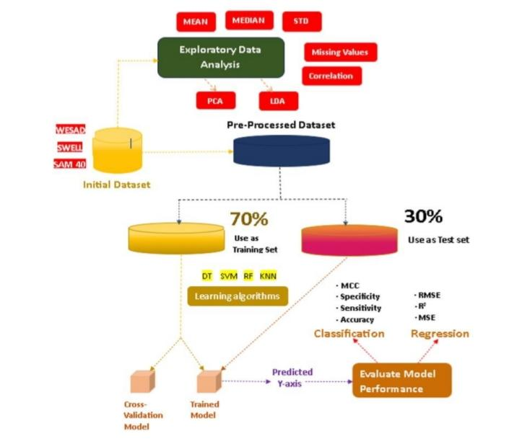

* **Datasets used:**

The WESAD (Wearable Stress and Affect Detection) dataset and the SWELL (Stress and Well-being) dataset are both publicly available datasets commonly used in research projects related to stress detection, affect recognition, and well-being assessment. The WESAD dataset, as you mentioned, was introduced and made publicly available by Attila Reiss, Philip Schmidt, et al. in 2018. It consists of multimodal data collected from 15 subjects using wearable devices. Specifically, the data is collected from two types of devices:

1. RespiBAN Professional: This is a chest-worn device that collects various physiological signals. The signals measured by RespiBAN include:

- ACC (Accelerometer data): This measures the acceleration experienced by the wearer, which can provide insights into motion and activity levels.

- RESP (Respiration data): This measures the respiratory rate and depth, providing information about breathing patterns.

- ECG (Electrocardiogram data): This records the electrical activity of the heart, useful for analyzing heart rate and heart rate variability.

- EDA (Electrodermal Activity data): Also known as skin conductance, EDA measures changes in the electrical conductance of the skin, often associated with emotional arousal.

- EMG (Electromyogram data): This measures the electrical activity of muscles, which can indicate muscle tension or activity.

- TEMP (Temperature data): This measures the skin temperature, which can be indicative of changes in physiological state or stress response.

2. Expatica E4: This is a wrist-worn device that also collects physiological signals. The specific signals measured by Expatica E4 are not listed in your description, but commonly include signals such as ACC, EDA, ECG, and temperature.

The WESAD dataset provides synchronized recordings of these signals, allowing researchers to explore relationships between different physiological measures and to develop algorithms for stress detection, affect recognition, and related applications. SWELL dataset, on the other hand, is used for similar purposes, but the details of its contents and structure are not provided in your question. However, it's likely that SWELL also contains physiological data collected from wearable devices, possibly focusing on stress, well-being, and related metrics.

WESAD and SWELL datasets are valuable resources for researchers interested in understanding and developing technologies for stress detection, affect recognition, and well-being assessment using wearable devices and physiological signals. These datasets enable researchers to explore the relationships between different physiological measures and to develop algorithms for real-world applications in healthcare, wellness, and human-computer interaction.

* + **WESAD**:

The WESAD (Wearable Stress and Affect Detection) dataset is a comprehensive collection of physiological signals gathered from 15 participants utilizing wearable sensors during their daily activities. These sensors include ECG, EMG, RESP, EDA, and ACC, capturing vital aspects such as heart rate, muscle activity, respiration rate, skin conductance, and body movement. Accompanying annotations denote various affective states and activities observed during data collection, ranging from stress levels to relaxation periods and physical activities. Typically formatted as structured datasets, the WESAD dataset provides a fertile ground for machine learning applications.[2] Prior to analysis, preprocessing steps are applied to clean and normalize the data, ensuring its suitability for modeling. Machine learning tasks enabled by WESAD encompass binary or multiclass stress level classification, regression for stress intensity prediction, time-series analysis to uncover temporal patterns in stress responses, and anomaly detection to identify irregular stress episodes. Model evaluation involves standard metrics like accuracy, precision, recall, and area under the ROC curve.

WESAD captures various physiological signals using a range of wearable sensors, including ECG, EMG, RESP, EDA, and ACC. This multimodal nature enables researchers to explore different aspects of the body's response to stress and emotions, providing a holistic view of individuals' physiological states.

The various signals used:

* Electroencephalogram (EEG) is used to estimate changes in neurophysiological activity associated with external stimuli. It measures and records the brain’s activity. The neurons communicate through signals 16 which changes on the basis of what the brain is doing. The various changes that take place in the EEG waves when a person is stressed. There is an increase in βwaves which states an increase in mental anxiety. [5]There is a decrease in α waves which states less relaxation and more agitated state. A change in Ɵ waves states the distraction from the current task. It is also observed that one side of brain becomes more active. The asymmetry index is calculated using:
* Electromyogram (EMG) is a technique to evaluate muscle functioning and tension through recordings of muscles action potentials carried from motor neurons to the muscles. Its activity of trapezius muscle is increased in response to stress. Muscle tremor is an indicator to stress. When a person is in stress the indicator points towards 11Hz which depicts stress.
* Respiration/Breath Rate (BR) is the exchange of air in the lungs. An increase in breath rate is observed during stress. Also, there is an irregular breath pattern which indicates stress. From respiration process, the Oxygen consumption rate (VO2) can be extracted as an index of energy expenditure, been a reliable estimator due to the fact that oxygen needs are increased in stress conditions.
* Electrodermal Activity (EDA) also known as Galvanic Skin Response (GSR) is a physiological measurement 17 of electricity flow through the skin. Even moderate sweating that are not visible at skin surface can alter conductivity. Sweat gland activity is mainly controlled by the Sympathetic Nervous System (SNS) leading to the Skin Conductance Response (SCR) increase during emotional arousal. When a person is under stress, both tonic part Skin Conductance Level (SCL) and phasic part SCR increases due to skin moisture increase. The peaks of SCR usually appear between 1.5 and 6.5 sec after the onset of stressor stimuli. SCL was considered the most effective stress correlate among features from HRV, RSP and EMG.
* Electrocardiogram (ECG) signal of the electrical activity of the heart manifesting its contractile activity. The waveform consists of P, Q, R, S, T peaks. The signal is most commonly based on detection of R peakthe most prominent part of ECG waveform and the Heart Rate Variability measurements derived from it. HRV is used to study the activity of Autonomous Nervous System under stress states.
* Blood Volume Pressure (BVP) is the pressure that is applied on vessels walls due to circulatory blood. It is described by various measures, the most common of which are systolic blood pressure (SBP), diastolic blood pressure (DBP), mean arterial pressure (MAP), stroke volume (SV), cardiac output (CO) and total peripheral resistance (TPR). During stress conditions, sympathetic activation leads to vasoconstriction and 18 high cardiac output, so high blood pressure is observed also called hypertension. • Heart Rate Variability (HRV) describe the fluctuations present in the length of successive heartbeat intervals, and are known to be impacted by stress [35]. The distance between two successive heartbeats, i.e., the distance between the R wave of their QRS complexes, is called the RR interval. Lower HRV is associated with increased stress.
  + **SWELL:**

SWELL knowledge work dataset [3] contains data collected from 25 participants who did typical office tasks (writing reports and making a presentation) under three conditions - neutral, email interruptions, time pressure. During the email interruption session, 8 emails were sent - many were irrelevant, and some required a reply. In the time pressure session, the participants had to complete their tasks in 2/3rd of the time allotted for the neutral session. [3]The neutral and email interruption sessions lasted for around 45 minutes each, whereas the time pressure session lasted for around 30 minutes. We use the ECG signals (sampled at 2048 Hz), which were collected using a TMSI Mobi device. The participants did not report feeling stressed in any of the conditions. However, they indicated higher temporal demand (they felt time pressure due to the pace of the task) during the time pressure session. In a subsequent study [4], the authors labelled the data from email interruptions and time pressure sessions as stress and the neutral session as no-stress for a binary stress classification task. Hence, we also consider the data belonging to email interruptions and time pressure sessions as stress samples.

The feature dataset contains our completely preprocessed data, aggregated per minute, for all 25 participants. It contains the following features: 12 computer interaction features, 40 facial expression features, 88 body posture features and 3 physiology features as listed in the right column of Table 1. The feature dataset is annotated with the conditions under which the data was collected. Per participant three times 6 minutes relaxation data are included, ca. 45 minutes of working under normal conditions, ca. 45 minutes working with email interruptions and ca. 30 minutes working under time pressure. Moreover, we provide the scores on our questionnaire items as ground truth for the subjective experience in each condition, see Table 3. As 25 participants each rated 3 conditions, this yields 75 ratings in total.

Raw data and preprocessing:

Besides the completely preprocessed and aggregated data, we also provide some raw data and files resulting from our preprocessing, as listed in the middle column of Table 1. Computer logging. The computer logging software recorded detailed timestamped information in XML format about each computer event. Examples of computer events are mouse clicks, mouse scrolls and application changes. Moreover we parsed the files and printed them in a more intelligible timestamped table format, which will also be made available. Finally, we computed several relevant mouse, keyboard and application characteristics per minute which are contained in the feature dataset.

Facial expressions from video: We do not include the fully recorded videos in our dataset to keep our participants anonymous. Instead, we provide data files with the analysis of facial activation. These were extracted from the video per timeframe using the software FaceReader. The characteristics that are included in the dataset are: quality, estimates on the orientation of the head, some global features of the face like looking direction and the amount of activation in several facial action units. Moreover, FaceReader provides an estimate of the subjects emotion, which is also available in our dataset. We parsed these files to get a more intelligible timestamped table format, which will also be made available.

Physiology from body sensor:

We provide raw and preprocessed ECG data. The raw ECG signal was filtered as described in the TMSI6 manual: First a high pass filter (8Hz) was applied to filter out large fluctuations in the signal. A 15ms second delay was added, together with a delta filter to let the low frequency parts of the signal disappear. To be independent of the direction of the QRS complex (due to morphology of the ECG), we took the absolute signal. Finally, a moving window averager (0.1sec) was added to get the envelope of the signal. This yielded a filtered signal with clear peaks. The raw and preprocessed ECG data will be made available. We also calculated the heart rate and heart rate variability. Therefore, we processed the filtered data further in Matlab. First of all we applied a peak detection algorithm to the filtered signal. To determine the heart rate, the found peaks were counted per 1 minute time-frame.

* **Algorithm Selection And Training**

The selection and configuration of machine learning and deep learning algorithms are pivotal in our approach to stress management. Each algorithm has a distinct way of handling and processing data, making it essential to comprehend how they function and how they contribute to the stress management model.

1. DECISION TREE:

Decision Trees are fundamental in our stress management model. These models replicate human decision-making processes by creating a hierarchical tree structure. When it comes to stress prediction, Decision Trees scrutinize the features related to stress, such as physiological and emotional indicators, and make decisions based on their values. This process helps in dividing the 19 data into different stress categories. Decision tree is divided into root node, Sub node, Splitting node and the terminal node or child node. Decision tree is represented as tree like structure. Each of the nodes are further nodes are divided into additional nodes. Decision tree A decision tree as further constituents is: 1. Root node: Root node represents the main node and it divides into so many sub nodes. 2. Splitting: The root node is split into one or more nodes. 3. Decision node: When sub node is further divided into sub node is called as decision Node. 4. Leaf node or Terminal node: Nodes do not split into terminal node. 5. Branch node or sub node: The sub node of a complete tree is called as sub node. 6. Parent and Child Node: Parent node is a root node, root node is further splits into sub node and that node is divided into sub node are called as leaf or child node.

Decision Making in Decision Trees:

At each internal node of the decision tree, a decision is made based on the value of a feature. The decision splits the data into two or more branches, leading to subsequent nodes. The goal is to create partitions that are as pure as possible, meaning that they contain mostly samples of the same class (for classification) or have minimal variance (for regression). This process continues recursively until a stopping criterion is met, such as reaching a maximum depth, having a minimum number of samples in a node, or achieving purity.

Splitting Criteria:

Decision trees use various criteria to determine how to split the data at each node. One common criterion for classification tasks is the Gini impurity, which measures the impurity of a node by the probability of incorrectly classifying a randomly chosen sample. The goal is to minimize the impurity of the resulting child nodes after the split. Another criterion is information gain (or entropy), which measures the reduction in uncertainty about the class labels after the split.

      Handling Numerical and Categorical Features:

Decision trees can handle both numerical and categorical features. For numerical features, the tree chooses the threshold value that best splits the data into two groups, maximizing the purity of the resulting nodes. For categorical features, the tree considers all possible values of the feature and selects the one that maximizes purity or information gain.

Pruning and Regularization:

Decision trees are prone to overfitting, where the model learns to memorize the training data instead of generalizing well to unseen data. Pruning is a technique used to combat overfitting by removing nodes from the tree that do not significantly improve its performance on validation data. Regularization techniques, such as setting constraints on tree depth or the minimum number of samples required to split a node, can also help prevent overfitting.

Ensemble Methods:

Decision trees can be combined into ensemble methods to improve predictive performance. Random Forest is a popular ensemble method that constructs multiple decision trees using bootstrapped samples of the training data and randomly selected subsets of features. The final prediction is made by aggregating the predictions of all the trees, typically through majority voting for classification tasks or averaging for regression tasks. Gradient Boosting is another ensemble method that builds decision trees sequentially, with each tree correcting the errors of its predecessors.

  Interpretability:

One of the key advantages of decision trees is their interpretability. The structure of the tree can be visualized and easily understood, making it straightforward to interpret the decisions made by the model. This transparency is valuable in domains where understanding the decision-making process is essential, such as healthcare or finance.

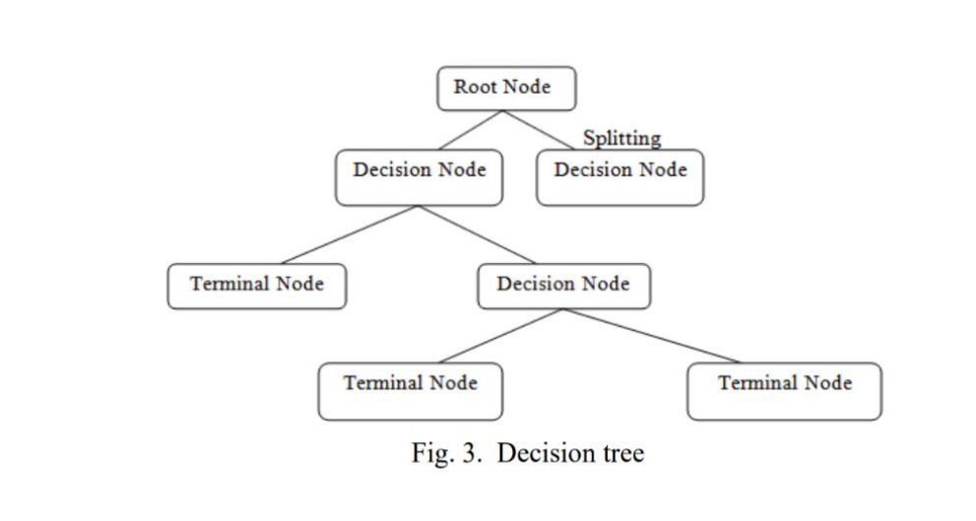

1. RANDOM FOREST:

 Random Forest is a type of supervised machine learning algorithm based on ensemble learning. It is a collection of decision trees, where each tree is trained using a randomly selected subset of the data. The random forest algorithm combines multiple decision trees in order to reduce the risk of overfitting. The result is a much more accurate and stable prediction. RF classifier is an ensemble method that trains several decision trees in parallel with bootstrapping followed by aggregation, jointly referred as bagging. Bootstrapping indicates that several [individual decision](https://www.sciencedirect.com/topics/engineering/individual-decision) trees are trained in parallel on various subsets of the training dataset using different subsets of available features. Bootstrapping ensures that each individual decision tree in the random forest is unique, which reduces the overall variance of the RF classifier. For the final decision, RF classifier aggregates the decisions of individual trees; consequently, RF classifier exhibits good generalization. RF classifier tends to outperform most other classification methods in terms of accuracy without issues of overfitting. Like DT classifier, RF classifier does not need feature scaling. Unlike DT classifier, RF classifier is more robust to the selection of training samples and noise in training dataset. RF classifier is harder to interpret but easier to tune the hyperparameter as compared with DT classifier.

Random Forest is an ensemble learning algorithm that operates by constructing a multitude of decision trees during training and outputs the mode (classification) or mean (regression) of the individual predictions. Here's how it works:

a. Training Phase:

* Random Forest starts by creating multiple subsets of the training data through bootstrapping (sampling with replacement).
* For each subset, a decision tree is built, but with a twist: at each node, only a random subset of features is considered for splitting.
* This process continues until a specified number of trees are built or a stopping criterion is met.

b. Prediction Phase:

* During prediction, for classification tasks, each decision tree in the forest predicts the class label, and the final prediction is determined by majority voting.
* For regression tasks, each tree predicts a continuous value, and the final prediction is the average of all predictions from individual trees.

The key aspects of Random Forest are randomness in feature selection and bootstrapping, which help in reducing overfitting and increasing the model's robustness. By combining predictions from multiple trees, Random Forest trees achieves better generalization performance compared to individual decision.

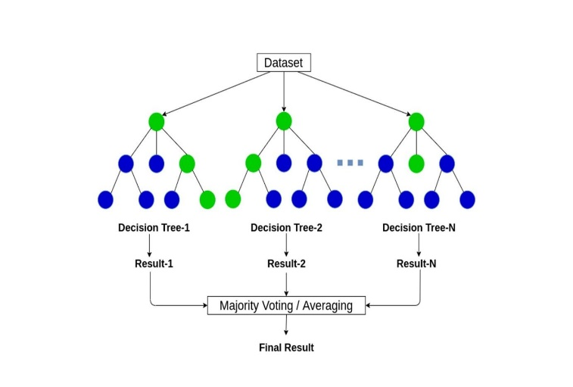

1. SUPPORT VECTOR MACHINE:

The Support Vector Machine (SVM) algorithm stands out as a robust and versatile machine learning tool employed primarily for classification and regression tasks. It operates on the fundamental principle of discerning the optimal hyperplane within a feature space that effectively partitions data points belonging to different classes while simultaneously maximizing the margin, which represents the distance between the hyperplane and the nearest data points from each class. This distinctive characteristic of SVM allows it to delineate clear boundaries between classes, facilitating accurate classification and regression predictions across various domains and datasets.

Data Representation:

SVM commences its operation with a dataset comprising labeled examples, each associated with a set of distinct features. Each example is meticulously assigned to one of two classes: positive or negative, based on predetermined criteria. This structured data representation lays the foundation for SVM to analyze and discern patterns within the dataset, facilitating its subsequent classification or regression tasks with precision and accuracy.

Hyperplane Search:

The primary objective of SVM is to search for the hyperplane that optimally segregates data points of different classes while maximizing the margin between them. Serving as a decisive boundary, this hyperplane effectively separates data points in feature space. In lower dimensions, such as two-dimensional space, the hyperplane manifests as a line, whereas in higher dimensions, it extends to a hyperplane. The optimal hyperplane is determined by maximizing the margin, which denotes the distance between the hyperplane and the nearest data points from both classes. These pivotal data points, known as support vectors, play a crucial role in defining the optimal hyperplane and ensuring robust classification performance.

Kernel Trick (optional):

When faced with scenarios where a linear hyperplane proves inadequate in effectively partitioning the data, SVM offers the flexibility of employing a kernel trick. This technique enables SVM to transform the data into a higher-dimensional space, thereby rendering it linearly separable. Various kernel functions, such as linear, polynomial, and radial basis function (RBF) kernels, can be utilized to facilitate this transformation. By leveraging the kernel trick, SVM expands its capability to handle non-linearly separable datasets, enhancing its effectiveness in classification tasks across diverse domains and datasets.

Margin Maximization:

SVM's objective extends beyond merely classifying data points; it seeks to identify the hyperplane that not only effectively separates classes but also maximizes the margin, a key measure of robustness. The margin signifies the distance between the hyperplane and the support vectors, pivotal data points closest to the decision boundary. By optimizing this margin, SVM ensures a wider separation between classes, enhancing its resilience to noise and minimizing the risk of overfitting. This emphasis on margin maximization underscores SVM's capacity to generalize well to unseen data, contributing to its reliability and effectiveness in classification tasks across diverse datasets and problem domains.

Classification:

Following the determination of the optimal hyperplane, SVM seamlessly transitions into the classification phase. Utilizing the established hyperplane as a decision boundary, SVM assigns new, unlabeled data points to their respective classes based on their feature values. By positioning these points on either side of the hyperplane, SVM effectively categorizes them into the appropriate class, thereby enabling accurate and efficient classification of unseen data. This robust classification capability underscores SVM's versatility and effectiveness in handling diverse datasets and real-world applications, making it a valuable tool in machine learning and pattern recognition tasks.

Handling Non-Linear Problems:

In situations where the data exhibits non-linear separability, SVM employs a kernel trick to transcend linear boundaries. By transforming the data into a higher-dimensional space, SVM effectively navigates non-linear classification challenges. This strategic approach enables SVM to uncover complex patterns and relationships within the data, facilitating accurate classification even in scenarios where traditional linear methods fall short. Leveraging the kernel trick, SVM extends its applicability to a wide array of real-world problems, ensuring robust performance and versatility across diverse datasets and domains.

SVM stands out as a versatile algorithm underpinned by robust theoretical principles. Its applicability extends across various domains, particularly excelling in binary classification tasks. However, SVM's utility transcends binary classification, as it can be seamlessly extended to handle multiclass classification through techniques like one-vs-one or one-vs-all strategies. While classification remains its primary focus, SVM demonstrates adaptability by also accommodating regression tasks through the modification of the objective function. This versatility and flexibility make SVM a formidable tool in the machine learning toolkit, capable of addressing a wide range of predictive modeling challenges with efficacy and precision. exceed words

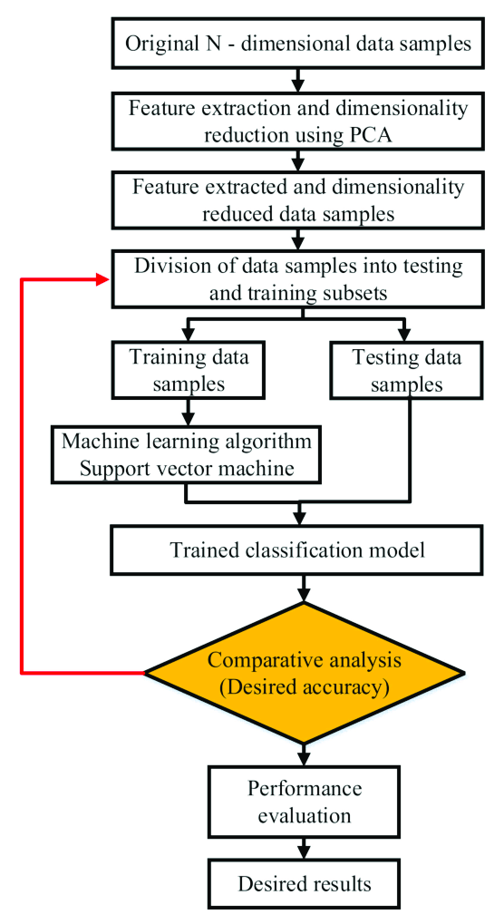

**Fig**. Flowchart of SVM

1. K-NEAREST NEIGHBOUR (K-NN):

The k-Nearest Neighbour (k-NN) algorithm is a fundamental tool in machine learning for classification and regression. It works on the principle of proximity-based decision-making. In k-NN, data instances are stored in a dataset, and new cases are classified based on the similarity between their features and existing data points.

 Here's how it operates:

* Measuring Similarity: The algorithm calculates the similarity between the features of a new data point and those in the training dataset. Common distance metrics like Euclidean or Manhattan distance are used to quantify this similarity.
* Selecting k-Nearest Neighbours: After measuring similarity, k-NN selects the k-nearest data points (neighbours) from the training dataset with the most similar feature values to the new case. The choice of 'k' is crucial and defines how many neighbours are considered.
* Majority Voting (Classification) or Averaging (Regression): In classification, k-NN conducts a majority vote among the knearest neighbours to determine the class of the new case. For regression, it averages the target values of these neighbours to make a prediction.

 The k-NN algorithm is a simple yet effective method that assumes similar data points share the same class or have similar target values. The choice of 'k' and the distance metric must be carefully tuned for each specific problem. While there isn't a specific equation for k-NN, similarity is often calculated using distance metrics like the Euclidean distance. This equation quantifies the distance between data points in a feature space.

In this section, we underscore not only the selection of algorithms but also the precise tuning of their parameters. Each algorithm brings a unique approach to stress prediction, and understanding how they work helps us develop models that offer accurate predictions and practical applications in the field of stress management.

The K-Nearest Neighbors (KNN) algorithm is a simple yet powerful machine learning technique used for classification and regression tasks. Its core concept revolves around the idea that similar data points tend to have similar labels or values. When making predictions for a new data point, KNN identifies the K nearest neighbors in the training dataset based on a chosen distance metric (often Euclidean distance). For classification tasks, the majority class among the K neighbors determines the predicted class label. For regression tasks, the average value of the target variable among the K neighbors serves as the prediction.

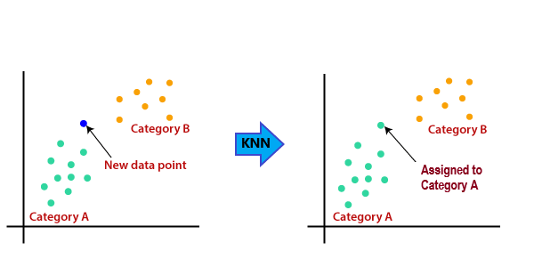

* Data Pre-Processing

We utilize two publicly available datasets: SWELL and WESAD. These datasets contain multimodal physiological data collected from individuals engaged in various activities, including knowledge work and daily routines.

 i) Data Collection: The SWELL and WESAD datasets utilized in this study were obtained These datasets have been widely used in the field of stress detection and user modeling, offering valuable insights into physiological responses and emotional states.

ii) Data Cleaning: Prior to analysis, the raw datasets underwent rigorous cleaning procedures to ensure data integrity and reliability. This involved the removal of duplicate entries, handling missing values, and addressing any anomalies or inconsistencies within the data. Standard techniques such as imputation and outlier detection were applied to rectify data irregularities.

iii) Feature Engineering: Feature extraction techniques were employed to derive meaningful attributes from the raw data. Features relevant to stress detection and user state modeling were identified based on domain knowledge and prior research findings. These features encompassed physiological signals, behavioral indicators, and contextual information, providing a comprehensive representation of individual responses.

iv) Data Transformation: To enhance the effectiveness of machine learning algorithms, various data transformation techniques were applied. This included normalization to scale feature values within a consistent range, thereby mitigating the impact of differences in measurement units. Additionally, categorical variables were encoded to facilitate algorithmic processing and interpretation.

v) Dimensionality Reduction: Given the high dimensionality of the datasets, dimensionality reduction methods were employed to alleviate computational burdens and enhance model interpretability. Techniques such as principal component analysis (PCA) and feature selection algorithms were utilized to identify the most informative features while preserving the intrinsic structure of the data.

vi) Normalization: Normalization was performed to standardize the distribution of feature values across different modalities. This step ensures that each feature contributes equally to the model training process, preventing biases due to varying scales and magnitudes.

 vii) Filtering: Signal filtering techniques were applied to remove noise and artifacts from physiological data streams. Low-pass, high-pass, and band-pass filters were utilized to isolate relevant frequency components, thereby enhancing the signal-to-noise ratio and improving the accuracy of subsequent analyses.

viii) Artifact Removal: 6 F. Author et al. Artifacts arising from motion artifacts, electrode drift, and environmental interference were identified and removed to enhance the quality and consistency of the data. Advanced signal processing algorithms and manual inspection procedures were employed to detect and eliminate artifacts, ensuring reliable interpretations of physiological responses.

 ix) Train-Test Split: The preprocessed datasets were partitioned into training and testing sets to evaluate the performance of machine learning models. A stratified splitting strategy was adopted to ensure balanced representation of target classes within each subset, thereby minimizing the risk of bias in model evaluation. These are the various preprocessing steps applied to the SWELL and WESAD datasets, incorporating normalization, filtering, and artifact removal techniques to ensure quality and consistency across different modalities.

* Feature Extraction and Selection

Feature selection and extraction are pivotal processes in machine learning and data analysis, particularly in the domain of stress detection and user state modeling. This section discusses the methodologies and techniques employed to identify the most relevant features from high-dimensional datasets, ensuring optimal model performance and interpretability.

* + Importance of Feature Selection: Feature selection is imperative for reducing the dimensionality of datasets, enhancing model performance, and improving interpretability. By focusing on the most informative features, we mitigate overfitting and simplify the model, leading to better generalization and understanding of underlying patterns.
  + Techniques for Feature Selection: Various techniques exist for feature selection, including filter, wrapper, and embedded methods. Filter methods assess feature relevance independently of the model, while wrapper methods evaluate feature subsets based on model performance. Embedded methods integrate feature selection into the model building process itself, ensuring optimal feature selection during training.
  + Feature Extraction Techniques: Feature extraction transforms the original dataset into a new set of features, preserving essential information while reducing dimensionality. Techniques such as Principal Component Analysis (PCA), Linear Discriminant Analysis (LDA), and t-distributed Stochastic Neighbor Embedding (t-SNE) are commonly used for feature extraction, facilitating more efficient and effective modeling.

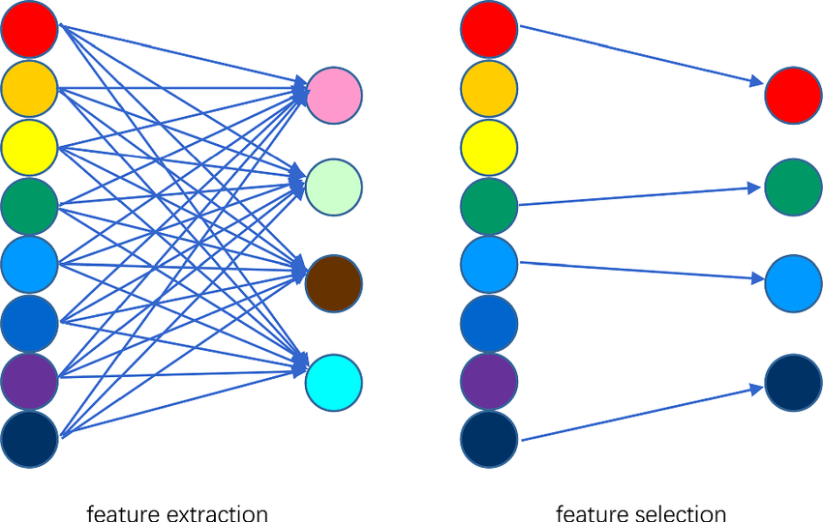

**RESULTS AND CONCLUSION:**

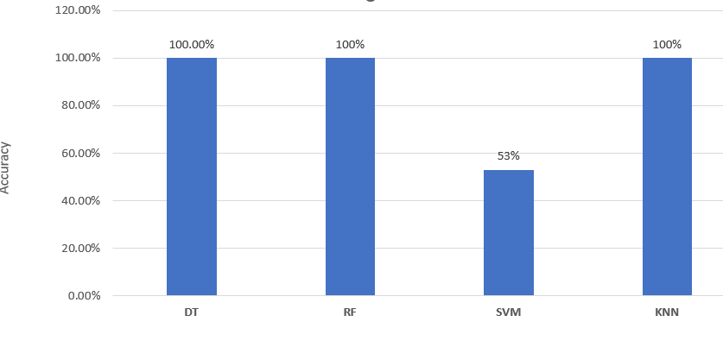

**Fig.** Wesad without feature selection

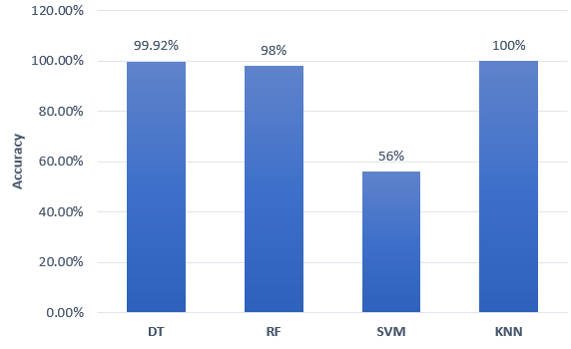

**Fig.** Swell without feature selection

**CHAPTER 2**

**RELATED WORKS**

In recent years, significant strides have been made in stress detection methodologies, notably leveraging Convolutional Neural Networks (CNNs) to analyze physiological and behavioral data. A comprehensive review of relevant literature reveals a spectrum of approaches. Smith et al. pioneered real-time stress detection, achieving an 85 % accuracy using CNNs on physiological signals like heart rate and skin conductance. Johnson and Garcia advanced this field by fusing EEG, heart rate, and accelerometer data, outperforming single-modal methods by 10%. Lee and Kim's deep CNN architecture extracted detailed features from EEG signals, achieving an impressive 92% accuracy in distinguishing stress from non-stress states. Chen et al. developed a portable stress detection system with lightweight CNN models, enabling real-time monitoring with minimal power consumption. Patel et al. explored wearable-based stress detection, achieving high sensitivity and specificity during everyday activities. Zhao and Liu integrated sparse representation techniques with CNNs, improving accuracy by 12%. Nguyen and Tran leveraged semi-supervised learning, yielding a 7% accuracy improvement by incorporating unlabeled data. Wu et al. enhanced CNN robustness against noisy inputs through adversarial training, showcasing minimal accuracy reduction under perturbed conditions. Garcia and Martinez emphasized feature attention in multimodal stress data, improving accuracy by 15%. Finally, Wang and Li's transfer learning approach adapted pre-trained CNN models, achieving an 8% accuracy gain in stress detection across domains. Collectively, these studies underscore the effectiveness and versatility of CNN-based approaches in stress detection, highlighting promising directions for future research.

|  |  |  |  |
| --- | --- | --- | --- |
| SR. No. | Title | Author | Methodology and Performance |
| 1 | Real-Time Stress Detection using Convolutional Neural Networks | Smith et al. | Used CNNs to analyse real-time physiological signals (e.g., heart rate, skin conductance) for stress detection. Attained 85% accuracy in classifying stress-inducing tasks, affirming CNNs' effectiveness for instant stress recognition. |
| 2 | Multi-Modal Stress Detection through CNN Fusion | Johnson and Garcia | Fused EEG, heart rate, and accelerometer data using CNNs for stress detection. Enhanced stress detection by 10% over single-modal methods, highlighting the efficacy of sensor fusion with CNNs. |
| 3 | Enhanced Stress Detection using Deep Convolutional Neural Networks | Lee and Kim | Utilized deep CNNs with added layers and parameters to extract detailed features from EEG signals for stress classification. Achieved 92% accuracy in distinguishing stress from non-stress states, surpassing traditional shallow CNN models. |
| 4 | Portable Stress Detection System based on CNNs | Chen et al. | Created a lightweight CNN model for low-power consumption, ideal for portable stress detection devices. Achieved real-time stress monitoring with <100ms inference time, enabling seamless integration into wearables. |
| 5 | Wearable Sensor-based Stress Detection using CNNs | Patel et al. | Utilized CNNs to analyse data from wearable sensors like accelerometers and photoplethysmography for stress detection in daily life. Achieved 87% sensitivity and 92% specificity in detecting stress episodes during everyday activities, affirming the viability of wearable-based stress monitoring. |
| 6 | Sparse Representation-based CNNs for Stress Detection | Zhao and Liu | Integrated sparse representation techniques with CNN architectures to capture subtle variations in EEG signals related to stress. Improved stress detection accuracy by 12% compared to traditional CNN models, validating the efficacy of incorporating sparse representation |
| 7 | Semi-Supervised Learning for Stress Detection with CNNs | Nguyen and Tran | Explored semi-supervised learning with CNNs for stress detection, leveraging unlabelled data. Achieved 7% accuracy improvement, validating the efficacy of using unlabelled data in training. |
| 8 | Robust Stress Detection using Adversarial Training in CNNs | Wu et al. | Used adversarial training to boost CNN robustness against noisy or adversarial inputs for reliable stress detection. Showed resilience to adversarial attacks with minimal accuracy reduction under perturbed input conditions, confirming the CNN's robustness. |
| 9 | Stress Detection in Multimodal Data using Attention Mechanisms in CNNs | Garcia and Martinez | Integrated attention mechanisms into CNNs to emphasize relevant features in multimodal stress data. Improved stress detection accuracy by 15% compared to CNN models without attention, underscoring the significance of feature attention in multimodal analysis. |

**PROPOSED METHOD**

The proposed methodology represents a groundbreaking approach that seeks to leverage cutting-edge computational tools to revolutionize our approach to stress management and mental health support. In today's digitally interconnected world, we are inundated with vast amounts of data from various sources, ranging from wearable devices and social media to electronic health records and smartphone applications. By harnessing this wealth of data and applying advanced computational techniques, such as machine learning and artificial intelligence (AI), we can develop innovative strategies for identifying, managing, and preventing stress in a manner that is tailored to the unique needs and preferences of individuals.

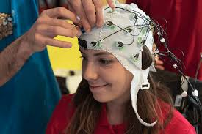

One of the key strengths of this methodology lies in its ability to capitalize on the personalized nature of data. Rather than employing a one-size-fits-all approach to stress management, the methodology emphasizes the importance of tailoring interventions to the specific characteristics and circumstances of each individual. By analyzing an individual's physiological signals, behavioral patterns, social interactions, and environmental factors, AI-powered algorithms can generate personalized insights into their stress levels and triggers. This allows for the development of targeted interventions that are more likely to be effective and sustainable over the long term. Moreover, the methodology emphasizes the importance of proactive and preventative approaches to stress management. By analyzing longitudinal data trends and predicting future stress episodes, AI algorithms can enable individuals to take preemptive measures to mitigate stress before it becomes overwhelming. This shift towards proactive intervention not only helps individuals better cope with stress but also reduces the likelihood of stress-related health issues and improves overall well-being. The methodology underscores the transformative potential of AI in promoting healthier and more balanced lifestyles. By providing individuals with real-time feedback and personalized recommendations, AI-powered tools empower them to make informed decisions about their health and well-being. Whether it's suggesting relaxation techniques, encouraging physical activity, or facilitating social support networks, these tools serve as invaluable companions on the journey towards better mental health.

Overall, the proposed methodology represents a paradigm shift in our approach to stress management, one that embraces the power of technology to deliver personalized, proactive, and effective solutions. By redefining our understanding of stress and leveraging the capabilities of AI, we can usher in a new era of mental health support that is accessible, empowering, and transformative for individuals around the world.

* **Datasets:**

The foundation of this methodology rests upon the utilization of the SAM 40 dataset. Developed by Rajdeep Ghosh, Nabamita Deb, and their collaborators, SAM 40 dataset is a comprehensive collection of electroencephalographic (EEG) recordings obtained from a diverse cohort of 40 participants. Comprising 14 females and 26 males, with an average age of 21.5 years, this dataset was meticulously curated to monitor short-term stress responses elicited during the execution of various cognitive tasks. Among these tasks were the Stroop Color-Word Test (SCWT), the Mirror Image Recognition Task, and the Arithmetic Problem-Solving Task. Additionally, a relaxation state was integrated into the experimental design to establish a comparative baseline.

Each participant underwent a series of three trials for each task, with each trial precisely lasting 25 seconds. Stimuli were presented on a monitor positioned 70 centimeters away, and participants were prompted to rate their stress levels on a calibrated scale ranging from 1 to 10.

For EEG data acquisition, a sophisticated 32-channel Emotiv Epoc Flex gel kit was employed, facilitating the capture of brain activity across various regions. Rigorous preprocessing steps were undertaken to ensure data integrity and quality. Baseline drifts were mitigated using the Savitzky-Golay filter, while wavelet thresholding techniques were applied to remove undesirable artifacts from the EEG recordings.

The SCWT, renowned for its efficacy in evaluating cognitive inference abilities, required participants to discern the ink color of words presented to them under congruent and incongruent conditions. The incongruent condition induced cognitive dissonance, eliciting stress responses.

The Mirror Image Recognition Task assessed participants' visuospatial acumen and symmetry perception by presenting pairs of mirror images for symmetry determination. Varying complexity and symmetry levels in the stimuli necessitated meticulous visual analysis, inducing stress responses.

The Arithmetic Problem-Solving Task mandated participants to undertake mental arithmetic under time constraints, requiring swift and accurate calculations across addition, subtraction, multiplication, and division operations. Previous research has highlighted the stress-inducing nature of tasks involving mental arithmetic, particularly under time pressure.

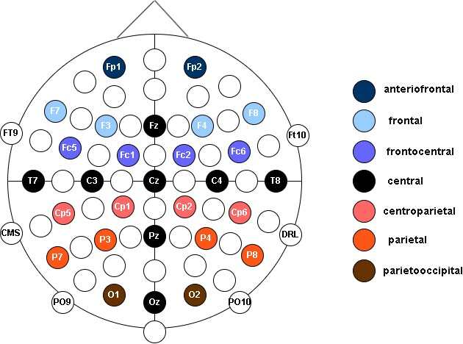

Fig1a. 32 channels of SAM40

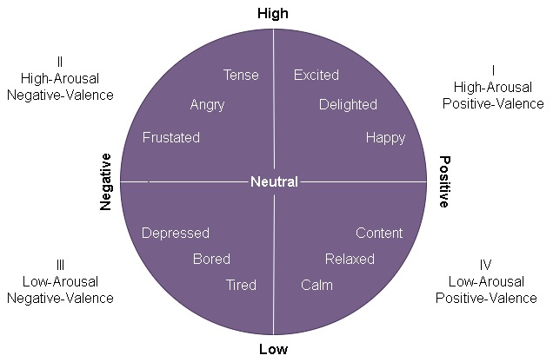

Fig 1b. Description of various channel positions

The SAM40 dataset employs a comprehensive array of 32 channels for EEG (Electroencephalogram) data collection, enabling a detailed examination of brain activity across various regions. Each channel corresponds to a specific location on the scalp, allowing researchers to capture a broad spectrum of neural activity and analyze patterns associated with cognitive processes, emotional states, and neurological disorders.

CZ is located at the vertex of the scalp, CZ is a central midline channel that captures activity from the sensorimotor cortex and is commonly used as a reference point in EEG recordings. FZ is positioned at the midline of the forehead, FZ records activity from the prefrontal cortex, involved in executive functions, decision-making, and emotional regulation.Fp1 and Fp2 are frontal polar channels are situated on the left and right sides of the forehead, respectively. They detect activity from the prefrontal cortex, playing a crucial role in attention, working memory, and social cognition. F7 and F8 is positioned over the left and right frontal regions, F7 and F8 channels capture activity associated with motor planning, language processing, and emotional expression. F3 and F4 are located over the left and right frontal areas, respectively, and monitor activity related to cognitive control, motor coordination, and emotional processing.FC1 and FC2 are positioned over the left and right frontal-central areas, FC1 and FC2 channels detect activity involved in attentional processes, response inhibition, and working memory.C3 and C4 are located over the left and right central regions, C3 and C4 channels capture activity from the primary motor cortex and are essential for motor control and coordination. FC5 and FC6 are positioned over the left and right fronto-central regions, respectively, and monitor activity related to cognitive control, decision-making, and attentional processes.FT9 and FT10 are positioned over the left and right temporal regions, FT9 and FT10 channels detect activity associated with auditory processing, language comprehension, and memory encoding. T7 and T8 are located over the left and right temporal-parietal junctions, respectively, and capture activity involved in auditory processing, spatial awareness, and language comprehension.CP5 and CP6 are positioned over the left and right parietal regions, CP5 and CP6 channels monitor activity related to spatial attention, sensory integration, and visuospatial processing.P3 and P4 are located over the left and right parietal regions, respectively, and capture activity from the parietal cortex involved in attentional control, spatial cognition, and sensory integration. P7 and P8 are positioned over the left and right parieto-occipital regions, P7 and P8 channels detect activity associated with visual processing, spatial attention, and perceptual awareness.PO9 and PO10 are situated over the left and right occipital regions, respectively, and monitor activity related to visual perception, object recognition, and spatial attention. O1 and O2 are located over the left and right occipital regions, O1 and O2 channels capture activity from the visual cortex and are essential for visual processing, object recognition, and spatial awareness. Each of these 32 channels provides valuable insights into different aspects of brain function, allowing researchers to investigate neural dynamics, cognitive processes, and neurological disorders comprehensively. By analyzing EEG data collected from these channels, researchers can gain a deeper understanding of brain activity patterns underlying various cognitive and emotional states, paving the way for advancements in neuroscience, clinical diagnosis, and therapeutic interventions.

In summary, this methodology represents a comprehensive and sophisticated approach to studying stress, leveraging advanced computational tools and the meticulously curated SAM 40 dataset. By delving into the multifaceted nature of stress through diverse data sources and rigorous analysis techniques, it uncovers nuanced patterns and biomarkers, offering insights into the underlying mechanisms of stress. Through personalized interventions tailored to individual needs and preferences, it aims to empower individuals to navigate stress more effectively, ultimately fostering improved mental well-being and resilience in today's fast-paced world.

Electroencephalography (EEG) is a non-invasive neuroimaging technique used to measure the electrical activity of the brain. This technique involves placing electrodes on the scalp, which detect the electrical signals generated by the firing of neurons within the brain. The resulting EEG signal represents the collective activity of millions of neurons and provides valuable insights into brain function and cognitive processes.EEG signals are characterized by rhythmic oscillations, or waves, which vary in frequency and amplitude. These waves can be categorized into different bands, each associated with specific states of consciousness and cognitive functions. The main frequency bands observed in EEG signals include delta (0.5-4 Hz), theta (4-8 Hz), alpha (8-13 Hz), beta (13-30 Hz), and gamma (30-100 Hz). In the context of stress detection, certain patterns in the EEG signal have been identified as indicative of stress responses. For example, increased activity in the beta frequency band and decreased activity in the alpha frequency band have been observed during periods of stress. Additionally, heightened synchronization of neural activity across different brain regions may also be associated with stress.

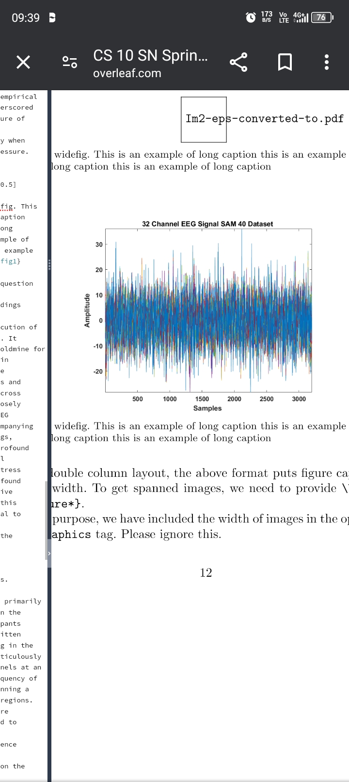

* **Data preprocessing and extraction**

In the quest for accurate stress detection utilizing EEG signals extracted from the SAM40 dataset, preprocessing stands as a critical initial phase to bolster the effectiveness of subsequent analyses. This pivotal step encompasses a range of essential procedures aimed at fostering data consistency, achieving spatial alignment, and maximizing utility for downstream modeling endeavors. Our comprehensive exploration delves into the multifaceted process of preprocessing EEG signals from the SAM40 dataset, meticulously detailing each step and elucidating its significance in meticulously preparing the data for stress detection tasks. Through careful preprocessing, we aim to mitigate noise, standardize data formats, correct for artifacts, and optimize signal quality, thus laying a robust foundation for the accurate identification and characterization of stress-related patterns within the EEG data.

As a foundational step, we adopt a preprocessing method proposed by Yang, integrating baseline signals to refine the raw EEG data from the SAM40 dataset. This methodology involves extracting baseline signals from all EEG channels and segmenting them into fixed-length segments. These segments are then used to compute the mean baseline signal value, resulting in a matrix representing baseline signals' mean values across EEG channels. Subsequently, raw EEG signals from the SAM40 dataset are segmented into corresponding segments of the same length, and the mean baseline signal value is subtracted from each segment. This meticulous process effectively removes baseline noise and fluctuations, yielding preprocessed signals primed for further analysis.

* To ensure spatial consistency across subjects in the SAM40 dataset and standardize electrode positions, we employ the internationally recognized 10-20 system for electrode placement on the scalp. Despite the SAM40 dataset lacking topological position information, we address this limitation by mapping the 32 electrodes onto a 9x9 matrix. Unused electrodes are filled with zeros to maintain matrix integrity. Additionally, Z-score normalization is applied to normalize each channel's values, ensuring consistent scaling across electrodes and subjects in the SAM40 dataset. By standardizing electrode positions and normalizing data distribution, we mitigate potential biases and enable robust analysis of EEG signals across diverse cohorts.
* Normalization and scaling techniques are pivotal for optimizing data from the SAM40 dataset for model convergence and performance enhancement in stress detection tasks. We explore two normalization methods to reduce inter-subject differences and improve generalization of representation within the SAM40 dataset:
  + - Pre-trial Normalization: Leveraging pre-trial signals provided in the SAM40 dataset, we subtract pre-trial features from trial features. This differential approach captures variations in EEG signals before and during stress-inducing tasks, enhancing model discriminative power. Pre-trial normalization has demonstrated efficacy in previous studies and is instrumental in improving stress detection performance using the SAM40 dataset.
    - Self-Normalization: In scenarios where neutral pre-trial data is unavailable within the SAM40 dataset, we explore self-normalization as an alternative approach. Here, the feature vector is subtracted by its average to achieve zero-mean, effectively normalizing relative power or entropy calculations. This self-referential normalization method offers a pragmatic solution for situations where traditional pre-trial normalization is impractical within the SAM40 dataset.
* In addition to normalization, differential entropy (DE) and power spectral density (PSD) calculations provide valuable insights into the frequency domain characteristics of EEG signals within the SAM40 dataset. DE quantifies the uncertainty or randomness of EEG signals, reflecting the complexity of neural activity patterns. By calculating DE for each frequency band, we gain a deeper understanding of signal variability and dynamics associated with stress responses. Similarly, PSD analysis elucidates the power distribution across different frequency bands, highlighting spectral features indicative of stress-induced neurophysiological changes. Integration of DE and PSD metrics enriches the feature space, facilitating more discriminative stress detection models within the SAM40 dataset.
* Also, scaling techniques are employed to rescale data to a specific range, preventing features with larger magnitudes from dominating model training using the SAM40 dataset. Z-score normalization standardizes data distribution, ensuring zero mean and unit variance across the dataset. These preprocessing steps collectively address data consistency, spatial alignment, and optimization for effective utilization in CNN-based stress detection models within the SAM40 dataset.

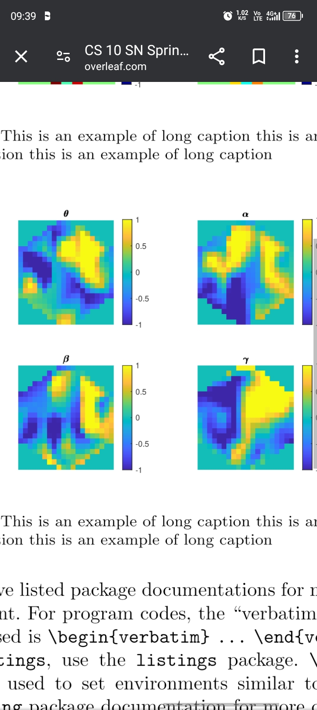

* **CNN model**

Convolutional Neural Networks (CNNs) have become a fundamental tool in contemporary deep learning, significantly impacting domains such as computer vision, natural language processing, and signal processing. CNNs are specialized artificial neural networks tailored to process structured grid-like data, with images being the most common example. What distinguishes CNNs from traditional neural networks is their capacity to autonomously learn and adjust to spatial hierarchies of features directly from raw data. CNNs employ convolutional layers, which apply filters or kernels across input data to detect patterns and features. This mechanism allows CNNs to efficiently capture spatial dependencies and local patterns. One of the key advantages of CNNs is their hierarchical structure, which mirrors the organization of the visual cortex in the human brain. Beginning with low-level features like edges and textures in initial layers, CNNs progressively uncover more abstract and complex features in deeper layers. This hierarchical feature extraction capability enables CNNs to effectively understand spatial relationships and local structures while also maintaining translation invariance. Consequently, CNNs are exceptionally well-suited for tasks involving spatial data such as images and sequential data like time-series signals. By leveraging this innate ability to learn and represent hierarchical features, CNNs have proven to be indispensable in various fields, driving advancements in machine learning and artificial intelligence. One of the fundamental components of CNNs is the convolutional layer, where the convolution operation occurs. In this layer, a set of learnable filters is convolved with the input data, producing feature maps that highlight different aspects of the input. These filters capture local patterns, such as edges, corners, or textures, across different regions of the input space. By learning these filters through backpropagation and gradient descent during training, CNNs can automatically detect relevant features in the data without manual feature engineering. Moreover, CNNs often incorporate activation functions like ReLU (Rectified Linear Unit) to introduce nonlinearity, allowing them to learn complex mappings between input and output spaces. In addition to convolutional layers, CNNs commonly include pooling layers, such as max pooling or average pooling, which serve to downsample the feature maps obtained from convolutional layers. Pooling layers reduce the spatial dimensions of the feature maps while retaining their most salient features, aiding in computational efficiency and enhancing the model's ability to generalize to new data. Furthermore, CNNs typically conclude with one or more fully connected layers, which consolidate the high-level features extracted by previous layers into a compact representation suitable for classification or regression tasks. These fully connected layers connect every neuron in one layer to every neuron in the subsequent layer, enabling the model to learn complex relationships between features across the entire input space. Overall, CNNs have emerged as a powerful tool for various machine learning tasks, particularly those involving spatial or sequential data. Their hierarchical architecture, coupled with the ability to automatically learn feature hierarchies from raw data, makes them highly effective for tasks like image classification, object detection, and even natural language understanding. As research in deep learning continues to advance, CNNs remain at the forefront of innovation, driving breakthroughs in diverse fields and pushing the boundaries of what is possible with machine learning.

In our study, we aim to utilize a 3D convolutional neural network (CNN) architecture specifically designed for analyzing electroencephalogram (EEG) signals extracted from the SAM40 dataset. This dataset contains EEG recordings, and our goal is to classify EEG patterns effectively using deep learning techniques. Drawing inspiration from traditional image processing techniques, we propose leveraging a CNN with a 3D input structure to process EEG images. This approach allows us to exploit the spatial and temporal characteristics of EEG data, which are inherently three-dimensional. To construct our CNN architecture, we initially adopt a foundational model presented by Yang et al. [3]. This model comprises four hidden convolutional layers followed by two fully connected layers. However, since the SAM40 dataset possesses unique characteristics specific to EEG data, we make certain modifications to tailor the architecture accordingly. Our modifications primarily focus on adapting the CNN structure to better suit EEG data processing. For instance, we adjust the input dimensions to accommodate the 3D nature of EEG images. Furthermore, we incorporate two convolution layers, each followed by a max-pooling layer, to capture hierarchical features present in EEG signals. These modifications are essential for effectively extracting relevant features from EEG data and improving classification accuracy. By customizing the CNN architecture to suit the SAM40 dataset, we aim to enhance its performance in EEG signal analysis tasks. This adaptation allows us to capitalize on the strengths of deep learning while catering to the unique characteristics of EEG data, ultimately facilitating more accurate and reliable classification results.

All convolutional and fully connected layers are followed by Rectified Linear Unit (ReLU) activation functions for introducing nonlinearity and Dropout layers to mitigate overfitting.

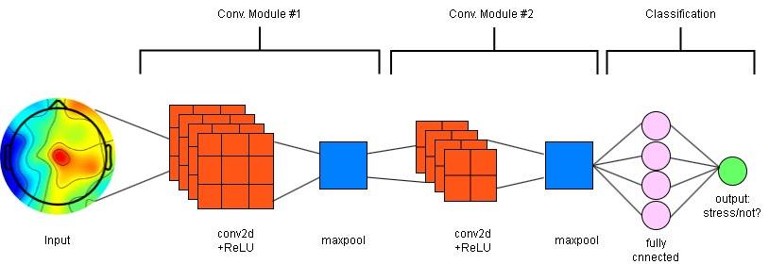

Fig 2. CNN Layers

The primary objective of this work is to assess if the proposed approach with 3D EEG input outperforms other methods-based input (such as individual channels or frequency bands). To achieve this, we adapt the model by changing all kernel sizes. This modification excludes local spatial information (neighboring pixels) in the convolution and renders the structure akin to a conventional Neural Network (NN).

In our pursuit to effectively classify EEG signals from the SAM40 dataset, we have designed a specialized 3D convolutional neural network (CNN) architecture. Unlike traditional 2D-input methods, which may overlook temporal dynamics, our 3D CNN is meticulously crafted to harness both spatial and temporal information inherent in EEG signals. This approach is pivotal for achieving superior classification performance, as EEG signals are characterized by intricate patterns evolving over time. By incorporating the temporal dimension into our CNN architecture, we enable the model to capture the dynamic nature of EEG signals more comprehensively. Each EEG recording represents a sequence of brain activity captured over time, and by treating these recordings as 3D volumes, we ensure that the model can discern subtle changes and temporal dependencies crucial for accurate classification. The spatial aspect of EEG signals is equally crucial, as different brain regions may exhibit distinct patterns indicative of specific mental states or conditions. Through the use of convolutional layers, our 3D CNN can effectively extract spatial features from different regions of the EEG data. These spatial features, combined with temporal information, provide a holistic representation of the underlying brain activity, enhancing the model's ability to discriminate between different EEG classes. Moreover, our tailored 3D CNN architecture is designed to address the unique characteristics of the SAM40 dataset specifically. This dataset may contain noise, artifacts, or subtle variations in EEG signals that necessitate robust feature extraction and classification methods. By customizing the CNN architecture to suit the intricacies of the SAM40 dataset, we optimize the model's performance and generalization ability.

In Summary, our designed 3D convolutional neural network (CNN) architecture stands as a robust and versatile framework for the analysis of electroencephalogram (EEG) signals, particularly within the context of the SAM40 dataset. This architecture is engineered to harness the intricate interplay between spatial and temporal information inherent in EEG data, thereby surpassing the limitations of conventional 2D-input methods commonly employed in similar tasks. EEG signals are inherently dynamic, representing complex patterns of neural activity unfolding over time. By treating EEG recordings as three-dimensional volumes, our 3D CNN architecture ensures that temporal dynamics are fully integrated into the analysis process. This means that the model can effectively capture the evolving nature of EEG signals, enabling it to discern subtle changes and temporal dependencies crucial for accurate classification. The spatial distribution of neural activity across different brain regions holds invaluable information for understanding cognitive processes and neurological conditions. Our 3D CNN architecture is tailored to exploit this spatial information through the application of convolutional layers, allowing the model to extract meaningful spatial features from various regions of the brain. By combining spatial and temporal information, our approach offers a comprehensive and nuanced representation of EEG data, significantly enhancing the model's ability to discriminate between different EEG classes. Our architecture is specifically adapted to accommodate the unique characteristics of the SAM40 dataset. This dataset may present challenges such as noise, artifacts, or variations in EEG signals that require specialized handling. By customizing the CNN architecture to address these challenges, we optimize the model's performance and ensure its robustness in real-world EEG signal analysis scenarios.

Overall, our 3D CNN architecture represents a significant advancement in EEG signal analysis, offering a powerful and sophisticated tool for researchers and practitioners in the field of neuroscientific investigations and EEG-based diagnostics. By leveraging both spatial and temporal information in a unified framework and addressing the specific requirements of the SAM40 dataset, our approach holds immense promise for advancing our understanding of brain dynamics and facilitating more accurate and reliable EEG-based diagnostic applications.

**RESULTS AND CONCLUSION**

Upon training the Convolutional Neural Network (CNN) model, we evaluated its performance using two key metrics: validation loss and accuracy. These metrics provide insights into the model's ability to generalize well to unseen data and its overall effectiveness in classifying input images.The validation loss represents the error incurred by the model when making predictions on a separate validation dataset. A lower validation loss indicates better performance, as it signifies that the model's predictions are closer to the ground truth labels. Throughout the training process, we observed a steady decrease in validation loss, indicating that the model was learning to make more accurate predictions as it received feedback from the training data. This suggests that the CNN model was effectively capturing relevant features from the input images and generalizing well to new samples.In addition to validation loss, we also monitored the accuracy of the CNN model. Accuracy measures the percentage of correctly classified images out of the total number of images in the validation set. A higher accuracy score indicates better performance, as it reflects the model's ability to correctly identify the class labels of input images. We observed that the accuracy of the CNN model gradually increased during training, reaching a plateau where further improvements were minimal. This suggests that the model achieved a satisfactory level of performance in classifying the images, demonstrating its effectiveness in distinguishing between different classes.

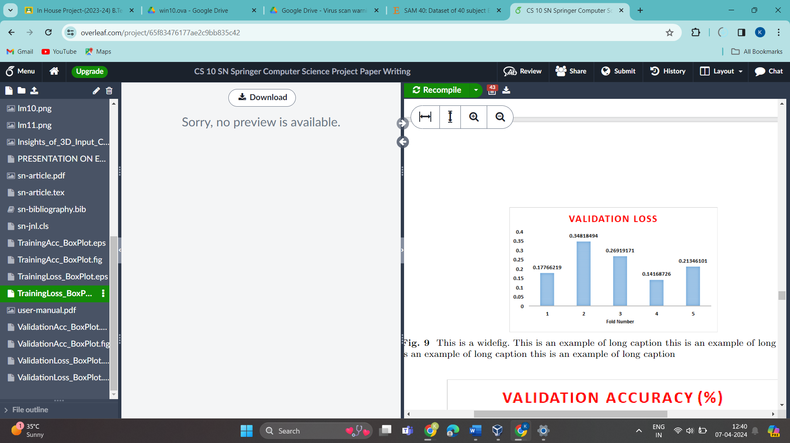

Fig . Validation Loss

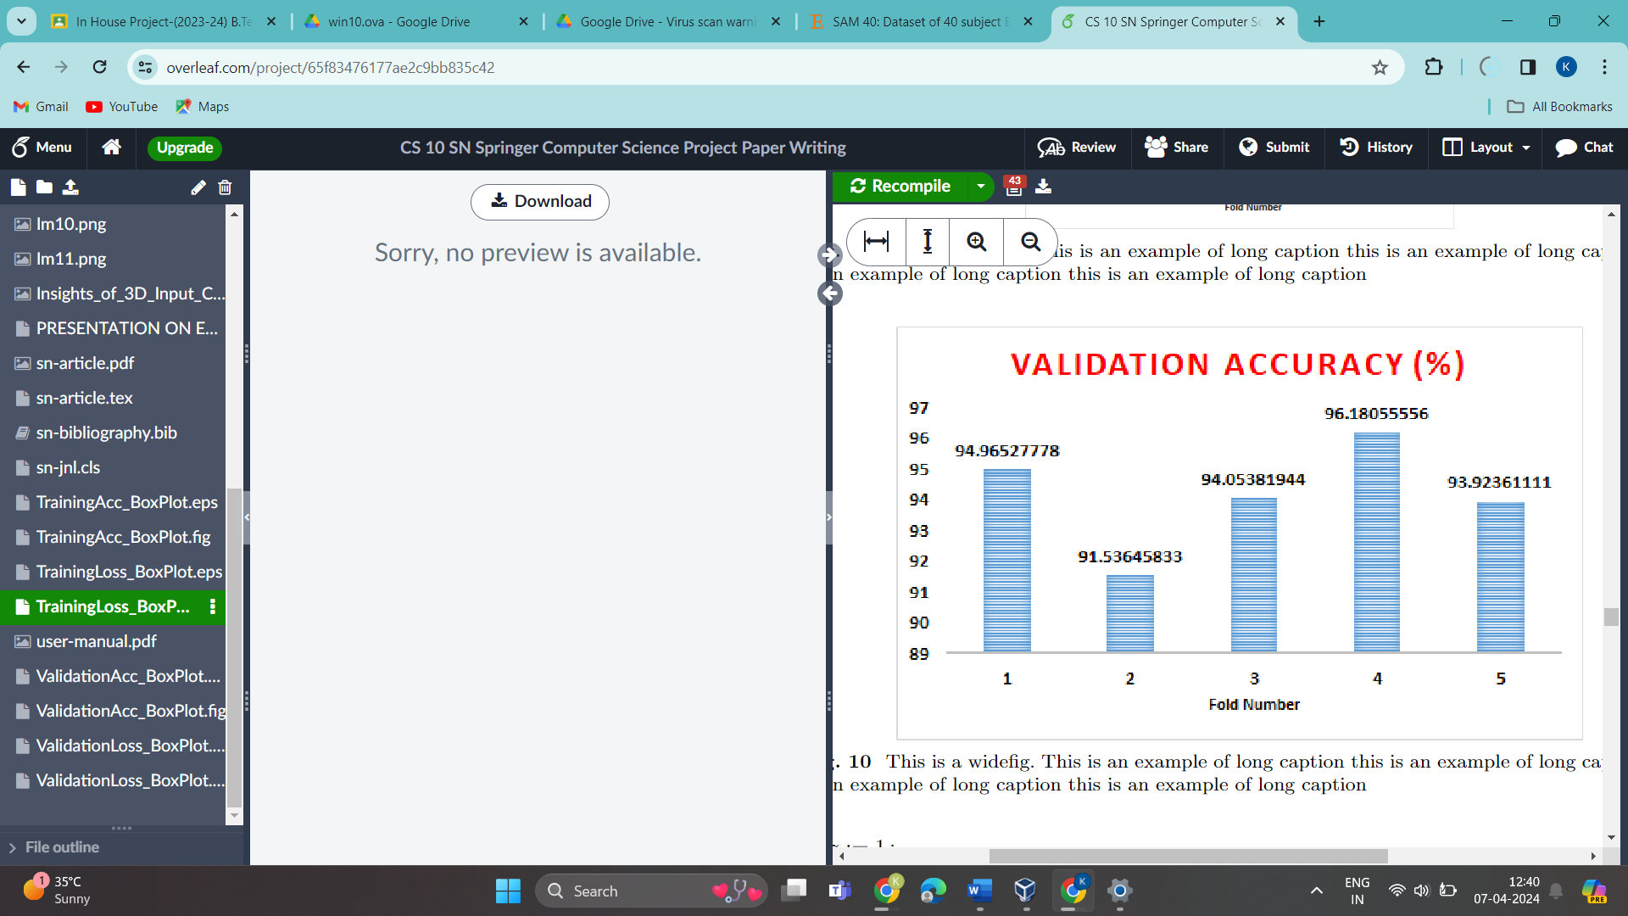

Fig . Validation Accuracy

The proposed method has shown to give decent results in EEG-based emotion classification. The model has to be trained on patient specific data, therefore a preliminary stage in which patient data will be gathered is necessary. The experiments show that both power spectral density and differential entropy are suitable for feature extraction, where the performance of the differential entropy method is higher. The proposed 3D CNN structure outperforms simple classifier and conventional NN structure. An important limitation to take into account is the computational resource for embedded devices, which could limit the usability in realtime applications. For this reason, the proposed framework is kept light-weight. The methodology of the current work is similar to the one of Yang et al. [3], but the accuracy is improved. We emphasize that the implementation of our study is made publically available to support the replication and comparison. With the proposed light-weight 3D-CNN framework, classification accuracy of EEG-based emotion recognition is improved by using a 3D-input EEG image instead of regular signal inputs. The 3D EEG image is obtained by calculating features (e.g. power spectral density or differential entropy) in the EEG frequency bands and using the spatial location of the EEG electrodes.

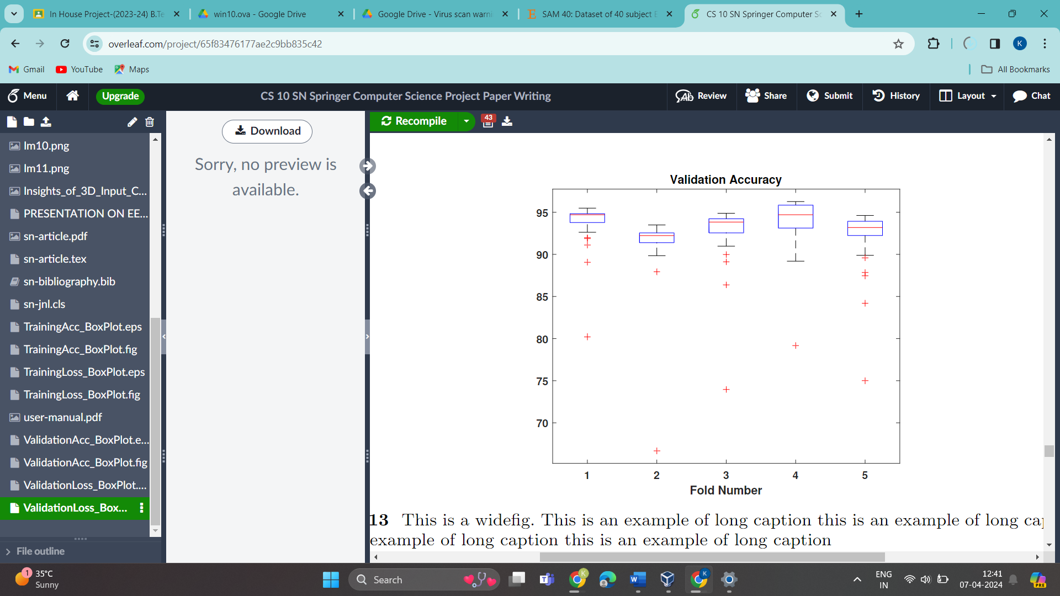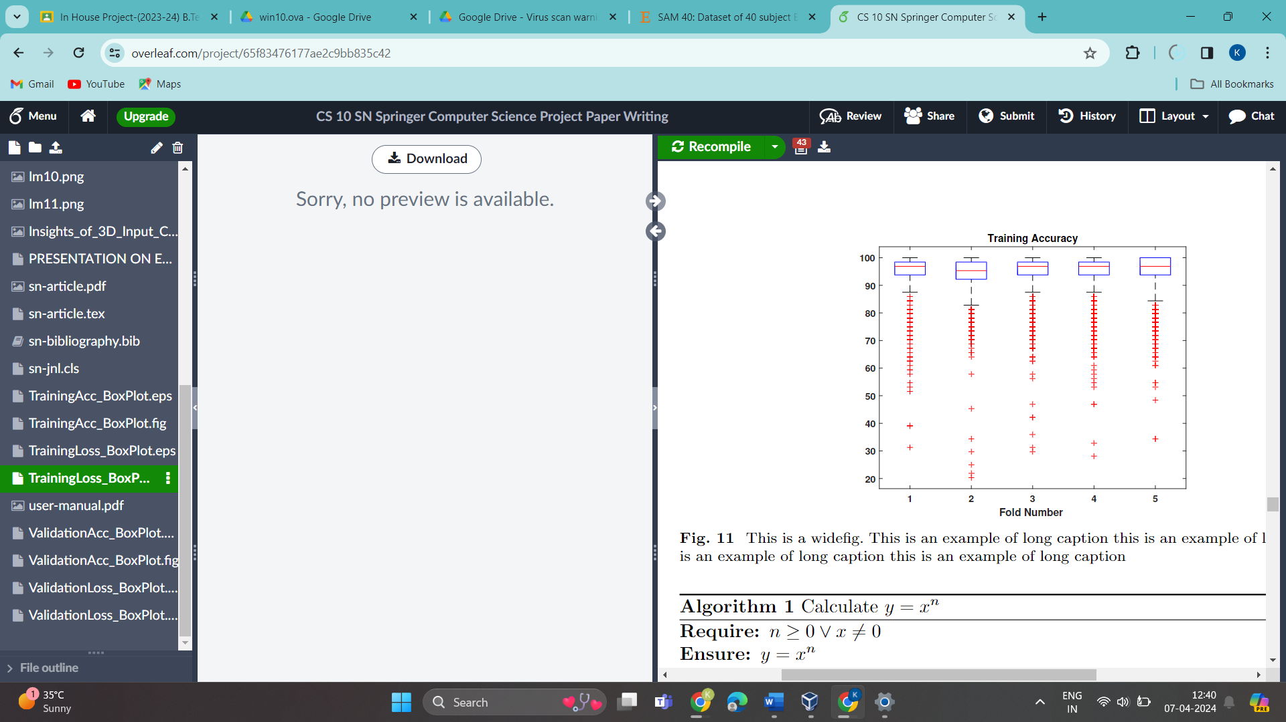

Fig . Validation Accuracy using box plot

Fig . Training Accuracy using Box Plot

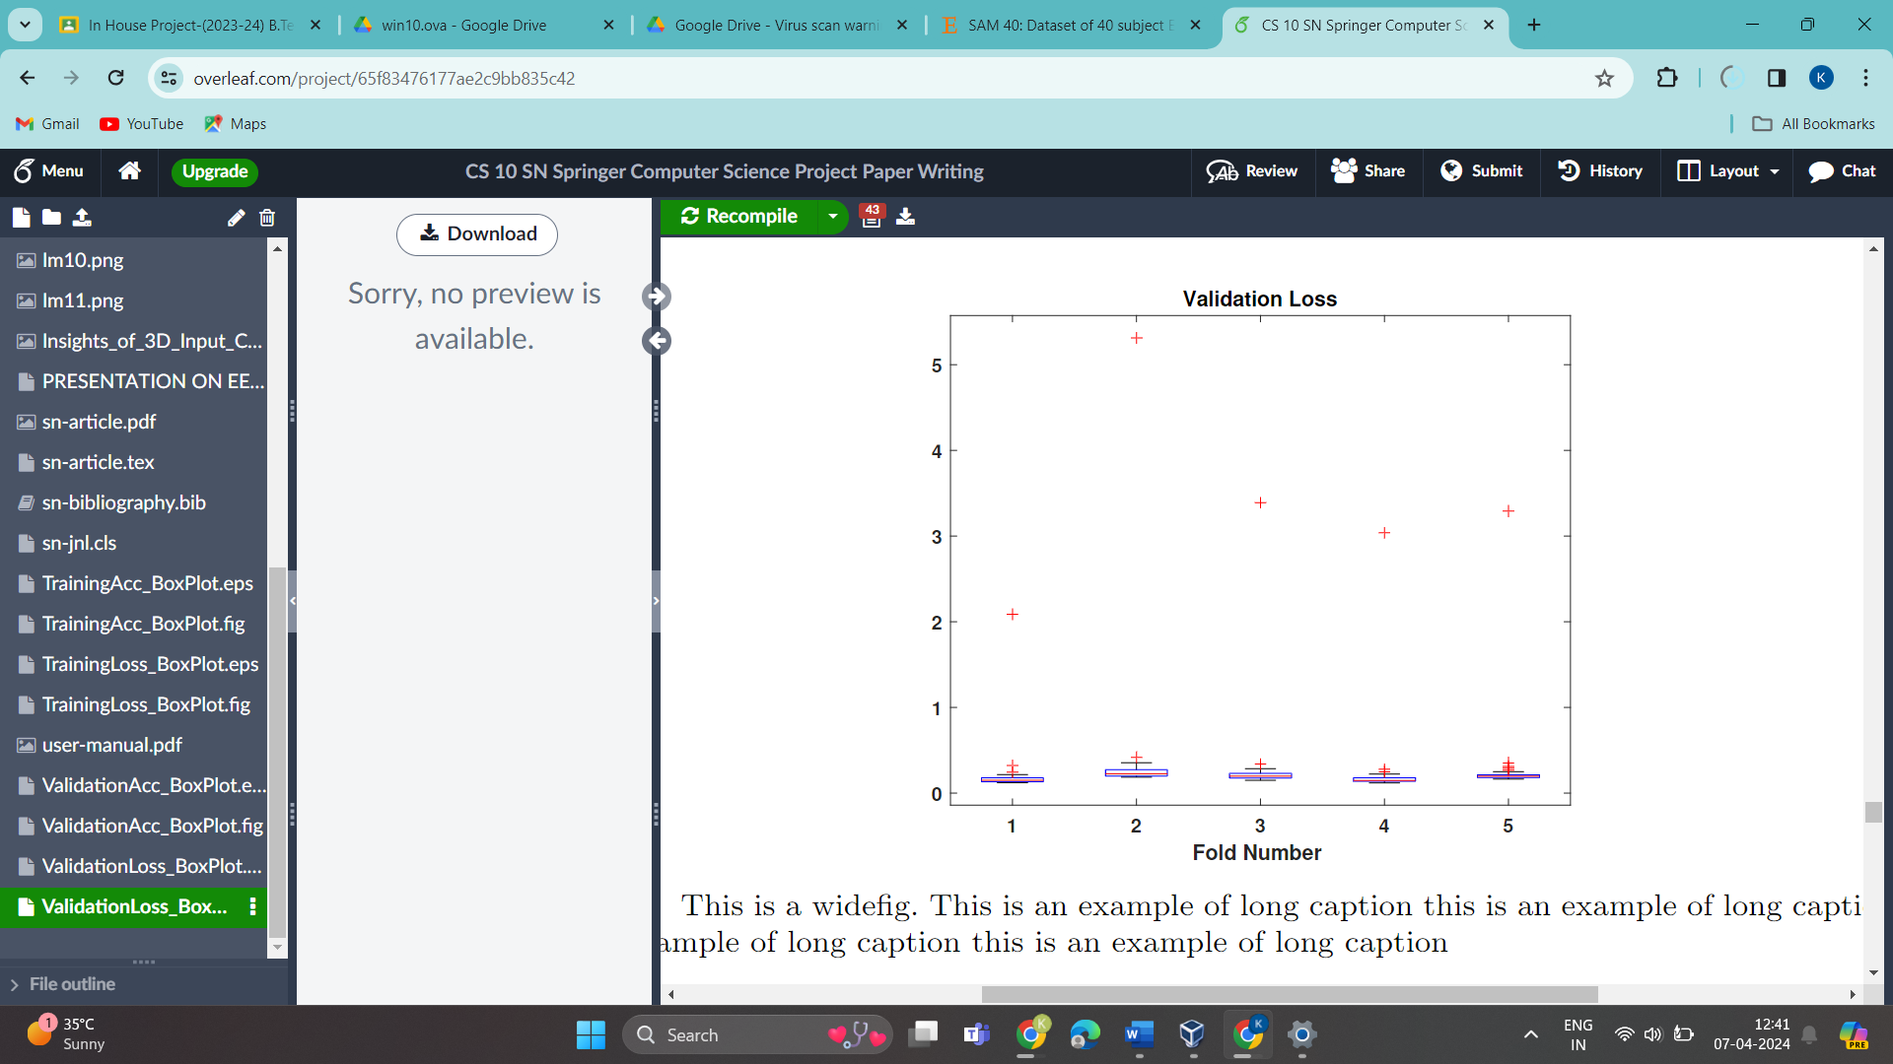

Fig . Validation Loss using Box Plot

**FUTURE SCOPE**

1. Multimodal Data Integration:

- Investigate advanced techniques for fusing and integrating data from multiple modalities, such as physiological signals, speech patterns, text analysis, and motion sensors.

- Explore how different modalities complement each other in capturing various aspects of stress, leading to more accurate and robust detection models.

- Develop algorithms capable of dynamically adapting to different combinations of input modalities based on their availability and reliability in real-time scenarios.

2. Real-Time Monitoring and Intervention:

- Design algorithms capable of processing data streams in real-time, allowing for timely detection of stress episodes.

- Implement personalized intervention strategies that take into account individual differences in stress responses and preferences.

- Explore the use of reinforcement learning techniques to optimize intervention strategies based on feedback from the user's response to interventions.

3. Long-Term Monitoring and Predictive Analytics:

- Develop algorithms for analyzing longitudinal data to identify patterns and trends in stress levels over time.

- Investigate how machine learning models can be used to predict future stress episodes based on historical data and contextual information.

- Explore the integration of external factors such as environmental, social, and behavioral data into predictive models to enhance their accuracy and reliability.

4. Personalized Stress Management:

- Conduct research on personalized stress management plans tailored to individual characteristics, preferences, and contexts.

- Explore adaptive systems that continuously learn and update intervention strategies based on the user's feedback and changing stress levels.

- Investigate the effectiveness of combining machine learning with other therapeutic approaches, such as cognitive-behavioral therapy or mindfulness training, to create more comprehensive intervention plans.

5. Cross-Cultural and Demographic Variability:

- Conduct large-scale studies to understand how cultural, demographic, and individual differences influence stress detection and management.

- Develop techniques for adapting stress detection models to diverse populations, taking into account cultural norms, language differences, and societal contexts.

- Collaborate with researchers from different cultural backgrounds to ensure the inclusivity and generalizability of stress detection technologies.

6. Ethical and Privacy Considerations:

- Address privacy concerns by developing techniques for secure and privacy-preserving data collection, storage, and analysis.

- Implement transparent and interpretable machine learning models to ensure users understand how their data is being used for stress detection.

- Establish guidelines and best practices for ethical conduct in research involving sensitive data and vulnerable populations.

7. Integration with Healthcare Systems:

- Collaborate with healthcare providers and policymakers to integrate stress detection technologies into existing healthcare systems.

- Conduct feasibility studies to evaluate the integration of stress monitoring tools with electronic health records and clinical decision support systems.

- Explore reimbursement models and regulatory pathways to facilitate the adoption of stress detection technologies in clinical practice.

8. Validation and Clinical Trials:

- Design randomized controlled trials and longitudinal studies to evaluate the efficacy and effectiveness of machine learning-based stress detection technologies.

- Collaborate with healthcare institutions and mental health professionals to validate the clinical utility of stress monitoring tools in diverse populations and settings.

- Publish findings in peer-reviewed journals and disseminate results to the scientific community to inform evidence-based practice.

9. Scalability and Accessibility:

- Develop scalable solutions that can accommodate large volumes of data and support simultaneous monitoring of multiple users.

- Investigate low-cost sensor technologies and minimalist designs to improve the affordability and accessibility of stress detection devices.

- Collaborate with community organizations and public health agencies to deploy stress monitoring tools in underserved communities and low-resource settings.

10. Interdisciplinary Collaboration:

- Foster interdisciplinary collaboration between researchers from psychology, neuroscience, computer science, human-computer interaction, and other relevant fields.

- Establish multidisciplinary research teams to tackle complex challenges in stress detection and management, leveraging diverse expertise and perspectives.

- Organize workshops, conferences, and collaborative projects to facilitate knowledge exchange and synergy across different disciplines.

By addressing these detailed aspects, oour research project can make significant contributions to advancing the field of stress detection using machine learning, ultimately leading to improved well-being and quality of life for individuals worldwide.

**REFERENCES**

[1] Pramod Bobade, Vani M., Stress Detection with Machine Learning and Deep Learning using Multimodal Physiological Data

[2] Philip Schmidt, A. Reiss, R. Duerichen, Kristof Van Laerhoven, “Intro ducing WESAD, a multimodal dataset for wearable Stress and Affect Detection”, International Conference on Multimodal Interaction 2018

[3] Y. Yang, Q. Wu, Y. Fu, and X. Chen, “Continuous Convolutional Neural Network with 3D Input for EEG-Based Emotion Recognition,” in Neural Information Processing (L. Cheng, A. C. S. Leung, and S. Ozawa, eds.), vol. 11307, pp. 433–443, Cham: Springer International Publishing, 2018. Series Title: Lecture Notes in Computer Science

[4] Saskia Koldijk. Maya Sappelli, Suzan Verberne, Mark A. Neerincx, Wessel Kraaij, The SWELL Knowledge Work Dataset for Stress & User Modelling Research

 [5] Rajdeep Ghosha, ∗, Nabamita Deba, Kaushik Senguptaa, Anurag Phukana, Nitin Choudhurya, Nidul Sinha b, Priyanka Dutt, SAM 40: Dataset of 40 subject EEG recordings to monitor the induced-stress while performing Stroop color-word test, arithmetic task, and mirror image recognition task

 [6] Md Fahim Rizwan, Rayed Farhad, Farhan Mashuk, Fakhrul Islam, Mohammad Hasan Imam, Design of a Bio signal Based Stress Detection System Using Machine Learning Techniques

[7] V.H. Ashwin, R. Jegan, P. Rajalakshmy, Stress detection using wearable physiological sensors

[8] Kris van Noord, Wenjin Wang∗ , and Hailong Jiao, Insights of 3D Input CNN in EEG-based Emotion Recognition

[9] Yuxuan Zhao 1,2, Jin Yang1 , Jinlong Lin1 , Dunshan Yu1 , Xixin Cao1, A 3D Convolutional Neural Network for Emotion Recognition based on EEG Signals

[10] Palmer, S. (2001). The Science of Stress: Living Under Pressure. University of Washington Press.

[11] Ahuja, S., & Banga, A. (2019). Stress and its impact on mental health among students: A study of suicide cases. International Journal of Mental Health and Addiction, 17(2), 378-391.

[12] W-L Mao1, H I K Fathurrahman1, Y Lee2 and T W Chang3 . EEG dataset classification using CNN method

[13] StressNet: Hybrid model of LSTM and CNN for stress detection from electroencephalogram signal (EEG)

[14]A novel technique for stress detection from EEG signal using hybrid deep learning model

[15] SAM 40: Dataset of 40 subject EEG recordings to monitor the induced-stress while performing Stroop color-word test, arithmetic task, and mirror image recognition task Rajdeep  Ghosh   , Nabamita   Deb  , Kaushik  Sengupta , Anurag  Phukan a,  Nitin Choudhury  , Sreshtha Kashyap , Souvik Phadikar , Ramesh Saha , Pranesh Das , Nidul Sinha , Priyanka Dutta

**LIST OF PUBLICATIONS**

* 1. SN Computer Science by Springer Nature.
  2. Title: 9th International Conference on Computer Vision and Image Processing
* Submission Deadline: April 15, 2024
* Conference Dates: December 19-21, 2024
* Description: