**PROGRAM 1**

Write a class Triangle, which has two member variables base of type int, and height of type int.

Write a constructor which initialises the base and the height of a Triangle instance.

Write a method getArea() that returns the area of the Triangle as a double.

Write a method show(), to print the dimensions and area of the Triangle instance.

Write a method compare(Triangle t1, Triangle t2), which determines compares the area of two given Triangle objects (hint: recall the Float class compare() method used in Lab #2).

In the main method of the Triangle class, obtain user input for the Triangle's base and height.

If the user wishes to do a comparison, ask for the dimensions of Triangle t1 and Triangle t2.

**SOURCE CODE**

import java.util.*;

class Triangle {

int base;

int height;

Triangle() {

base = 0;

height = 0;

}

Triangle(int b, int h) {

base = b;

height = h;

}

double getArea() {

return 0.5 * this.base * this.height;

}

void show() {

System.out

.println("Height and Base of the triangle are " + this.height + " and " + this.base + " respectively");

System.out.println("Area:" + this.getArea());

}

static void compare(Triangle t1, Triangle t2) {

if (t1.getArea() == t2.getArea())

System.out.println("Triangles are equal");

else if (t1.getArea() > t2.getArea())

System.out.println("First triangle is larger");

else

System.out.println("Second triangle is larger");

}

public static void main(String args[]) {

Scanner sc = new Scanner(System.in);

int b, h;

System.out.println("Do you wish to do a comparison?(1 for Yes and 0 for No)");

int ch = sc.nextInt();

switch (ch) {

case 0:

System.out.println("Enter the dimensions for Triangle:");

b = sc.nextInt();

h = sc.nextInt();

checkValidity(b, h);

Triangle t = new Triangle(b, h);

t.show();

break;

case 1:

System.out.println("Enter the dimensions for first triangle:");

b = sc.nextInt();

h = sc.nextInt();

checkValidity(b, h);

Triangle t1 = new Triangle(b, h);

System.out.println("Enter the dimensions for second triangle:");

b = sc.nextInt();

h = sc.nextInt();

checkValidity(b, h);

Triangle t2 = new Triangle(b, h);

System.out.println("1st triangle:");

t1.show();

System.out.println();

System.out.println("2nd triangle:");

t2.show();

System.out.println();

compare(t1, t2);

break;

default:

System.out.println("Invalid Input");

}

scanner.close();

}

public static void checkValidity(int base, int height) {

if (base <= 0 || height <= 0) {

System.out.println("Base/Height cannot be 0 or negative");

System.exit(0);

}

}

}

**OUTPUT**

**PROGRAM 2**

The following methods work on an array which can be used to store up to 11 integers. From the second element to the last element of the array, they are used to store the integer data. The first element of the array is used to store the number of integer data that are stored in the array.

Write the code for the following methods and then a main() method to test them. In the main() method, a menu that can support the following methods should be given: (1) initialize; (2) insert; (3) remove; (4) display; (5) quit. Then, the user selects an option from the menu. After the user has selected an option, the corresponding method will then be executed. If option (5) is not selected, then the menu will be repeated, and the user can select another option for execution.

**SOURCE CODE**

import java.util.*;

public class q2

{

public static int[ ] arr = new int[11];

public static void main(String[] args)

{

int choice;

Scanner sc=new Scanner(System.in);

do {

System.out.println("Perform the following methods:");

System.out.println("1: initialize");

System.out.println("2: insert");

System.out.println("3: remove");

System.out.println("4: display");

System.out.println("5: quit");

// read user input

choice = sc.nextInt();

switch (choice)

{

case 1: initialize();

break;

case 2: System.out.println("Enter element");

int ele=sc.nextInt();

if(insert(ele,arr[0]+1)==1)

arr[0]++;

break;

case 3: System.out.println("Enter position of the element to be removed");

int p=sc.nextInt();

remove(p);

break;

case 4: display();

break;

case 5: System.out.println("Terminating program");

break;

default: System.out.println("Invalid choice retry");

}

} while(choice != 5);

}

public static void initialize(){

Scanner sc=new Scanner(System.in);

System.out.println("Enter the no of elements (<=10)");

arr[0]=sc.nextInt();

while(arr[0]>10){

System.out.println("Re-Enter the no of elements (<=10)");

arr[0]=sc.nextInt();

}

System.out.println("Enter element");

for(int i=1;i<=arr[0];i++){

int el=sc.nextInt();

if(insert(el,i)==0)

break;

}

int temp;

for(int i=1;i<=arr[0]-1;i++)

{

for(int j=1;j<=arr[0]-i;j++)

{

if(arr[j]>arr[j+1])

{

temp=arr[j+1];

arr[j+1]=arr[j];

arr[j]=temp;

}

}

}

}

public static int insert(int ele, int p){

if(p>10){

System.out.println("Array is full");

return 0;

}

else{

arr[p]=ele;

System.out.println("Element inserted");

return 1;

}

}

public static void remove(int p){

if(arr.length==0)

System.out.println("Array is empty");

else{

for(int i=p;i<arr[0];i++)

arr[i]=arr[i+1];

arr[0]--;

System.out.println("Successfully deleted");

}

}

public static void display(){

for(int i=1;i<=arr[0];i++){

System.out.print(arr[i]+",");

}

System.out.println();

}

}

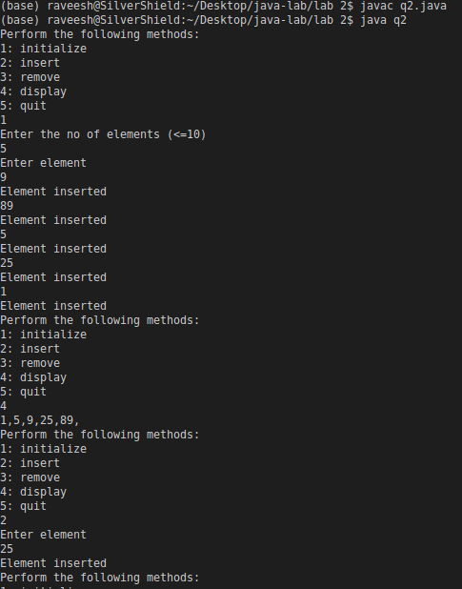**OUTPUT**

