**PROGRAM 1**

Using the command line input arguments obtain 4 floating point numbers e.g. 3.141593.

* Arrange them in ascending order (hint: use the compare() method of the Float class).
* Print the numbers, correct to 2 decimal places (hint: use the format() method of PrintStream class).
* Print the total of the 4 numbers, correct to 2 decimal places (hint: instead of the '+' operator, use the sum() method of Float class)

**SOURCE CODE**

import java.io.*;

import java.util.*;

public class q1

{

public static void main(String[] args)

{

float arr[]=new float[4];

arr[0] = Float.parseFloat(args[0]);

arr[1] = Float.parseFloat(args[1]);

arr[2] = Float.parseFloat(args[2]);

arr[3] = Float.parseFloat(args[3]);

int n=4;

float temp;

for(int i=0; i < n-1; i++){

for(int j=0; j < (n-i-1); j++){

if(Float.compare(arr[j+1], arr[j])>0){

//swap elements

temp = arr[j+1];

arr[j+1] = arr[j];

arr[j] = temp;

}

}

}

for(int i=0;i<n;i++)

System.out.print(String.format("%.2f", arr[i])+" , ");

System.out.println();

float sum = 0;

for(int i=0;i<n;i+=2)

sum+= Float.sum(arr[i],arr[i+1]);

System.out.println("sum: "+String.format("%.2f", sum));

System.out.println();

}

}

**OUTPUT**

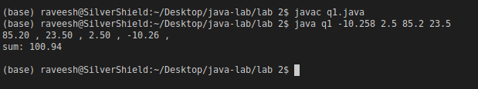

**PROGRAM 2**

The following methods work on an array which can be used to store up to 11 integers. From the second element to the last element of the array, they are used to store the integer data. The first element of the array is used to store the number of integer data that are stored in the array.

Write the code for the following methods and then a main() method to test them. In the main() method, a menu that can support the following methods should be given: (1) initialize; (2) insert; (3) remove; (4) display; (5) quit. Then, the user selects an option from the menu. After the user has selected an option, the corresponding method will then be executed. If option (5) is not selected, then the menu will be repeated, and the user can select another option for execution.

**SOURCE CODE**

import java.util.*;

public class q2

{

public static int[ ] arr = new int[11];

public static void main(String[] args)

{

int choice;

Scanner sc=new Scanner(System.in);

do {

System.out.println("Perform the following methods:");

System.out.println("1: initialize");

System.out.println("2: insert");

System.out.println("3: remove");

System.out.println("4: display");

System.out.println("5: quit");

// read user input

choice = sc.nextInt();

switch (choice)

{

case 1: initialize();

break;

case 2: System.out.println("Enter element");

int ele=sc.nextInt();

if(insert(ele,arr[0]+1)==1)

arr[0]++;

break;

case 3: System.out.println("Enter position of the element to be removed");

int p=sc.nextInt();

remove(p);

break;

case 4: display();

break;

case 5: System.out.println("Terminating program");

break;

default: System.out.println("Invalid choice retry");

}

} while(choice != 5);

}

public static void initialize(){

Scanner sc=new Scanner(System.in);

System.out.println("Enter the no of elements (<=10)");

arr[0]=sc.nextInt();

while(arr[0]>10){

System.out.println("Re-Enter the no of elements (<=10)");

arr[0]=sc.nextInt();

}

System.out.println("Enter element");

for(int i=1;i<=arr[0];i++){

int el=sc.nextInt();

if(insert(el,i)==0)

break;

}

int temp;

for(int i=1;i<=arr[0]-1;i++)

{

for(int j=1;j<=arr[0]-i;j++)

{

if(arr[j]>arr[j+1])

{

temp=arr[j+1];

arr[j+1]=arr[j];

arr[j]=temp;

}

}

}

}

public static int insert(int ele, int p){

if(p>10){

System.out.println("Array is full");

return 0;

}

else{

arr[p]=ele;

System.out.println("Element inserted");

return 1;

}

}

public static void remove(int p){

if(arr.length==0)

System.out.println("Array is empty");

else{

for(int i=p;i<arr[0];i++)

arr[i]=arr[i+1];

arr[0]--;

System.out.println("Successfully deleted");

}

}

public static void display(){

for(int i=1;i<=arr[0];i++){

System.out.print(arr[i]+",");

}

System.out.println();

}

}

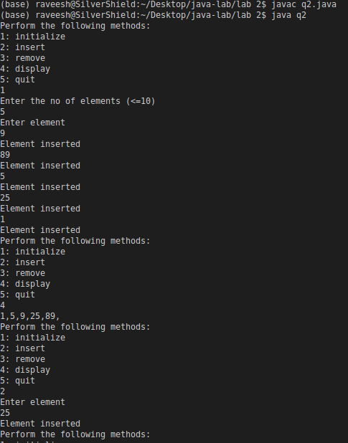**OUTPUT**

