**Phase5 process:**

Running Spring Boot Application:

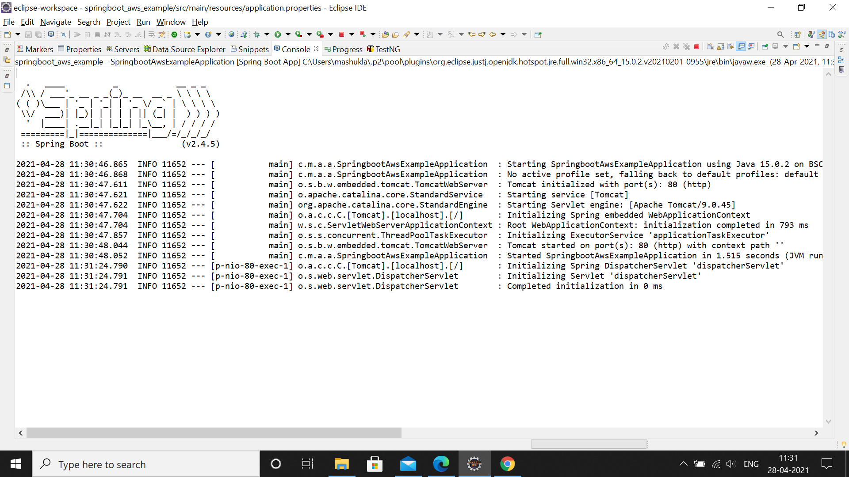

OUTPUT at localhost:

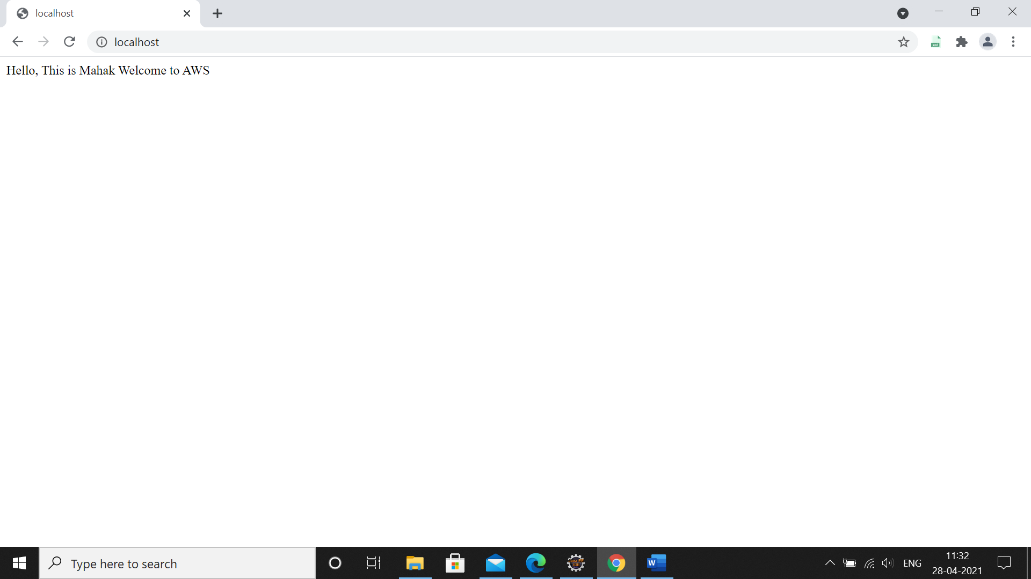

Creating Jar file by adding finalName tag in build part of pom.xml:

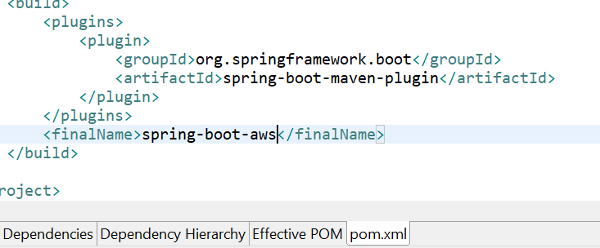

Then update Maven Project and run mvn clean install to create Jar file of project:

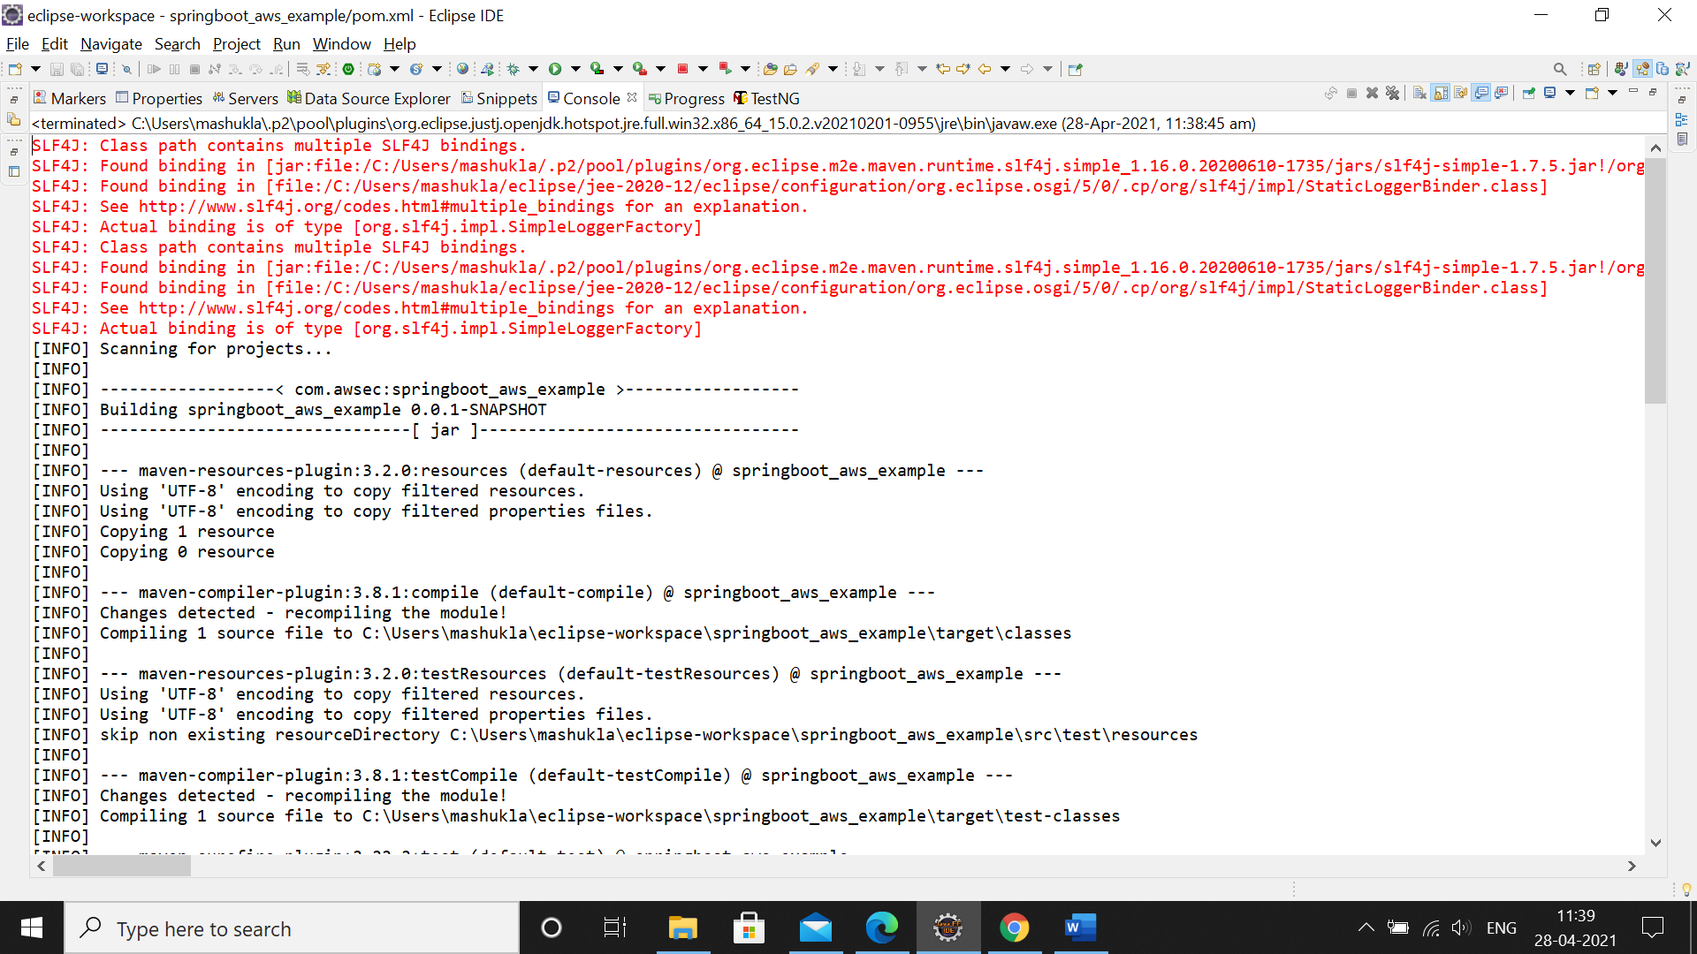

We can try this in cmd also:

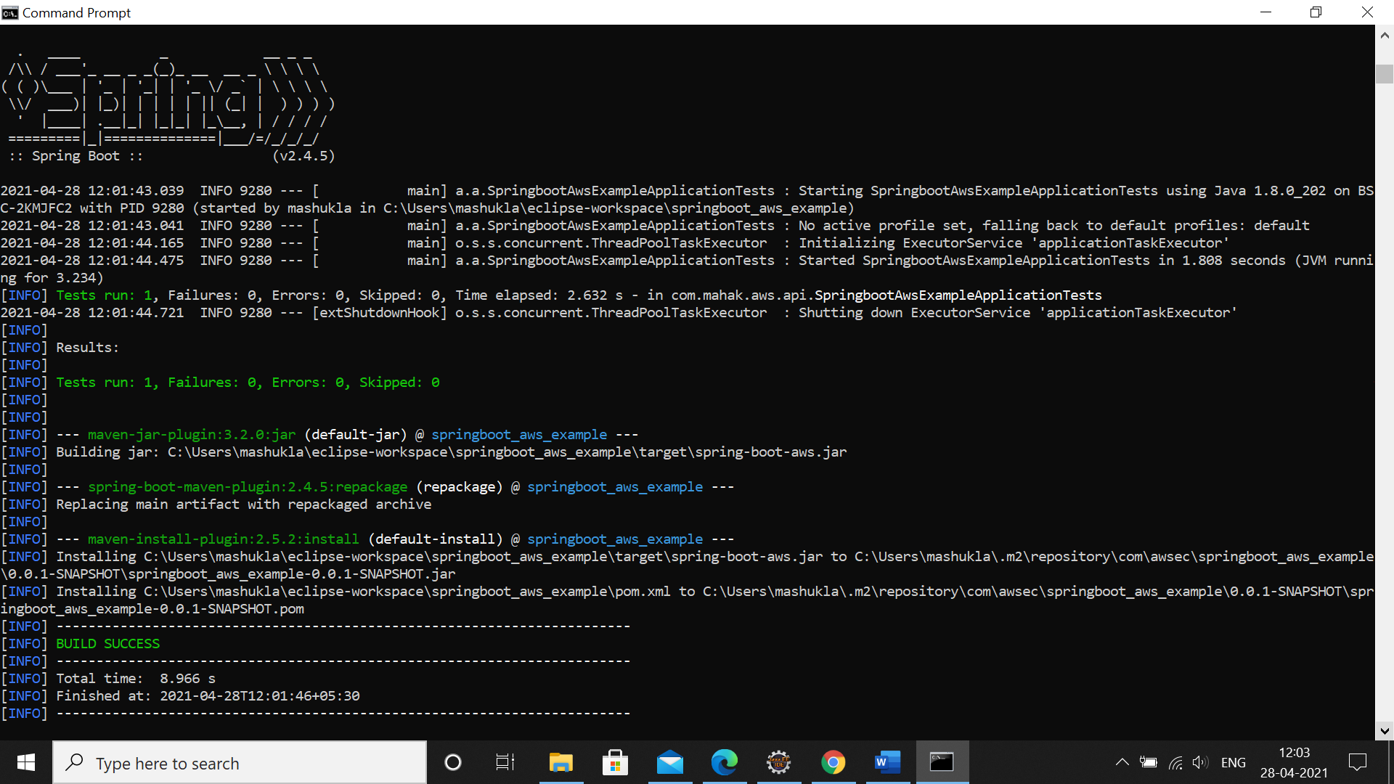

In eclipse we get jar files created:

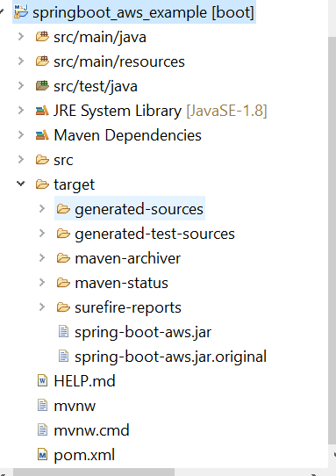

Login to AWS Account:

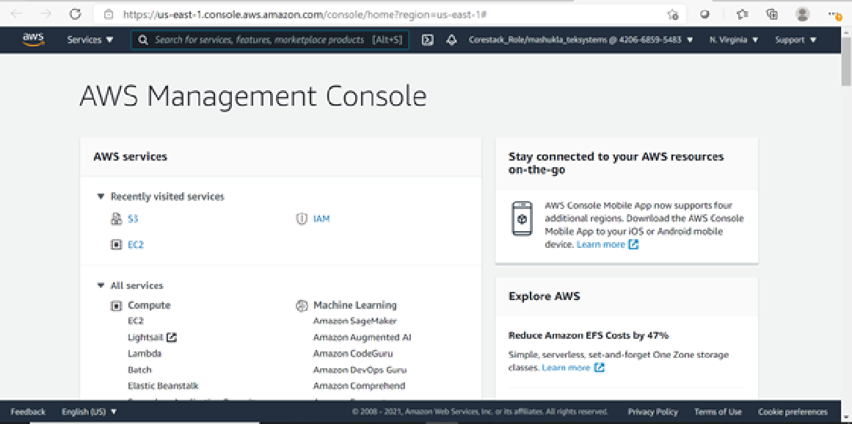

Create an instance:

* Choose EC2 as service
* We will select AMI as Amazon Linux AMI

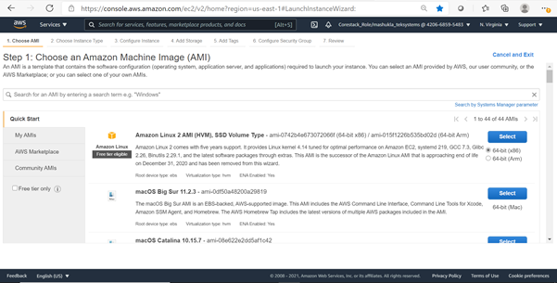

* Launch Instance and download key-pair(we can see at left corner in screen shot)

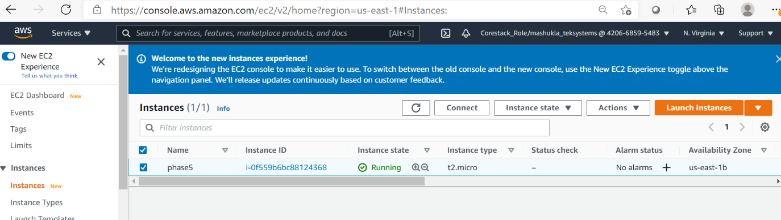

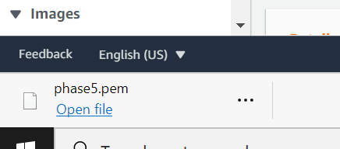

Use Puttygen to create a private key:

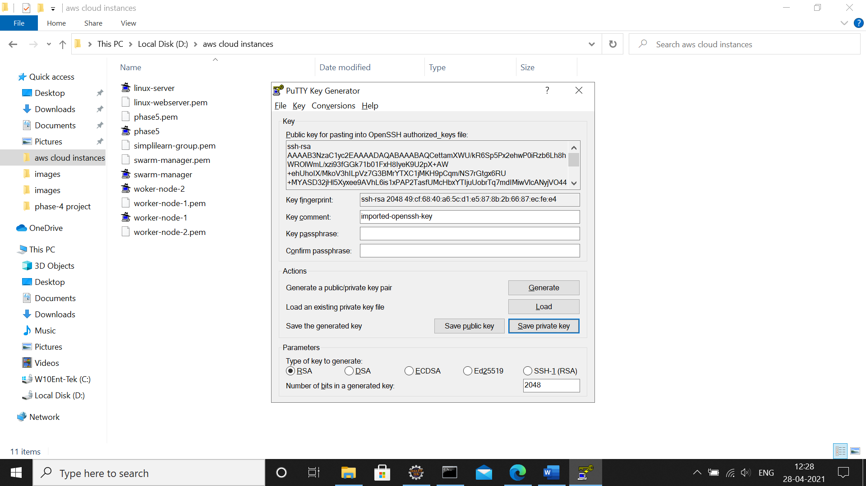

Launch Putty phase5:

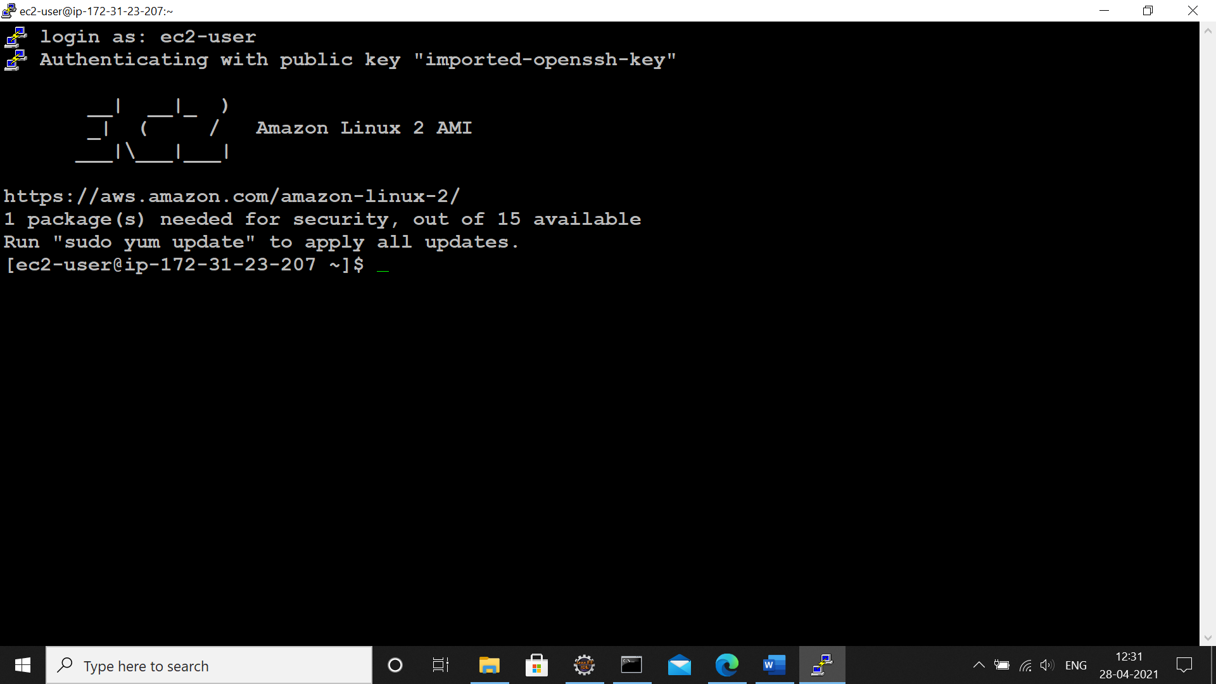

Install jdk 1.8 in Amazon Linux AMI:

First to go to root: sudo su

Installing java: yum install java-1.8.0-openjdk

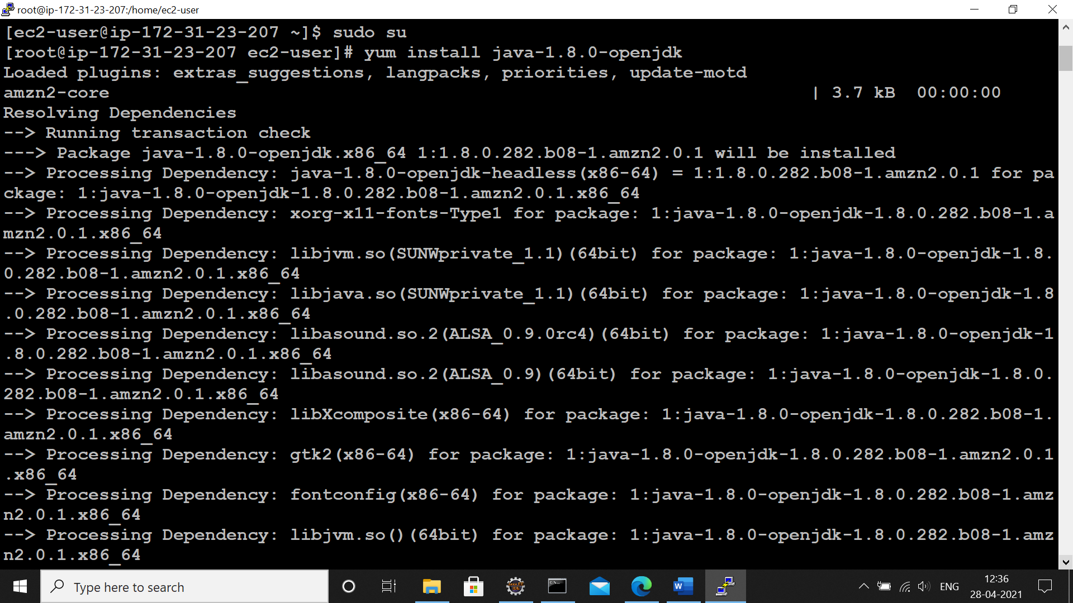

Create an S3 Bucket in AWS to add the JAR file and make that file public:

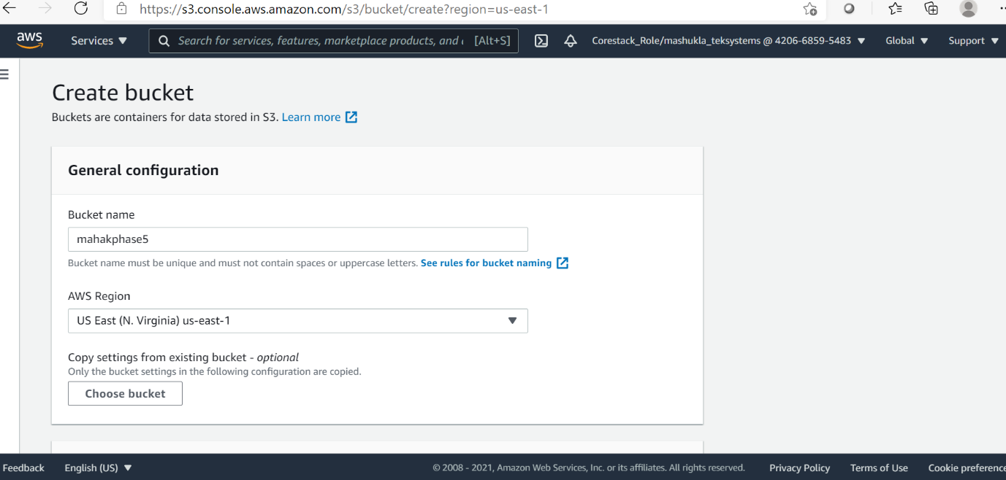

Upload jar file:

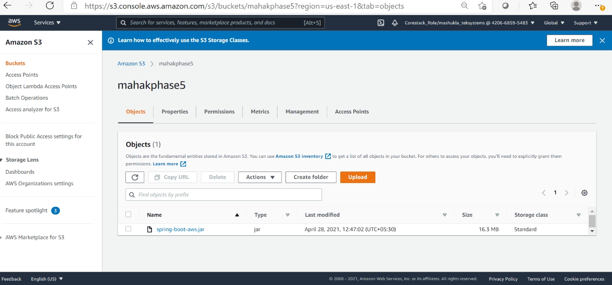

Copy Object URL and make it public:

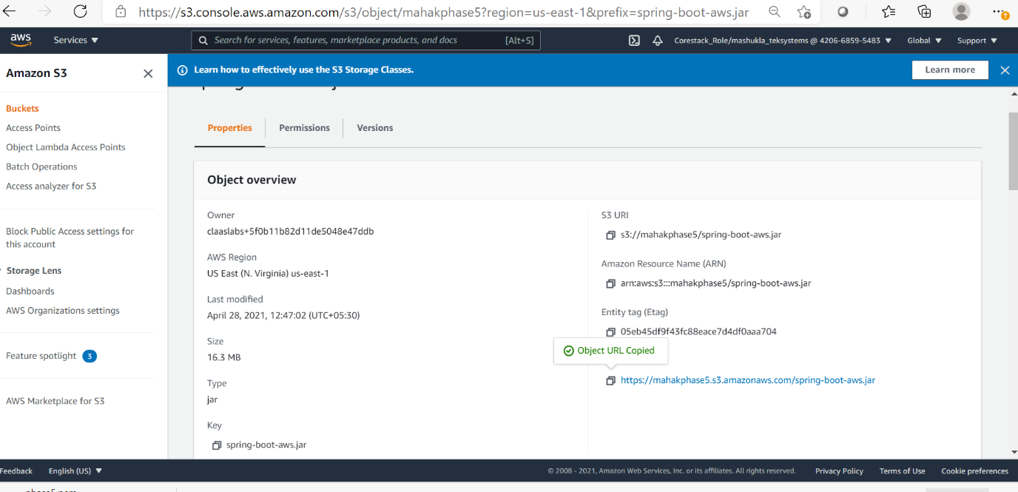

Add the JAR file in the created amazon linux instance using the link copied from S3 Bucket:

Enter root: sudo su

Command to add jar in this instance is:

wget <https://mahakphase5.s3.amazonaws.com/spring-boot-aws.jar>

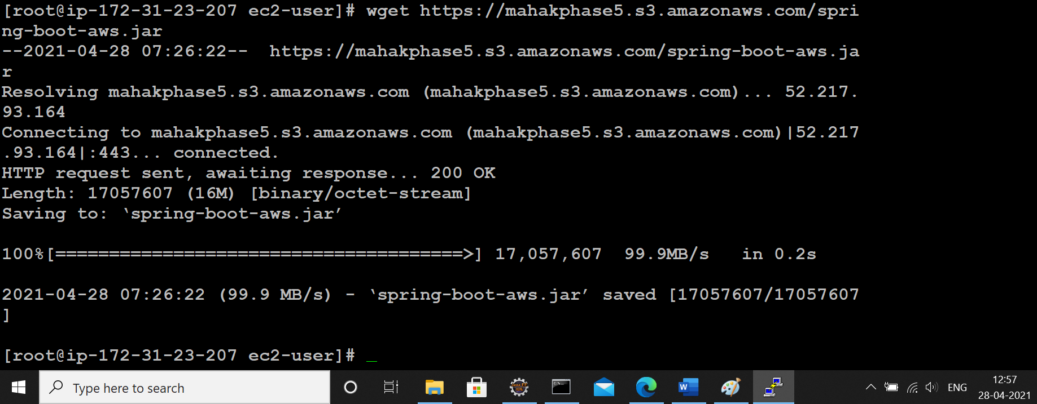

Run the JAR file using the command java -jar JARname.jar:

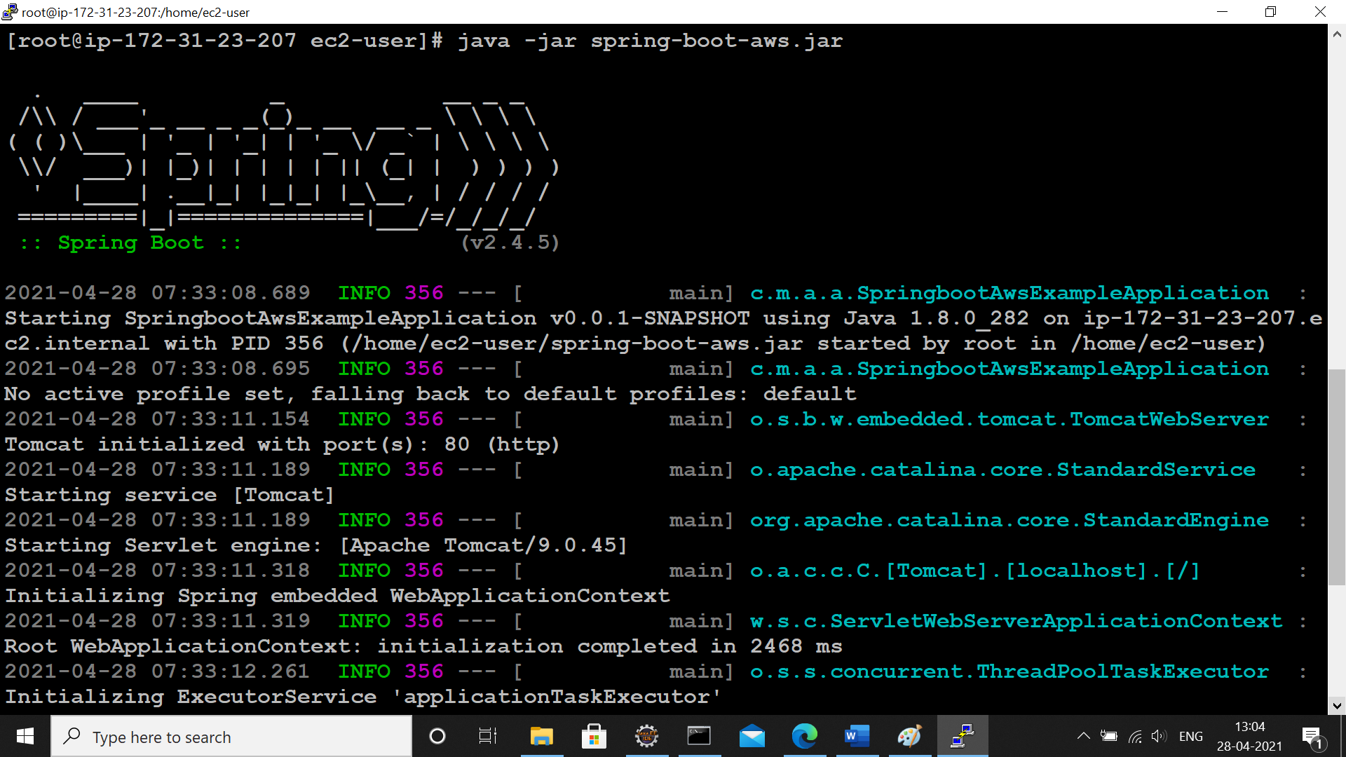

Copy the Public DNS from the instance created:

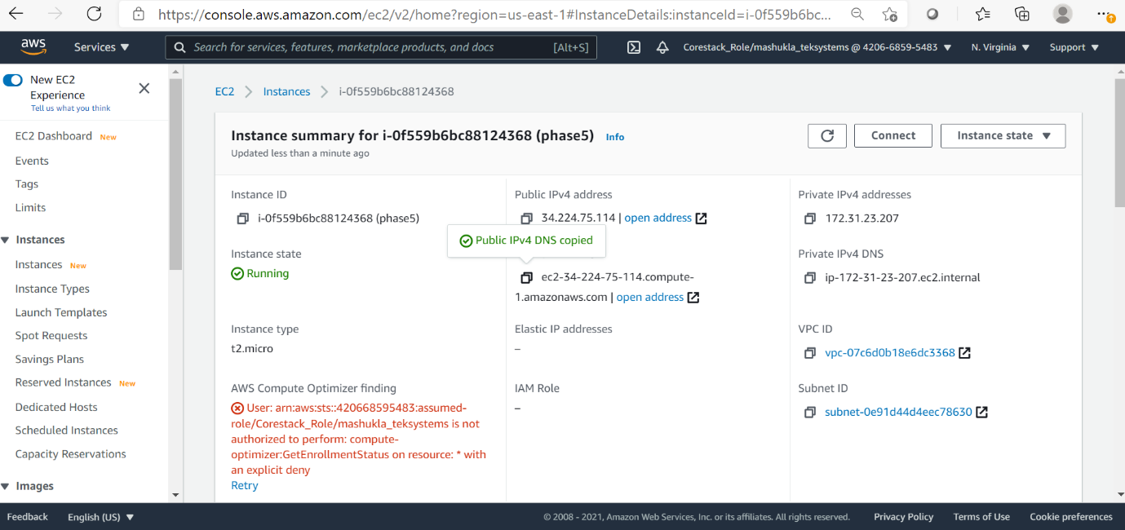

When u run this Public dns OUTPUT would be:

