HR Analytics Dashboard Report
Workforce & Talent Intelligence Analysis
1. Introduction
This HR Analytics Dashboard provides a comprehensive analysis of workforce structure, diversity, hiring trends, talent distribution, and tenure metrics. The dashboard was developed using Excel to transform raw HR data into actionable business insights for strategic decision-making.
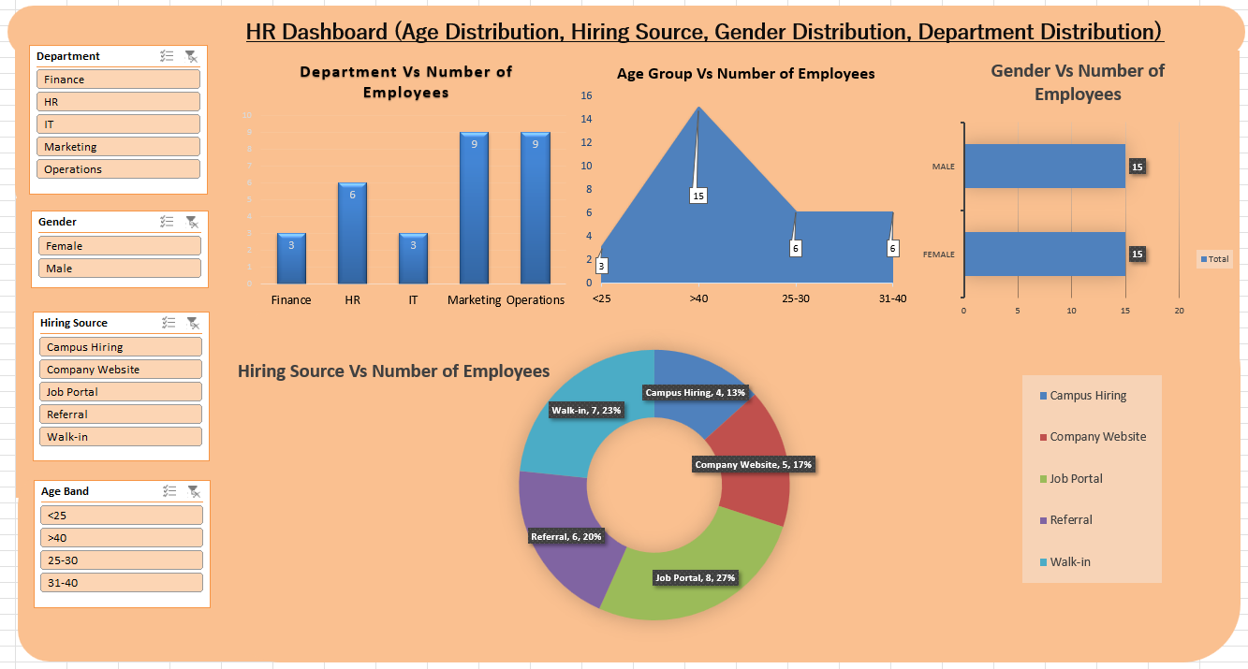

2. Workforce Structure Analysis
Total Headcount
The organization’s total active employee count provides an overview of workforce size and organizational scale.
Department-wise Headcount
Analysis of employees across departments helps evaluate resource allocation and functional workforce distribution.
Location-wise Headcount
Regional distribution highlights geographic workforce concentration and operational spread.
Age Band Distribution
The workforce is categorized into age groups to understand the balance between young professionals and experienced employees.

3. Diversity & Inclusion Metrics
Gender Ratio (%)
The percentage of female employees indicates the organization’s gender diversity balance.
Gender Mix by Department
Department-level gender distribution identifies diversity gaps and inclusivity patterns.

4. Hiring & Recruitment Analysis
Hiring Source Effectiveness
Tracks recruitment channels such as job portals, referrals, or campus hiring to determine the most effective sourcing strategy.
Average Experience at Joining
Indicates whether the organization hires freshers or experienced professionals.
Average Age at Joining
Helps evaluate hiring strategy orientation.
Hiring Trend (Year-wise)
Identifies growth or slowdown patterns in recruitment over time.

5. Experience & Talent Metrics
Average Experience
Measures workforce maturity.
Experience Band Distribution
Classifies employees into experience groups (0–2, 2–5, 5–10, 10+ years) to assess succession readiness.
Senior Workforce Ratio (>10 years)
Shows dependency on highly experienced employees.

6. Tenure & Retention Metrics
Average Tenure
Measures employee retention strength.
Long-Tenure Employees (>5 years)
Indicates workforce stability.
Recent Joiners (<1 year)
Reflects hiring growth or replacement trends.

7. Strategic HR Insights
- Talent concentration risk in critical departments
- Hiring source dependency analysis
- Workforce mobility and regional dependency patterns

8. Key Dashboard KPIs
- Total Headcount
- Average Age
- Average Experience
- Percentage of Female Employees
- Top Hiring Source
- Average Tenure

9. Conclusion
The HR Analytics Dashboard provides a data-driven approach to workforce planning, talent management, diversity monitoring, and recruitment strategy evaluation. It enables HR leaders to make informed strategic decisions backed by measurable insights.

