- Write a program with Abstract class with both abstract and concrete method

package javaassign;

abstract class Bus{
//abstract method
public abstract void start();
//concrete method
public void ticket() {
System.out.println("Ticket Price is RS.20");
}
}

public class AbstractClass extends Bus{

public static void main(String[] args) {
AbstractClass as = new AbstractClass();
as.start();
as.ticket();

}
//Method overriding polymorphsim
@Override
public void start() {
System.out.println("Bus is Starting");
}

}
Output:
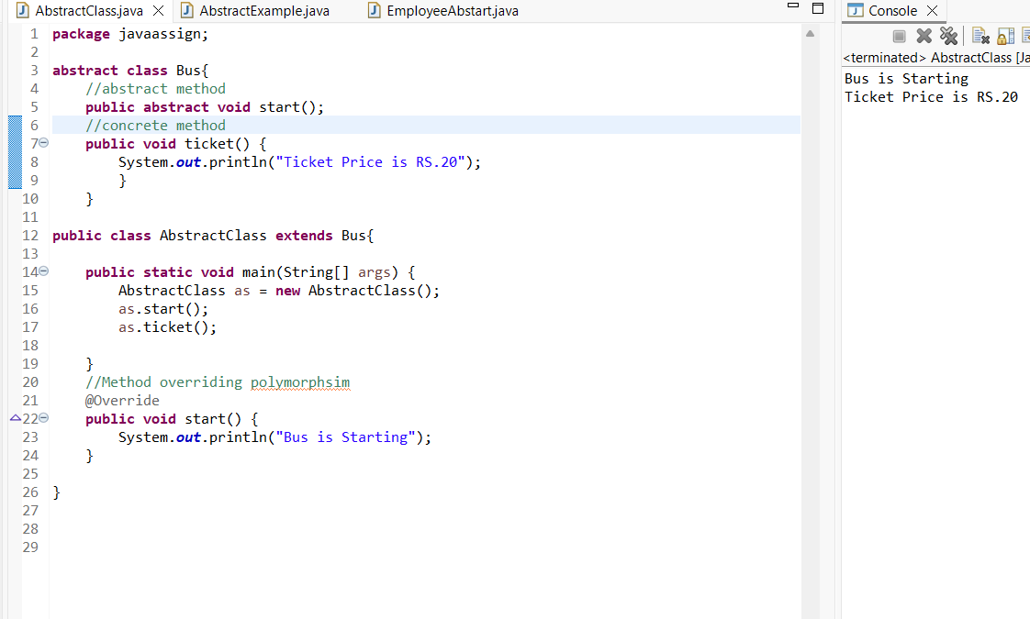

2.Write a program with Interface (Employee) which should have abstract method performTask,getSalary and implement the same in subclass (Manager).
- Employee: performTask(), getSalary()
- Manager: assignTask() [Manager class own method]

interface Employee {

void performTask();

void getSalary();
}
class Manager implements Employee {

@Override
public void performTask() {
System.out.println("Manager is managing the team.");
}
@Override
public void getSalary() {
System.out.println("Manager salary is Rs. 80,000.");
}
// Manager's own method
public void assignTask() {
System.out.println("Manager assigns tasks to employees.");
}
}

public class EmployeeAbstart {

public static void main(String[] args) {

Manager m = new Manager();

m.performTask();
m.getSalary();
m.assignTask();
}
}

Output:
