**SNS, SQS, CW**

1. SNS SIMPLE NOTIFICATION SERIVCE
2. SQS SIMPLE QUEUE SERVICE
3. CW CLOUD WATCH
4. SES SIMPLE EMAIL SERVICE
5. URL UNIFORM RESOURCE LOCATOR
6. ARN AMAZON RESOURCE NAME

* SQS – Simple queue service (1-1)
* Create a queue

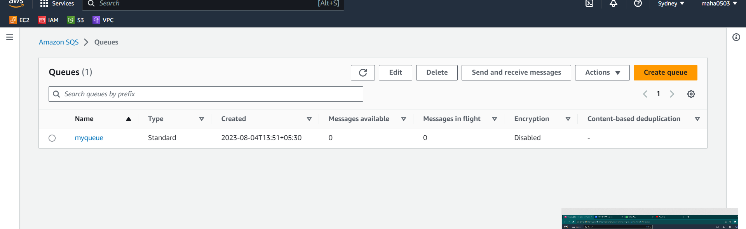

* Click send and receive message and type the body of the message and click send message
* You will receive the message by clicking poll for messages

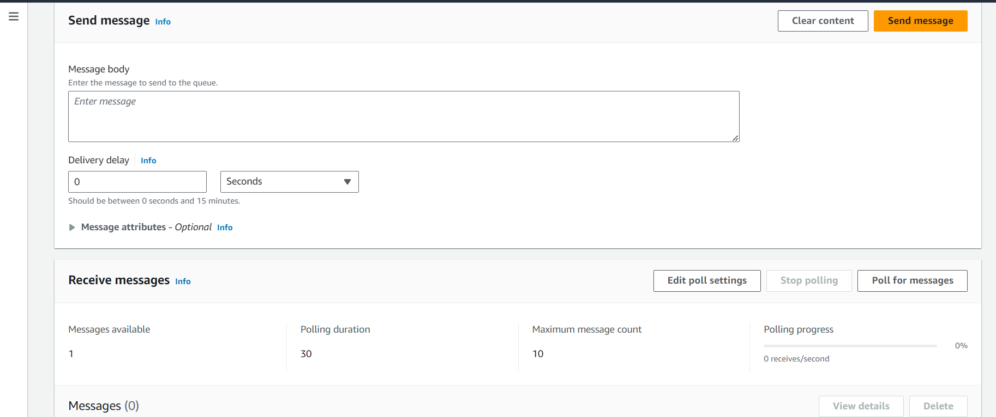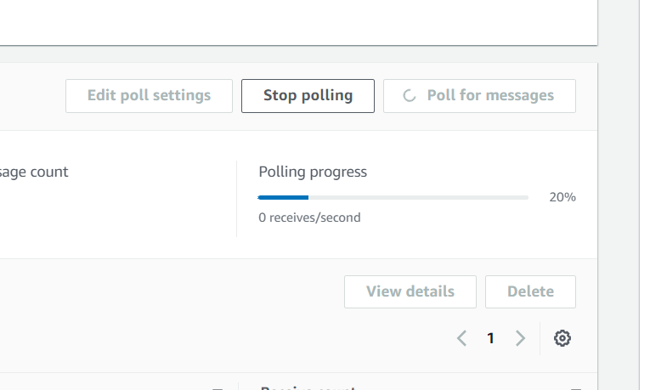

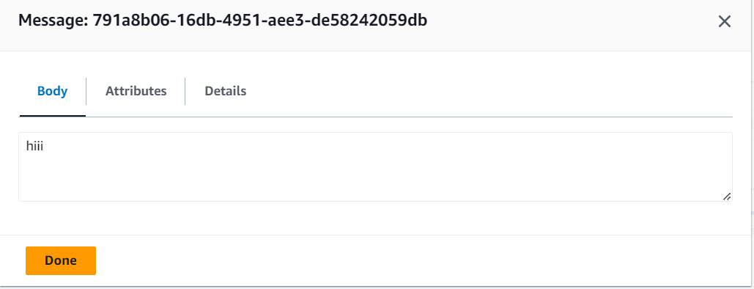

* SNS -Simple notification service (1-M)
* Create a **topic and subscription**

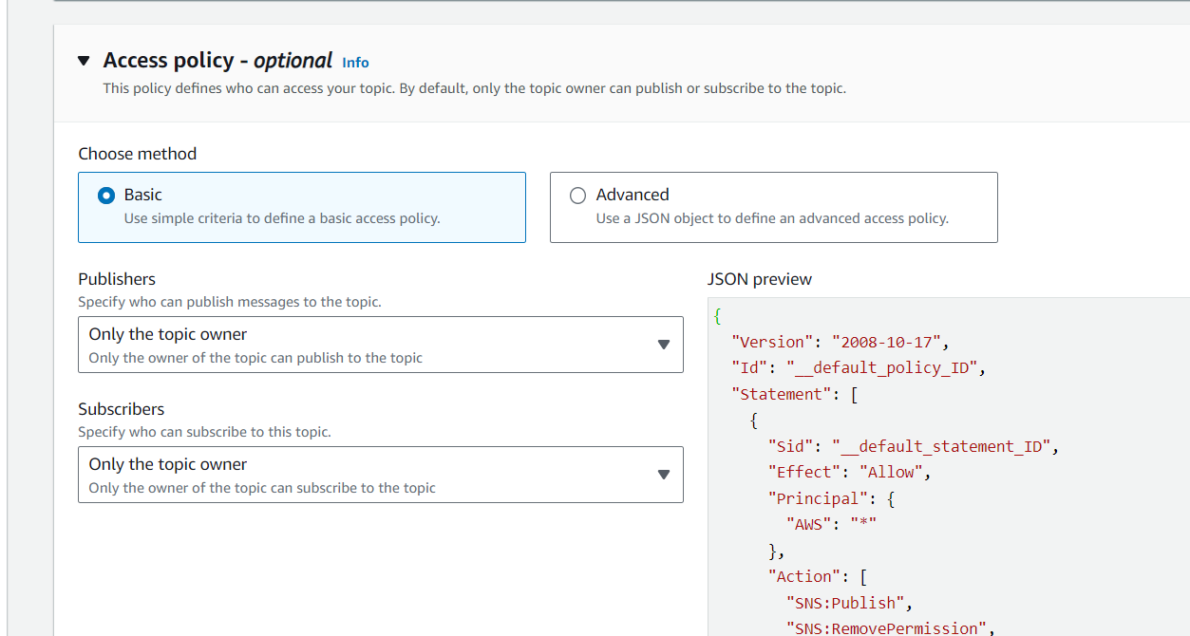

* We’ll use standard type because if we us FIFO then we can choose a protocol as amazon SQS only

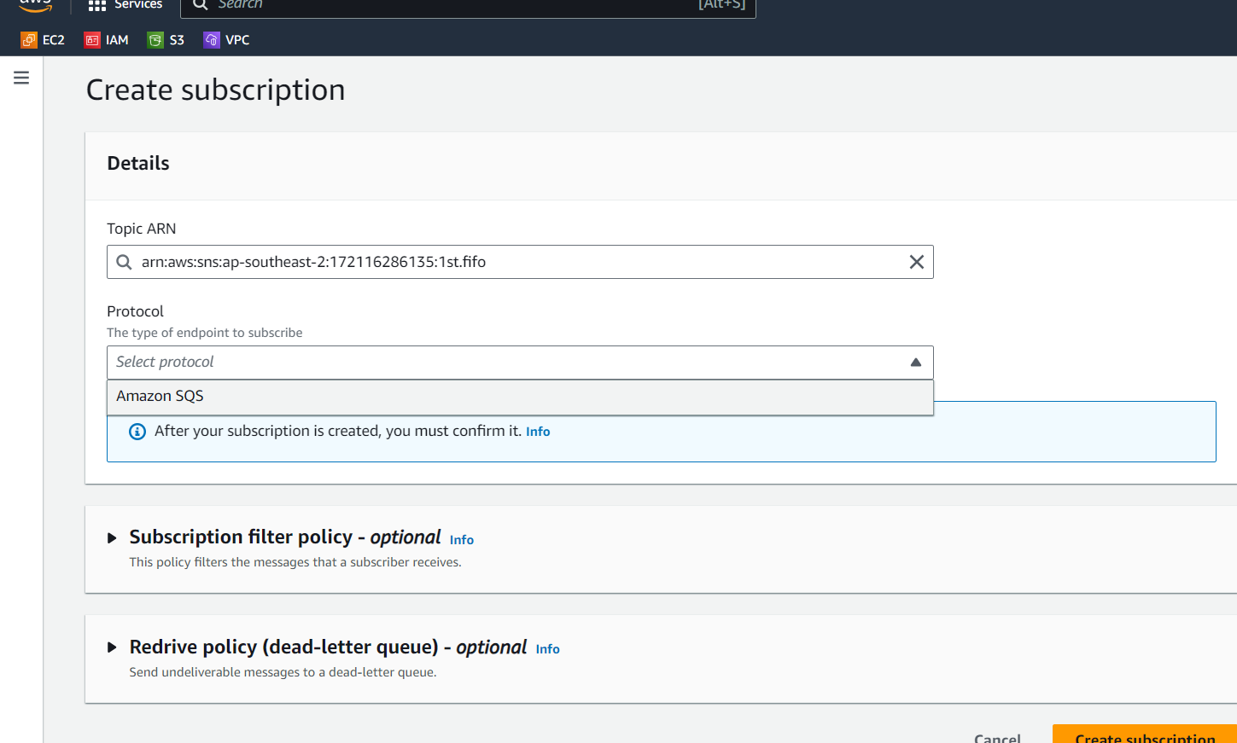

* So create a another topic with standard type

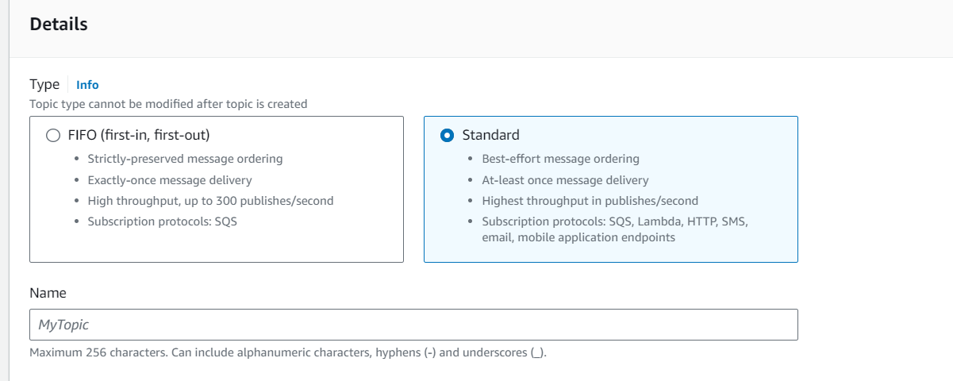

* To confirm the status the subscription person should click the link to accept to send a message.

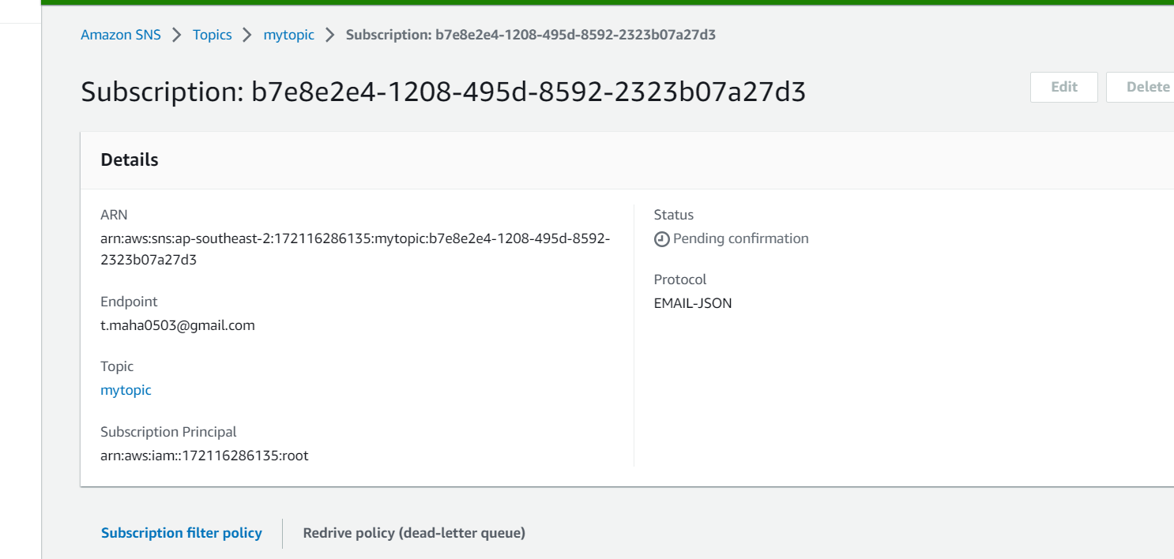

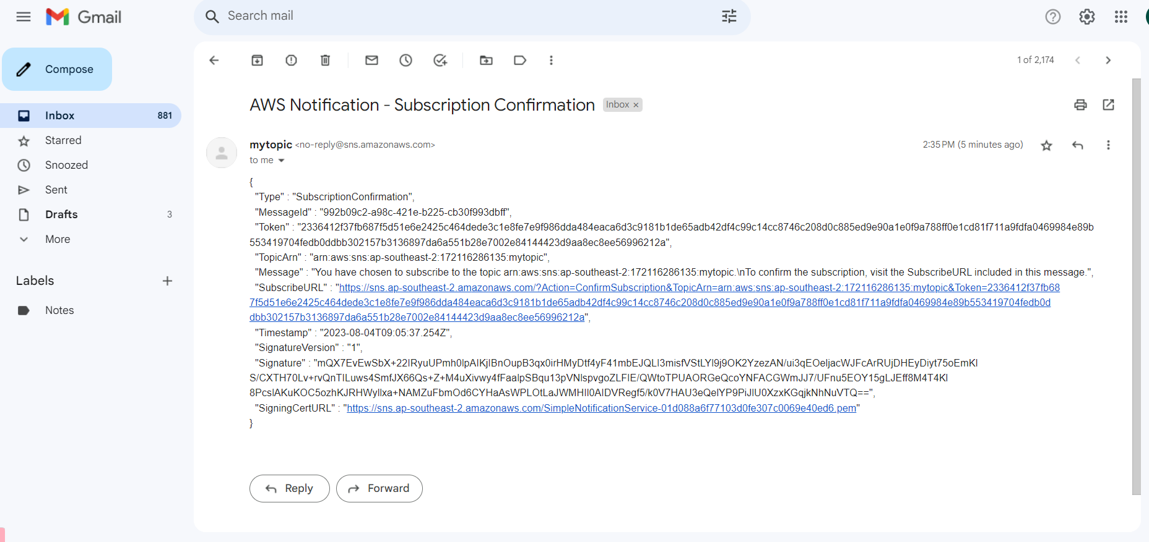

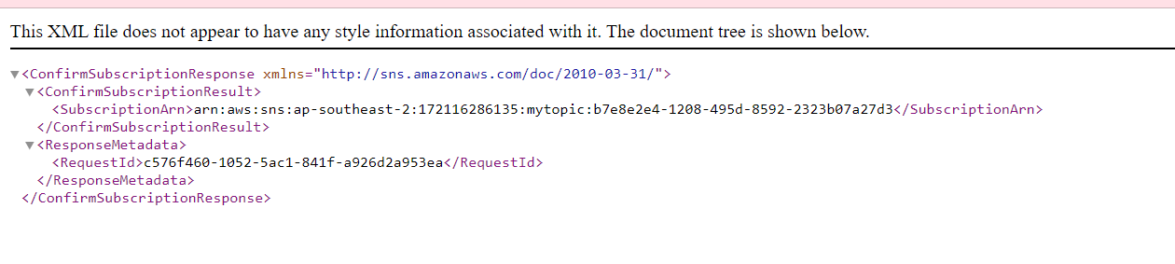

* Now we can send message to the subscriber.

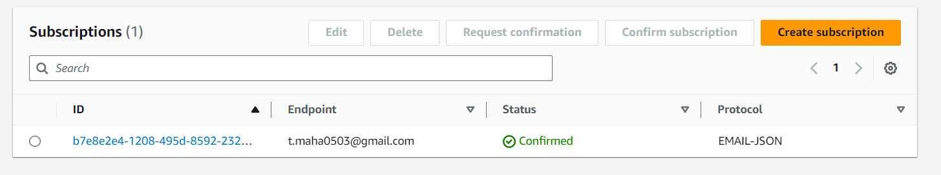

* Now I created a subscribers with a protocol as SMS, SQS and email

1. As we get an confirmation mail for email Jason same for email to we have to confirm through mail
2. Likewise, we will get an OTP verification for SMS protocol to confirm the subscriber.
3. For SQS protocol we can create subscriber through subscription or from queue too.
4. Here I got the four subscribers.

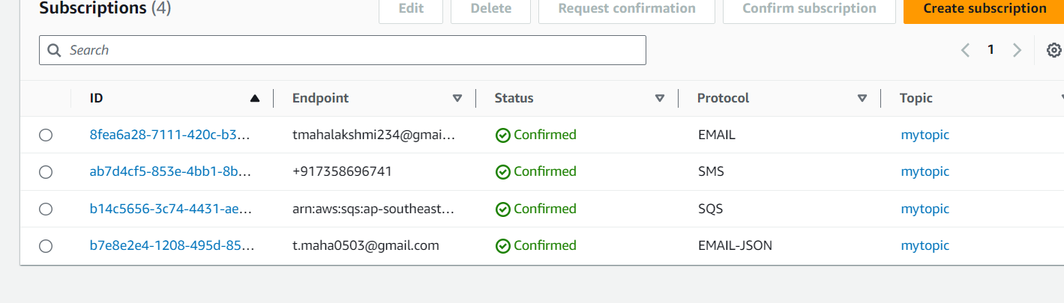

1. Now we can publish message if I publish a message through **my topic** with standard type it will send the message to all the four subscribers.
2. Here is the result.

From: 7358696741

Protocol: SMS

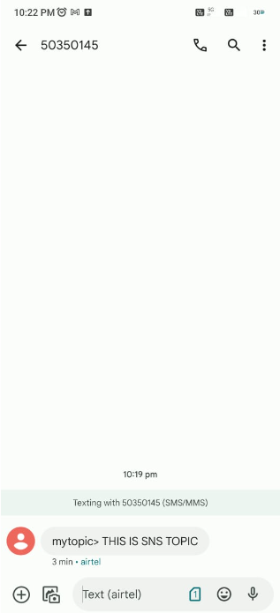

From: [t.maha0503@gmail.com](mailto:t.maha0503@gmail.com)

Protocol: Email jason

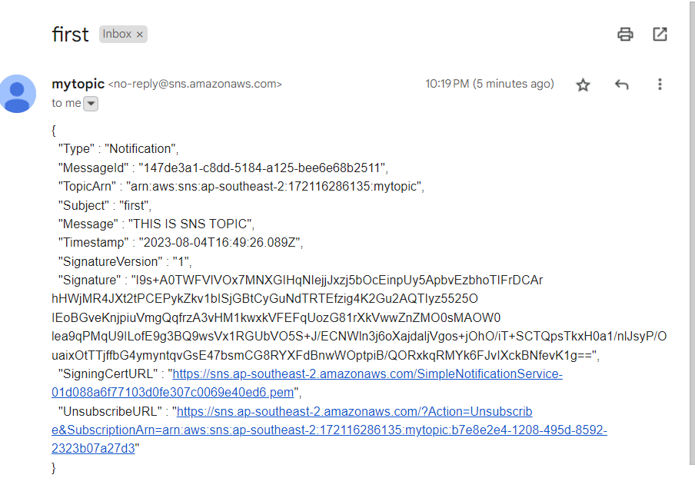

From: my queue

Protocol: SQS

At first I have 1 message but now I got 2 message.

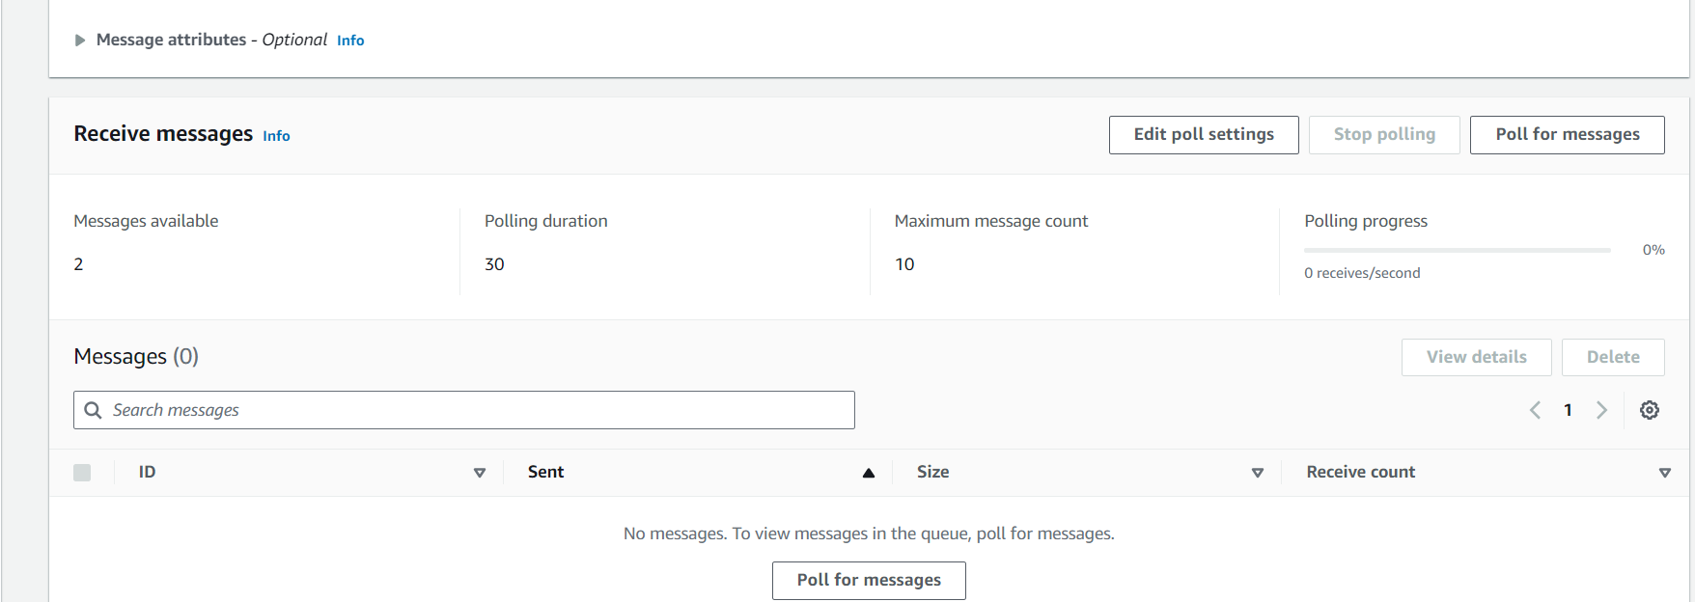

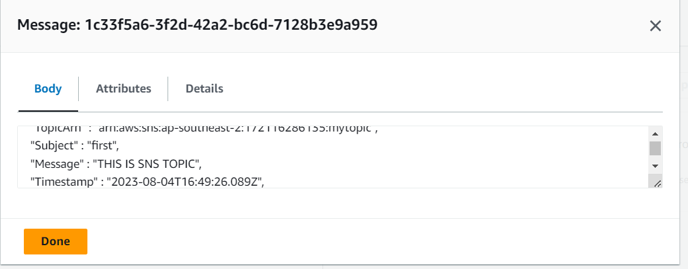

PROJECT:

Whenever the cw server CPU utilization goes below or goes above it will send alarm to subscribers through SNS.

1. Created a ec2 instance in a name of cw.

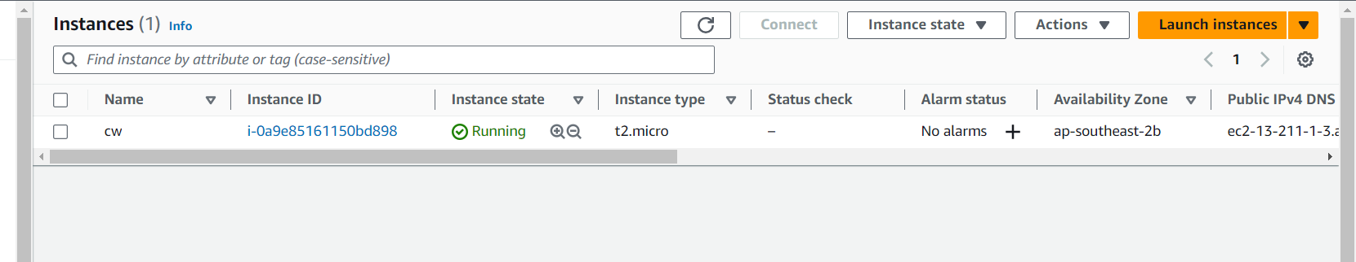

1. Now copy the instance id and paste it in a cloud watch service in metrics and select the specialization as CPU utilization. So it can monitor the CPU utilization and it’ll send an alarm to subscribers.

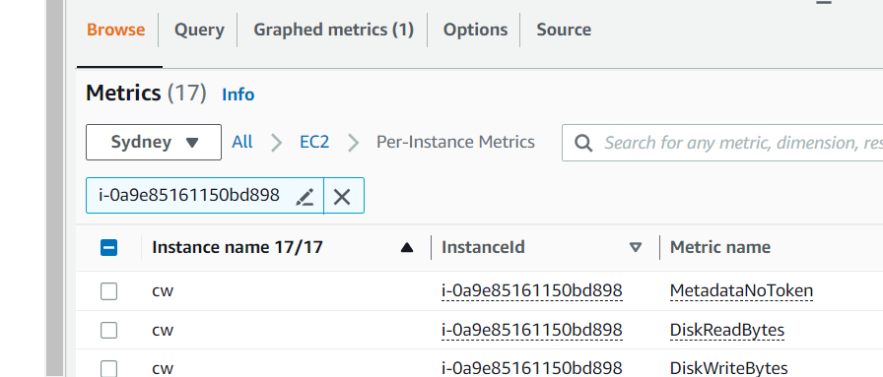

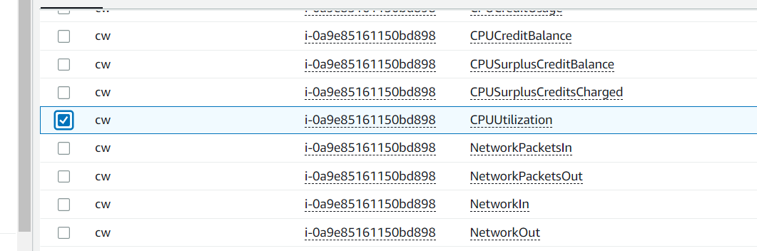

1. After this go to graphed metrics and set the specifications that we want and click the alarm button

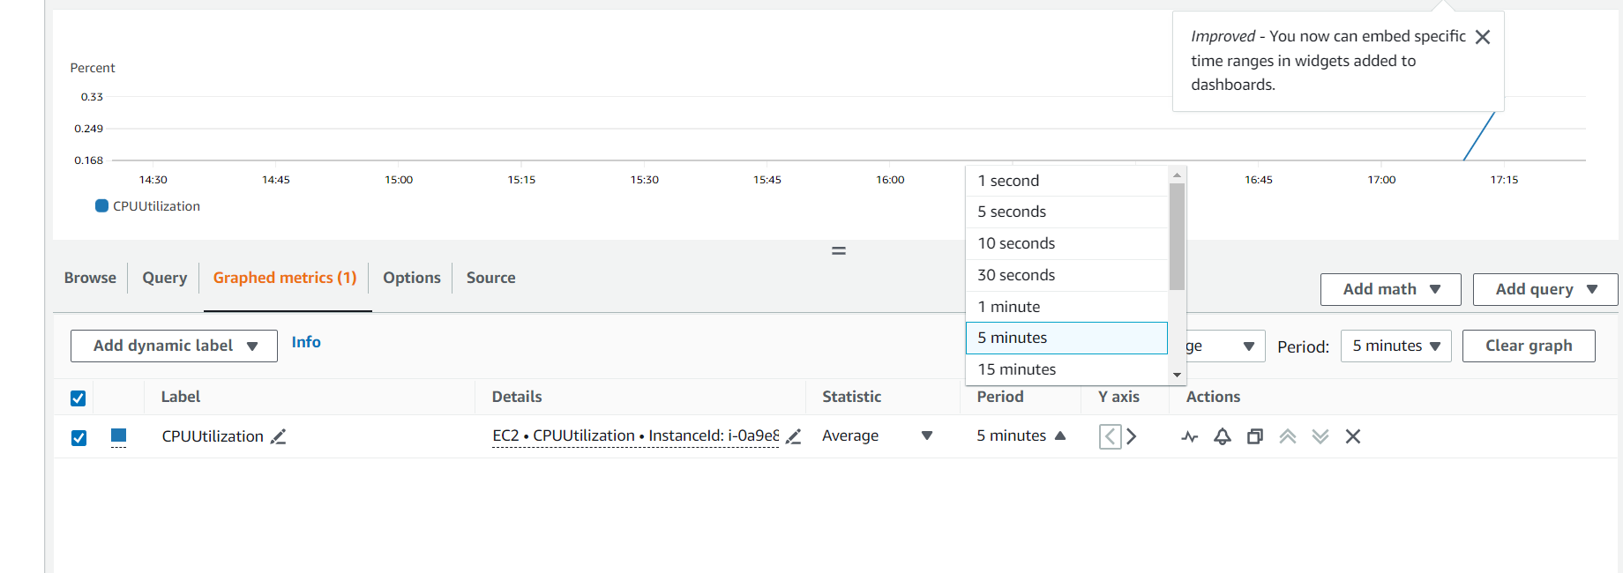

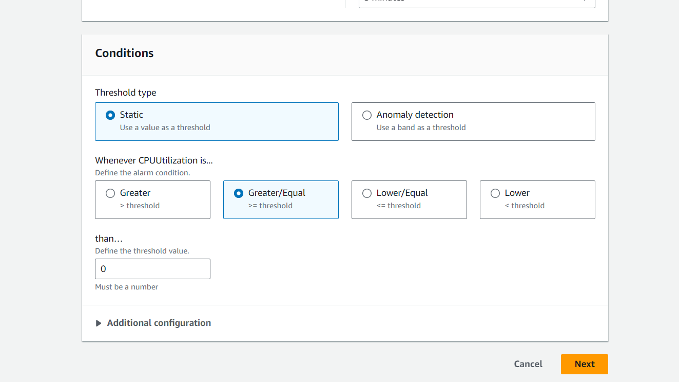

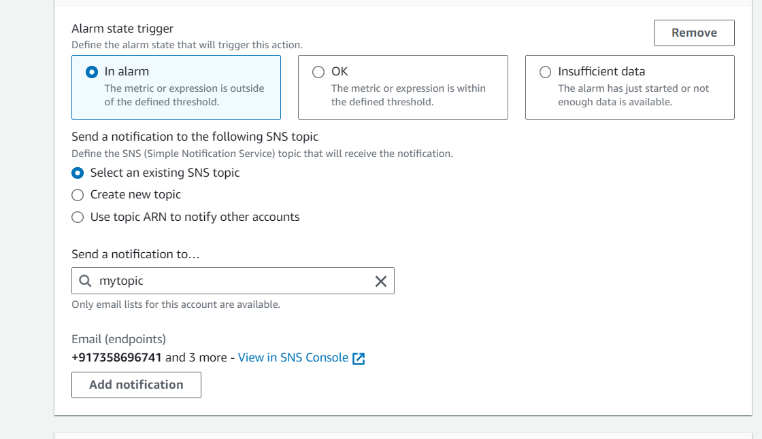

1. So in my alarm notification I’ll get the message that is given in description

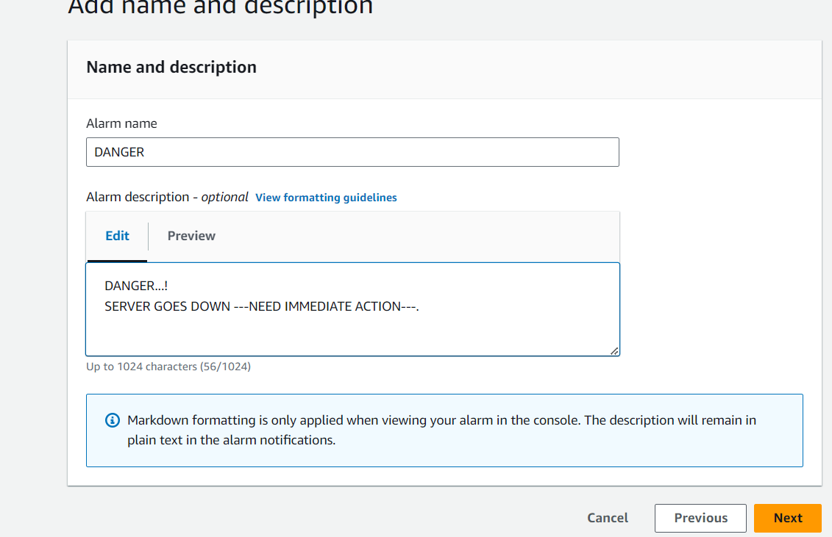

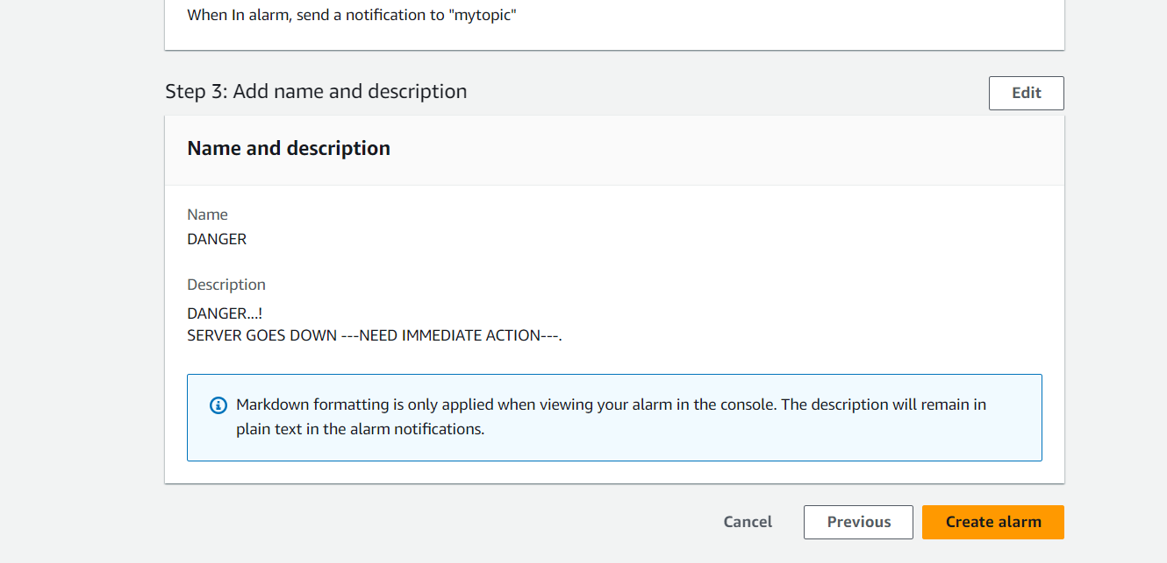

Status:

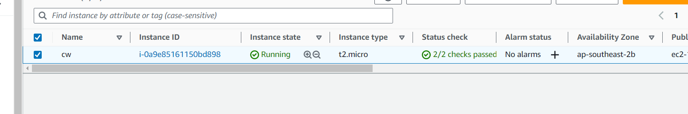

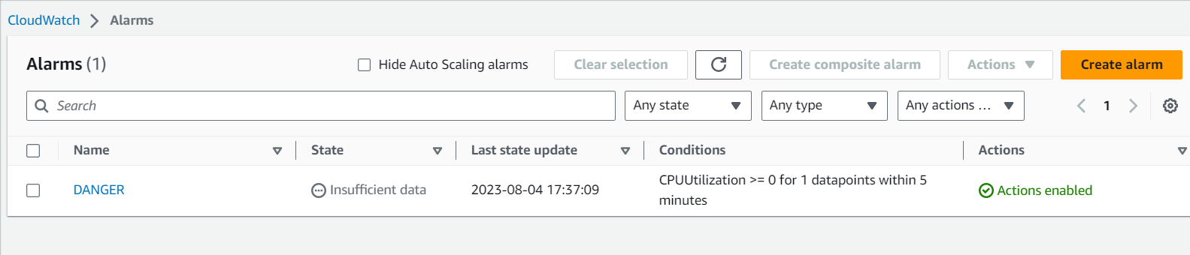

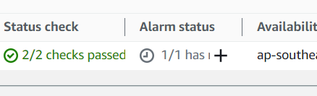

So I got an danger symbol and all the subscribers got the alarm here are the results.

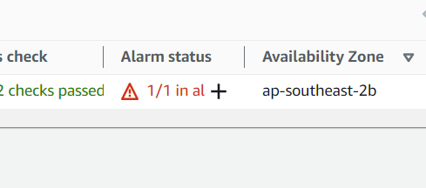

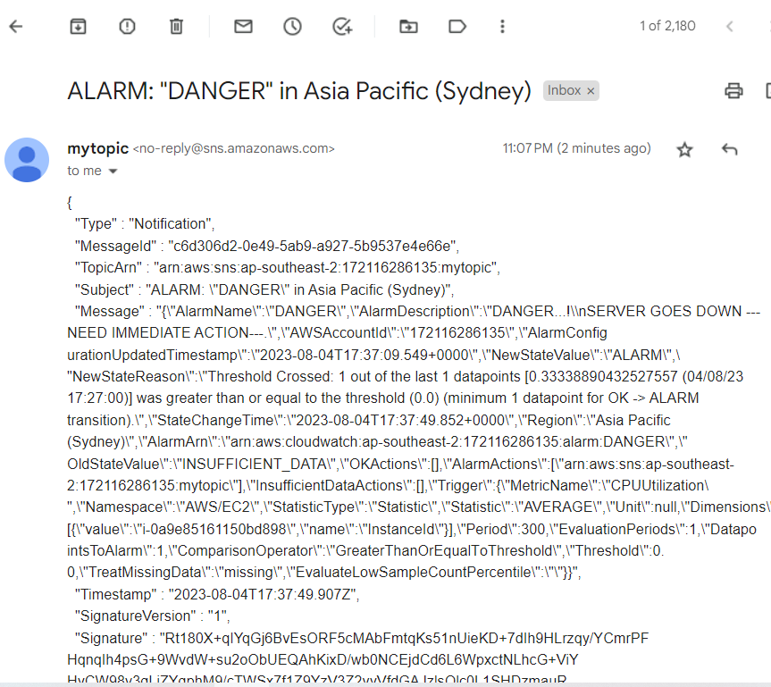

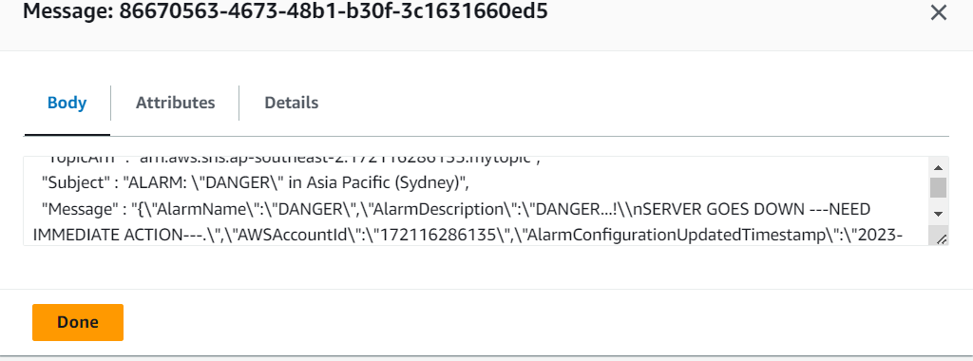

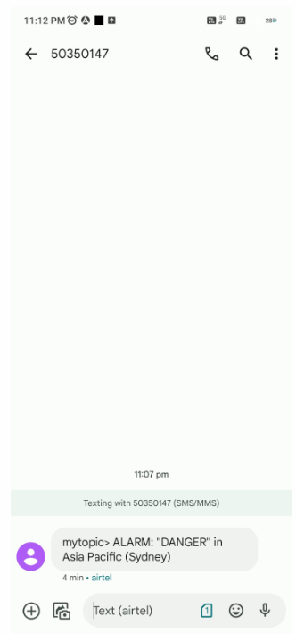

**LOG MONITORING AND SNS NOTIFICATION:**

1. Create a cloud trail
2. Enable create new s3 bucket
3. Enable cloud watch logs
4. Create IAM role
5. Choose event type as management events
6. Create trail

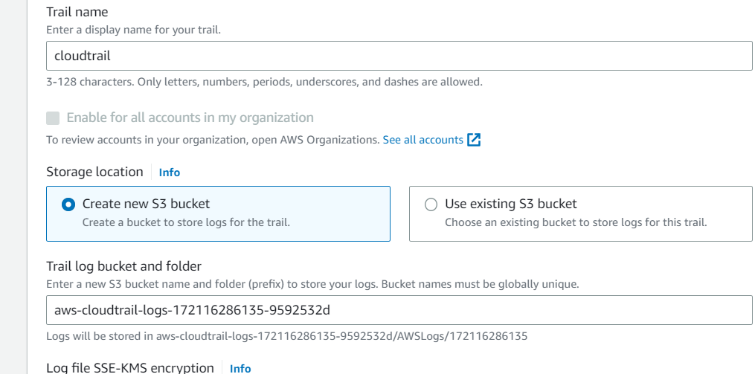

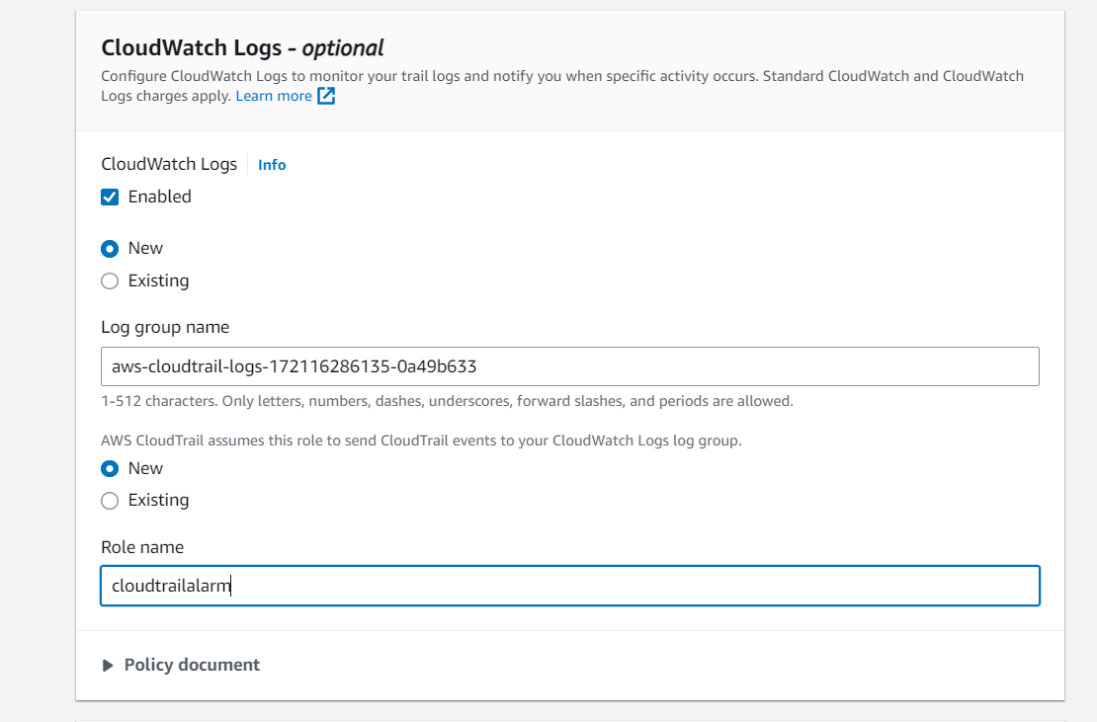

1. Trail, S3, IAM role and a log group created

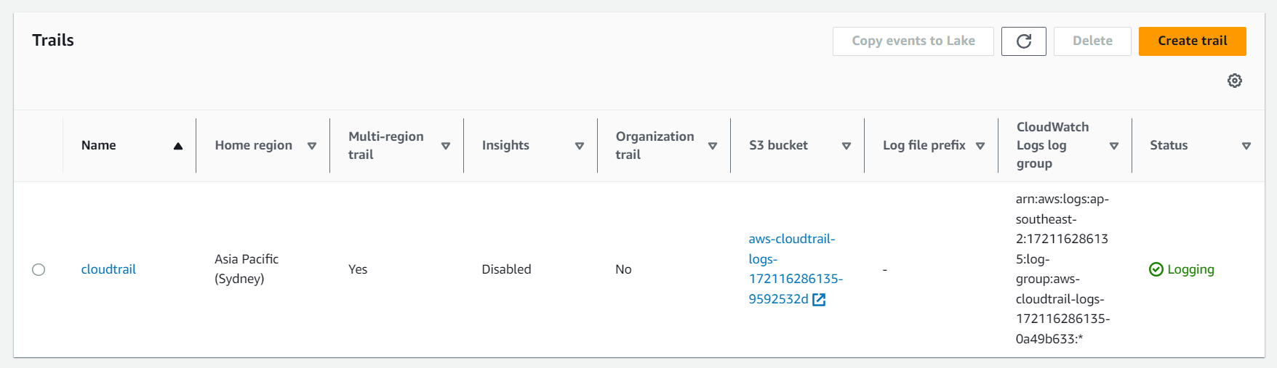

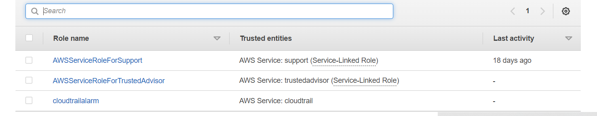

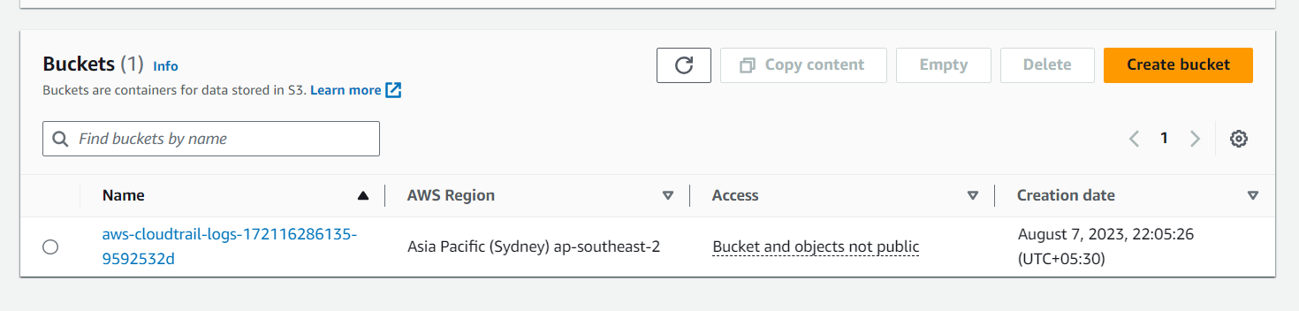

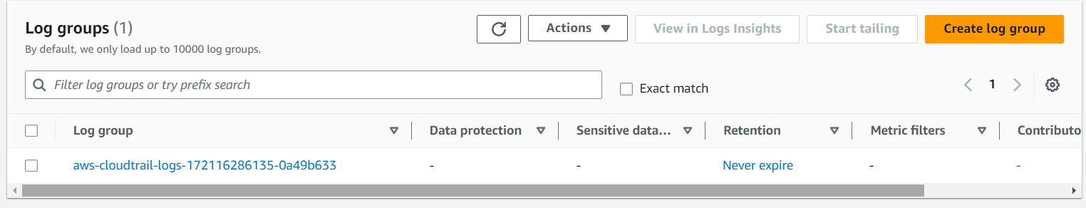

1. Create an alarm and by adding subscribers in SNS will get an alarm notification like this.

