**Phase-1_LockerScreenFileSystem**

**Project Description:**

Need to develop a prototype for the Locker's Company with generic features and three operations:

1. Retrieving the file names in an ascending order
2. Business-level operations:
   * 1. Option to add a user specified file to the application
     2. Option to delete a user specified file from the application
     3. Option to search a user specified file from the application
     4. Navigation option to close the current execution context and return to the main context
3. Option to close the application

**Scrum Planning:**

Scrum Planning document will be shared that includes the screen of JIRA Tools creating Epic,Version,User Stories and Sprints.

**Project GIT Repositories:**

GIT Repository Link: <https://github.com/mahalaxmikc/phase1-LockerFileSystem>

**How to Execute the Project:**

Package Structure :

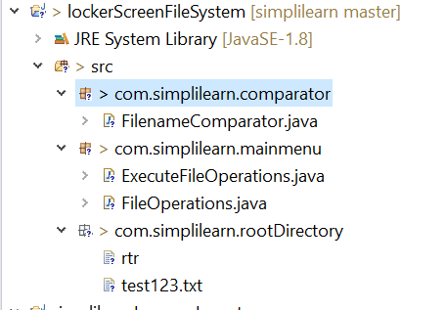

Execution: com>simplilearn>mainmenu> ExecuteFileOperations.java 🡺 SampleOutput.txt (Text File)

Note:

Directory to perform file operations is within the classpath: **com>simplilearn>rootDirectory**