<https://github.com/UnpredictablePrashant/TravelMemory.git>

clone the project in local

git clone <https://github.com/UnpredictablePrashant/TravelMemory.git>

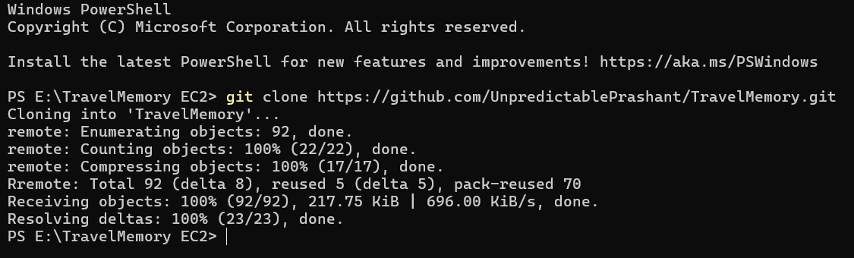

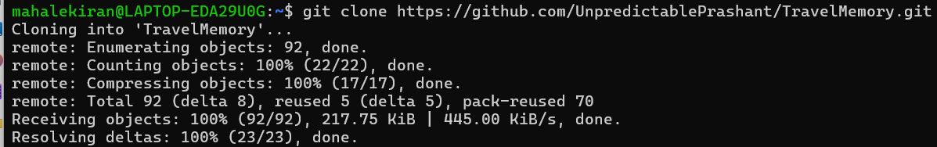

Apt update

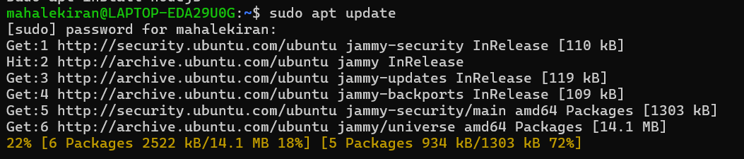

Apt install nodejs

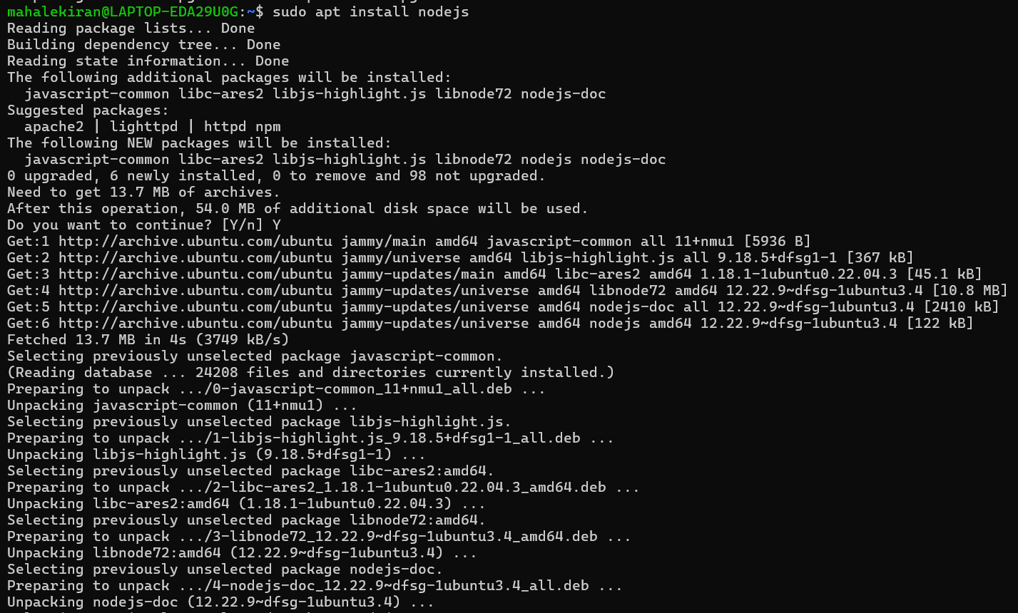

Apt install npm

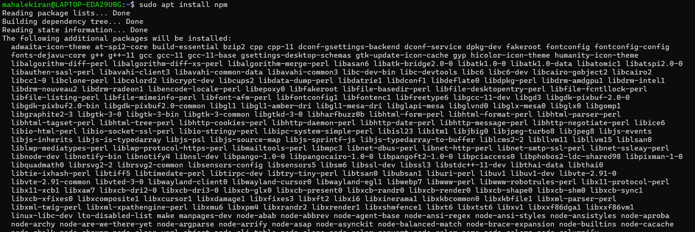

Check versions

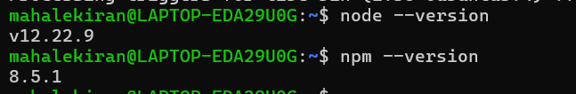

Create .env file and add the below content

MONGO_URI='ENTER_YOUR_URL'

PORT=3000

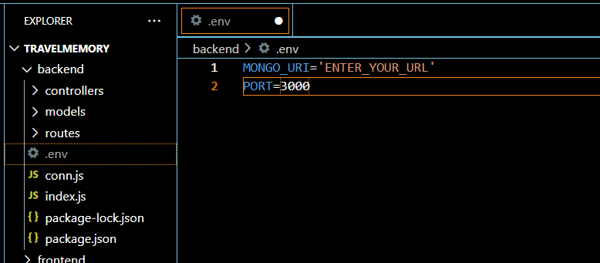

- Set up the backend running on Node.js.

Go to backend folder

