Sheetwright
Team Install Guide
Add Sheetwright to Claude in ~2 minutes — once per computer.

What this is
Sheetwright is a Claude plugin that lets Claude create, edit and format your Google Sheets natively — real colors and currency, native Tables, HYPERLINK formulas to Drive files, and locale awareness. This guide shows how to install it in Claude Cowork (desktop app).
Once per computer. Installing a plugin in Cowork is done through the interface (not with slash commands). Each person installs it once on their own machine — it is saved locally and does not carry over between computers.

Install steps

Step 1 — Open Plugins
In the Claude desktop app, open Settings → Customize → Plugins. Click the "Add" button at the top right.
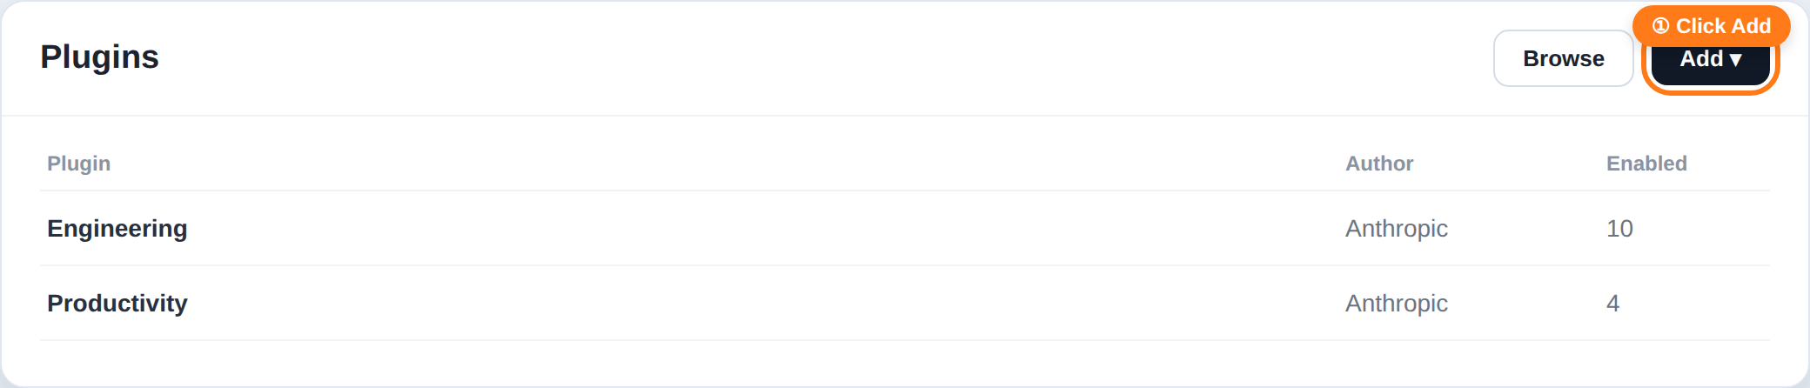

Step 2 — Add marketplace
In the menu that appears, choose "Add marketplace" (not "Upload plugin" or "Create with Claude").
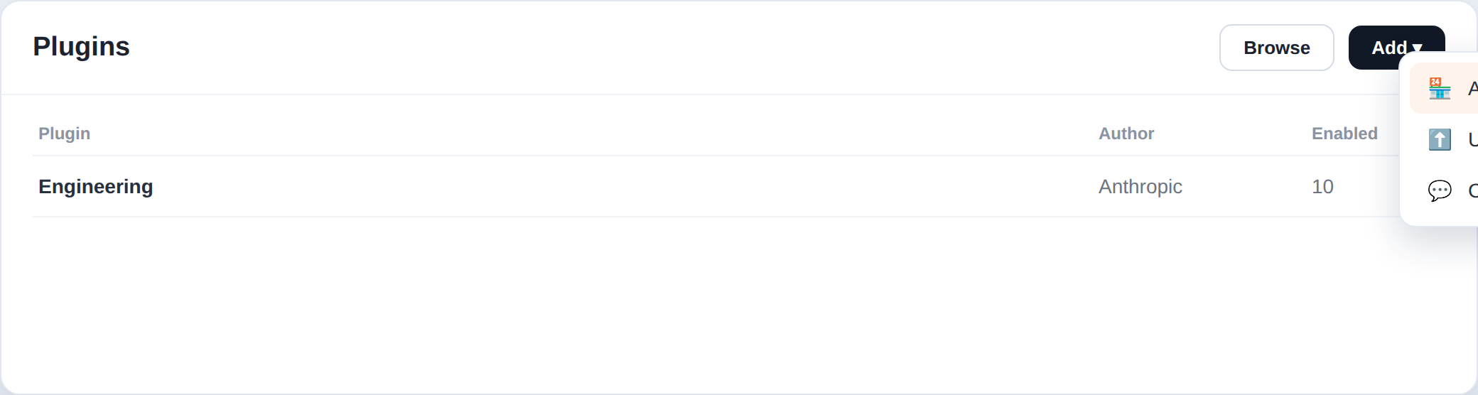

Step 3 — From a repository
Choose "Add from a repository" — this syncs the marketplace straight from GitHub, so you always get updates.
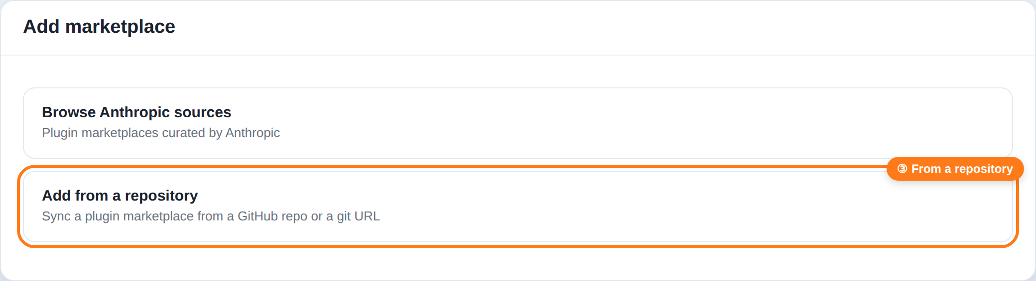

Step 4 — Paste the repo and Sync
In the URL field type or pick the repository, then click "Sync":
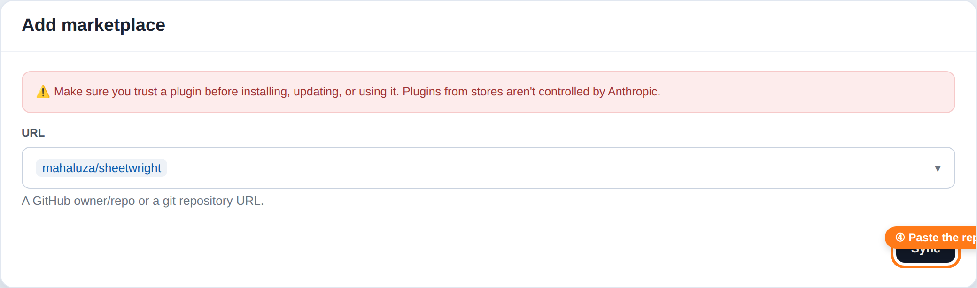
The red warning is normal. It is the generic notice for third-party plugins. Sheetwright is open-source; you can review the whole thing at github.com/mahaluza/sheetwright.

Step 5 — Install and confirm
The "haluza" marketplace is added and the Sheetwright plugin appears. Click Install (the "+"). Open it and confirm the toggle is ON.
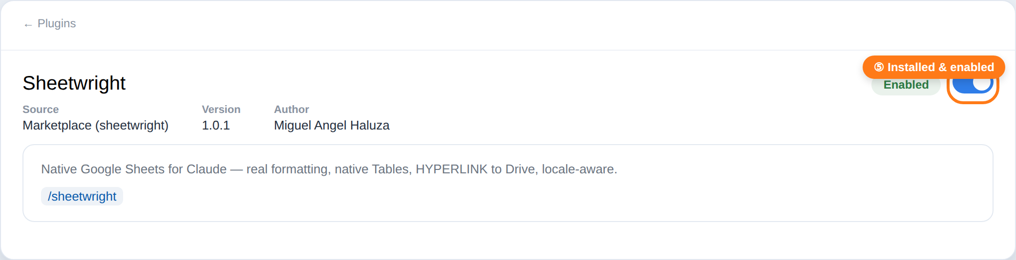
Installed from Marketplace and enabled — this is the state that persists.

Verify it works
Open a new Chat or Cowork and type "/sheet" — /sheetwright should appear. Or just ask, in plain language: "make an invoice list in my Google Sheet with links to each PDF". The first time, Claude will guide you through a one-time Google access setup (~15 min per Google account); after that it just works.

If something goes wrong
- Slash commands didn’t work: commands like /plugin only exist in Claude Code (the terminal), not in Cowork. In Cowork use the interface, as above.
- The plugin isn’t showing: make sure you completed Step 5 (Install) on THIS computer — it is per machine. Restart the app once.
- There’s an update: if the plugin panel shows "Update", click it to pull the latest version from GitHub.

In one line
Customize → Plugins → Add → Add marketplace → From a repository → mahaluza/sheetwright → Sync → Install. Done, once per computer.

