DEPARTMENT OF COMPUTER SCIENCE
Subject: Database Systems

PROJECT REPORT
Structured Genomic Surveillance System
for Rare Disorders (SGSS-RD)
Topic: Somatic Mosaicism — Tracking and Genomic Surveillance
Submitted by | Maham Amjad
Course | CS-408
Semester-section | 4th Semester-M2
Registration number | 2024-ag-9429
Submitted to | Dr. Sumaira Nishat

SGSS-RD | Structured Genomic Surveillance System for Rare Disorders



1. Introduction

1.1 Background:
Genetic diseases caused by somatic mosaicism represent one of the most underdiagnosed categories in modern medicine. Somatic mosaicism occurs when a post-zygotic DNA mutation arises after fertilisation, resulting in two or more genetically distinct cell populations coexisting within a single individual. Unlike germline mutations which are present in every cell from conception, mosaic mutations affect only a subset of cells, distributed according to when and where in embryonic development the error occurred.Standard diagnostic pipelines rely on blood-derived DNA which reliably captures germline variants but frequently misses tissue-specific mosaic mutations present at low variant allele fractions.

1.2 What is Somatic Mosaicism?
Every human begins as a single fertilized cell containing a complete diploid genome. As that cell divides and differentiates into the trillions of cells forming a complete organism, DNA replication errors occasionally arise. If such an error occurs in a progenitor cell early in embryogenesis, the mutation will be inherited by all descendant cells of that lineage. The result is a mosaic organism: genetically normal cells and mutant cells coexist in proportions determined by the timing and location of the original copying error.

1.3 Project Overview:
The Structured Genomic Surveillance System for Rare Disorders (SGSS-RD) is a relational database designed specifically to address the diagnostic and monitoring challenges of somatic mosaicism. It stores patient profiles, tissue sample metadata, mosaic variant cells with VAF measurements, formal rare-disease diagnoses, and longitudinal surveillance logs. By recording VAF across multiple tissue types and time points, SGSS-RD enables clinicians and researchers to detect mutation spread, trigger alerts when VAF crosses clinical thresholds, and build evidence bases for conditions that are individually rare but collectively significant.

1.4 Objectives:
- Store multi-tissue variant data: Record sequencing results and mosaic variants identified from different organ biopsies of the same patient.
- Track VAF over time: Log Variant Allele Frequency at each clinical visit and compute change relative to the previous measurement.
- Measure diagnostic delay: Record and analyse the number of years patients waited for a correct diagnosis to identify systemic healthcare gaps.
- Support research queries: Enable aggregate queries across patients, genes, organs, and countries for epidemiological and translational research.

1.5 Scope:
SGSS-RD is designed for academic and research use within a bioinformatics curriculum context. The schema is implemented in MySQL and models all core entities required for somatic mosaicism surveillance. Patient names are stored as plain text for demonstration; a clinical deployment would replace identifiable fields with anonymisation tokens and implement role-based access control and regulatory compliance infrastructure.

2. System Design and Architecture

2.1 Design Philosophy:
SGSS-RD is built on three core principles. Normalization eliminates redundancy by decomposing data into entities at appropriate granularity with foreign key relationships. Surveillance-first architecture gives the schema a dedicated longitudinal table that stores VAF at each clinical visit, the computed change from the previous measurement, and an automated alert flag, making trend detection a first-class database operation. Clinical standardization aligns attribute names and values with internationally recognized nomenclature to facilitate future integration with external resources.

2.2 Entity Identification:
Analysis of the somatic mosaicism domain identified five core entities, each with independent existence and multiple attributes of interest:
- Patient: The human individual receiving clinical care. The central entity around which all others are organized.
- Tissue Sample: A biological specimen collected from a specific organ at a specific time. The material substrate for sequencing.
- Mosaic Variant: A genetic mutation identified in a tissue sample, characterized by gene, mutation type, and critically its VAF percentage.
- Disease Diagnosis: A formal attribution of a named rare disease to a patient, including confirmation method and diagnostic delay.
- Surveillance Log: A time-stamped record of a VAF measurement at a follow-up visit, capturing change from the preceding measurement and any alert condition.
3. Database Schema

3.1 patients
The root entity of the schema. Every other table references it directly or indirectly. Patient identity is separated from clinical and genomic data to support de-identification workflows in production deployments.

Key | Attribute | Type | Constraint | Description
PK | patient_id | INT | AUTO_INCREMENT, NOT NULL | Unique numeric identifier for each patient
 | patient_name | VARCHAR(50) | NOT NULL | Full name of the patient
 | age | INT | NOT NULL | Age of the patient in years at time of registration
 | gender | VARCHAR(10) | NOT NULL | Biological sex: Male, Female, or Other
 | country | VARCHAR(50) | NOT NULL | Country of residence for epidemiological analysis

3.2 tissue_samples
Each row records one biological specimen. A patient may have samples from multiple organs at multiple time points. The sample_method affects the expected VAF range of any variants detected.

Key | Attribute | Type | Constraint | Description
PK | sample_id | INT | AUTO_INCREMENT, NOT NULL | Unique identifier for each biological sample
FK | patient_id | INT | NOT NULL, FK -> patients | Links sample to its source patient
 | organ_name | VARCHAR(50) | NOT NULL | Organ sampled: Brain, Skin, Blood, Liver, Muscle, Spinal Cord
 | sample_date | DATE | NOT NULL | Calendar date the sample was collected
 | sample_method | VARCHAR(20) | NOT NULL | Collection technique: Biopsy, Blood draw, or Saliva

3.3 mosaic_variants
The central scientific table. The vaf_percent column is the most clinically significant attribute in the entire schema, quantifying what fraction of cells in the sampled tissue carry the mutation and defining the mosaic state.

Key | Attribute | Type | Constraint | Description
PK | variant_id | INT | AUTO_INCREMENT, NOT NULL | Unique identifier for each variant record
FK | sample_id | INT | NOT NULL, FK -> tissue_samples | Links variant to the sample in which it was detected
 | gene_name | VARCHAR(30) | NOT NULL | HGNC gene symbol of the affected gene (e.g. MTOR, HRAS, GNAQ)
 | mutation_type | VARCHAR(20) | NOT NULL | Category of DNA change: SNV, Indel, or CNV
 | vaf_percent | DECIMAL(5,2) | NOT NULL | Variant Allele Frequency: percentage of reads carrying the mutation (0.00 to 100.00)
 | is_harmful | VARCHAR(10) | NOT NULL | Pathogenicity assessment: Yes (pathogenic), No (benign), Unknown (VUS)

3.4 disease_diagnosis
Records the formal rare disease diagnosis issued to a patient. The years_to_diagnose attribute captures the diagnostic odyssey length — the years between symptom onset and confirmed diagnosis.
Key | Attribute | Type | Constraint | Description
PK | diagnosis_id | INT | AUTO_INCREMENT, NOT NULL | Unique identifier for each diagnosis record
FK | patient_id | INT | NOT NULL, FK -> patients | Links diagnosis to the patient
 | disease_name | VARCHAR(100) | NOT NULL | Full clinical name of the rare disease (e.g. Focal Cortical Dysplasia, Sturge-Weber Syndrome)
 | diagnosis_date | DATE | NOT NULL | Date on which the diagnosis was formally confirmed
 | how_confirmed | VARCHAR(20) | NOT NULL | Confirmation method: DNA Test, Clinical exam, or Both
 | years_to_diagnose | INT | NOT NULL | Years elapsed between first symptom presentation and confirmed diagnosis

3.5 surveillance_log

The surveillance_log implements the temporal monitoring capability that distinguishes SGSS-RD from a static variant registry. Every clinical follow-up visit produces a new row. The alert field is set to Yes when vaf_change exceeds 5 percentage points.
Key | Attribute | Type | Constraint | Description
PK | log_id | INT | AUTO_INCREMENT, NOT NULL | Unique identifier for each surveillance entry
FK | patient_id | INT | NOT NULL, FK -> patients | Links entry to the monitored patient
FK | variant_id | INT | NOT NULL, FK -> mosaic_variants | Links entry to the specific variant being tracked
 | check_date | DATE | NOT NULL | Date of the clinical visit
 | vaf_recorded | DECIMAL(5,2) | NOT NULL | VAF percentage measured at this visit
 | vaf_change | DECIMAL(5,2) | NOT NULL | Since previous log entry; positive means mutation is spreading
 | alert | VARCHAR(5) | NOT NULL | Yes if vaf exceeds 5.00%

4. Entity Relationship Diagram

4.1 ERD Overview:
The Entity Relationship Diagram for SGSS-RD illustrates five entity tables and five relationships connecting them. All relationships are one-to-many, reflecting the real-world cardinality of the domain. The ERD uses crow's-foot notation with a double vertical tick on the mandatory one-side and a circle-plus-crow's-foot on the optional many-side. All connector lines use straight horizontal and vertical routing to eliminate directional ambiguity. The full ERD is provided in the accompanying PDF diagram file.

4.2 Cardinality Constraints:

Parent Table | Child Table | Cardinality | Business Rule
patients | tissue_samples | 1 : Many (1:M) | One patient yields zero or more tissue samples
patients | disease_diagnosis | 1 : Many (1:M) | One patient receives one or more diagnoses
patients | surveillance_log | 1 : Many (1:M) | One patient has zero or more log entries
tissue_samples | mosaic_variants | 1 : Many (1:M) | One sample contains zero or more variants
mosaic_variants | surveillance_log | 1 : Many (1:M) | One variant generates zero or more log entries

4.3 Referential Integrity
All foreign key relationships are enforced at the database level using MySQL FOREIGN KEY constraints. This ensures that no tissue sample can be inserted without referencing a valid patient, no mosaic variant can reference a non-existent sample, no diagnosis can be assigned to an unregistered patient, and no surveillance log entry can reference a non-existent variant or patient. These constraints guarantee data consistency throughout the schema and prevent orphaned records.

Entity Relationship Diagram:

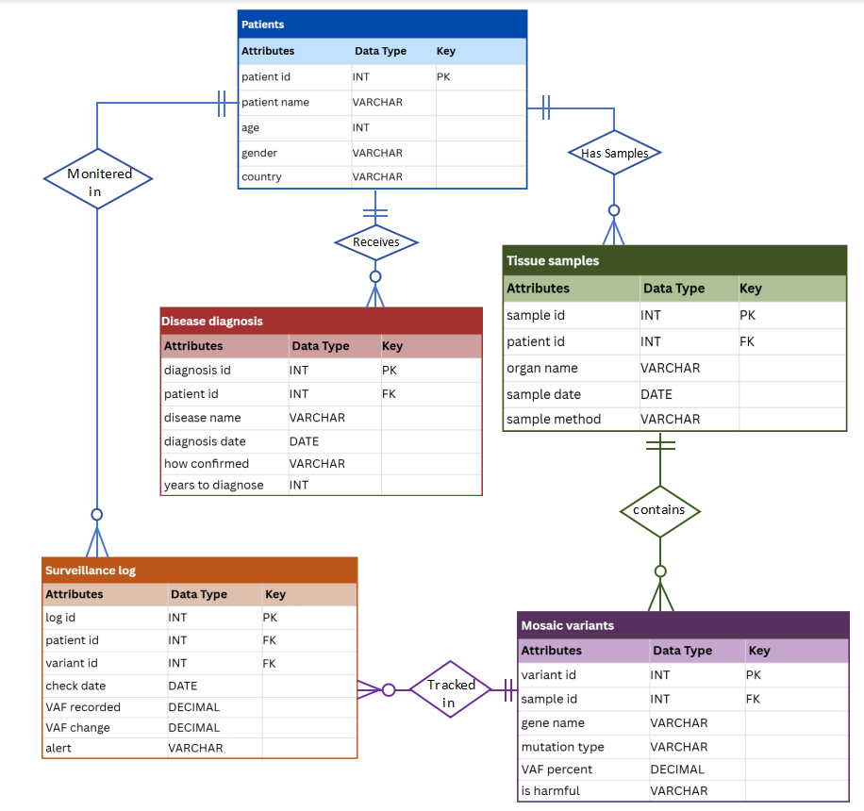

5. SQL Implementation

5.1 Table Creation
CREATE DATABASE sgss_rd;
USE sgss_rd;

CREATE TABLE patients (
patient_id INT PRIMARY KEY AUTO_INCREMENT,
patient_name VARCHAR(50) NOT NULL,
age INT NOT NULL,
gender VARCHAR(10) NOT NULL,
country VARCHAR(50) NOT NULL
);

CREATE TABLE tissue_samples (
sample_id INT PRIMARY KEY AUTO_INCREMENT,
patient_id INT NOT NULL,
organ_name VARCHAR(50) NOT NULL,
sample_date DATE NOT NULL,
sample_method VARCHAR(20) NOT NULL,
FOREIGN KEY (patient_id) REFERENCES patients(patient_id)
);

CREATE TABLE mosaic_variants (
variant_id INT PRIMARY KEY AUTO_INCREMENT,
sample_id INT NOT NULL,
gene_name VARCHAR(30) NOT NULL,
mutation_type VARCHAR(20) NOT NULL,
vaf_percent DECIMAL(5,2) NOT NULL,
is_harmful VARCHAR(10) NOT NULL,
FOREIGN KEY (sample_id) REFERENCES tissue_samples(sample_id)
);

CREATE TABLE disease_diagnosis (
diagnosis_id INT PRIMARY KEY AUTO_INCREMENT,
patient_id INT NOT NULL,
disease_name VARCHAR(100) NOT NULL,
diagnosis_date DATE NOT NULL,
how_confirmed VARCHAR(20) NOT NULL,
years_to_diagnose INT NOT NULL,
FOREIGN KEY (patient_id) REFERENCES patients(patient_id)
);

CREATE TABLE surveillance_log (
log_id INT PRIMARY KEY AUTO_INCREMENT,
patient_id INT NOT NULL,
variant_id INT NOT NULL,
check_date DATE NOT NULL,
vaf_recorded DECIMAL(5,2) NOT NULL,
vaf_change DECIMAL(5,2) NOT NULL,
alert VARCHAR(5) NOT NULL,
FOREIGN KEY (patient_id) REFERENCES patients(patient_id),
FOREIGN KEY (variant_id) REFERENCES mosaic_variants(variant_id)
);

5.2 Sample Data Insertion
Fifty rows of representative data were inserted across all five tables. A representative subset is shown below; the complete data set is provided in the accompanying SQL file SGSS_RD_database.sql.

-- patients
INSERT INTO patients (patient_name, age, gender, country) VALUES
('Ahmed Raza', 7, 'Male', 'Pakistan'),
('Sara Khan', 34, 'Female', 'Pakistan'),
('John Miller', 12, 'Male', 'USA'),
('Liu Wei', 6, 'Male', 'China'),
('Fatima Al-Sayed', 29, 'Female', 'Saudi Arabia');

-- mosaic_variants
INSERT INTO mosaic_variants
(sample_id, gene_name, mutation_type, vaf_percent, is_harmful) VALUES
(1, 'MTOR', 'SNV', 25.40, 'Yes'),
(5, 'MTOR', 'Indel', 42.70, 'Yes'),
(7, 'NF1', 'CNV', 55.30, 'Yes'),
(8, 'GNAQ', 'SNV', 37.60, 'Yes');

-- surveillance_log
INSERT INTO surveillance_log
(patient_id, variant_id, check_date, vaf_recorded, vaf_change, alert) VALUES
(1, 1, '2022-06-10', 25.40, 0.00, 'No'),
(1, 1, '2022-12-10', 29.80, 4.40, 'No'),
(1, 1, '2023-06-10', 36.20, 6.40, 'Yes');

5.3 SQL Queries

Query 1 — Selecting all the tables

USE sgss_rd;
SELECT * FROM patients;
SELECT * FROM tissue_samples;
SELECT * FROM mosaic_variants;
SELECT * FROM disease_diagnosis;
SELECT * FROM surveillance_log;

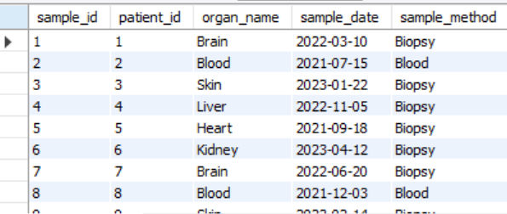
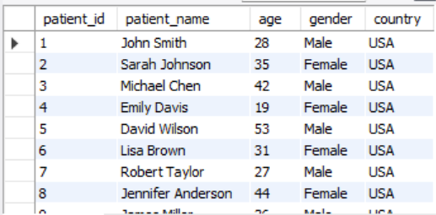

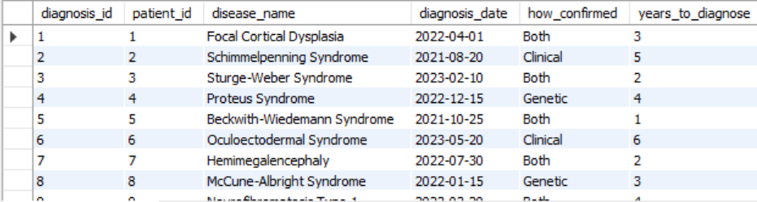

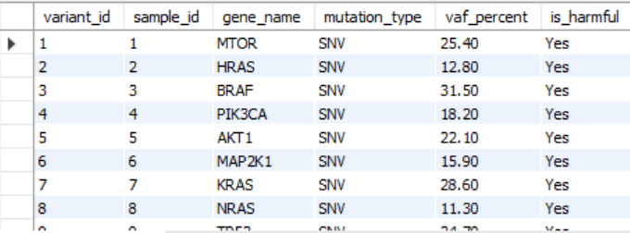
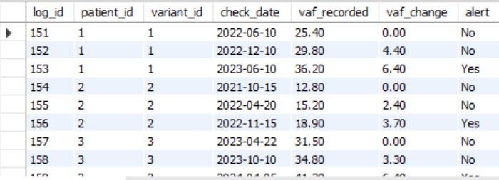

Query 2 — Selecting specific columns from surveillance_log

SELECT patient_id, check_date, vaf_recorded, alert
FROM surveillance_log;

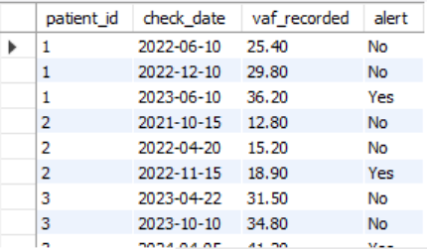

Query 3 — Using SELECT DISTINCT statement

SELECT DISTINCT organ_name
FROM tissue_samples;
SELECT DISTINCT gene_name
FROM mosaic_variants;
SELECT DISTINCT mutation_type
FROM mosaic_variants;
SELECT DISTINCT country
FROM patients;

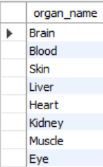
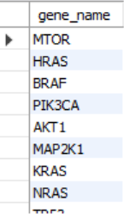
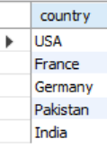

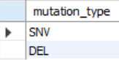

Query 4— Using SELECT DISTINCT statement for multiple columns

SELECT DISTINCT organ_name, sample_method
FROM tissue_samples
SELECT DISTINCT gene_name, mutation_type
FROM mosaic_variants;
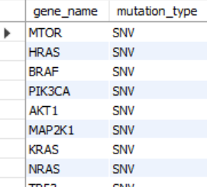
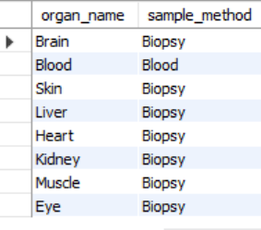

Query 5 — Using SELECT with WHERE clause

--Find all tissue samples collected from the Brain
SELECT * FROM tissue_samples
WHERE organ_name = 'Brain';

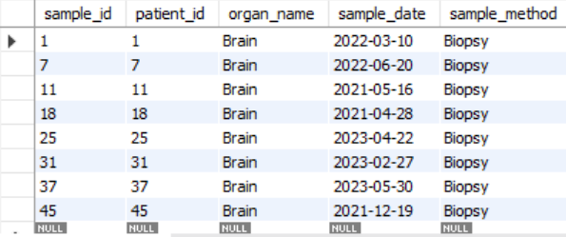

-- Find surveillance entries where alert was triggered
SELECT * FROM surveillance_log
WHERE alert = 'Yes';

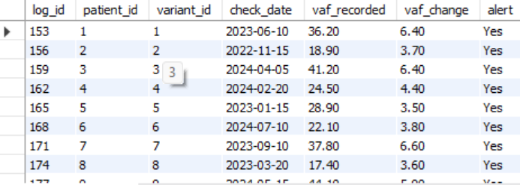

Query 6 — Using SELECT with ORDER BY clause

-- List all variants ordered by VAF highest to lowest (DESC)
SELECT gene_name, vaf_percent, organ_name
FROM mosaic_variants
JOIN tissue_samples ON mosaic_variants.sample_id = tissue_samples.sample_id
ORDER BY vaf_percent DESC;
-- List all variants ordered by VAF highest to lowest (ASC)
SELECT gene_name, vaf_percent, organ_name
FROM mosaic_variants
JOIN tissue_samples ON mosaic_variants.sample_id = tissue_samples.sample_id
ORDER BY vaf_percent ASC;

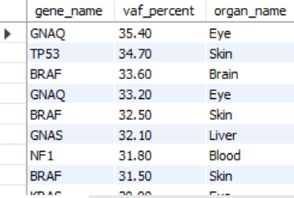
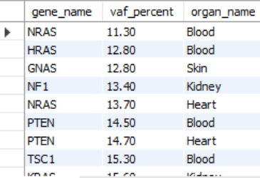

Query 7 — Using Arithmetic Operators

-- Calculate how many healthy cells remain (100 - VAF%)
SELECT gene_name,
vaf_percent AS mutated_cells_percent,
100 - vaf_percent AS healthy_cells_percent
FROM mosaic_variants;

-- Calculate difference between vaf_recorded and vaf_change
SELECT log_id,
vaf_recorded,
vaf_change,
vaf_recorded - vaf_change AS previous_vaf
FROM surveillance_log;

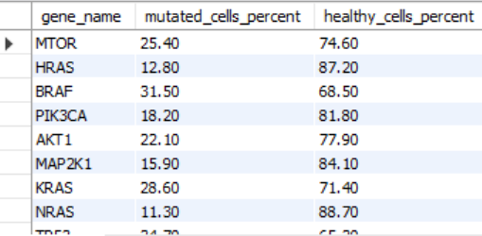
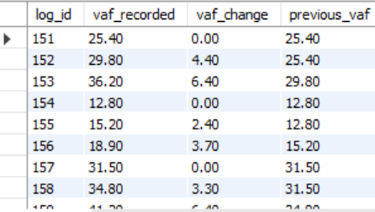

Query 8 — Using Operator Precedence

-- Calculate a risk score: (vaf_percent * 2) + years_to_diagnose
SELECT p.patient_name,
m.vaf_percent,
d.years_to_diagnose,
(m.vaf_percent * 2) + d.years_to_diagnose AS risk_score
FROM patients p
JOIN tissue_samples t ON p.patient_id = t.patient_id
JOIN mosaic_variants m ON t.sample_id = m.sample_id
JOIN disease_diagnosis d ON p.patient_id = d.patient_id;

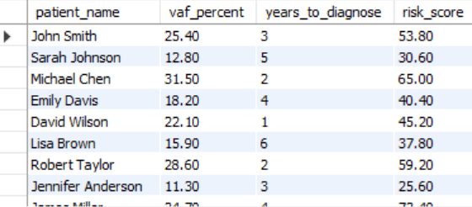

Query 9 — Using Relational Operators

SELECT * FROM mosaic_variants
WHERE vaf_percent > 32;

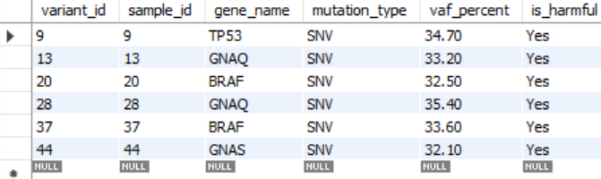

Query 10 — Using Logical Operators

-- Find harmful variants with high VAF or from blood
SELECT m.gene_name, m.vaf_percent, m.is_harmful, t.organ_name
FROM mosaic_variants m
JOIN tissue_samples t ON m.sample_id = t.sample_id
WHERE m.is_harmful = 'Yes'
AND (m.vaf_percent > 30 OR t.organ_name = 'Blood');

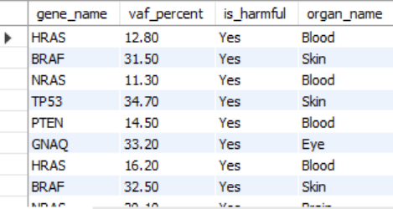

Query 11 — Using LIKE Operator

-- Find disease names that contain the word 'Syndrome'
SELECT disease_name, years_to_diagnose
FROM disease_diagnosis
WHERE disease_name LIKE '%Syndrome%';
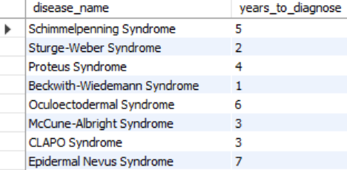

Query 12 — Using LIKE Operator
-- Find all 5 functions together on mosaic_variants
SELECT COUNT(*) AS total_variants,
ROUND(AVG(vaf_percent), 2) AS avg_vaf,
MAX(vaf_percent) AS max_vaf,
MIN(vaf_percent) AS min_vaf,
ROUND(SUM(vaf_percent), 2) AS sum_vaf
FROM mosaic_variants;

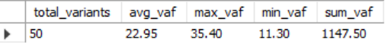

6. Data Flow Diagrams

6.1 DFD Level 0 — Context:
The Level 0 context diagram presents SGSS-RD as a single system process exposing only its external boundaries. Three categories of external entity supply data to the system: doctors provide patient demographic and medical history records; laboratory technicians upload biological sample metadata and sequencing results; patients provide informed consent and symptom histories. Three categories of external entity receive data from the system: specialist physicians receive diagnosis and variant reports; researchers receive anonymised variant datasets; health authorities receive epidemiological statistics; and the alert subsystem receives VAF threshold notifications for urgent clinical review.

6.2 DFD Level 1 — Detailed Processes:
The Level 1 diagram decomposes the system into six distinct sub-processes, each corresponding to a major operational function. Five data stores are shown with their read and write flows.
- P1 — Register Patient: Accepts demographic and consent data from the clinician and patient, validates completeness, and writes a new record to the patients data store (D1).
- P2 — Collect Sample: Accepts biological sample metadata from the laboratory technician, reads the patient record from D1 to verify the patient identifier, and writes a new record to tissue_samples (D2).
- P3 — Detect Variant and VAF: Reads the sample record from D2, stores the sequencing-derived variant call and VAF percentage in mosaic_variants (D3), and exports anonymized data to researchers.
- P4 — Record Diagnosis: Accepts formal diagnosis information from the specialist physician, reads supporting data from D3 and D1, and writes the completed record to disease_diagnosis (D4).
- P5 — Monitor VAF: Reads variant and patient identifiers from D3 and D1, computes the VAF change relative to the previous log entry, and writes the time-stamped measurement to surveillance_log (D5).
- P6 — Generate Alert and Report: Reads aggregated data from D5, emits real-time alerts when VAF change exceeds 5 percent, and produces epidemiological trend reports for health authorities.

DFD Level 0 Diagram:

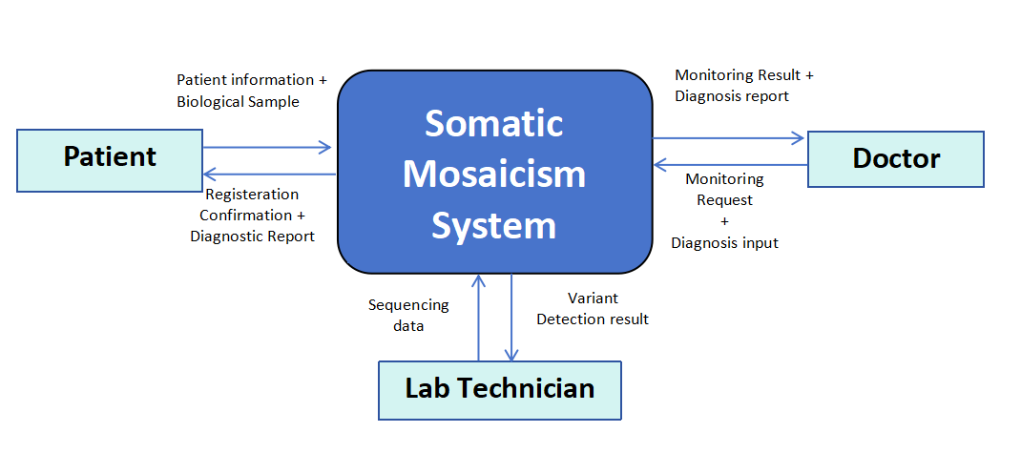

DFD Level 1 Diagram:
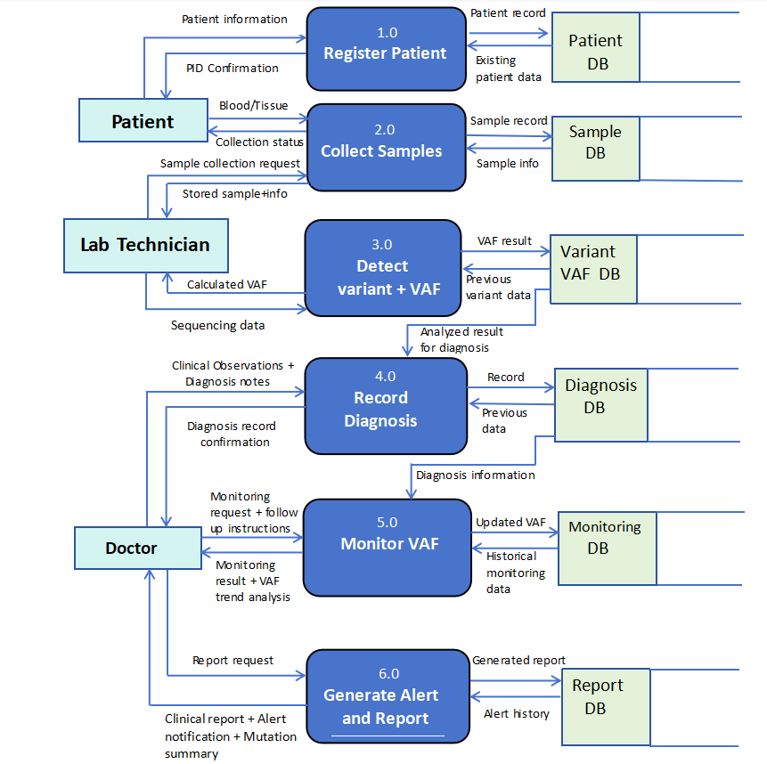

DFD Level 2 Diagram:
Decomposing Process 3.0(Detect Variant + VAF):
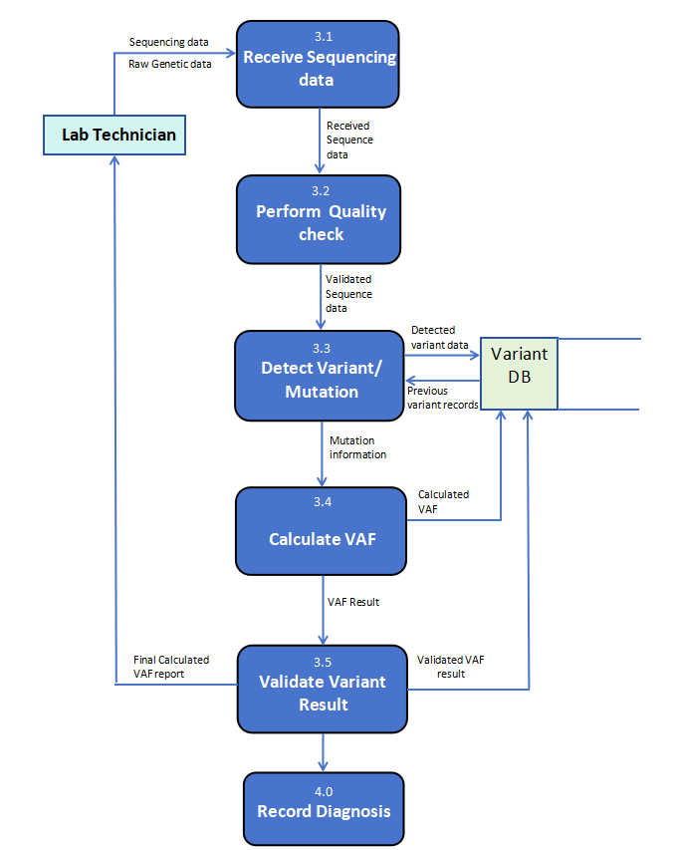

7. Results and Discussion

7.1 Schema Validation
The SGSS-RD schema was implemented and tested in MySQL 8.0. All five CREATE TABLE statements executed without error. Foreign key constraints were verified by attempting to insert child records with non-existent parent identifiers; MySQL correctly rejected all such attempts with constraint violation errors. Fifty rows of representative data were successfully inserted across all five tables, producing a consistent and fully traversable relational dataset.

7.2 Surveillance Demonstration
The surveillance functionality of SGSS-RD was demonstrated using Patient 1 (Ahmed Raza), who carries an MTOR SNV identified in a brain biopsy. Three surveillance log entries spanning twelve months show VAF progression from 25.40 percent to 29.80 percent to 36.20 percent. The third entry triggered an alert with a vaf_change value of 6.40, exceeding the 5.00 percent threshold. This time series illustrates the system's ability to detect clinically significant mutation spread that would be entirely invisible to a static variant registry.

7.3 Limitations and Future Work
The current implementation stores patient names as plaintext. Production deployment would require anonymisation tokens, role-based access control, and regulatory compliance infrastructure. The 5 percent VAF alert threshold is hardcoded in application logic rather than stored as a configurable database parameter; a future configuration table would allow clinical teams to adjust thresholds per gene or disease. Integration with OMIM, Orphanet, HPO, and ClinVar identifiers would further enhance interoperability with global genomic databases and enable federated queries across institutions.
8. Conclusion
The Structured Genomic Surveillance System for Rare Disorders demonstrates that a carefully normalised relational database schema can meaningfully advance the clinical management of somatic mosaicism. By organising data across five interrelated tables,The schema's most significant contribution is its surveillance architecture. The surveillance_log table records not simply what mutation a patient has, but how that mutation behaves over time. The schema is fully normalised to Third Normal Form, all foreign key relationships are enforced at the database level, fifty rows of representative data populate the system, and twelve SQL queries demonstrate analytical capabilities. The accompanying Entity Relationship Diagram and two-level Data Flow Diagrams provide complete documentation of the system's structure and process flows.Most importantly, SGSS-RD demonstrates that thoughtful database design grounded in a genuine clinical problem produces a system with real potential to reduce the diagnostic odyssey experienced by patients with rare mosaic genetic conditions.

