Internationally  Recognized:  UET graduates are eiligible to work globally as it is associate to Washington accord. Program offered in computer science department are recognized by Washington accord. |  | Visit us online  lms.uet.com.pk |  |  | 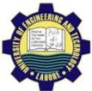  University of engineering and technology  (main campus) lahore  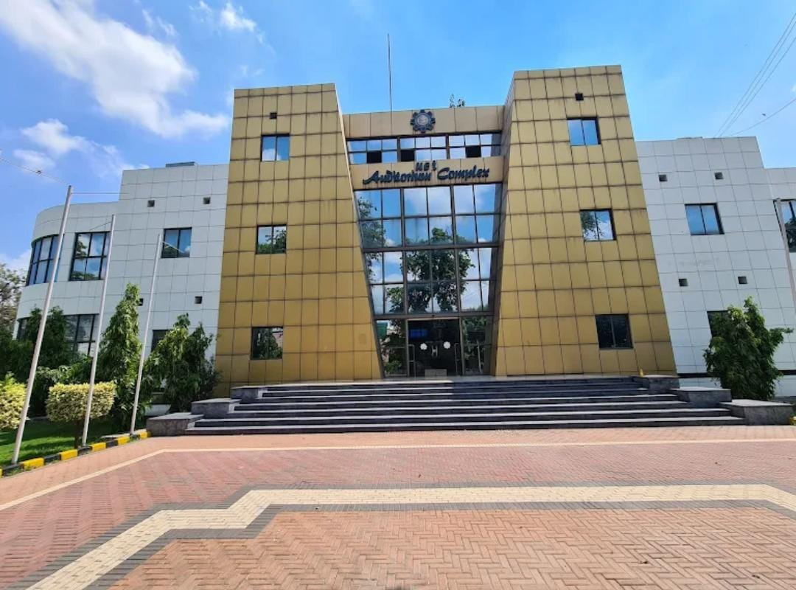

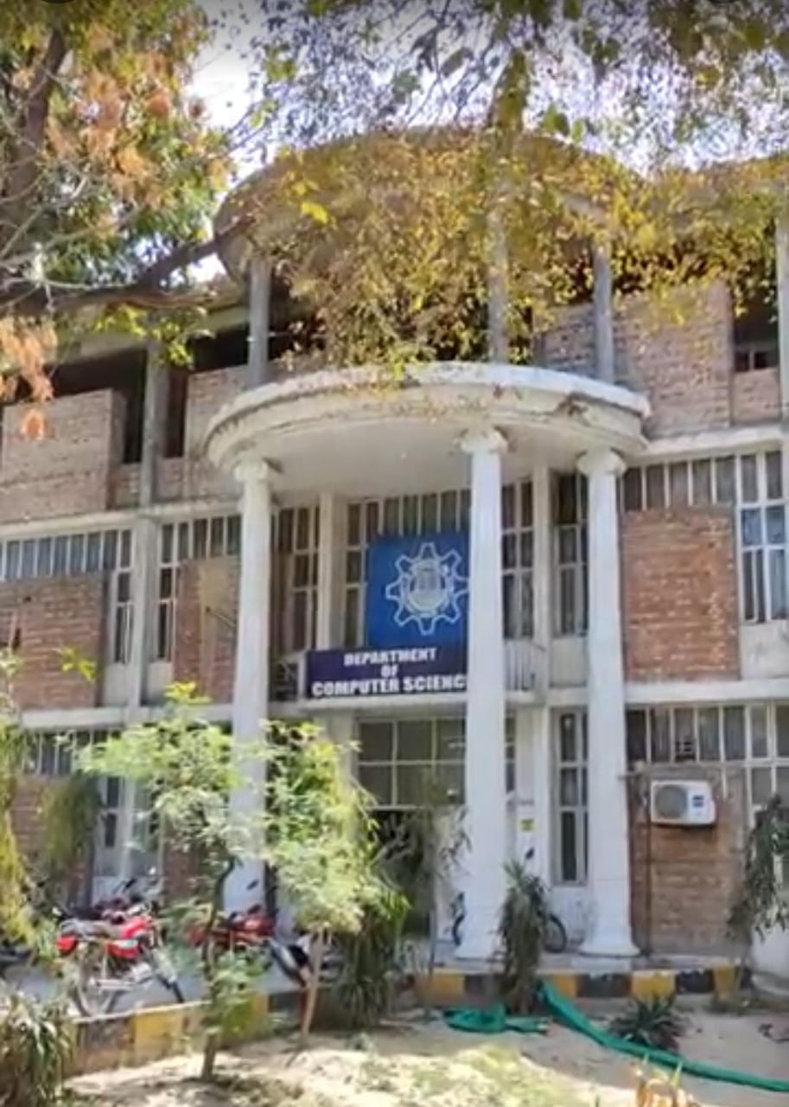  Courses offered:  - BSC computer engineering  - BSc computer science  - MSc computer science  - MSc computer engneering | THE Science of today is technology of tomorrow.  Technology society:  UET ACM is one of the most celebrated scientific society which is actively participated in different events in collaborate with IOCASST (KICS). | Silent feature:  - Library  - Computer lab  - Admin office  - Workshop  - Play area  - caftarea  Contact Us:  UET Admissions 042-9902616  Register:042-990290227  Deputy registar:042-9902909  Assistant register:042-99029417
-

