

**Artificial Intelligence**

**Lab 02 Tasks**

**Name: Maham Bibi**

**Sap ID: 45652**

**Batch:** BSCS-6th semester

**Lab Instructor:**

Ayesha Akram

**Task1.**

**Solution:**

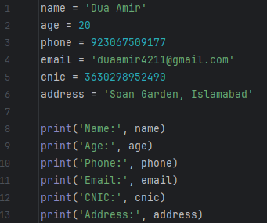

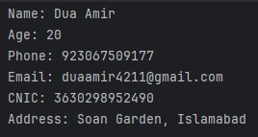

**Task2.**

**Solution:**

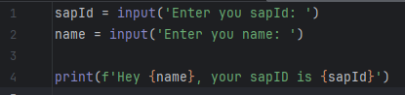

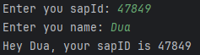

**Task3.**

**Solution:**

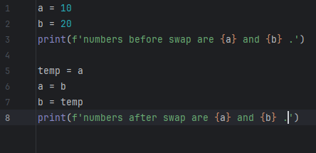 

**Task4.**

**Solution:**

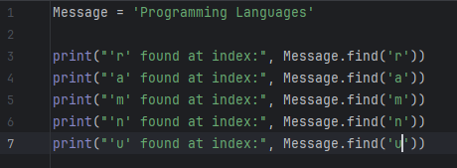 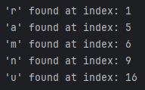

**Task5.**

**Solution:**



