Software Engineering Project Report
Prepared By: Maham
Subjects: Programming Fundamentals, Software Engineering
Programming Language: C++

Table of Contents

Introduction
The Hospital Management System is developed in C++ to simplify the management of hospital records by digitalising them. It allows users to manage patient records, doctor records, appointments, and billing in an organised manner. The system provides an efficient alternative to manual record-keeping by allowing users to store, search, update, and retrieve information quickly.
This project has been developed to demonstrate the practical implementation of Programming Fundamentals and Software Engineering concepts. It follows a modular approach by dividing the system into separate modules for patients, doctors, appointments, and billing. The application is console-based and stores data using text files, making it simple, efficient, and suitable for educational purposes.

Problem Statement
Hospitals that rely on manual record-keeping often face difficulties in storing, searching, and updating patient information. Managing doctor records, appointments, and billing manually can be time-consuming and may lead to errors. The Hospital Management System was developed to digitise these tasks, reduce paperwork, and organise hospital records efficiently through a simple C++ console-based application.

Objectives
- Develop a simple Hospital Management System using C++.
- Manage patient, doctor, appointment, and billing records digitally.
- Reduce manual paperwork and improve record organisation.
- Apply Programming Fundamentals and Software Engineering concepts.
- Store and retrieve records using text files.
- Provide a simple menu-driven interface.

Scope and Limitations

Scope
The Hospital Management System provides basic hospital management features, including patient management, doctor management, appointment scheduling, and billing. It is a console-based application developed for educational purposes to demonstrate the practical implementation of Programming Fundamentals and Software Engineering concepts.
The system focuses on maintaining organised hospital records while providing a simple menu-driven interface. It enables users to perform essential operations such as adding, updating, searching, and viewing records efficiently.

Limitations (Out of Scope)
- Online payment system
- Pharmacy management
- Laboratory management
- Staff and duty scheduling
- Salary management
- Real-time doctor availability
- User authentication and login system
- Database integration

Functional Requirements

Patient Management
The system shall allow the user to add new patient records, update existing patient information, search for a specific patient, and display all stored patient records.

Doctor Management
The system shall allow the user to add new doctors, update doctor information, search for a particular doctor, display all doctor records, and update the doctor's availability status.

Appointment Management
The system shall enable users to book appointments, search appointment records, display all scheduled appointments, and reschedule appointments.

Billing Management
The system shall provide facilities for generating bills, searching billing records, and displaying all generated bills.

Non-Functional Requirements
Usability: The system provides a simple menu-driven interface.
Reliability: Records are stored in text files for persistence.
Maintainability: The modular class-based design makes future modifications easier.
Performance: The system efficiently performs operations on educational-scale datasets.

System Modules
Patient Module: Add, update, search and view patient records.
Doctor Module: Add, update, search, view doctors and update doctor status.
Appointment Module: Book, search, view and reschedule appointments.
Billing Module: Generate, search and view billing records.

Class Diagram (Simplified UML)
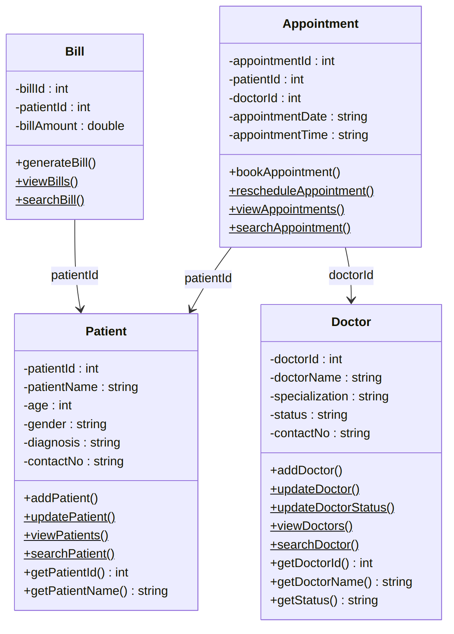

Use Case Diagram
A single actor, the Receptionist / Staff User, interacts with every use case in the system.
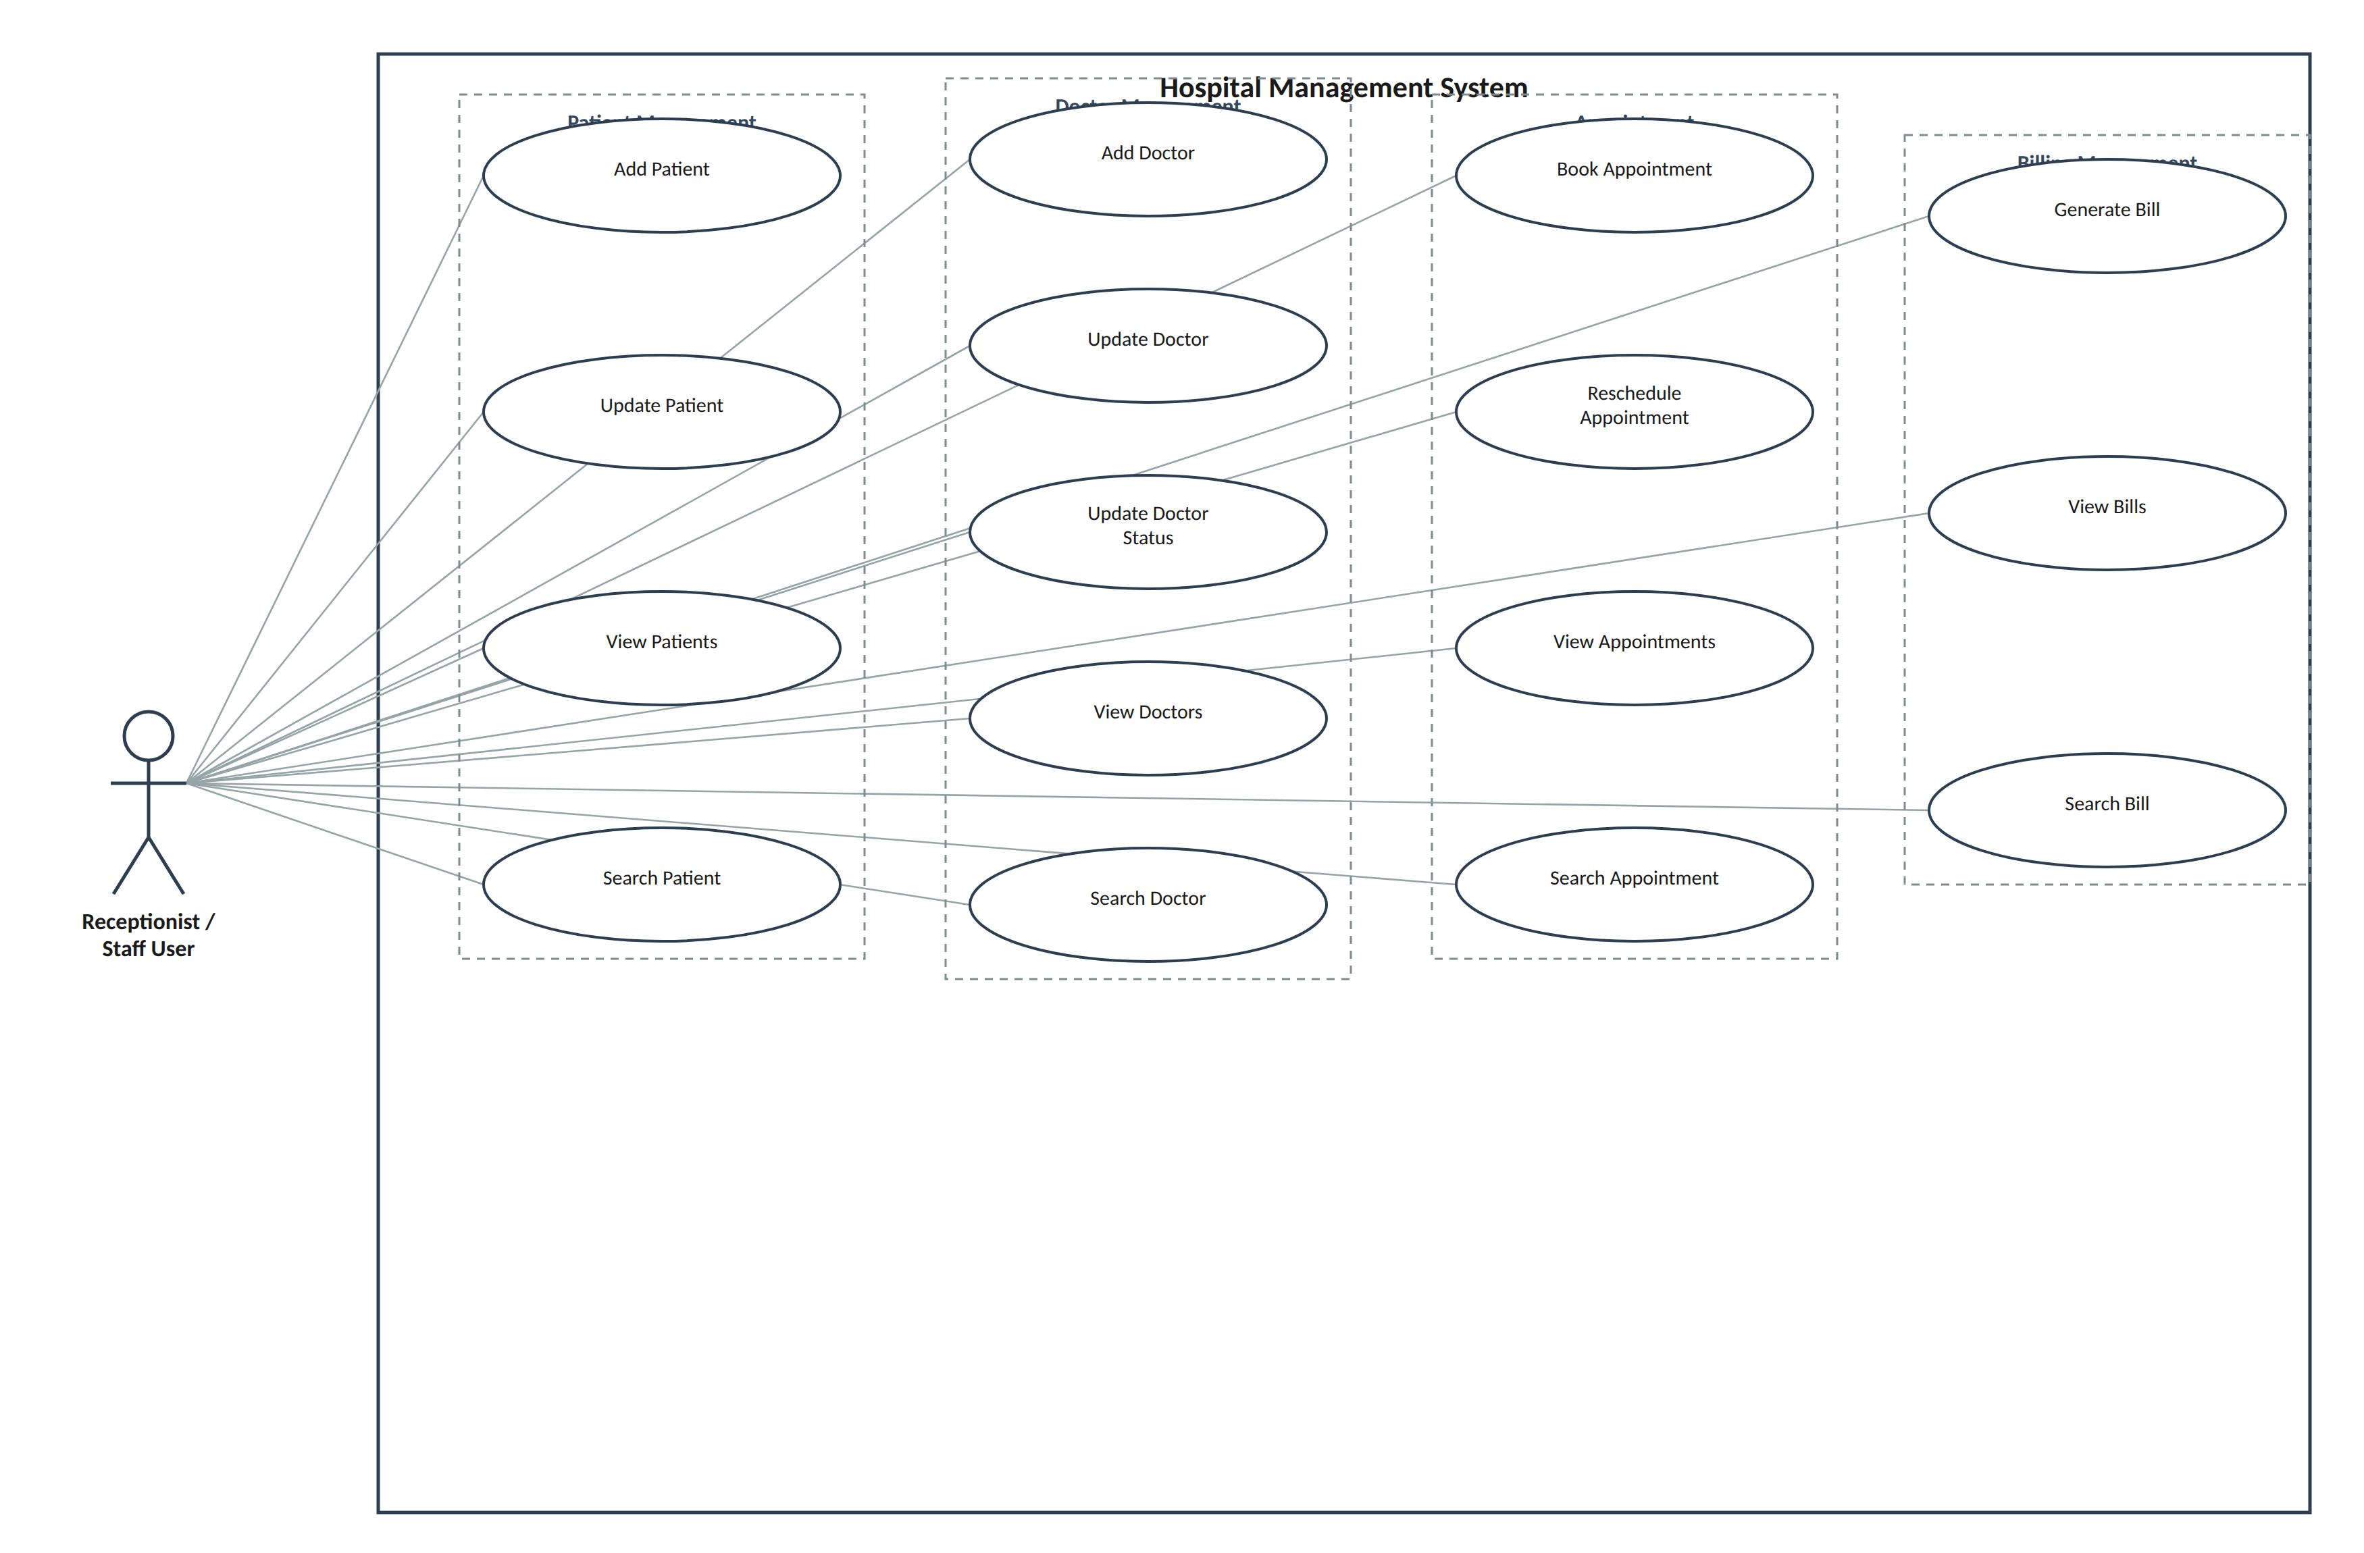

Flowcharts

1. Overall System Flow
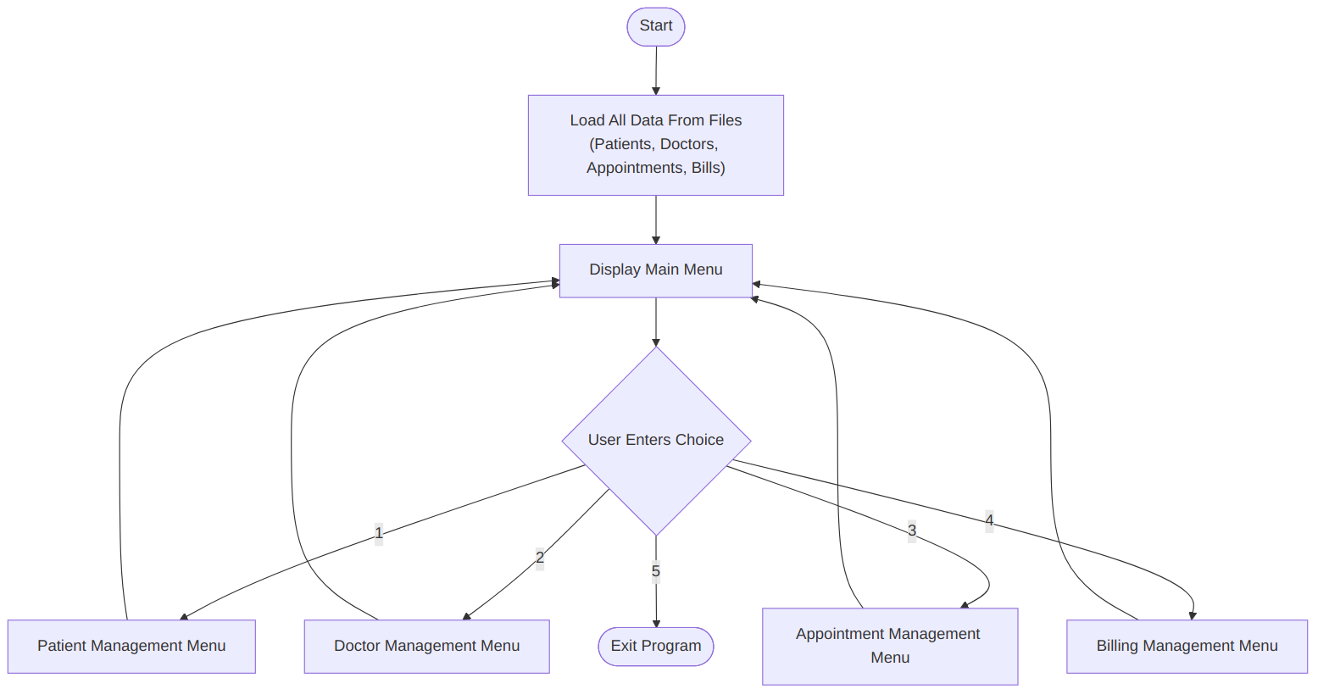

2. General Add Record
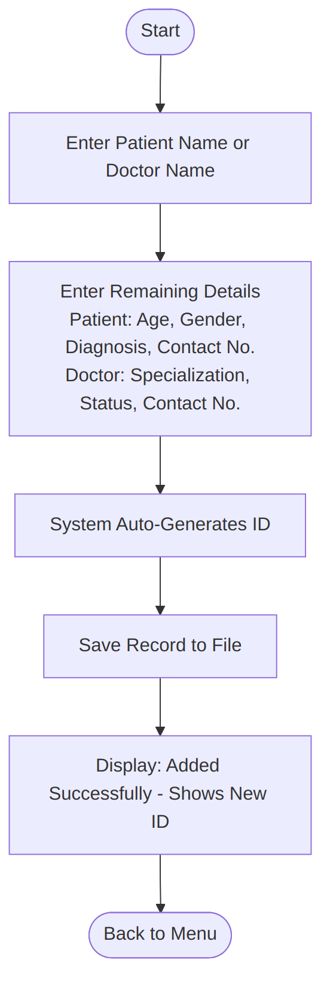
Note: This flowchart also represents Add Patient, Add Doctor and Generate Bill since these operations follow the same logic.

3. General Update Record
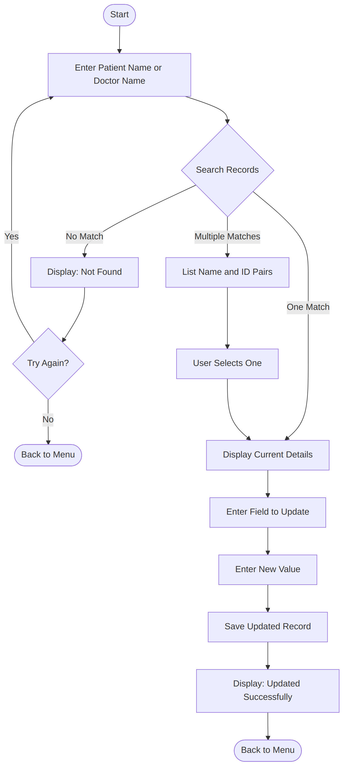
Note: This flowchart applies to updating patient and doctor records, and to rescheduling appointments.

4. General Search Record
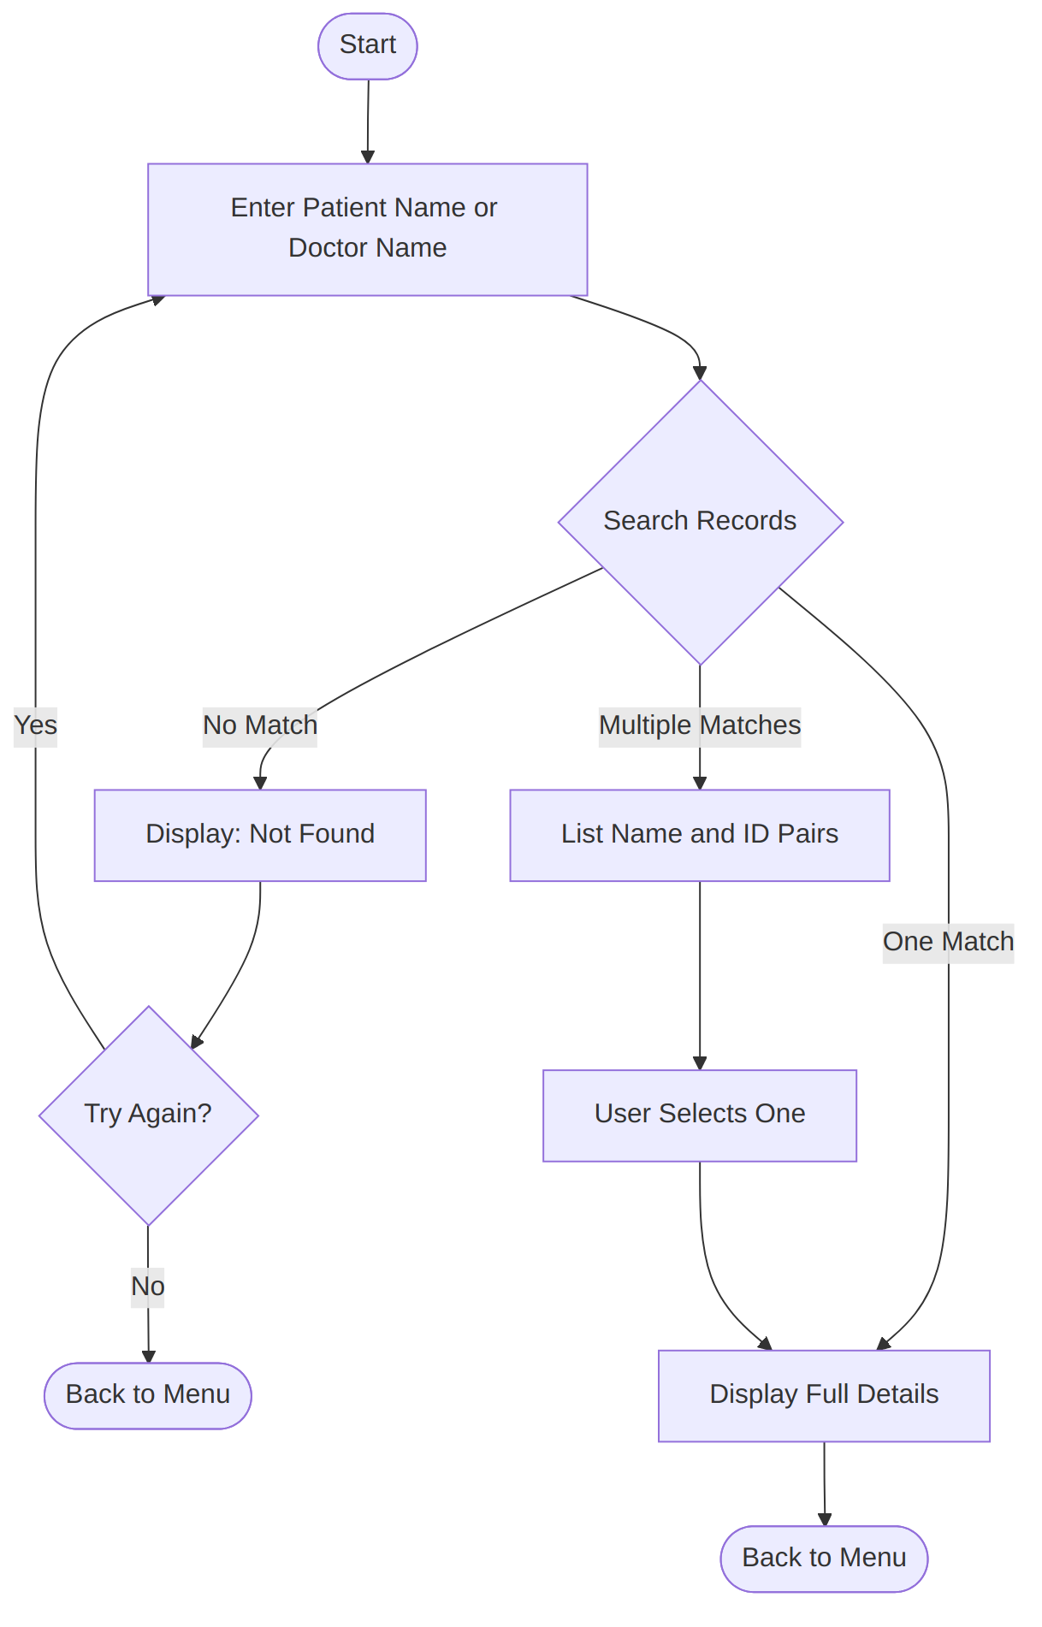
Note: Applicable to patient, doctor, appointment and billing searches.

5. General View Records
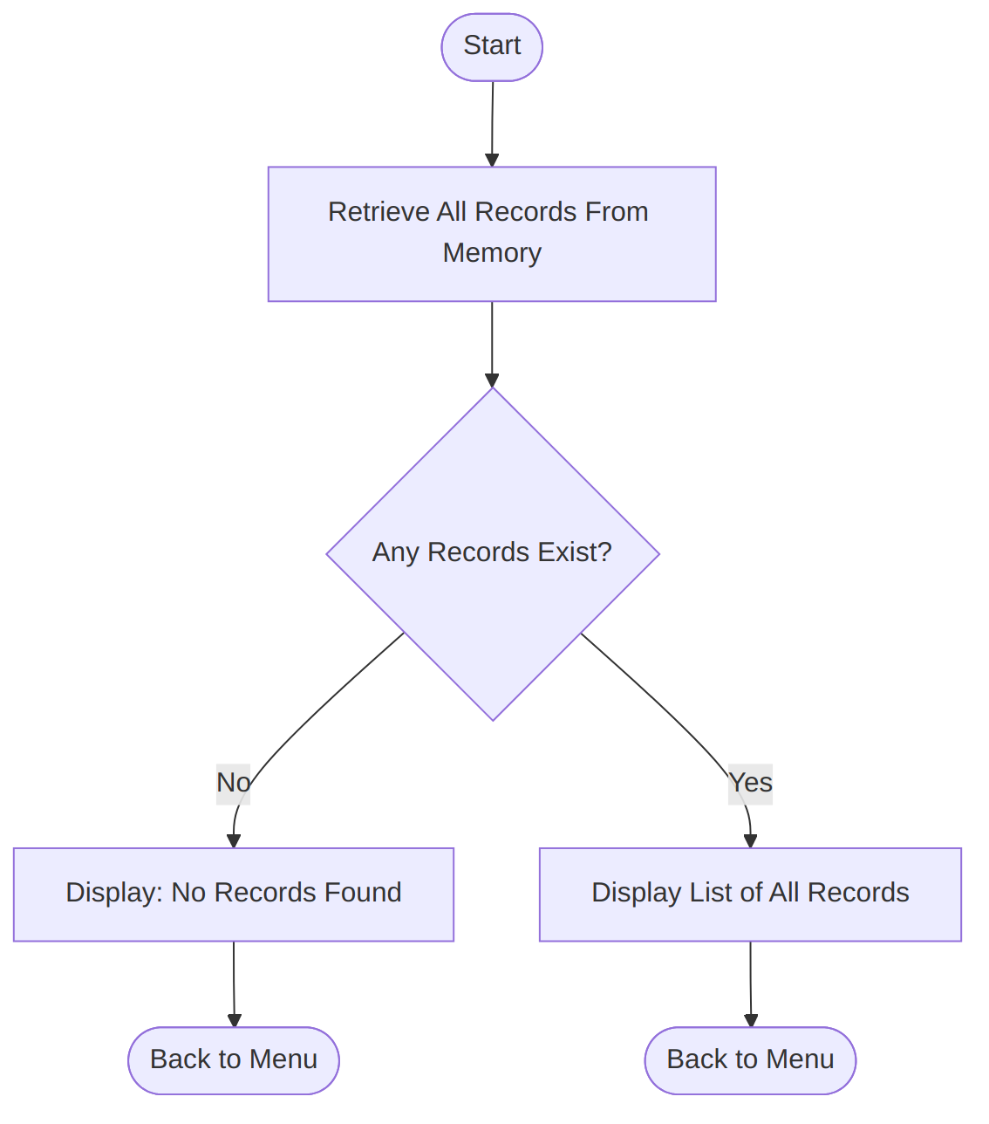
Note: Applicable to viewing all records across all modules.

6. Appointment Booking
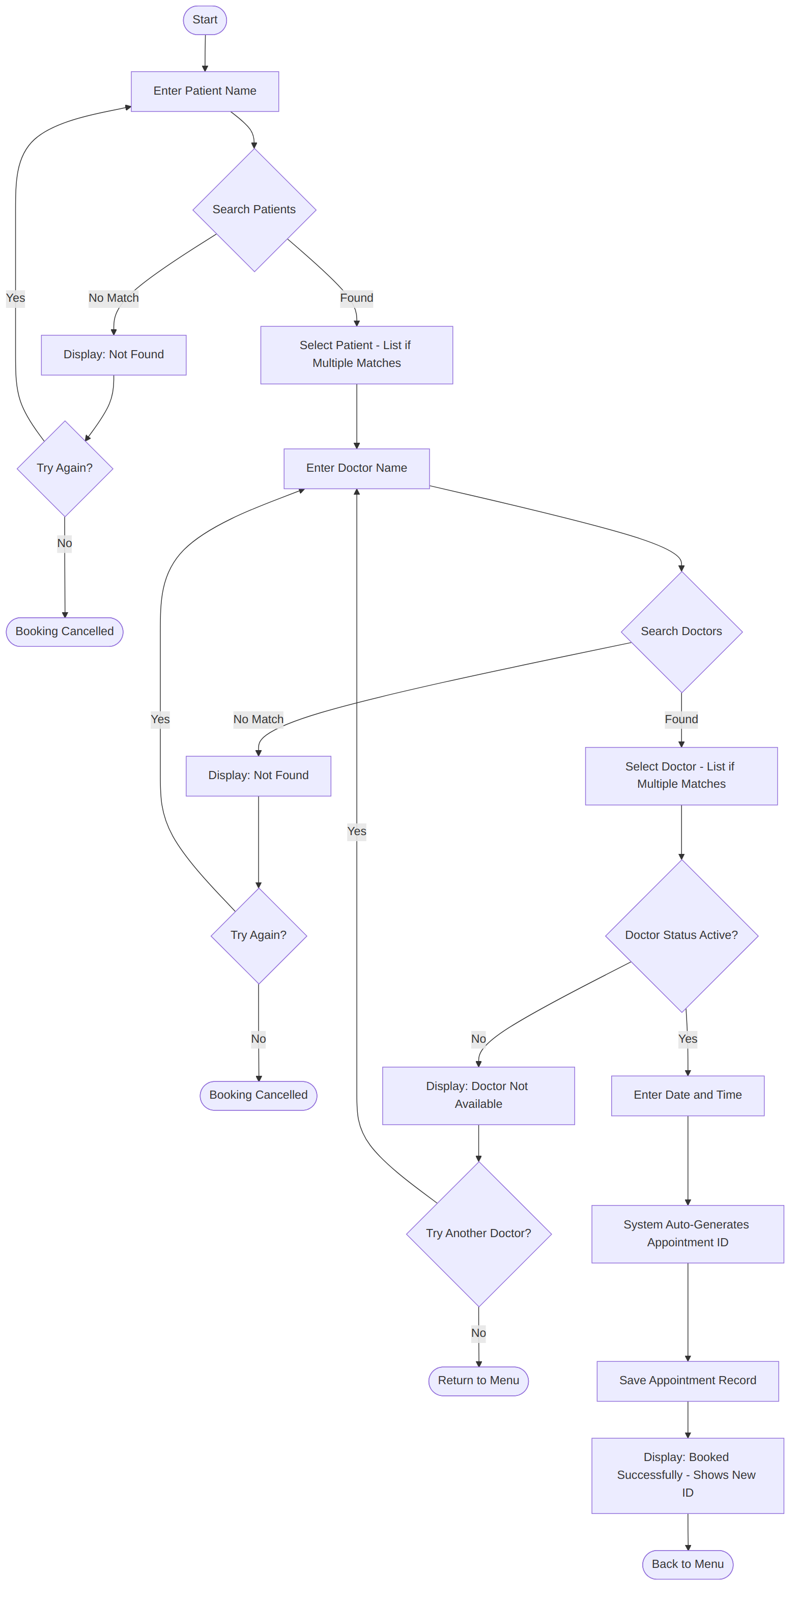

7. Doctor Status
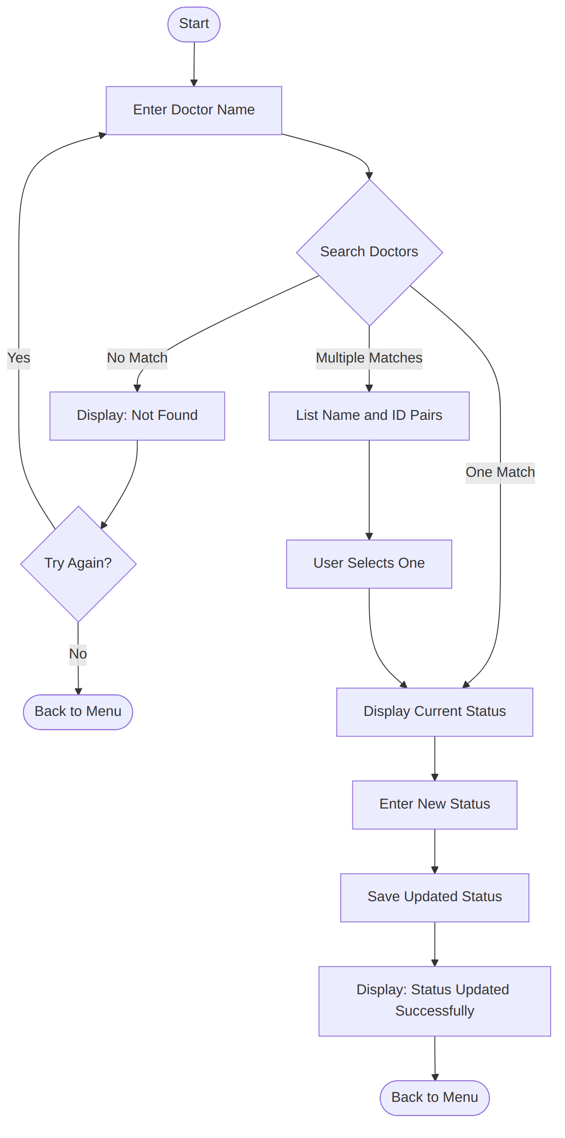

Tools and Technologies
Tool / Technology | Purpose
C++ | Programming language
Object-Oriented Programming | Classes and objects
Vectors (STL) | Temporary in-memory record management
Text Files (fstream) | Permanent data storage
Menu-driven Console | User interface
Microsoft Word | Documentation

Implementation
The Hospital Management System is implemented in C++ using a modular, menu-driven approach. The application is divided into four main classes: Patient, Doctor, Appointment, and Billing. Each class is responsible for handling its own records and related operations.
The system stores records temporarily using STL vectors during program execution and permanently using text files through file handling. This ensures that data remains available after the program is closed. Users interact with the system through a console-based menu where they can manage patients, doctors, appointments, and billing efficiently.
The implementation demonstrates the use of classes, objects, vectors, functions, conditional statements, loops, and file handling while following a modular design.
Program screenshots will be inserted in this section in the final report.

Testing
Test Case | Expected Result | Actual Result | Status
Add Patient | Patient record saved | Patient record saved | Passed
Search Patient | Correct patient displayed | Correct patient displayed | Passed
Update Patient | Record updated | Record updated | Passed
Add Doctor | Doctor added | Doctor added | Passed
Update Doctor Status | Status updated | Status updated | Passed
Book Appointment | Appointment booked | Appointment booked | Passed
Reschedule Appointment | Appointment updated | Appointment updated | Passed
Generate Bill | Bill generated | Bill generated | Passed
Search Bill | Correct bill displayed | Correct bill displayed | Passed

Conclusion
The Hospital Management System successfully demonstrates the practical application of Programming Fundamentals and Software Engineering concepts. It provides an organised way to manage patient, doctor, appointment, and billing records through a simple console-based interface. It also demonstrates the use of object-oriented programming, vectors and text-file handling in a real-world project.

Known Limitations
- Appointment status tracking has not been implemented.
- Date and time validation is not implemented; values are stored as simple strings.
- Appointment rescheduling can currently be applied regardless of the appointment date.
- Appointment cancellation is not currently available.
- Doctors can only be searched by name, not by specialisation.
- Bill updating is not currently supported.

Future Enhancements
- Implement appointment status tracking.
- Validate date and time formats before saving records.
- Allow doctor searches by specialisation.
- Add appointment cancellation functionality.
- Add bill update/edit functionality.
- Introduce user authentication and role-based access.
- Replace text files with a database such as MySQL or SQL Server.
- Develop a graphical user interface (GUI).

