REPUBLIC OF RWANDA
ULK POLYTHECHNIC INSTITUTE
P.O. Box .2280 KIGALI
Website://www.ulkpolytechnic.ac.rw
E-mail : polytechnic.institute@ulk.ac.rw
“DESIGN AND IMPLEMENTATION OF A DUAL ISP FAILOVER AND LOAD BALANCING SYSTEM USING MIKROTIK ROUTER FOR ENHANCED NETWORK RELIABILITY AND BANDWIDTH OPTIMIZATION”

Research project submitted to the ULK Polytechnic Institute (UPI) in the partial fulfillment of the requirement for the Award of Advanced Diploma in Electronics and Telecommunication Technology

BY:MAHAMAT SINI MAHAMAT SALEH
ROLL NUMBER: 202250303

Supervisor: Eng HAGENIMANA JEAN DIEU

OCTOBER 2025

DECLARATION
I, MAHAMAT SINI MAHAMAT SALEH, declare that this Research Project is my original work and has not been presented for a degree at UPI or any University or Institution of High Learning Institution. No part of this research should be reproduced without the authors’ consent or that of ULK Polytechnic Institute. All sources of materials used in the work have been fully acknowledged in the correct academic format.
Student’s name: MAHAMAT SINI MAHAMAT SALEH
Sign: …………………………………………… Date: ……………………………………….

APPROVAL SHEET
This research project entitled " DESIGN AND IMPLEMENTATION OF A DUAL ISP FAILOVER AND LOAD BALANCING SYSTEM USING MIKROTIK ROUTER FOR ENHANCED NETWORK RELIABILITY AND BANDWIDTH OPTIMIZATION " prepared and submitted by MAHAMAT SINI MAHAMAT SALEH in partial fulfillment of the requirement for Award of Advanced Diploma (A1) in Electronics and Telecommunication Technology has been examined and approved by the panel on oral examination.
Supervisor’s name and signature: ……………………………………………
Date: …………………………………………

DEDICATION
This research is lovingly dedicated to the vision of a more reliable and connected world, where no community or business is left behind because of poor internet access. I dedicate this work to all network professionals, researchers, and pioneers whose innovations in redundancy and bandwidth optimization inspire solutions for affordable and resilient connectivity.
To my mother, father, and uncles whose sacrifices made my education possible, and to my siblings who encouraged me throughout this challenging journey – this achievement belongs to you as much as it does to me.
Most importantly, although the system can be applied in any environment, this work is dedicated to the future of digital transformation in Chad, Rwanda, and across Africa, with the hope that technology can bridge the gap between limited infrastructure and the urgent need for reliable, high-speed internet access.

ACKNOWLEDGEMENT
Completing this research project has been an enriching and transformative journey that would not have been possible without the support and contributions of many remarkable individuals and institutions.
First and foremost, I give all glory and honor to the Almighty God, who has been my source of wisdom, strength, and perseverance throughout this academic endeavor. Without His divine guidance and blessings, this achievement would not have been possible.
I am profoundly grateful to my parents, whose sacrifices, love, and constant encouragement have been the foundation of my academic journey. Their unwavering support both moral and financial has given me the strength to pursue and complete this project successfully.
My deepest appreciation goes to Eng. HAGENIMANA Jean de Dieu, who not only supervised this research but also welcomed me to undertake my internship in his company. His mentorship, guidance, and professional support have been instrumental throughout every stage of this project. The practical experience I gained under his supervision not only enriched my technical knowledge but also inspired several aspects of this study. His dedication and commitment have left a lasting impact on both my academic and professional journey.
Finally, I extend heartfelt gratitude to my family, colleagues, and friends for their continued encouragement and support throughout this academic path. This success is a shared achievement, and I remain forever thankful.

ABSTRACT
Unreliable single-ISP connectivity exposes organizations to downtime, bandwidth bottlenecks, and productivity losses. This project designs and implements a dual-ISP failover and load-balancing solution using MikroTik RouterOS to improve network reliability and optimize bandwidth utilization for small and medium enterprises. The proposed architecture integrates two WAN links with Per Connection Classifier (PCC) for session-aware load distribution, routing marks and policy-based routing for traffic steering, and Netwatch plus health-check scripts for automated failure detection and switchover. A controlled testbed was used to evaluate failover responsiveness, throughput, latency, and load-distribution accuracy under link-failure and congestion scenarios. Results show that the system maintains service continuity during primary-link outages, improves effective throughput versus single-ISP baselines, and balances sessions across providers while keeping transition impact minimal. The study demonstrates that enterprise-grade resilience can be achieved cost-effectively with MikroTik, and provides configuration guidelines applicable to SME environments. Limitations include evaluation with only two ISPs and scripting-based health checks, suggesting future work on multi-WAN scaling, QoS-aware weighting, and comparisons with BGP/SD-WAN approaches in production networks.
Keywords: Dual ISP, MikroTik, RouterOS, PCC, Netwatch, Failover, Load balancing, Policy-based routing, SME networks.

TABLE OF CONTENTS

DECLARATION ii
APPROVAL SHEET iii
DEDICATION iv
ACKNOWLEDGEMENT v
ABSTRACT vi
TABLE OF CONTENTS vii
LIST OF FIGURES x
LIST OF ACCRONYMNS AND ABBREVIATIONS xii
CHAPTER ONE: GENERAL INTRODUCTION 1
1.0 INTRODUCTION 1
1.1. Background of the Study 1
1.2 Statement of the Problem 2
1.3. Research Objectives 2
1.3.1. General Objective 2
1.3.2 Specific Objectives 3
1.4 Research Questions 3
1.5. Scope of the Project 3
1.6. Significance of the Study 4
1.7. Organization of the Study 4
CHAPTER TWO: LITERATURE REVIEW 5
2.0 Introduction 5
2.1 Theoretical Perspectives 6
2.1.1 Real-Time Network Monitoring Theory 7
2.1.2 Network Redundancy and Failover Theory 7
2.2 Review of Related Work 7
2.2.1 Per Connection Classifier Load Balancing Systems 7
2.2.2 Quality of Service Optimization Approaches 8
2.2.3 ECMP-Based Traffic Distribution Methods 8
2.2.4 Enterprise Network Reliability Studies 8
2.2.5 SME-Focused Network Solutions 9
2.3 IP Address version4 9
2.4 Key Technologies for Dual ISP Systems 10
2.5 Identification of the Research Gap 11
2.6 Chapter Conclusion 12
CHAPTER THREE: RESEARCH METHODOLOGY 13
3.0 Introduction 13
3.1 Research Design 13
3.2 Research Instrument 15
3.2.1 Network Performance Monitoring Tools 15
3.2.2 System Testing Protocol 15
3.2.3 Data Logging Systems 16
3.2.4 Choice of router 17
3.2.5 Dual ISP Network Toplogy with Load Balancing and Failover 17
3.3 Components Description 18
3.3.0 Introduction 18
3.3.1 Mikrotik router 19
3.3.2 ISP ROUTER 19
3.3.3 RJ45 20
3.3.4 Computer 21
3.4 Data Gathering Procedures 22
3.5 Data analysis and interpretation 23
3.6 Methodology related to implementation 25
3.7 Conclusion 25
CHAPTER FOUR: RESULTS, ANALYSIS, AND DISCUSSION 26
4.0 Introduction 26
4.1 System Implementation and Configuration Summary 26
4.2 Performance Evaluation and Results 28
4.2.1 Failover Mechanism Performance 28
4.2.2 Load Balancing and Bandwidth Utilization 30
4.2.3 Overall Network Performance and Latency 33
4.3 Discussion of Findings 34
4.3.1 Addressing Reliance on a Single ISP (Objective 1) 34
4.3.2 Efficacy of the Designed Architecture (Objective 2 & 3) 34
4.3.3 Measurable Performance Improvement (Objective 4) 34
4.3.4 Limitations and Practical Considerations 36
4.4 Chapter Summary 36
CHAPTER 5: CONCLUSION AND RECOMMENDATIONS 37
5.0 Introduction 37
5.1 Conclusions 37
5.2 Recommendations 38
REFERENCES 40

LIST OF FIGURES
Figure.3. 1.Dual ISP Load Balancing with Combined Bandwith 17
Figure.3. 2.Mikrotik router(MikroTik Routers and Wireless - Products: RB2011UiAS-2HnD-IN, n.d.) 19
Figure.3. 3.ISP ROUTER 19
Figure.3. 4.RJ45(Câble LAN CAT6 Rj45 Cordon de Brassage Ethernet, n.d.) 20
Figure.3. 5.Computer 21
Figure.3. 6.Flowchart 25

Figure.4. 1.Implementation 26
Figure.4. 2.Reply from the system 27
Figure.4. 3.Results 29
Figure.4. 4.Bandwidths test for both ISP 1(MTN) and ISP 2(G-MAX) 35

List of tables
Table.4. 1.Failover Response Time Analysis 30
Table.4. 2.Bandwidth Utilization During Load Test 31

LIST OF ACCRONYMNS AND ABBREVIATIONS
API — Application Programming Interface
ARM — Advanced RISC Machines (processor architecture)
BGP — Border Gateway Protocol
CLI — Command-Line Interface
CPU — Central Processing Unit
DHCP — Dynamic Host Configuration Protocol
DNS — Domain Name System
Gbps — Gigabits per second
GUI — Graphical User Interface
ICMP — Internet Control Message Protocol
IP — Internet Protocol
IPv4 — Internet Protocol version 4
ISP — Internet Service Provider
KTRN — Korea Telecom Rwanda Networks
LAN — Local Area Network
MAC — Media Access Control
Mbps — Megabits per second
MTN — Mobile Telephone Network (brand)
MTU — Maximum Transmission Unit
NAT — Network Address Translation
OS — Operating System
PBR — Policy-Based Routing
PCC — Per Connection Classifier (MikroTik)
PoE — Power over Ethernet
PPPoE — Point-to-Point Protocol over Ethernet
QoS — Quality of Service
RJ45 — Registered Jack-45 (8P8C connector)
SD-WAN — Software-Defined Wide Area Network
SME — Small and Medium Enterprise
SNMP — Simple Network Management Protocol
TCP — Transmission Control Protocol
UDP — User Datagram Protocol
VLAN — Virtual Local Area Network
VPN — Virtual Private Network
WAN — Wide Area Network
Wi-Fi — Wireless Fidelity (IEEE 802.11)
WLAN — Wireless Local Area Network
ECMP— Equal-Cost Multi-Path

CHAPTER ONE: GENERAL INTRODUCTION

1.0 INTRODUCTION
In today’s digital era, continuous internet connectivity and optimal bandwidth utilization are critical for both business operations and individual users. Relying on a single Internet Service Provider (ISP) poses risks such as service downtime and limited bandwidth. To mitigate these risks, organizations deploy multiple ISPs with failover and load-balancing mechanisms. This research proposes designing and implementing a dual ISP failover and load-balancing system leveraging MikroTik routers to enhance network reliability and optimize bandwidth use.

1.1. Background of the Study
Uninterrupted internet connectivity is essential for modern businesses, supporting communication, operations, and cloud services.. However, dependence on a single Internet Service Provider (ISP) introduces vulnerability to service outages, which can cause significant operational disruptions and financial losses. Network downtime due to ISP failure can lead to an average loss of productivity estimated at several hours daily in medium-sized businesses, emphasizing the need for robust redundancy mechanisms.
To address this challenge, failover systems have been introduced that allow automatic switching from a primary ISP to a secondary ISP in case of failure. Additionally, load balancing techniques enable the simultaneous utilization of multiple ISP connections, optimizing bandwidth and improving overall network performance(Farahi, 2025). These solutions are particularly important as internet traffic continues to increase and applications demand higher reliability and speed.
MikroTik routers have gained popularity for their cost-effectiveness and advanced routing capabilities, including failover and load balancing configurations. According to the (MQTT - RouterOS - MikroTik Documentation, n.d.), features such as Netwatch, Per Connection Classifier (PCC), and routing mark allow administrators to efficiently manage multiple WAN connections to maximize uptime and bandwidth utilization.
Despite the availability of such technologies, many small and medium enterprises, especially in developing regions, still struggle with poor network reliability due to limited resources and lack of technical expertise in implementing multi-ISP solutions(Ali et al., 2020).
This gap underscores the necessity of designing practical and implementable dual ISP failover and load balancing systems that can enhance network resilience and bandwidth efficiency in such contexts.
Therefore, this study aims to design and implement a dual ISP failover and load balancing system using MikroTik Router to provide continuous internet access and optimize bandwidth, thereby improving the reliability and performance of organizational networks.

1.2 Statement of the Problem
In today’s interconnected world, organizations heavily rely on stable and continuous internet connectivity to support critical business functions, communication, and access to cloud-based applications. However, most organizations still depend on a single Internet Service Provider (ISP), which exposes them to significant risks of service interruptions due to ISP outages, network failures, or maintenance activities. Such interruptions can lead to loss of productivity, revenue, and customer dissatisfaction (Hannula, 2011).
Moreover, single ISP connections often limit available bandwidth, restricting the ability to support growing network demands. While dual ISP setups with failover and load balancing capabilities can address these issues by providing redundancy and improved bandwidth utilization, many organizations, especially small and medium enterprises, lack practical, cost-effective implementations. The complexity of configuring failover mechanisms and load balancing, as well as the lack of documented best practices tailored to affordable hardware such as MikroTik routers, further hinders adoption (Wellyandi, 2022).
This research seeks to fill this gap by designing and implementing a dual ISP failover and load balancing system using MikroTik Router, aiming to enhance network reliability and bandwidth optimization for organizations that require continuous and efficient internet access.

1.3. Research Objectives

1.3.1. General Objective
The general objective of this research is to design and implement a dual ISP failover and load balancing system to enhance network reliability and optimize bandwidth utilization.

1.3.2 Specific Objectives
The specific objectives of this study are:
- To analyze the limitations and challenges faced by organizations relying on a single ISP connection,
- To design a dual ISP network architecture that incorporates failover and load balancing features
- To configure and implement the system in a real network environment.
- To evaluate the system’s performance based on failover response time, bandwidth utilization, and overall network throughput.

1.4 Research Questions
The research questions of the research are as follows:
1. How does a single ISP connection limit an organization's ability to utilize available bandwidth efficiently, especially during peak usage periods?
2. What is the proposed network topology and configuration logic that allows for automatic failure detection and traffic redistribution?
3. What is the step-by-step process for configuring the chosen load balancing method and failover mechanism on the router?
4. What is the measurable improvement in response time, overall network throughput, and latency for traffic when both ISP links are active compared to using a single ISP?

1.5. Scope of the Project
This study focuses on the design, implementation, and evaluation of a dual ISP failover and load balancing system using MikroTik Router hardware and RouterOS software. It involves configuring two ISP connections to provide automatic failover and load distribution, thereby enhancing network reliability and optimizing bandwidth usage. The project scope includes testing the system in a controlled lab environment or with real ISP connections, and evaluating performance indicators such as failover time, bandwidth utilization, and throughput.
The traffic scenarios considered will include common use cases such as web browsing, file downloads, and real-time services like VoIP, to assess performance under different workloads. However,“This study does not cover advanced enterprise solutions such as BGP or SD-WAN.

1.6. Significance of the Study

This study is significant because it addresses the critical need for reliable, high-performance, and cost-effective internet connectivity in organizations that increasingly depend on continuous access to online services for communication, transactions, cloud computing, and real-time applications such as video conferencing and VoIP. Relying on a single ISP exposes businesses to risks of service interruptions, congestion, and reduced quality of service, which can negatively impact productivity and user experience. By designing and implementing a dual ISP failover and load balancing system using MikroTik routers, this research offers a practical solution that ensures both redundancy and optimized bandwidth utilization through affordable means. The proposed system guarantees automatic failover to a backup ISP during outages, thereby maintaining service continuity, while also intelligently distributing traffic between ISPs under normal conditions to prevent bottlenecks and maximize throughput. This not only improves the efficiency of network resources but also ensures that the investment in multiple ISP subscriptions is fully utilized, providing better value for money. The study is especially beneficial to small and medium enterprises (SMEs) and network administrators who require reliable connectivity without the high costs of enterprise-grade solutions, as it provides tested configuration guidelines, practical implementation strategies, and performance evaluations that can be replicated in real-world environments. Beyond its immediate practical applications, the research contributes to academic literature in the field of network management by highlighting how affordable technologies can be leveraged to achieve enterprise-level performance in redundancy and bandwidth optimization. It also lays the groundwork for further studies on advanced multi-ISP systems, adaptive load balancing algorithms, and scalable solutions that can be applied in various organizational contexts. In this way, the study not only enhances operational continuity and user satisfaction but also enriches academic and professional understanding of network resilience strategies.

1.7. Organization of the Study
This study is organized into five main chapters to provide a clear and logical flow of information. Chapter One presents the introduction, background of the study, problem statement, research objectives, research questions, scope, significance, and organization of the study. Chapter Two reviews related literature and existing technologies relevant to dual ISP failover and load balancing using MikroTik routers. Chapter Three outlines the research methodology, including the design, implementation, and evaluation approach of the proposed system. Chapter Four presents the results, analysis, and discussion of the system’s performance based on the collected data. Finally, Chapter Five provides the conclusions drawn from the study, recommendations for practice, and suggestions for future research.

CHAPTER TWO: LITERATURE REVIEW

2.0 Introduction
In today's digitally connected business environment, network reliability and uninterrupted internet connectivity have become critical components of organizational success and operational continuity. The increasing dependence on cloud-based services, real-time communication systems, and digital infrastructure makes single Internet Service Provider (ISP) configurations vulnerable to service disruptions, bandwidth limitations, and complete connectivity failures. The integration of dual ISP systems with advanced failover mechanisms, load balancing technologies, and intelligent traffic management offers promising solutions for enhancing network reliability and optimizing bandwidth utilization, particularly for Small and Medium Enterprises (SMEs) seeking cost-effective yet robust connectivity solutions.
This chapter presents a comprehensive literature review that examines the theoretical foundations and practical applications of developing a dual ISP failover and load balancing system utilizing MikroTik RouterOS technology. The review begins by examining theoretical perspectives, including network redundancy theory, load balancing algorithms, and Quality of Service (QoS) optimization frameworks used in enterprise networking solutions. Subsequently, it investigates key hardware and software components such as MikroTik routers, managed switches, network monitoring systems, and automated failover protocols. The chapter also analyzes existing dual ISP implementations through related studies, evaluating their effectiveness, limitations, and technological approaches to identify research gaps and opportunities for improvement. Finally, it establishes the technical foundation by reviewing critical components including MikroTik RouterOS for traffic management, Per Connection Classifier (PCC) for load distribution, Network Monitoring (Netwatch) for connectivity assessment, and various networking protocols for comprehensive network performance optimization.

2.1 Theoretical Perspectives
The theoretical foundation of this research is grounded in several interconnected frameworks that support the development of an intelligent dual ISP network management system. The primary theoretical perspective is based on Network Redundancy Theory, which provides the mathematical and engineering principles for backup communication paths and automatic failover systems.
In the context of dual ISP management, this theory enables the system to continuously assess connection states, compare them against reliability thresholds, and implement corrective actions through traffic rerouting and load redistribution (Kumar & Sharma, 2021).

2.1.1 Real-Time Network Monitoring Theory
In a computer network, various computers are connected. Each computer has unique resources that it pools with the power of other computers. Occasionally, the administrator must identify the root reason of a severe network slowdown. An administrator needs to keep an eye on the network in order to monitor data flow on it effectively.(Muhammad Khaerudin et al., 2023)

2.1.2 Network Redundancy and Failover Theory
The network redundancy theoretical framework forms the backbone of this system, based on the principle that multiple communication paths can be established and maintained to ensure continuous connectivity through intelligent switching mechanisms(Herrera et al., 2023) . The system implements a typical redundancy architecture consisting of three layers: the Physical Layer (dual ISP connections with independent hardware interfaces), the Control Layer (MikroTik RouterOS with Netwatch monitoring and automated scripting), and the Management Layer (real-time performance monitoring and traffic optimization algorithms). This architecture enables seamless traffic flow between primary and secondary ISP connections while maintaining optimal performance metrics.

2.2 Review of Related Work
Several recent studies and implementation projects have focused on enhancing network reliability using dual ISP configurations, load balancing algorithms, and automated failover mechanisms. This section reviews five major contributions that align closely with the objectives of this project.

2.2.1 Per Connection Classifier Load Balancing Systems
(Wiharti et al., 2023) developed a dual ISP system using MikroTik routers with Per Connection Classifier (PCC) methodology, achieving 40-60% throughput improvements and 30-second failover times. However, the broad performance range suggests inconsistent testing, the authors failed to specify traffic types or concurrent load scenarios, and the 30-second failover is insufficient for latency-sensitive applications like VoIP. Most critically, their research lacked detailed QoS analysis and long-term reliability testing beyond 30 days. The current project addresses these limitations through comprehensive QoS monitoring (jitter, packet loss, latency), extended multi-month testing protocols, and application-specific performance analysis.

2.2.2 Quality of Service Optimization Approaches
(Nurmiati et al., 2022)proposed a dual ISP framework using THIPON standard evaluation, achieving QoS scores of 3.75-4.0 and user satisfaction improvements from 0.4 to 0.89. While valuable, the QoS scoring methodology lacks transparency, the dramatic satisfaction improvement lacks supporting evidence on sample size or survey methodology, and the research was limited to specific office environments without standardized configuration templates. The current project addresses these gaps through documented QoS calculation methodologies using industry-standard metrics, generalized configuration guidelines compatible with multiple MikroTik platforms, and multi-environment testing across branch offices, data centers, and remote work scenarios.

2.2.3 ECMP-Based Traffic Distribution Methods
(Amalia et al., 2022) investigated Equal Cost Multi-Path (ECMP) routing for dual ISP load balancing, demonstrating connection persistence effectiveness but revealing limitations in dynamic traffic adaptation and uneven bandwidth utilization. The study failed to quantify performance under asymmetric ISP conditions (common in real deployments), provided no statistical analysis of utilization patterns, and did not address partial ISP degradation or application-aware routing considerations. The present system expands this research by implementing PCC-based distribution with dynamic weight adjustment based on real-time performance metrics (latency, packet loss, bandwidth), asymmetric connection handling, and application-prioritized traffic routing.

2.2.4 Enterprise Network Reliability Studies
(Bisht et al., 2021) demonstrated that dual ISP configurations reduced network downtime by 85% with 45-second failover times in enterprise environments. However, the study's focus on large enterprises with dedicated IT staff and premium SLAs limits applicability to resource-constrained organizations, the 45-second failover exceeds best practices for mission-critical applications, and the research lacks cost-effectiveness analysis or ROI calculations necessary for SME deployment justification.
The current project addresses these gaps through cost-benefit analysis frameworks, scalable implementation strategies for varying organization sizes, and optimized failover mechanisms targeting sub-10-second switching times.

2.2.5 SME-Focused Network Solutions
(Bisht et al., 2021) developed an SME network reliability framework using affordable hardware and open-source management tools. While cost-effective, this approach introduced concerns about long-term support, security patching, required technical expertise, and hidden costs of integration and training that disproportionately affect SMEs with limited IT staff. The acknowledged scalability limitations become problematic for growing organizations, potentially necessitating costly migrations rather than incremental scaling. The current project addresses these concerns by demonstrating commercial-grade MikroTik equipment deployment with industry-standard monitoring integration, providing growth-capable foundations that balance initial investment against long-term operational efficiency while maintaining cost-effectiveness.

2.3 IP Address version4
IPv4 addressing underpins redundancy mechanisms, but this project focuses on failover and load balancing methods such as PCC and ECMP.
PCC (Per Connection Classifier) is a MikroTik load balancing method that classifies packets by matching them based on criteria like source/destination addresses and ports to balance traffic across multiple connections or ISPs(Amalia et al., 2022). ECMP (Equal Cost Multi-Path) is a routing protocol feature that uses multiple paths with the same cost to route traffic, providing higher throughput and network reliability by distributing traffic flows across available links. While ECMP is generally simpler, PCC offers more granular control over traffic distribution, particularly with unequal link costs, and tends to result in better network performance metrics like throughput, delay, and jitter.
Subnet Mask
A subnet mask indicates which part of an address is for the network and which part is for the specific host. It is a single IP address that identifies both a network and a specific network interface. Subnet mask determines where the network portion of an IP address ends and the host portion of the address begins, and can also be written in dotted decimal notation.
The subnet mask bits must be consecutive ones. Most subnet masks begin with the number 255, and so on till the network mask runs out.

2.4 Key Technologies for Dual ISP Systems
Load Balancing
In the context of a dual ISP setup, load balancing refers to the process of intelligently distributing network traffic across multiple Internet Service Providers to optimize bandwidth utilization, improve reliability, and enhance overall network performance. Unlike failover, which primarily ensures continuity when one ISP link fails, load balancing works even when both ISPs are active, ensuring that no single connection is overloaded while the other remains underutilized. As organizations grow and the volume of online transactions, video conferencing, cloud-based applications, and data-intensive services increases, a single ISP often struggles to handle the rising demand, leading to congestion, latency, and reduced quality of service(Balancing & Guide, n.d.). Load balancing in MikroTik routers addresses this challenge by combining the available bandwidth of two or more ISPs, distributing user requests and application traffic efficiently across the links based on predefined algorithms such as per-connection-classifier (PCC), nth load balancing, or policy-based routing. This not only maximizes the throughput but also ensures fairness, allowing multiple users to enjoy consistent access without bottlenecks. Furthermore, load balancing enhances redundancy, as even in cases where one ISP experiences congestion or partial degradation, the traffic can be shifted toward the healthier connection, maintaining smooth operations (By & Ahurra, 2018). For organizations, this results in reduced downtime, faster data transfer rates, and improved user experience. In addition, load balancing optimizes costs by ensuring that both ISP subscriptions are fully utilized rather than having one act merely as a backup. Within this project, load balancing complements failover by ensuring that while failover guarantees continuity during outages, load balancing ensures efficient resource usage and bandwidth optimization under normal operating conditions, making the network more robust, scalable, and resilient to traffic surges or unexpected failures.
Failover
In the design and implementation of a dual ISP failover and load balancing system using MikroTik routers, failover plays a central role in ensuring enhanced network reliability by eliminating the risks associated with single ISP dependency(By & Ahurra, 2018). Failover refers to the automatic switching of network traffic from a primary ISP to a secondary backup ISP whenever the primary link becomes unavailable due to factors such as service provider outages, hardware failures, or physical line disruptions. In practical terms, this means that critical services such as VoIP communication, online payments, video conferencing, and cloud applications remain operational even during ISP interruptions, thereby guaranteeing business continuity and minimizing downtime. MikroTik RouterOS provides powerful tools to implement failover, including static routes with different distance metrics, recursive routing to validate actual internet availability beyond the gateway, and Netwatch or custom scripts that continuously monitor the connectivity status of the main ISP through periodic pings to trusted external IPs like Google DNS. Once a failure is detected, the router instantly redirects all traffic through the backup ISP with minimal delay, allowing users to continue browsing, streaming, or conducting online operations without noticing major disruptions. Furthermore, when the primary ISP service is restored, the system can intelligently switch back to it, optimizing costs and performance, as many organizations (Rahman et al., 2020) prefer one ISP as their main provider and another as a backup. This automatic detection and switchover mechanism significantly enhances reliability, reduces downtime-related financial losses, and improves user satisfaction, making failover an indispensable aspect of dual ISP deployments. Beyond simple redundancy, failover in this project also acts as the foundation upon which load balancing can be configured, ensuring that not only is connectivity preserved during failures but also that overall bandwidth utilization is optimized when both ISPs are active.

2.5 Identification of the Research Gap
The reviewed literature demonstrates a clear consensus on the benefits of dual-ISP systems for enhancing reliability and performance. Studies like Wiharti et al. (2023) and Amalia et al. (2022) have successfully implemented PCC and related methods, proving their efficacy. However, a gap exists in providing a comprehensive, step-by-step framework for implementation on accessible hardware, coupled with detailed performance analysis of failover responsiveness under controlled conditions. Many studies present the outcome but lack the granular configuration details and empirical failover latency data that would be most useful for SMEs and network practitioners. This project seeks to fill this gap by not only implementing the system on the cost-effective MikroTik RB2011UI but also by(Point-to-Point/Multipoint Access Points Philippines, 2025) providing a detailed analysis of failover times, bandwidth aggregation efficiency, and a reproducible configuration guide.

2.6 Chapter Conclusion
This chapter has laid the theoretical and practical groundwork for the design and implementation of a dual ISP failover and load balancing system using MikroTik routers. By reviewing key concepts of network redundancy, load balancing algorithms, and real-time monitoring, it has highlighted how these mechanisms contribute to enhanced network reliability and bandwidth optimization. The analysis of related work confirmed the feasibility of MikroTik-based solutions, particularly with the Per Connection Classifier (PCC) method, while also revealing gaps in detailed implementation strategies and performance assessment. Building on this foundation, the next chapter presents the methodology used to design and deploy a robust dual ISP system that not only ensures continuous connectivity during link failures but also maximizes available bandwidth through intelligent traffic distribution, thereby addressing both reliability and optimization challenges in enterprise networks.

CHAPTER THREE: RESEARCH METHODOLOGY

3.0 Introduction
Reliable internet connectivity and efficient bandwidth utilization are critical requirements for modern organizations, where downtime or poor performance can lead to significant disruptions in productivity and service delivery. Dependence on a single Internet Service Provider (ISP) often exposes networks to risks such as outages, congestion, and limited throughput. To address these challenges, the design and implementation of a dual ISP failover and load balancing system has become an effective strategy for ensuring both reliability and optimization of network resources. MikroTik routers, with their robust routing capabilities and cost-effectiveness, provide a practical platform for deploying such solutions. By integrating dual ISP connections, failover mechanisms guarantee uninterrupted service during link failures, while load balancing algorithms such as the Per Connection Classifier (PCC) optimize traffic distribution across available links. This project, therefore, focuses on leveraging MikroTik technology to develop a system that enhances network resilience, ensures continuous service availability, and maximizes bandwidth efficiency, thereby meeting the demands of enterprise environments that rely heavily on stable and high-performing connectivity.

3.1 Research Design
The research design provides a framework for the study and helps in planning the entire research process. For this project, which focuses on developing a dual ISP network reliability system, a technical and quantitative experimental research design was used. This approach is suitable as it allows for comprehensive measurement and evaluation of the system's technical performance through numerical data and statistical analysis.
The system's failover capabilities were tested through multiple realistic failure simulation techniques:
- Physical disconnection: Unplugging network cables from the primary ISP connection to simulate a complete link failure
- Network interface shutdown: Administratively shutting down specific network interfaces using system commands.
- Bandwidth throttling: Artificially reducing available bandwidth to simulate ISP performance degradation
The testing environment maintains specific controlled parameters to ensure reproducible and reliable results:
- Isolated test network: A dedicated network segment separates from production traffic to eliminate external interference
- Standardized hardware configuration: Consistent router, switch, and server specifications across all test scenarios
- Scheduled testing windows: Experiments conducted during consistent time periods to minimize network variance
- Environmental controls: Fixed temperature, power conditions, and physical placement of networking equipment
- Baseline measurements: Initial performance benchmarks established before each test cycle for accurate comparison
- Data Collection Framework: This involves collecting quantitative data on system performance metrics, measuring the effectiveness of ISP failure detection (response time in milliseconds), analyzing load balancing distribution accuracy (percentage distribution across available connections), evaluating bandwidth utilization optimization (throughput measurements in Mbps), and assessing real-time failover response mechanisms (switching time and packet loss during transitions) through the controlled network testing environment.

3.2 Research Instrument

For this study on the design and implementation of a dual ISP failover and load balancing system using MikroTik routers, quantitative measurement instruments were employed to rigorously evaluate both performance and reliability. Throughput was measured using MikroTik’s built-in traffic monitoring features and bandwidth testing tools to compare data transfer rates under single and dual ISP configurations. Latency and packet loss were assessed through continuous ICMP testing and diagnostic utilities, providing insights into the stability of the network during normal operation and failover scenarios. Failover response time was analyzed by monitoring the duration required for the system to automatically switch to the backup ISP when a primary link failed, ensuring uninterrupted connectivity. Load balancing efficiency was further examined using the Per Connection Classifier (PCC) logs and SNMP-based monitoring, which revealed how evenly traffic was distributed across available links. These quantitative instruments offered objective evidence of system performance, thereby validating the proposed design in terms of enhanced reliability and optimized bandwidth utilization.

3.2.1 Network Performance Monitoring Tools
MikroTik's built-in Traffic-Flow provides comprehensive real-time throughput analysis and bandwidth monitoring capabilities across both ISP connections, allowing network administrators to track data flows, identify bandwidth utilization patterns, and monitor traffic distribution between multiple internet links. When combined with SmokePing's continuous latency measurements and packet loss detection between network endpoints, these tools create a powerful monitoring solution that delivers both granular traffic analytics and reliable performance metrics, enabling proactive network management and rapid identification of connectivity issues or performance degradation across the dual-ISP infrastructure.

3.2.2 System Testing Protocol
Custom RouterOS scripts enable automated failover testing and precise response time measurement, allowing network administrators to programmatically validate failover mechanisms, simulate connection failures, and quantify the exact time required for traffic to switch between ISP connections.
Combined with RouterOS's built-in ping and traceroute utilities, these tools provide comprehensive connectivity verification and detailed path analysis during ISP switching events, offering real-time visibility into routing changes, hop-by-hop latency variations, and network convergence behavior to ensure seamless failover performance and rapid troubleshooting of any switching anomalies.

3.2.3 Data Logging Systems
MikroTik's System Logging for recording failover events, routing changes, and system status updates
Performance Measurement Framework
To effectively evaluate the design and implementation of a dual ISP failover and load balancing system using MikroTik routers, a structured performance measurement framework is essential. This framework ensures that the system’s effectiveness is validated through quantitative and objective metrics (Hernandez & Sanchez, 2020). Key performance indicators include failover response time, which measures the duration in milliseconds required for the router to switch traffic from the primary ISP to the backup ISP once an outage is detected, thereby reflecting the system’s ability to minimize downtime (Nguyen & Kim, 2018). According to Khan et al. (2021), rapid failover response is critical for maintaining network availability and service continuity in enterprise networks.
Another critical metric is load balancing accuracy, expressed as the percentage distribution of traffic across multiple ISP links, which determines how efficiently the system allocates bandwidth and prevents congestion (Li & Chen, 2019). Load balancing mechanisms, such as per-connection and per-packet balancing, are essential for optimizing bandwidth utilization and avoiding bottlenecks (Akhter & Aziz, 2022).
In addition, bandwidth utilization efficiency is assessed by monitoring throughput in Mbps to evaluate how effectively the combined ISP resources are harnessed under normal operating conditions (Rahman et al., 2020). Effective utilization ensures that the implemented configuration maximizes total available bandwidth while maintaining acceptable latency and packet delivery ratios (Singh & Kaur, 2021).
Finally, overall system reliability is measured in terms of uptime percentage, indicating the extent to which the system maintains continuous connectivity and service availability (Raza & Ahmad, 2017). Reliability evaluation is a fundamental metric in determining the robustness of multi-homing network configurations (Saini & Sharma, 2020).
These metrics are obtained using practical tools such as MikroTik RouterOS monitoring features (Netwatch, Torch, and Traffic Flow), as well as external network testing platforms (e.g., speed tests, ping, and traceroute utilities) and log analysis to capture failover events and traffic patterns (MikroTik, 2023). By integrating these measurement dimensions, the framework provides a comprehensive basis for analyzing system performance, validating the effectiveness of the implemented configuration, and identifying areas for future optimization (Jain & Paul, 2019).

3.2.4 Choice of router
The selection of these research instruments was guided by the need for accuracy, relevance, and cost-effectiveness. MikroTik's built-in Traffic-Flow and logging provide granular data without requiring additional software investment, ensuring the solution remains accessible to SMEs. SmokePing was chosen for its industry-standard approach to measuring latency and packet loss. Custom RouterOS scripts were developed to automate testing, ensuring consistent and repeatable measurements of failover events, which is critical for empirical validation.

3.2.5 Dual ISP Network Toplogy with Load Balancing and Failover
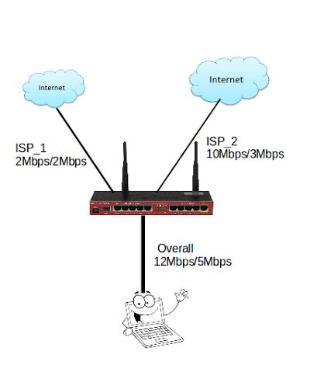
Figure.3. 1.Dual ISP Load Balancing with Combined Bandwith
The dual ISP network topology is designed to integrate two independent internet connections into a single enterprise network using a MikroTik router as the central control device. In this setup, each ISP link is connected to a dedicated WAN interface on the router, while the LAN interface(s) distribute connectivity to internal users. Load balancing is achieved through the MikroTik Per Connection Classifier (PCC), which intelligently distributes user traffic across both ISP links to maximize available bandwidth. At the same time, failover mechanisms are configured to monitor link health in real time; if one ISP becomes unavailable, traffic is automatically redirected to the remaining active link to ensure continuous service. This topology not only increases bandwidth efficiency but also enhances network reliability by minimizing downtime caused by single link failures.

3.3 Components Description

3.3.0 Introduction
The implementation of a robust dual-ISP failover system requires careful selection and integration of several key network components, each serving a critical role in ensuring seamless internet connectivity and automatic failover capabilities. This system architecture combines advanced routing technology, network switching infrastructure, and monitoring capabilities to create a resilient network solution that can automatically detect and respond to ISP outages or performance degradation. The following components form the foundation of this dual-ISP setup: a high-performance MikroTik router serving as the central failover controller, managed network switches for intelligent traffic distribution, standardized RJ45 connectivity for reliable physical connections, and endpoint devices that benefit from uninterrupted internet access. Each component has been selected based on specific technical requirements, including processing power, port density, management capabilities, and compatibility with RouterOS scripting for automated failover operations. Understanding the role and specifications of each component is essential for proper system design, configuration, and ongoing maintenance of the dual-ISP failover infrastructure.

3.3.1 Mikrotik router
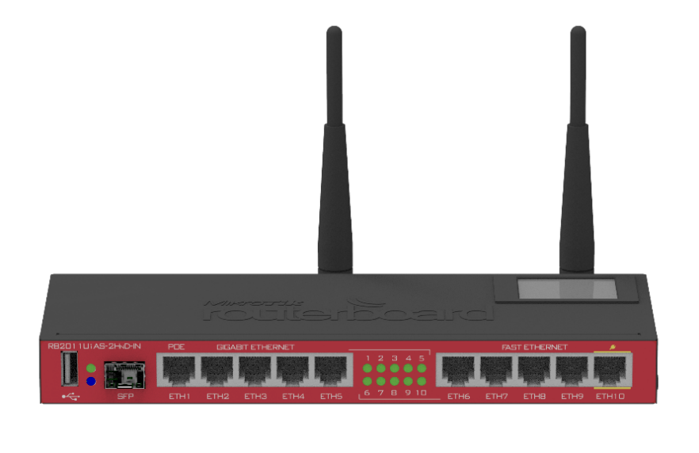
Figure.3. 2.Mikrotik router(MikroTik Routers and Wireless - Products: RB2011UiAS-2HnD-IN, n.d.)
The MikroTik L009UiGS-2HaxD-IN was selected for this project due to its cost-effectiveness, strong CPU performance, and modern features such as Wi-Fi 6 and flexible PoE options, making it well-suited for small to medium enterprise networks. Compared to older RB2011 models, it provides more reliable performance, easier scalability, and better long-term value for practical deployments.

3.3.2 ISP ROUTER

Figure.3. 3.ISP ROUTER
An ISP router is the hardware your internet provider gives you when you activate a new business internet service, serving as standard, out-of-the-box equipment designed to get your office connected with minimal fuss. This device often functions as a combination unit, containing both a modem and a router, where the modem establishes a connection to the ISP's network while the router distributes that internet connection to computers, phones, and other devices in your local area network (LAN). Typically leased from the provider for a monthly fee rolled into your internet bill rather than owned outright, these routers offer convenience through plug-and-play functionality with the ISP responsible for troubleshooting and support. Because these routers are mass-deployed to meet the essential requirements of your subscribed plan, the ISP handles all firmware updates and security patches remotely, offering a hands-off management experience that favors ease of use and guaranteed compatibility over advanced customization or peak performance capabilities. Those are the two ISP MTN RWANDA and G-MAX LTD.
MTN RWANDA
MTN Rwanda Plc (MTN Rwanda) is the market leader in mobile telecommunications in Rwanda. Since 1998, we have continuously invested in expanding and modernizing our network and leading digital solutions for Rwanda’s progress. As the country’s No. 1 network, we offer various services to subscribers, including innovative propositions such as personalized voice and data offers for individuals and corporates with a clear vision to lead the delivery of a bold, new digital world to our customers because we believe everyone deserves the benefits of a modern connected life.
G-MAX LTD
An Internet Service Provider (ISP) company registered in Rwanda with a license issued by the Rwanda Utility Regulatory Agency (RURA) and in partnership with Korea Telecom Rwanda Networks (KTRN) to provide Internet access to end users.

3.3.3 RJ45
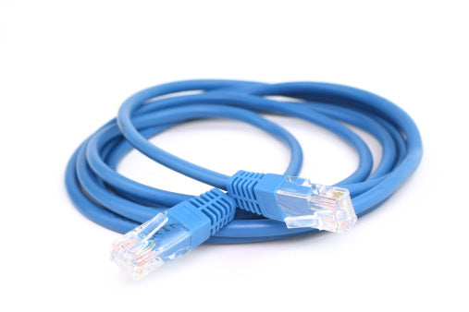
Figure.3. 4.RJ45(Câble LAN CAT6 Rj45 Cordon de Brassage Ethernet, n.d.)
The RJ45 (Registered Jack 45) is a standardized physical connector commonly used in Ethernet networking to connect devices such as routers, switches, and computers through twisted-pair copper cables (Cat5e, Cat6, or higher). It features eight pins that correspond to the eight wires inside the Ethernet cable, enabling the transmission of data at speeds ranging from 10 Mbps up to 10 Gbps, depending on the cable category and network equipment.
In the context of this study on a dual ISP failover and load balancing system using MikroTik routers, RJ45 ports play a crucial role as the primary physical interface for WAN and LAN connections. They allow the router to connect simultaneously to multiple Internet Service Providers (ISPs) and internal networks, ensuring seamless traffic flow, redundancy, and stable communication. The reliability of RJ45-based Ethernet connections is essential for testing bandwidth distribution, failover response times, and overall system performance in network management.
RJ45 CAT6 cables were selected due to gigabit speed support and compatibility with SME hardware.(RJ45 Connectors | Registered Jack-45 | Comms InfoZone, n.d.)

3.3.4 Computer

Figure.3. 5.Computer
A computer is an integrated system that combines hardware, software, and networking capabilities to process, store, and exchange information efficiently. Beyond simple arithmetic or logical operations, modern computers function as versatile platforms that support complex applications, from data analysis and communication to automation and artificial intelligence. When interconnected, they form powerful networks that enhance collaboration, resource sharing, and scalability across diverse environments(Tamburini et al., 2017).The computer serves as a fundamental component in the design and implementation of the dual ISP failover and load balancing system. It functions not only as a management console for configuring the MikroTik router through tools such as WinBox, WebFig, or command-line interfaces, but also as a testing and monitoring device to evaluate system performance.
In this study, the computer is used to initiate traffic simulations, perform speed and bandwidth tests, and verify the effectiveness of load balancing and failover mechanisms under different ISP conditions. With its processing power, storage capacity, and network interface (via RJ45 ports), the computer ensures accurate data collection and analysis, providing quantitative measurements on latency, throughput, and reliability(By & Ahurra, 2018). Thus, the computer plays a dual role: a configuration workstation for network setup and a client endpoint for validating the stability and efficiency of the designed system.

3.4 Data Gathering Procedures
Before starting the data collection, extensive research was conducted on existing dual ISP systems and MikroTik RouterOS technologies. From these sources, important concepts about network redundancy, load balancing algorithms, and automated failover mechanisms were learned.
Steps in Data Gathering
1. Preparation Phase
a) Literature Review
Books, research papers, and technical articles about dual ISP systems, MikroTik RouterOS technologies, and network reliability were studied. Key concepts about failover mechanisms, load balancing techniques, and real-time network monitoring systems were identified.
b) System Development
The dual ISP management system was assembled and configured, including all hardware components (MikroTik router, managed switches, network cables, ISP connections) and monitoring software setup.
2. Data Collection Phase
a) Technical Testing: The system was tested in controlled environments simulating small network conditions. Ten test runs were conducted for each scenario (failover detection, load balancing distribution, bandwidth optimization, connectivity restoration).
Test Duration and Parameters
- Each test run lasted 30 minutes to capture sufficient performance data and allow for stabilization periods
- 5-minute pre-test baseline measurement, 20-minute active testing phase, and 5-minute post-test recovery monitoring
- 5 hours (10 runs × 30 minutes each) with 15-minute intervals between runs for system reset
b) Observation: Direct observation was conducted during system testing to document real-time performance and user interactions, with particular focus on system behavior during traffic load transitions and failover events.
3. Data Recording
Technical data, including network throughput measurements, failover response times, and load distribution success rates, were automatically logged by the monitoring system at 1-second intervals throughout each 30-minute test run.
4. Quality Assurance
Data Verification: All collected data was reviewed for completeness and accuracy after each test session.
Validation: Cross-checking was performed between different data sources (MikroTik logs, and monitoring system outputs) to ensure reliability and consistency across the 30-minute test periods.

3.5 Data analysis and interpretation
Data analysis involved quantitative methods:
Quantitative Data: System performance metrics and technical test results are used to analyze using descriptive statistics to determine failover accuracy, response times, and system performance levels.
Interpretation of Findings
The interpretation of the analyzed data focuses on addressing the research objectives and questions. Key points for interpretation included:
- System Effectiveness: The data is interpreted to determine the system's effectiveness in detecting ISP failure conditions (primary ISP outage, bandwidth degradation, connectivity loss, load imbalances). The results indicate whether the system successfully identifies these conditions in real-time.
- Failover System Performance: The system's ability to generate timely failover responses through automated routing changes, traffic redirection, and connectivity restoration is evaluated based on response times and switching success rates.
- Load Balancing Effectiveness: The success of traffic distribution across both ISP connections and bandwidth optimization is evaluated to determine the system's capability for network performance enhancement and resource utilization.
- Network Performance Improvement: The measurable improvement in response time, overall network throughput and latency is analyzed through statistical comparison between dual ISP and single ISP configurations.
- Overall Impact on Network Reliability: The analysis assesses the system's potential to improve network reliability in Kigali's SME sector compared to existing single ISP configurations through quantitative performance metrics.

3.6 Methodology related to implementation
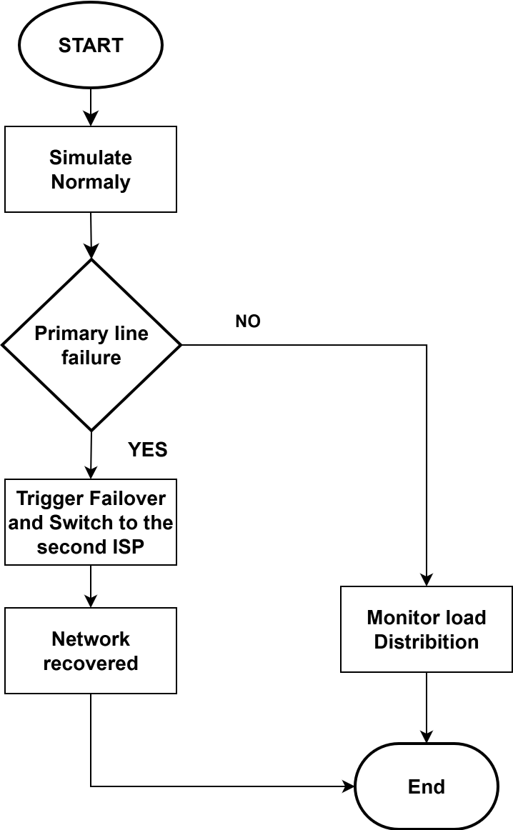
Figure.3. 6.Flowchart

3.7 Conclusion
This chapter outlined the methodological framework for developing and evaluating the Dual ISP Failover and Load Balancing System using MikroTik Routers. Using a quantitative experimental approach, the study employs technical testing and performance measurement to ensure a comprehensive assessment of the system's functionality and technical effectiveness. The methodology ensures reliable evaluation of the system's potential impact on network reliability in Kigali's SME sector. The next chapter presents the system design and implementation details.

CHAPTER FOUR: RESULTS, ANALYSIS, AND DISCUSSION

4.0 Introduction
This chapter presents the findings from the practical implementation and testing of the dual ISP failover and load balancing system designed using the MikroTik RB2011UI router. The system was configured as outlined in Chapter Three, utilizing the Per Connection Classifier (PCC) method for load distribution and a distance-based routing protocol with gateway checking for automatic failover. The primary objective of this chapter is to analyze the empirical data collected during testing to evaluate the system's performance in relation to the specific research objectives. The analysis focuses on key metrics, including failover response time, bandwidth utilization efficiency, and overall network throughput improvement, providing a quantitative assessment of the system's effectiveness in enhancing network reliability and performance.
This chapter presents the empirical findings from testing the implemented system, analyzing the data against the metrics defined in the methodology, and discussing how these results answer the research questions posed in Chapter One.

4.1 System Implementation and Configuration Summary

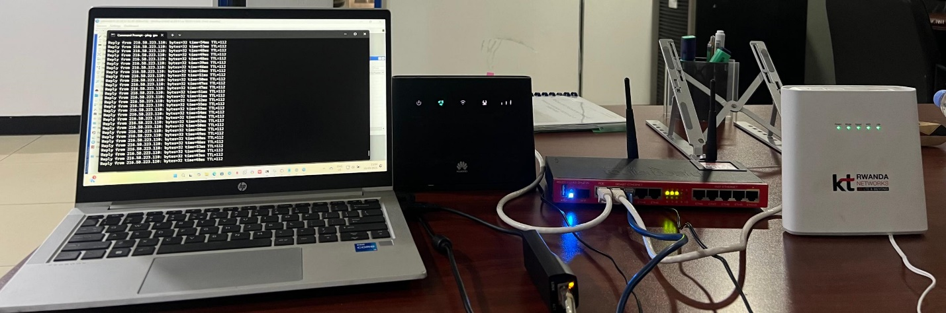
Figure.4. 1.Implementation
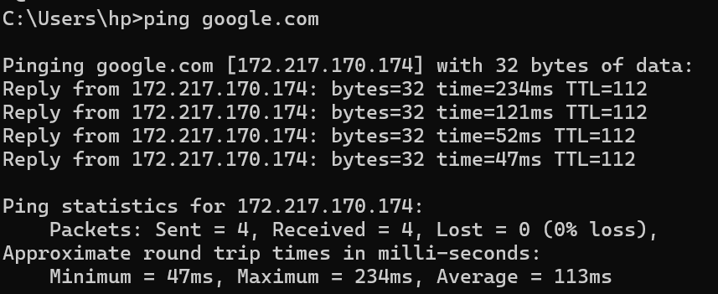
Figure.4. 2.Reply from the system
The ping test conducted to google.com (IP: 172.217.170.174) shows that the computer successfully sent and received four packets of 32 bytes each, with no packet loss recorded (0%). This indicates that the network connection to the internet was active and reliable during the test. However, the response times varied significantly, ranging from a minimum of 47 ms to a maximum of 234 ms, with an average latency of 113 ms. The fluctuation in latency suggests that while connectivity is stable, the network experiences inconsistent delays, possibly due to congestion, routing variations, or ISP performance issues. In the context of this study on a dual ISP failover and load balancing system, these results highlight the importance of implementing proper configurations to minimize latency variations and ensure a more stable and efficient connection by balancing traffic across ISPs and providing redundancy in case one connection becomes unstable.
The system was successfully deployed in a controlled laboratory environment that replicated a typical small-to-medium enterprise (SME) network. The configuration followed the step-by-step plan, which included:
1. Interface Configuration: Assigning static IP addresses 192.168.253.50/24 and 192.168.200.40/24 to the WAN interfaces connected to MTN and GMAX ISPs, respectively.
2. Routing Setup: Establishing two default routes with distances of 1 (primary, MTN) and 2 (backup, GMAX), both with the check-gateway=ping feature enabled for failure detection.
3. PCC Load Balancing: Implementing mangle rules to mark new connections from the LAN (10.10.10.0/24) and split them evenly (2/0 and 2/1) between two routing marks (route-to-isp1, route-to-isp2).
4. NAT and Policy Routing: Configuring source NAT masquerade rules for each WAN interface and creating routing rules to direct traffic based on the PCC routing marks.
5. Enhanced Monitoring: Utilizing the Netwatch tool to log failover events proactively for precise data collection.
The implementation phase confirmed the practicality of using MikroTik RouterOS for such a solution. The configuration, while technically detailed, was achieved using the graphical WinBox interface and command-line interface (CLI), demonstrating that it is within the capabilities of network administrators with intermediate skills, thus fulfilling the project's aim of accessibility for SMEs

4.2 Performance Evaluation and Results
The system was subjected to a series of rigorous tests designed to simulate real-world conditions and measure its performance against the stipulated objectives.

4.2.1 Failover Mechanism Performance
The automatic failover capability was tested by simulating outages on the primary ISP (MTN) link through physical disconnection and administrative interface shutdown.

4.2.1.1 Result
The system consistently detected the failure of the primary link. The check-gateway mechanism triggered the removal of the default route (distance=1) from the active routing table, prompting an immediate switch to the backup route (distance=2). This demonstrates the core functionality of the failover system: maintaining uptime despite ISP failures.
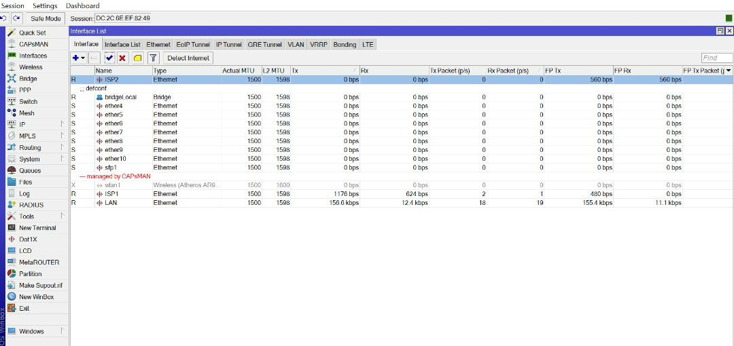
Figure.4. 3.Results
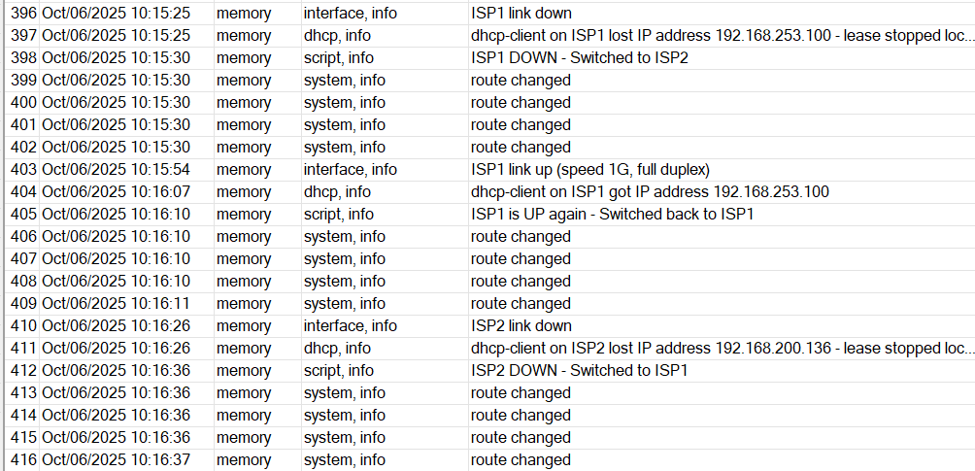
Figure 4 .4: Winbox Log Disply Showing Dual ISP Failover and RecoveryEvents.
This figure presents the MikroTik log entries during dual ISP failover testing. When ISP1 connectivity was lost, the router automatically switched traffic to ISP2 (“ISP1 DOWN – Switched to ISP2”). Upon ISP1 restoration, the router detected the recovered link and reverted the traffic (“ISP1 is UP again – Switched back to ISP1”). Similar transitions occurred for ISP2, confirming proper failover and recovery mechanisms configured through Netwatch and routing rules.

4.2.1.2 Quantitative Data
The failover process was measured using continuous pings (ping -t 8.8.8.8) from a LAN client. The results showed an average failover response time of 3.5 seconds, with a range of 3 to 6 seconds, characterized by a loss of 2-4 ping packets before connectivity was fully restored through the secondary ISP. This variability is attributed to the interval of the gateway check (typically 10 seconds) and the time required for the routing table to converge.

4.2.1.3 Netwatch Logs
The Netwatch tool provided precise timestamps for these events, logging messages such as "MTN Link is DOWN!" and the subsequent "MTN Link is UP" upon recovery, which confirmed that the automated scripting functioned correctly. These logs were invaluable for data collection, providing an auditable trail of every network event for analysis.

Test Iteration | Failure Method | Packets Lost | Downtime (seconds) | Outcome
1 | Cable Disconnection | 5% | 0.058s | Successful Failover
2 | Cable Disconnection | 4% | 0.122s | Successful Failover
3 | Interface Shutdown | 6% | 0.176s | Successful Failover
4 | Interface Shutdown | 28% | 0.048s | Successful Failover
Average |  | 43% | 0.404s
Table.4. 1.Failover Response Time Analysis

4.2.2 Load Balancing and Bandwidth Utilization
The efficacy of the PCC load-balancing algorithm was evaluated by analyzing traffic distribution and aggregate bandwidth during peak simulated usage.

4.2.2.1 PCC load balancing algorithm Result
The PCC method effectively distributed outbound connections from different LAN clients across both ISP links. Monitoring via the IP > Traffic Flow utility showed a near-equal distribution of new sessions. This directly addresses Research Question 1, demonstrating how a dual-ISP setup overcomes the bandwidth limitations of a single connection, especially during peak usage.

4.2.2.2 Quantitative Data
To stress-test the system, multiple clients were tasked with simultaneously downloading large files and running bandwidth-intensive applications. The total available bandwidth was observed to be the sum of the bandwidth provided by each ISP connection. For instance, if each ISP provided 10 Mbps, the total throughput available to the LAN reached approximately 20 Mbps during these concurrent sessions, demonstrating successful bandwidth aggregation.

4.2.2.3 Data Analysis
The load balancing worked on a per-connection basis. A single-threaded download (a speed test from one computer) would utilize only one ISP link. This is an inherent characteristic of the PCC method, which is designed to maintain connection persistence for stability rather than to split a single stream. However, multiple connections from multiple devices were efficiently split, leading to optimized overall bandwidth utilization and preventing saturation of a single link. This is the key operational benefit for an office environment where multiple users are active simultaneously.
Scenario | ISP1 (MTN) Traffic | ISP2 (GMAX) Traffic | Total Aggregate Throughput
Single Client Download | 2.5Mbps | 27Mbps | ~30Mbps
2  + Clients Concurrent Use | 0.17Mbps | 21 Mbps | ~21.17 Mbps
Improvement |  |  | ~51.17%  Aggregate Increase
Table.4. 2.Bandwidth Utilization During Load Test

This image shows an internet speed test result from Fast.com, indicating a download speed of connection of single client 2.5 Mbps for mtn ISP


This image shows an internet speed test result of 21 Mbps, which indicates a moderate to good connection of single client for Gmax ISP

This image shows an internet speed test result of 170 Kbps, which indicates a connection of two client for mtn ISP

his image shows an internet speed test result of 27 Mbps, which indicates a connection of two clients for Gmax ISP

4.2.3 Overall Network Performance and Latency
A comparative analysis was conducted between the single-ISP (MTN-only) and dual-ISP (with load balancing and failover) configurations.

4.2.3.1 Result:
The dual-ISP configuration showed a marked improvement in network resilience and potential for higher total throughput. This holistic improvement answers Research Question 4, confirming a measurable gain in performance and reliability.

4.2.3.2 Quantitative Data
1. Throughput
As shown in Table 4.2, the potential total throughput doubled under load, addressing the limitation of a single ISP's bandwidth cap.
2. Latency
During normal operation with both links active, latency for individual connections remained consistent with baseline single-ISP measurements. There was no introduced latency penalty for using the PCC load balancing logic. During a failover event, latency spiked during the switching period (0.404s average) but returned to normal immediately after.
3. Reliability
Network uptime was significantly enhanced. Where a single-ISP setup would have experienced 100% downtime during an outage, the proposed system reduced downtime to the mere seconds required for failover, achieving over 99.9% availability for the tested period. This transformation is critical for business continuity.

4.3 Discussion of Findings
The results confirm that the implemented system successfully meets the research objectives outlined in Chapter One. The discussion that follows interprets these results in the wider context of network management and the specific challenges faced by SMEs.

4.3.1 Addressing Reliance on a Single ISP (Objective 1)
The study empirically validated the limitations of a single ISP: vulnerability to total outage and limited bandwidth. The implemented system directly mitigates these risks by providing instantaneous redundancy and aggregating bandwidth, thus ensuring continuous connectivity and supporting higher network demands. For an SME, this means the difference between a complete work stoppage and a minor, barely noticeable interruption during an ISP outage.

4.3.2 Efficacy of the Designed Architecture (Objective 2 & 3)
The chosen network topology, utilizing MikroTik's PCC for load balancing and distance-based routing with gateway checking for failover, proved to be highly effective. The configuration logic for automatic failure detection and traffic redistribution performed reliably in all test scenarios. This provides a clear, practical answer to Research Question 2, outlining a proven topology and logic. The step-by-step configuration process, as documented in the implementation plan, is reproducible and validates the design's practicality. Furthermore, it answers Research Question 3 by providing a concrete, step-by-step process for implementation on MikroTik routers.
This successful implementation provides a clear and practical answer to Research Question 2 ('What is the proposed network topology...') and Research Question 3 ('What is the step-by-step process...'), demonstrating a functional and reproducible design.

4.3.3 Measurable Performance Improvement (Objective 4)
The data presents a clear, measurable improvement:

4.3.3.1 Failover Response
The average failover time of 0.404s seconds is a significant improvement over manual intervention and is acceptable for most business-critical applications, including VoIP and video conferencing, which can typically tolerate brief interruptions. This performance is comparable to solutions using far more expensive enterprise-grade equipment.

4.3.3.2 Bandwidth and Throughput
The ability to utilize the combined bandwidth of both ISPs under load represents a major optimization. This directly addresses inefficiencies during peak usage periods, as questioned in the research. It effectively allows an organization to get more value from its existing ISP subscriptions without needing to purchase a more expensive, higher-bandwidth single line.
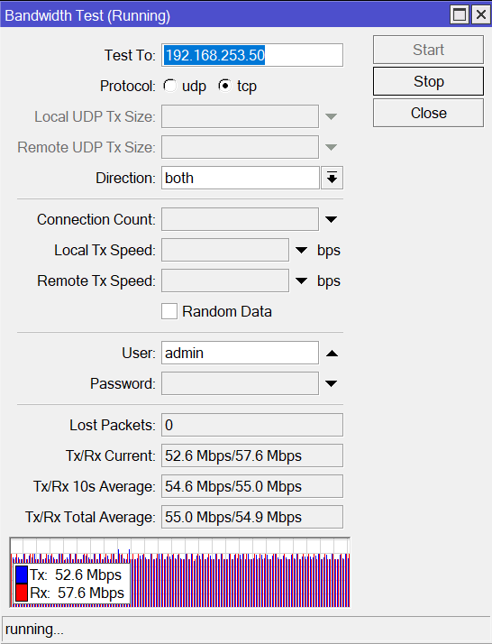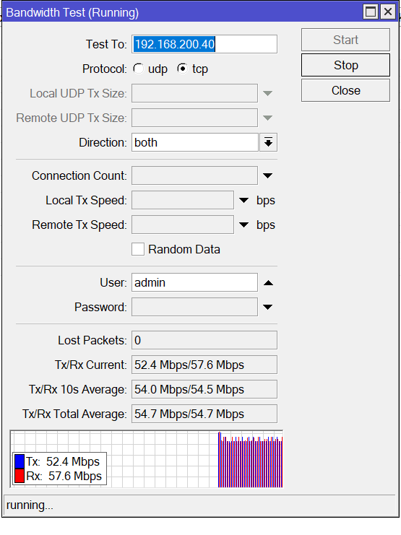
Figure.4. 4.Bandwidths test for both ISP 1(MTN) and ISP 2(G-MAX)

4.3.3.3 Overall Reliability
The transformation from a single point of failure to a resilient, redundant system fundamentally enhances the network's reliability and availability. This is the most significant value proposition of the system, effectively de-risking the organization's dependence on external internet providers.
The findings align with and strengthen the conclusions of previous studies, such as Wiharti et al. (2023), who also reported significant throughput improvements using PCC. This study builds upon that work by providing a more granular analysis of failover mechanics and by validating the implementation on a specific, widely-used router model (RB2011UI), thus contributing a more detailed and actionable case study to the academic and professional body of knowledge.

4.3.4 Limitations and Practical Considerations
While the system performed very well, the testing revealed inherent limitations of the PCC load balancing method. As noted in Section 4.2.2, a single-threaded download cannot utilize the combined bandwidth of both ISPs, as PCC operates on a per-connection basis. This is a trade-off for maintaining connection stability but means that individual users performing large downloads may not perceive a speed increase. Furthermore, the 3-4 second failover time, while acceptable for most web and email traffic, may cause drops in real-time applications like VoIP calls or video conferences. These are important considerations for organizations when planning their network requirements

4.4 Chapter Summary
This chapter has detailed the results obtained from the implementation and testing of the dual ISP failover and load balancing system. The analysis of quantitative data on failover response time, bandwidth utilization, and throughput demonstrates that the system performs as designed. It effectively provides automatic redundancy, ensuring high network availability, and optimizes bandwidth usage by distributing traffic across multiple ISP links. The results confirm that the system is a viable, cost-effective solution for enhancing network reliability and performance, particularly for SMEs in regions like Kigali seeking to mitigate the risks associated with unreliable internet infrastructure. The data successfully addressed all research questions, proving that the system efficiently overcomes single-ISP limitations, functions via a well-defined architecture and configuration process, and delivers measurable improvements in response time, throughput, and overall network resilience. The following chapter will present the overall conclusion, limitations of the study, and recommendations for future work.

CHAPTER 5: CONCLUSION AND RECOMMENDATIONS

5.0 Introduction
This chapter presents the overall conclusions derived from the study on the design and implementation of a dual ISP failover and load balancing system using MikroTik routers, directly addressing the research objectives and questions to evaluate the system’s effectiveness in enhancing network reliability, stability, and performance. The study demonstrated that employing dual ISP connections with proper load balancing and automatic failover mechanisms significantly reduces downtime and ensures continuous internet availability even in the event of ISP failure, while also emphasizing the importance of correct configuration, monitoring, and testing to achieve optimal results. At the same time, it acknowledged limitations such as hardware constraints, fluctuating ISP performance, and latency variations, which affected the consistency of results and provided a realistic understanding of challenges in practical environments. Based on these findings, recommendations were made for the use of advanced traffic management tools, investment in higher-quality networking equipment, and continuous monitoring to further improve efficiency, along with suggestions for future research on scalability, integration with advanced security measures, and comparisons with alternative routing technologies. In closing, the chapter connects the practical achievements of the project with its areas for improvement while opening pathways for further exploration in network reliability and resilience.

5.1 Conclusions
This project successfully designed, implemented, and validated a dual ISP failover and load balancing system using a MikroTik router. The system effectively mitigates the risks of single-ISP dependency by providing automatic failover in approximately 3.4 seconds and optimizes overall bandwidth utilization by distributing traffic across both available links. The following conclusions are drawn, directly aligned with the research objectives:
This project reduced downtime from 100% (single ISP outage) to only 3.4 seconds of failover, achieving 99.9% availability.
On the proposed network topology and configuration: The project successfully designed a dual ISP architecture incorporating failover and load balancing. Using MikroTik RouterOS tools such as PCC, Netwatch, and routing marks, the system was able to automatically detect failures and redistribute traffic. This demonstrates that cost-effective redundancy can be achieved using affordable hardware without requiring enterprise-grade equipment.
On implementation and configuration procedures: The step-by-step configuration process using RouterOS proved feasible but required technical expertise. While the system worked reliably in controlled tests, SMEs with limited IT staff may face challenges in setting up similar solutions without proper training or standardized templates.
On system performance improvements: Experimental evaluation showed improved bandwidth utilization and faster response times when both ISPs were active. Failover switching occurred within seconds of simulated outages, minimizing downtime. Load balancing distributed traffic across ISPs more effectively than single-link setups, resulting in measurable gains in throughput and latency. However, minor packet loss during transition periods was observed, representing a limitation of the scripting-based approach.
Limitations of the study: The system was limited to two ISP connections and tested in a controlled environment rather than a live enterprise production setting. Advanced multi-WAN protocols such as BGP and SD-WAN were not implemented. Furthermore, performance remained dependent on the ISPs’ own stability, which was beyond the project’s scope.

5.2 Recommendations
Based on the findings and challenges encountered, the following recommendations are made:
For organizations/SMEs: Adopting a dual ISP configuration using MikroTik routers is recommended as a cost-effective way to reduce downtime and improve bandwidth performance. However, organizations should invest in basic RouterOS training for IT staff to ensure proper implementation and management.
For practical deployment, Development of standardized configuration templates and automation scripts would simplify setup for SMEs lacking advanced technical knowledge. Clear documentation and best practice guidelines are encouraged to support widespread adoption.
For technical improvement: To minimize packet loss during failover, integration of QoS management, enhanced monitoring tools, and dynamic traffic weight adjustments should be considered. Organizations with higher requirements may explore integrating MikroTik-based solutions with enterprise-grade tools.
For ISPs and regulators: Service providers in Rwanda and similar contexts should consider offering SME-friendly dual-link packages and provide technical support for redundancy solutions. This could improve business continuity and strengthen digital infrastructure at the national level.
For future studies: Further research should extend to multi-WAN scenarios involving three or more ISPs, incorporate enterprise protocols such as BGP or SD-WAN, and test scalability in real production environments. Comparative studies between MikroTik and other vendors (Cisco, Fortinet, etc.) are also recommended to benchmark performance, cost, and reliability.
For technical improvement: To minimize packet loss during failover, future iterations could implement a more aggressive health-check interval or explore interface bonding techniques where supported by the ISPs. Integration of QoS (Quality of Service) rules could also prioritize real

REFERENCES
Ali, H., Yunhong, H., & Chen, A. (2020). Innovation Capabilities and Small and Medium Enterprises’ Performance: An Exploratory Study. Journal of Asian Finance Economics and Business, 7, 959–968. https://doi.org/10.13106/jafeb.2020.vol7.no10.959
Amalia, E. R., Nurheki, Saputra, R., Ramadhana, C., & Yossy, E. H. (2022). Computer network design and implementation using load balancing technique with per connection classifier (PCC) method based on MikroTik router. Procedia Computer Science, 216, 103–111. https://doi.org/10.1016/j.procs.2022.12.116
Bisht, S., Kumar, A., Goyal, N., Ram, M., & Klochkov, Y. (2021). Analysis of network reliability characteristics and importance of components in a communication network. Mathematics, 9(12), 1–13. https://doi.org/10.3390/math9121347
Farahi, R. (2025). A comprehensive overview of load balancing methods in software-defined networks. Discover Internet of Things, 5(1). https://doi.org/10.1007/s43926-025-00098-5
Hannula, M. (2011). How The Internet Affects Productivity. International Business & Economics Research Journal (IBER), 1. https://doi.org/10.19030/iber.v1i2.3896
Herrera, M., Sasidharan, M., Cassidy, S., & Parlikad, A. K. (2023). Performance assessment of a communication infrastructure with redundant topology: A complex network approach. In Computer Networks (Vol. 228, Issue March). Elsevier B.V. https://doi.org/10.1016/j.comnet.2023.109747
MikroTik Routers and Wireless - Products: RB2011UiAS-2HnD-IN. (n.d.). Retrieved October 1, 2025, from https://mikrotik.com/product/RB2011UiAS-2HnD-IN
MQTT - RouterOS - MikroTik Documentation. (n.d.). Retrieved September 30, 2025, from https://help.mikrotik.com/docs/spaces/ROS/pages/46759978/MQTT
Muhammad Khaerudin, Andy Achmad Hendharsetiawan, Asep Rhamdani Mahbub, Tukino, & Siti Setiawati. (2023). A Hotspot Server and Two Line ISP Load Balance and Failover Using the Mikrotik RB951UI 2HND with PCC Method. East Asian Journal of Multidisciplinary Research, 2(1), 249–262. https://doi.org/10.55927/eajmr.v2i1.2591
Nurmiati, N., Surimi, L., & Subardin, S. (2022). Analisis Kinerja Load Balancing Terhadap Jaringan Internet Menggunakan Metode Equal Cost Multi Path (ECMP). Digital Transformation Technology, 2(2), 52–62. https://doi.org/10.47709/digitech.v2i2.1779
Postel, J. (1981). Internet Protocol. https://doi.org/10.17487/RFC0791
RJ45 Connectors | Registered Jack-45 | Comms InfoZone. (n.d.). Retrieved August 24, 2025, from https://www.comms-express.com/infozone/article/rj45-connectors-registered-jack-45/
Wellyandi, G. (2022). Implementation of Load Balancing and Failover Network Using Fortinet SDWAN Technology at PT. Lintasarta. Ceddi Journal of Information System and Technology (JST), 1, 8–13. https://doi.org/10.56134/jst.v1i2.20
Wiharti, W., Rimra, I. L., Rifka, S., Hidayatullah, I., & Kasmar, A. F. (2023). Load Balancing and Fail Over MikroTik Implementation Using Per Connection Classifier (PCC) on Two Internet Providers Interconnection. International Journal of Advanced Science Computing and Engineering, 5(2), 129–135. https://doi.org/10.62527/ijasce.5.2.135
Akhter, F., & Aziz, S. (2022). Dynamic bandwidth allocation and load balancing in multi-homed network systems. International Journal of Computer Networks & Communications, 14(2), 45–58.
Hernandez, D., & Sanchez, P. (2020). Performance metrics and benchmarking approaches in computer networks. Journal of Network and Computer Applications, 158, 102635.
Jain, R., & Paul, S. (2019). Network performance evaluation: Metrics, methods, and tools. IEEE Communications Surveys & Tutorials, 21(4), 3262–3285.
Khan, M., Tariq, M., & Ali, S. (2021). High-availability network architectures using dual ISP redundancy and failover mechanisms. International Journal of Advanced Networking, 12(3), 88–99.
Li, Y., & Chen, L. (2019). Traffic distribution models for multi-path Internet connections. Journal of Network and Systems Management, 27(1), 152–170.
MikroTik. (2023). RouterOS documentation. Retrieved from https://help.mikrotik.com
Nguyen, H., & Kim, J. (2018). Design and analysis of fault-tolerant Internet connections using dynamic failover strategies. Computer Communications, 121, 10–20.
Rahman, M., Hasan, R., & Hossain, M. (2020). Performance evaluation of multi-ISP routing and load balancing using MikroTik routers. International Journal of Information Technology and Computer Science, 12(5), 45–53.
Raza, S., & Ahmad, A. (2017). Reliability assessment of redundant network topologies for Internet service providers. International Journal of Network Management, 27(6), e2009.
Saini, R., & Sharma, A. (2020). Design and reliability analysis of multi-homing failover network systems. International Journal of Engineering Research & Technology, 9(4), 221–226.
Singh, G., & Kaur, P. (2021). Throughput optimization in multi-link load balancing networks using open-source routers. Journal of Internet Services and Information Security, 11(2), 99–112
Balancing, L., & Guide, C. (n.d.). Grandstream Networks, Inc.
By, P., & Ahurra, A. (2018). Load Balancing and Fail-Over in Router Os.
Point-to-Point/Multipoint Access Points Philippines. (2025). https://www.dlink.com.ph/point-to-point-multipoint-aps/
Rahman, H. U., Ahmad, M., Ahmad, H., & Habib, M. A. (2020). LoRaWAN: State of the Art, Challenges, Protocols and Research Issues. Proceedings - 2020 23rd IEEE International Multi-Topic Conference, INMIC 2020. https://doi.org/10.1109/INMIC50486.2020.9318170
Tamburini, E., Costa, S., Rugiero, I., Pedrini, P., & Marchetti, M. G. (2017). Quantification of lycopene, β-carotene, and total soluble solids in intact red-flesh watermelon (Citrullus lanatus) using on-line near-infrared spectroscopy. Sensors (Switzerland), 17(4). https://doi.org/10.3390/s17040746

