Universal Stationary
User Guide
Premium Stationery E-Portal - Complete Navigation & Feature Guide

——— ✨ ———

Version 1.0 | 2026

Table of Contents
Right-click the TOC and select "Update Field" to refresh page numbers

Introduction 3
Website Overview 3
Page Structure 3
Home Page 3
Shop Page 3
About Page 3
Contact Page 3
Checkout Page 3
Brand Battle Arena 3
Features Guide 3
Shopping Cart 3
Product Comparison 3
Dark Mode 3
Navigation Guide 3
Support & Contact 3

Introduction
Welcome to the Universal Stationary User Guide. This comprehensive document will help you navigate and make the most of our premium stationery e-commerce platform. Whether you are a first-time visitor or a returning customer, this guide provides all the information you need to browse, compare, and purchase high-quality stationery products from world-renowned brands.
Universal Stationary is Pakistan's leading online destination for premium stationery items, featuring authentic products from STAPLES, Parker, and Faber-Castell. Our digital portal brings the complete catalog to your fingertips, making it easy to find the perfect tools for your office, school, or creative projects.
Website Overview
The Universal Stationary website is designed with user experience in mind. The platform features a modern, responsive design with playful colors and intuitive navigation. Key highlights of the website include:
- Premium brand partnerships with STAPLES, Parker, and Faber-Castell
- Interactive product catalog with detailed specifications
- Brand Battle Arena for side-by-side product comparison
- Seamless shopping cart and checkout experience
- Dark mode for comfortable browsing
- 3D animated backgrounds for visual appeal
- Mobile-responsive design for shopping on any device
Page Structure
The Universal Stationary website consists of six main pages, each serving a specific purpose in your shopping journey.
Home Page (index.html)
The Home Page serves as the welcoming gateway to Universal Stationary. It features:
- Animated hero section with dynamic text showcasing use cases
- Quick navigation to the shop and contact pages
- Feature highlights including branded stocks, product battle, and shop locations
- 3D animated background with floating geometric shapes
Theme toggle button for switching between light and dark modes. 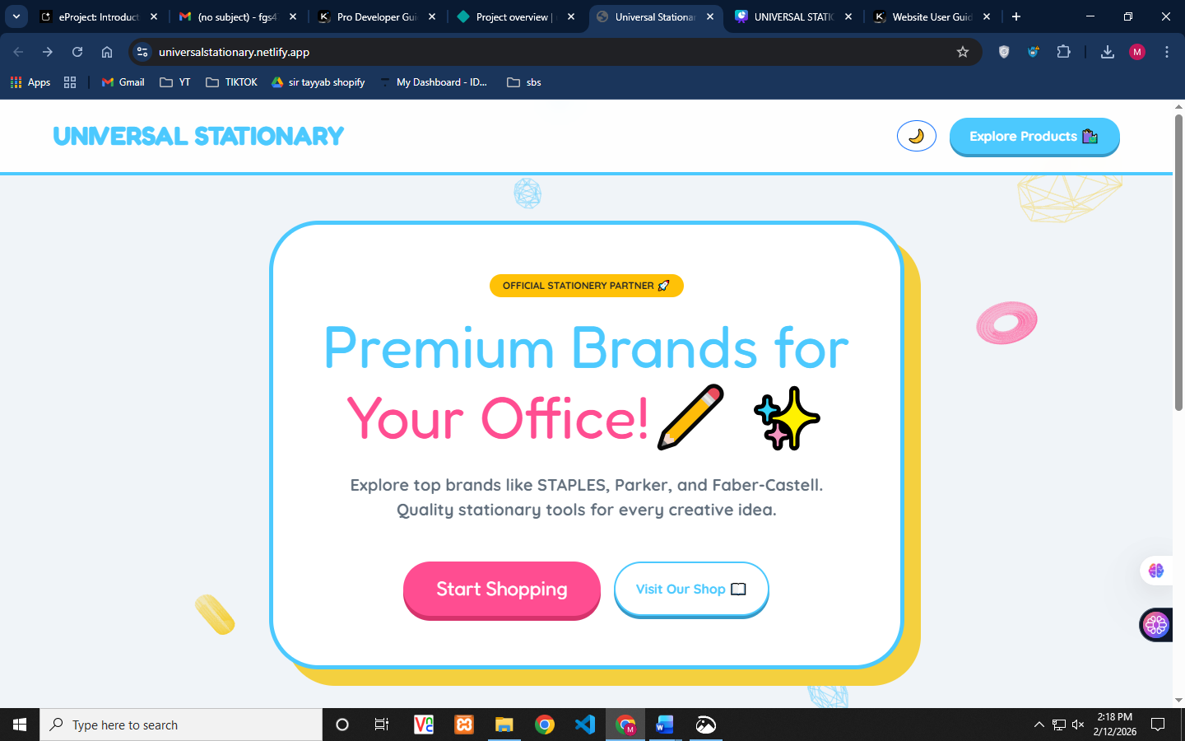

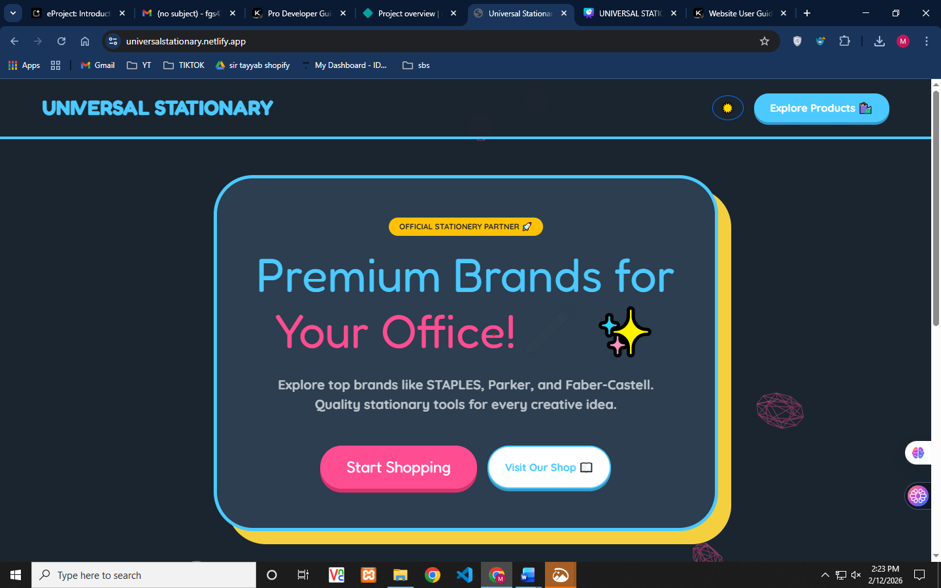

Shop Page (shop.html)
The Shop Page is the heart of the e-commerce experience, featuring the complete product catalog:
- Category filters for All Brands, Staples, Parker, and Faber-Castell
- Product cards with images, prices, and brand badges
- Quick-add to Battle Arena button (⚔️) on each product
- Product modal with detailed description and specifications
- Downloadable product specifications in Word format
- Sliding cart sidebar showing selected items
Available Product Categories:
Brand | Product Types | Price Range (RS)
STAPLES | Staplers, Pins, Punches, Markers, Pens | 350 - 2,299
PARKER | Ballpoint Pens, Fountain Pens | 3,200 - 14,500
Faber-Castell | Color Pencils, Art Sets, Watercolors | 1,650 - 99,450
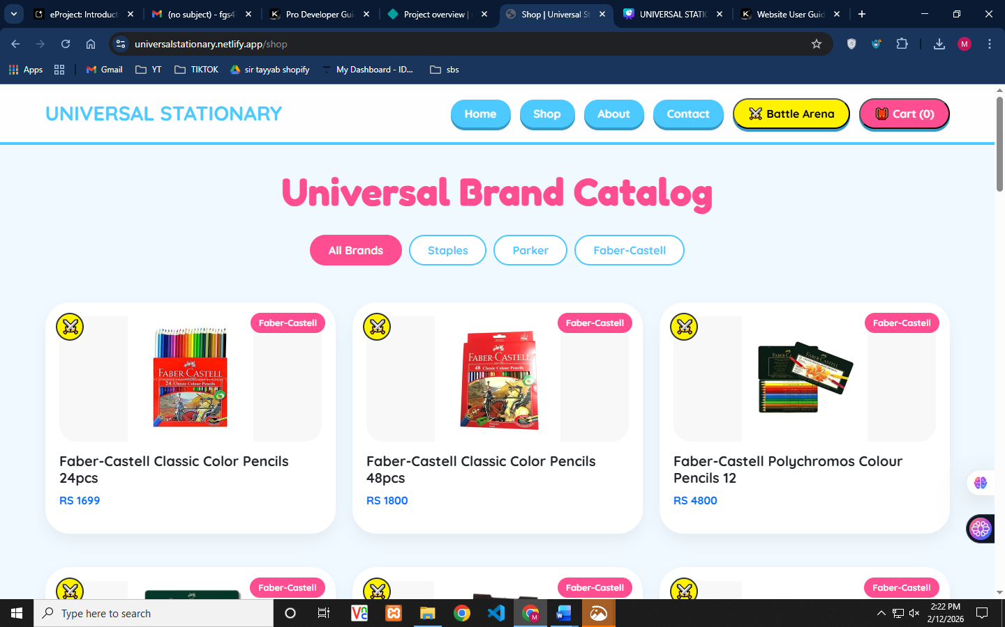

About Page (about.html)
The About Page tells the story of Universal Stationary and introduces the team:
- Company history and evolution from traditional to digital
- Mission statement and brand values
- Leadership team profiles
- Trust badges: Established Brand, 100% Original, Based in Karachi
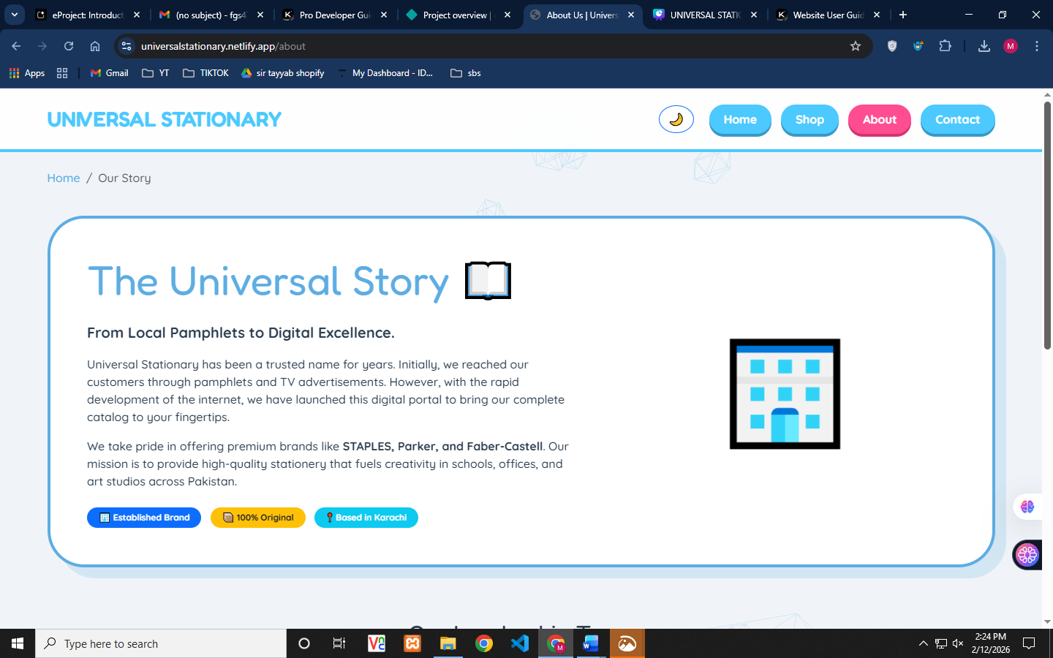

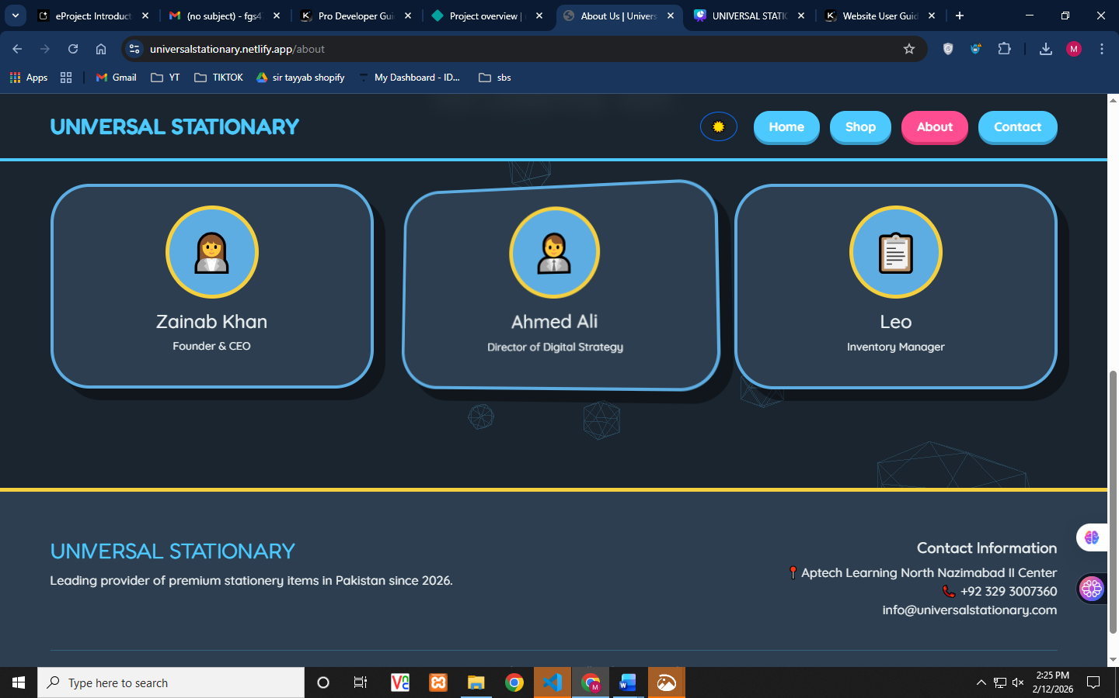
Contact Page (contact.html)
The Contact Page provides multiple ways to reach Universal Stationary:
- Interactive contact form with name, email, and message fields
- Animated "carrier pigeon" message submission effect
- Direct email link to info@universalstationary.com
- Physical address: 123 Stationery Lane, Near Civic Center, Karachi
- 3D bubble animation background
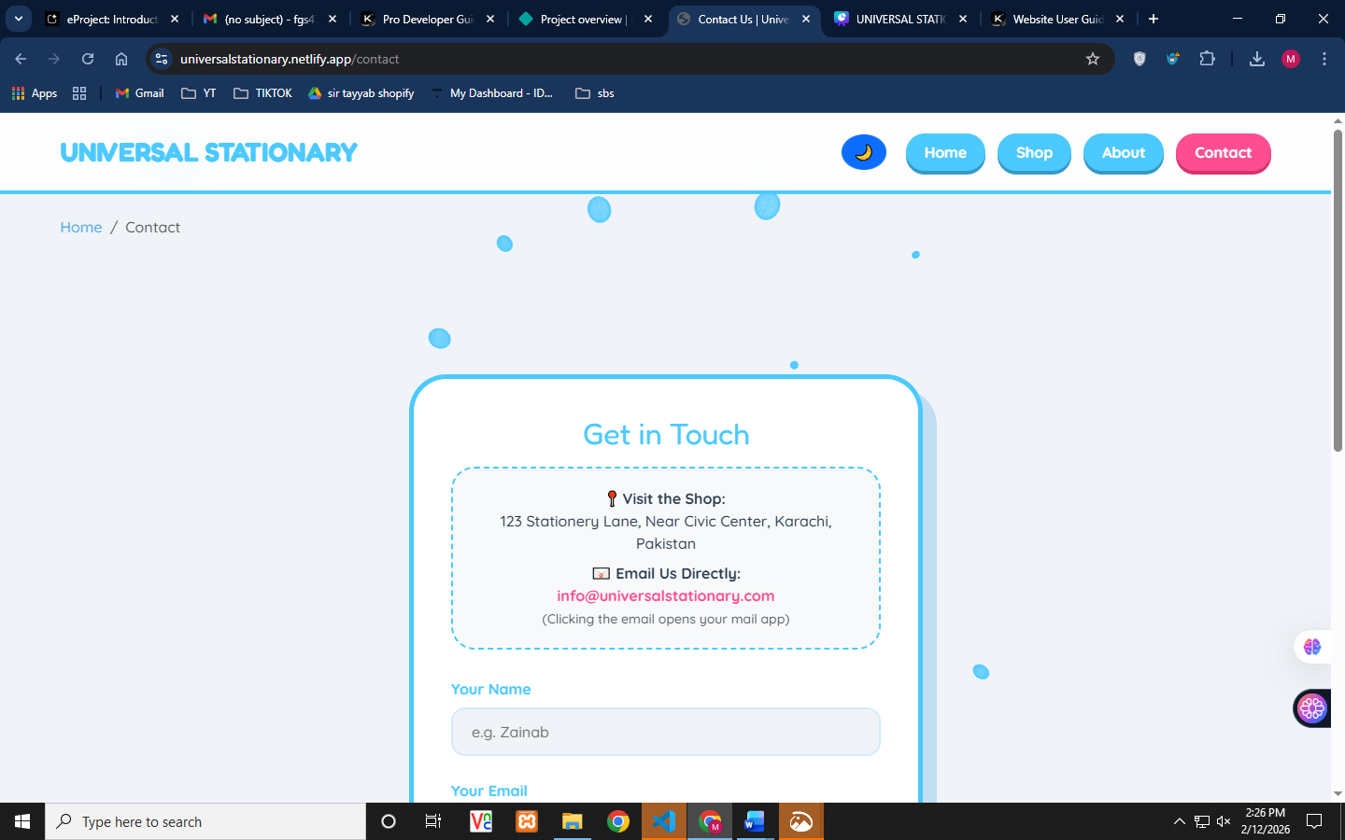
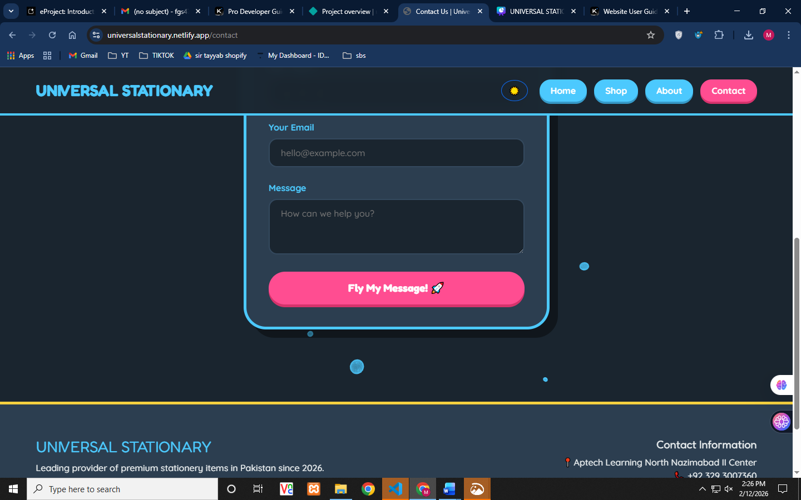
Checkout Page (checkout.html)
The Checkout Page streamlines the order completion process:
- Delivery details form with name, address, and phone fields
- Payment method selection: Cash on Delivery, JazzCash/EasyPaisa, or Bank Transfer
- Order summary showing all items and total amount
- Order confirmation with unique Order ID
- Confetti celebration animation on successful order placement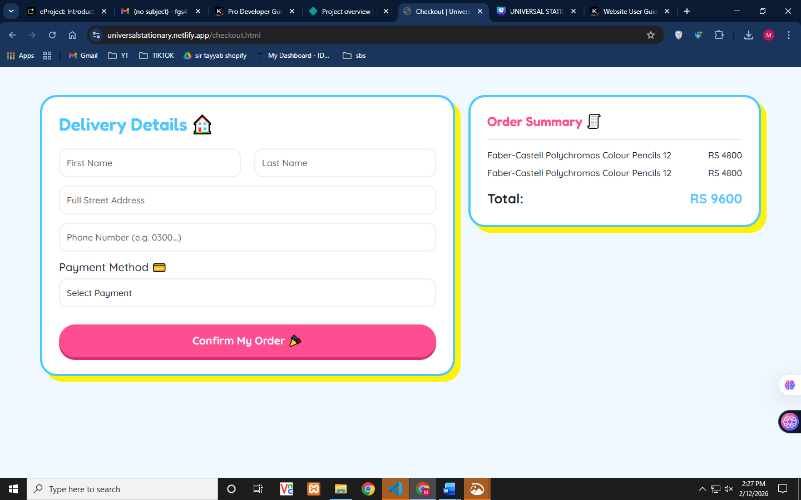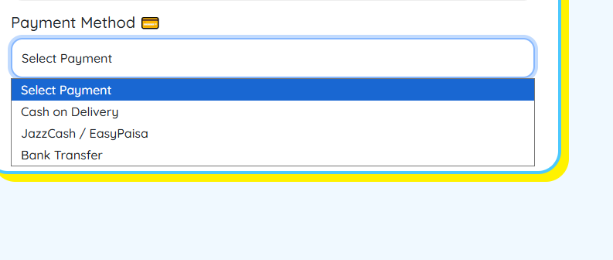

Brand Battle Arena (compare.html)
The Brand Battle Arena is a unique feature that allows side-by-side product comparison:
- Compare up to 2 products simultaneously
- Visual VS badge between compared items
- Product images, names, brands, and prices displayed
- "Choose This Winner!" selection button
- Reset Battle button to clear comparisons
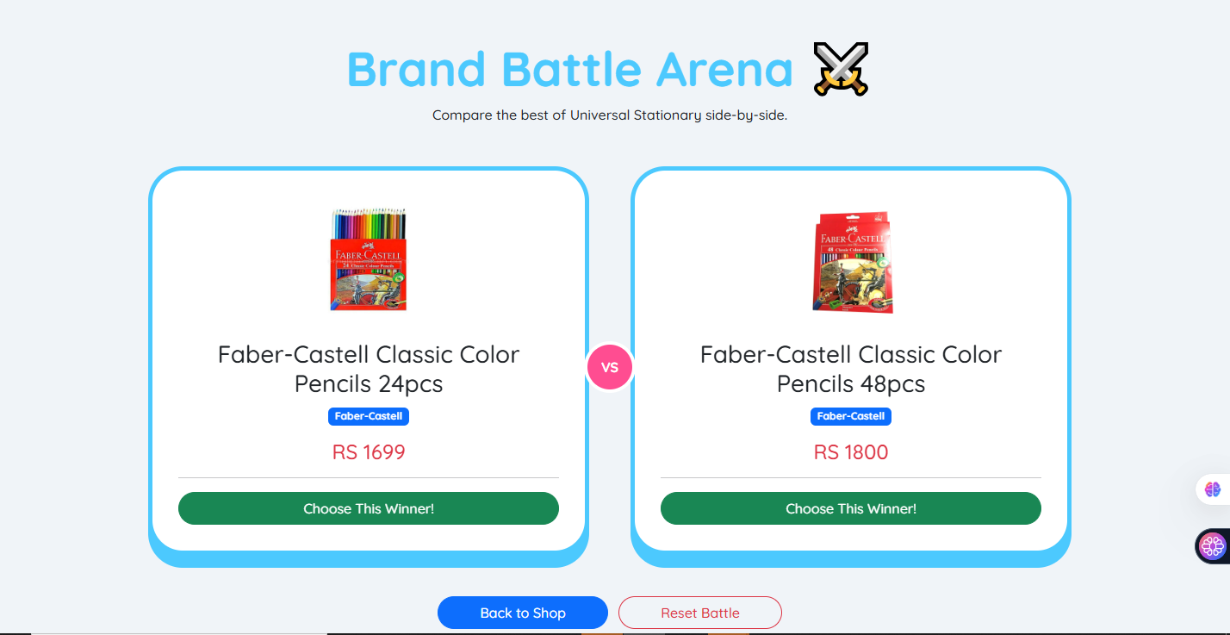
Features Guide
Shopping Cart (My Backpack)
The shopping cart, branded as "My Backpack," follows you throughout your shopping journey:
- Access Cart: Click the "🎒 Cart" button in the navigation bar to open the cart sidebar
- Add Items: From any product modal, click "Add to Backpack" to add items
- Review Items: The cart displays all selected items with individual prices
- View Total: The cart automatically calculates and displays the total amount in Pakistani Rupees (RS)
- Proceed to Checkout: Click "Checkout Now" to complete your purchase
Note: Your cart is saved in your browser's local storage, so items will persist even if you close the browser. 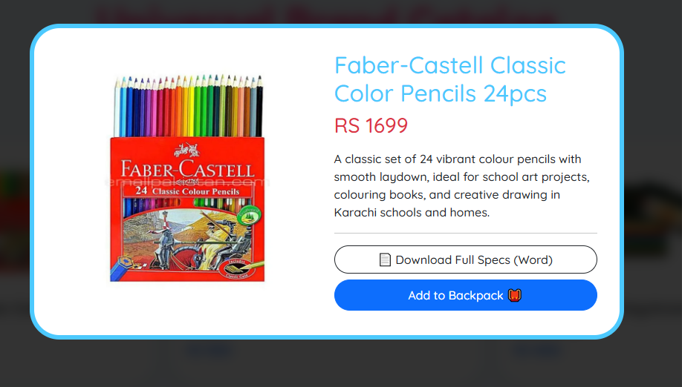

Product Comparison
The Brand Battle Arena feature helps you make informed purchasing decisions:
- Add to Compare: On any product card, click the ⚔️ button to add it to the Battle Arena
- Navigate to Arena: Click "⚔️ Battle Arena" in the navigation or go to compare.html
- Compare Features: View products side-by-side with images, prices, and brand information
- Make Selection: Click "Choose This Winner!" to select your preferred product
- Reset if Needed: Use "Reset Battle" to clear comparisons and start over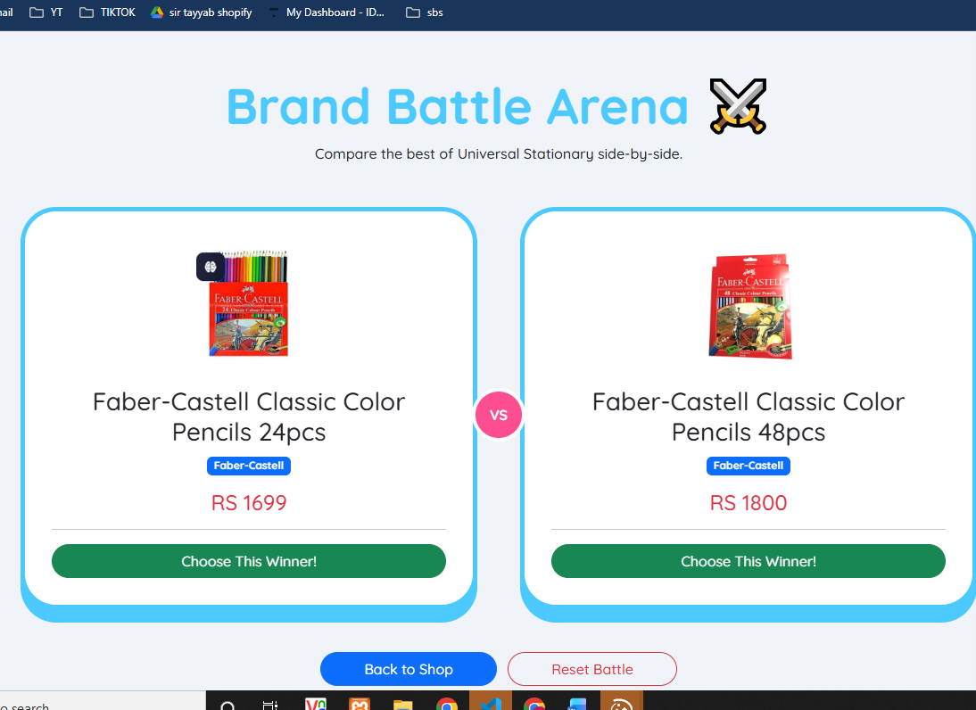

Dark Mode
Universal Stationary offers a dark mode for comfortable browsing in low-light conditions:
- Click the 🌙 (moon) icon in the navigation bar to enable dark mode
- The icon changes to ☀️ (sun) when dark mode is active
- Dark mode changes the background to a deep blue-gray color
- All text and UI elements automatically adjust for optimal contrast
- Your preference is maintained during your browsing session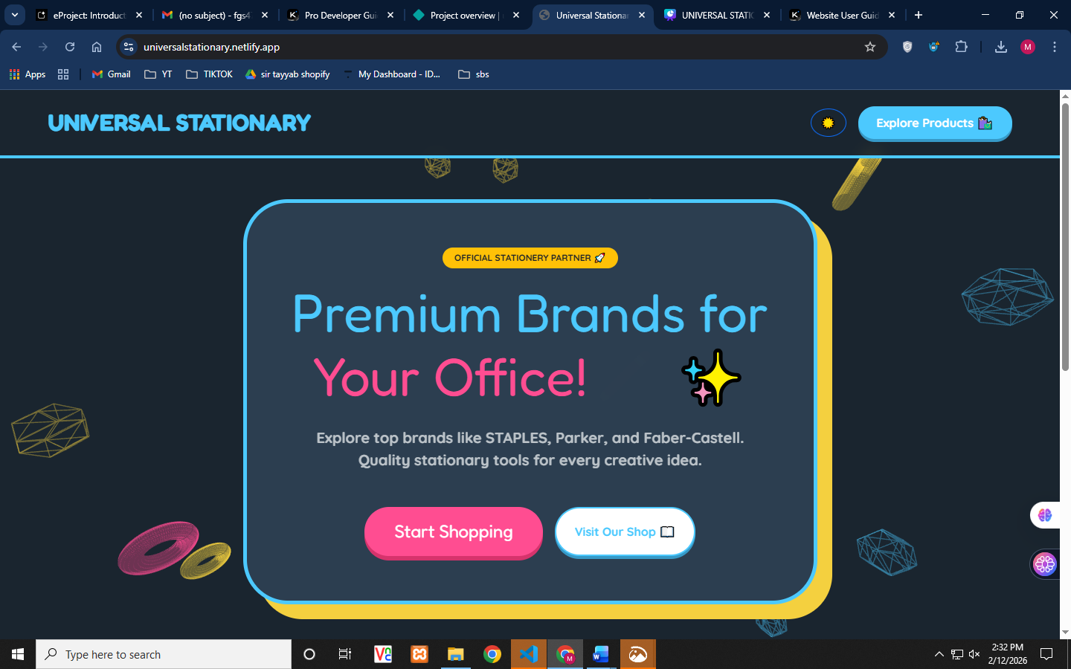

Navigation Guide
The Universal Stationary website features consistent navigation across all pages:
Main Navigation Bar
Located at the top of every page, the navigation bar provides quick access to all sections:
Button | Function
Home | Returns to the homepage with featured content
Shop | Browse the complete product catalog
About | Learn about Universal Stationary's story and team
Contact | Get in touch with customer support
Battle Arena | Compare products side-by-side
Cart | View and manage your shopping cart

Navigation Tips
- The Universal Stationary logo always returns you to the Home page
- The active page is highlighted with a different color in the navigation
- Breadcrumb navigation appears on About and Contact pages
- All navigation buttons feature hover effects for better interactivity
- 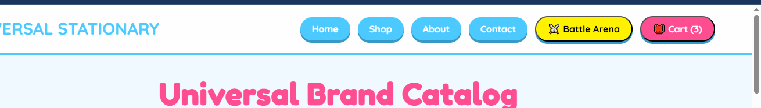
Support & Contact
Universal Stationary is committed to providing excellent customer support. Here's how you can reach us:
Contact Information
Method | Details
Email | info@universalstationary.com
Phone | +92 329 3007360
Address | Aptech Learning North Nazimabad II Center, Karachi
Website | Universal Stationary E-Portal

Business Hours
Our customer service team is available during the following hours:
- Monday - Saturday: 9:00 AM - 6:00 PM (PKT)
- Sunday: Closed
- Response time: Within 24 hours for email inquiries
Frequently Asked Questions
Q: Are all products authentic?
A: Yes, all products are 100% original and sourced directly from authorized distributors.
Q: What payment methods are accepted?
A: We accept Cash on Delivery, JazzCash, EasyPaisa, and Bank Transfer.
Q: Do you offer delivery outside Karachi?
A: Yes, we deliver across Pakistan. Delivery times may vary based on location.

Universal Stationary
Premium Stationery E-Portal

Leading provider of premium stationery items in Pakistan since 2026

📍 Aptech Learning North Nazimabad II Center, Karachi
📞 +92 329 3007360
✉️ info@universalstationary.com

© 2026 Universal Stationary - All Rights Reserved

