Final Project Report - Booknest

1. INTRODUCTION
1.1 Project Overview:
Booknest is a MERN stack-based web application that allows users to browse, wishlist, and purchase books online, while also providing sellers with an interface to list and manage their books.
1.2 Purpose:
The purpose of this project is to demonstrate the implementation of a full-stack online bookstore using modern web development technologies.

2. IDEATION PHASE
2.1 Problem Statement:
Traditional book shopping lacks digital convenience. Booknest solves this by enabling an online platform for buyers and sellers.
2.2 Empathy Map Canvas:

2.3 Brainstorming:
Features like Seller Portal, Wishlist, Cart, and Admin Dashboard were ideated to streamline the book shopping experience.

3. REQUIREMENT ANALYSIS
3.1 Customer Journey Map:
Test Case ID | Test Scenario | Test Steps | Expected Result | Actual Result | Pass/Fail
TC-001 | User Registration using Email | 1. Open registration page  2. Enter valid email, password, confirm password  3. Click register | User account is created and confirmation email is sent | Confirmation email received | Pass
TC-002 | User Login | 1. Open login page  2. Enter registered email and password  3. Click login | User is redirected to dashboard | Redirected to dashboard | Pass
TC-003 | Registration with existing email | 1. Enter already registered email  2. Submit the form | Error message: "Email already exists" | Error shown correctly | Pass
TC-004 | Wishlist book addition | 1. Login  2. Browse a book  3. Click "Add to Wishlist" | Book is saved in wishlist and visible in the Wishlist page | Wishlist updated successfully | Pass
TC-005 | Checkout with empty cart | 1. Login  2. Go to cart  3. Click "Checkout" | Error message: "Your cart is empty" | Error shown correctly | Pass

3.2 Solution Requirement:
- Simple navigation
- User authentication
- Book CRUD operations
- Seller management
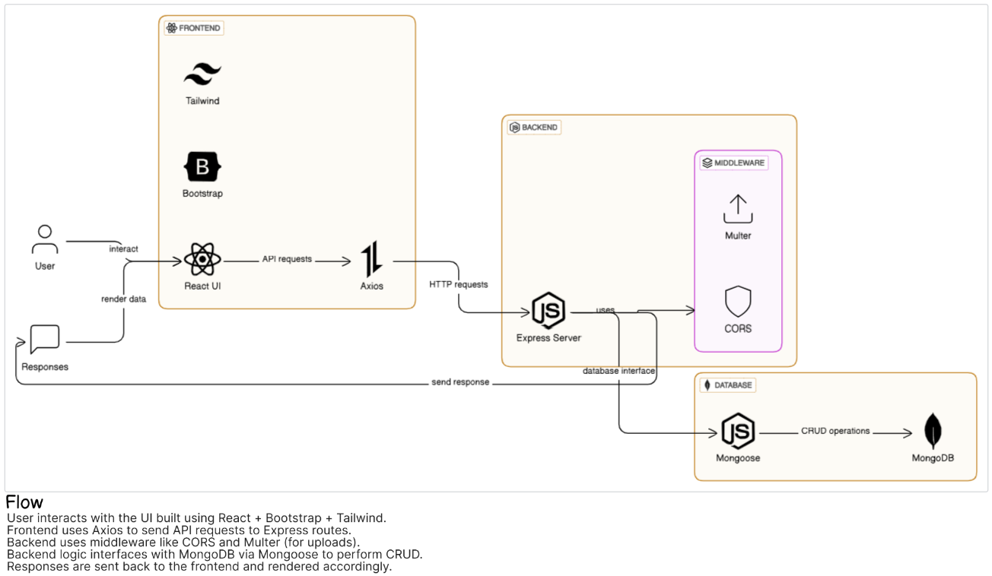
3.3 Data Flow Diagram:
3.4 Technology Stack:
Frontend: React (placeholder)
Backend: Node.js + Express
Database: MongoDB
Authentication: JWT (assumed)

4. PROJECT DESIGN
4.1 Problem Solution Fit:
This platform directly solves the need for an efficient online bookstore with role-based user access.
4.2 Proposed Solution:
A responsive MERN-based system supporting sellers, users, and admin.
4.3 Solution Architecture:
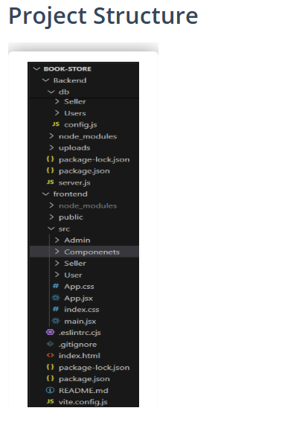
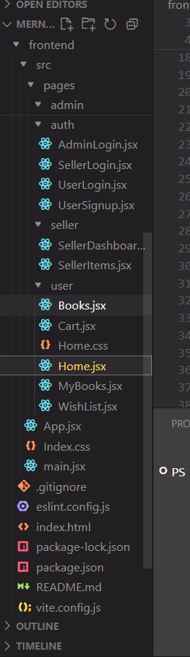

5. PROJECT PLANNING & SCHEDULING
5.1 Planning:
The project was broken into sprints for designing database schema, backend APIs, frontend UI, integration, and testing.

6. FUNCTIONAL AND PERFORMANCE TESTING
6.1 Performance Testing:
Postman was used for API testing, manual testing for UI flows, and browser developer tools for performance evaluation.

7. RESULTS
7.1 Output Screenshots:

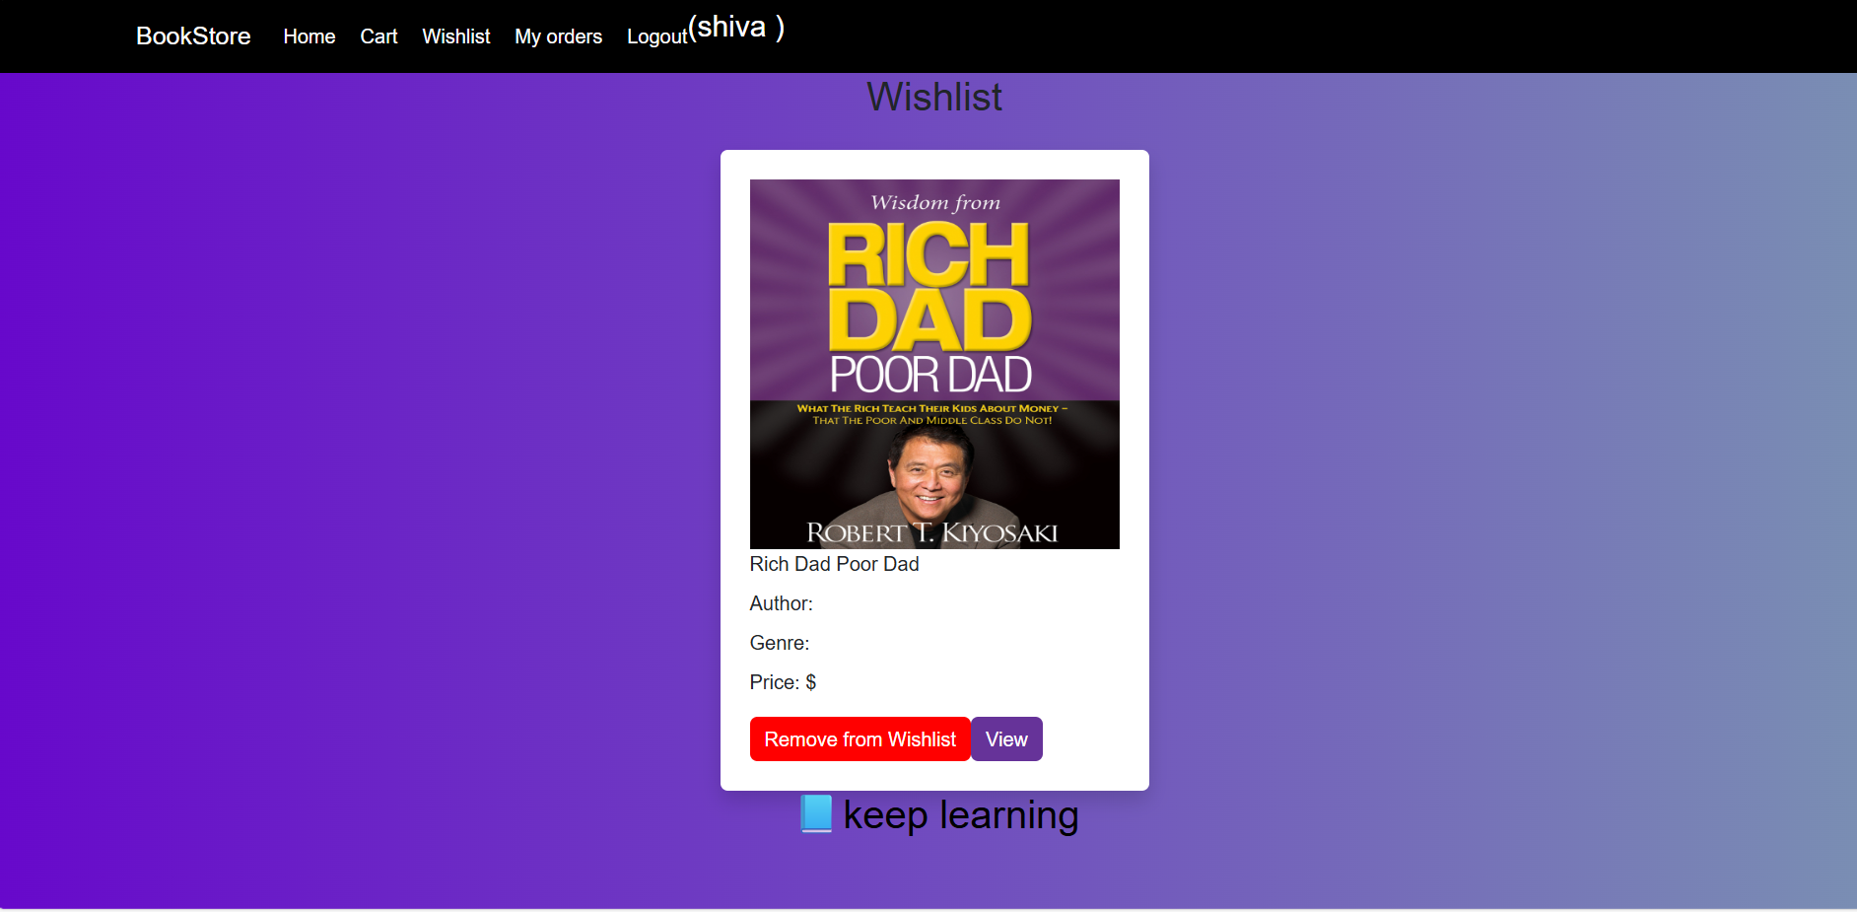


8. ADVANTAGES & DISADVANTAGES
Advantages:
- Full stack skills demonstrated
- Scalable architecture
- User-friendly UI
Disadvantages:
- Payment system not integrated
- Limited book categorization

9. CONCLUSION
Booknest proves to be a viable and educational full stack development project that mimics a real-world e-commerce solution.

10. FUTURE SCOPE
- Add payment gateway integration
- Enable user reviews
- Improve search and filtering
- Deploy on cloud (e.g., Render, Vercel)

11. APPENDIX
Source Code in github:
https://github.com/MohanVenkat14/BookNest-Where-Stories-Nestle
Video Demo Link in drive : https://drive.google.com/file/d/1YxCG12jB3P65poJ1TCLed2GKD0H2ao7r/view?usp=drive_link

